Container management service

Key words of docker are Develop, Ship, run anywhere

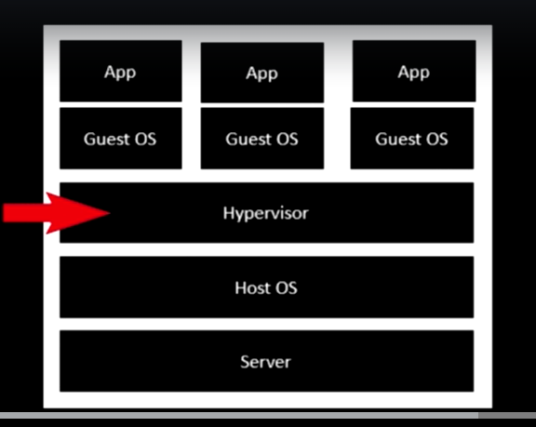

Docker can be deployed to virtual machine , physical machine and even to cloud

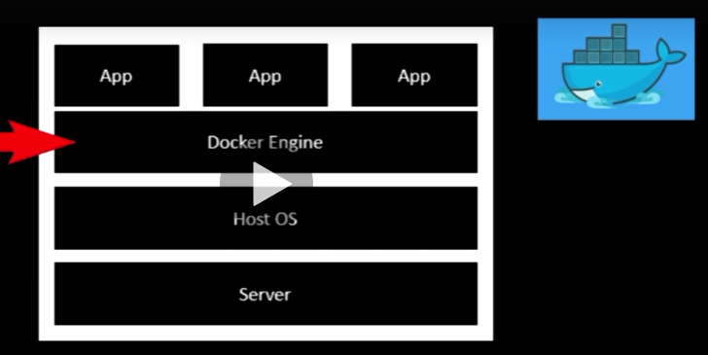

Whole idea is to develop application inside a single container and deploy it anywhere you want.

These container are lightweight they are very easily scalable. With this we can develop smaller foot prints of the application.

In tradition way of development architecture we have hypervisor which is vm ware or window wiser on which virtualization is done

With modern virtualization we have docker engine in the place of hypervisor that will run docker container through which your app rns.

Installing docker:

Docker for windows

Docker tool files

Docker image:

File comprises of multiple layers used to execute the code in docker container.

It has everything inside it to run the application

Code, runtime, system tools, system library.

Container vs image

You have an image set of layer so by running the image running image called container

Image are layers inside the container helps you to run the code inside container

Container is running image

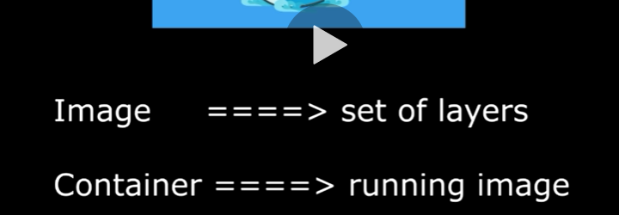

Docker engine: (client CLI vs demon):

Underlying client server technology used to build and run the docker containers. Using docker services

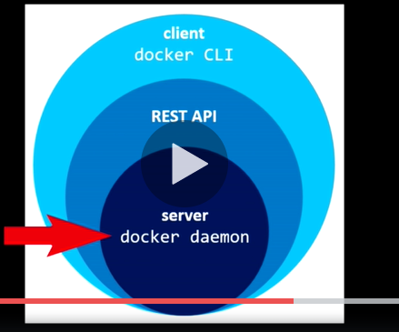

Docker CLI though which client e=interact with docker server using RestApi services.

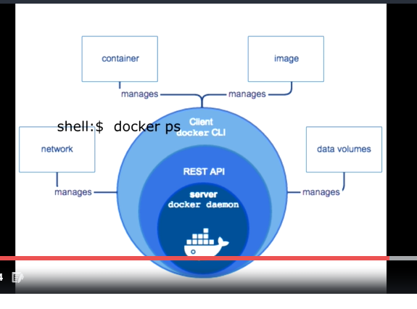

Docker file is plaintext file that basically contain all docker command that user calls on the command line to assemble all image

Docker file should be named as

‘Dockerfile’ it’s a reserved name

Docker hub: is image registry provider where in we can find lot of registry and also we can pus so thing of our own.

Docker registry: is storage and distribution system for named docker images. Same image might have multiple version identified by tag.

Docker Repository: organizes all docker images where in each repository will have all the versions of images which has tag name. so its possible to pull any version from the repository

$ Docker version

Gets the version of docker