EF is ORM

Object to relation mapping

Layered tire architecture

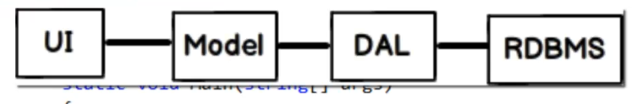

Lot of code to map Db tables with the models class so the every record in DB can be used like strongly typed class object

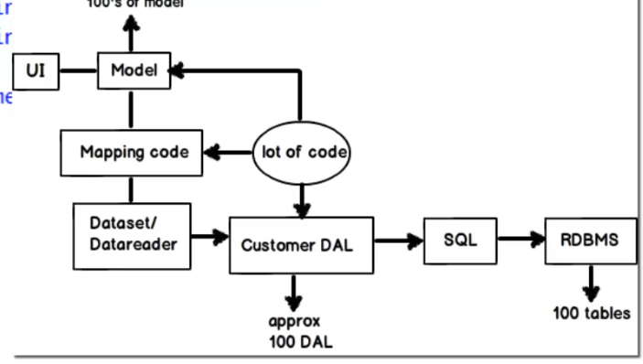

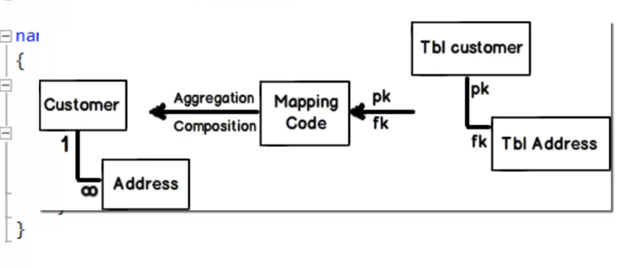

Tool that automate the process of model building by applying the mapping logic on data the us being returned from the db

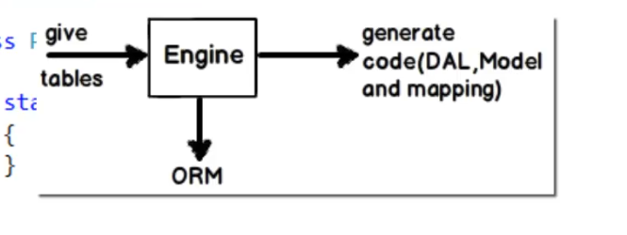

Tool does the work of building the models

O - object- model

R - relation – Data access layer

M -mapping – mapping logic

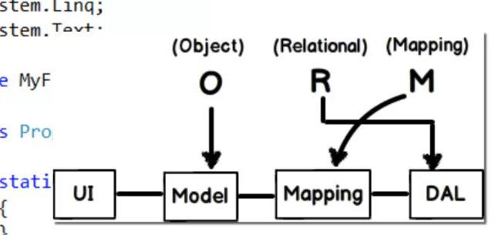

EDMX, context models

EDMX - Entity data model XML

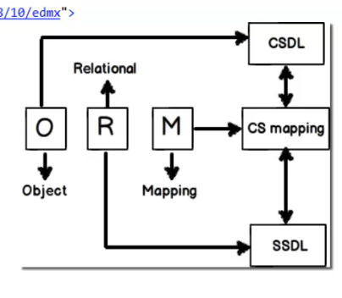

SSDL: deals with the data access logic and stuffs related to the table

CSDL: deals with the object or the entity files and stuffs like that.

CS: mapping between storage and conceptual models

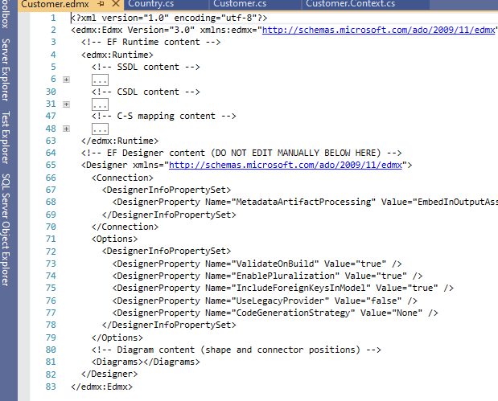

Every table has two parts associated with it

Entity class: Where entity class mainly deals with fields associated with table as entity

Context class: Deals with operation that can eb performed on the entity.

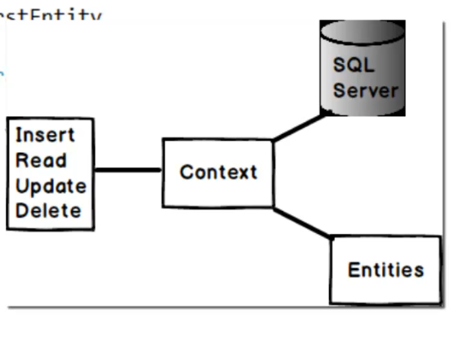

Crud operation with entity frame work:

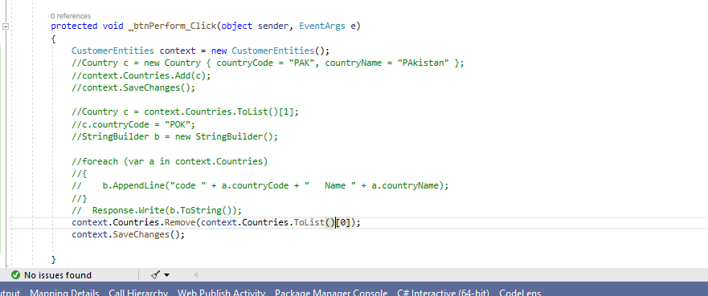

Business validation in entity framework:

1. Do validation on tope of set property of the class
2. Use partial class with name same as entity name and override partial methods to validate

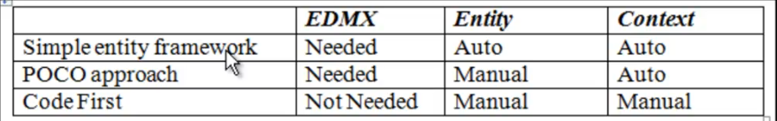

Poco class

Plain old CLR objects

Entity files written with simple code clean class

Code first approach of building entity:

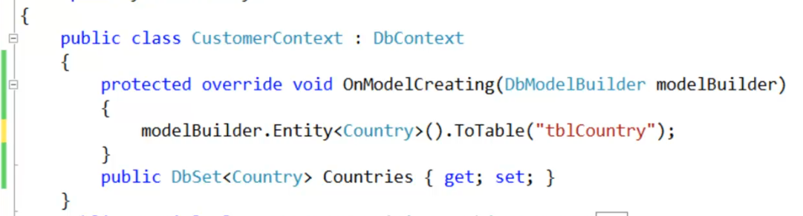

Mode; builder to map between class and table

Specify the code for key

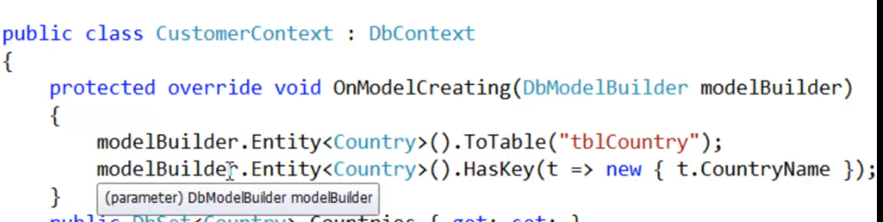

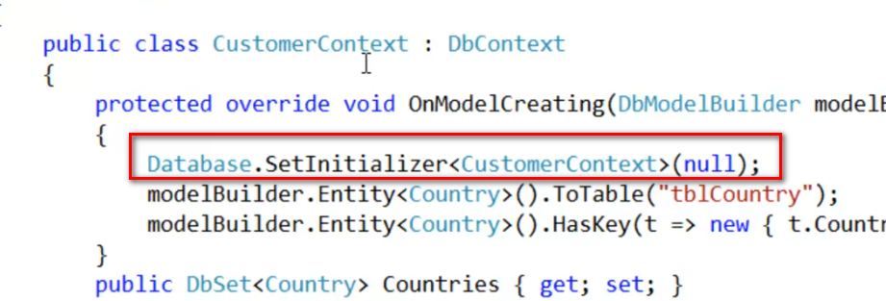

Concurrency in Entity framework:

Multiple user are trying to update the same record at same time which might lead to update from the commit of others.

So we need to apply optimistic lock on the data field

This will eliminate the concurrency issue

So to do this first wee need to add concurrency mode to the field fixed

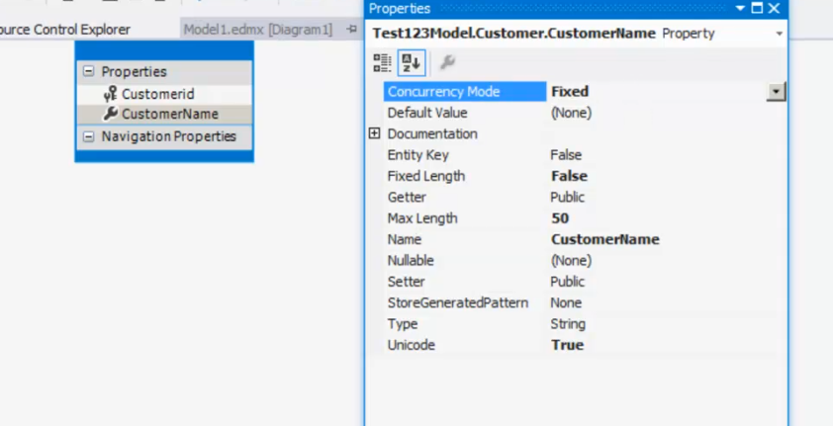

This will again lead to another problem where we have huge number of column we cannot go and set concurrency mode for each an every column.

SO to address this issue we can add one extra column with type timestamp

Which will add the Unique Guide value for every time when the record is modified

Set optimistic lock on this column and when the exception is thrown from the db due to concurrency issue catch the exception and handel the concurrency update.

Handling of the concurrency:

Using this ClientWins and ServerWins we can decide eon which data to update when the currency issue fires.

May be freshly fetch the record and update the db.

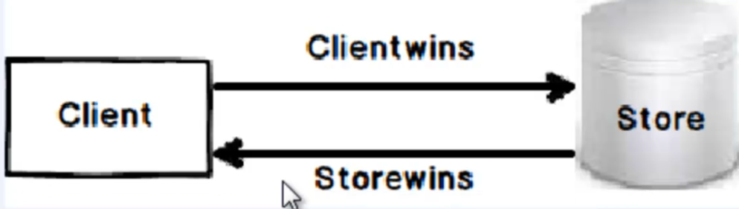

ClientWins: Basically this will update db data to the in memory entity data

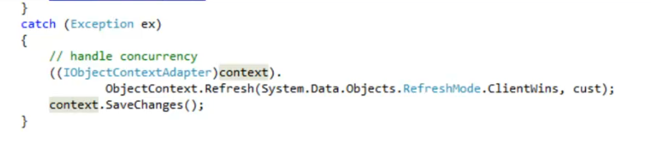

StoreWins:

This will basically update the in memory data with the db store data.

