Machine wide cache of the assembly the is saved in client machine. So that multiple application can use the share the assembly.

So with this we don’t have to maintain the copy of the assembly in the bin folder of the each and every application.

To put assembly to the cache.

Create strong naming for the assembly or even may be signing if needed.

Build assembly is release mode. Then copy the release build GAC directly or using

GacUtil.exe run this command in vs command prompt

First changes the location to where the assembly is present and then run

GacUtil.exe -i assembly name

Multiple version of same assembly can present in GAC

To make application to use new version we have to write assembly binding in the configuration file assembly redirect tag with old and new version to map.

Signing is done so that nobody can tamper the Dll files.

Delay signing: Preventing the developer from tampering production dll.

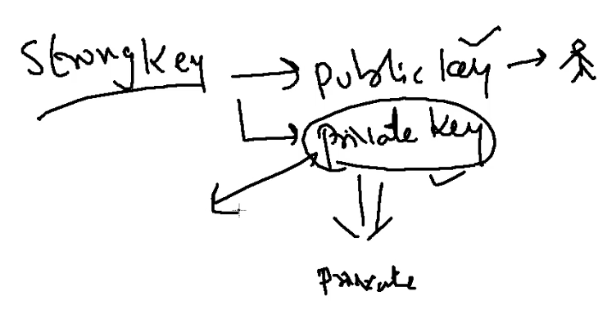

Public key is used for signing at the time of development

When the DLL goes for production it signed with the private key which is safe in some deployment department.

To create strong name need to run Sn command

So the step goes like this

Go to the assembly folder using vs command prompt. Then run

Sn -k name.snk (makes private key and public key)

Sn -p name.snk pk.snk (makes public key by extracting from the main file)

To sign assembly

Right click on project 🡪 Property of the project 🡪 Signing tab 🡪select the public key snk file. Select delay sign

To sign an assembly

Sn -R file.dll name.snk

Difference between strong and weak references.

Client is identify the DLL or valid publisher only by class name or namespace.

So we need to sign the assembly with strong key

In strong reference

Your application and the assembly is strongly bound together with the key value (strong name or public key assembly)that cannot be produced by the others.