Why we need TDD:

Unit test: set of the test that can be run automatically to verify if the everything works fine or anything wrong int code

If the unit test can cover 100% of the code base then wee can avoid lot of errors in the deployment phase.

Eg: Canonical form where in search functionality is performed with canonical for of text

Here first algorithm is designed

The deployed

Bug found in the production (null reference)

Write a test and deploy again

again, new bug found (empty text issue)

again, fixed and deployed.

TDD is a solution this problem we do a development along with unit test cases written using unit test framework

TDD: test driven development, Test first development

Write test ahead of production code.

Unit testing is a framework where in you write testable code. Code which passes the unit test will go to the production else we need to write the complex code to make it go to the production.

Common misconception

1. Double the developer efforts (Avoid lot of production bug)
2. Cant write test until know the design, cant know the design until you implement the code (helps in arriving the better design by identifying all possible race conditions.)
3. Have to write all test before you start code

Approach would be:

Write one test

Watch it fail

Implement the code

Watch it pass

Repeate

Main technique of TDD is Red/ Green/ Refactor:

Red mean test fail

Green is test pass

Refactor is we basically dos changes to the code so that next time when the test run it meets all acceptance criteria.

3 laws of TDD

1. Don’t write production code before writing a failing test
2. Write minimal test which is enough to see the failure.
3. Don’t write production code more than enough to pass the failing test.

Changing requirement:

Rigidity:

Any changes to the system takes lot of time to implement.

High coupling between the modules

Fragile:

Small change to one module causes failure to the other module reason tight coupling

Isolate module

Immobile: again because of tight coupling things cannot be reused or shared among multiple modules.

Viscosity:

Adding feature lead to checking lot of things.

F I R S T:

% Requirement decides the good unit test.

F: Fast should run very fast

I:Independednt (each test should be independent of each other) Ordered test feature of the TDD

Helps is running the test in some order

R:Repeatabe produce same result and consistence wherever you run

S: self-valid table pass or fail result should be clear

T: in time written before production code so that no logic before the production code.

Code coverage:

Matrix that indicate the amount of the code covered by the test

Always shown in percentage

.Ie total lines of code divided by the amount of the code test has gone through

Best coverage is 705 of the code.

Types of test and TDD:

Unit : verify the behaviour of the unit under test isolation

Integration: verify the part of the system or whole system.

Acceptance test: verify the software from the user point of view (special test cases written will be converted into u it test by the tools)

Pyramid of test:

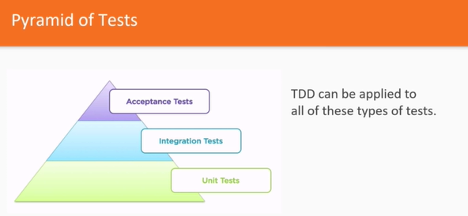

Framework and tools:

Writing test ahead of production code

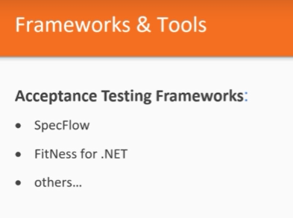

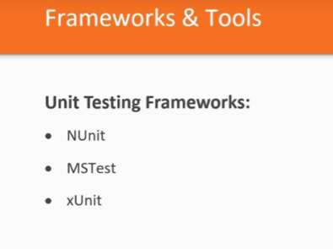

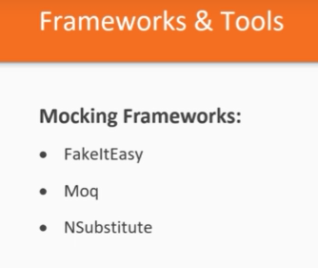

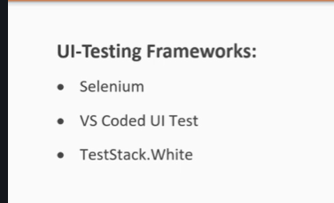

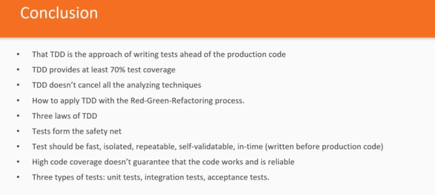

In action:

Triangulation:

Not generalizing implementation. Drive the implementation by writing the test is called triangulation

Initially install the Nuinit from the NuGet package manager

And use the name space

Using NUnit.Framework

Attributes used:

TestFicture for the class

Test

TestCase(parameter list)

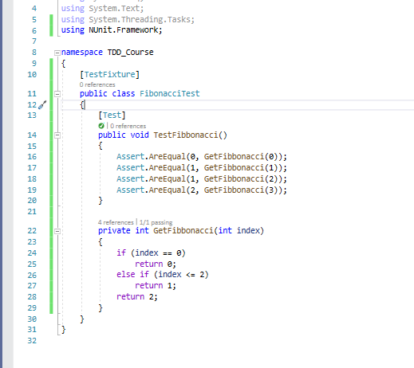

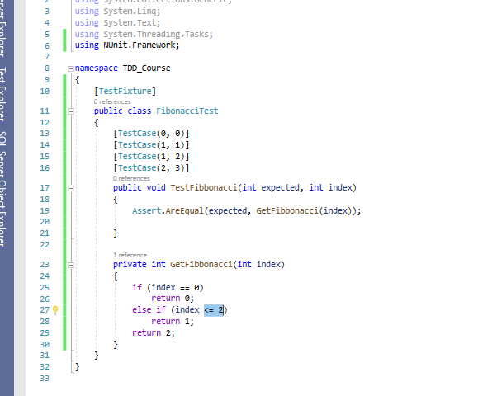

3 techniques used in TDD

Faking

Send fake result of constant value from the methods

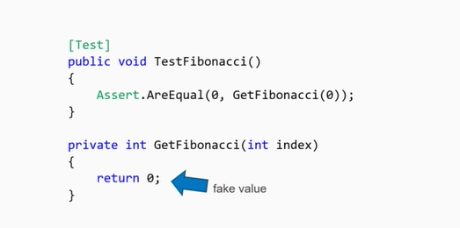

Triangulation

1. Keep adding the test cases until the right way of implementation emerged out
2. Two or more test cases are enough to stop triangulation.
3. Faking triangulation lead to the implementation where the generalization becomes obvious.

Obvious implementation:

Right implementation is obvious skip triangulation and faking

Careful implementing the whole algorithms out of mind

Very often you think implementation is obvious

Often it fails in edge cases.

Obvious implementation

Fizz buzz

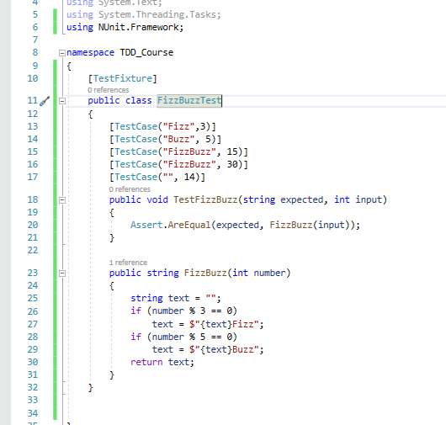

CT: Continuous testing:

Tools

Ncrunch

Live unit testing

TIcTacToe or crosses and Noughts

NCRUNCH test runner tool

Automated testing:

Practice to write a code to test our production code. Later this test code is run automatically to test our production ready code

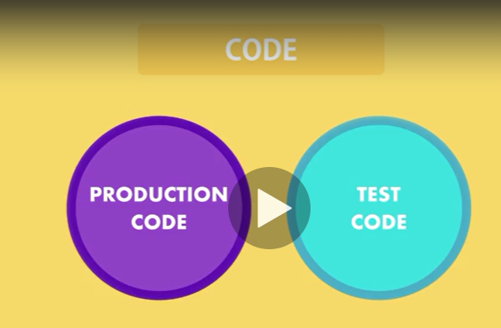

Why:

Code can be tested automatically any number of time with less time and without the involvement of the user

Bugs can be minimized before the code goes to production

Code refracturing: changing the structure without changing the behaviour. After changing the code test can be run automatically.

Automated test has

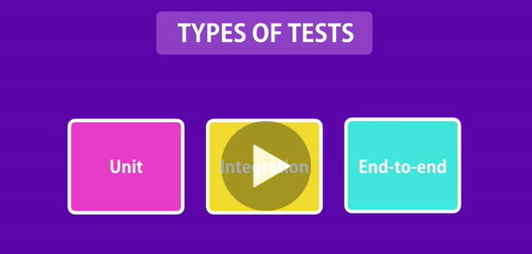

Unit test: test code without external dependency.

Cheap to write, execute fast

Unit of functionality is tested

Test logic, looping ,if cases, edge conditions.

Integration text: text for the external dependency. (DB, file, services)

End to end test:

Drives the application with its UI

Test Pyramid:

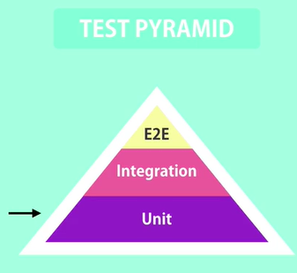

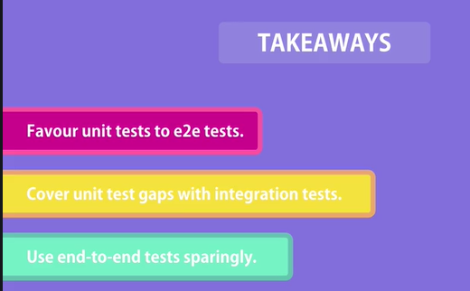

Tools:

Unit test:

NUinit

MStest

XUnit

All the unit test framework has two part

Library which helps in writing the unit test

Test runner to run the test cases. (report of test pass and fail)

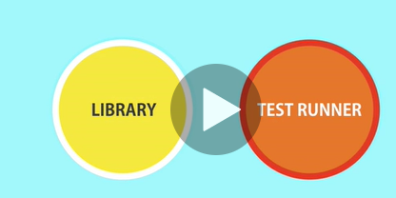

MSTest:

You have to add test project for this purpose VS provides with the built in template for this.

Each test in Mstest follows AAA method

A—Arrange (deals with the creation of the data or object)

A – Act (executing the methods n that object)

A – Assert (Basically execute the test logic here)

Uses name space:

using Microsoft.VisualStudio.TestTools.UnitTesting;

Class ned to be decorated with [TestClass] and method with [TestMethod]

While writing the test user the format

Methos_Secnario_ExpecetedResult

NUnit testing:

We need 2 package to be installed for this purpose

Install-Package NUnit -version 3.1.1.1

Install-Package NUnitAdaptor -version 3.1.1.1

TextFixture decorator for the class

Test decorator for the method

Asset.That(value, is.Equall);

TDD:

Test driven development or test ahead development

Foundation for TDD

First you write the failing test

Then write simplest possible code of implementation that will pass all the test

Finally refractor your code.

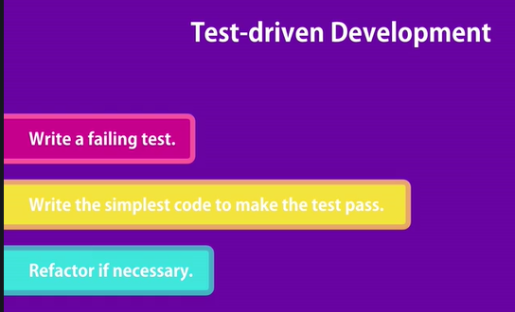

Code is tested in advance

Covers every line of code

Simpler implementation

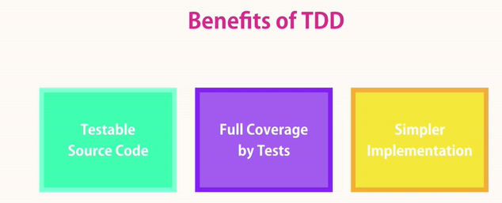

Fundamentals of unit testing:

Characteristics of good unit test:

1. Firsts class citizen
2. Clean readable maintainable code
3. No logic in test like loop conditions etc (simply call methods and assert)
4. Isolated
5. Not to specific not too general

What to test and what not to test:

1.All query methods basically it returns some data so all such methods can be tested

2. Command methods: does some changes to the data present on the memory or performs some action and it also returns value from the executed action.

Not to test:

3rd part library

Test project

Maintain separate project for the test

For every class in main project add test class in unit test project and add one or more unit test method

Number of test methods is greater than equal to the execution path.

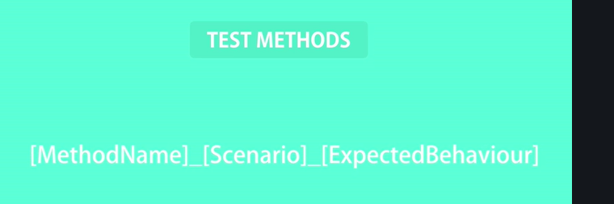

Assert.That(result, Is.EqualTo(3));

Blackbox testing:

We make a test without knowing actual logic inside the method

We start write possible test case that covers all execution paths

Setup and teardown

Associated with the arrange part of the code that may be a few lines of code in real world scenarios.

Setup:

Decorator called by the test runner before call the test method for initialization part

Tear down: attribute

Called when the test method is completed basically to perform the clean up in integration test

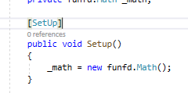

Ignoring test:

Basically used to exclude the test from the test instead of deleting or the commenting

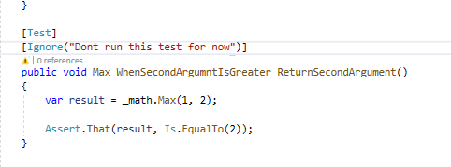

Writing the trust worthy test:

Which we can trust that TDD

Core unit testing teqniques

Testing string:

Assert.That(result, Is.EqualTo("<strong>abc</strong>").IgnoreCase);

Assert.That(result, Does.StartWith("<strong").IgnoreCase);

Assert.That(result, Does.EndWith("</strong>").IgnoreCase);

Assert.That(result, Does.Contain("abc").IgnoreCase);

Testing array:

//Assert.That(result, Is.Not.Empty);

//Assert.That(result.Count, Is.EqualTo(3));

//Assert.That(result, Does.Contain(1));

//Assert.That(result, Does.Contain(3));

//Assert.That(result, Does.Contain(5));

Assert.That(result, Is.EquivalentTo(new[] { 1, 3, 5 }));

// Assert.That(result, Is.Ordered);

//Assert.That(result, Is.Unique);

Testing return type:

Assert.That(res, Is.TypeOf<Ok>()); (exact match of the type)

Assert.That(res, Is.InstanceOf<Ok>()); (exact match or derivative of the type)

Testing void methods (without return values):

These are command functions that does some changes to the file od db or perform some actions.

Or change the state of an object

Test method that throws an exception

Here we cannot use normal asset result check we have to use the delegate to compare the results

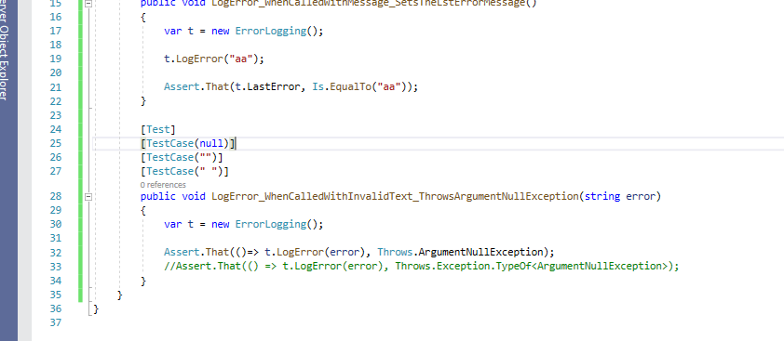

Testing the event in the method:

For this first subscribe to the event in the test method then read the value from the event

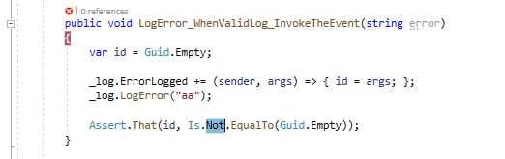

Testing private methods:

Shouldn’t implement the private method

Always test public methods and Api

Code coverage tools:

Toll scans the code and test and tells you which is covered in test and what not.

Reshaper ultimate

VS Enterprise editon

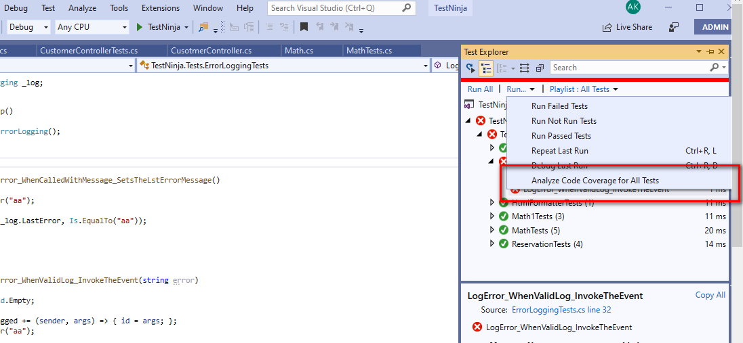

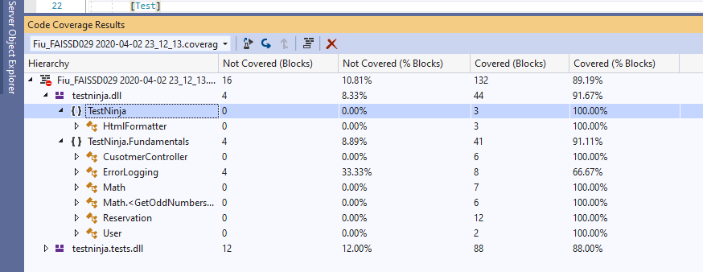

Exercises

FIzzBuzz

Print fizz if the number divisible by 3

Print Buzz if it is divisible by 5

Print FizzBuzz if it is divisible by both 3 and 5.

Breaking external dependency:

Test that touches externa; dependency called integration testing

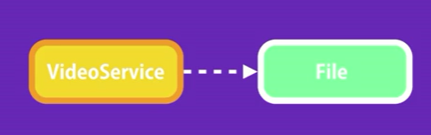

Class accessing the data from DB

Fake or test double class to fake the external object

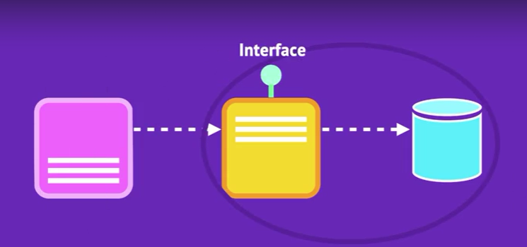

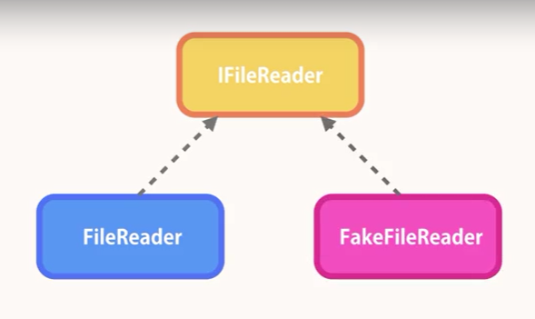

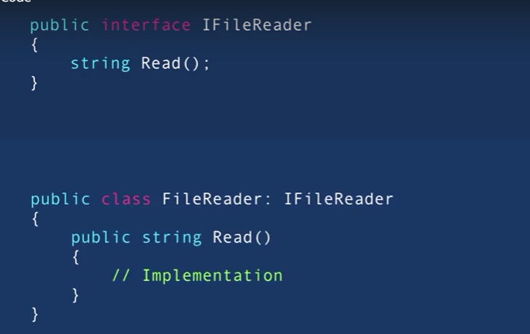

Mock objects: (basically we are making the fake objects to test our real world object and the class)

Stubs

Mocks

Use the concept of dependency injection to pass the object to the low level calls to use the implementation

Concepts of Di make sure that eliminate the tight coupling of the class by passing objects created as a parameter to the low low level class tht provide the implementation.

Di using property:

Di using method parameter:

DI using constructor:

In real world enterprise level application we have DI framework

Which basically has the container with all interfaces and the implementation of this interfaces

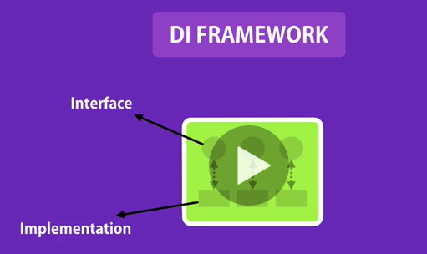

Famous DI framework:

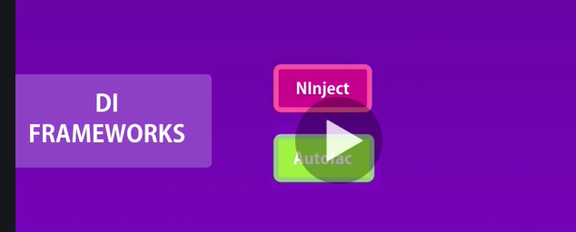

Mocking:

Using this frame work we can create entire object to be tested and

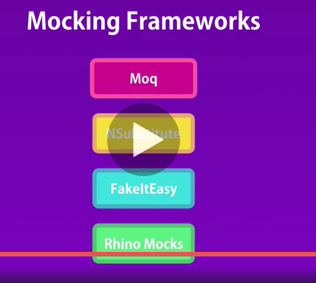

Here we are using moq frame work

Install from Nuget Packaage manager

Refer

using Moq;

Create an instance of the mock object

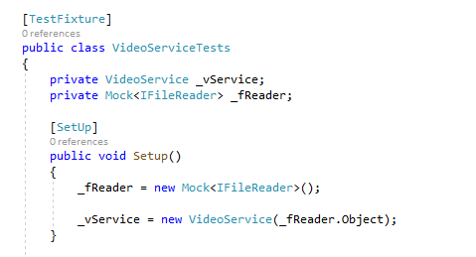

Implement mock to implement the interface

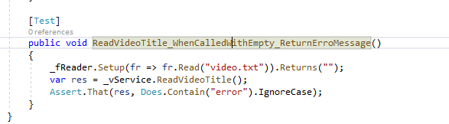

State based Vs Interaction based testing:

In order to compare if the two objects interaction we need use verify method of the Mock objects

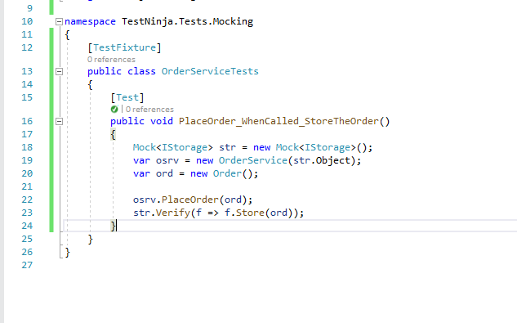

Abusing mock

Exercises:

1. VideoService
2. Installer Helper

To generate any random generic string

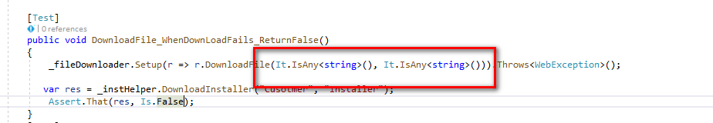

1. Employee helper

Booking Helper:

Unit test function calls the another function and check the correctness of the outcome of the called function.

Instance of the class that you are going to test is called SUTS

VS 17 onward install both Nuini, NUnit3TestAdaptor, from Nuget package manger

Ply list in Unit test

Group all the similar test under single section and run them together when needed

We this we can have kind of grouping

Right click on the test file and add to play lists

Debugging test:

Go to test explorer and right click on the particular test and say debug test, with this we can debug the test of our choice.

Asset is heart of unit testing framework:

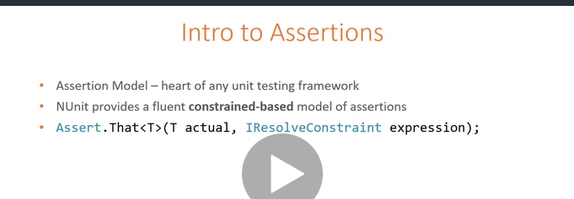

Resolve constraint is Soule of assert statement.

IresolveConstraint

Logical constraint:

Is

Has

Does

2nd level constraint:

All

Some

Not

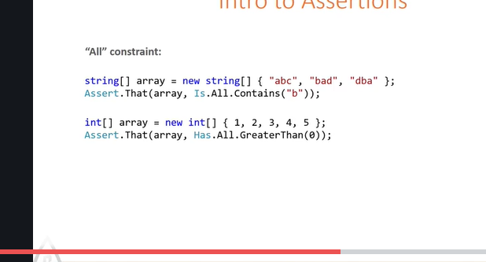

AAA

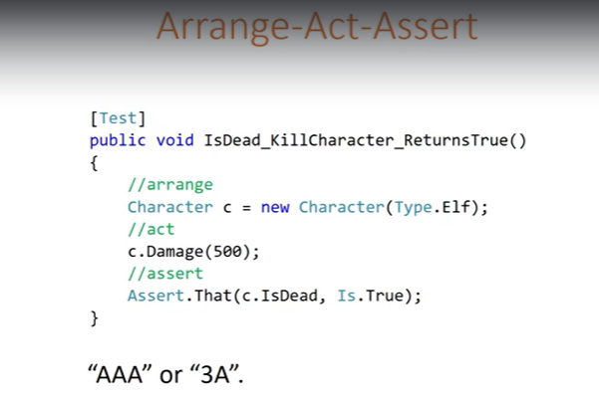

To run Nuinit from the console

Nunit3-console.exe “Dll location of the test project”

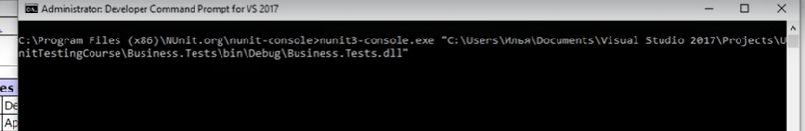

This attributes used to setup the text at the top level

If this setup is down outside the name space then setup is used for all test running on that assembly

[SetUpFixture]

[OnTimeSetUp]

[OnTimeTearDown]

If the setup is done inside a name space then all the test inside the namespace will use the same setup

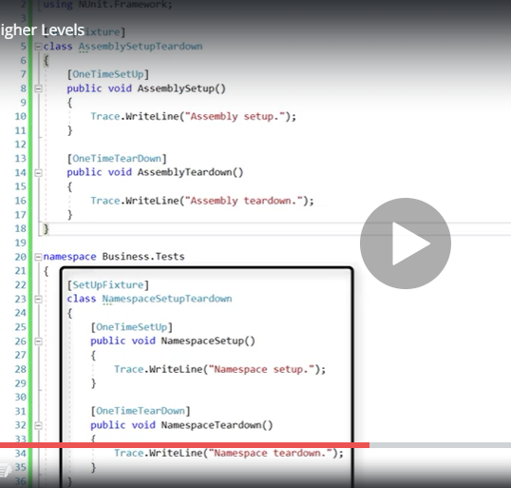

Execution flow:

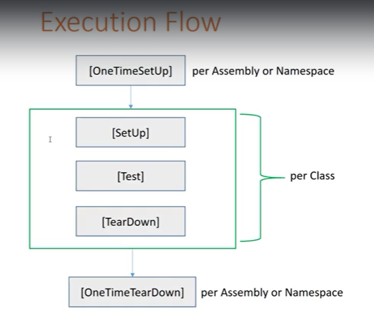

Parameterized test feature

Use

[TestCase(parameter list)]

Grouping of the test can be done with the help of Category attribute on top of the test method

[Category(“name”)]

Can be at the test method level or test class level

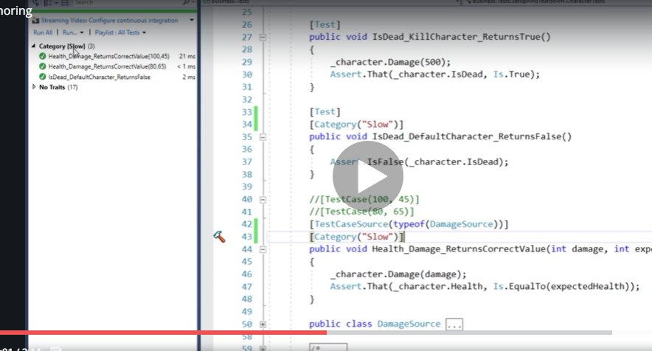

Running nuit from command prompt

Running test from test runner

Run NUiniT using command prompt:

Run assembly directly:

nunit-console nunit.tests.dll

Run test project

nunit-console nunit.tests.csproj

Run unit test project directly

nunit-console nunit.tests.nunit

Run particular test in assembly

nunit-console /run:NUnit.Tests.AssertionTests nunit.tests.dll

Load fixture in assembly:

nunit-console /fixture:NUnit.Tests.AssertionTests nunit.tests.dll

Clr version to test:

clr net-2.0 nunit-console nunit.tests.dll

Include and exclude the category under test

nunit-console myassembly.dll /include:BaseLine

nunit-console myassembly.dll /exclude:Database

category expressions:

**A|B|C**

Selects tests having any of the categories A, B or C.

**A,B,C**

Selects tests having any of the categories A, B or C.

**A+B+C**

Selects only tests having all three of the categories assigned

**A+B|C**

Selects tests with both A and B OR with category C.

**A+B-C**

Selects tests with both A and B but not C.

**-A**

Selects tests not having category A assigned

**A+(B|C)**

Selects tests having both category A and either of B or C

Redirecting the output:

nunit-console nunit.tests.dll /out:TestResult.txt

nunit-console nunit.tests.dll /err:StdErr.txt