Define 2 sub config file on each for application setting and db connection settings at same level as main config file

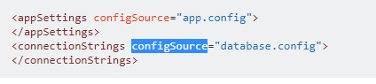

We can have multiple configuration file Web.config at different folder level if any code form that level try to get values it will be taken from that level

If no value found take from main root.

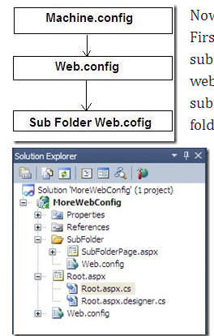

System.Web.Configuration.WebConfigurationManager

System.Web.Configuration.WebConfigurationManager.AppSettings.Get("MySetting")