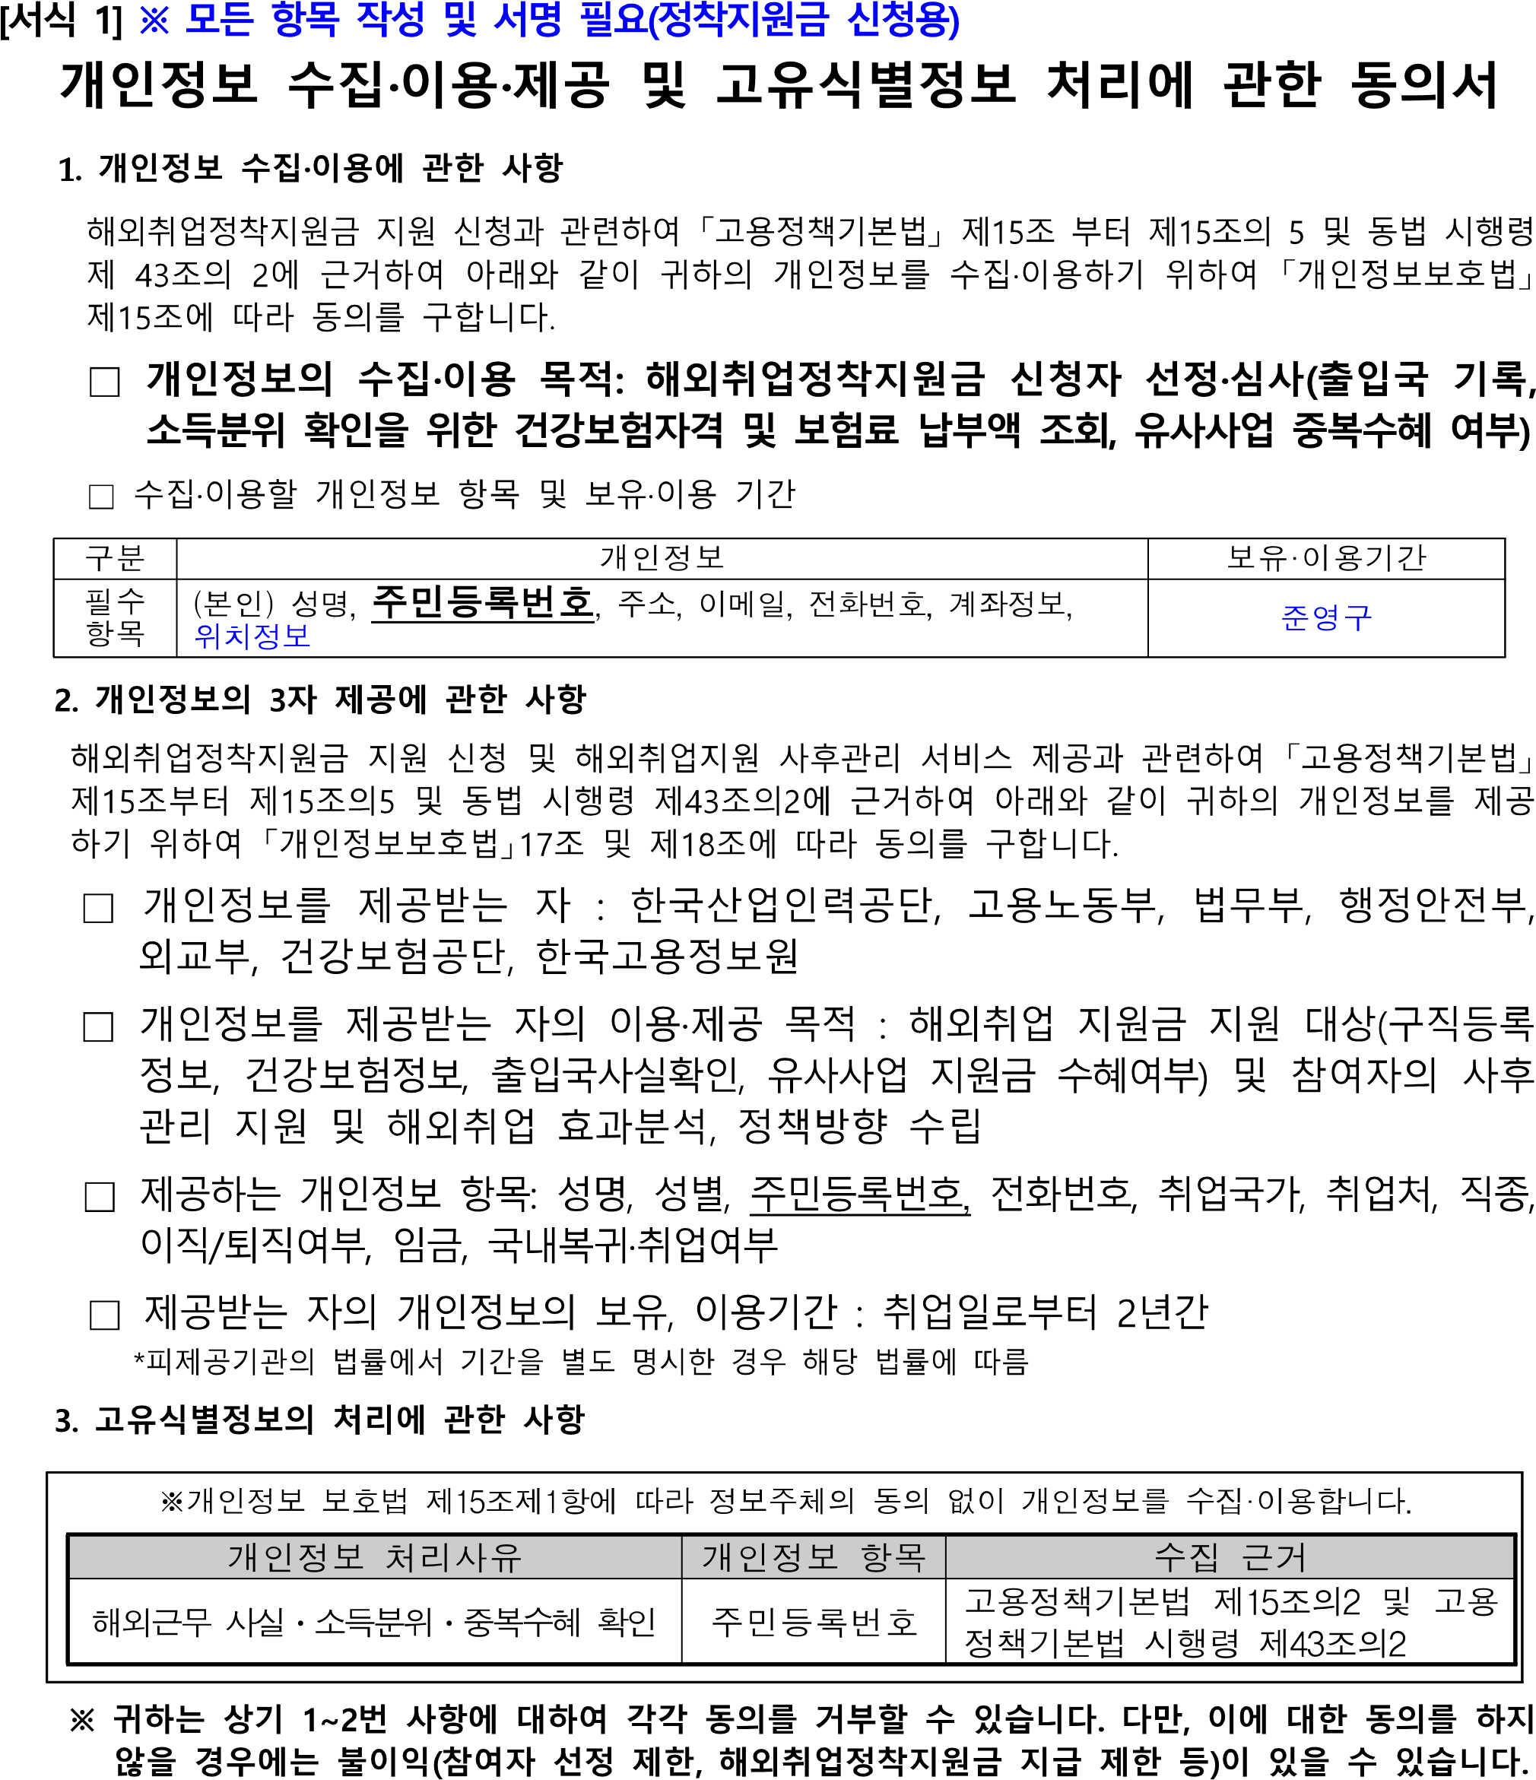

|  |  |  |  |  |
| --- | --- | --- | --- | --- |
|  |  |  |  |  |
| 김재민 | 950429-1860523 |  | 10 17 |  |



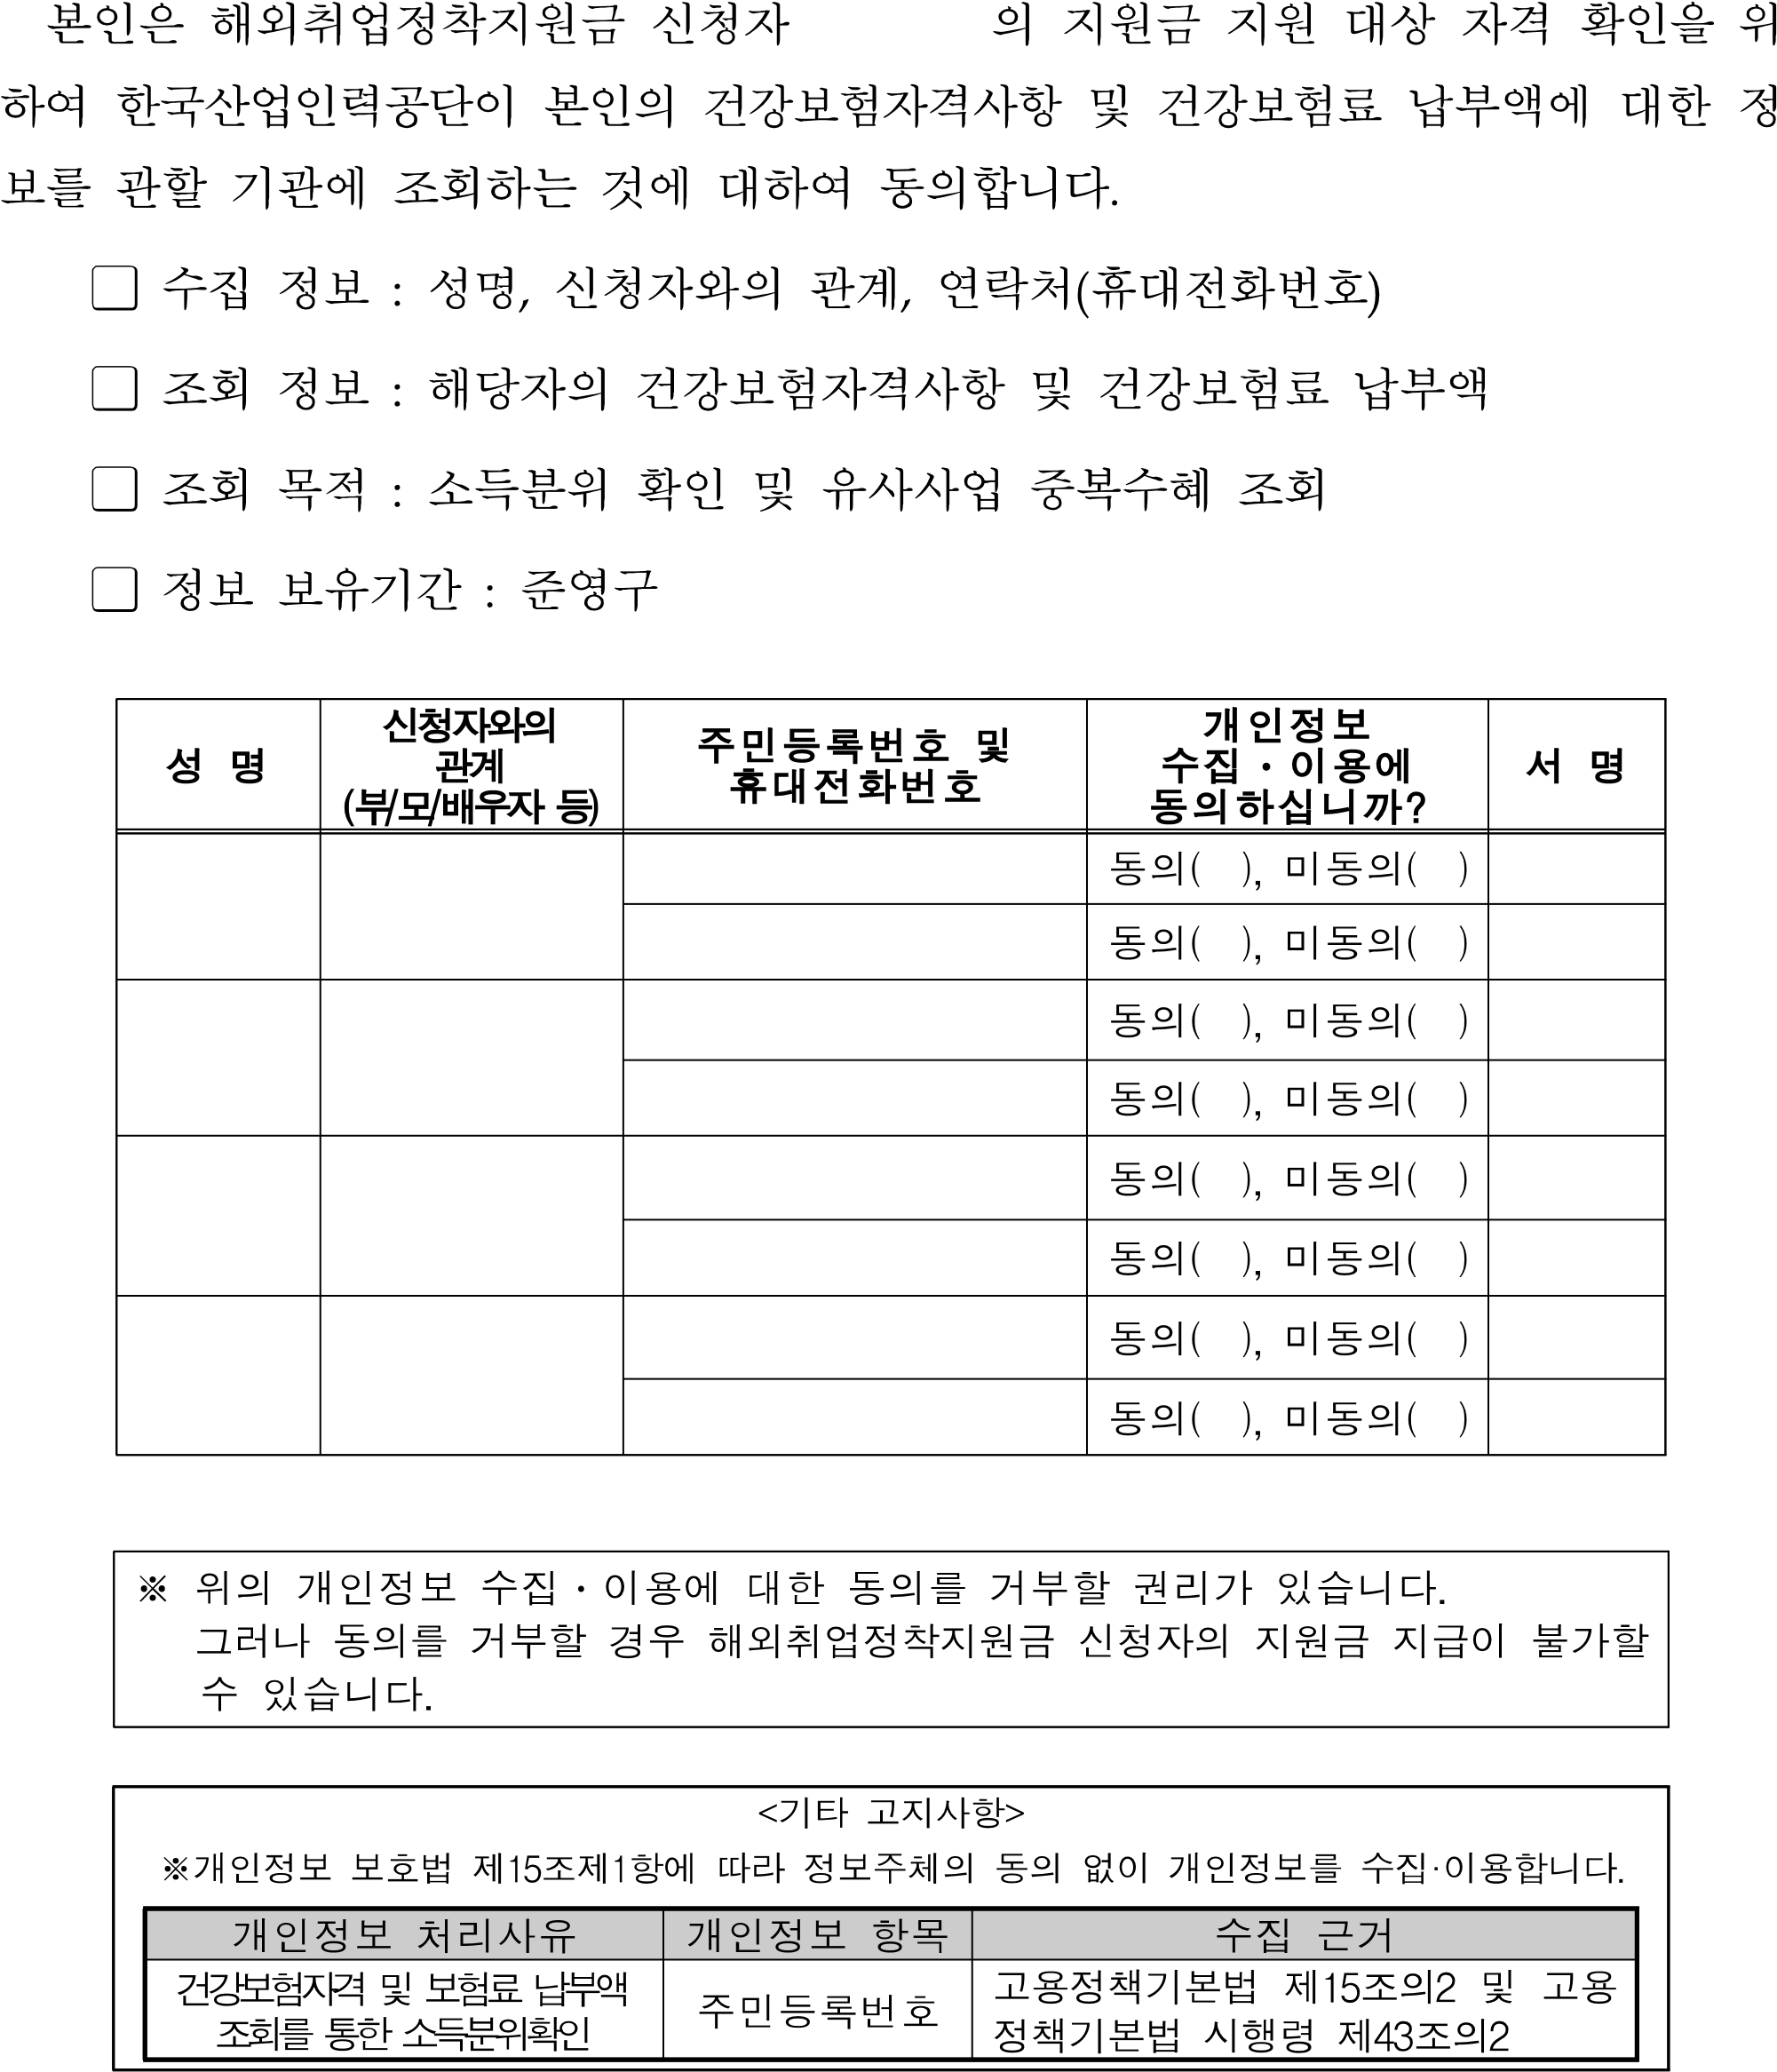

10 17



최정희

최정희

010-8307-6996

670509-2822316

모

최정희

