CMPS 400. Use the online version of MATLAB at : <https://octave-online.net/>

Assignment No. 10 (MATLAB lecture 1) Names ……………………………………………………………….

------------------------------------------------------ ----------------------------------------------------------------------------

1. The perimeter P of an ellipse with semi-minor axes a and

b is given by:

P=2π (a2 + b2) /2

Determine the perimeter of an ellipse with a=9 and b=3

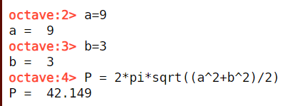

1. For the triangle shown, a=200m, b=250m, and c=300m. Define a,b,c,as variables and then
2. Calculate the angle ϴ (in degree) by using

The Law of cosine

(Law of Cosine: c2=a2+b2-2abcos( ϴ) ) c

1. Calculate radius r of the circle inscribed

in the triangle using the formula: b

r=(a+b+c)/2 .tan(ϴ/2)

1. Calculate the radius r using the formula

s(s-a)(s-b)(s-c)

r= ------------------------------- where s=(a+b+c)/2 a

s ϴ

1. Solve the following system of equations using matrices

3x -2y + 5z = 7.5

-4.5x +2y + 3z= 5.5

5x+y -2.5z = 4.5

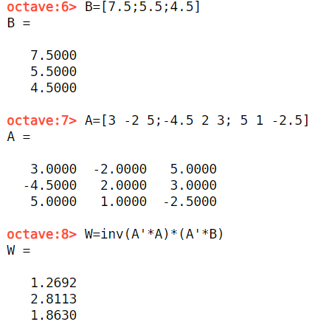

X = 1.2692

Y = 2.8113

Z = 1.8630

1. Define x and y vectors as x=[1 3 5 7 9] and y=[2 5 8 11 14]. Then use them in the following expressions to calculate z using element-by-element calculations.
2. Z=(xy2)/(x+y) b. z=x(x2-y)(-(x-y)2
3. Define the vector v=[5 4 3 2 1 ]. Use another vector y to create the following vectors when you apply both v and y vectors ( R1=v ? y, what iv vector y and operation ?
4. R1=[1/5 1/4 1/3 1/2 1]

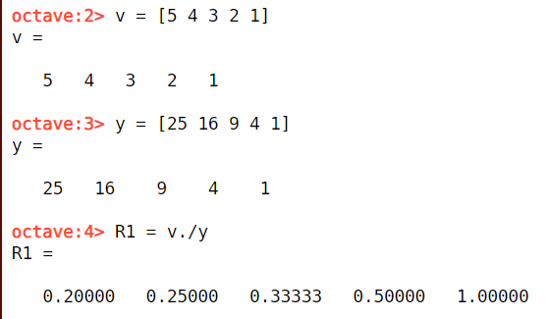

y = [25 16 9 4 1] and operator is ./

1. R2=[52 44 33 22 12 ]

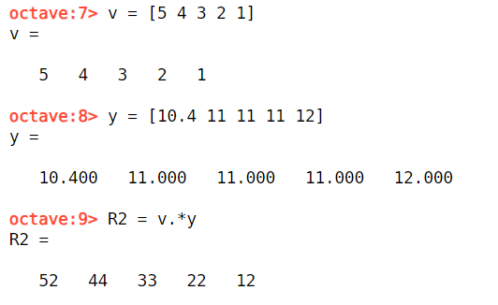

y = [10.4 11 11 11 12] and operator is .\*

1. R3=[25 20 15 10 5]

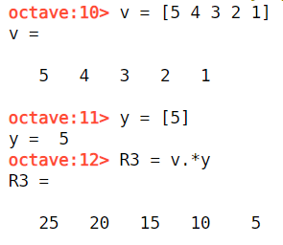

y = [5] and operator is .\*

1. R4=[55 44 33 22 11 ]

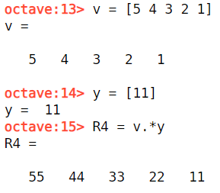

y = [11] and operator is .\*

1. R5=[4 3 2 1 0]

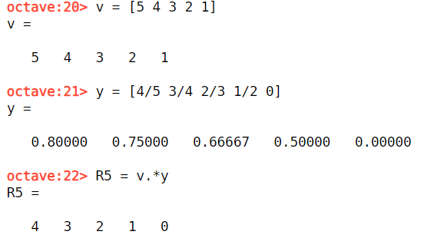

y = [4/5 3/4 2/3 1/2 0] and operator is .\*

1. Generate three 3X3 random matrices A, B, and C in which their entries are integer numbers between 10 and 20.
2. Calculate A+B and B+A to show that addition of matrices is commutative.
3. Calculate 5(A+C) and 5A + 5C to show that when matrices are multiplied by a constant, the multiplication is distributive
4. Calculate A\*(B+C) and A\*B + A\*C to show that matrix multiplication is distributive