CMPS 400 Name ……………………………………………………………..

**Assignment No. 11** (polynomials, graph of polynomials, 3D graphs, Modeling )

1. Plot the polynomial y=-0.4x4 + 7x2 -20.5x – 28 in the domain -5<=x <=4. First create a vector for x, next create a vector for the coefficients of polynomial, use the **polyval** to calculate y, and then use the plot function
2. Use MATLAB to carry out the following multiplication of two polynomials:

Y= (2x2 + 3)(x3 + 3.5x2 + 5x -16)

Plot the polynomial for -1.5<= x <= 1.5, increment x by 0.1

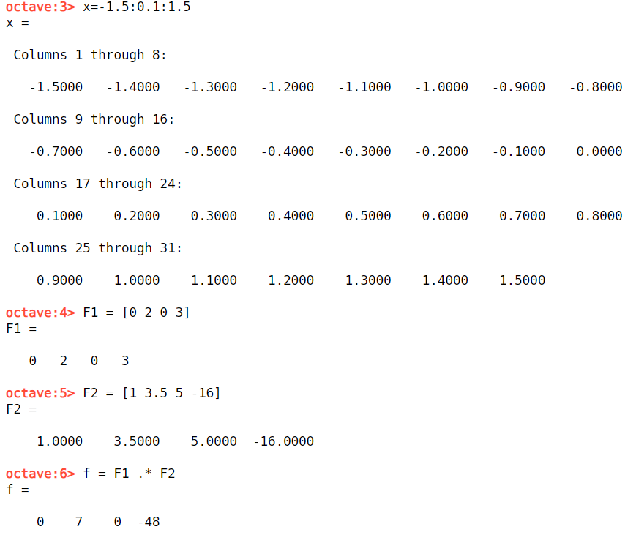 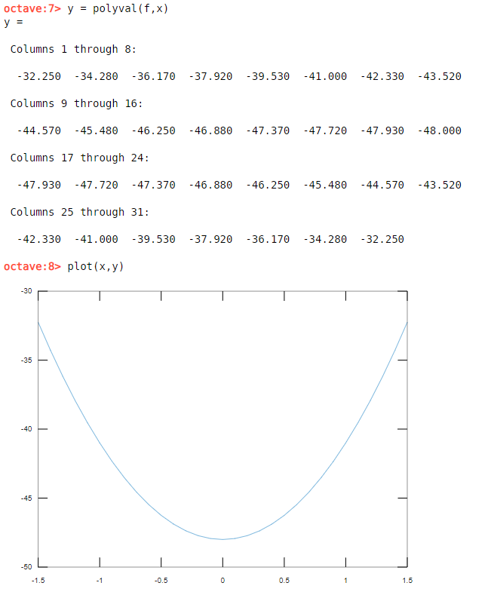

1. The following points are given

|  |  |  |  |  |  |  |  |  |  |  |  |
| --- | --- | --- | --- | --- | --- | --- | --- | --- | --- | --- | --- |
| X | -5 | -3.4 | -2.0 | -0.8 | 0 | 1.2 | 2.5 | 4 | 5.0 | 7 | 8.5 |
| Y | 4.4 | 4.5 | 4 | 3.6 | 3.9 | 3.8 | 3.5 | 2.5 | 1.2 | 0.5 | -0.2 |

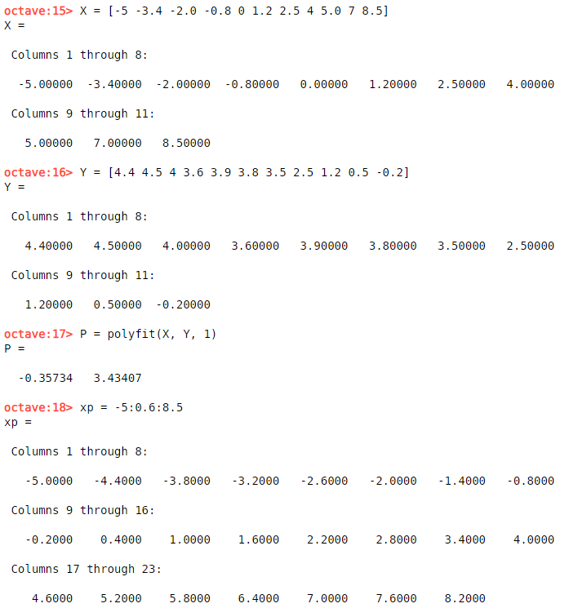

1. Fit the data with a first-order polynomial. Make the plot of the points and the polynomial

in blue color.



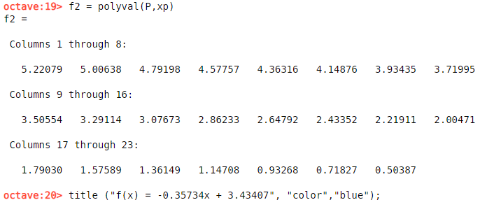



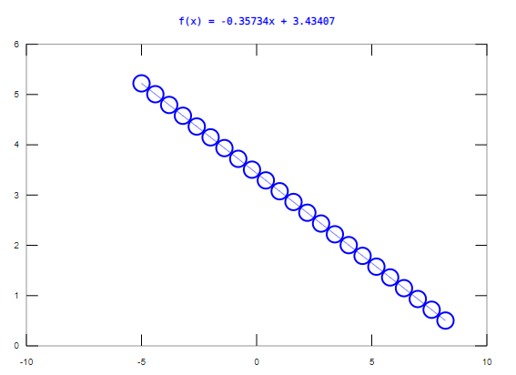

1. Fit the data with a fourth-order polynomial. Make a plot of polynomial in black color

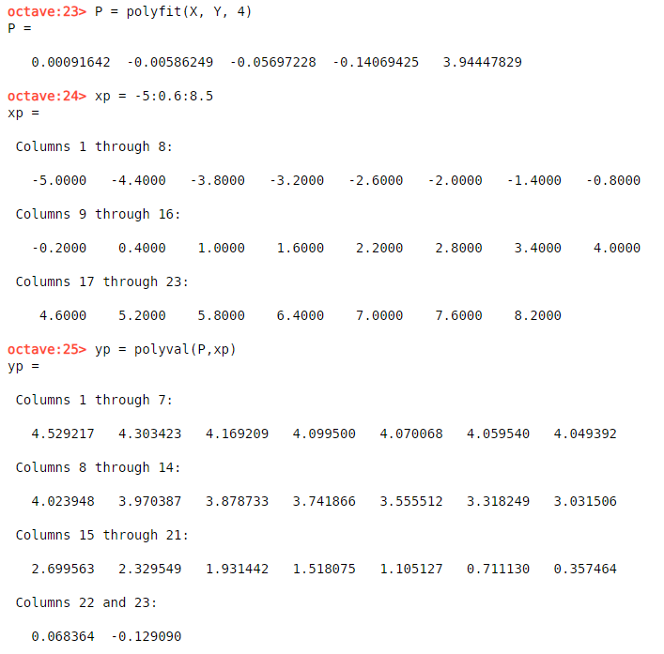

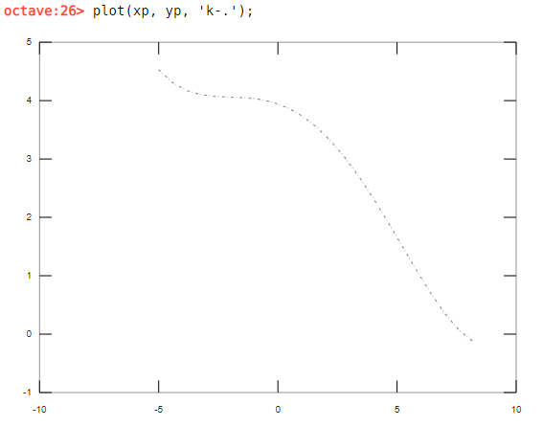

1. Fit the data with an eight-order polynomial. Make a plot polynomial in red color

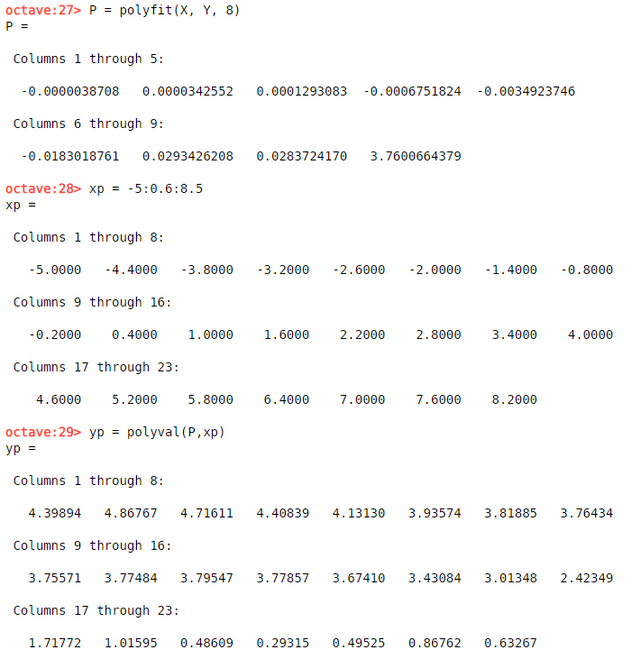

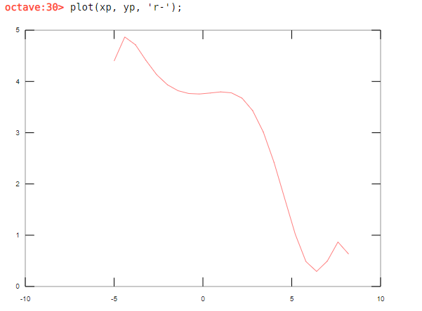

1. Show the 3D graph of z=sin(r)/r where r=√ (X2 + Y2 ).

Use x=-10: 0.5 : 10 and y=-10: 0.5: 10. Also use [X,Y]=meshgrid(x,y), r=sqrt(X.^2 + Y.^2) and Z=sin(r)./r. In addition use mesh(X,Y,Z) to display