**Cal State University Fullerton**

**Fullerton, California**

Fall 2020

**CPSC 544**

Advanced Software Process

**Dr. Bin Cong**

**Project Report Summary**

**Team D:**

Amber Kimberling

Dan Lungaro

Johnathan Hernandez

Luis Hidalgo

Raymond Magdaleno

Sze Lee Wong

# Introduction

Project: Student Information System

Roles:

* 1. **Amber Kimberling(Lead):** Scrum Master
  2. **Dan Lungaro:** SE Backend
  3. **Jonathan Hernandez:** SE Frontend 1
  4. **Luis Hidalgo:** QAE
  5. **Raymond Magdaleno:** Product Owner(PO)
  6. **Sze Lee Wong:** SE Frontend 2

Through the process of this project Team D learned about how to work in a team of individuals with different backgrounds and specialities. While navigating through the project together we discovered that physically assigning work to individuals made each of us more accountable to the work we produce. After each scrum meeting we began becoming more efficient with our communication and with our production of work. By the third sprint we had a well defined process that produced capable solutions to our assigned user stories..

Future enhancements to our software and the process:

* Be more detail oriented with the features we produced
  + Secure login, separate interfaces for each user, etc…
* Increase our scrum meeting time by 30 min
* Create more content for the product
* Develop authentication and sessions in the software
* Delegate work evenly to each team member
* Implement more structure and defined responsibilities into the team

# Product Backlog

Blue - Finished

Red - In Progress

Black - not yet attempted

** sample of finished and in progress. Currently all the In progress work was completed. **

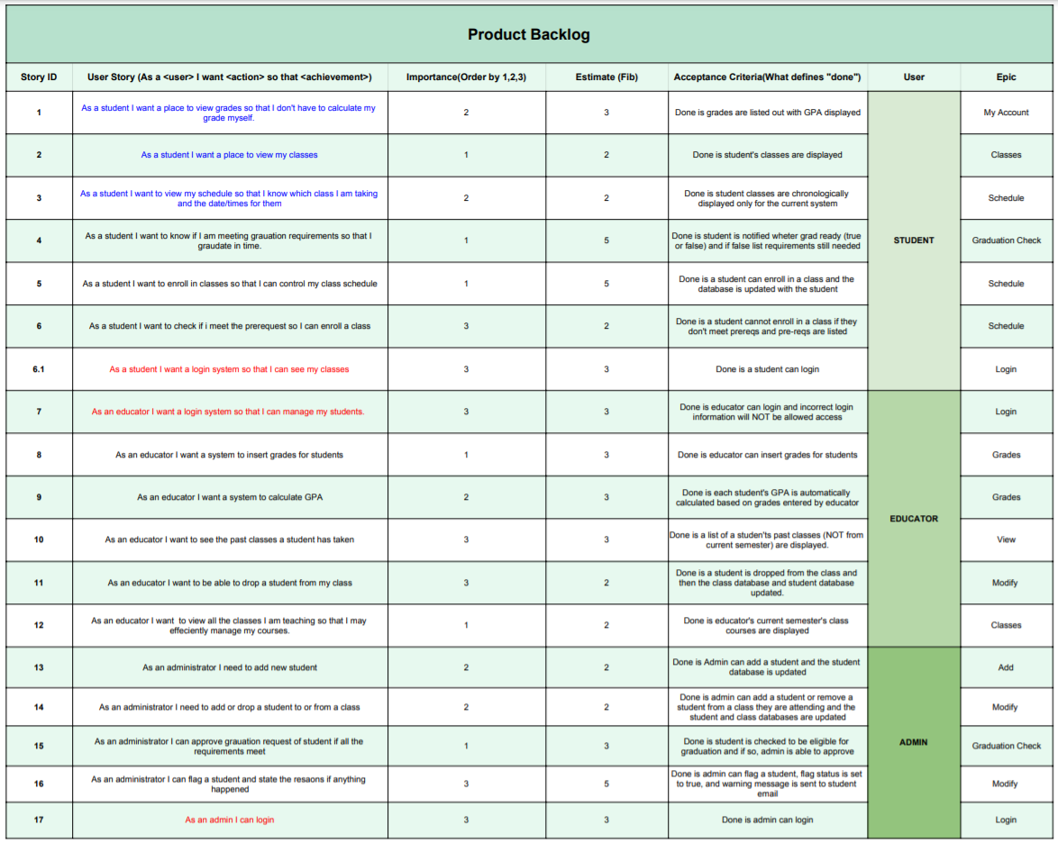

* Each Story ID is referenced in the github repository for the software product.
* Importance is issued on a 1 - 3 scale (1 being the most important and 3 being less important)
* Estimate is the difficulty or time consumption of a given feature. The fibonacci scale was used 1 - 5 (1 being less difficult and time consuming and 5 being more difficult and time consuming)

# Release

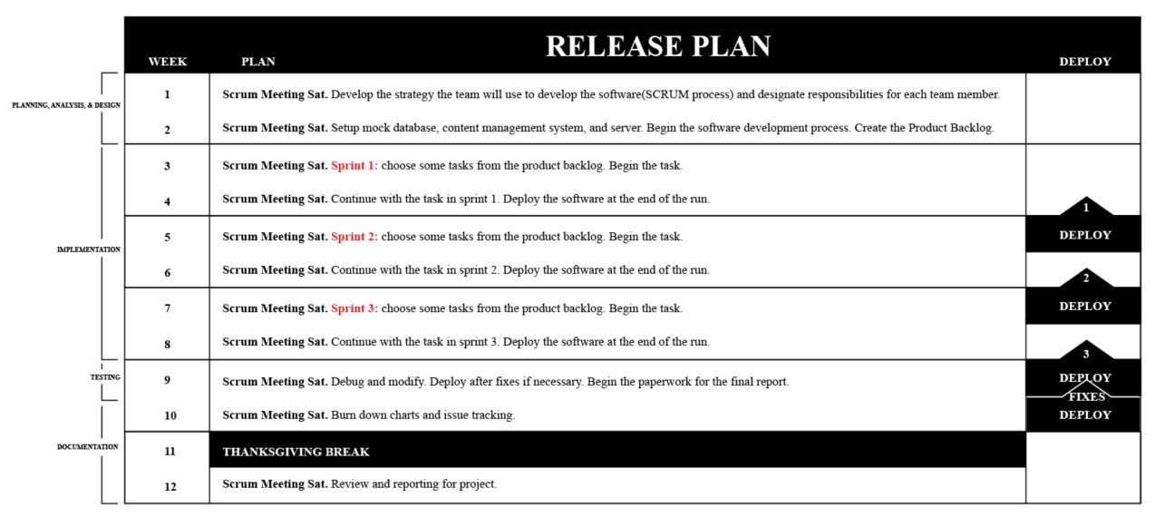

# Scrum Process

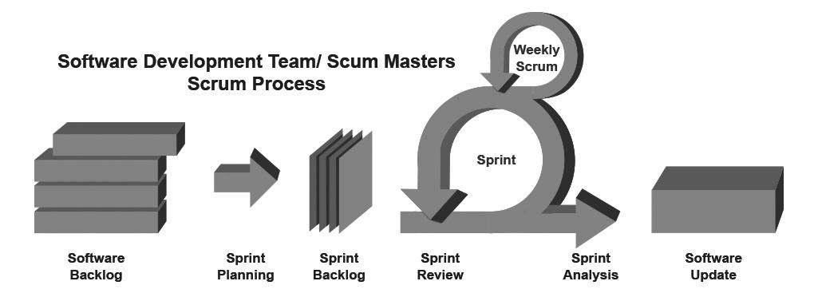

* In the scrum process, the team developed the backlog containing all the tasks needed to complete the software.
* Next each sprint was planned out containing items from backlog items with the use of Github.
* At the beginning of each sprint the chosen backlog items were taken and assigned to developers.
* The project gets developed within Visual Studio that is connected to the Github repository. Each scrum was designed to be completed in two weeks. Within each two week sprint, there were two scrum meetings.. One for progress checking and a second for a review of the completed tasks.
* After a member of the team(other than the person who created the code) will review the updates to the software and run an update.

# Issues for Each Sprint

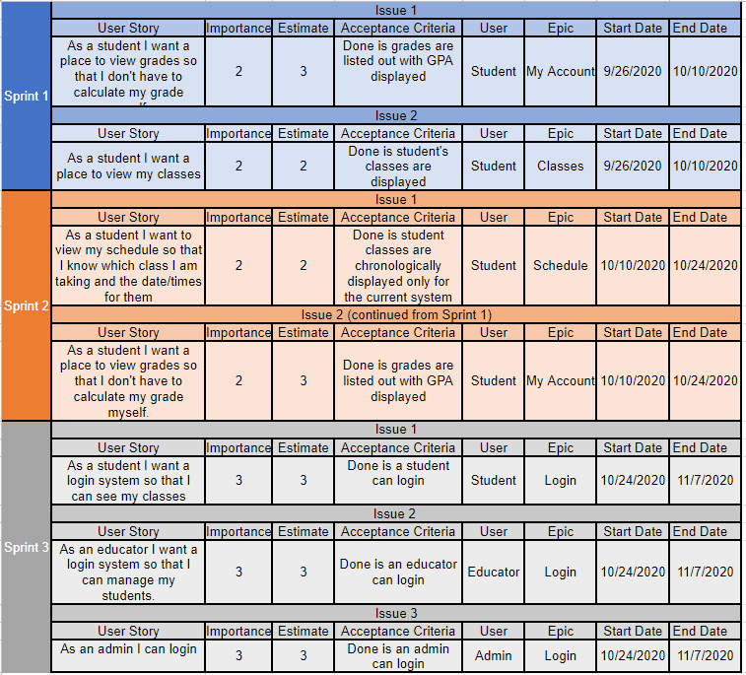

# Top 5 risks at the beginning of each sprint

* 1. Sprint 1
     1. Setting up the Blazor project
     2. Setting up collaborative GitHub project
     3. Get all code contributing team members as collaborators on the repository
     4. Set standard for merging in branches
     5. Developing code in new framework (Blazor)
  2. Sprint 2
     1. Accurate and punctual code reviews
     2. All collaborators are able to fetch accurate version of master
     3. All collaborators can successfully create pull requests
     4. Set up studentClass
     5. Set up studentGrades
  3. Sprint 3
     1. Deploying a stable web application via Azure
     2. Implement a login feature
     3. Ensure content can be seen only when logged in with proper credentials
     4. Create global variable to contain Login information
     5. Ensure consistency of login feature through testing

# Improvements after each sprint

* 1. Sprint 1
     1. Blazor project was up and running.
     2. Github hub environment was successfully set up
     3. All team members became collaborators within the Github environment
     4. Set the standard of merging branches (pull request, review, approve, delete)
     5. Code implementation successful within Blazor
  2. Sprint 2
     1. QAE member set to review code before allowing branch merges to master
     2. All contributors can fetch their own copy from the master branch
     3. All contributors can submit pull requests for review and approval
     4. Both studentClass and studentGrades were successfully created as intended
  3. Sprint 3
     1. Deployment of web application via Azure was successful and is now accessible
     2. Login feature successfully done. Student, Teacher, and Admin can now attempt logins.
     3. Content visibility and restriction successfully implemented. Depending on credentials, a user can see specific content.
     4. Created a pseudo database for credential verification
     5. Login attempts are accurate and should not accept input that is incorrect.

# Burn Down Charts (Release & Sprints)

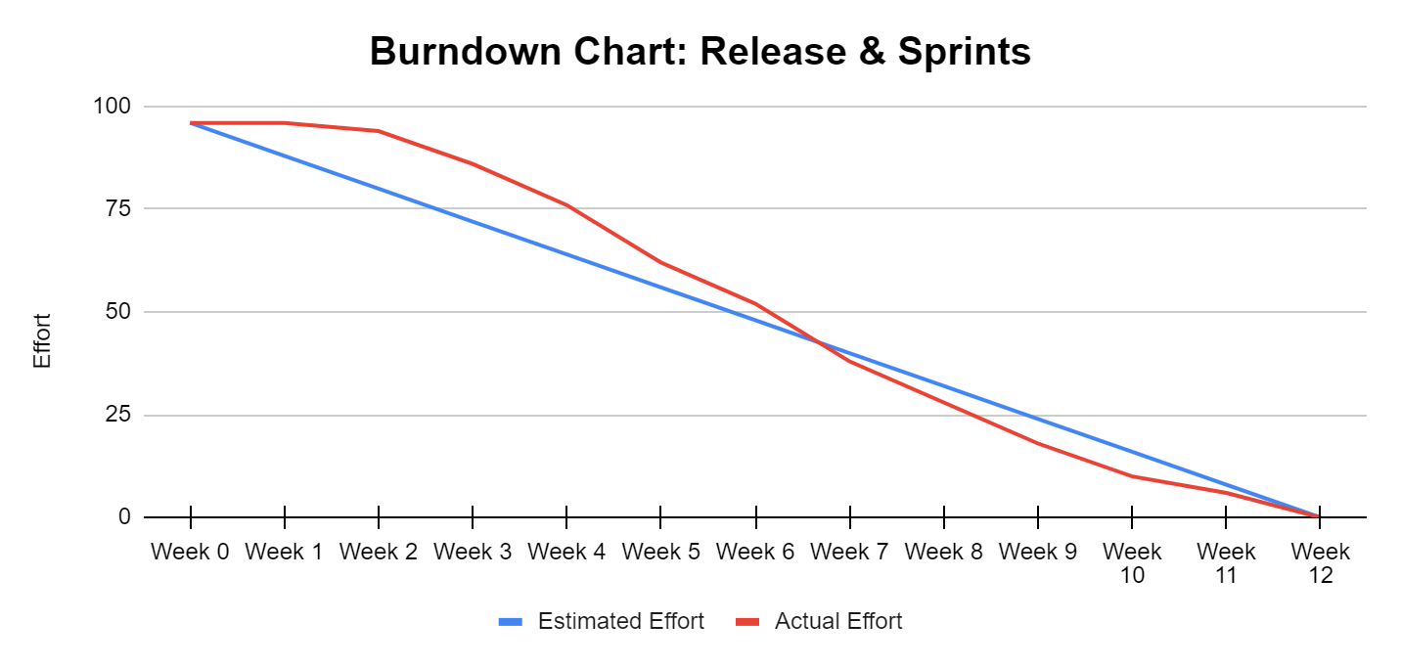

1. **Requirements met for CMMI**

**Continuous Representation Capability Levels [1]**

The goal of this project is to build a student information system. As listed, the following requirements are met:

* Product backlog has been built and features prioritized
* Release plan has been made and progress is met according to the plan
* Scrum process is made
* Issues have been identified during each sprint
* Top five risks have been identified

Level 2 requirements are met. A managed group project has been performed in the past few months. The plan is executed and every member of the team follows and completes their tasks assigned to them.

A capability level 2 process is characterized as a managed process. A managed process is a performed process that is planned and executed in accordance with policy; employs skilled people having adequate resources to produce controlled outputs; involves relevant stakeholders; is monitored, controlled, and reviewed; and is evaluated for adherence to its process description. Since this is a temporary group, everyone simply agreed to engage in the project actively and submit all the work on time. There are no written guidelines or procedures to follow. So, this project has tried to meet the level 3 requirements, but can only complete the level 2.

**Staged Representation Maturity Levels**

According to CMII, at maturity level 2, the projects have ensured that processes are planned and executed in accordance with policy; the projects employ skilled people who have adequate resources to produce controlled outputs; involve relevant stakeholders; are monitored, controlled, and reviewed; and are evaluated for adherence to their process descriptions. The process discipline reflected by maturity level 2 helps to ensure that existing practices are retained during times of stress. When these practices are in place, projects are performed and managed according to their documented plans.

This project has met the requirements at level 2. There are meetings held every week for the members to report the progress and tasks need to be done next week. There are reminders sent out to remind members to submit their work every week. Every member has committed their work and the progress is under control. The product is in the progress to meet all the requirements stated at the beginning.

At maturity level 3, processes are well characterized and understood, and are described in standards, procedures, tools, and methods. In this project, there is no protocol set. This is a loose team project, so no organized rules or setting is made.

1. **Reference**

1. Software Engineering Process Management Program. “CMMI® for Development, Version 1.3.” Software Engineering Institute, Nov. 2010.