

**Department of Computer Science**

CPSC 597 / 598 PROJECT / THESIS DEFINITION

|  |
| --- |
| **To the graduate student:** 1. Complete a project proposal, following the department guidelines. 2. Have this form signed by your advisor and reviewer / committee. 3. Submit it with the proposal attached, to the Department of Computer Science. |

|  |  |
| --- | --- |
| **X** | Project |
|  |  |
|  | Thesis |

Please print or type.

|  |  |  |  |  |  |  |  |  |  |  |  |
| --- | --- | --- | --- | --- | --- | --- | --- | --- | --- | --- | --- |
| Student Name: | | Amber Kimberling | | | Student ID: | | | | 886706803 | | |
| Address: | | ­­­­­­­­­­­­­­­­­­­­­­­­­­­­­­­­­­­­­­­­­­­­­­­­1376 Purdue Street Upland, CA 91786 | | | | | | | | | |
|  | | Street | | | City | | | | | Zip Code | |
| Home Phone: | | (626)940-6280 | Work Phone: | | | |  | | | | |
| E-Mail: | Akimberling3@csu.fullerton.edu | | | Units: | |  | | Semester: | | |  | |

Are you a Classified graduate student? Is this a group project?

|  |  |  |  |  |  |  |
| --- | --- | --- | --- | --- | --- | --- |
| **X** | Yes |  | | |  | Yes |
|  |  |  | | |  |  |
|  | No |  | | | **X** | No |
| Proposal Date: | | | |  |
| Tentative Date for Demonstration  /Presentation/Oral Defense: | | | |  |
| Completion Deadline: | | | |  |
| Tentative Title: | | | | **Virtual Classroom Dashboard** | | | | |

We recommend that this proposal be approved:

|  |  |  |  |
| --- | --- | --- | --- |
| Faculty Advisor |  |  |  |
|  | Printed name | Signature | Date |
| Faculty Reviewer |  |  |  |
|  | Printed name | Signature | Date |
| Faculty Reviewer |  |  |  |
|  | Printed name | Signature | Date |

CAL STATE UNIVERSITY FULLERTON

FULLERTON, CALIFORNIA

SPRING 2021

PROJECT PROPOSAL

VIRTUAL CLASSROOM DASHBOARD

A PROJECT SUBMITTED TO:

THE FACULTY OF

COMPUTER SCIENCE AND COMPUTER ENGINEERING

IN CANDIDANCY FOR THE DEGREE OF

MASTER OF SCIENCE COMPUTER SCIENCE

BY:

AMBER KIMBERLING

**Table of Contents**

Abstract 5

1.0 Introduction 6

1.1 Background 6

1.2 Motivation 7

1.3 Related Work 7

2.0 Problem Statement 9

3.0 Proposed Project & Significance 10

4.0 Objectives 11

4.1 Project 11

4.2 Technical 11

4.3 Significance 12

5.0 Activities 12

5.1 The Process 12

5.2 Phases 14

6.0 Development Environment 15

7.0 Reports and Products 15

7.1 Deliverables 15

8.0 Schedule 16

9.0 References 17

**Table of Figures**

Figure 5.1.1 Software Lifecycle Development and Descriptions…………………………..……13

Figure 5.2.1 Sample Product Backlog for the Virtual Dashboard Classroom Web App……...…14

Figure 8.0.1 Virtual Classroom Dashboard Project Timeline……………………………………16

Abstract

Learning Management Systems are very important in our technological world for educating young minds in the courses they are passionate about. This paper proposes to build such a system and determines the significance of doing so. The proposal outlines the problem, objectives, activities, development environment, what is to be delivered, and the timeline of doing so.

1. Introduction

“By 24 April 2020, education institutions in approximately 180 countries were closed, affecting 85 percent of the world’s student population and causing nearly 1.5 billion students to stay out of the classroom” (United Nations University - Institute for Environment and Human Security, 2020). Covid-19 has caused a strain on the educational industry and has forced many institutions to turn to online learning. E-learning is not a new concept and has been around for many years. E-learning (Electronic learning) is education through the forms of electronic devices and digital media. One of the leading tools in online learning are Learning Management Systems (LMS). A LMS is a software platform for the tracking of online courses or programs.

1.1 Background

In 1924 the testing machine was created as an automatic teacher. The automatic teacher was used for rote-and-drill learning. This machine was also considered a big failure. In 1954 the teaching machine was developed by B.F. Skinner and was used for students to learn at their own pace (Gogos, 2017). In the 1960’s training on the computer was developed and was called Programmed Logic for Automated Teaching Operations (or PLATO). This implemented drills and questions. From these inventions and developments emerged Digital Native in the 1990’s. This is where the concept of electronic learning began to be recognized as a tool for learning. In the 2000’s businesses began to implement the concept of E-learning by training their workers electronically. From 2010 and up social media began to inspire more tools to be used for E-learning such as YouTube and Twitter.

Today there are over 1000 plus LMS to choose from, each one containing a lot of useful learning features (Pappas, 2021). It is currently used as a tool for learning in both education and in corporate life. The educational system utilizes E-learning to teach their students. Corporate companies or lower-level businesses use online learning for training their workers. There are several different types of Learning Management Systems including cloud-based and open-source. Cloud-based systems can be accessed anywhere since they do not require hardware specifications or software to be installed. Open-source systems provide free code allowing organizations to customize the type of environment they will be using. Some of the key features LMS use are social learning tools, gamification, course management, assessment tools, notifications, and intuitive user management.

1.2 Motivation

My personal motive for working, researching, and developing a learning management system are because of my passion for education. I have been a tutor for almost three years now for several different computer science subjects including programming concepts, object-oriented programming, data structures, python, compiler design, algorithms, and discrete mathematics. My goal is to one day be a professor of computer science at the undergraduate level. Other motives for choosing the topic of E-learning and LMS are because I hope to develop better communication between users, bring all educational content into one place, track learning progress and performance, reduce learning costs, and create up to date information.

1.3 Related Work

**1.3.1 Learning Management Systems**

Moodle (Modular Object-Oriented dynamic Learning) is a popular open-source online learning platform. It has many enticing features such as fast grading, gamification, online testing, assignment submission, analytics, and group options (Sf, 2019). Another LMS is Canvas. Canvas is web-based and is used for all education levels. It includes a variety of features such as speed grading, provides learning outcomes, integrated calendars, online testing, originality checks for submissions, and discussion boards (Key Features: Canvas Course Design, 2021). Google Classroom is another free web-based learning service. This LMS was created with the primary purpose to streamline file sharing. It also has several great features like class management, announcement posting, question-driven discussions, work tracking, and a student summary that can be shared with a parent or guardian (Google, a2021). Each one of these Learning Management Systems share similar features but seem to be missing the most important feature of all, video conferencing within the applications.

**1.3.2 Video Conferencing**

Zoom is one of the most common video conferencing softwares. It is utilized in meetings for businesses, friends, and in educational settings. Zoom allows for physical video chatting, voice calls, and allows for message chatting. Some of the best features of this application are the following: zoom has easy adoption to WebRTC, screen sharing options, role-based user permissions, HD video calls, calendaring with Outlook or Google, recording, and breakout groups (Carter, 2020). These are only some of the features Zoom offers, they have many more. WebEx is another video conferencing software. This software is cloud-based that allows for collaboration across multiple device types. WebEx offers a variety of features like but not limited to audio conferencing, facilitator functions, file transfer options, instant messaging, screen share, and virtual whiteboard (W., 2020). Google Meet is also a video conferencing application that was created by Google. Google Meet is business-oriented and allows for people with any type of Google account. It is primarily for video conferencing but can be used as a voice chat as well. This application has several features that include live captioning, unlimited meetings, adjustable layout and screen settings, host controls, cross compatibility for devices, screen sharing, and much more (Google, b2021). Each one of these products have similar features but it is about who does it better with their features, accessibility, security, etc.

1. Problem Statement

Learning Manage Systems have been around for several years. Each type of system contains some unique and similar sets of features. Each year new technology arises as well as new tools for learning. With these developments comes changes to the educational system in a more technological way. In 2020 the world was hit with the Covid-19 pandemic leaving institutions with no choice but to turn to online learning. This proved difficult because they had to find the right LMS and video conferencing application. Having multiple tools and platforms can prove to be difficult especially for lower levels of educations. Why can’t these tools be all in one? There is need for a uniform all-in-one easy to use platform where teachers can video chat, communicate, provide material, submissions, and assessments.

“The best online learning combines elements where students go at their own pace, on their own time, and are set up to think deeply and critically about subject matter combined with elements where students go online at the same time and interact with other students, their teacher and content” (Greenhow, 2020). Education is a key asset to providing us with the tools to move through our life and careers. If the world were to move to hybrid or e-learning applications, they would need to be equipped with the best tools and be flexible. As we move toward the future how we learn will be an ongoing issue especially if there is another pandemic or outbreak of some kind.

1. Proposed Project & Significance

The proposed project is called Virtual Classroom Dashboard (VCD). This application is about providing a more diverse environment for educators to immerse their students into their classes. This development project would take the best features from top learning management systems and integrate it with a video chatting system like Zoom, WebEx, or Google Meet. It would contain three types of users, students, educators, and administrators. This application would be a free web-based application. VCD would contain features such as automatic grading, discussion boards, chatting, content management, online testing, and analytics. Educators need one application to provide for their students and students need a single place to find all their materials for a given class. This is all about bridging the gap between communication and defining a diverse learning environment.

“From 2021 to 2024, the learning management system market is expected to expand to $25.4 billion at a CAGR (Compound annual growth rate) of 23.8 percent” (Dykes, 2021). Learning Management Systems are becoming very important and continue to be essential in the growth of the educational industry. Schools are not the only ones who are invested in LMS, companies are as well. Businesses use this technology to train their staff. This development project can be manipulated in the future to include businesses as well. The future of LMS include AI-driven smart course personalization features, social media integration, big data implementation, and user generated content.

1. Objectives
   1. Project
      1. **Project Objective 1**

A deployable application completed by December 2021 with over 200 hours of work.

* + 1. **Project Objective 2**

Design a full stack application that provides a multitier platform for users such as educators, students, and administrators.

* + 1. **Project Objective 3**

Develop a final report with a full explanation of the development and software.

* + 1. **Project Objective 4**

Develop three user manuals.

* 1. Technical
     1. **Technical Object 1**

Design a cross browser compatible application.

* + 1. **Technical Object 2**

Design a responsive app for all devices.

* + 1. **Technical Object 3**

Develop a secure app using authentication, authorization, limit access, and encryption tactics.

* + 1. **Technical Object 4**

Develop an accessible application that is easy to use and adheres to the guidelines for accessibility.

* + 1. **Technical Object 5**

Design an application that has high modifiability and testability with separation of concerns using the MVC framework.

* 1. Significance

The topic of E-learning is a current topic and will continue to be current with the future advances in technology. Learning Management Systems are very important especially since the Covid-19 pandemic. Covid-19 has shown that having easy to use LMS can make the switch to online schooling a bit easier on the students and the teachers. The other factors that make this development project significant enough for a master’s project are the extended amounts of research time, it requires the knowledge from the courses I have taken in the master’s program, and knowledge gained outside of the classroom. This project will also take over 200 plus hours to complete.

1. Activities
   1. The Process

The objective of this application will be met by using a deviation of agile/scrum methods as well as following the life cycle of software development depicted in *Figure 5.1.1 Software Lifecycle Development and Descriptions*. The first step is planning, which consists of defining the problem, objectives, environment, reports and products, and estimated timeline. The next step is analysis where the requirements and users’ needs will be defined. The third step will be design with a series of charts, diagrams, and to demonstrate how the application will look and the movement through the application. The fourth step is the physical coding portion of the project where steps 1 – 3 will come to life. Following the fourth step will be the testing portion of the project. In this step a series of tests will be conducted to reveal the bugs in the program, if proper inputs are accepted, outputs are correct, and to ensure that all aspects of the program are working. The most important part of this is checking that all user requirements are met. The second to last step is deploying the program into a real-life environment and having users approve the software application. Last will be to maintain the software where updates may be deployed, or any further issues found will be fixed.

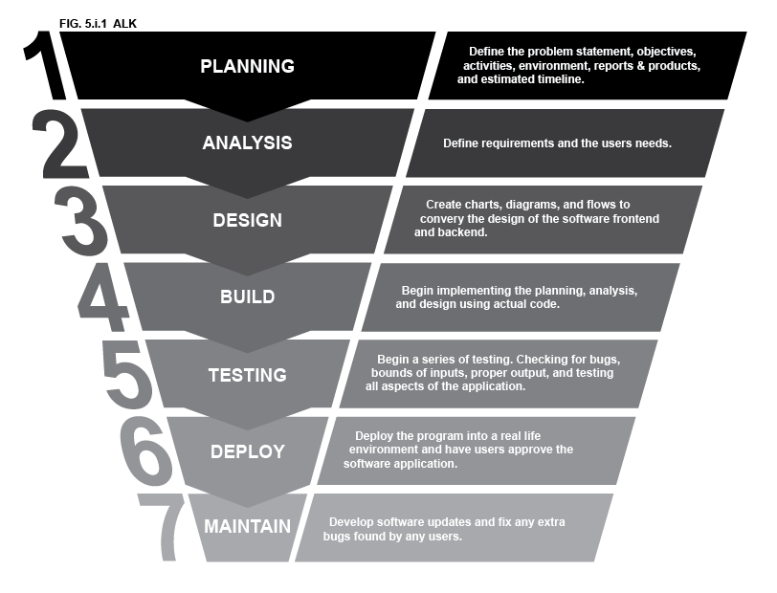

**Figure 5.1.1 Software Lifecycle Development and Descriptions**

* 1. Phases

**Phase 1: Planning, Analysis, Research, and Design**

* Planning & Analysis: Project Proposal.
* Research all necessary pieces of the project.
* Design: Visually representing all aspects of the project
  + User Flow, Wireframe, sitemaps, ER diagrams, etc.…

**Phase 2: Build and Testing**

* Build – Programming in phases based off Agile/Scrum product backlog (*Figure 5.2.1 Sample Product Backlog for the Virtual Dashboard Classroom Web App*) and Feature driven development.

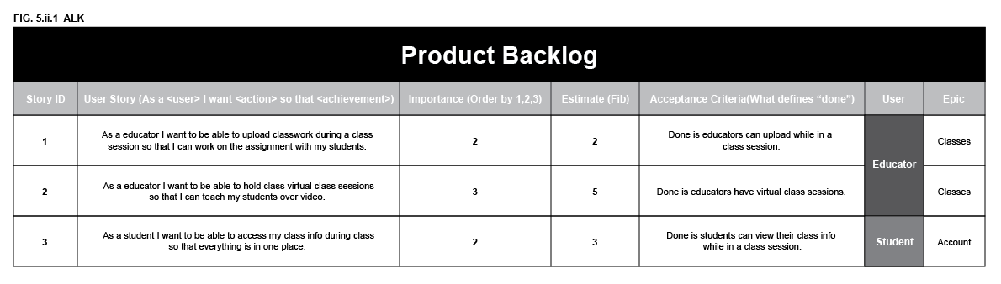

**Figure 5.2.1 Sample Product Backlog for the Virtual Dashboard Classroom Web App**

* Testing – Test in phases along with each feature develop. This goes hand in hand with the build portion of phase 2.

**Phase 3: Deploy and Maintain**

* Deploy the application.
* Run tests on the application as a part of the maintenance portion of this phase.
* Have users test the application revealing any other issues with the program.

**Phase 4: Documents and Demonstrations**

* User’s Manual
* Final Report
* Demonstration

1. Development Environment

The Full Stack Application is going to be a C# ASP.Net internet application that will be hosted using a web server. It will be cross-browser compatible and responsive for all device types. This application will work on any operating system because it is a web-based application. The main languages used for the software development will be HTML5, CSS3, JavaScript, embedded SQL statements, and C#. It will also be using a MySQL relational database using constraints and keys. The tools used to develop this application will be Visual Studio 2019, Zoom/WebEx API, Microsoft SQL Server (for development), GitHub, Azure Database(for deployed application), and a web server hosted in a cloud provider such as Azure.

1. Reports and Products
   1. Deliverables

The final product of this project will be a full stack application that provides a multi-tier platform for users such as: educators, admins, and students. Along with the application a Final Report with a full explanation of development and software, 3 User Manuals that include: 1 for educators, 1 for admins, and 1 for students, the source code for the project, and a Demonstration will be provided.

1. Schedule

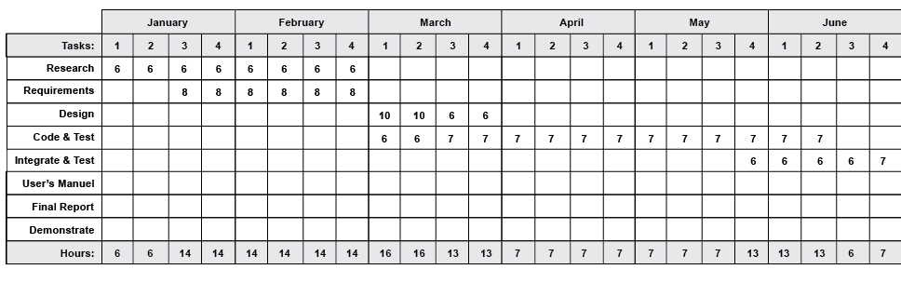

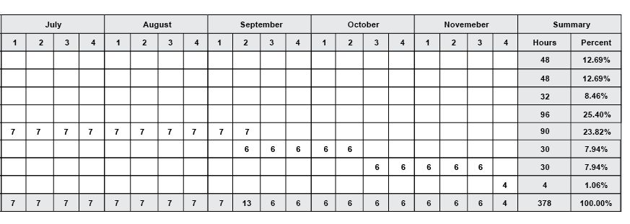

**Figure 8.0.1 Virtual Classroom Dashboard Project Timeline**

1. References

Carter, R. (2020, June 24). Zoom Meetings Review: The Ultimate Video Solution? UC Today. https://www.uctoday.com/collaboration/zoom-meetings-review/

Dykes, A. (2021, February 17). Predictions for the Future of LMS. TechnologyAdvice. https://technologyadvice.com/blog/human-resources/predictions-for-the-future-of-lms/

Gogos, B. R. (2017, May 6). A brief history of elearning (infographic). EFront Blog. https://www.efrontlearning.com/blog/2013/08/a-brief-history-of-elearning-infographic.html

Google. (2021). About Classroom - Classroom Help. Google Support. https://support.google.com/edu/classroom/answer/6020279?hl=en

Greenhow, C. (2020, June 4). Ask the Expert: Online learning vs. classroom learning. MSUToday | Michigan State University. https://msutoday.msu.edu/news/2020/ask-the-expert-online-learning-vs-classroom-learning

Key features: Canvas Course Design. (2021). Canvas. https://canvas.uw.edu/courses/866251/pages/key-features

Pappas, C. (2021, February 23). *The Best Learning Management Systems (2020 Update)*. ELearning Industry. https://elearningindustry.com/the-best-learning-management-systems-top-list

Sf, S. (2019, January 4). 8 Reasons Why Moodle Is Still Awesome. ELearning Industry. https://elearningindustry.com/why-moodle-still-awesome-8-reasons

United Nations University - Institute for Environment and Human Security. (2020, September 25). Five facts on e-learning that can be applied to COVID-19 - Institute for Environment and Human Security. United Nations University. https://ehs.unu.edu/news/news/five-facts-on-e-learning-that-can-be-applied-to-covid-19.html

W. (2020, July 9). Meet the leader in web conferencing | Cisco. Webex. https://www.webex.com/web-conferencing