

**Department of Computer Science**

CPSC 597 / 598 PROJECT / THESIS DEFINITION

|  |
| --- |
| **To the graduate student:** 1. Complete a project proposal, following the department guidelines. 2. Have this form signed by your advisor and reviewer / committee. 3. Submit it with the proposal attached, to the Department of Computer Science. |

|  |  |
| --- | --- |
| **X** | Project |
|  |  |
|  | Thesis |

Please print or type.

|  |  |  |  |  |  |  |  |  |  |  |  |
| --- | --- | --- | --- | --- | --- | --- | --- | --- | --- | --- | --- |
| Student Name: | | Amber Kimberling | | | Student ID: | | | | 886706803 | | |
| Address: | | ­­­­­­­­­­­­­­­­­­­­­­­­­­­­­­­­­­­­­­­­­­­­­­­­1376 Purdue Street Upland, CA 91786 | | | | | | | | | |
|  | | Street | | | City | | | | | Zip Code | |
| Home Phone: | | (626)940-6280 | Work Phone: | | | |  | | | | |
| E-Mail: | Akimberling3@csu.fullerton.edu | | | Units: | |  | | Semester: | | |  | |

Are you a Classified graduate student? Is this a group project?

|  |  |  |  |  |  |  |
| --- | --- | --- | --- | --- | --- | --- |
| **X** | Yes |  | | |  | Yes |
|  |  |  | | |  |  |
|  | No |  | | | **X** | No |
| Proposal Date: | | | |  |
| Tentative Date for Demonstration  /Presentation/Oral Defense: | | | |  |
| Completion Deadline: | | | |  |
| Tentative Title: | | | | **Virtual Classroom Dashboard** | | | | |

We recommend that this proposal be approved:

|  |  |  |  |
| --- | --- | --- | --- |
| Faculty Advisor |  |  |  |
|  | Printed name | Signature | Date |
| Faculty Reviewer |  |  |  |
|  | Printed name | Signature | Date |
| Faculty Reviewer |  |  |  |
|  | Printed name | Signature | Date |

CAL STATE UNIVERSITY FULLERTON

FULLERTON, CALIFORNIA

FALL 2020

PROJECT PROPOSAL

VIRTUAL CLASSROOM DASHBOARD

A PROJECT SUBMITTED TO:

THE FACULTY OF

COMPUTER SCIENCE AND COMPUTER ENGINEERING

IN CANDIDANCY FOR THE DEGREE OF

MASTER OF SCIENCE COMPUTER SCIENCE

BY:

AMBER KIMBERLING

**FACULTY ADVISOR:**

**MIKHAIL GOFMAN**

**Table of Contents**

1. Introduction 1

2. Organizational Overview 1

3. Problem Statement 1

4. Objectives 1

5. Activities 1

i. The Process 1

ii. Phases 2

6. Development Environment 3

7. Reports and Products 4

i. Deliverables 4

8. Schedule 4

9. References 5

1. Introduction

The proposed project is about providing a more diverse environment for educators

to immerse their students into their classes. Educators need one application to provide for their students and students need a single place to find all their materials for a given class. This is all about bridging the gap between communication and defining a diverse learning environment.

1. Organizational Overview

This is for all the educators out there struggling to provide their students the education they need and deserve during the covid19 pandemic.

1. Problem Statement

The covid19 pandemic has shown how switching to online is not all that easy at any educational level. It is both a hardship on the educators and the students. Many educators especially at lower levels have issues with using multiple platforms for providing their students with lessons, materials, and communication. Why can’t all of this be all one platform? By creating a uniform platform where educators can video chat, communicate, provide materials, and submissions, this should bridge the gap of issues and hardships on those out there who need a all in one easy to use learning/teaching platform.

1. Objectives

By December 2021, a deployable educational virtual dashboard will be completed, 10-11 months of work to create an easy to use environment with over 200 hours of work put in. This is significant enough for a master’s project because it requires a significant amount of time, is a full stack application, will require the knowledge from the courses taken at CSUF, and extensive research.

1. Activities
2. The Process

The objective of this application will be met by using a deviation of agile/scrum methods as well as following the life cycle of software development depicted in *Figure 5.i.1*. The first step is planning which, consists of defining the problem, objectives, environment, reports and products, and estimated timeline. The next step is analysis where the requirements and users’ needs will be defined. The third step will be design with a series of charts, diagram, and to demonstrate how the application will look and the movement through the application. The fourth step is the physical coding portion of the project where steps 1 – 3 will come to life. Following the fourth step will be the testing portion of the project. In this step a series of tests will be conducted to reveal the bugs in the program, if proper inputs are accepted, outputs are correct, and to ensure that all aspects of the program are working. The most important part of this is checking that all user requirements are met. The second to last step is deploying the program into a real-life environment and having users approve the software application. Last will be maintain the software where updates may be deployed, or any further issues found will be fixed.

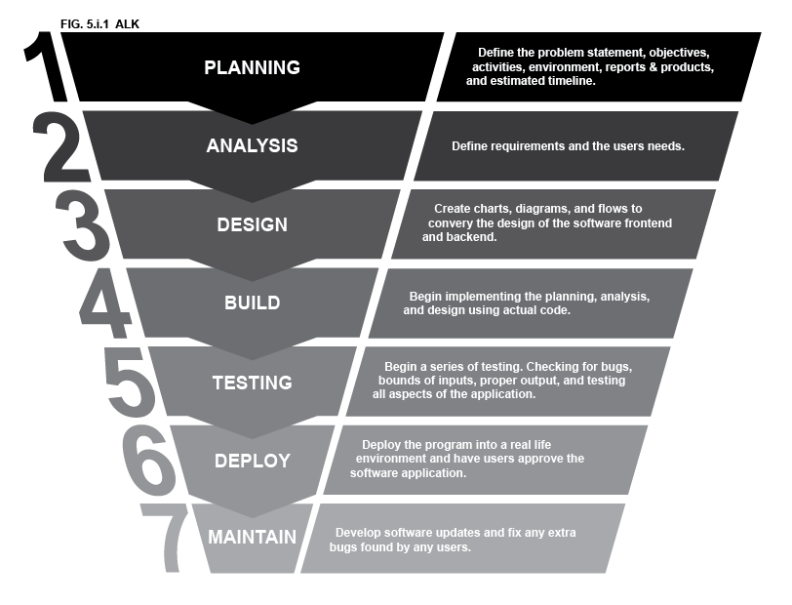

1. Phases

Phase 1: Planning, Analysis, Research, and Design

* Planning & Analysis: Project Proposal
* Research all necessary pieces of the project
* Design: Visually representing all aspects of the project
  + User Flow, Wireframe, sitemaps, ER diagrams, etc…

Phase 2: Build and Testing

* Build – Programming in phases based off Agile/Scrum product backlog and Feature driven development

**EX:**

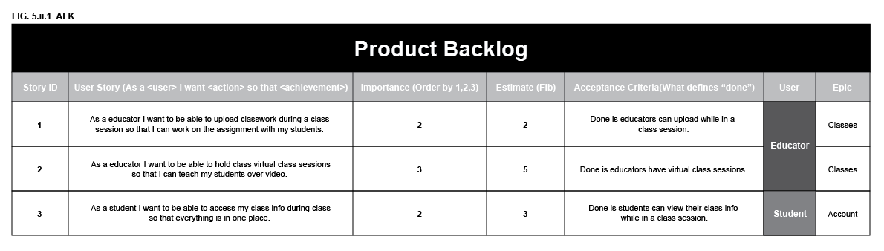

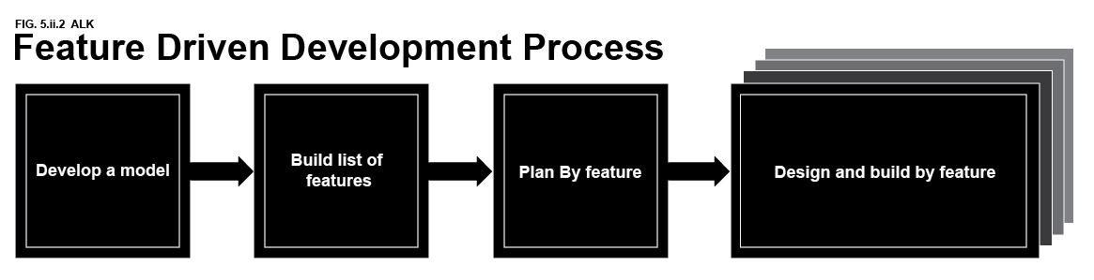

* Testing – Test in phases along with each feature develop. This goes hand in hand with the build portion of phase 2.

Phase 3: Deploy and Maintain

* Deploy the application
* Run tests on the application as a part of the maintenance portion of this phase
* Have users test the application revealing any other issues with the program.

Phase 4: Documents and Demonstrations

* User’s Manual
* Final Report
* Demonstration

1. Development Environment

The Full Stack Application is going to be a C# ASP.Net internet application that will be hosted using a web server. It will be cross-browser compatible and responsive for all device types. This application will work on any operating system because it is a web-based application. The main languages used for the software development will be HTML5, CSS3, JavaScript, embedded SQL statements, and C#. It will also be using a MySQL relational database using constraints and keys. The tools used to develop this application will be Visual Studio 2019, XAMPP, Localhost, PhpMyAdmin, and a web server hosted in a cloud provider such as Bluehost or Azure.

1. Reports and Products
2. Deliverables

The final product of this project will be a full stack application that provides a multi-tier platform for users such as: educators, admins, and students. Along with the application a Final Report with a full explanation of development and software, 3 User Manuals that include: 1 for educators, 1 for admin, and 1 for students, the source code for the project, and Demonstration will be provided.

1. Schedule

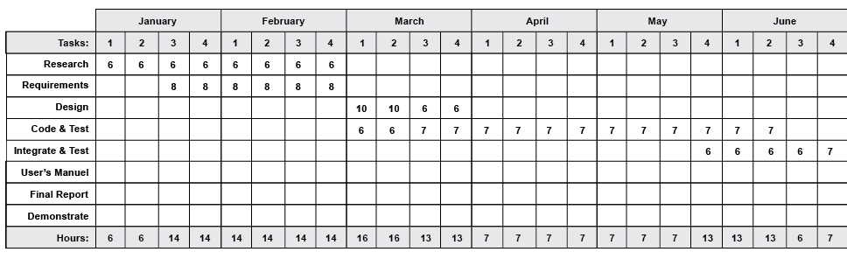

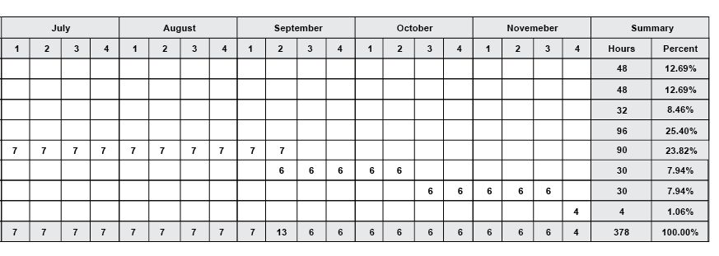

1. References

Cormen, Thomas, et al. *Introduction to Algorithms, 3rd Edition (The MIT Press)*. 3rd ed., The MIT Press, 2009.

Elmasri, Ramez, and Shamkant Navathe. *Fundamentals of Database Systems*. 7th ed., Pearson, 2015.

Humphrey, Watts and Software Engineering Institute. *Managing the Software Process*. Addison-Wesley, 1989.

“RxJS, Ggplot2, Python Data Persistence, Caffe2, PyBrain, Python Data Access, H2O, Colab, Theano, Flutter, KNime, Mean.Js, Weka, Solidity.” *Tutorialspoint*, www.tutorialspoint.com/index.htm. Accessed 17 Oct. 2020.

“W3Schools Online Web Tutorials.” *W3schools*, www.w3schools.com. Accessed 17 Oct. 2020.

Zoom Video Communications. “Web - Client SDKs - Zoom Software Development Kit (Zoom SDK).” *Zoom | Developer*, 2020, marketplace.zoom.us/docs/sdk/native-sdks/web.