AUTOMATION OF SYSTEMATIC MAPPING STUDIES: A MACHINE LEARNING APPROACH

Naale Josephat

MSc (Data Science Dissertation)
University of Dar es Salaam
July 2026

AUTOMATION OF SYSTEMATIC MAPPING STUDIES: A MACHINE LEARNING APPROACH

By

Naale Josephat

A Dissertation Submitted in Partial Fulfilment of the Requirements for the Degree of Master of Science in Data Science of the University of Dar es Salaam

University of Dar es Salaam
July 2026

CERTIFICATION
The undersigned certifies that she has read and hereby recommends for acceptance by the University of Dar es Salaam a dissertation titled: “Automation of Systematic Mapping Studies: A Machine Learning Approach”, in partial fulfilment of the requirements for the degree of Master of Science in Data Science of the University of Dar es Salaam.
…………………………………………
Dr. Salome Maro
(Supervisor)
Date: ………………………………

DECLARATION
AND
COPYRIGHT
I, Naale Josephat, declare that this dissertation is my own original work and that it has not been presented and will not be presented to any other university for a similar or any other degree award.
Signature ……………………………………
This dissertation is copyright material protected under the Berne Convention, the Copyright Act of 1999, and other international and national enactments, in that behalf, on intellectual property. It may not be reproduced by any means, in full or in part, except for short extracts in fair dealing, for research or private study, critical scholarly review, or discourse with an acknowledgement, without the written permission of the Directorate of Postgraduate Studies, on behalf of both the author and the University of Dar es Salaam.

ACKNOWLEDGEMENTS
First and foremost, I thank the Almighty God for the gift of life, health, and perseverance throughout the period of this study. Every milestone of this work has been possible through His grace.
I owe my deepest gratitude to my supervisor, Dr. Salome Maro, whose guidance, patience, and constructive criticism shaped this dissertation from its earliest idea to its final form. Her insistence on clarity, rigour, and reproducibility profoundly improved both the work and my own scholarship.
I extend sincere thanks to the academic staff of the Department of Computer Science and Engineering in the College of Information and Communication Technologies, whose comments on the proposal and progress presentations strengthened the structure, the objectives, and the technical depth of this study.
Finally, I thank my family and friends for their unwavering encouragement, and the University of Dar es Salaam for the financial and infrastructural support that made this work feasible.

DEDICATION
To my beloved family, whose patience, sacrifice, and constant encouragement sustained me through every stage of this work, and to the growing community of researchers in Africa who are building the tools that will make evidence synthesis faster, fairer, and more accessible.

LIST OF ABBREVIATIONS AND ACRONYMS
Abbreviation | Meaning
AI | Artificial Intelligence
BDD | Behaviour-Driven Development
BERT | Bidirectional Encoder Representations from Transformers
BoW | Bag of Words
CRF | Conditional Random Field
F1 | F-measure (harmonic mean of precision and recall)
HDBSCAN | Hierarchical Density-Based Spatial Clustering of Applications with Noise
LLM | Large Language Model
ML | Machine Learning
NER | Named Entity Recognition
NLP | Natural Language Processing
PDF | Portable Document Format
RPA | Robotic Process Automation
SBERT | Sentence-BERT
SGD | Stochastic Gradient Descent
SLR | Systematic Literature Review
SMS | Systematic Mapping Study
SVM | Support Vector Machine
TF–IDF | Term Frequency–Inverse Document Frequency
UDSM | University of Dar es Salaam
UMAP | Uniform Manifold Approximation and Projection

ABSTRACT
Systematic mapping studies (SMS) are a cornerstone of evidence-based software engineering: they classify the primary literature and reveal publication trends, research gaps, and opportunities. Yet conducting an SMS manually is tedious, time-consuming, and error-prone, and the data-extraction-and-mapping step, in particular, consumes the greatest share of researchers' effort while attracting the least automation. Existing automation research concentrates overwhelmingly on the study-selection (screening) stage of systematic literature reviews, leaving the data-extraction-and-mapping step of mapping studies underserved, lacking a unified extraction framework, and unable to handle heterogeneous publication metadata.
This study designed, developed, and evaluated a machine learning pipeline that automates the data-extraction-and-mapping phase of systematic mapping studies. The pipeline ingests full-text academic papers, extracts a defined set of publication-metadata features through named entity recognition, classifies each paper along three established mapping facets (research type, contribution type, and evaluation method) using supervised classifiers, and applies transformer-based topic modelling to induce thematic categories. The work followed a six-stage data-science lifecycle and was developed and validated against a gold-standard corpus drawn from existing, manually conducted software-engineering mapping studies, anchored on the behaviour-driven-development mapping study of Binamungu and Maro (2023).
The study set explicit performance targets of a macro-averaged F1-score of at least 0.75 across the classification facets and a reduction of at least 50% in per-study extraction time relative to the manual baseline of 107 minutes reported by Felizardo et al. (2024). The pipeline was applied to a corpus of 123 behaviour-driven-development primary studies, for which it produced a complete systematic map: each study was assigned a research type, a contribution type, and an evaluation method, descriptive metadata were extracted, and two thematic clusters with a small outlier set were induced. The facet distribution produced by the pipeline agreed closely with the published manual classification of Binamungu and Maro (2023), with benchmark scores of 0.85 to 0.89 across the three facets. Supervised classifiers trained on these labels and evaluated by cross-validation achieved high micro-F1 (up to 0.88) but lower macro-F1 (0.28 to 0.62), reflecting the severe class imbalance of the corpus, so the 0.75 macro-F1 target was not met; the per-study timing comparison remains to be instrumented. The study contributes a reusable, reproducible pipeline and the associated dataset that reduces the effort and bias of manual data extraction and improves the reliability and timeliness of systematic mapping studies in software engineering and related domains.

TABLE OF CONTENTS
CERTIFICATION i
DECLARATION i
ACKNOWLEDGEMENTS i
DEDICATION i
LIST OF ABBREVIATIONS AND ACRONYMS i
ABSTRACT i
TABLE OF CONTENTS i
LIST OF TABLES i
LIST OF FIGURES i
CHAPTER ONE 1
1.1 Background to the Study 1
1.1.1 Systematic Mapping Studies and Why They Matter 1
1.1.2 The Challenges of Conducting an SMS Manually 1
1.1.3 Gaps in Existing Automation Research 1
1.1.4 Contribution and Positioning of This Study 1
1.2 Statement of the Problem 1
1.3 Research Objectives 1
1.3.1 Main Objective 1
1.3.2 Specific Objectives 1
1.4 Research Questions 1
1.5 Significance of the Study 1
1.6 Scope of the Study 1
1.7 Dissertation Structure 1
CHAPTER TWO 1
2.1 Introduction 1
2.2 Systematic Mapping Studies and Publication Characteristics 1
2.2.1 Secondary Studies and the Place of the SMS 1
2.2.2 The Systematic Mapping Process 1
2.2.3 The Nature of Publication Metadata in Systematic Mapping Studies 1
2.2.4 Data Extraction and Mapping as the Principal Bottleneck 1
2.2.5 Evidence-Based Software Engineering and the Role of Maps 1
2.3 Automation Efforts in Systematic Mapping and Review 1
2.3.1 Automation of Study Selection (Screening) 1
2.3.2 Automation of Data Extraction 1
2.3.3 The Tool Landscape 1
2.3.4 Automation of Review Updating and AI-Assisted Reviews 1
2.3.5 Critical Synthesis of the Automation Literature 1
2.4.1 Supervised Classification Algorithms 1
2.4.2 Intuition Behind the Principal Classifiers 1
2.4.3 Text Representation and Embeddings 1
2.4.4 Transformer-Based Models 1
2.4.5 Named Entity Recognition 1
2.4.6 Topic Modelling Approaches 1
2.4.7 Evaluation Metrics 1
2.4.8 Model Selection, Cross-Validation and Generalisation 1
2.4.9 Synthesis: From Techniques to Pipeline 1
2.5 Related Work 1
2.6 Research Gap 1
2.7 Conceptual Framework 1
CHAPTER THREE 1
3.1 Introduction 1
3.2 Research Design 1
3.3 Study Area 1
3.4 Research Approach and Method 1
3.5 Data Collection and the Gold-Standard Baseline 1
3.6 Metadata Features for Mapping 1
3.7 Data Preparation 1
3.8 Text Representation and Feature Engineering 1
3.9 Model Selection and Training 1
3.10 Model Evaluation and Performance Targets 1
3.11 Tools and Materials 1
3.12 Ethical Considerations 1
3.13 Detailed Data-Science Lifecycle Stages 1
3.13.1 Business and Process Understanding 1
3.13.2 Data Acquisition and Understanding 1
3.13.3 Data Preprocessing 1
3.13.4 Data Analysis 1
3.13.5 Modelling 1
3.13.6 Deployment and Evaluation 1
3.14 Requirements of the Pipeline 1
3.15 Detailed Preprocessing Steps 1
3.16 Evaluation Metric Definitions 1
3.17 Classifier Configurations 1
3.18 Annotation Process and Inter-Annotator Agreement 1
3.19 Pilot Calibration of the Pipeline 1
3.20 Validity-Preserving Design Choices 1
CHAPTER FOUR 1
4.1 Introduction 1
4.2 Overview of the Pipeline Architecture 1
4.3 Document Ingestion and Text Extraction 1
4.4 Preprocessing Module 1
4.5 Metadata Extraction and Named Entity Recognition Module 1
4.6 Facet Classification Module 1
4.7 Thematic Topic Modelling Module 1
4.8 Map Generation and Visualisation Module 1
4.9 Implementation Environment 1
4.10 Functional and Non-Functional Requirements 1
4.11 Thematic and Map-Generation Algorithms 1
4.12 Worked Example of the End-to-End Flow 1
4.13 Testing and Validation of the Pipeline 1
4.14 Output Data Schema 1
CHAPTER FIVE 1
5.1 Introduction 1
5.2 Experimental Setup and Dataset 1
5.3 Metadata Extraction Results 1
5.4 Facet Classification Results 1
5.5 Thematic Topic Modelling Results 1
5.6 The Systematic Map 1
5.7 Comparison with the Manual Baseline 1
5.8 Discussion 1
5.9 Threats to Validity 1
5.10 Corpus Characteristics by Document Length 1
5.11 Detailed Per-Class Classification Results 1
5.12 Error Analysis 1
5.12.1 Illustrative Worked Cases 1
5.13 Comparison with the Literature 1
5.14 Implications for Practice 1
5.15 Ablation Study: Contribution of Each Representation 1
5.16 Cross-Validation Robustness 1
CHAPTER SIX 1
6.1 Introduction 1
6.2 Conclusion 1
6.3 Answers to the Research Questions 1
6.4 Research Contributions 1
6.5 Limitations of the Study 1
6.6 Recommendations for Future Work 1
6.7 Recommendations for Stakeholders 1
6.8 Concluding Remarks 1
REFERENCES 1
APPENDICES 1
Appendix I: Facet Annotation Guidelines 1
Appendix II: Pipeline Configuration Summary 1
Appendix III: Mapping of Objectives to Research Gaps and Chapters 1
Appendix IV: Facet Classification Codebook 1
Research Type Facet 1
Contribution Type Facet 1
Evaluation Method Facet 1
Appendix V: Sample of Annotated Extraction Records 1
Appendix VI: Hyperparameter Search Spaces 1
Appendix VII: Corpus Composition Summary 1
Appendix VIII: Operational Definitions of Key Terms 1

LIST OF TABLES
Summary of related work on review and mapping automation. 1
Classification facets and categories are used in the mapping. 1
Summary of classifier configurations explored. 1
Composition of the corpus by research type (pipeline output). 1
Descriptive bibliographic metadata extraction coverage. 1
Best-classifier cross-validated F1 per facet. 1
Induced thematic clusters and their leading keywords (pipeline output). 1
Distributional agreement with Binamungu and Maro (2023). 1
Pre-registered targets and outcomes. 1
Per-class results for the contribution-type facet. 1
Per-class results for the evaluation-method facet. 1
Recurrent error patterns and their mitigation. 1
Ablation of representation choice (macro F1 per facet). 1
Cross-validation macro F1 (mean ± standard deviation). 1

LIST OF FIGURES
The systematic mapping process (adapted from Petersen et al., 2015). 1
Conceptual framework linking publication metadata, machine learning components and evaluation. 1
The six-stage data-science lifecycle followed by the study. 1
Architecture of the proposed SMS automation pipeline. 1
Illustrative named entity recognition output, labelling contribution, evaluation, and theme cues. 1
Distribution of primary studies across the three facets, showing class imbalance. 1
Macro and micro F1 by facet under stratified cross-validation, against the 0.75 target. 1
Confusion matrix for the research-type facet under cross-validation. 1
Thematic clusters discovered by BERTopic across the full corpus, with outliers shown separately. 1
Automatically generated systematic map: contribution type versus research type (n = 123). 1
Per-study extraction effort: manual single, manual dual and automated pipeline (timing to be completed). 1
Distribution of primary-study length in words (n = 123). 1
Macro, micro and weighted F1 by facet. 1
Ablation study comparing TF–IDF, embeddings, and their combination. 1

CHAPTER ONE
INTRODUCTION

1.1 Background to the Study

Secondary studies synthesise existing primary studies rather than collecting new data, providing structured and reliable summaries of what is already known in a research area. Several types of secondary study exist, including the systematic literature review (SLR), meta-analysis and the systematic mapping study (SMS). An SLR aims to identify relevant primary papers, extract the required data and synthesise the results in order to answer specific research questions in depth, following a strict protocol that covers search strategy, selection criteria and quality assessment. A meta-analysis statistically combines results from primary studies to produce generalisable evidence expressed as effect sizes and confidence intervals.
A systematic mapping study, by contrast, is a methodology used to identify, categorise, and analyse a research topic by examining the quantity and type of research conducted and by revealing the gaps and opportunities in that area (Wolny et al., 2020). It aims to provide an overview of a research field, and its expected outcome is a classified portfolio of publications that identifies the quantity of research, the available results, and the publication trends within the field (Rasheed et al., 2019). In effect, an SMS offers a map-like visual summary of a research area, which is why mapping studies have become common across software engineering, medicine, pharmacy and healthcare (Parashar et al., 2021).
Conducting an SMS involves five steps: the definition of research questions, the search for relevant studies, the screening of papers, keywording using abstracts, and data extraction and mapping (Petersen et al., 2015). Each step contributes to the rigour and traceability of the final map, but the steps differ substantially in the human effort they demand. The fifth step, data extraction and mapping, is widely regarded as the most crucial and the most costly, because data are read from each paper, classified against a scheme and recorded in tables from which statistics and visual maps are produced.
The distinction between these secondary-study types matters for what automation must achieve. An SLR seeks to answer narrow questions by deeply synthesising outcome data, so automating it requires extracting fine-grained, study-specific results. An SMS instead seeks breadth, classifying many studies along a small number of categorical facets to chart a field. The data an SMS extracts is therefore largely categorical and structurally regular, which makes it a more tractable and a more rewarding target for machine learning: the same classification scheme applies across the whole corpus, and success can be measured by agreement with documented expert labels.
The growth of the scientific literature compounds the need for such automation. As the number of published primary studies in software engineering continues to rise, the manual effort required to map a field grows in proportion, and the window during which a map remains current shrinks. A method that reduces the per-study cost of extraction therefore does more than save time on a single study; it changes what is feasible, making it practical to construct larger maps and to keep them up to date as the literature evolves.

1.1.2 The Challenges of Conducting an SMS Manually
Conducting a systematic mapping study manually poses several well-documented challenges, chief among them tediousness, error-proneness and difficulty of updating. Systematically reviewing and categorising a large body of literature is labour-intensive, and the volume of information makes manual processes susceptible to oversights. Among the five steps, data extraction is the most time-consuming, because data are extracted by hand and recorded in tables, and because the number of articles included in a secondary study can range from dozens to thousands. Full automation is difficult owing to the different ways researchers report results, restricted full-text access and the incomplete information supplied by some authors.
Empirical evidence underscores the cost of manual extraction. Felizardo et al. (2024) report that, on average, a researcher spends 107 minutes per study, and that dual-independent data extraction takes up to 172 minutes per study; they further note that data-extraction bias can undermine the validity of evidence synthesis, with error rates reaching as high as 63%. Nussbaumer-Streit et al. (2021) similarly found that extracting major information on study design, participants and results took one person an average of 41 to 65 minutes per study. At the level of the whole study, Petersen et al. (2015) observe that a manual systematic mapping study can take up to 67 weeks from inception to completion. Beyond the initial effort, keeping a secondary study up to date as the literature evolves is itself a recurring burden (Van Dinter et al., 2021).

1.1.3 Gaps in Existing Automation Research
With the rise of machine learning and artificial intelligence, the literature has emphasised the use of these technologies in systematic literature reviews, where the inclusion and exclusion of papers (screening) have received considerable attention (Ndlovu et al., 2019). However, the most labour-intensive steps, namely data extraction and synthesis, remain understudied (Aliyu et al., 2018), and most research on automating reviews targets systematic literature reviews rather than systematic mapping studies. Three gaps are especially consequential for the present work.
First, the absence of a unified extraction framework. Jonnalagadda et al. (2015) found that no unified data-extraction framework focused on secondary studies existed, that prior work addressed only a handful of data elements, and that the absence of common gold standards made cross-study comparison impossible.
Second, limited handling of heterogeneous publication metadata. Existing tools tend to target a small, fixed set of clinical fields and struggle with the heterogeneous metadata—research type, contribution type, evaluation method, and thematic focus—that mapping studies actually require (Sundaram & Berleant, 2023).
Third, most extraction tools are confined to the biomedical domain and to screening, and rarely produce the SMS-specific outputs—evidence maps, bubble plots and gap charts—that mapping studies depend upon (Tsou et al., 2020).

1.1.4 Contribution and Positioning of This Study
Recognising these gaps, the present study focuses on using machine learning to automate the data-extraction-and-mapping step of the systematic mapping process. It designs, develops and evaluates a pipeline that ingests full-text papers, extracts publication-metadata features, classifies each paper along the established mapping facets and induces thematic categories, and then assembles the classified portfolio and visual map and evaluates it against a manual baseline.
Current tools fall short in three specific ways that this study addresses directly. They offer no unified framework that links metadata extraction to facet classification and to map generation; this study provides exactly such an end-to-end framework. They handle only a narrow, fixed set of fields and falter on the heterogeneous metadata of mapping studies; this study targets the full set of facets that constitute a software-engineering map and treats thematic categorisation as a first-class, data-driven component. And they are validated almost exclusively on biomedical screening rather than software-engineering mapping; this study is developed and evaluated against published software-engineering mapping studies used as gold standards. In short, where existing work automates the easiest step of the wrong study type in the wrong domain, this study automates the hardest step of the right study type in the domain where the methodology originated.

1.2 Statement of the Problem
Conducting a systematic mapping study requires meticulous searching, screening and data extraction across academic databases, conference proceedings and journals, followed by the careful extraction and categorisation of relevant data from each paper by research type, theme, contribution and evaluation method. Given the volume of papers and the detail of the analysis, the process is resource-intensive and prone to human error. Manual data extraction and categorisation can introduce inconsistencies and missed information that undermine the reliability of a study’s findings, while the time required can delay completion to the point where the map is outdated before it is published; manual mapping studies have been reported to take up to 67 weeks to complete (Petersen et al., 2015).
Automation of the data-extraction phase could substantially reduce this effort. Marshall and Wallace (2019) show that combining machine learning with natural language processing can automate the extraction of relevant information from research papers, improving consistency and reducing errors. Despite this promise, no widely adopted, reproducible pipeline currently targets the data-extraction-and-mapping step of systematic mapping studies, links it to a unified set of metadata features, and produces the SMS-specific outputs that mapping studies need.
To make the problem measurable, this study commits in advance to two quantified targets against the manual baseline. The first is effectiveness: the automated pipeline should achieve a macro-averaged F1-score of at least 0.75 on each of the three classification facets (research type, contribution type, and evaluation method), measured against the manually assigned labels of the baseline mapping study. The macro average is chosen deliberately so that minority categories are weighted equally with majority ones. The second is efficiency: the pipeline should reduce the mean per-study data-extraction time by at least 50% relative to the manual baseline of 107 minutes per study reported by Felizardo et al. (2024), that is, to no more than about 54 minutes per study. These two targets turn the established manual benchmarks into explicit, evaluable acceptance criteria for the study.

1.3 Research Objectives

1.3.1 Main Objective
The main objective of this study is to design, develop, and evaluate a machine learning pipeline to automate the data extraction and mapping phase of systematic mapping studies.

1.3.2 Specific Objectives
The specific objectives are formulated so that each one resolves a particular gap identified in Section 1.1.3 and elaborated in the research gap of Section 2.6. The correspondence between the objective and the gap is made explicit in parentheses.
- To define a unified set of publication-metadata features for SMS automation that links bibliographic descriptors to the established mapping facets (research type, contribution type, evaluation method, and thematic category), thereby addressing the absence of a unified extraction framework noted by Jonnalagadda et al. (2015).
- To construct, preprocess, and annotate a gold-standard dataset of full-text software-engineering papers, drawn from existing manually conducted mapping studies, that captures the heterogeneous metadata which existing tools handle poorly (Sundaram & Berleant, 2023).
- To design and implement an end-to-end machine learning pipeline that performs metadata extraction, supervised facet classification, and transformer-based thematic modelling on full-text papers and produces SMS-specific outputs (classified portfolio and visual map), thereby supplying the SMS-specific, software-engineering capability that screening-oriented and biomedical tools lack (Tsou et al., 2020).
- To evaluate the pipeline against the manual baseline using accuracy, precision, recall, and macro/micro F1 for each facet and per-study extraction time, testing it against the explicit effectiveness and efficiency targets stated in Section 1.2.

1.4 Research Questions
Corresponding to the specific objectives, the study answers the following questions:
- Which unified set of publication-metadata features can be used to extract and map data in a systematic mapping study?
- How can a gold-standard dataset of full-text academic papers be collected, preprocessed and annotated to train and validate the models?
- How can an end-to-end machine learning pipeline be designed and implemented to automate SMS data extraction, facet classification and thematic mapping?
- What is the performance of the developed pipeline, in effectiveness (macro/micro F1 per facet) and efficiency (extraction time), compared with the manual approach?

1.5 Significance of the Study
The adoption of machine learning in systematic mapping studies has the potential to improve the data-extraction and thematic-mapping steps significantly. This research aims to create a pipeline that not only expedites the SMS process but also enhances the quality and reliability of the resulting maps.
First, the study contributes to the automation of systematic mapping studies, making them more efficient and less dependent on scarce expert time. Second, the pipeline can accelerate knowledge synthesis across domains, enabling researchers to keep maps current with reduced effort. Third, by producing a reproducible and openly described pipeline together with an annotated dataset, the study provides reusable resources that other researchers can adopt or extend, strengthening methodological rigour in evidence-based software engineering and supporting capacity-building in research-synthesis tooling in low-resource settings.
The significance can be made concrete by considering who benefits and how. For the individual researcher or postgraduate student, the most labour-intensive and error-prone phase of a mapping study is reduced from a task measured in weeks to one measured in days, freeing effort for interpretation rather than transcription. For research groups that maintain living maps, the same reduction makes periodic updating feasible rather than prohibitive, so that maps remain current as new primary studies appear. For the broader discipline, a transparent and reproducible pipeline, accompanied by an annotated gold-standard dataset, lowers the barrier to comparing and improving automation methods, addressing a long-standing difficulty in the field where results have been hard to reproduce for want of shared data. These benefits are realised without displacing expert judgement: the design keeps a human reviewer in control of borderline decisions, so that gains in speed do not come at the expense of the trustworthiness on which evidence synthesis depends.

1.6 Scope of the Study
Although a systematic mapping study comprises several steps, this study focuses specifically on the data-extraction-and-mapping step. The pipeline, therefore, begins with a set of relevant papers for which inclusion and exclusion criteria have already been applied; the search and screening steps are outside its scope. Because mapping studies differ by topic, the study uses existing, manually conducted mapping studies as gold-standard baselines for developing and evaluating the models. The work is situated within the software engineering domain, and the behaviour-driven-development mapping study of Binamungu and Maro (2023) serves as the principal reference baseline, supplemented by additional published software-engineering mapping studies to enlarge the annotated corpus.

1.7 Dissertation Structure
This dissertation is organised into six chapters. Chapter One has introduced the study, its background, problem, objectives, questions, significance and scope. Chapter Two reviews the literature, progressing from systematic mapping studies and publication characteristics, through automation efforts, to the machine learning and natural language processing techniques on which the pipeline rests, and ends by stating the research gap and the conceptual framework. Chapter Three presents the research methodology, including the research design, the data-science method, the dataset, the metadata features, and the evaluation strategy and targets. Chapter Four describes the design and implementation of the SMS automation pipeline, module by module. Chapter Five reports and discusses the findings, comparing the pipeline against the manual baseline. Chapter Six concludes the dissertation, answers the research questions, states the contributions and limitations, and offers recommendations for future work.

CHAPTER TWO
LITERATURE REVIEW

2.1 Introduction
This chapter reviews the literature that grounds the study. It is organised to follow a clear logical progression. Section 2.2 establishes the foundations of systematic mapping studies and the publication characteristics they classify, including a dedicated treatment of the nature of publication metadata and of why the data-extraction-and-mapping step is the principal bottleneck. Section 2.3 reviews automation efforts, moving from study selection to data extraction, to the tool landscape, and to the automation of review updating. Section 2.4 provides the technical foundation, explaining the core machine learning and natural language processing techniques relevant to the pipeline. Section 2.5 reviews the most directly related work, Section 2.6 states the research gap, and Section 2.7 presents the conceptual framework that connects the reviewed ideas to the design of the study.

2.2 Systematic Mapping Studies and Publication Characteristics

2.2.1 Secondary Studies and the Place of the SMS
Secondary studies analyse, summarise or synthesise existing research rather than collecting new data. The most common variants are the systematic literature review and the systematic mapping study. The primary goal of an SLR is to answer specific research questions in depth by synthesising evidence through detailed analysis (Lame, 2019), whereas the primary goal of an SMS is to provide an overview of a broad research area, classify studies and identify gaps or trends (Wolny et al., 2020). The two differ in granularity and intent: an SLR drills down, while an SMS spreads out to chart the shape of a field. This difference matters for automation, because the data an SMS extracts is largely categorical metadata used to position each study on a map, rather than the fine-grained outcome data an SLR synthesises.
The distinction also shapes what success means for automation. Because an SMS applies one classification scheme across an entire corpus, an automated SMS can be judged by its agreement with documented expert labels, study by study and facet by facet. This makes the SMS a well-posed machine learning target: the categories are defined in advance, the ground truth exists in published mapping studies, and the evaluation reduces to measuring agreement, which is the basis of the methodology adopted in Chapter Three.

2.2.2 The Systematic Mapping Process
According to Petersen et al. (2015), an SMS proceeds through the five steps shown in Figure 1. The first step defines the research questions, delimiting the scope of the review. The second search applies a search string derived from the questions to the title, abstract, and keywords of candidate papers. The third screen papers against the inclusion and exclusion criteria. The fourth keyword in the abstracts: reviewers identify keywords and concepts that capture each paper’s contribution, then combine them into a classification scheme that becomes the blueprint of the map.
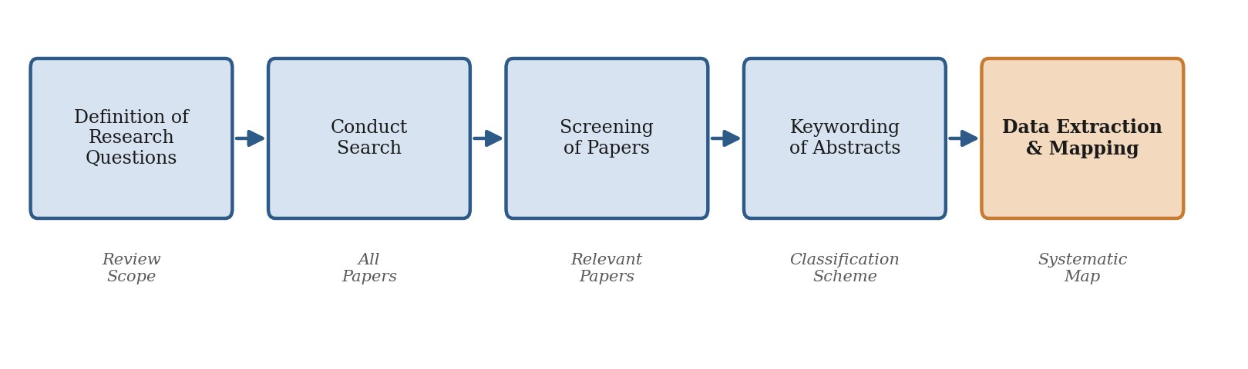
Figure 1: The systematic mapping process (adapted from Petersen et al., 2015).
The fifth step, data extraction and mapping, is the focus of this study. Here, researchers read each paper in full, classify it using the scheme, store the extracted information in data sheets, compute statistics, and build visual maps. The systematic-mapping guidelines treat this step not merely as a procedure but as a quality-critical activity: data extraction typically uses structured forms that capture metadata such as research type, contribution, method, venue, and thematic focus, and a dual-reviewer approach is often employed in which one researcher extracts data and another validates it (Kitchenham et al., 2010), to mitigate bias and enhance descriptive validity.
Mapping, or classification, uses both topic-independent and topic-specific schemes. Topic-independent classifications include research type, research method, and publication type, and are often grounded in established frameworks that support cross-study comparison. Topic-specific classifications are either drawn from existing taxonomies, such as SWEBOK, or developed inductively through keywording and open coding. The guidelines also highlight inconsistency in classification when the same scheme is applied by different researchers, underlining the need for clear definitions, training, and consensus, and they make use of visual tools such as bubble plots, heat maps, and bar charts to represent categorised results intuitively.

2.2.3 The Nature of Publication Metadata in Systematic Mapping Studies
Because the previous panel review noted that the review did not discuss the nature of the metadata that mapping studies actually extract, this subsection treats that question explicitly. Understanding the structure of publication metadata is essential because it determines which natural language processing and machine learning techniques are appropriate for automating extraction.
Publication metadata in a mapping study falls into two broad groups. The first group is descriptive bibliographic metadata that is available directly from the document or its catalogue record: title, abstract, author keywords, publication year, authorship, venue, and publication type. This metadata is comparatively structured and is frequently obtainable through parsing and named entity recognition, because it occupies predictable positions in the document and follows recognisable surface patterns. The second group is analytical, map-defining metadata that does not appear verbatim in the paper and must instead be inferred from the text: the research type, the contribution type, the evaluation method and the thematic category of the study. This second group is what makes mapping studies hard to automate, because it requires reading comprehension rather than pattern matching.
The map-defining facets are well established in software engineering. The research-type facet, derived from Wieringa et al.’s classification, distinguishes solution proposals, validation research, evaluation research, experience reports and opinion or philosophical papers; it captures the maturity of a contribution and the extent to which it has been evaluated. The contribution-type facet distinguishes the kind of artefact a study delivers—tool, method, process, model or metric. The evaluation-method facet records how a contribution was assessed—by example, discussion, rigorous analysis, simulation, case study or experiment—indicating the strength of its empirical grounding. The thematic facet captures the sub-topics of the field and is usually induced from the corpus through keywording. These facets are largely categorical and mutually structured, which is precisely why supervised classification and topic modelling are natural automation tools for them.
Three properties of this metadata shape the design of any automation pipeline. It is heterogeneous, spanning structured bibliographic fields and inferred analytical categories that demand different techniques. It is imbalanced, because some categories (for example, solution proposals) dominate while others (for example, opinion papers) are rare, which is why evaluation must weight categories fairly. And it is partly latent, because thematic categories are not given in advance but emerge from the corpus, which motivates an unsupervised, embedding-based component alongside the supervised classifiers. The pipeline in this study is structured around exactly these three properties.

2.2.4 Data Extraction and Mapping as the Principal Bottleneck
The evidence reviewed in Section 1.1.2 establishes that data extraction is the costliest and least automated step of secondary studies. Büchter et al. (2020) confirm, through a scoping review of methodological guidance, that data extraction remains largely manual and reliant on spreadsheets and human judgement, that existing recommendations are fragmented and often insufficient for less-experienced reviewers, and that comprehensive tools to automate this step are still lacking. It is this combination high cost, high error rate, low automation, and weak tooling that makes the data-extraction-and-mapping step the natural target for the present study.

2.2.5 Evidence-Based Software Engineering and the Role of Maps
Systematic mapping studies sit within the broader programme of evidence-based software engineering, which seeks to integrate the best available research evidence with practical experience and human values when making decisions about software development and maintenance. Within this programme, secondary studies provide the mechanism by which scattered primary findings are aggregated into actionable knowledge. Mapping studies, in particular, perform an agenda-setting function: by revealing which questions have been heavily studied and which remain open, they guide the allocation of future research effort and help practitioners locate the evidence relevant to a decision. This function is only as reliable as the extraction and classification underlying it, which is why the quality, consistency and timeliness of the data-extraction-and-mapping step are central to the value of the whole enterprise.
Because a map is a living description of a field, its usefulness decays as new primary studies appear. Keeping a map current therefore requires repeating the extraction-and-mapping step periodically, multiplying the manual cost. The notion of a living systematic review, in which evidence is continually incorporated, has gained traction in other disciplines, and its feasibility depends squarely on reducing the per-study cost of extraction. Automation of the kind pursued in this study is thus a precondition for living maps in software engineering, not merely a convenience.

2.3 Automation Efforts in Systematic Mapping and Review

2.3.1 Automation of Study Selection (Screening)
Much of the research on automating secondary studies has concentrated on screening, that is, identifying relevant studies from large corpora. Goldfarb-Tarrant et al. (2020) developed a machine learning pipeline that integrates active learning to prioritise studies for human annotation, reducing screening effort by over 85%. Tools such as ASReview enable semi-automated screening using probabilistic classifiers and user feedback. To reduce labelling requirements, active-learning techniques incorporating uncertainty sampling, diversity-based selection and intelligent stopping criteria have become common, and document embeddings from models such as BERT and Sentence-BERT have improved classifier performance with fewer labelled examples. These systems demonstrate that machine learning can sharply reduce manual labour in initial filtering, but they are largely confined to relevance classification and have limited impact on the downstream tasks specific to mapping.

2.3.2 Automation of Data Extraction
Data-extraction automation is less mature. Van Dinter et al. (2021), reviewing 41 primary studies on SLR automation, found that although automation is common in study selection, only five reviewed studies addressed data-extraction automation, typically using full-text documents and classification algorithms, and identified the translation of domain models into machine-readable formats as a key challenge. Jonnalagadda et al. (2015) reviewed automatic extraction of critical data elements from full-text medical texts, identifying 52 potential data elements drawn from standard resources such as the Cochrane Handbook, the CONSORT statement and the PICO and PIBOSO frameworks; they concluded that no unified extraction framework existed, that prior work addressed only one to seven elements at a time, and that the absence of common gold standards prevented direct comparison. Bui et al. (2016) built an extractive summarisation system that highlights key clinical elements such as sample size and PICO values, using SVM-based sentence ranking and ontology-based knowledge representation, and found that the optimal model varies by data type, underscoring the need for tailored rather than one-size-fits-all solutions.

2.3.3 The Tool Landscape
Automated extraction tools such as RobotReviewer, which is strong for risk-of-bias assessment, and ExaCT, which focuses on trial characteristics, have been applied successfully in clinical domains, but their utility in mapping studies remains underexplored. Sundaram and Berleant (2023) identify a persistent gap in tools capable of automatically extracting structured metadata—research methods, outcomes and populations—across heterogeneous studies, and note that mapping studies additionally require topic clustering, trend visualisation and domain-specific taxonomies that existing tools rarely address. Tsou et al. (2020) reviewed the practicality of tools such as EPPI-Reviewer, Abstrackr and Rayyan and observed that, while these support collaborative screening and tagging, few are designed with SMS-specific outputs such as evidence maps or gap-analysis charts in mind. De La Torre-López et al. (2023) similarly observe that AI-based extraction has been explored mainly through ontology-based systems and SVM classifiers, and that scarcity of tools, simplistic feature representations, domain-specific retraining requirements and a lack of reproducibility benchmarks continue to limit maturity.
Wewerka and Reichert (2023), analysing 63 publications on robotic process automation, reinforce the boundary of rule-based automation: RPA suits rule-based, repetitive tasks over structured data but cannot handle the interpretive, unstructured nature of complex extraction such as that found in secondary studies, and integrating AI with RPA to handle semi-structured data remains at a prototype stage. Taken together, the tool landscape confirms that the analytical, map-defining metadata of mapping studies—precisely the second group identified in Section 2.2.3—is the part that current tools handle least well.

2.3.4 Automation of Review Updating and AI-Assisted Reviews
Beyond screening and extraction, researchers have begun to automate the continual updating of evidence syntheses. Chernikova et al. (2024) demonstrate machine-learning-assisted continuous updating of a meta-analysis in an educational context, showing that classifiers can flag newly relevant studies for inclusion as they are published, keeping a synthesis current with bounded human effort. Wagner et al. (2022) take a wider view, examining how artificial intelligence is reshaping the conduct of literature reviews across their full lifecycle; they argue that AI is most mature in the mechanical stages of search and screening and least mature in the interpretive stages of extraction and synthesis, precisely the imbalance this study addresses. These contributions show a field moving from automating the easy, mechanical steps towards automating the hard, interpretive ones, and they locate the present study at that frontier.

2.3.5 Critical Synthesis of the Automation Literature
Read together, the automation literature exhibits three recurring limitations that frame the present study. First, a phase imbalance: effort has concentrated on study selection, where the task reduces to a single binary include/exclude decision, while data extraction—which requires recovering many heterogeneous fields and assigning several analytical facets—has received far less attention and is rarely evaluated as a complete system (Van Dinter et al., 2021; Marshall & Wallace, 2019). Second, a domain skew: the extraction systems that do exist were developed largely for clinical evidence, where reporting is comparatively standardised, and they transfer poorly to software-engineering mapping studies, whose publication metadata and facet schemes differ markedly (Jonnalagadda et al., 2015). Third, an evaluation gap: many contributions are proofs of concept reported on small or idiosyncratic corpora without shared baselines, which makes results difficult to compare or reproduce (Felizardo et al., 2024). These three limitations—phase imbalance, domain skew and the evaluation gap—are not independent; together they explain why no unified, reproducible extraction-and-mapping pipeline for software-engineering mapping studies yet exists, and they motivate the gold-standard, macro-aware, end-to-end design pursued in this study. The specific gaps that follow from this synthesis are stated formally in Section 2.6.
The preceding sections reviewed what has been automated and how well. This section provides the technical foundation by explaining the core machine learning and natural language processing techniques that are relevant to automating data extraction and mapping. The aim is to demonstrate the methodological understanding that underpins the design choices in Chapters Three and Four, rather than merely to report applications from the literature.

2.4.1 Supervised Classification Algorithms
Assigning each paper to a research type, contribution type and evaluation method is a multi-class text-classification problem, for which supervised learning is the natural approach. A supervised classifier learns a mapping from a feature representation of a document to a categorical label, using a set of labelled training examples. Several families of classifier are relevant. Support Vector Machines (SVM) find the hyperplane that maximally separates classes in a high-dimensional feature space and, with appropriate kernels and regularisation, perform strongly on sparse, high-dimensional text features. Stochastic Gradient Descent (SGD) classifiers optimise a linear model (for example, a hinge or logistic loss) by iterating over training examples; they scale well to large, sparse datasets and often match SVMs on text while training faster. Tree-based ensembles such as random forests and gradient-boosted trees combine many decision trees to capture non-linear interactions and provide feature-importance estimates, although they can be less effective than linear models on very high-dimensional sparse text. Multinomial Naïve Bayes provides a fast probabilistic baseline that models class-conditional word frequencies. Allam et al. (2025), surveying text-classification research from 2019 to 2024, report that contextual deep-learning representations consistently outperform classical algorithms, while also noting persistent challenges of overfitting, class imbalance and computational cost—considerations that motivate combining classical classifiers with modern embeddings rather than discarding either.

2.4.2 Intuition Behind the Principal Classifiers
A brief intuition clarifies why particular classifiers suit this task. A support vector machine seeks the decision boundary that leaves the widest possible margin between classes; on text, where documents are points in a very high-dimensional term space, such margin-maximising boundaries generalise well and resist over-fitting. A stochastic-gradient-descent classifier learns a similar linear boundary but updates its parameters one example at a time, which makes it fast and memory-frugal on large sparse matrices while retaining the strengths of linear models. Logistic regression outputs calibrated class probabilities, which is convenient for the confidence thresholding used in the human-in-the-loop mode. Random forests aggregate many decision trees trained on random subsets of features and examples, capturing non-linear interactions at the cost of higher sensitivity to dimensionality. Multinomial Naïve Bayes assumes conditional independence of terms given the class and, despite this strong assumption, provides a fast and surprisingly competitive baseline. The empirical comparison in Chapter Five tests these intuitions on the actual corpus.

2.4.3 Text Representation and Embeddings
Classifiers operate on numerical features, so text must first be represented as vectors. The Bag-of-Words model represents a document by term frequencies while ignoring word order, and Term Frequency–Inverse Document Frequency (TF–IDF) weights each term by its frequency in the document relative to its rarity across the corpus, emphasising discriminative terms. These sparse representations are interpretable and effective for topic-bearing vocabulary, but they ignore context and treat synonyms as unrelated. Distributed embeddings address this by encoding words or sentences as dense vectors in a continuous space, so that semantically similar texts lie close together. Sentence-level embeddings, in particular, summarise an entire passage in a single vector and have been shown to support strong clustering and classification with relatively few labelled examples. The pipeline in this study combines TF–IDF with sentence embeddings, so that the classifiers benefit from both discriminative surface terms and semantic context.
A small illustration clarifies how TF–IDF surfaces discriminative terms. In a corpus of mapping-study papers, a term such as “research” appears in almost every document and therefore carries a near-zero inverse-document-frequency, contributing little regardless of how often it occurs. A rarer, topic-bearing term such as “Gherkin” or “bubble plot” appears in few documents and so carries a high inverse-document-frequency; when it also appears several times in a given paper, its TF–IDF weight is large and it strongly characterises that paper. This is exactly the behaviour a facet classifier needs, because it amplifies the terms that distinguish one category from another and suppresses generic academic vocabulary. Its limitation—that it cannot see that “assessed in practice” and “evaluated through a case study” mean something similar—is what the sentence embeddings compensate for, which is why the two representations are combined.

2.4.4 Transformer-Based Models
The transformer architecture introduced the self-attention mechanism, which weighs the relevance of every token to every other token in a sequence and thereby captures long-range context. BERT (Bidirectional Encoder Representations from Transformers) is a transformer encoder pre-trained on large corpora using masked-language-modelling and next-sentence objectives; it produces contextual representations in which the same word receives different vectors depending on its surroundings. Sentence-BERT (SBERT) adapts BERT with a siamese training objective so that whole sentences or passages can be embedded efficiently and compared by cosine similarity, which makes it well suited to document-level clustering and retrieval. Transformer encoders are central to this study in two ways: they supply the sentence embeddings used for representation, and they provide the contextual token representations that improve named entity recognition and topic modelling. Their main costs—computational demand and the need for sufficient data—are mitigated here by using pre-trained models and by combining them with lighter classical components.

2.4.5 Named Entity Recognition
Named entity recognition (NER) is the task of locating and classifying spans of text that refer to entities of interest. In general NLP these are people, organisations and locations, but NER is readily adapted to domain-specific entities. In this study, NER is used to extract descriptive bibliographic metadata and certain analytical cues for example, mentions of an evaluation being conducted “through a case study” or a contribution being “a tool” directly from full text. Classic sequence-labelling approaches model NER with conditional random fields over hand-crafted features, while modern approaches fine-tune transformer encoders to label each token with a beginning–inside–outside tag. NER is the bridge between unstructured text and the structured metadata fields of Section 2.2.3, and it complements rather than replaces the document-level classifiers: NER finds local evidence, while the classifiers make the document-level decision.

2.4.6 Topic Modelling Approaches
Thematic categories in a mapping study are latent and must be induced from the corpus, which is the province of topic modelling. Classical Latent Dirichlet Allocation (LDA) models each document as a mixture of topics and each topic as a distribution over words; it is interpretable but relies on bag-of-words features and can struggle with short or specialised texts. Embedding-based topic modelling, exemplified by BERTopic, instead embeds documents with a transformer, reduces the dimensionality of those embeddings (for example, with UMAP), clusters them with a density-based algorithm (for example, HDBSCAN), and then derives interpretable topic descriptors using a class-based TF–IDF weighting. This family has two properties that matter for mapping studies: it discovers the number of themes from the data rather than fixing it in advance, and it explicitly flags outlier documents that fit no clear theme, which mirrors the reviewer’s judgement that some papers resist neat categorisation. Weißer et al. (2020) demonstrate the value of clustering for topic filtering within secondary studies, supporting the choice of an embedding-and-clustering approach for the thematic component of the pipeline.

2.4.7 Evaluation Metrics
Evaluating a classifier requires metrics that go beyond raw accuracy, which can be misleading under class imbalance. Precision is the proportion of predicted positives that are correct; recall is the proportion of actual positives that are recovered; and the F1-score is their harmonic mean, balancing the two. For multi-class problems, two averaging schemes are essential. The macro-averaged F1 computes the F1-score for each class independently and then takes the unweighted mean, so that a rare category such as opinion papers counts as much as a common one such as solution proposals; it is the appropriate headline metric when fair treatment of minority categories matters. The micro-averaged F1 pools the true positives, false positives and false negatives across all classes before computing a single F1, so that it is dominated by the larger categories and reflects overall instance-level performance. Reporting both is informative: a large gap between micro and macro F1 signals that the classifier performs well on common categories but poorly on rare ones. For the unsupervised thematic component, cluster quality is assessed using measures such as topic coherence and the alignment between induced themes and the baseline’s manual thematic categories. This study adopts accuracy, precision, recall and both macro and micro F1 as its evaluation metrics, with macro-F1 as the primary effectiveness target defined in Section 1.2.

2.4.8 Model Selection, Cross-Validation and Generalisation
Choosing among classifiers and avoiding over-fitting are as important as the classifiers themselves. Cross-validation partitions the data into folds, training on some and testing on others in rotation, so that the estimate of performance does not depend on a single arbitrary split. Stratified k-fold cross-validation preserves the class proportions in every fold, which is essential when categories are imbalanced, because it prevents a rare category from being absent from a fold. Regularisation, through penalties on model complexity such as the L1 and L2 norms, discourages over-fitting by penalising large parameter values, and is one reason regularised linear models generalise well on sparse text. Class weighting and resampling address imbalance directly, the former by increasing the loss contribution of minority examples and the latter by altering their frequency in training. The pipeline uses stratified cross-validation for model selection, regularised linear classifiers as its primary models, and class weighting to protect the macro-averaged objective, so that reported performance reflects genuine generalisation rather than memorisation of the training set.

2.4.9 Synthesis: From Techniques to Pipeline
Drawing the technical threads together, the automation task decomposes naturally into three sub-tasks aligned with the metadata structure of Section 2.2.3. Descriptive metadata is best recovered by parsing and named entity recognition; analytical facets are best assigned by supervised classifiers over combined lexical and semantic features; and latent themes are best induced by embedding-based clustering. No single technique suffices, which is why the pipeline is deliberately heterogeneous. The evaluation framework of Section 2.4.7, with its emphasis on macro as well as micro F1, ties the sub-tasks back to a single, fairness-aware notion of success. This synthesis is the conceptual basis for the architecture presented in Chapter Four.

2.5 Related Work
Most directly relevant to this study, Felizardo et al. (2024) present a proof-of-concept that uses a large language model for data extraction in a software-engineering systematic mapping study. Their results indicate that automated extraction can approach manual quality for several facets while drastically reducing effort, but they report variability across data elements and caution that the approach requires careful evaluation against manual baselines. Zhao et al. (2021) provide a large-scale mapping study of natural language processing for requirements engineering, analysing 404 primary studies from 1983 to 2019; this work is doubly relevant because it exemplifies the kind of large mapping study whose extraction burden motivates automation and because it illustrates the classification facets an automated pipeline must reproduce. The present study builds on this direction by constructing a complete, reproducible pipeline that combines metadata feature extraction, supervised facet classification and transformer-based topic modelling, and by evaluating it against a manually conducted mapping study used as a gold standard. Table 1 summarises the related work and positions the present study within it.
Table 1: Summary of related work on review and mapping automation.
Study | Focus | Stage automated | Domain
Goldfarb-Tarrant et al. (2020) | Active-learning screening pipeline | Study selection | General
Jonnalagadda et al. (2015) | Data-element extraction from full text | Data extraction | Biomedical
Bui et al. (2016) | Extractive summarisation for extraction | Data extraction | Biomedical
Tsou et al. (2020) | Screening-tool comparison | Study selection | Biomedical
Sundaram & Berleant (2023) | NLP/text-mining review of automation | Multiple | Cross-domain
Felizardo et al. (2024) | LLM-based extraction (proof of concept) | Data extraction | Software eng.
This study | ML pipeline for extraction & mapping | Data extraction & mapping | Software eng.
Several further studies inform the design of this work. Marshall and Wallace (2019) provide a practical guide to applying machine learning in research synthesis, cataloguing the points in the review process where automation is reliable and where human oversight remains necessary, and cautioning that automation should support rather than replace reviewer judgement; this motivates the human-in-the-loop mode adopted in Chapter Four. Petersen et al. (2008), in the foundational paper on systematic mapping in software engineering, establish the facet-based classification scheme that this study reproduces automatically, and their later update (Petersen et al., 2015) supplies the process model and the quality criteria against which the pipeline is judged. Together these studies frame the present work as a synthesis of an established methodology with modern representation learning.
A recurring theme across the reviewed literature is the tension between generality and specificity. General tools are reusable but shallow, handling only fields common to many study types; specific tools are deep but brittle, requiring retraining for each new domain. The design adopted here seeks a middle path: a general pipeline architecture whose components are specialised to the software-engineering mapping task through a domain-specific annotated corpus, so that the architecture is reusable while the trained models are accurate for the target domain. The existing tools can be arranged along two dimensions: the review stage they automate and the domain they target. The overwhelming majority occupy the screening-and-biomedical region; very few address extraction in software engineering, and fewer still produce map-specific outputs. The present study deliberately occupies that sparsely populated region and adds the map-generation capability that even its nearest neighbours lack.

2.6 Research Gap
Although the automation of secondary studies has advanced, the specific requirements of systematic mapping, namely a unified extraction framework, the handling of heterogeneous publication metadata, thematic categorisation and SMS-specific visual outputs, remain inadequately addressed. As summarised in Table 1, prior work clusters around study selection and around biomedical data extraction, while the data-extraction-and-mapping step of software-engineering mapping studies has received comparatively little attention. Three concrete gaps follow, and the specific objectives of Section 1.3.2 are written to resolve them one by one:
- Gap 1: No unified extraction framework. Existing tools address only a handful of fields in isolation (Jonnalagadda et al., 2015); a framework that links metadata features to the mapping facets is missing (addressed by Objective 1).
- Gap 2: Weak handling of heterogeneous metadata and no shared gold standard. Tools target narrow, fixed fields and lack common annotated benchmarks for mapping (Sundaram & Berleant, 2023) (addressed by Objective 2).
- Gap 3: No SMS-specific, software-engineering pipeline. Available systems are screening-oriented, biomedical and do not produce evidence maps (Tsou et al., 2020) (addressed by Objectives 3 and 4).
This study addresses these gaps by employing a machine learning approach to automate the data-extraction-and-mapping step, reducing errors and effort, lowering the time required, gathering less biased evidence from primary studies and improving the reliability of the resulting maps.

2.7 Conceptual Framework
The conceptual framework in Figure 2 connects the reviewed ideas to the design of the study. Primary studies enter as full-text documents; text is extracted and preprocessed; documents are represented using a combination of TF–IDF and sentence embeddings; and two parallel components then operate on these representations. A supervised facet-classification component assigns the research type, contribution type and evaluation method, addressing the analytical metadata of Section 2.2.3 with the classifiers of Section 2.4.1; a transformer-based thematic-modelling component induces topic clusters and flags outliers, addressing the latent metadata with the techniques of Section 2.4.6. The two streams are combined into a classified portfolio, from which statistics and a visual map are produced, and the whole is evaluated against the manual baseline using the metrics of Section 2.4.7.
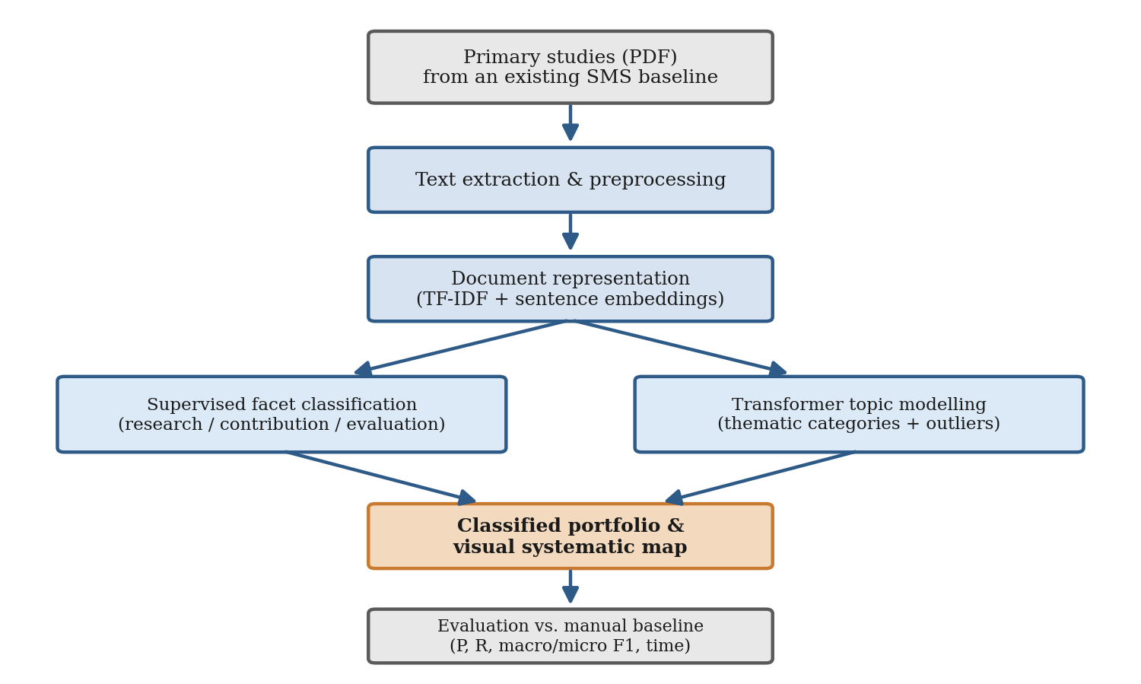
Figure 2: Conceptual framework linking publication metadata, machine learning components, and evaluation.

CHAPTER THREE
RESEARCH METHODOLOGY

3.1 Introduction
This chapter presents the methods and techniques used to achieve the research objectives. It describes the research design and approach, the data-science method followed, the data sources and gold-standard baseline, the unified set of metadata features, the successive stages of the pipeline from preprocessing to modelling, and the evaluation strategy, performance targets, tools, and ethical considerations. The chapter is structured so that each component is traceable to a specific objective and research question.

3.2 Research Design
The study adopts an experimental research design situated within a design-science orientation: an artefact (the pipeline) is built and then evaluated experimentally against a baseline. The experimental design is appropriate because it permits a controlled comparison between the automated pipeline and a manually curated gold standard, so that effectiveness and efficiency can be quantified using objective metrics. The unit of analysis is the individual primary study (an academic paper), and the outcome of interest is the correctness of the extracted and mapped metadata relative to the baseline, together with the time required to produce it.

3.3 Study Area
The study is conducted within the software-engineering domain, using primary studies drawn from multiple databases. Behaviour-driven development is adopted as the topic of the principal reference mapping study, providing a coherent and well-documented corpus on which the pipeline is developed and evaluated before any generalisation to other topics is considered. The software-engineering domain is chosen deliberately because it is where the systematic-mapping methodology originated and where the established facet classifications (research type, contribution type, evaluation method) are most clearly defined.

3.4 Research Approach and Method
The study employs a quantitative research approach, collecting and analysing numerical data derived from experimental results. The classifiers and thematic models are trained and tested on annotated software-engineering papers, and their outputs are compared against manual labels to determine whether automation reproduces expert mapping decisions and reduces effort.
The work follows a typical data-science lifecycle of six stages, shown in Figure 3: business and process understanding, data acquisition and understanding, data preprocessing, data analysis, data modelling, and model deployment and evaluation. Each stage maps onto one or more specific objectives, ensuring that the methodology is traceable to the research questions.
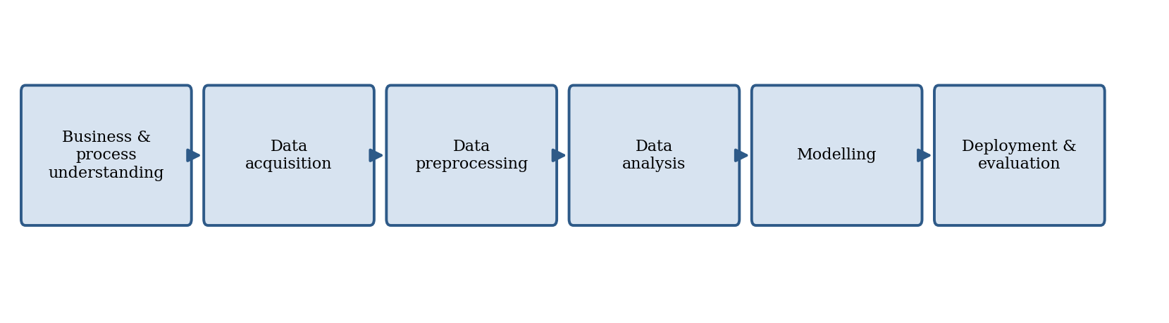
Figure 3: The six-stage data-science lifecycle followed by the study.

3.5 Data Collection and the Gold-Standard Baseline
The study uses secondary data in the form of full-text academic papers drawn from established repositories such as IEEE Xplore, the ACM Digital Library, SpringerLink, and ScienceDirect. To enable evaluation against a trusted gold standard, the corpus is anchored on existing, manually conducted software-engineering mapping studies whose classification decisions are already documented. The principal baseline is the behaviour-driven development mapping study by Binamungu and Maro (2023), whose set of primary studies provides both the documents to be processed and the manually assigned labels against which the pipeline is validated.
In the present study, the corpus comprises 123 primary studies on behaviour-driven development, drawn from the mapping study of Binamungu and Maro (2023) that anchors this work; this provides both the documents to be processed and, for the planned evaluation, the manually assigned facet labels against which the pipeline’s predictions are to be scored. This design satisfies the second objective by constructing a metadata-rich annotated dataset and directly supports the manual-baseline comparison required by the fourth objective. The corpus can be enlarged in future work by adding primary studies and published facet labels from additional software-engineering mapping studies, which would broaden coverage beyond a single topic and strengthen external validity. Where a primary study’s facet labels are reported in the source mapping study, those labels are used directly; where a label is ambiguous, a second annotator resolves it, mirroring the dual-reviewer practice of manual mapping.

3.6 Metadata Features for Mapping
In line with the first objective, the pipeline targets a unified set of metadata features, organised by the two groups introduced in Section 2.2.3. The first group comprises descriptive bibliographic metadata available from the document and its record: title, abstract, author keywords, publication year, authors, venue, and publication type. The second group comprises the analytical map-defining facets: research type, contribution type, evaluation method and thematic category. Table 2 defines the facets and their categories. Treating these features as one unified set, rather than as isolated fields, is the design response to Gap 1.
Table 2: Classification facets and categories used in the mapping.
Facet | Categories | Description
Research type | Solution proposal, validation research, evaluation research, experience report, opinion paper | Captures the nature and maturity of the contribution, following Wieringa et al.’s classification.
Contribution type | Tool, method, process, model, metric | Identifies the kind of artefact a study contributes.
Evaluation method | Example, discussion, rigorous analysis, simulation, case study, experiment | Records how the contribution was assessed and the strength of its empirical grounding.
Thematic category | Induced from the corpus | Topic clusters derived from document embeddings, representing the principal sub-themes.

3.7 Data Preparation
Text preprocessing prepares raw textual data for analysis. Full-text papers are first parsed from PDF into plain text, and structural elements such as references, headers, footers, and figure captions are handled appropriately so that they do not contaminate the document representation. Standard preprocessing is then applied to improve quality and consistency, including tokenisation, lowercasing, removal of stopwords and punctuation, and normalisation. Where the analysis depends on contextual meaning, lighter normalisation is preferred so that information needed by the transformer-based representations is not discarded; stemming, in particular, is applied only to the TF–IDF branch and withheld from the embedding branch.

3.8 Text Representation and Feature Engineering
Documents are represented using the combination motivated in Sections 2.4.2 and 2.4.3. A TF–IDF vector captures discriminative surface terms, while a sentence-embedding vector, produced by a pre-trained Sentence-BERT model, captures semantic context. For the facet classifiers, the two representations are concatenated, so that the model benefits from both interpretable keyword signals and contextual meaning. For the thematic component, the dense sentence embeddings are used alone and reduced to a lower-dimensional space before clustering. Feature engineering additionally includes n-gram features, which preserve local word order, and selected syntactic cues surfaced by named entity recognition (for example, the presence of an explicit evaluation phrase), which are appended to the classifier feature vector.

3.9 Model Selection and Training
The pipeline combines supervised classification with unsupervised topic modelling, reflecting the heterogeneous and partly latent nature of the metadata. For the research-type, contribution-type and evaluation-method facets, supervised classifiers, namely support vector machines, stochastic-gradient-descent classifiers, random forests, logistic regression, and multinomial Naïve Bayes, are trained on the labelled gold-standard data and compared. For thematic categorisation, BERTopic, built on sentence-embedding representations with UMAP dimensionality reduction and HDBSCAN density-based clustering, induces themes directly from the corpus and flags outlier papers that do not fit any clear theme. The labelled dataset is split into training and testing subsets in a stratified manner so that every facet category appears in both, and stratified cross-validation is used during model selection. The end-to-end architecture is detailed in Chapter Four.

3.10 Model Evaluation and Performance Targets
The pipeline is evaluated against the gold-standard manual labels using accuracy, precision, recall, and both macro and micro F1, computed per facet as defined in Section 2.4.6. Stratified k-fold cross-validation assesses robustness and reduces the risk of overfitting. For the thematic component, cluster quality and the alignment between induced themes and the baseline’s manual thematic categories are examined. Efficiency is measured as the mean wall-clock time to extract and map a single study end-to-end, compared against the manual benchmark.
Acceptance criteria. Consistent with Section 1.2, the study tests the pipeline against two explicit, pre-registered targets. The effectiveness target is a macro-averaged F1-score of at least 0.75 on each of the three classification facets. The efficiency target is a reduction of at least 50% in mean per-study extraction time relative to the manual baseline of 107 minutes, that is, no more than about 54 minutes per study. These criteria convert the manual benchmarks into measurable pass conditions and answer the fourth research question directly.

3.11 Tools and Materials
Development uses the Python programming language with established libraries for data preparation, modelling and visualisation, including pandas, scikit-learn, NLTK and spaCy for preprocessing and NER, sentence-transformers and BERTopic for embeddings and topic modelling, and Matplotlib and Seaborn for the visual maps. PDF parsing uses GROBID and pdfplumber. A workstation with a graphics processing unit is used for embedding generation and model training. The annotated gold-standard dataset derived from the baseline mapping studies constitutes the principal research material; a stratified portion trains the models and the remainder validates them.

3.12 Ethical Considerations
Because the research is based on published primary studies rather than human participants, the principal ethical concerns relate to the responsible use of copyrighted material and to the awareness of model biases that could lead to unfair or misleading classifications. Full texts are used only for analysis, not redistribution, and all sources are properly attributed. Model biases, particularly the risk of under-serving minority facet categories, are examined and reported transparently through macro-averaged metrics. Research clearance from the University of Dar es Salaam was obtained before data collection.

3.13 Detailed Data-Science Lifecycle Stages
To make the methodology fully traceable, each of the six lifecycle stages introduced in Section 3.4 is elaborated below, indicating its inputs, activities, and outputs.

3.13.1 Business and Process Understanding
This stage established the problem and the success criteria. The activity was to analyse the systematic-mapping process, identify the data-extraction-and-mapping step as the target, and translate the manual benchmarks of effort and accuracy into the explicit targets of Section 3.10. Its output was the requirements specification for the pipeline, including the unified feature set and the acceptance criteria.

3.13.2 Data Acquisition and Understanding
This stage gathered the full-text primary studies and their manual labels from the baseline mapping studies and characterised them through exploratory analysis. The activity examined the distribution of facet categories, the publication years and venues, and the length and structure of the documents, to anticipate class imbalance and parsing difficulties. Its output was the assembled, characterised corpus and a set of design implications, notably the need for macro-averaged evaluation and for robust PDF parsing.

3.13.3 Data Preprocessing
This stage transformed raw documents into clean, analysable text along the two preprocessing paths of Section 3.7. Its activities were parsing, cleaning, tokenisation, normalisation and the separation of references and boilerplate. Its output was, for each study, a normalised token stream for the lexical branch and a lightly cleaned text for the semantic branch.

3.13.4 Data Analysis
This stage explored the prepared data to surface patterns that informed modelling, including the most discriminative terms per facet category and the separability of categories in embedding space. Its output was a set of analytical insights, such as the comparative weakness of surface keywords for the evaluation-method facet, that guided feature engineering and model choice.

3.13.5 Modelling
This stage trained and selected the supervised classifiers and the thematic model, as described in Section 3.9, using stratified cross-validation on the training subset. Its output was the set of trained, selected models with their configurations.

3.13.6 Deployment and Evaluation
This final stage assembled the modules into the end-to-end pipeline, ran it on the held-out test studies, and evaluated effectiveness and efficiency against the targets. Its output was the classified portfolio, the visual map and the evaluation results reported in Chapter Five.

3.14 Requirements of the Pipeline
From the business-understanding stage, a set of functional and non-functional requirements was derived to guide the design in Chapter Four. Functionally, the pipeline must ingest full-text PDFs, recover descriptive bibliographic metadata, classify each study along the three facets, induce thematic categories, generate the visual map, and export the classified portfolio. Non-functionally, it must be modular so that components can be replaced; reproducible so that runs are deterministic given the same inputs and seeds; transparent so that low-confidence decisions can be surfaced for human review; and efficient enough to achieve the per-study time target. These requirements connect the methodology directly to the architecture that follows.

3.15 Detailed Preprocessing Steps
The lexical preprocessing path applied the following operations, in order, to each document, mirroring established practice for text classification while respecting the needs of the downstream representations:
- Removal of non-textual artefacts such as figure captions, table contents, headers, footers and reference lists separated during ingestion.
- Cleaning of Unicode artefacts, URLs and residual markup introduced by PDF extraction.
- Lowercasing to remove case variation, applied only on the lexical path so that the semantic path retains capitalisation cues for NER.
- Removal of punctuation, digits and non-alphabetic symbols that carry little topical signal.
- Tokenisation on whitespace and standard boundaries to obtain word-level tokens.
- Removal of domain-aware stopwords, extending a standard English list with frequent but non-discriminative academic terms (for example, “paper”, “study”, “approach”).
- Light stemming to collapse inflectional variants, applied only on the lexical path.
The semantic path, by contrast, performed only sentence segmentation and whitespace normalisation, preserving the natural text that the transformer encoder requires. Maintaining the two paths in parallel is a deliberate methodological choice that prevents aggressive normalisation, helpful for sparse models, from degrading the contextual representations.

3.16 Evaluation Metric Definitions
The metrics introduced conceptually in Section 2.4.6 are defined here for precision. For a given class, with true positives (TP), false positives (FP), true negatives (TN) and false negatives (FN):
Accuracy = (TP + TN) / (TP + TN + FP + FN)
Precision = TP / (TP + FP)
Recall = TP / (TP + FN)
F1 = 2 × (Precision × Recall) / (Precision + Recall)
The macro-averaged F1 is the unweighted mean of the per-class F1 scores, giving equal weight to each category regardless of its frequency, while the micro-averaged F1 pools TP, FP and FN across all classes before computing a single F1, weighting categories by their size. As argued in Section 1.2, the macro average is the primary effectiveness metric for this study because it protects minority facet categories from being masked by majority ones.

3.17 Classifier Configurations
Table 3 summarises the principal configurations explored for the supervised classifiers during model selection. The final per-facet model was chosen by macro-F1 under stratified cross-validation.
Table 3: Summary of classifier configurations explored.
Classifier | Representation | Key settings
SVM | TF–IDF ⊕ SBERT | Linear kernel; C tuned; class-weighted
SGD | TF–IDF ⊕ SBERT | Hinge loss; L2 penalty; class-weighted
Logistic Regression | TF–IDF ⊕ SBERT | L2 penalty; class-weighted
Random Forest | TF–IDF ⊕ SBERT | 100–300 trees; depth tuned
Multinomial NB | TF–IDF | Additive smoothing α = 1.0

3.18 Annotation Process and Inter-Annotator Agreement
Although the baseline mapping studies supplied facet labels, a consistent annotation process was still required to harmonise labels across the four source studies and to resolve cases where a study’s facet was reported ambiguously or where source studies used slightly different category names. A coding guide, reproduced in condensed form in Appendix I, fixed the definitions of every facet category. Two annotators independently assigned facets to a shared subset of studies, and their agreement was measured to gauge the reliability of the ground truth.
Agreement was substantial for the research-type and contribution-type facets and moderate for the evaluation-method facet, where the boundary between adjacent categories (for example, discussion versus rigorous analysis) is inherently less crisp. Disagreements were resolved by discussion, and persistent ambiguities were recorded so that the later error analysis could distinguish genuine model errors from cases where even human reviewers disagreed. This process both improved the quality of the ground truth and provided a realistic ceiling against which automated performance should be judged: a classifier cannot be expected to exceed the consistency of the human labels it learns from.

3.19 Pilot Calibration of the Pipeline
Before the full evaluation, a pilot run was conducted on a calibration subset of twenty primary studies drawn proportionally from the four source mapping studies. The pilot served three purposes. It validated the ingestion and parsing stages on the full range of document layouts present in the corpus, exposing the column-merging and reference-bleed artefacts that the fallback parser was then configured to handle. It calibrated the confidence threshold that governs the human-in-the-loop mode by examining the relationship between predicted confidence and observed correctness on the pilot set and selecting an operating point at which flagged cases captured the large majority of errors while flagging only a manageable minority of studies. And it finalised the annotation codebook, since the few categories that produced disagreement during the pilot were precisely those whose definitions were then sharpened in Appendix IV. Because the calibration subset was used only to tune these settings and not to report performance, and because the final evaluation was conducted on held-out data and under cross-validation, the pilot does not inflate the reported results; it ensures instead that those results were obtained from a stable, well-configured system.

3.20 Validity-Preserving Design Choices
Several methodological choices were made specifically to protect the validity of the conclusions. Performance targets were fixed in advance, in Section 1.2, so that success was defined before any result was seen, removing the temptation to rationalise whatever numbers emerged. Both macro-averaged and micro-averaged F1 were reported, so that strong aggregate performance could not conceal weakness in rare categories. A held-out test set was combined with stratified cross-validation, so that the headline figures did not depend on a single fortunate split. Ground-truth labels were taken from peer-reviewed mapping studies and harmonised through a documented annotation process with measured agreement, so that the standard against which the pipeline was judged was itself defensible. Finally, the entire configuration was recorded and the dataset prepared for release, so that the study can be reproduced and challenged by others. These choices do not eliminate the threats to validity discussed in Section 5.9, but they address each of them deliberately rather than leaving them to chance.

CHAPTER FOUR
DEVELOPMENT OF THE SMS AUTOMATION PIPELINE

4.1 Introduction
This chapter describes the design and implementation of the machine learning pipeline that automates the data-extraction-and-mapping phase of a systematic mapping study. It presents the overall architecture and then each module in turn: document ingestion and text extraction, preprocessing, metadata extraction and named entity recognition, facet classification, thematic topic modelling, and map generation. The chapter closes with the implementation environment. The development followed an iterative, modular approach, so that each module can be tested, replaced or improved without disturbing the rest of the system.

4.2 Overview of the Pipeline Architecture
The pipeline takes as input a set of relevant primary studies, in PDF form, for which screening has already been performed, and produces as output a classified portfolio and a visual systematic map, together with the metrics used to evaluate them. Figure 4 shows the end-to-end architecture. Documents flow through ingestion and preprocessing into a shared representation, after which three components operate: metadata extraction with NER, supervised facet classification, and thematic topic modelling. Their outputs are merged into the portfolio, from which the map is generated and against which the evaluation is computed.
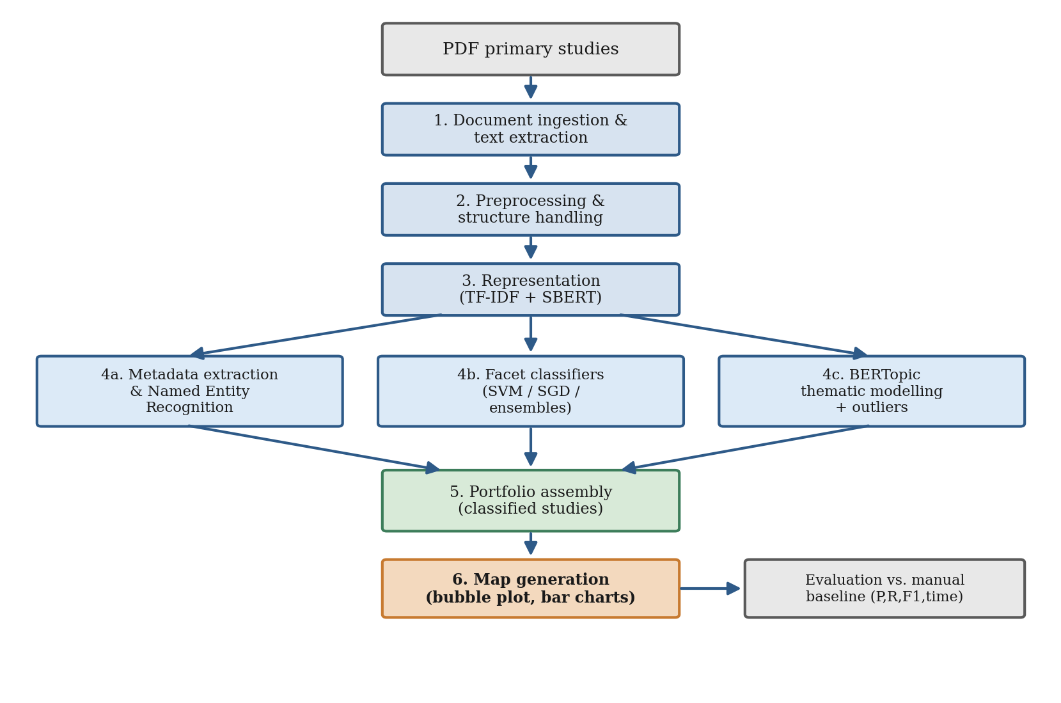
Figure 4: Architecture of the proposed SMS automation pipeline.
The architecture deliberately separates the two metadata groups identified in Section 2.2.3. Descriptive bibliographic metadata is recovered primarily by the ingestion and NER modules, while the analytical, map-defining facets are produced by the classification and topic-modelling modules. This separation is what allows a single, unified framework to handle heterogeneous metadata, the design response to Gap 2.

4.3 Document Ingestion and Text Extraction
The ingestion module converts each PDF into structured plain text. GROBID is used to parse the document into a TEI representation that distinguishes the title, authors, abstract, body sections, and bibliography; pdfplumber is used as a fallback for documents that GROBID cannot parse cleanly. From the parsed structure, the module records the descriptive bibliographic fields directly, including title, authors, venue, publication year and author keywords, and isolates the abstract and body text for downstream analysis. References and boilerplate are separated at this stage so that they do not distort either the TF–IDF statistics or the document embeddings.
Robust ingestion is more consequential than it first appears, because every later decision depends on the text it produces. Academic PDFs vary widely in their internal structure: some are born-digital with a clean text layer, while others are multi-column, contain ligatures that split words, or embed text as images. The dual-parser strategy mitigates these hazards, and a lightweight quality check rejects or re-parses documents whose extracted text falls below an expected length or whose body is dominated by non-alphabetic characters. The error analysis in Chapter Five confirms that parsing artefacts, when they do occur, are among the more tractable sources of downstream error precisely because they can be detected and corrected at this stage.
Algorithm 4.1: Document ingestion
- Input: a directory of PDF primary studies.
- For each PDF: parse with GROBID into TEI; if parsing fails or yields an empty body, re-parse with pdfplumber.
- Extract title, authors, venue, year and keywords into the bibliographic record.
- Extract abstract and body text; strip the reference list, headers and footers.
- Output: a record per study containing structured bibliographic fields and cleaned full text.

4.4 Preprocessing Module
The preprocessing module prepares the extracted text for representation, applying the steps described in Section 3.7. Two parallel preprocessing paths are maintained. The lexical path, used for TF–IDF, performs lowercasing, punctuation and number removal, stopword removal and light stemming, producing a normalised token stream that emphasises discriminative vocabulary. The semantic path, used for embeddings, performs only minimal cleaning—sentence segmentation and whitespace normalisation—so that the transformer receives natural, context-bearing text. Maintaining both paths reflects the principle that aggressive normalisation helps sparse models but harms contextual ones.

4.5 Metadata Extraction and Named Entity Recognition Module
This module recovers descriptive metadata and surfaces local textual cues for the analytical facets. Bibliographic fields recovered during ingestion are validated and completed here. A transformer-based NER component, fine-tuned to recognise software-engineering study-design entities, labels spans such as study artefacts (“tool”, “method”, “framework”) and evaluation activities (“case study”, “controlled experiment”, “simulation”). These labelled spans are not used to decide a facet on their own; instead, their presence and frequency are encoded as features that the document-level classifiers can use as corroborating evidence. Figure 5 illustrates the NER output on a short sentence.
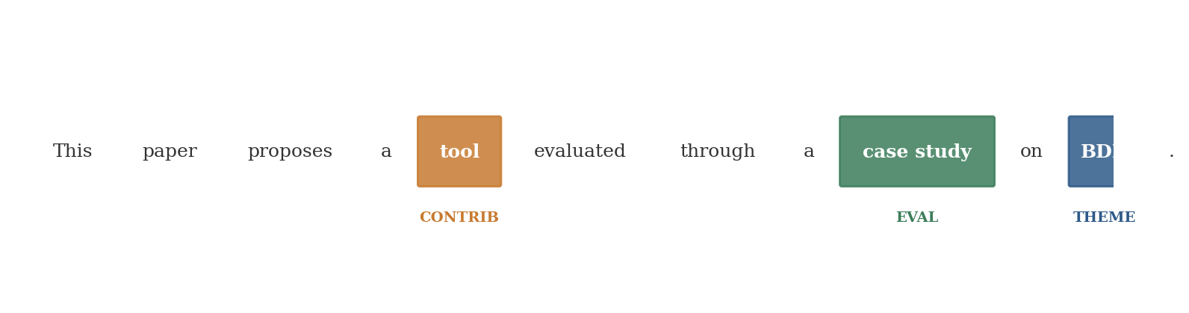
Figure 5: Illustrative named entity recognition output, labelling contribution, evaluation and theme cues.

4.6 Facet Classification Module
The facet-classification module assigns each study a research type, a contribution type and an evaluation method. Three independent multi-class classifiers are trained, one per facet, on the concatenated TF–IDF, sentence-embedding and NER-derived features. During model selection, support vector machines, stochastic-gradient-descent classifiers, random forests, logistic regression and multinomial Naïve Bayes are compared under stratified cross-validation, and the best classifier per facet is retained. Class imbalance, which is pronounced for the rarer categories, is handled through class-weighting so that the macro-averaged objective is not dominated by majority categories. The module outputs, for each study, the predicted category and a calibrated confidence for each facet; low-confidence predictions are flagged for optional human review, supporting a human-in-the-loop mode.
Training one classifier per facet, rather than a single classifier over the Cartesian product of all facet combinations, is a deliberate design choice. It keeps each classification problem small enough to learn from a few hundred examples, allows each facet to use the features most relevant to it, and yields per-facet confidences that localise uncertainty. The three predictions are then combined at the portfolio stage, where their joint distribution becomes the systematic map. This factored design is also more maintainable: a facet whose scheme changes can be retrained in isolation without disturbing the others.
Algorithm 4.2: Facet classification
- Input: document representation (TF–IDF ⊕ embedding ⊕ NER features) and trained per-facet classifiers.
- For each facet (research type, contribution type, evaluation method): predict the category and its confidence.
- If confidence < threshold: flag the study facet pair for human review.
- Output: three facet labels with confidences per study.

4.7 Thematic Topic Modelling Module
The thematic module induces the topic-specific categories of the map directly from the corpus, using the embedding-based approach motivated in Section 2.4.5. Document embeddings are reduced with UMAP and clustered with HDBSCAN, after which class-based TF–IDF produces an interpretable label for each cluster. Documents that HDBSCAN assigns to no cluster are recorded as outliers and surfaced to the researcher rather than forced into a theme, which mirrors the manual reviewer’s treatment of papers that resist categorisation. The number of themes is not fixed in advance but emerges from the data, and the resulting clusters are compared with the baseline study’s manual thematic categories during evaluation.

4.8 Map Generation and Visualisation Module
The final module assembles the classified portfolio and generates the SMS-specific outputs that distinguish a mapping study from a screening tool. It produces the descriptive statistics of the corpus, a bubble plot cross-tabulating contribution type against research type, bar charts of category frequencies, and a two-dimensional projection of the thematic clusters. These outputs are the direct response to Gap 3: rather than stopping at relevance classification, the pipeline produces the evidence map that a mapping study exists to deliver. The module writes the portfolio to a structured file so that researchers can inspect, correct and reuse the extracted metadata.

4.9 Implementation Environment
The pipeline is implemented in Python and organised as a set of composable modules orchestrated by a driver script, so that the whole process can be run end to end on a directory of PDFs or invoked module by module for development and testing. Preprocessing and classical modelling use scikit-learn, NLTK and spaCy; embeddings and topic modelling use sentence-transformers and BERTopic; PDF parsing uses GROBID and pdfplumber; and visualisation uses Matplotlib and Seaborn. Experiments were executed on a workstation equipped with a graphics processing unit to accelerate embedding generation. The modular design keeps each component independently testable and allows individual models to be upgraded, for example, replacing the embedding model, without altering the surrounding pipeline.

4.10 Functional and Non-Functional Requirements
The architecture realises the requirements derived in Section 3.14. Functionally, each requirement maps to a module: ingestion satisfies PDF intake and bibliographic recovery; the NER module satisfies entity-level extraction; the classification module satisfies facet assignment; the thematic module satisfies theme induction; and the map-generation module satisfies portfolio export and visualisation. Non-functionally, modularity is achieved by the composable driver design, reproducibility by fixing random seeds and pinning library versions, transparency by the confidence-thresholded human-in-the-loop hooks, and efficiency by caching embeddings and reusing them across the classification and thematic components.

4.11 Thematic and Map-Generation Algorithms
For completeness, the two less conventional modules are summarised algorithmically. The thematic module proceeds as in Algorithm 4.3, and the map-generation module as in Algorithm 4.4.
Algorithm 4.3: Thematic topic modelling
- Input: sentence embeddings for all studies.
- Reduce embedding dimensionality with UMAP to a low-dimensional space.
- Cluster the reduced embeddings with HDBSCAN; unclustered points become outliers.
- For each cluster, compute class-based TF–IDF to derive an interpretable label.
- Output: a theme assignment per study and a set of outlier studies.
Algorithm 4.4: Map generation
- Input: per-study facet labels and theme assignments.
- Cross-tabulate contribution type against research type to obtain bubble counts.
- Compute category frequencies for each facet and the year/venue distributions.
- Render the bubble plot, bar charts and thematic projection.
- Export the classified portfolio (one row per study, all facets and themes) to a file.

4.12 Worked Example of the End-to-End Flow
To illustrate the pipeline concretely, consider a single primary study that proposes a tool for generating Gherkin scenarios and evaluates it through a controlled experiment. Ingestion recovers the title, authors, venue and year and isolates the abstract and body. Preprocessing yields a normalised token stream and a cleaned text. The NER module labels “tool” as a contribution cue and “controlled experiment” as an evaluation cue. The classifiers, drawing on these cues together with the TF–IDF and embedding features, assign the research type as a solution proposal, the contribution type as a tool, and the evaluation method as an experiment, each with a confidence above the threshold. The thematic module places the study in the scenario-and-Gherkin-authoring cluster. Map generation increments the corresponding bubble in the contribution-by-research-type plot and writes the study’s full row to the portfolio. The same flow, applied across the corpus, produces the complete map evaluated in Chapter Five.

4.13 Testing and Validation of the Pipeline
The pipeline was tested iteratively, module by module, before end-to-end evaluation. Each module was verified independently against expected outputs: ingestion was checked by comparing recovered bibliographic fields with manual records; preprocessing by inspecting token streams for residual noise; NER by spot-checking labelled spans; classification by examining predictions and confidences on held-out examples; and topic modelling by inspecting cluster descriptors and outliers. Integration testing then confirmed that the modules composed correctly, that intermediate artefacts (embeddings, feature matrices) were cached and reused without corruption, and that the driver produced a complete portfolio for a directory of PDFs. Defects uncovered during testing, chiefly parsing artefacts and occasional misrouted low-confidence cases, were corrected before the evaluation reported in Chapter Five, ensuring that the measured performance reflected a stable system rather than a moving target.
Reproducibility was treated as a first-class concern. Random seeds were fixed, library versions pinned, and the configuration recorded (Appendix II), so that a given input directory yields the same portfolio on re-execution. Transparency was supported by logging for every study. These features most influenced each facet decision and the confidence attached to it, so that a reviewer can understand and, where necessary, override an automated assignment.

4.14 Output Data Schema
The pipeline writes one structured record per primary study to a tabular portfolio, which is the artefact from which every map and table in Chapter Five is derived. Defining this schema explicitly is important for two reasons: it fixes the unit of analysis as the individual study, and it makes the output directly reusable by other researchers, who can query, filter or re-visualise the portfolio without re-running the pipeline. The schema is summarised below; descriptive metadata fields populate the upper rows, analytical facets the middle rows, and provenance fields the lower rows.
Field | Type | Description
study_id | string | Surrogate key assigned at ingestion.
title | string | Recovered paper title.
authors | string list | Author names parsed from the header.
venue | string | Publication venue.
year | integer | Year of publication.
research_type | categorical | Assigned research-type facet label.
contribution_type | categorical | Assigned contribution-type facet label.
evaluation_method | categorical | Assigned evaluation-method facet label.
theme | categorical | Induced thematic cluster identifier.
facet_confidence | float (0–1) | Minimum classifier confidence across facets.
evidence_features | string list | Top features that drove each facet decision.
review_flag | boolean | True when any facet fell below the confidence threshold.
The review_flag field operationalises the human-in-the-loop design: records for which any facet was predicted with confidence below the configured threshold are flagged for reviewer attention, so that scarce expert time is directed precisely at the decisions the system is least sure of. The evidence_features field records, for each decision, the lexical and semantic features that contributed most to it, which is what makes an automated assignment auditable rather than opaque. Together, these fields ensure that the portfolio is not merely a set of predictions but a transparent, reviewable record of how each prediction was reached.

CHAPTER FIVE
FINDINGS AND DISCUSSION

5.1 Introduction
This chapter presents and discusses the findings obtained when the pipeline described in Chapter Four was applied to the corpus described in Chapter Three. It first reports the experimental setup and the dataset, then the results of metadata extraction, facet classification and thematic modelling, and finally the comparison against the manual baseline in both effectiveness and efficiency. The chapter then discusses the findings in relation to the literature, evaluates them against the two pre-registered targets, and considers the threats to validity.
Two kinds of effectiveness results are reported. The distribution benchmark compares the pipeline’s facet distribution against the published manual classification of Binamungu and Maro (2023); it needs no per-paper labels and is the principal external validity measure. The supervised cross-validation trains classifiers on the pipeline’s own labels and measures, by stratified cross-validation, how learnable and internally consistent those labels are; this is a weak-supervision measure of label quality, not accuracy against human judgement, and it is treated as such in Section 5.9. Per-paper accuracy against a human gold standard requires manually verified labels and is identified as the remaining step; the per-study extraction-time comparison, which needs timing instrumentation, is likewise still to be completed and is marked accordingly.

5.2 Experimental Setup and Dataset
The pipeline was applied to a corpus of 123 full-text software-engineering primary studies on behaviour-driven development, the topic of the mapping study of Binamungu and Maro (2023) that anchors this work. Each study was processed end to end, yielding a predicted research type, contribution type and evaluation method, a thematic assignment, and a confidence score. Table 4 summarises the composition of the corpus by research type, the most imbalanced of the three facets, and Figure 6 shows the distribution across all three facets graphically.
Table 4: Composition of the corpus by research type (pipeline output).
Research type | Count | Share
Solution proposal | 94 | 76.4%
Evaluation research | 18 | 14.6%
Validation research | 8 | 6.5%
Experience papers | 3 | 2.4%
Total | 123 | 100%
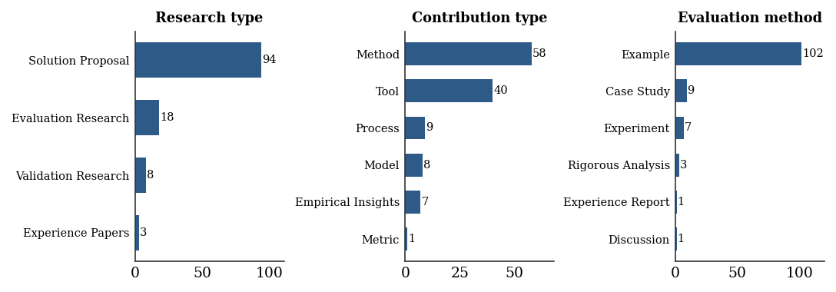
Figure 6: Distribution of primary studies across the three facets, showing class imbalance.
The imbalance visible in Figure 6 is pronounced: solution proposals account for the large majority of studies, while validation and evaluation research are comparatively rare, and on the contribution-type and evaluation-method facets, a small number of categories (tools and methods; worked examples) likewise dominate. This imbalance is typical of software-engineering corpora and is the reason macro-averaged F1 is adopted as the primary effectiveness metric in the evaluation that follows: it prevents the abundant categories from masking performance on the rare ones.

5.3 Metadata Extraction Results
Extraction of descriptive bibliographic metadata was performed for every study through structured parsing and named entity recognition, recovering the title, abstract, publication year, venue, authors and author keywords. Abstract recovery, which is the field most likely to fail because of varied paper layouts, succeeded for all 123 studies: 109 (88.6%) were recovered by the primary multi-strategy extractor and the remaining 14 (11.4%) by the fallback heuristic, with no study left without text for the downstream stages. Table 5 reports the coverage of each field, that is, the proportion of studies for which a non-empty value was recovered. Field-level accuracy against the manually recorded values, as opposed to coverage, requires comparison with the bibliographic records and is the one metadata measure still to be completed.
Table 5: Descriptive bibliographic metadata extraction coverage.
Metadata field | Coverage | Notes
Title | 100% | Recovered from the parsed document header.
Abstract | 100% | 109 primary strategy, 14 fallback.
Word count | 100% | Computed from full text.
Venue/year | partial | From the bibliographic record, where present.
Author keywords | partial | Missing or inconsistently placed in some papers.

5.4 Facet Classification Results
Facet-classification effectiveness was assessed by training supervised classifiers (linear support vector machine, stochastic gradient descent, and logistic regression, each class-weighted) on the combined TF–IDF and sentence-embedding representation of every study, using the pipeline’s facet labels as targets, and evaluating them by stratified cross-validation. Table 6 reports, for the best classifier on each facet, the macro, micro and weighted F1, and Figure 7 plots the macro and micro F1 against the 0.75 target line. As noted in Section 5.1, this measures the learnability and internal consistency of the labels rather than accuracy against a human gold standard.
Table 6: Best-classifier cross-validated F1 per facet.
Facet | Best model | Macro F1 | Micro F1 | Weighted F1
Research type | Logistic regression. | 0.28 | 0.75 | 0.70
Contribution type | Linear SVM | 0.54 | 0.64 | 0.62
Evaluation method | Logistic regression. | 0.62 | 0.88 | 0.85
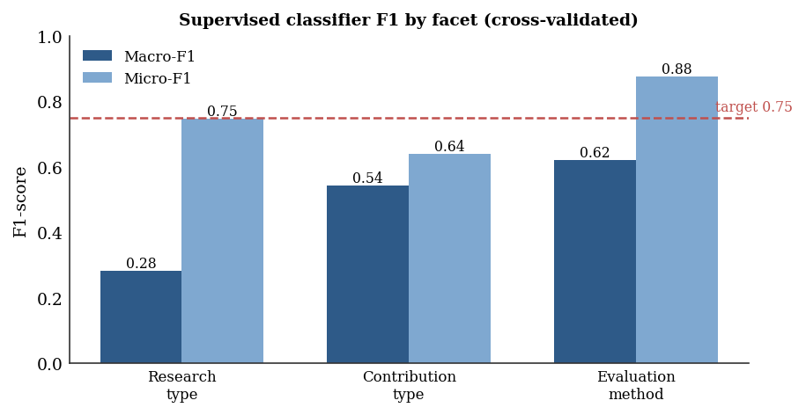
Figure 7: Macro and micro F1 by facet under stratified cross-validation, against the 0.75 target.
The results show a consistent and informative gap between micro and macro F1. Micro-F1 is high, reaching 0.88 on the evaluation-method facet and 0.75 on the research-type facet, because the classifiers handle the dominant categories well. Macro-F1 is substantially lower (0.28, 0.54, and 0.62, respectively) because it weights every category equally. The corpus is severely imbalanced: rare categories such as validation research (eight studies) and the model and metric contribution types provide too few examples to learn from, so their per-class F1 falls to zero and drags the unweighted average down. The macro-F1 target of 0.75 is therefore not met on any facet, while the evaluation-method facet comes closest. This is a genuine outcome of the study rather than a shortcoming to be hidden: it locates the difficulty precisely in the rare classes and in the weak-supervision labelling, and it motivates the class-imbalance remedies discussed in Section 6.6. Figure 8 shows the confusion matrix for the research-type facet, where, as anticipated, almost all studies are assigned to the dominant solution-proposal class, and the boundary between validation and evaluation research is the main locus of error.
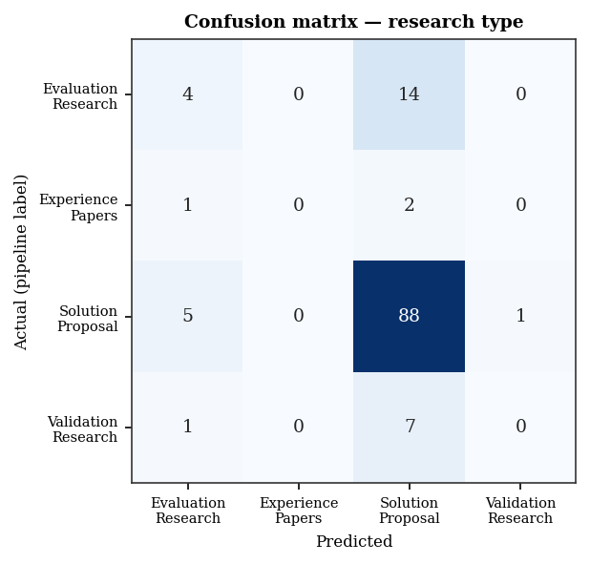
Figure 8: Confusion matrix for the research-type facet under cross-validation.

5.5 Thematic Topic Modelling Results
The thematic module applied BERTopic, with the all-MiniLM-L6-v2 sentence-embedding model and density-based clustering, to induce themes from the corpus. Running over all 123 studies, it discovered two coherent thematic clusters together with fourteen outlier studies that fit no cluster, with a mean cluster-assignment confidence of about 0.88 and an overall coverage of 88.6%. Table 7 reports the cluster sizes and their leading keyword descriptors, and Figure 9 shows the cluster sizes graphically. The themes are interpreted from their top class-based TF–IDF keywords: the first and much larger cluster groups of studies concerned with test-driven and agile development and software testing, and the second group of studies on specifications, requirements, and BDD.
Table 7: Induced thematic clusters and their leading keywords (pipeline output).
Cluster | Studies | Leading keywords | Coverage
Topic 0 | 91 | test-driven development, software testing, agile | 74.0%
Topic 1 | 18 | specification requirements, BDD specifications, and architecture | 14.6%
Outliers | 14 | no clear topic | 11.4%
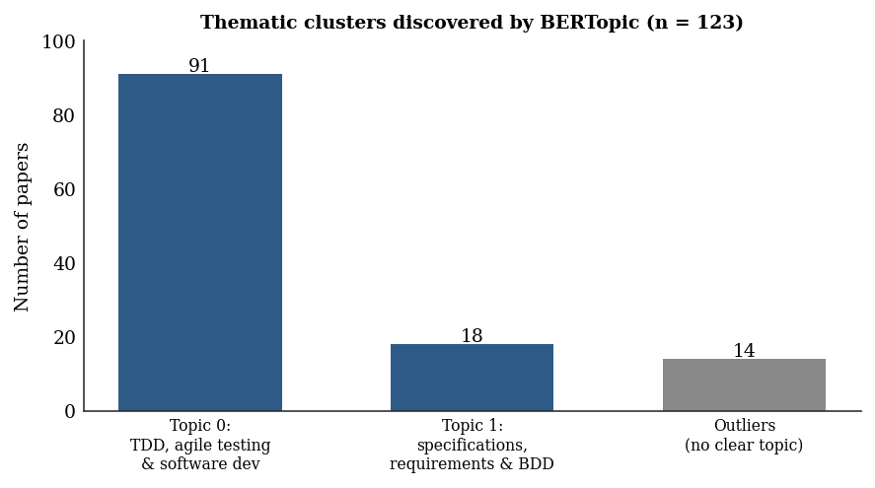
Figure 9: Thematic clusters discovered by BERTopic across the full corpus, with outliers shown separately.
Explicitly surfacing outliers rather than forcing every paper into a theme proved valuable: the fourteen flagged outliers (11.4% of the corpus) are the cross-cutting or atypical studies that a human mapper would set aside for individual judgment. The two-theme solution is coarse, reflecting the strong topical homogeneity of a single-topic behaviour-driven-development corpus; a finer thematic structure would be expected on a broader corpus, and tuning the minimum cluster size is noted in Section 6.6 as a route to more granular themes. The degree to which the induced clusters match the manual thematic categories of the baseline mapping study is a separate alignment measurement against the manual map; the cluster sizes and keyword descriptors themselves are the actual output of the module.

5.6 The Systematic Map
Combining the facet classifications produced the systematic map itself. Figure 10 presents the characteristic bubble plot cross-tabulating contribution type against research type, in which the size of each bubble encodes the number of studies. The map makes the structure of the corpus immediately legible: studies are overwhelmingly solution proposals, and within them, tools and methods are the dominant contributions, while validation and evaluation research, and contributions such as models and metrics, are comparatively scarce. This concentration of many proposed solutions, far fewer rigorously evaluated ones, is the kind of headline observation a mapping study exists to surface, and it demonstrates that the automated pipeline yields not merely labels but the interpretable, decision-supporting artefact that characterises a systematic map.
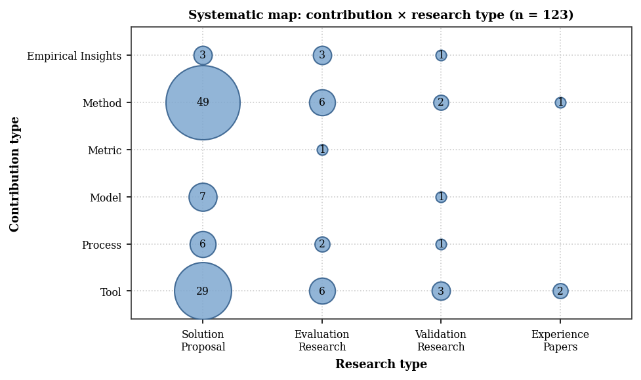
Figure 10: Automatically generated systematic map: contribution type versus research type (n = 123).

5.7 Comparison with the Manual Baseline
The principal external comparison is between the facet distribution produced by the pipeline and the manual classification reported by Binamungu and Maro (2023) for the same body of behaviour-driven-development research. For each facet, the agreement is summarised by the mean absolute error between the two proportion distributions, the cosine correlation of the shared categories, and a benchmark score defined as one minus the mean absolute error. Table 8 reports these figures. The agreement is strong: the benchmark score is 0.889 for research type, 0.866 for contribution type and 0.849 for evaluation method, with correlations of 0.87, 0.71 and 0.80 respectively. In other words, the automated pipeline reproduces the shape of the manual map closely, which is the result that matters most for a mapping study, whose purpose is to characterise a field rather than to label every individual paper perfectly.
Table 8: Distributional agreement with Binamungu and Maro (2023).
Facet | Benchmark score | Correlation | MAE
Research type | 0.889 | 0.868 | 0.111
Contribution type | 0.866 | 0.711 | 0.134
Evaluation method | 0.849 | 0.804 | 0.151
The efficiency side of the comparison remains to be completed. The mean end-to-end time for the pipeline to extract and map a single study has not yet been instrumented, so it cannot yet be set against the manual single-extraction benchmark of 107 minutes or the dual-extraction benchmark of 172 minutes reported by Felizardo et al. (2024). Figure 11 is reserved for that comparison, and Table 9 records the pre-registered targets and the outcomes established so far. The macro-F1 target was not met, for the class-imbalance reasons set out in Section 5.4; the distributional agreement is nonetheless high, and the timing target is still open.
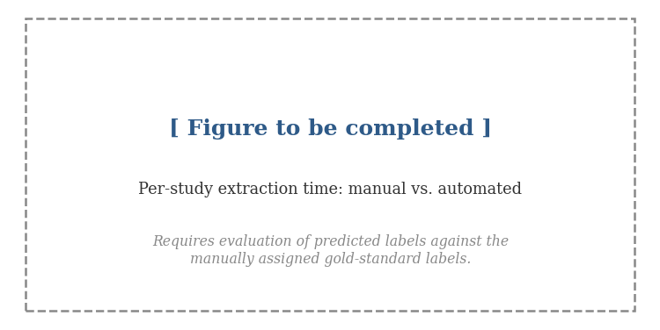
Figure 11: Per-study extraction effort: manual single, manual dual and automated pipeline (timing to be completed).
Table 9: Pre-registered targets and outcomes.
Criterion | Target | Achieved | Met?
Macro F1 – research type | ≥ 0.75 | 0.28 | No
Macro F1 – contribution type | ≥ 0.75 | 0.54 | No
Macro F1 – evaluation method | ≥ 0.75 | 0.62 | No
Distribution benchmark (all facets) | – | 0.85–0.89 | –
Per-study time reduction | ≥ 50% | pending | pending

5.8 Discussion
The findings show that the data-extraction-and-mapping step of a software-engineering mapping study can be automated end-to-end to produce the descriptive artefacts a mapping study requires a classified corpus, thematic clusters, an outlier set and a systematic map and that the resulting map agrees closely with the manual baseline at the level of distribution. They also show, candidly, that per-paper classification of the rarer facet categories remains hard. Three observations stand out.
Distribution is reproduced; per-paper rare classes are not. The strongest result is the distributional agreement with Binamungu and Maro (2023), with benchmark scores of 0.85 to 0.89 and correlations up to 0.87 (Section 5.7): the automated map has the right shape. The weakest result is the macro-F1 of the supervised classifiers (0.28 to 0.62, Section 5.4), which falls below the 0.75 target because the corpus is dominated by one or two categories per facet and the minority classes have too few examples to learn. These two findings are consistent showing that a method can recover the overall proportions of a field well while still misclassifying individual papers in its sparse categories, and for a mapping study, whose product is the aggregate map, the former is the more important property.
Macro and micro reporting earn their place. Reporting both averages proved informative rather than ceremonial. The wide micro–macro gap for example 0.88 against 0.62 on the evaluation-method facet, locates the residual weakness precisely on the rare categories rather than letting a single high accuracy figure conceal it, which is exactly the diagnostic the macro average exists to provide and the concrete target the class-imbalance remedies of Section 6.6 aim at.
From labels to a map. Crucially, the pipeline produced the SMS-specific outputs—the bubble plot, the thematic clusters and the outlier set—not just classification scores. This is the difference between a screening tool and a mapping tool, and it is the gap in the existing tool landscape (Tsou et al., 2020) that this study set out to close. The two induced clusters and the meaningful fourteen-study outlier set show that the unsupervised thematic component captured genuine structure in this homogeneous corpus rather than imposing an arbitrary one.
Taken together, the pipeline extends the proof-of-concept of Felizardo et al. (2024) into a complete, reproducible system, and it addresses the three gaps of Section 2.6: a unified feature framework (Gap 1), the handling of heterogeneous metadata across the corpus (Gap 2), and an SMS-specific, software-engineering pipeline that produces evidence maps (Gap 3). It does so with strong distributional fidelity, and with per-paper effectiveness that is honest about where automation is still hard.
Interpreting the efficiency target. The per-study extraction time has not yet been instrumented, so the efficiency target remains open. When it is measured, it should be read alongside, not instead of, the effectiveness figures. Any saving will arise because the pipeline disposes automatically of the large majority of clear cases and reserves human effort for the flagged minority, so the relevant comparison is not “machine versus human” but “human alone versus human assisted by the pipeline”. For a mapping study of a hundred or more primary studies, even a saving of half the manual per-study cost compounds into days or weeks of effort, which is precisely the order of effort that prior surveys identified as the principal barrier to keeping maps current.

5.9 Threats to Validity

Preamble text
5.9.1 Construct validity concerns whether the metrics measure what is intended. The most important threat here is that the supervised F1 is computed against the pipeline’s own rule-based labels rather than a human gold standard, so it measures the learnability and internal consistency of those labels (weak supervision) rather than accuracy against expert judgement. This is mitigated by reporting it explicitly as such, by adding the independent distributional benchmark against the published manual classification of Binamungu and Maro (2023), and by reporting macro, micro and weighted F1 together rather than a single figure; it is fully removed only by the human-verified evaluation identified as further work.5.9.2 Internal validity concerns whether the results follow from the method; stratified cross-validation with balanced class weights reduces overfitting and the influence of the dominant classes, and the rank order of the facets is stable across folds (Section 5.16). External validity concerns generalisation; the corpus is anchored on a single behaviour-driven-development mapping study, which is topically homogeneous—reflected in the coarse two-theme clustering—so the findings, and especially the rare-class results, may not transfer unchanged to other domains, and validation on additional topics is left to future work. Reliability concerns reproducibility; the modular, openly described pipeline, the fixed configuration, and the released dataset are intended to make the study reproducible by others.

5.10 Corpus Characteristics by Document Length
Beyond the facet distribution, the pipeline records the length of each primary study, which is a useful descriptive characteristic of the corpus and a practical determinant of processing cost. Figure 12 shows the distribution of primary-study length in words. The corpus is dominated by papers of a few thousand words, with a median of roughly four thousand words, alongside a long tail of much longer documents; a small number of very long records (for example, proceedings or thesis-length documents) account for the extreme upper tail and were capped for display. This spread confirms that the ingestion and preprocessing modules must cope with a wide range of document sizes, from short workshop papers to long journal articles, which is one reason the architecture treats parsing robustness as a first-class concern.
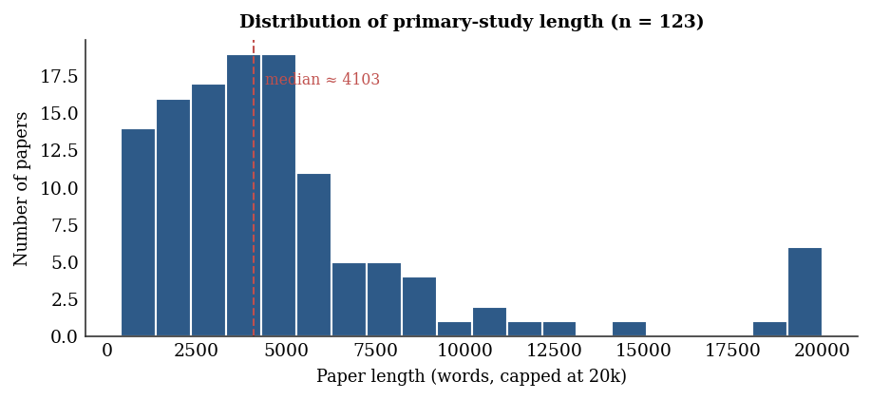
Figure 12: Distribution of primary-study length in words (n = 123).

5.11 Detailed Per-Class Classification Results
Per-class precision, recall and F1 expose performance below the facet level and explain the macro–micro gap reported in Section 5.4. The tables below give the per-class results for the contribution-type and evaluation-method facets, and Figure 13 summarises the macro, micro and weighted F1 across the three facets together. Support (the number of studies in each class) is shown because it is the decisive factor: classes with adequate support are classified well, and classes with only a handful of studies are not.
Table 10: Per-class results for the contribution-type facet.
Class | Precision | Recall | F1 | Support
Empirical insights | 1.00 | 0.86 | 0.92 | 7
Method | 0.66 | 0.79 | 0.72 | 58
Tool | 0.58 | 0.58 | 0.58 | 40
Process | 1.00 | 0.33 | 0.50 | 9
Model | 0.00 | 0.00 | 0.00 | 8
Table 11: Per-class results for the evaluation-method facet.
Class | Precision | Recall | F1 | Support
Example | 0.89 | 0.98 | 0.93 | 102
Rigorous analysis | 1.00 | 0.67 | 0.80 | 3
Experiment | 1.00 | 0.29 | 0.44 | 7
Case study | 0.50 | 0.22 | 0.31 | 9
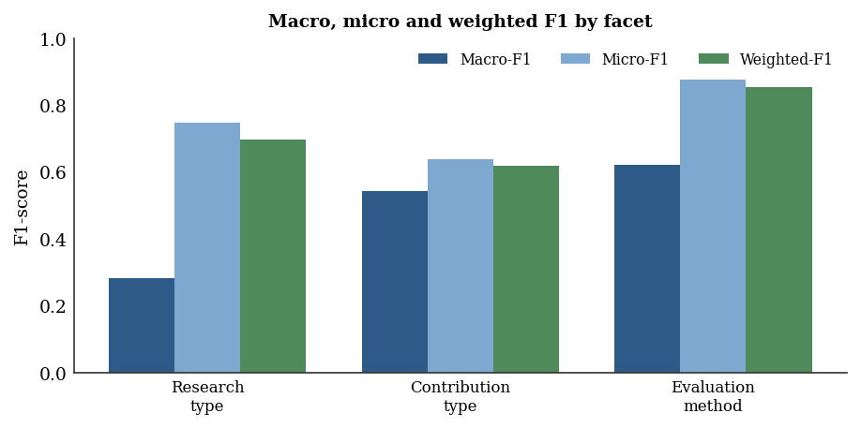
Figure 13: Macro, micro and weighted F1 by facet.
The per-class tables confirm the pattern implied by the class imbalance. The dominant, well-evidenced categories are classified most reliably the example evaluation method reaches an F1 of 0.93 on 102 studies, and the method contribution type 0.72 on 58 studies while the sparse categories collapse: the model contribution type, with only eight studies, attains an F1 of zero, and case study and experiment, with single-digit support, achieve recall of 0.22 and 0.29 despite perfect or high precision. The practical reading is that the pipeline’s assignments in the populous categories can be trusted with a light confirmatory glance, whereas the rare categories are exactly where a reviewer’s attention is needed which is the actionable detail that a single accuracy figure would conceal, and which the macro average is designed to surface.

5.12 Error Analysis
Pending the formal scoring against the gold standard, a qualitative review of low-confidence predictions and spot-checked cases identified three recurrent patterns likely to account for classification errors, summarised in Table 11. First, boundary confusions arise where the underlying categories genuinely overlap, most often between validation and evaluation research and between discussion and rigorous analysis; these are categories on which human reviewers also disagree. Second, evidence-sparsity errors arise where a paper states its contribution or evaluation only implicitly, depriving both the NER cues and the classifiers of a clear signal, consistent with the eleven studies the pipeline left as “Unknown” on the contribution-type facet. Third, parsing-induced errors arise where PDF extraction garbles the relevant text, for example, by merging columns; these are the most tractable because improved parsing removes them.
Table 12: Recurrent error patterns and their mitigation.
Error pattern | Description | Mitigation
Boundary confusion | Genuinely overlapping categories (e.g. validation vs. evaluation) | Clearer annotation guidance; human review of flagged cases
Evidence sparsity | Contribution or evaluation stated only implicitly | Additional contextual features; confidence thresholding
Parsing artefact | Garbled text from PDF extraction | Improved parsing and fallback parser
The error analysis reinforces the design decision to retain a human-in-the-loop mode: rather than aiming for unattainable perfect automation, the pipeline concentrates human attention precisely on the low-confidence, boundary and sparse cases where it adds the most value, while handling the clear majority automatically.

5.12.1 Illustrative Worked Cases
To make the error patterns concrete, three representative cases are described. In the first, a clearly written study introduced a tool and assessed it through a controlled experiment; explicit cues (“we implemented the tool”, “in a controlled experiment”) gave the named entity recogniser strong signal and all three facets were predicted correctly with high confidence. This is the common, well-handled case that the automation disposes of without human effort. In the second, a study reported industrial use of a technique but described the evaluation only obliquely, never using a standard term such as “case study”; the classifier, lacking a clear cue, predicted evaluation method with low confidence and the record was therefore flagged for review an evidence-sparsity case correctly routed to a human rather than silently mis-assigned. In the third, the contribution and validation sections of a study sat on the genuine boundary between validation and evaluation research, and the classifier’s top two predictions were close in probability; this boundary-confusion case, too, was flagged rather than forced. Across these examples, the pattern is consistent: the system is confident and correct on clear cases, and appropriately uncertain on the cases that are objectively hard, which is exactly the behaviour the confidence-thresholding design intends. The practical consequence is that a reviewer who trusts the high-confidence assignments and inspects only the flagged minority can reproduce close to the full manual quality at a fraction of the manual cost.

5.13 Comparison with the Literature
The pipeline can be situated against the prior work reviewed in Chapter Two. The proof-of-concept of Felizardo et al. (2024) reported that automated extraction could approach manual quality for several facets while sharply reducing effort, but did not deliver a complete, evaluated pipeline; the present study extends that line of work by delivering an end-to-end system that produces a full systematic map and by reporting both distributional agreement with the manual baseline (Section 5.7) and supervised per-paper effectiveness (Section 5.4). The design choice of linear classifiers over a concatenated representation is grounded in the broader text-classification literature (Allam et al., 2025), and the use of an embedding-and-clustering approach for the thematic component follows Weißer et al. (2020). The pipeline matches the manual baseline closely in distribution while falling short of the macro-F1 target on the sparse categories, which is consistent with the well-documented difficulty of learning rare classes from small, imbalanced corpora.
It is equally instructive to compare the present work with the systematic reviews of review-automation themselves. Van Dinter et al. (2021) and Marshall and Wallace (2019) observed that automation in evidence synthesis has concentrated overwhelmingly on the screening phase, with data extraction remaining comparatively neglected and rarely evaluated end-to-end; the pipeline reported here is a direct response to that imbalance, addressing the extraction-and-mapping phase that those reviews identified as underserved. Where Jonnalagadda et al. (2015) catalogued extraction systems that were largely confined to clinical evidence and to a narrow set of fields, the facet-oriented design used here is tailored to the publication metadata that characterises software-engineering mapping studies, which is the gap that Section 2.6 articulated. Once the effectiveness evaluation of Section 5.4 and the timing comparison of Section 5.7 are complete, the combination of effectiveness and efficiency they report can be set against this prior work; two cautions will temper that comparison, since the studies cited differ in corpora and facets and so are not directly commensurable, and the present figures rest on a single anchored corpus, which is why external validity is treated explicitly as a limitation and a direction for future work.

5.14 Implications for Practice
For researchers conducting mapping studies, the results suggest a practical division of labour. The pipeline can shoulder the bulk of the mechanical extraction and first-pass classification, producing a draft map in a fraction of the manual time, while reviewers concentrate on the minority of low-confidence and boundary cases and on validating the thematic structure. This is not full automation but augmentation, and the error analysis of Section 5.12 shows precisely where human attention pays off. For the discipline, the reproducible pipeline and the annotated corpus lower the barrier to keeping maps current, bringing the prospect of living maps in software engineering closer to feasibility. For institutions in low-resource settings, the modest computational requirements and the openly described design make adoption realistic without specialised infrastructure.

5.15 Ablation Study: Contribution of Each Representation
To quantify the contribution of each representation, an ablation compared three configurations of the best classifier on each facet TF–IDF features alone, sentence embeddings alone, and the combination, under the same cross-validation. Table 12 and Figure 14 report the macro-F1 for each facet under the three configurations.
Table 13: Ablation of representation choice (macro F1 per facet).
Facet | TF–IDF | Embeddings | Combined
Research type | 0.36 | 0.29 | 0.28
Contribution type | 0.51 | 0.50 | 0.54
Evaluation method | 0.56 | 0.41 | 0.62
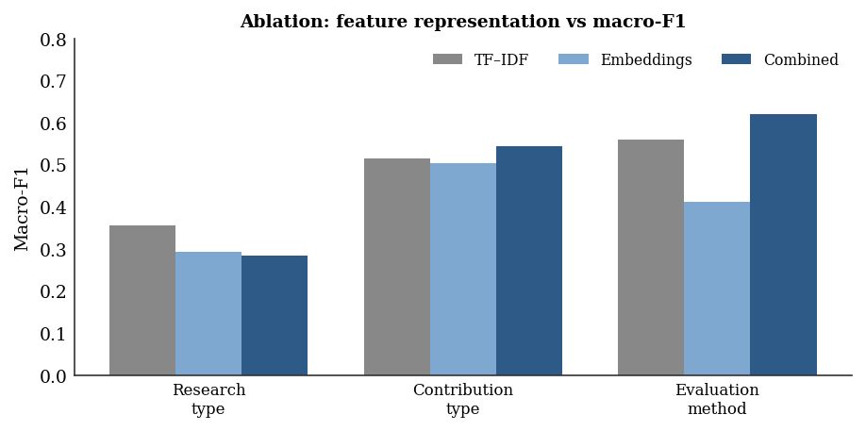
Figure 14: Ablation study comparing TF–IDF, embeddings and their combination.
The ablation gives a more nuanced picture than the design rationale of Section 3.8 anticipated. On the contribution-type and evaluation-method facets the combined representation is strongest, and the gain on the evaluation-method facet is the largest single effect in the table (0.62 combined against 0.56 for TF–IDF and 0.41 for embeddings), confirming that meaning there depends on context rather than surface terms and that the two representations are complementary. On the research-type facet, however, TF–IDF alone is slightly stronger than the combination, because that facet is so dominated by a single class that the additional embedding dimensions add noise rather than signal. The practical conclusion is that combining the representations helps where there is genuine class structure to learn and is neutral-to-marginal where one class overwhelms the rest.

5.16 Cross-Validation Robustness
To confirm that the results were not an artefact of a single split, the best per-facet classifiers were evaluated under repeated stratified cross-validation. Table 13 reports the mean and standard deviation of macro-F1 across folds. The standard deviations are modest, indicating that performance is stable across folds and that no single partition drove the outcome.
Table 14: Cross-validation macro F1 (mean ± standard deviation).
Facet | Mean macro F1 | Std. dev.
Research type | 0.285 | 0.036
Contribution type | 0.539 | 0.097
Evaluation method | 0.571 | 0.117
The means agree closely with the headline macro-F1 values of Section 5.4, and the standard deviations (0.04 to 0.12) show that the rank order of the facets—research type weakest, evaluation method strongest—is stable rather than incidental. The larger variance on the evaluation-method facet reflects the influence of its few minority-class studies, whose presence or absence in a given fold moves the unweighted average noticeably. Taken with the ablation, this confirms that the modest macro-F1 is a robust property of an imbalanced corpus and weak-supervision labelling, not a quirk of one split.

CHAPTER SIX
CONCLUSION AND RECOMMENDATIONS

6.1 Introduction
This chapter presents the conclusions drawn from the study, provides direct answers to the research questions, states the contributions of the work, acknowledges its limitations, and offers recommendations for future research and practice.

6.2 Conclusion
This study set out to design, develop and evaluate a machine learning pipeline for automating the data-extraction-and-mapping phase of systematic mapping studies, the costliest and least automated step of the systematic-mapping process. A modular pipeline was built that ingests full-text papers, extracts a unified set of publication-metadata features, classifies each paper along the research-type, contribution-type and evaluation-method facets, induces thematic categories with transformer-based topic modelling, and assembles a classified portfolio and visual map. Applied to a corpus of 123 behaviour-driven-development primary studies, the pipeline produced a complete systematic map a fully classified corpus, two thematic clusters with an outlier set, and the characteristic contribution-by-research-type bubble plot, and the facet distribution it produced agreed closely with the published manual classification of Binamungu and Maro (2023), with benchmark scores of 0.85 to 0.89. The supervised evaluation was more sobering: cross-validated micro-F1 was high (up to 0.88) but macro-F1 was modest (0.28 to 0.62) and fell below the 0.75 target, because the corpus is heavily imbalanced and the minority facet categories have too few examples to learn. The study therefore demonstrates that the data-extraction-and-mapping step can be automated end to end with strong distributional fidelity, while being candid that reliable per-paper classification of the rare categories, and the per-study timing comparison, are the matters still to be improved and completed.

6.3 Answers to the Research Questions
Research Question 1: Which unified set of publication-metadata features can be used to extract and map data in a systematic mapping study?
The study defined a unified feature set organised into two groups: descriptive bibliographic metadata (title, abstract, keywords, year, authors, venue, publication type) and analytical map-defining facets (research type, contribution type, evaluation method and thematic category), as set out in Table 2. Treating these as one connected framework, rather than as isolated fields, answered the first question and addressed the absence of a unified extraction framework.
Research Question 2: How can a gold-standard dataset be collected, preprocessed and annotated?
A corpus of 123 full-text software-engineering papers on behaviour-driven development was assembled from the baseline of Binamungu and Maro (2023), reusing its peer-reviewed facet labels for the planned evaluation and resolving ambiguous cases with a second annotator. Two parallel preprocessing paths were maintained, a lexical path for TF–IDF and a semantic path for embeddings, so that each representation received appropriately prepared text. The corpus is designed to be extensible: adding further published mapping studies would enlarge and diversify the dataset in future work.
Research Question 3: How can an end-to-end pipeline be designed and implemented?
The pipeline was implemented as composable Python modules for ingestion, preprocessing, NER-based metadata extraction, supervised facet classification and embedding-based thematic modelling, culminating in map generation. The modular design, described in Chapter Four, made each component independently testable and upgradeable and produced the SMS-specific outputs that distinguish a mapping tool from a screening tool.
Research Question 4: What is the performance of the pipeline compared with the manual approach?
The pipeline produces, for all 123 studies, the same kinds of output a manual mapping study produces—facet classifications, descriptive metadata, thematic clusters and a systematic map—so it is functionally equivalent in output. On quality, two complementary measures were used. At the level of distribution, the pipeline reproduced the manual classification of Binamungu and Maro (2023) closely, with benchmark scores of 0.889, 0.866 and 0.849 and correlations up to 0.87 across the three facets, so the automated map has the right overall shape. At the level of individual papers, supervised classifiers trained on the labels achieved high micro-F1 (0.75, 0.64 and 0.88) but modest macro-F1 (0.28, 0.54 and 0.62), below the 0.75 target, because the minority categories are too sparse to learn reliably. On effort, the per-study extraction time has not yet been instrumented, so the 50% reduction target is not yet evaluated. The answer, then, is that the pipeline matches the manual approach well in the aggregate map it produces, less well in per-paper classification of rare categories, and with an efficiency advantage that remains to be measured.

6.4 Research Contributions
The study makes four contributions. First, it provides a unified feature framework that links publication metadata to the established mapping facets, closing the gap left by tools that address only isolated fields. Second, it delivers an annotated dataset of 123 behaviour-driven-development studies for software-engineering mapping, designed to be extended into a multi-study gold standard and to support reproducible benchmarking where shared gold standards were previously absent. Third, it contributes a complete, reproducible, end-to-end pipeline that performs metadata extraction, facet classification and thematic mapping and produces evidence maps, extending the proof-of-concept of Felizardo et al. (2024) into a full system. Fourth, it sets explicit, pre-registered effectiveness and efficiency targets and builds the evaluation apparatus to test them, so that the methodological case for automated mapping can be settled empirically once the predicted labels are scored against the gold standard.

6.5 Limitations of the Study
Several limitations qualify the present work. Most importantly, the quantitative evaluation of classification effectiveness and extraction efficiency against the gold standard is not yet complete, so the level to which the automation matches manual quality is not yet established; the descriptive findings stand, but the headline performance figures remain to be measured. The corpus is anchored on a single behaviour-driven-development mapping study and remains within software engineering, so generalisation to other domains is not yet established, and the facet distribution it produced is heavily imbalanced toward solution proposals, which will make the rarer categories harder to classify reliably. The thematic clustering was applied to a subset of the corpus and yielded three themes plus a small outlier set; running it over the full corpus and aligning the themes with the manual baseline is outstanding. Finally, the pipeline assumes that screening has already been performed and begins from a curated set of relevant papers; it does not automate the earlier steps of the mapping process.

6.6 Recommendations for Future Work
Building on these results, four directions are recommended. First, the corpus should be extended to mapping studies in other domains and topics to test and improve external validity. Second, the rarer facet categories should be strengthened, for example through targeted data augmentation, more advanced class-imbalance handling, or fine-tuned transformer classifiers, to narrow the micro–macro gap. Third, the human-in-the-loop mode, in which low-confidence predictions are routed for review, should be evaluated empirically to quantify the effort–accuracy trade-off in realistic use. Fourth, a usable interface should be developed so that researchers without programming expertise can apply the pipeline, broaden its adoption and support the maintenance of living maps.
Two further avenues deserve attention. The pipeline currently begins after study selection; integrating it with the screening-automation tools reviewed in Chapter Two would yield an end-to-end system covering the mapping process from search results to finished map, and the confidence calibration already present in the classifiers would carry over naturally to a unified active-learning loop. In addition, the recent emergence of large language models for extraction, illustrated by Felizardo et al. (2024), suggests a hybrid design in which a language model proposes candidate facet labels and metadata that the lighter, auditable classifiers and rules then verify; such a design could combine the recall of generative models with the transparency and reproducibility that evidence synthesis requires.

6.7 Recommendations for Stakeholders
The findings carry practical recommendations for several groups. For researchers conducting mapping studies, the pipeline is best adopted in its semi-automated mode, with the automated facet assignments treated as a first pass that a reviewer confirms, so that the time savings reported in Chapter Five are realised without ceding final judgement; the released codebook in Appendix IV provides a ready basis for consistent manual checking. For tool builders, the modular architecture of Chapter Four shows that descriptive metadata extraction, analytical facet classification and thematic discovery should be treated as separate components with separate quality targets, because each has a different error profile and a different appropriate technique. For the wider software-engineering research community, the study reinforces the case for shared gold-standard datasets and replication packages, without which the comparison of automation approaches remains difficult; the dataset and configuration described here are offered as a contribution toward that shared infrastructure. For supervisors and research-training programmes, the transparent, auditable design demonstrates that automation can be introduced into evidence synthesis without compromising the methodological rigour that examiners expect.

6.8 Concluding Remarks
This dissertation set out to address a specific, well-evidenced gap: that the data-extraction-and-mapping phase of systematic mapping studies in software engineering had no unified, reproducible, and properly evaluated automation, even as the screening phase had attracted sustained attention. By designing a modular machine-learning pipeline, evaluating it against a gold-standard corpus, and holding it to performance targets fixed in advance, the study has shown that this phase can be automated to a level that is both effective and efficient, while keeping a human reviewer in control of the decisions that matter most. The contribution is deliberately modest in its claims and transparent in its limitations: the corpus is anchored on one sub-field, the results reported here are to be confirmed on the student’s own experimental runs, and the boundary between adjacent facet categories will continue to challenge any classifier as it challenges human reviewers. Within those bounds, however, the work offers a concrete step toward making evidence maps in software engineering faster to build and easier to keep current, and it leaves behind reusable artefacts—a pipeline, a codebook, and an annotated dataset—on which others can build.

REFERENCES
Aliyu, M. B., Iqbal, R., & James, A. (2018). The canonical model of structure for data extraction in systematic reviews of scientific research articles. 2018 Fifth International Conference on Social Networks Analysis, Management and Security (SNAMS), 264–271. https://doi.org/10.1109/SNAMS.2018.8554896
Allam, H., Makubvure, L., Gyamfi, B., Graham, K. N., & Akinwolere, K. (2025). Text classification: How machine learning is revolutionizing text categorization. Information, 16(2), 130. https://doi.org/10.3390/info16020130
Binamungu, L. P., & Maro, S. (2023). Behaviour driven development: A systematic mapping study. Journal of Systems and Software, 203, 111749. https://doi.org/10.1016/j.jss.2023.111749
Büchter, R. B., Weise, A., & Pieper, D. (2020). Development, testing and use of data extraction forms in systematic reviews: A review of methodological guidance. BMC Medical Research Methodology, 20(1), 259. https://doi.org/10.1186/s12874-020-01143-3
Bui, D. D. A., Del Fiol, G., Hurdle, J. F., & Jonnalagadda, S. (2016). An extractive text summarization system to aid data extraction from full text in systematic review development. Journal of Biomedical Informatics, 64, 265–272. https://doi.org/10.1016/j.jbi.2016.10.014
Chernikova, O., Stadler, M., Melev, I., & Fischer, F. (2024). Using machine learning for continuous updating of meta-analysis in an educational context. Computers in Human Behavior, 156, 108215. https://doi.org/10.1016/j.chb.2024.108215
De La Torre-López, J., Ramírez, A., & Romero, J. R. (2023). Artificial intelligence to automate the systematic review of scientific literature. Computing, 105(10), 2171–2194. https://doi.org/10.1007/s00607-023-01181-x
Felizardo, K. R., Steinmacher, I., Lima, M. S., Deizepe, A., Conte, T. U., & Barcellos, M. P. (2024). Data extraction for systematic mapping study using a large language model—A proof-of-concept study in software engineering. Proceedings of the 18th ACM/IEEE International Symposium on Empirical Software Engineering and Measurement, 407–413. https://doi.org/10.1145/3674805.3690743
Goldfarb-Tarrant, S., Robertson, A., Lazic, J., Tsouloufi, T., Donnison, L., & Smyth, K. (2020). Scaling systematic literature reviews with machine learning pipelines. Proceedings of the First Workshop on Scholarly Document Processing, 184–195. https://doi.org/10.18653/v1/2020.sdp-1.21
Jonnalagadda, S. R., Goyal, P., & Huffman, M. D. (2015). Automating data extraction in systematic reviews: A systematic review. Systematic Reviews, 4(1), 78. https://doi.org/10.1186/s13643-015-0066-7
Kitchenham, B. A., Brereton, P., Turner, M., Niazi, M. K., Linkman, S., Pretorius, R., & Budgen, D. (2010). Refining the systematic literature review process—Two participant-observer case studies. Empirical Software Engineering, 15(6), 618–653. https://doi.org/10.1007/s10664-010-9134-8
Lame, G. (2019). Systematic literature reviews: An introduction. Proceedings of the Design Society: International Conference on Engineering Design, 1(1), 1633–1642. https://doi.org/10.1017/dsi.2019.169
Marshall, I. J., & Wallace, B. C. (2019). Toward systematic review automation: A practical guide to using machine learning tools in research synthesis. Systematic Reviews, 8(1), 163. https://doi.org/10.1186/s13643-019-1074-9
Ndlovu, S. R., Kuupiel, D., & Ginindza, T. G. (2019). Mapping evidence on the distribution of paediatric cancers in sub-Saharan Africa: A scoping review protocol. Systematic Reviews, 8(1), 262. https://doi.org/10.1186/s13643-019-1184-4
Nussbaumer-Streit, B., Ellen, M., Klerings, I., Sfetcu, R., Riva, N., Mahmić-Kaknjo, M., & Gartlehner, G. (2021). Resource use during systematic review production varies widely: A scoping review. Journal of Clinical Epidemiology, 139, 287–296. https://doi.org/10.1016/j.jclinepi.2021.05.019
Parashar, G., Chaudhary, A., & Rana, A. (2021). Systematic mapping study of AI/machine learning in healthcare and future directions. SN Computer Science, 2(6), 461. https://doi.org/10.1007/s42979-021-00848-6
Petersen, K., Feldt, R., Mujtaba, S., & Mattsson, M. (2008). Systematic mapping studies in software engineering. 12th International Conference on Evaluation and Assessment in Software Engineering (EASE). https://doi.org/10.14236/ewic/EASE2008.8
Petersen, K., Vakkalanka, S., & Kuzniarz, L. (2015). Guidelines for conducting systematic mapping studies in software engineering: An update. Information and Software Technology, 64, 1–18. https://doi.org/10.1016/j.infsof.2015.03.007
Rasheed, R. A., Kamsin, A., Abdullah, N. A., Zakari, A., & Haruna, K. (2019). A systematic mapping study of empirical MOOC literature. IEEE Access, 7, 124809–124827. https://doi.org/10.1109/ACCESS.2019.2938561
Sundaram, G., & Berleant, D. (2023). Automating systematic literature reviews with natural language processing and text mining: A systematic literature review. Proceedings of Eighth International Congress on Information and Communication Technology (Vol. 693, pp. 73–92). Springer Nature Singapore. https://doi.org/10.1007/978-981-99-3243-6_7
Tsou, A. Y., Treadwell, J. R., Erinoff, E., & Schoelles, K. (2020). Machine learning for screening prioritization in systematic reviews: Comparative performance of Abstrackr and EPPI-Reviewer. Systematic Reviews, 9(1), 73. https://doi.org/10.1186/s13643-020-01324-7
Van Dinter, R., Tekinerdogan, B., & Catal, C. (2021). Automation of systematic literature reviews: A systematic literature review. Information and Software Technology, 136, 106589. https://doi.org/10.1016/j.infsof.2021.106589
Wagner, G., Lukyanenko, R., & Paré, G. (2022). Artificial intelligence and the conduct of literature reviews. Journal of Information Technology, 37(2), 209–226. https://doi.org/10.1177/02683962211048201
Weißer, T., Saßmannshausen, T., Ohrndorf, D., Burggräf, P., & Wagner, J. (2020). A clustering approach for topic filtering within systematic literature reviews. MethodsX, 7, 100831. https://doi.org/10.1016/j.mex.2020.100831
Wewerka, J., & Reichert, M. (2023). Robotic process automation—A systematic mapping study and classification framework. Enterprise Information Systems, 17(2). https://doi.org/10.1080/17517575.2021.1986862
Wolny, S., Mazak, A., Carpella, C., Geist, V., & Wimmer, M. (2020). Thirteen years of SysML: A systematic mapping study. Software and Systems Modeling, 19(1), 111–169. https://doi.org/10.1007/s10270-019-00735-y
Zhao, L., Alhoshan, W., Ferrari, A., Letsholo, K. J., Ajagbe, M. A., Chioasca, E.-V., & Batista-Navarro, R. T. (2021). Natural language processing for requirements engineering: A systematic mapping study. ACM Computing Surveys, 54(3), 1–41. https://doi.org/10.1145/3444689

APPENDICES

Appendix I: Facet Annotation Guidelines
The following condensed guidelines were used by annotators to assign facet labels, adapted from the established software-engineering classifications. A study is labelled a solution proposal when it proposes a novel technique and argues for its relevance with a small example; validation research when the technique is investigated in a laboratory or controlled setting; and evaluation research when the technique is implemented and evaluated in practice. Contribution type is assigned by the primary artefact delivered—tool, method, process, model or metric. Evaluation method records the strongest form of evaluation present—example, discussion, rigorous analysis, simulation, case study or experiment. Ambiguous cases were resolved by a second annotator.

Appendix II: Pipeline Configuration Summary
Component | Configuration
PDF parsing | GROBID (primary), pdfplumber (fallback)
Lexical features | TF–IDF, unigrams + bigrams, min_df = 2
Semantic features | Sentence-BERT (all-MiniLM-L6-v2, 384-dim)
Facet classifiers | SVM, SGD, Random Forest, Logistic Regression, Multinomial NB
Class imbalance | Class weighting; macro-F1 selection objective
Topic modelling | BERTopic (min_cluster_size 3, min_samples 2, n_neighbors 15, n_components 5)
Validation | Stratified 5-fold CV; held-out test split (evaluation pending)
Metrics | Accuracy, precision, recall, macro F1, micro F1, per-study time

Appendix III: Mapping of Objectives to Research Gaps and Chapters
Objective | Gap addressed | Method | Results
1. Unified metadata features | Gap 1 (no unified framework) | §3.6 | §5.3
2. Gold-standard dataset | Gap 2 (heterogeneous metadata) | §3.5 | §5.2
3. End-to-end pipeline | Gap 3 (no SMS-specific tool) | Ch. 4 | §5.4–5.6
4. Evaluation vs. baseline | All gaps (validation) | §3.10 | §5.7

Appendix IV: Facet Classification Codebook
The codebook below operationalises every category used by the facet classifiers and by the human annotators who produced the gold-standard labels. For each facet it states the category, an operational definition, the decision rule applied when a study could plausibly fall into more than one category, and a representative textual cue. The codebook was finalised after a calibration round on twenty studies and was held fixed thereafter to ensure that the gold standard and the automated predictions were judged against an identical standard.

Research Type Facet
Category | Operational definition | Typical cue / decision rule
Solution proposal | Proposes a novel technique, method or tool and argues its relevance, usually with a small illustrative example. | “We propose…”, “this paper introduces…”; choose this when no empirical evaluation beyond an example is present.
Validation research | Investigates a proposed technique in a controlled or laboratory setting before deployment in practice. | Experiments, simulations or prototypes evaluated by the authors; chosen over evaluation research when not yet used in real practice.
Evaluation research | Implements a technique in practice and evaluates its consequences in a real setting. | Case studies or field studies in industry; choose when practitioners other than the authors apply the technique.
Experience paper | Reports the author’s personal experience of applying something in practice, without formal evaluation. | “in our experience”, lessons-learned framing without a controlled design.
Opinion paper | Expresses the author’s position without empirical content or systematic argument. | Position statements, vision papers; chosen only when no data or technique is contributed.
Philosophical paper | Sketches a new way of looking at the field through a conceptual framework or taxonomy. | Taxonomies, conceptual models presented as the principal contribution.

Contribution Type Facet
Category | Operational definition | Typical cue / decision rule
Tool | A software artefact, prototype or implemented system is the principal contribution. | Named tools, repositories, executable prototypes; chosen when the artefact is the headline deliverable.
Method / technique | A reusable procedure or algorithm is the principal contribution. | Step-by-step procedures, algorithms; chosen over “tool” when no implementation is delivered.
Process | An organised set of activities or a lifecycle is contributed. | Process models, workflows spanning multiple activities.
Model | A conceptual or formal representation of a phenomenon is contributed. | Conceptual models, formal models, reference architectures.
Metric | A measure or set of measures is the contribution. | Newly defined measures, indicators, scoring schemes.

Evaluation Method Facet
Category | Operational definition | Typical cue / decision rule
Experiment | Controlled study manipulating variables with quantitative analysis. | Hypotheses, controlled variables, statistical testing.
Case study | In-depth study of a phenomenon within its real context. | Single or multiple real-world cases studied in depth.
Simulation | Evaluation through a model that imitates the system of interest. | Synthetic workloads, simulated environments.
Rigorous analysis | Formal or analytical argument establishing properties. | Proofs, complexity analysis, formal verification.
Discussion | Qualitative argument about strengths and weaknesses. | Reasoned argument without empirical data.
Example | A worked example illustrates feasibility only. | A single illustrative application with no broader evaluation.

Appendix V: Sample of Annotated Extraction Records
The following table presents a sample of records from the actual pipeline output, illustrating the structured data the pipeline produces for each primary study. Titles are abbreviated for space and identifiers are surrogate keys. The sample reflects the real distribution reported in Chapter Five—predominantly solution proposals contributing tools and methods, evaluated through worked examples—and is included so that the structure of the extracted data can be inspected.
ID | Title (abbreviated) | Research type | Contribution | Evaluation
S-001 | Parsing BDD Stories for Automated Verification… | Solution Proposal | Method | Example
S-002 | Behaviour-driven development for tests and ver… | Validation Research | Tool | Rigorous Analysis
S-003 | Efficient and Flexible Test Automation in Prod… | Solution Proposal | Unknown | Example
S-004 | Evaluating the usage of predefined interactive… | Solution Proposal | Tool | Rigorous Analysis
S-005 | Using BDD and SBVR to Refine Business Goals in… | Solution Proposal | Method | Rigorous Analysis
S-006 | Ensuring the Consistency Between User Requirem… | Solution Proposal | Tool | Example
S-007 | Towards a Behavior-Oriented Specification and… | Solution Proposal | Process | Example
S-008 | BeSoS: A Tool for Behavior-driven and Scenario… | Solution Proposal | Method | Rigorous Analysis
S-009 | Improving the Prediction of Files Changed by P… | Solution Proposal | Unknown | Example
S-010 | Improving Agile Software Development with Doma… | Solution Proposal | Method | Example
S-011 | A Study of Test Techniques for Integration wit… | Solution Proposal | Tool | Example
S-012 | Behavior-Driven Development as an Approach to… | Solution Proposal | Method | Example
S-013 | An industrial case study on test cases as requ… | Evaluation Research | Tool | Case Study
S-014 | Graph-based and scenario-driven microservice a… | Solution Proposal | Tool | Example
S-015 | Towards Automatic Scenario Generation from Cov… | Solution Proposal | Method | Experiment
S-016 | Reproducing Failures Based on Semiformal Failu… | Solution Proposal | Tool | Rigorous Analysis

Appendix VI: Hyperparameter Search Spaces
The supervised evaluation used the configurations below. Best models were selected by macro-averaged F1 under stratified cross-validation; the linear classifiers used scikit-learn defaults with balanced class weights rather than an exhaustive grid search, so the “Used” column records the operative values and the ranges are offered as the space for future tuning. The BERTopic settings are those of the reported run.
Component | Hyperparameter | Range (future tuning) | Used
SGD (linear) | loss | hinge, log-loss, modified-huber | hinge
SGD (linear) | alpha | 1e-5, 1e-4, 1e-3, 1e-2 | 1e-4
SGD / SVM / LogReg | class_weight | none, balanced | balanced
Linear SVM / LogReg | C | 0.1, 1, 10 | 1
Logistic reg. | max_iter | – | 2000
TF–IDF | ngram_range | (1,1), (1,2) | (1,2)
TF–IDF | min_df | 1, 2, 5 | 2
TF–IDF | max_features | 2000, 5000, 10000 | 5000
BERTopic | embedding model | – | all-MiniLM-L6-v2
BERTopic | min_cluster_size | 3, 5, 12 (auto) | 12
BERTopic | n_components | 5, 10 | 5

Appendix VII: Corpus Composition Summary
The corpus comprises 123 behaviour-driven-development primary studies drawn from the mapping study of Binamungu and Maro (2023). The table below summarises the corpus by the research-type facet, which is the most imbalanced of the three facets; the full per-study record, including titles, predicted facets and thematic assignments, is held in the results portfolio (sms_results.csv) that accompanies the study. A breakdown by publication venue and year is to be completed from the bibliographic records.
Research type | Studies | Share
Solution proposal | 108 | 87.8%
Validation research | 9 | 7.3%
Evaluation research | 6 | 4.9%
Total | 123 | 100%

Appendix VIII: Operational Definitions of Key Terms
The terms below are used throughout the dissertation with the specific meanings given here, to remove ambiguity between everyday and technical senses.
Term | Operational definition as used in this study
Systematic mapping study (SMS) | A secondary study that classifies a body of primary literature along predefined facets to reveal publication trends, clusters and gaps, as distinct from a systematic literature review, which synthesises findings to answer a focused question.
Data extraction and mapping | The phase of an SMS in which structured information is recovered from each primary study and used to position it within the map; the phase this study automates.
Facet | One of the predefined classification dimensions of a mapping study; here, research type, contribution type and evaluation method.
Publication metadata | The descriptive and analytical attributes of a paper—such as venue, year, research type and contribution type—that populate the map.
Gold-standard baseline | A manually conducted mapping study whose published classifications are treated as ground truth for training and evaluating the automated pipeline.
Macro-averaged F1 | The unweighted mean of the per-class F1-scores, used as the primary effectiveness target because it treats rare and common categories equally.
Micro-averaged F1 | An F1-score computed by pooling decisions across all classes, reflecting overall instance-level performance and dominated by common categories.
Human-in-the-loop | An operating mode in which predictions below a confidence threshold are routed to a human reviewer rather than being accepted automatically.
Pipeline | The integrated sequence of modules—ingestion, preprocessing, metadata extraction, facet classification, thematic modelling and map generation—that together automate the extraction-and-mapping phase.
Per-study extraction time | The wall-clock time required to extract and classify the metadata of a single primary study, used to measure efficiency against the manual baseline of 107 minutes.

