AUTOMATION OF SYSTEMATIC MAPPING STUDIES: A MACHINE LEARNING APPROACH

Naale Josephat

MSc (Data Science Dissertation)
University of Dar es Salaam
September 2026

AUTOMATION OF SYSTEMATIC MAPPING STUDIES: A MACHINE LEARNING APPROACH

By

Naale Josephat

A Dissertation Submitted in Partial Fulfilment of the Requirements for the Degree of Master of Science in Data Science of the University of Dar es Salaam

University of Dar es Salaam
September 2026

CERTIFICATION
The undersigned certifies that she has read and hereby recommends for acceptance by the University of Dar es Salaam a dissertation titled: “Automation of Systematic Mapping Studies: A Machine Learning Approach”, in partial fulfilment of the requirements for the degree of Master of Science in Data Science of the University of Dar es Salaam.
…………………………………………
Dr. Salome Maro
(Supervisor)
Date: ………………………………

DECLARATION
AND
COPYRIGHT
I, Naale Josephat, declare that this dissertation is my own original work and that it has not been presented and will not be presented to any other university for a similar or any other degree award.
Signature ……………………………………
This dissertation is copyright material protected under the Berne Convention, the Copyright Act of 1999, and other international and national enactments, in that behalf, on intellectual property. It may not be reproduced by any means, in full or in part, except for short extracts in fair dealing, for research or private study, critical scholarly review, or discourse with an acknowledgement, without the written permission of the Directorate of Postgraduate Studies, on behalf of both the author and the University of Dar es Salaam.

ACKNOWLEDGEMENTS
First and foremost, I thank the Almighty God for the gift of life, health, and perseverance throughout the period of this study. Every milestone of this work has been possible through His grace.
I owe my deepest gratitude to my supervisor, Dr. Salome Maro, whose guidance, patience, and constructive criticism shaped this dissertation from its earliest idea to its final form. Her insistence on clarity, rigour, and reproducibility profoundly improved both the work and my own scholarship.
I extend sincere thanks to the academic staff of the Department of Computer Science and Engineering in the College of Information and Communication Technologies, whose comments on the proposal and progress presentations strengthened the structure, the objectives, and the technical depth of this study.
Finally, I thank my family and friends for their unwavering encouragement, and the University of Dar es Salaam for the financial and infrastructural support that made this work feasible.

DEDICATION
To my beloved family, whose patience, sacrifice, and constant encouragement sustained me through every stage of this work, and to the growing community of researchers in Africa who are building the tools that will make evidence synthesis faster, fairer, and more accessible.

LIST OF ABBREVIATIONS AND ACRONYMS
Abbreviation | Meaning
AI | Artificial Intelligence
BDD | Behaviour-Driven Development
BERT | Bidirectional Encoder Representations from Transformers
BoW | Bag of Words
c-TF–IDF | Class-based Term Frequency–Inverse Document Frequency
CV | Cross-Validation
F1 | F-measure (harmonic mean of precision and recall)
HDBSCAN | Hierarchical Density-Based Spatial Clustering of Applications with Noise
LLM | Large Language Model
MAE | Mean Absolute Error
ML | Machine Learning
NLP | Natural Language Processing
OCR | Optical Character Recognition
PDF | Portable Document Format
RPA | Robotic Process Automation
SBERT | Sentence-BERT
SGD | Stochastic Gradient Descent
SLR | Systematic Literature Review
SMS | Systematic Mapping Study
SVM | Support Vector Machine
TF–IDF | Term Frequency–Inverse Document Frequency
UDSM | University of Dar es Salaam
UMAP | Uniform Manifold Approximation and Projection

ABSTRACT
Systematic mapping studies (SMS) are a cornerstone of evidence-based software engineering: they classify the primary literature and reveal publication trends, research gaps and opportunities. Conducting an SMS manually is tedious, time-consuming and error-prone, and the data extraction and mapping step consumes the greatest share of researchers' effort while attracting the least automation. Existing automation research concentrates on the study-selection (screening) stage of systematic literature reviews, leaving the data extraction and mapping step of mapping studies underserved, without a unified extraction framework and without shared gold standards against which automation can be judged.
This study designed, developed and evaluated a machine learning pipeline that automates the data-extraction-and-mapping phase of systematic mapping studies. The pipeline ingests full-text papers (with optical character recognition as a fallback for scanned documents), extracts descriptive metadata, assigns each paper to the three established mapping facets (research type, contribution type and evaluation method) with a lexicon-based labeller and with supervised classifiers, induces thematic categories with transformer-based embeddings and k-means clustering, and assembles the classified portfolio and visual map. The work followed a six-stage data-science lifecycle and was evaluated against a gold standard: the per-paper classification of every primary study published in the behaviour-driven-development mapping study of Binamungu and Maro (2023), matched to the same full-text corpus.
Applied to 122 primary studies, the pipeline produced a complete systematic map: every study received a research type, a contribution type and an evaluation method, descriptive metadata were extracted for all studies, and the map was generated automatically. Against the expert labels, the lexicon-based labeller reached per-paper accuracies of 0.46, 0.37 and 0.50 (macro-F1 0.33, 0.35 and 0.42) on the three facets, and supervised classifiers trained on the gold labels under stratified cross-validation reached macro-F1 of 0.40, 0.34 and 0.41. At the level of the map, the facet distributions produced by the pipeline agreed closely with the manual classification (distribution scores 0.93, 0.86 and 0.94). The pipeline processed a study in 5.6 seconds on average, against a manual baseline of 107 minutes per study. The study contributes a reproducible pipeline, a gold-standard dataset of 122 labelled software-engineering papers and an honest account of where automated facet classification is reliable (the aggregate map) and where it is not yet (individual papers in rare categories).

TABLE OF CONTENTS
CERTIFICATION i
DECLARATION ii
ACKNOWLEDGEMENTS iii
DEDICATION iv
LIST OF ABBREVIATIONS AND ACRONYMS v
ABSTRACT vi
TABLE OF CONTENTS viii
LIST OF TABLES xiv
LIST OF FIGURES xv
CHAPTER ONE 1
1.1 Background to the Study 1
1.1.1 The Challenges of Conducting an SMS Manually 2
1.1.2 Gaps in Existing Automation Research 2
1.1.3 Contribution and Positioning of This Study 3
1.2 Statement of the Problem 4
1.3 Research Objectives 5
1.3.1 Main Objective 5
1.3.2 Specific Objectives 5
1.4 Research Questions 5
1.5 Significance of the Study 6
1.6 Scope of the Study 6
1.7 Dissertation Structure 7
CHAPTER TWO 8
2.1 Introduction 8
2.2 Systematic Mapping Studies and Publication Characteristics 8
2.2.1 Secondary Studies and the Place of the SMS 8
2.2.2 The Systematic Mapping Process 9
2.2.3 The Nature of Publication Metadata in Systematic Mapping Studies 10
2.2.4 Data Extraction and Mapping as the Principal Bottleneck 11
2.2.5 Evidence-Based Software Engineering and the Role of Maps 11
2.3 Automation Efforts in Systematic Mapping and Review 12
2.3.1 Automation of Study Selection (Screening) 12
2.3.2 Automation of Data Extraction 12
2.3.3 The Tool Landscape 13
2.3.4 Automation of Review Updating and AI-Assisted Reviews 13
2.3.5 Critical Synthesis of the Automation Literature 14
2.4 Machine Learning and Natural Language Processing Techniques 14
2.4.1 Supervised Classification Algorithms 14
2.4.2 Intuition Behind the Principal Classifiers 15
2.4.3 Text Representation and Embeddings 16
2.4.4 Transformer-Based Models 16
2.4.5 Lexicon- and Pattern-Based Cue Extraction 17
2.4.6 Topic Modelling Approaches 17
2.4.7 Evaluation Metrics 18
2.4.8 Model Selection, Cross-Validation and Generalisation 18
2.4.9 Synthesis: From Techniques to Pipeline 19
2.5 Related Work 19
2.6 Research Gap 21
CHAPTER THREE 22
3.1 Introduction 22
3.2 Research Design 22
3.3 Study Area 22
3.4 Research Approach and Method 22
3.5 Data Collection and the Gold-Standard Baseline 23
3.6 Metadata Features for Mapping 24
3.7 Data Preparation 24
3.8 Text Representation and Feature Engineering 25
3.9 Model Selection and Training 25
3.10 Model Evaluation 26
3.11 Tools and Materials 27
3.12 Ethical Considerations 27
3.13 Detailed Data-Science Lifecycle Stages 27
3.13.1 Business and Process Understanding 27
3.13.2 Data Acquisition and Understanding 28
3.13.3 Data Preprocessing 28
3.13.4 Data Analysis 28
3.13.5 Modelling 28
3.13.6 Deployment and Evaluation 28
3.14 Requirements of the Pipeline 29
3.15 Detailed Preprocessing Steps 29
3.16 Evaluation Metric Definitions 30
3.17 Classifier Configurations 30
3.18 Handling of the Gold-Standard Labels 31
3.19 Confidence Threshold and Human-in-the-Loop Mode 31
3.20 Validity-Preserving Design Choices 32
CHAPTER FOUR 33
4.1 Introduction 33
4.2 Conceptual Framework 33
4.3 Overview of the Pipeline Architecture 34
4.4 Document Ingestion and Text Extraction 35
4.5 Preprocessing Module 36
4.6 Lexicon-Based Facet Labelling Module 37
4.7 Supervised Facet Classification Module 38
4.8 Thematic Topic Modelling Module 39
4.9 Map Generation and Visualisation Module 40
4.10 Corpus Characteristics 40
4.11 Implementation Environment 41
4.12 Functional and Non-Functional Requirements 42
4.13 Thematic and Map-Generation Algorithms 42
4.14 Worked Example of the End-to-End Flow 43
4.15 Testing and Validation of the Pipeline 43
4.16 Output Data Schema 44
CHAPTER FIVE 46
5.1 Introduction 46
5.2 Experimental Setup and Dataset 46
5.3 Metadata Extraction Results 47
5.4 Facet Labelling Results against the Gold Standard 48
5.5 Supervised Facet Classification Results 50
5.6 Thematic Topic Modelling Results 52
5.7 The Systematic Map 53
5.8 Comparison with the Manual Baseline 54
5.9 Evaluation of the Human-in-the-Loop Flag 56
5.10 Discussion 57
5.11 Threats to Validity 58
5.11.1 Construct Validity 58
5.11.2 Internal Validity 59
5.11.3 External Validity 59
5.11.4 Reliability 59
5.12 Detailed Per-Class Results 60
5.13 Error Analysis 61
5.13.1 Illustrative Cases 62
5.14 Comparison with the Literature 63
5.15 Implications for Practice 63
CHAPTER SIX 65
6.1 Introduction 65
6.2 Conclusion 65
6.3 Answers to the Research Questions 66
6.4 Research Contributions 67
6.5 Limitations of the Study 67
6.6 Recommendations for Future Work 68
6.7 Recommendations for Stakeholders 69
6.8 Concluding Remarks 69
REFERENCES 71
APPENDICES 75
Appendix I: Facet Category Definitions 75
Appendix II: Pipeline Configuration Summary 75
Appendix III: Mapping of Objectives to Research Gaps and Chapters 76
Appendix IV: Facet Classification Codebook 76
Research Type Facet 76
Contribution Type Facet 77
Evaluation Method Facet 78
Appendix V: Sample of Extraction Records with Gold Labels 78
Appendix VI: Hyperparameter Search Spaces 80
Appendix VII: Corpus Composition Summary 81
Appendix VIII: Operational Definitions of Key Terms 82

LIST OF TABLES
Summary of related work on review and mapping automation. 19
Classification facets and categories used in the mapping. 24
Summary of classifier configurations explored. 30
Output data schema of the classified portfolio (sms_results.csv). 44
Composition of the corpus by research type: gold labels versus pipeline labels. 46
Descriptive metadata extraction coverage. 48
Agreement of the lexicon-based labeller with the gold labels, per facet. 48
Best supervised configuration per facet under stratified five-fold cross-validation. 50
Feature-set ablation: best macro-F1 over classifiers for each feature set and facet. 51
Induced thematic clusters and their leading descriptors (thematic module, Colab run). 52
Distributional agreement between the pipeline's facet distribution and the manual classification of Binamungu and Maro (2023). 55
Summary of the evaluation outcomes. 56
Accuracy of flagged versus unflagged labels of the lexicon-based labeller, per facet. 57
Per-class results for the contribution-type facet (lexicon-based labeller; F1 of the best supervised classifier in the last column). 60
Per-class results for the evaluation-method facet (lexicon-based labeller; F1 of the best supervised classifier in the last column). 60
Recurrent error patterns and their mitigation. 62

LIST OF FIGURES
The systematic mapping process (adapted from Petersen et al., 2015). 9
The six-stage data-science lifecycle followed by the study. 23
Conceptual framework linking publication metadata, machine learning components and evaluation. 34
Architecture of the SMS automation pipeline. 35
Output of the lexicon-based labelling module for one primary study, with the matched cue phrases as evidence and the gold labels for comparison. 37
Distribution of primary-study length in words (n = 122). 41
Distribution of primary studies across the three facets: gold labels versus pipeline labels (n = 122). 47
Macro- and micro-F1 against the gold labels: lexicon-based labeller and best supervised classifier, per facet. 49
Confusion matrix of the lexicon-based labeller for the research-type facet (rows: gold label; columns: pipeline label). 50
Feature-set ablation for the supervised facet classifiers (best macro-F1 over classifiers). 51
Thematic clusters discovered by the thematic module, with outliers shown separately (Colab run). 53
Automatically generated systematic map: contribution type versus research type (n = 122). 54
Per-study extraction-and-mapping effort: manual single-reviewer and dual extraction (Felizardo et al., 2024), the pipeline with review of flagged studies, and the fully automated pipeline (measured). 56
Per-class F1 against the gold labels for the lexicon-based labeller and the best supervised classifier, per facet. 61

CHAPTER ONE
INTRODUCTION

1.1 Background to the Study
Secondary studies synthesise existing primary studies rather than collecting new data, providing structured and reliable summaries of what is already known in a research area. Several types of secondary studies exist, including systematic literature reviews (SLRs), meta-analyses, and systematic mapping studies (SMSs). An SLR aims to identify relevant primary papers, extract the required data, and synthesise the results to answer specific research questions in depth, following a strict protocol that covers search strategy, selection criteria, and quality assessment. A meta-analysis statistically combines results from primary studies to produce generalisable evidence expressed as effect sizes and confidence intervals.
A systematic mapping study, by contrast, is a methodology used to identify, categorise, and analyse a research topic by examining the quantity and type of research conducted and by revealing the gaps and opportunities in that area (Wolny et al., 2020). It aims to provide an overview of a research field, and its expected outcome is a classified portfolio of publications that identifies the quantity of research, the available results, and the publication trends within the field (Rasheed et al., 2019). In effect, an SMS offers a map-like visual summary of a research area, which is why mapping studies have become common across software engineering, medicine, pharmacy, and healthcare (Parashar et al., 2021).
Conducting an SMS involves five steps: the definition of research questions, the search for relevant studies, the screening of papers, keywording using abstracts, and data extraction and mapping (Petersen et al., 2015). Each step contributes to the rigour and traceability of the final map, but the steps differ substantially in the human effort they demand. The fifth step, data extraction and mapping, is widely regarded as the most crucial and the most costly, because data are read from each paper, classified against a scheme and recorded in tables from which statistics and visual maps are produced.
The distinction between these secondary study types matters for what automation must achieve. An SLR seeks to answer narrow questions by deeply synthesising outcome data, so automating it requires extracting fine-grained, study-specific results. An SMS instead seeks breadth, classifying many studies along a small number of categorical facets to chart a field. The data an SMS extracts are therefore largely categorical and structurally regular, which makes it a more tractable and more rewarding target for machine learning: the same classification scheme applies across the whole corpus, and success can be measured by agreement with documented expert labels.
The growth of the scientific literature compounds the need for such automation. As the number of published primary studies in software engineering continues to rise, the manual effort required to map a field grows in proportion, and the window during which a map remains current shrinks. A method that reduces the per-study cost of extraction therefore does more than save time on a single study; it changes what is feasible, making it practical to construct larger maps and to keep them up to date as the literature evolves.

1.1.1 The Challenges of Conducting an SMS Manually
Conducting a systematic mapping study manually poses several well-documented challenges, chief among them tediousness, error-proneness and difficulty of updating. Systematically reviewing and categorising a large body of literature is labour-intensive, and the volume of information makes manual processes susceptible to oversights. Among the five steps, data extraction is the most time-consuming, because data are extracted by hand and recorded in tables, and because the number of articles included in a secondary study can range from dozens to thousands. Full automation is difficult owing to the different ways researchers report results, restricted full-text access and the incomplete information supplied by some authors.
Empirical evidence underscores the cost of manual extraction. Felizardo et al. (2024) report that, on average, a researcher spends 107 minutes per study, and that dual-independent data extraction takes up to 172 minutes per study; they further note that data extraction bias can undermine the validity of evidence synthesis, with error rates reaching as high as 63%. Nussbaumer-Streit et al. (2021) similarly found that extracting major information on study design, participants and results took one person an average of 41 to 65 minutes per study. At the level of the whole study, Petersen et al. (2015) observe that a manual systematic mapping study can take up to 67 weeks from inception to completion. Beyond the initial effort, keeping a secondary study up to date as the literature evolves is itself a recurring burden (Van Dinter et al., 2021).

1.1.2 Gaps in Existing Automation Research
With the rise of machine learning and artificial intelligence, the literature has emphasised the use of these technologies in systematic literature reviews, where the inclusion and exclusion of papers (screening) have received considerable attention (Van Dinter et al., 2021; Marshall & Wallace, 2019). However, the most labour-intensive steps, namely data extraction and synthesis, remain understudied (Aliyu et al., 2018), and most research on automating reviews targets systematic literature reviews rather than systematic mapping studies. Three gaps are especially consequential for the present work.
First, the absence of a unified extraction framework. Jonnalagadda et al. (2015) found that no unified data-extraction framework focused on secondary studies existed, that prior work addressed only a handful of data elements, and that the absence of common gold standards made cross-study comparison impossible.
Second, limited handling of heterogeneous publication metadata. Existing tools tend to target a small, fixed set of clinical fields and struggle with the heterogeneous metadata research type, contribution type, evaluation method, and thematic focus that mapping studies actually require (Sundaram & Berleant, 2023).
Third, most extraction tools are confined to the biomedical domain and to screening, and rarely produce the SMS-specific outputs evidence maps, bubble plots and gap charts that mapping studies depend upon (Tsou et al., 2020).

1.1.3 Contribution and Positioning of This Study
Recognising these gaps, the present study focuses on using machine learning to automate the data extraction and mapping step of the systematic mapping process. It designs, develops and evaluates a pipeline that ingests full-text papers, extracts descriptive metadata, assigns each paper to the established mapping facets, induces thematic categories, assembles the classified portfolio and visual map, and evaluates every step against the published classification of a manually conducted mapping study.
Current tools fall short in three specific ways that this study addresses directly. They offer no unified framework that links metadata extraction to facet classification and to map generation; this study provides exactly such an end-to-end framework. They handle only a narrow, fixed set of fields and falter on the heterogeneous metadata of mapping studies; this study targets the full set of facets that constitute a software-engineering map and treats thematic categorisation as a first-class, data-driven component. And they are validated almost exclusively on biomedical screening rather than software-engineering mapping; this study is developed and evaluated against published software-engineering mapping studies used as gold standards. In short, where existing work automates the easiest step of the wrong study type in the wrong domain, this study automates the hardest step of the right study type in the domain where the methodology originated.

1.2 Statement of the Problem
Conducting a systematic mapping study requires meticulous searching, screening, and data extraction across academic databases, conference proceedings, and journals, followed by the careful extraction and categorisation of relevant data from each paper by research type, theme, contribution, and evaluation method. Given the volume of papers and the detail of the analysis, the process is resource-intensive and prone to human error. Manual data extraction and categorisation can introduce inconsistencies and missed information that undermine the reliability of a study’s findings, while the time required can delay completion to the point where the map is outdated before it is published; manual mapping studies have been reported to take up to 67 weeks to complete (Petersen et al., 2015).
Automation of the data-extraction phase could substantially reduce this effort. Marshall and Wallace (2019) show that combining machine learning with natural language processing can automate the extraction of relevant information from research papers, improving consistency and reducing errors. Despite this promise, no widely adopted, reproducible pipeline currently targets the data extraction and mapping step of systematic mapping studies, links it to a unified set of metadata features, and produces the SMS-specific outputs that mapping studies need.
To make the problem measurable, the study evaluates the pipeline against two reference points. Effectiveness is measured as agreement with the manually assigned labels of the reference mapping study of Binamungu and Maro (2023), reported per paper (accuracy, precision, recall, and macro- and micro-averaged F1 for each facet) and at the level of the map from the reference mapping study by Binamungu and Maro (2023). Efficiency is measured as the wall-clock time the pipeline needs per study, set against the manual baseline of 107 minutes per study for a single reviewer and 172 minutes for dual independent extraction reported by Felizardo et al. (2024).

1.3 Research Objectives

1.3.1 Main Objective
The main objective of this study is to design, develop, and evaluate a machine learning pipeline to automate the data extraction and mapping phase of systematic mapping studies.

1.3.2 Specific Objectives
The specific objectives of the study are:
- To identify a set of key metadata features for automating systematic mapping studies.
ii. To collect, preprocess, and annotate a dataset of academic papers to serve as training and validation data for the machine models.
iii. To design and implement a machine learning pipeline capable of automating the extraction and mapping process of SMS from full-text academic papers.
iv. To evaluate the performance of the pipeline against a manually curated baseline.

1.4 Research Questions
Corresponding to the specific objectives, the study answers the following questions:
- Which unified set of publication-metadata features can be used to extract and map data in a systematic mapping study?
- How can a gold-standard dataset of full-text academic papers be collected, preprocessed and annotated to train and validate the models?
- How can an end-to-end machine learning pipeline be designed and implemented to automate SMS data extraction, facet classification and thematic mapping?
- What is the performance of the developed pipeline, in effectiveness (per-paper and distribution-level agreement with the manual labels) and efficiency (extraction time), compared with the manual approach?

1.5 Significance of the Study
The adoption of machine learning in systematic mapping studies has the potential to improve the data extraction and thematic mapping steps significantly. This research aims to create a pipeline that not only expedites the SMS process but also enhances the quality and reliability of the resulting maps.
First, the study contributes to the automation of systematic mapping studies, making them more efficient and less dependent on scarce expert time. Second, the pipeline can accelerate knowledge synthesis across domains, enabling researchers to keep maps current with reduced effort. Third, by producing a reproducible and openly described pipeline together with an annotated dataset, the study provides reusable resources that other researchers can adopt or extend, strengthening methodological rigour in evidence-based software engineering and supporting capacity-building in research-synthesis tooling in low-resource settings.
The significance can be made concrete by considering who benefits and how. For the individual researcher or postgraduate student, the mechanical part of the most labour-intensive phase of a mapping study is reduced from minutes per paper to seconds, freeing effort for the judgement calls that remain. For research groups that maintain living maps, the same reduction makes periodic updating feasible. For the broader discipline, a transparent and reproducible pipeline, accompanied by a gold-standard dataset derived from a peer-reviewed mapping study, lowers the barrier to comparing and improving automation methods. These benefits are pursued without displacing expert judgement: the design keeps a human reviewer in control of low-confidence decisions, and the evaluation reports candidly where automation still falls short of the experts.

1.6 Scope of the Study
Although a systematic mapping study comprises several steps, this study focuses specifically on the data extraction and mapping step. The pipeline therefore begins with a set of relevant papers for which inclusion and exclusion criteria have already been applied; the search and screening steps are outside its scope. Because mapping studies differ by topic, the study uses an existing, manually conducted mapping study as its gold-standard baseline for developing and evaluating the models. The work is situated within the software-engineering domain, and the behaviour-driven-development mapping study of Binamungu and Maro (2023), whose primary studies and published per-paper classifications constitute the corpus and the ground truth, serves as the reference baseline.

1.7 Dissertation Structure
This dissertation is organised into six chapters. Chapter One has introduced the study by presenting its background and establishing the research problem. It has further outlined the study objectives, research questions, significance of the study, and its scope. Chapter Two reviews the literature, progressing from systematic mapping studies and publication characteristics, through automation efforts, to the machine learning and natural language processing techniques on which the pipeline rests, and ends by stating the research gap. Chapter Three presents the research methodology, including the research design, the data-science method, the corpus and gold-standard labels, the metadata features, and the evaluation strategy. Chapter Four presents the conceptual framework and the design and implementation of the SMS automation pipeline, module by module, together with the characteristics of the corpus it processes. Chapter Five reports and discusses the findings against the gold standard and the manual baseline. Chapter Six concludes the dissertation, answers the research questions, states the contributions and limitations, and offers recommendations for future work.

CHAPTER TWO
LITERATURE REVIEW

2.1 Introduction
This chapter reviews the literature that grounds the study. Section 2.2 establishes the foundations of systematic mapping studies and the publication characteristics they classify, including the nature of publication metadata and why the data extraction and mapping step is the principal bottleneck. Section 2.3 reviews automation efforts, moving from study selection to data extraction, to the tool landscape, and to the automation of review updating. Section 2.4 provides the technical foundation, explaining the core machine learning and natural language processing techniques relevant to the pipeline. Section 2.5 reviews the most directly related work, and Section 2.6 states the research gap. The conceptual framework that connects the reviewed ideas to the design of the study is presented at the start of Chapter Four, where it introduces the pipeline architecture.

2.2 Systematic Mapping Studies and Publication Characteristics

2.2.1 Secondary Studies and the Place of the SMS
Secondary studies analyse, summarise or synthesise existing research rather than collecting new data. The most commonly adopted variants are the Systematic Literature Review (SLR) and the Systematic Mapping Study (SMS). The primary goal of an SLR is to answer specific research questions in depth by synthesising evidence through detailed analysis (Lame, 2019), whereas the primary goal of an SMS is to provide an overview of a broad research area, classify studies and identify gaps or trends (Wolny et al., 2020). The two differ in granularity and intent: an SLR drills down, while an SMS spreads out to chart the shape of a field. This difference matters for automation, because the data an SMS extracts are largely categorical metadata used to position each study on a map, rather than the fine-grained outcome data an SLR synthesises.
The distinction also shapes what success means for automation. Because an SMS applies one classification scheme across an entire corpus, an automated SMS can be judged by its agreement with documented expert labels, study by study and facet by facet. This makes the SMS a well-posed machine learning target: the categories are defined in advance, the ground truth exists in published mapping studies, and the evaluation reduces to measuring agreement, which is the basis of the methodology adopted in Chapter Three.

2.2.2 The Systematic Mapping Process
According to Petersen et al. (2015), an SMS proceeds through the five steps as shown in Figure 1. The first step defines the research questions, delimiting the scope of the review. The second step applies a search string derived from the questions to the title, abstract, and keywords of candidate papers. The third step screens papers against the inclusion and exclusion criteria. The fourth step is keyword extraction in the abstracts: reviewers identify keywords and concepts that capture each paper’s contribution, then combine them into a classification scheme that becomes the blueprint of the map.
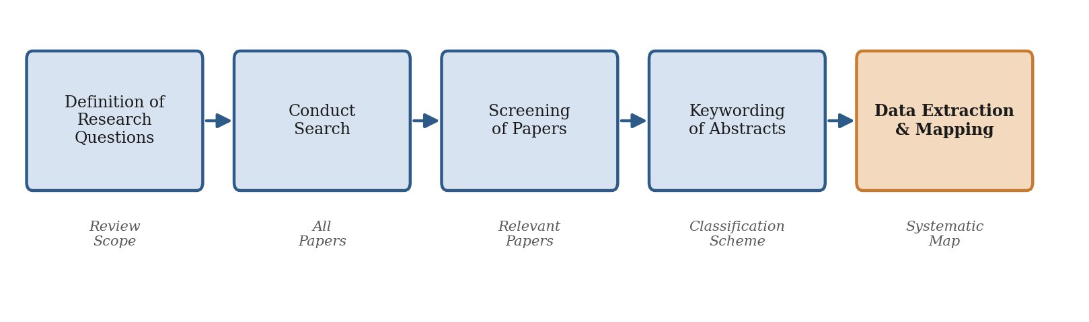
Figure 1: The systematic mapping process (adapted from Petersen et al., 2015).
The fifth step, data extraction and mapping, is the focus of this study. Here, researchers read each paper in full, classify it using the scheme, store the extracted information in data sheets, compute statistics, and build visual maps. The systematic mapping guidelines treat this step not merely as a procedure but as a quality-critical activity: data extraction typically uses structured forms that capture metadata such as research type, contribution, method, venue, and thematic focus, and a dual-reviewer approach is often employed in which one researcher extracts data and another validates it (Kitchenham et al., 2010), to mitigate bias and enhance descriptive validity.
Mapping, or classification, uses both topic-independent and topic-specific schemes. Topic-independent classifications include research type, research method, and publication type, and are often grounded in established frameworks that support cross-study comparison. Topic-specific classifications are either drawn from existing taxonomies, such as SWEBOK, or developed inductively through keywording and open coding. The guidelines also highlight inconsistency in classification when the same scheme is applied by different researchers, underlining the need for clear definitions, training, and consensus, and they make use of visual tools such as bubble plots, heat maps, and bar charts to represent categorised results intuitively.

2.2.3 The Nature of Publication Metadata in Systematic Mapping Studies
This subsection examines the nature of metadata that mapping studies actually extract. Understanding the structure of publication metadata is essential because it determines which natural language processing and machine learning techniques are appropriate for automating extraction.
Publication metadata in a mapping study falls into two broad groups. The first group is descriptive bibliographic metadata that is available directly from the document or its catalogue record: title, abstract, author keywords, publication year, authorship, venue, and publication type. This metadata is comparatively structured and is frequently obtainable through parsing and pattern matching, because it occupies predictable positions in the document and follows recognisable surface patterns. The second group is analytical, map-defining metadata that does not appear verbatim in the paper and must instead be inferred from the text: research type, contribution type, evaluation method, and thematic category of the study. This second group is what makes mapping studies hard to automate, because it requires reading comprehension rather than pattern matching.
The map-defining facets are well established in software engineering. The research-type facet, derived from Wieringa et al.’s classification, distinguishes solution proposals, validation research, evaluation research, experience reports, and opinion or philosophical papers; it captures the maturity of a contribution and the extent to which it has been evaluated. The contribution-type facet distinguishes the kind of artefact a study delivers: tools, methods, processes, models, or metrics. The evaluation-method facet records how a contribution was assessed, for example, discussion, rigorous analysis, simulation, case study, or experiment, indicating the strength of its empirical grounding. The thematic facet captures the sub-topics of the field and is usually induced from the corpus through keywording. These facets are largely categorical and mutually structured, which is precisely why supervised classification and topic modelling are natural automation tools for them.
Three properties of this metadata shape the design of any automation pipeline. It is heterogeneous, spanning structured bibliographic fields and inferred analytical categories that demand different techniques. It is imbalanced, because some categories (for example, solution proposals) dominate while others (for example, opinion papers) are rare, which is why evaluation must weight categories fairly. The process is partly latent, as the thematic categories are not predefined but instead emerge from the underlying corpus. This characteristic motivates the integration of an unsupervised, embedding-based component alongside supervised classification algorithms. The pipeline in this study is structured around exactly these three properties.

2.2.4 Data Extraction and Mapping as the Principal Bottleneck
The evidence reviewed establishes that data extraction constitutes the most resource-intensive and least automated stage of secondary studies. The study by Büchter et al. (2020) confirms, through a scoping review of methodological guidance, that data extraction remains largely manual and reliant on spreadsheets and human judgement, that existing recommendations are fragmented and often insufficient for less-experienced reviewers, and that comprehensive tools to automate this step are still lacking. Therefore, the combination of high cost, high error rate, low automation, and weak tooling makes the data extraction and mapping step the natural target for the present study.

2.2.5 Evidence-Based Software Engineering and the Role of Maps
Systematic mapping studies sit within the broader programme of evidence-based software engineering, which seeks to integrate the best available research evidence with practical experience and human values when making decisions about software development and maintenance. Within this programme, secondary studies provide the mechanism by which scattered primary findings are aggregated into actionable knowledge. Mapping studies, in particular, perform an agenda-setting function: by revealing which questions have been heavily studied and which remain open, they guide the allocation of future research effort and help practitioners locate the evidence relevant to a decision. This function is only as reliable as the extraction and classification underlying it, which is why the quality, consistency and timeliness of the data extraction and mapping step are central to the value of the whole enterprise.
Because a map is a living description of a field, its usefulness decays as new primary studies appear. Keeping a map current therefore requires repeating the data extraction and mapping step periodically, multiplying the manual cost. The notion of a living systematic review, in which evidence is continually incorporated, has gained traction in other disciplines, and its feasibility depends squarely on reducing the per-study cost of extraction. Automation of the kind pursued in this study is thus a precondition for living maps in software engineering, not merely a convenience.

2.3 Automation Efforts in Systematic Mapping and Review

2.3.1 Automation of Study Selection (Screening)
Much of the research on automating secondary studies has concentrated on screening, that is, identifying relevant studies from large corpora. Goldfarb-Tarrant et al. (2020) developed a machine learning pipeline that integrates active learning to prioritise studies for human annotation, reducing screening effort by over 85%. Tools such as ASReview enable semi-automated screening using probabilistic classifiers and user feedback. To reduce labelling requirements, active-learning techniques incorporating uncertainty sampling, diversity-based selection and intelligent stopping criteria have become common, and document embeddings from models such as BERT and Sentence-BERT have improved classifier performance with fewer labelled examples. These systems demonstrate that machine learning can sharply reduce manual labour in initial filtering; however, they are largely confined to relevance classification and have limited impact on the downstream tasks specific to mapping.

2.3.2 Automation of Data Extraction
Data-extraction automation is less mature. Van Dinter et al. (2021), reviewing 41 primary studies on SLR automation, found that although automation is common in study selection, only five reviewed studies addressed data-extraction automation, typically using full-text documents and classification algorithms, and identified the translation of domain models into machine-readable formats as a key challenge. Jonnalagadda et al. (2015) reviewed automatic extraction of critical data elements from full-text medical texts, identifying 52 potential data elements drawn from standard resources such as the Cochrane Handbook, the CONSORT statement and the PICO and PIBOSO frameworks; they concluded that no unified extraction framework existed, that prior work addressed only one to seven elements at a time, and that the absence of common gold standards prevented direct comparison. Bui et al. (2016) built an extractive summarisation system that highlights key clinical elements such as sample size and PICO values, using SVM-based sentence ranking and ontology-based knowledge representation, and they found that the optimal model varies by data type, underscoring the need for tailored rather than one-size-fits-all solutions.

2.3.3 The Tool Landscape
Automated extraction tools such as RobotReviewer, which is strong for risk-of-bias assessment, and ExaCT, which focuses on trial characteristics, have been applied successfully in clinical domains. However, their utility in mapping studies remains underexplored. Sundaram and Berleant (2023) identify a persistent gap in tools capable of automatically extracting structured metadata (research methods, outcomes and populations) across heterogeneous studies, and note that mapping studies additionally require topic clustering, trend visualisation and domain-specific taxonomies that existing tools rarely address. Tsou et al. (2020) compared the screening-prioritisation performance of Abstrackr and EPPI-Reviewer and found both useful for reducing screening workload; these tools, like Rayyan, support collaborative screening and tagging but are not designed to produce SMS-specific outputs such as evidence maps or gap-analysis charts. De La Torre-López et al. (2023) similarly observe that AI-based extraction has been explored mainly through ontology-based systems and SVM classifiers, and that scarcity of tools, simplistic feature representations, domain-specific retraining requirements and a lack of reproducibility benchmarks continue to limit maturity.
Wewerka and Reichert (2023), analysing 63 publications on robotic process automation, reinforce the boundary of rule-based automation: RPA suits rule-based, repetitive tasks over structured data but cannot handle the interpretive, unstructured nature of complex extraction such as that found in secondary studies, and integrating AI with RPA to handle semi-structured data remains at a prototype stage. Taken together, the existing tool landscape indicates that the analytical, map-defining metadata of systematic mapping studies remains the aspect least adequately addressed by current automation tools.

2.3.4 Automation of Review Updating and AI-Assisted Reviews
Beyond screening and extraction, researchers have begun to automate the continual updating of evidence syntheses. Chernikova et al. (2024) demonstrate machine-learning-assisted continuous updating of a meta-analysis in an educational context, showing that classifiers can flag newly relevant studies for inclusion as they are published, keeping a synthesis current with bounded human effort. Wagner et al. (2022) take a wider view, examining how artificial intelligence is reshaping the conduct of literature reviews across their full lifecycle; they argue that AI is most mature in the mechanical stages of search and screening and least mature in the interpretive stages of extraction and synthesis, precisely the imbalance this study addresses. These contributions show a field moving from automating the easy, mechanical steps towards automating the hard, interpretive ones, and they locate the present study at that frontier.

2.3.5 Critical Synthesis of the Automation Literature
Read together, the automation literature exhibits three recurring limitations that frame the present study. First, a phase imbalance: effort has concentrated on study selection, where the task reduces to a single binary include/exclude decision, while data extraction, which requires recovering many heterogeneous fields and assigning several analytical facets, has received far less attention and is rarely evaluated as a complete system (Van Dinter et al., 2021; Marshall & Wallace, 2019). Second, a domain skew: the extraction systems that do exist were developed largely for clinical evidence, where reporting is comparatively standardised, and they transfer poorly to software-engineering mapping studies, whose publication metadata and facet schemes differ markedly (Jonnalagadda et al., 2015).
Third, an evaluation gap: many contributions are proofs of concept reported on small or idiosyncratic corpora without shared baselines, which makes results difficult to compare or reproduce (Felizardo et al., 2024). These three limitations phase imbalance, domain skew, and the evaluation gap are not independent; together they explain why no unified, reproducible extraction-and-mapping pipeline for software-engineering mapping studies yet exists, and they motivate the gold-standard, macro-aware, end-to-end design pursued in this study. The specific gaps that follow from this synthesis are stated formally in Section 2.6.

2.4 Machine Learning and Natural Language Processing Techniques
The preceding sections reviewed what has been automated and how well. This section provides the technical foundation by explaining the core machine learning and natural language processing techniques that are relevant to automating data extraction and mapping. The aim is to demonstrate the methodological understanding that underpins the design choices in Chapters Three and Four, rather than merely to report applications from the literature.

2.4.1 Supervised Classification Algorithms
Assigning each paper to a research type, contribution type, and evaluation method is a multi-class text-classification problem, for which supervised learning is the natural approach. A supervised classifier learns a mapping from a feature representation of a document to a categorical label, using a set of labelled training examples. Several families of classifiers are relevant. Support Vector Machine (SVM) finds the hyperplane that maximally separates classes in a high-dimensional feature space and, with appropriate kernels and regularisation, performs strongly on sparse, high-dimensional text features. Stochastic Gradient Descent (SGD) classifiers optimise a linear model (for example, a hinge or logistic loss) by iterating over training examples; they scale well to large, sparse datasets and often match SVMs on text while training faster. Tree-based ensembles such as random forests and gradient-boosted trees combine many decision trees to capture non-linear interactions and provide feature-importance estimates, although they can be less effective than linear models on very high-dimensional sparse text. Multinomial Naïve Bayes provides a fast probabilistic baseline that models class-conditional word frequencies. Allam et al. (2025), surveying text-classification research from 2019 to 2024, report that contextual deep-learning representations consistently outperform classical algorithms, while also noting persistent challenges of overfitting, class imbalance, and computational cost considerations that motivate combining classical classifiers with modern embeddings rather than discarding either.

2.4.2 Intuition Behind the Principal Classifiers
A brief intuition clarifies why particular classifiers suit this task. A support vector machine seeks the decision boundary that leaves the widest possible margin between classes; on text, where documents are points in a very high-dimensional term space, such margin-maximising boundaries generalise well and resist overfitting. A stochastic-gradient-descent classifier learns a similar linear boundary but updates its parameters one example at a time, which makes it fast and memory-frugal on large sparse matrices while retaining the strengths of linear models. Logistic regression outputs calibrated class probabilities, which is convenient for the confidence thresholding used in the human-in-the-loop mode. Random forests aggregate many decision trees trained on random subsets of features and examples, capturing non-linear interactions at the cost of higher sensitivity to dimensionality. Multinomial Naïve Bayes assumes conditional independence of terms given the class and, despite this strong assumption, provides a fast and surprisingly competitive baseline. The empirical comparison in Chapter Five tests these intuitions on the actual corpus.

2.4.3 Transformer-Based Models
The transformer architecture introduced the self-attention mechanism, which weighs the relevance of every token to every other token in a sequence and thereby captures long-range context. BERT (Bidirectional Encoder Representations from Transformers) is a transformer encoder pre-trained on large corpora using masked-language-modelling and next-sentence objectives; it produces contextual representations in which the same word receives different vectors depending on its surroundings. Sentence-BERT (SBERT) adapts BERT with a Siamese training objective so that whole sentences or passages can be embedded efficiently and compared by cosine similarity, which makes it well suited to document-level clustering and retrieval. Transformer encoders are central to this study in two ways: they supply the sentence embeddings that represent each study for the thematic component and, where available, for the classifiers, and they underlie the class-based descriptors of the topic model. Their main costs, computational demand and the need for sufficient data, are mitigated here by using pre-trained models and by combining them with lighter classical components

2.4.5 Topic Modelling Approaches
Thematic categories in a mapping study are latent and must be induced from the corpus, which is the province of topic modelling. Classical Latent Dirichlet Allocation (LDA) models each document as a mixture of topics and each topic as a distribution over words; it is interpretable but relies on bag-of-words features and can struggle with short or specialised texts. Embedding-based topic modelling, exemplified by BERTopic, instead embeds documents with a transformer, reduces the dimensionality of those embeddings (for example, with UMAP), clusters them, and derives interpretable topic descriptors with a class-based TF–IDF weighting. The clustering step can be density-based (HDBSCAN), which discovers the number of themes and flags outliers, or centroid-based (k-means), in which the number of clusters k is chosen by an internal validity index such as the silhouette coefficient, the mean over documents of how much closer each document is to its own cluster than to the nearest other cluster. Weißer et al. (2020) demonstrate the value of clustering for topic filtering within secondary studies, supporting the choice of an embedding-and-clustering approach for the thematic component of the pipeline.

2.5 Related Work
Most directly relevant to this study, Felizardo et al. (2024) present a proof-of-concept that uses a large language model for data extraction in a software-engineering systematic mapping study. Their results indicate that automated extraction can approach manual quality for several facets while drastically reducing effort, but they report variability across data elements and caution that the approach requires careful evaluation against manual baselines. Zhao et al. (2021) provide a large-scale mapping study of natural language processing for requirements engineering, analysing 404 primary studies from 1983 to 2019; this work is doubly relevant because it exemplifies the kind of large mapping study whose extraction burden motivates automation and because it illustrates the classification facets an automated pipeline must reproduce. The present study builds on this direction by constructing a complete, reproducible pipeline that combines metadata feature extraction, supervised facet classification and transformer-based topic modelling, and by evaluating it against a manually conducted mapping study used as a gold standard. Table 1 summarises the related work and positions the present study within it.
Table 1: Summary of related work on review and mapping automation.
Study | Focus | Stage automated | Domain
Goldfarb-Tarrant et al. (2020) | Active-learning screening pipeline | Study selection | General
Jonnalagadda et al. (2015) | Data-element extraction from full text | Data extraction | Biomedical
Bui et al. (2016) | Extractive summarisation for extraction | Data extraction | Biomedical
Tsou et al. (2020) | Screening-tool comparison | Study selection | Biomedical
Sundaram & Berleant (2023) | NLP/text-mining review of automation | Multiple | Cross-domain
Felizardo et al. (2024) | LLM-based extraction (proof of concept) | Data extraction | Software eng.
This study | ML pipeline for extraction & mapping | Data extraction & mapping | Software eng.

Several further studies inform the design of this work. Marshall and Wallace (2019) provide a practical guide to applying machine learning in research synthesis, cataloguing the points in the review process where automation is reliable and where human oversight remains necessary, and cautioning that automation should support rather than replace reviewer judgement; this motivates the human-in-the-loop mode adopted in Chapter Four. Petersen et al. (2008), in the foundational paper on systematic mapping in software engineering, establish the facet-based classification scheme that this study reproduces automatically, and their later update (Petersen et al., 2015) supplies the process model and the quality criteria against which the pipeline is judged. Together these studies frame the present work as a synthesis of an established methodology with modern representation learning.
A recurring theme across the reviewed literature is the tension between generality and specificity. General tools are reusable but shallow, handling only fields common to many study types; specific tools are deep but brittle, requiring retraining for each new domain. The design adopted here seeks a middle path: a general pipeline architecture whose components are specialised to the software-engineering mapping task through a domain-specific annotated corpus, so that the architecture is reusable while the trained models are accurate for the target domain. The existing tools can be arranged along two dimensions: the review stage they automate and the domain they target. The overwhelming majority occupy the screening-and-biomedical region; very few address extraction in software engineering, and fewer still produce map-specific outputs. The present study deliberately occupies that sparsely populated region and adds the map-generation capability that even its nearest neighbours lack.

2.6 Research Gap
Although the automation of systematic reviews has seen substantial advances in automating systematic literature reviews (SLR), the specific requirements of systematic mapping, such as thematic categorization, visual summaries, and comprehensive data extraction and mapping, are still inadequately addressed. This study aims to address this gap by employing a machine-learning approach to automate data extraction, a crucial step in the systematic mapping study process. This automation is expected to reduce errors and effort and minimize the time required to carry out the SMS process, making it more efficient. The goal is to gather unbiased evidence from primary studies and improve the reliability of the results. This study addresses these gaps by employing a machine learning approach to automate the data extraction and mapping step, reducing errors and effort, lowering the time required, gathering less biased evidence from primary studies, and improving the reliability of the resulting maps.

CHAPTER THREE
RESEARCH METHODOLOGY

3.1 Introduction
This chapter presents the methods and techniques used to achieve the research objectives. It describes the research design and approach, the data-science method followed, the corpus and the gold-standard labels, the unified set of metadata features, the successive stages of the pipeline from preprocessing to modelling, and the evaluation strategy, tools and ethical considerations. The chapter is structured so that each component is traceable to a specific objective and research question.

3.2 Research Design
The study adopts an experimental research design situated within a design-science orientation: an artefact (the pipeline) is built and then evaluated experimentally against a baseline. The experimental design is appropriate because it permits a controlled comparison between the automated pipeline and a manually curated gold standard, so that effectiveness and efficiency can be quantified using objective metrics. The unit of analysis is the individual primary study (an academic paper), and the outcome of interest is the correctness of the extracted and mapped metadata relative to the baseline, together with the time required to produce it.

3.3 Study Area
The study is conducted within the software-engineering domain. Behaviour-driven development is the topic of the reference mapping study, providing a coherent and well-documented corpus on which the pipeline is developed and evaluated before any generalisation to other topics is considered. The software-engineering domain is chosen deliberately because it is where the systematic-mapping methodology originated and where the established facet classifications (research type, contribution type, evaluation method) are most clearly defined.

3.4 Research Approach and Method
The study employs a quantitative research approach, collecting and analysing numerical data derived from experimental results. The classifiers and thematic models are trained and tested on annotated software-engineering papers, and their outputs are compared against manual labels to determine whether automation reproduces expert mapping decisions and reduces effort.
The work follows a typical data-science lifecycle that follows six stages, shown in Figure 2: business and process understanding, data acquisition and understanding, data preprocessing, data analysis, data modelling, and model deployment and evaluation. Each stage maps onto one or more specific objectives, ensuring that the methodology is traceable to the research questions.
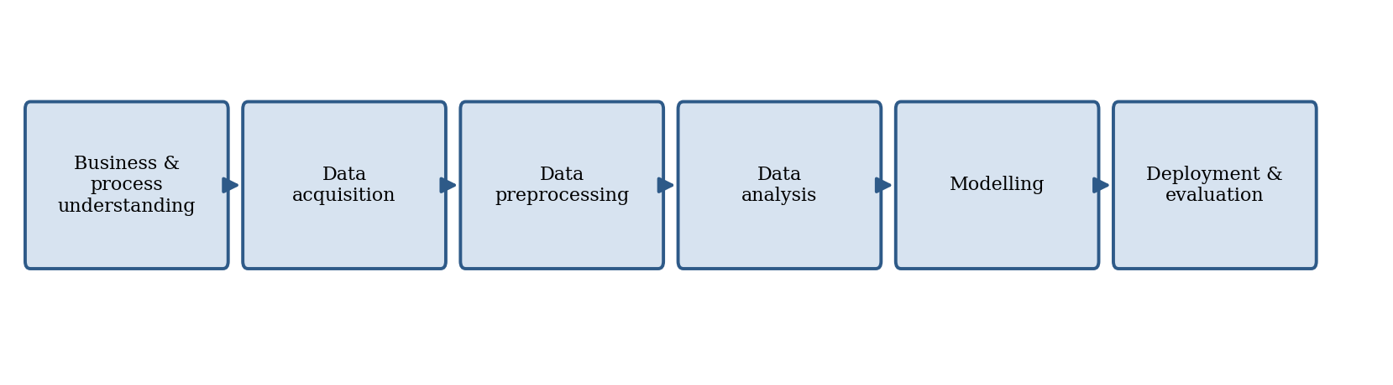
Figure 2: The six-stage data-science lifecycle followed by the study.

3.5 Data Collection and the Gold-Standard Baseline
The study employs secondary data in the form of full-text academic publications. The research corpus comprises the primary studies included in the Behaviour-Driven Development (BDD) systematic mapping study conducted by Binamungu and Maro (2023). The studies were obtained in PDF format from publishers' digital libraries and scholarly databases, including IEEE Xplore, the ACM Digital Library, SpringerLink, ScienceDirect, and other relevant sources
The mapping study by Binamungu and Maro (2023) provides the gold-standard classifications used in this research. Specifically, Appendix A reports the classification assigned by the original authors to each of the 166 primary studies with respect to research type, contribution type, and evaluation method. The corresponding reference list maps each reference number to the title of the associated publication.
The initial corpus contained 126 PDF files. Four files were excluded from the analysis for clearly documented reasons. One file represented a complete conference proceedings volume rather than an individual primary study, one was an exact duplicate of another file, and two were publications that were not included among the 166 primary studies in the reference mapping study, including one publication that appeared after the search period of the original study. Following these exclusions, 122 PDF files remained for analysis. All 122 files correspond to primary studies included in the mapping study by Binamungu and Maro (2023) and were assigned the published gold-standard classifications. Three of the retained publications were image-only PDF scans and therefore required optical character recognition (OCR) to obtain machine-readable text

3.6 Metadata Features for Mapping
In line with the first objective, the pipeline targets a unified set of metadata features, organised into two groups. The first group comprises descriptive bibliographic metadata available from the document, and its records are title, abstract, author keywords, publication year, authors, venue, and publication type. The second group comprises the analytical map-defining facets, which are research type, contribution type, evaluation method, and thematic category. Table 2 defines the facets and their categories.
Table 2: Classification facets and categories used in the mapping.
Facet | Categories | Description
Research type | Solution proposal, validation research, evaluation research, experience paper, philosophical paper, opinion paper | Captures the nature and maturity of the contribution, following Wieringa et al. (2006) as applied by Binamungu and Maro (2023).
Contribution type | Tool, method, process, model, metric, empirical insights | Identifies the kind of artefact or knowledge a study contributes.
Evaluation method | Example, case study, experiment, experience report, discussion, rigorous analysis, simulation | Records how the contribution was assessed and the strength of its empirical grounding.
Thematic category | Induced from the corpus | Topic clusters derived from document embeddings, representing the principal sub-themes.

3.7 Data Preparation
Text preprocessing prepares raw textual data for analysis. Full-text papers are first parsed from PDF into plain text with pdfplumber; a document whose pages contain no text layer (a scanned PDF) is passed page by page through the Tesseract optical-character-recognition engine instead. The abstract is located by a cascade of four strategies of decreasing strictness (a tightly delimited "Abstract" heading, a liberal look-ahead up to the next section heading, the text up to the first numbered heading, and finally the first 400 words of the body), so that every document yields a usable abstract. The reference list is stripped from the body so that cited titles do not contaminate either the cue counts or the term statistics. Two views of each document are then kept: the whole body text without references, used by the lexicon-based labeller and for TF–IDF features, and the title plus abstract, used for the sentence embeddings of the thematic component. Normalisation is deliberately light (lowercasing, tokenisation and English stop-word removal for the TF–IDF branch; no stemming), because the cue phrases and the transformer encoder both rely on natural surface forms.

3.8 Text Representation and Feature Engineering
Classifiers operate on numerical features, so text must first be represented as vectors. The Bag-of-Words model represents a document by term frequencies while ignoring word order, and Term Frequency–Inverse Document Frequency (TF–IDF) weights each term by its frequency in the document relative to its rarity across the corpus, emphasising discriminative terms. These sparse representations are interpretable and effective for topic-bearing vocabulary, but they ignore context and treat synonyms as unrelated. Distributed embeddings address this by encoding words or sentences as dense vectors in a continuous space, so that semantically similar texts lie close together. Sentence-level embeddings, in particular, summarise an entire passage in a single vector and have been shown to support strong clustering and classification with relatively few labelled examples. The pipeline in this study combines TF–IDF with sentence embeddings so classifiers benefit from both discriminative surface terms and semantic context.
A small illustration clarifies how TF–IDF surfaces discriminative terms. In a corpus of mapping-study papers, a term such as “research” appears in almost every document and therefore carries a near-zero inverse-document-frequency, contributing little regardless of how often it occurs. A rarer, topic-bearing term such as “Gherkin” or “bubble plot” appears in few documents and so carries a high inverse-document-frequency; when it also appears several times in a given paper, its TF–IDF weight is large and it strongly characterises that paper. This is exactly the behaviour a facet classifier needs, because it amplifies the terms that distinguish one category from another and suppresses generic academic vocabulary. Its limitation is that it cannot see that “assessed in practice” and “evaluated through a case study” mean something similar is what the sentence embeddings compensate for, which is why the two representations are combined.

3.9 Model Selection and Training
Facets are assigned in two complementary ways. The lexicon-based labeller scores every category of a facet by the weighted number of its cue phrases in the body text and assigns the highest-scoring category; when no cue matches, it falls back to the most common category of the facet and records zero confidence. Its lexicon was written from the category definitions before the gold labels were transcribed and was not tuned on them. The supervised classifiers are one-vs-rest linear models (linear support vector machine, logistic regression and stochastic-gradient-descent hinge-loss classifier, all with balanced class weights), a complementary naive Bayes model and a nearest-centroid (nearest-mean) classifier, trained on the gold labels with the multi-label targets binarised and predicting the single highest-scoring category. They are trained and evaluated by stratified five-fold cross-validation, stratified on the first gold label with categories rarer than five pooled for stratification only, and the configuration with the highest macro-F1 is retained per facet; its stability is checked by repeating the cross-validation with five different fold assignments. For thematic categorisation, the title and abstract embeddings are reduced with UMAP and clustered with k-means; the number of clusters is chosen by the silhouette method over k = 2 to 10 (and the UMAP setting by the same criterion), and a density-based HDBSCAN clustering is fitted for comparison. Cluster descriptors are obtained with class-based TF–IDF (BERTopic). The end-to-end architecture is detailed in Chapter Four.

3.10 Model Evaluation
The pipeline is evaluated against the gold-standard manual labels using accuracy, precision, recall and both macro- and micro-averaged F1, computed per facet as defined in Section 3.16. Because a paper may carry more than one gold category, a predicted label counts as correct when it is one of the paper's gold categories. The lexicon-based labeller is scored directly on all labelled papers; the supervised classifiers are scored by stratified five-fold cross-validation, so that every paper is predicted by a model that did not see it. Agreement at the level of the map is measured by comparing the facet distribution produced by the pipeline with the distribution of the gold labels (and with the distribution published for all 166 studies) using the mean absolute error of the category shares, summarised as a benchmark score of one minus that error, and the cosine similarity of the two share vectors. For the thematic component, the silhouette coefficient, topic diversity and topic coherence are reported. Efficiency is measured as the mean wall-clock time to ingest and label a single study, compared against the manual benchmarks of 107 minutes (single reviewer) and 172 minutes (dual extraction) per study reported by Felizardo et al. (2024); an assisted-mode estimate adds, for every study flagged for review, the manual single-reviewer time. Finally, the review flag itself is evaluated by comparing the accuracy of flagged and unflagged predictions.

3.11 Tools and Materials
Development uses the Python programming language with established libraries: pdfplumber, pymupdf and pytesseract (with the Tesseract 5 engine) for PDF parsing and optical character recognition, pandas and NumPy for data handling, scikit-learn for TF–IDF features, the supervised classifiers, k-means and the evaluation metrics, umap-learn and hdbscan for dimensionality reduction and density-based clustering, sentence-transformers and BERTopic for the embeddings and topic descriptors, and Matplotlib for the visual maps. Ingestion, labelling, and evaluation run on an ordinary CPU environment; the transformer components run on Google Colab.

3.12 Ethical Considerations
As the study relies on published primary studies rather than human participants, its principal ethical considerations concern the responsible use of copyrighted scholarly materials and the potential for model bias to result in unfair or misleading classifications. The full-text publications are used solely for research and analytical purposes and are not redistributed. All publications and data sources are appropriately acknowledged and referenced in accordance with established academic practices.
Potential biases in the automated classification models, particularly the risk of underrepresenting or inadequately classifying less frequently occurring facet categories, are systematically examined and transparently reported. To account for class imbalance and provide a more equitable assessment of model performance across categories, macro-averaged evaluation metrics are employed alongside other relevant performance measures. In addition, ethical and institutional approval for the research was obtained from the University of Dar es Salaam prior to data collection and analysis.

3.13 Detailed Data-Science Lifecycle Stages
To make the methodology fully traceable, each of the six lifecycle stages is explained below, indicating its inputs, activities, and outputs.

3.13.1 Business and Process Understanding
This stage established the problem and the evaluation criteria. The activity was to analyse the systematic-mapping process, identify the data extraction and mapping as the target, and translate the manual benchmarks of effort and the published expert classification into the evaluation criteria. Its output was the requirements specification for the pipeline, including the unified feature set and the evaluation design.

3.13.2 Data Acquisition and Understanding
This stage gathered the full-text primary studies and their manual labels from the baseline mapping studies and characterised them through exploratory analysis. The activity examined the distribution of facet categories, the publication years and venues, and the length and structure of the documents, to anticipate class imbalance and parsing difficulties. Its output was the assembled, characterised corpus and a set of design implications, notably the need for macro-averaged evaluation and for robust PDF parsing.

3.13.3 Data Preprocessing
This stage transformed raw documents into clean, analysable text along the two preprocessing paths. Its activities were parsing, cleaning, tokenisation, normalisation, and the separation of references and boilerplate. Its output was, for each study, a normalised token stream for the lexical branch and a lightly cleaned text for the semantic branch.

3.13.4 Data Analysis
This stage explored the prepared data to surface patterns that informed modelling, including the most discriminative terms per facet category and the separability of categories in embedding space. Its output was a set of analytical insights, such as the comparative weakness of surface keywords for the evaluation-method facet, that guided feature engineering and model choice.

3.13.5 Modelling
This stage trained and selected the supervised classifiers and the thematic model, as described using stratified cross-validation on the gold-labelled corpus and the silhouette method for the number of themes. Its output was the set of selected configurations, recorded in Appendix II.

3.13.6 Deployment and Evaluation
This final stage assembled the modules into the end-to-end pipeline, ran it over the whole corpus, and evaluated effectiveness and efficiency against the gold standard and the manual baseline. Its output was the classified portfolio, the visual map, and the evaluation results reported in Chapter Five.

3.14 Requirements of the Pipeline
From the business-understanding stage, a set of functional and non-functional requirements was derived to guide the design in Chapter Four. Functionally, the pipeline must ingest full-text PDFs, recover descriptive bibliographic metadata, classify each study along the three facets, induce thematic categories, generate the visual map, and export the classified portfolio. Non-functionally, it must be modular so that components can be replaced; reproducible so that runs are deterministic given the same inputs and seeds; transparent so that low-confidence decisions can be surfaced for human review; and efficient enough to process a study in a small fraction of the manual time. These requirements connect the methodology directly to the architecture that follows.

CHAPTER FOUR
DEVELOPMENT OF THE SMS AUTOMATION PIPELINE

4.1 Introduction
This chapter presents the conceptual framework, the design and implementation of the machine learning pipeline that automates the data extraction and mapping phase of a systematic mapping study. It describes the overall architecture and each module in turn: document ingestion and text extraction, preprocessing, lexicon-based facet labelling, supervised facet classification, thematic topic modelling, and map generation. It then characterises the corpus the pipeline processes, and closes with the implementation environment, the requirements the architecture satisfies, the algorithms, a worked example, the testing performed and the output data schema. Short listings of the actual code (Listings 4.1 to 4.5) accompany the modules whose steps are easiest to explain by showing them. The development followed an iterative, modular approach, so that each module can be tested, replaced, or improved without disturbing the rest of the system.

4.2 Conceptual Framework
The conceptual framework in Figure 3 connects the ideas reviewed in Chapter Two to the design of the study. Primary studies of an existing, manually conducted mapping study enter as full-text documents; text is extracted and preprocessed; documents are represented by TF–IDF terms, lexicon cue counts, section indicators and sentence embeddings; and three components then operate on these representations. A lexicon-based labeller assigns the research type, contribution type and evaluation method with a confidence score, addressing the analytical metadata of Section 2.2.3 with the transparent technique of Section 2.4.5; supervised classifiers trained on the gold labels provide a second, learned assignment (Section 2.4.1); and an embedding-based thematic component induces topic clusters (Section 2.4.6). The streams are combined into a classified portfolio with review flags, from which statistics and the visual map are produced, and the whole is evaluated against the gold standard of the reference mapping study with the metrics of Section 2.4.7.
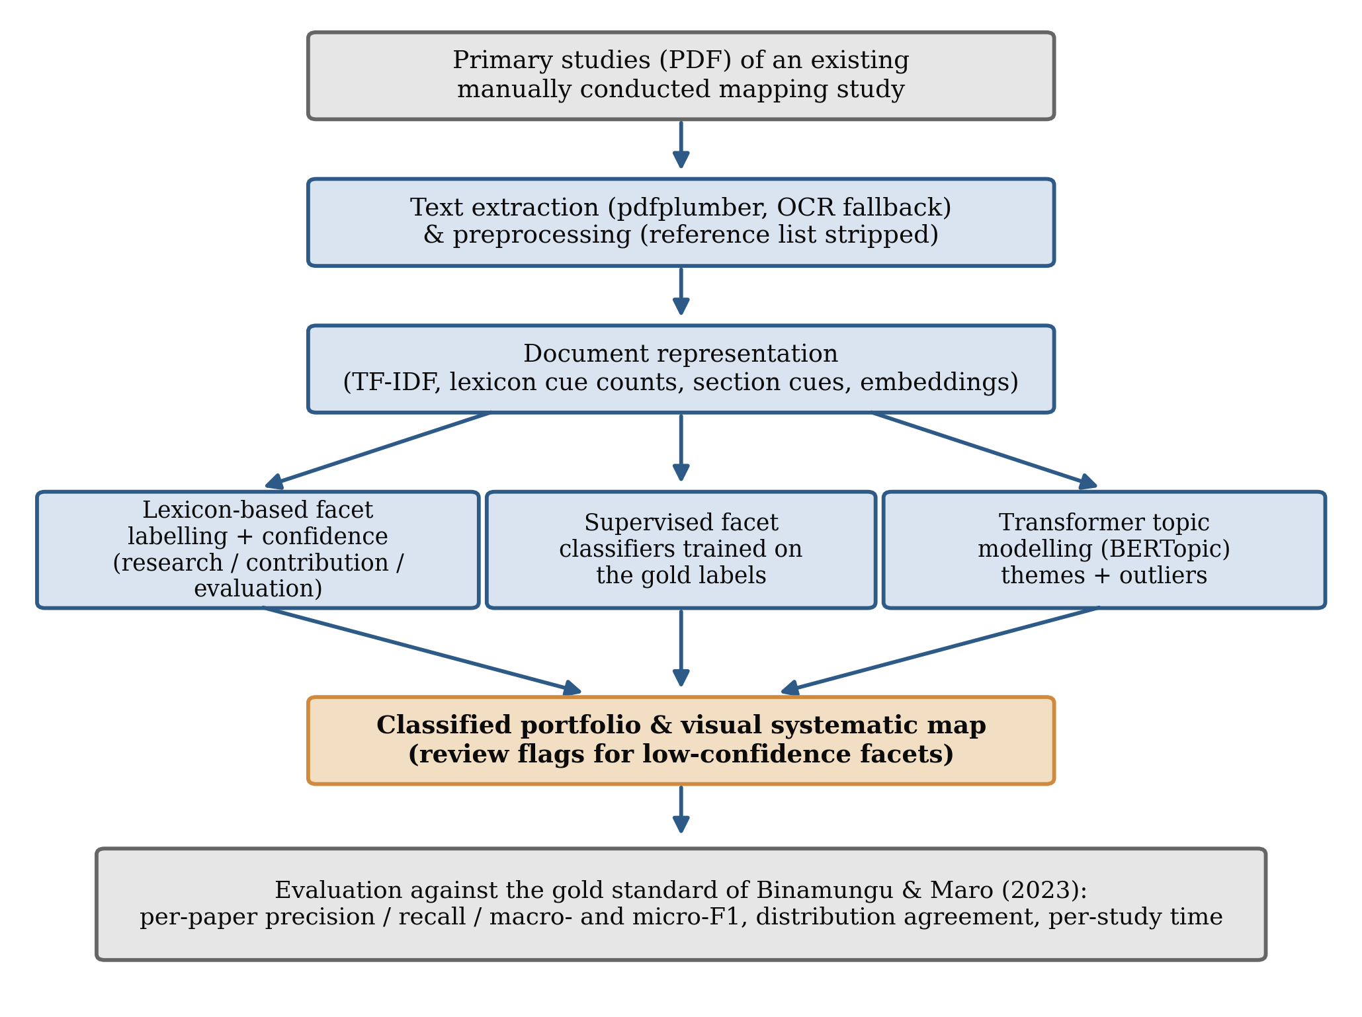
Figure 3: Conceptual framework linking publication metadata, machine learning components and evaluation.

4.3 Overview of the Pipeline Architecture
The pipeline takes as input a set of relevant primary studies, in PDF form, for which screening has already been performed, and produces as output a classified portfolio and a visual systematic map, together with the metrics used to evaluate them. Figure 4 shows the end-to-end architecture. Documents flow through ingestion and preprocessing into a shared representation, after which three components operate: the lexicon-based facet labeller, the supervised facet classifiers and the thematic topic model. Their outputs are merged into the portfolio, from which the map is generated and against which the evaluation is computed.
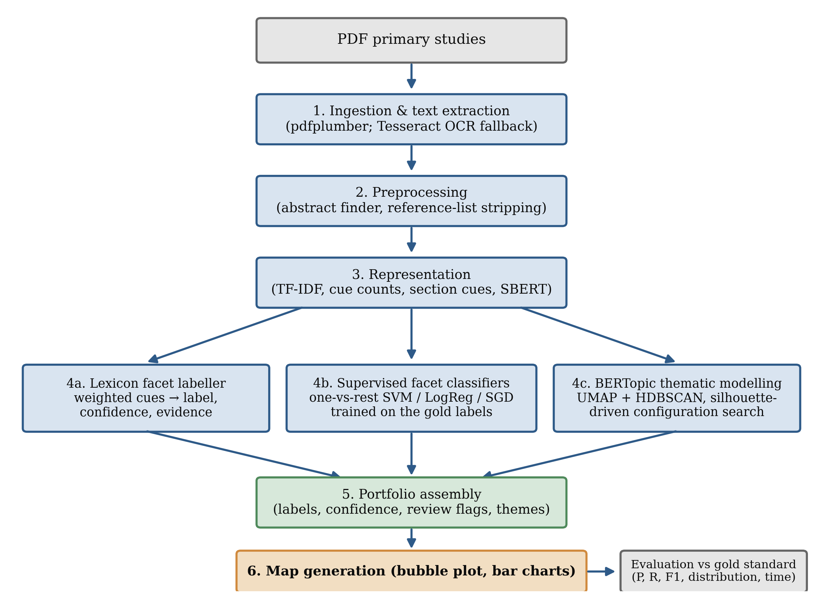
Figure 4: Architecture of the SMS automation pipeline.
The architecture deliberately separates the two metadata groups identified in Section 2.2.3. Descriptive bibliographic metadata (title, abstract, length, page count) is recovered by the ingestion and preprocessing modules, while the analytical, map-defining facets are produced by the labelling, classification and topic-modelling modules. This separation is what allows a single, unified framework to handle heterogeneous metadata, the design response to Gap 2.

4.4 Document Ingestion and Text Extraction
The ingestion module converts each PDF into plain text with pdfplumber, page by page. When a document has no text layer at all, which is the case for scanned papers, the module renders each page at 200 dots per inch and passes it to the Tesseract optical-character-recognition engine; in the corpus of this study 3 of the 122 primary studies were read in this way, so that no study was lost to its file format. The title is taken from the first substantive line of the first page. The abstract is located by a cascade of four strategies of decreasing strictness, described in Section 3.7, and the strategy that succeeded is recorded for every document so that the quality of the extraction can be audited. Robust ingestion is more consequential than it first appears, because every later decision depends on the text it produces: academic PDFs vary widely in their internal structure, and multi-column layouts, ligatures and image-only pages are all present in the corpus.
Algorithm 4.1: Document ingestion
- Input: a directory of PDF primary studies and a list of files to exclude, with reasons.
- For each PDF: extract the text layer of every page with pdfplumber; if no text was found, OCR every page with Tesseract.
- Record the page count and the word count; identify the title and the abstract (four-strategy cascade).
- Strip the reference list from the body; record the extraction time for the study.
- Output: a record per study containing the title, abstract, body text, page and word counts, text source (text layer or OCR) and extraction time; a log of excluded and failed files.
Listing 4.1: Ingestion with the OCR fallback (sms_pipeline.py, RobustPDFExtractor.extract)
with pdfplumber.open(pdf_path) as pdf:
rec["pages"] = len(pdf.pages)
for page in pdf.pages: # 1. text layer, page by page
t = page.extract_text()
if t:
text += t + "\n"
if not text.strip() and self.ocr_fallback: # 2. scanned PDF -> Tesseract OCR
for page in pdf.pages[: self.ocr_max_pages]:
img = page.to_image(resolution=200).original
text += (pytesseract.image_to_string(img) or "") + "\n"
rec["source"] = "ocr"
rec["full_text"] = text
rec["title"] = self._title(text)
rec["abstract"], rec["abstract_strategy"] = self._abstract(text) # four-strategy cascade

4.5 Preprocessing Module
The preprocessing module prepares the extracted text for the three consumers described in Section 3.7. The labeller receives the whole body text without the reference list, lower-cased; the TF–IDF vectoriser receives the same text (or its first 3,000 words) and applies tokenisation, English stop-word removal and unigram-plus-bigram extraction; and the sentence encoder receives the raw title and abstract. No stemming is applied, because the cue phrases of the labeller and the transformer encoder both rely on natural surface forms. The module also computes the lexicon cue counts and the section-heading indicators of Section 3.8, which are shared by the labeller and the classifiers.

4.6 Lexicon-Based Facet Labelling Module
The labelling module assigns each study a research type, a contribution type and an evaluation method by matching weighted cue phrases. Every category of a facet has a small lexicon of phrases with weights from 1 to 4 (multi-word phrases, which are more specific, carry higher weights); the score of a category is the weighted number of occurrences of its phrases in the body text, and the category with the highest score is assigned. The margin between the best and the second-best score, divided by the best score, is the confidence of the decision, and the phrases that fired are stored as evidence. When no phrase of any category matches, the module assigns the most frequent category of the facet in the reference mapping study and records a confidence of zero, so that such studies are always flagged for review. Figure 5 shows the module's actual output for one study of the corpus (reference [95] of Binamungu and Maro, 2023): the three labels, their confidence, the cue phrases that produced them and, for comparison, the gold labels.
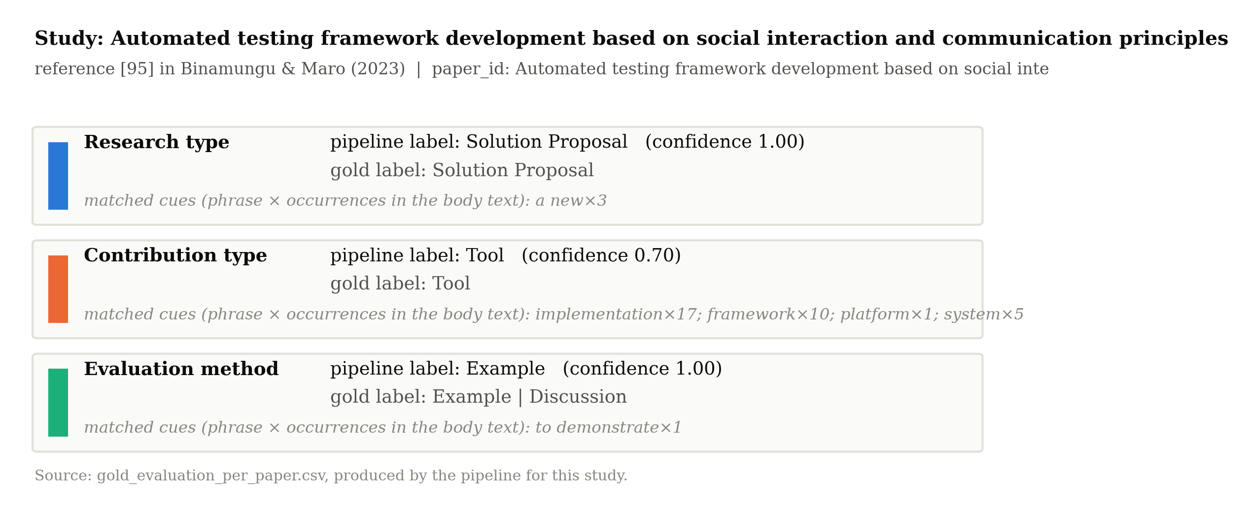
Figure 5: Output of the lexicon-based labelling module for one primary study, with the matched cue phrases as evidence and the gold labels for comparison.
The lexicon was written from the category definitions of Appendix IV before the gold labels were transcribed and was not altered afterwards; the evaluation in Chapter Five therefore measures how far an a-priori lexicon reproduces expert judgement, not how well phrases can be fitted to a known answer. The module's transparency is its main virtue: a reviewer who disagrees with a label can see exactly which phrases produced it.
Listing 4.2: Lexicon-based facet labelling with confidence and evidence (LexiconFacetLabeller.label)
def label(self, text, facet):
text = text.lower(); scores, cues = {}, {}
for cat, kws in self.LEXICONS[facet].items(): # weighted cue phrases per category
s, c = 0, []
for kw, w in kws:
h = self._hits(text, kw) # phrases: exact count; words: word boundary
if h: s += h * w; c.append(f"{kw}x{h}")
if s > 0: scores[cat], cues[cat] = s, c
if not scores: # no cue at all -> default, confidence 0
return {"label": self.DEFAULTS[facet], "confidence": 0.0, "cues": ""}
ranked = sorted(scores.items(), key=lambda x: -x[1])
best, s1 = ranked[0]; s2 = ranked[1][1] if len(ranked) > 1 else 0
return {"label": best, "confidence": (s1 - s2) / s1, "cues": "; ".join(cues[best][:6])}

4.7 Supervised Facet Classification Module
The supervised module learns each facet from the gold labels. Three independent classification problems are set up, one per facet, each with the gold categories binarised so that a paper with two gold categories is a positive example of both. Five classifier families are compared (linear support vector machine, logistic regression and hinge-loss stochastic gradient descent in one-vs-rest form, complement naive Bayes, and a nearest-centroid classifier that assigns the category whose mean feature vector is most similar), on four feature sets (TF–IDF of the first 3,000 words, TF–IDF of the whole body, and each of these concatenated with the cue counts and section indicators; sentence embeddings are appended when the encoder is available). Class imbalance, which is pronounced for the rarer categories, is handled through balanced class weights. The module predicts, for each study, the highest-scoring category per facet.
Training one classifier per facet, rather than a single classifier over the Cartesian product of all facet combinations, is a deliberate design choice. It keeps each classification problem small enough to learn from roughly a hundred examples, allows each facet to use the features most relevant to it, and localises errors. Because the gold labels are needed to train these models, their role in a new mapping study is that of a second opinion trained on a previously mapped corpus of the same field; the lexicon-based labeller, which needs no training data, remains the component that can be applied to a fresh topic immediately.
Algorithm 4.2: Supervised facet classification (evaluation mode)
- Input: feature matrices for the labelled studies; gold label sets per facet.
- For each facet: stratified five-fold split on the first gold label (rare categories pooled for stratification).
- For each fold, feature set and classifier: fit on the training folds (one-vs-rest, balanced class weights), predict the highest-scoring category on the held-out fold.
- Score the out-of-fold predictions against the gold sets; retain the configuration with the highest macro-F1; repeat its cross-validation with five fold assignments.
- Output: out-of-fold predictions per study, per-facet metrics, the selection grid and the stability of the selected configuration.
Listing 4.3: Out-of-fold prediction of the supervised classifiers (SupervisedFacetClassifier.cv_predict)
primary = np.array([g[0] for g in gold]) # first gold label -> stratification key
strat = primary.copy(); strat[np.isin(strat, rare)] = "_rare_"
Y = MultiLabelBinarizer().fit_transform(gold) # a paper with two categories is positive for both
for tr, te in StratifiedKFold(n_splits=5, shuffle=True, random_state=seed).split(X, strat):
keepc = Y[tr].sum(axis=0) > 0 # categories present in the training folds
mdl = OneVsRestClassifier(LinearSVC(class_weight="balanced", C=0.5)) # or LogReg / SGD / CNB
mdl.fit(X[tr], Y[tr][:, keepc])
scores = mdl.decision_function(X[te])
preds[te] = [kept[i] for i in scores.argmax(axis=1)] # single highest-scoring category
metrics = ml_metrics(list(preds), gold, labels) # multi-label-aware P / R / F1
Listing 4.4: Multi-label-aware scoring against the gold labels (ml_metrics)
for p, g in zip(y_pred, y_gold): # p: predicted category, g: set of gold categories
if p in g: correct += 1; tp[p] += 1
else: fp[p] += 1
for c in g:
if c != p: fn[c] += 1
for c in labels:
P = tp[c] / (tp[c] + fp[c]) if tp[c] + fp[c] else 0.0
R = tp[c] / (tp[c] + fn[c]) if tp[c] + fn[c] else 0.0
F = 2 * P * R / (P + R) if P + R else 0.0
macro_f1 = mean(F over classes with support > 0)
micro_f1 = 2*TP / (2*TP + FP + FN) # pooled over classes
accuracy = correct / len(y_pred)

4.8 Thematic Topic Modelling Module
The thematic module induces the topic-specific categories of the map directly from the corpus, using the embedding-based approach motivated in Section 2.4.6. The title and abstract of every study are embedded with the pre-trained Sentence-BERT model all-MiniLM-L6-v2 (384 dimensions); the embeddings are reduced with UMAP (cosine metric, minimum distance 0) and clustered with k-means. The number of clusters is not fixed in advance: k-means is fitted for k = 2 to 10 and for each UMAP setting of a small grid (2 or 5 components; 10, 15 or 30 neighbours), the silhouette coefficient is computed for every solution, and the solution with the highest silhouette in the clustered space is retained (the silhouette method). A density-based HDBSCAN clustering is fitted on the same space for comparison, because it can flag outliers that fit no theme. Each cluster is labelled with its most characteristic terms by class-based TF–IDF, and the cluster-assignment confidence of a study is the relative margin between its distance to the nearest and to the second-nearest centroid. Topic diversity (the share of distinct terms among the cluster descriptors) and C_v coherence are reported alongside the silhouette so that the quality of the thematic structure is judged on more than one criterion.
Listing 4.5: Number of themes by the silhouette method (run_topic_model)
for nc in UMAP_GRID["n_components"]: # 2 or 5 dimensions
for nn in UMAP_GRID["n_neighbors"]: # 10, 15 or 30 neighbours
reduced = UMAP(n_neighbors=nn, n_components=nc, min_dist=0.0,
metric="cosine", random_state=seed).fit_transform(embeddings)
for k in range(2, 11): # candidate numbers of clusters
km = KMeans(n_clusters=k, n_init=10, random_state=seed).fit(reduced)
sil_r = silhouette_score(reduced, km.labels_) # clustered space
sil_e = silhouette_score(embeddings, km.labels_, metric="cosine") # raw space
if best is None or sil_r > best["silhouette_reduced"]:
best = {"k": k, "umap": (nc, nn), "silhouette_reduced": sil_r, "model": km}
keywords = c_tfidf_keywords(docs, best["model"].labels_) # class-based TF-IDF descriptors

4.9 Map Generation and Visualisation Module
The final module assembles the classified portfolio and generates the SMS-specific outputs that distinguish a mapping study from a screening tool. It produces the descriptive statistics of the corpus, a bubble plot cross-tabulating contribution type against research type, bar charts of category frequencies, and the thematic cluster sizes with their descriptors. These outputs are the direct response to Gap 3: rather than stopping at relevance classification, the pipeline produces the evidence map that a mapping study exists to deliver. The module writes the portfolio to a structured file (Section 4.16) so that researchers can inspect, correct and reuse the extracted metadata, and it writes every figure of Chapter Five from the same run.

4.10 Corpus Characteristics
The pipeline records the length of each primary study, which is a useful descriptive characteristic of the corpus and a practical determinant of processing cost. Figure 6 shows the distribution of primary-study length in words for the 122 studies. The corpus is dominated by papers of a few thousand words, with a median of 4,070 words and an interquartile range from 2,414 to 5,792 words, alongside a tail of much longer documents (8 studies exceed 12,000 words; the longest, a 113,976-word monograph-length paper, is capped for display). Page counts range from 2 to 315. This spread confirms that the ingestion and preprocessing modules must cope with a wide range of document sizes, from short workshop papers to long journal articles, which is one reason the architecture treats parsing robustness as a first-class concern, and it is why the TF–IDF features are computed both on the first 3,000 words and on the whole body.
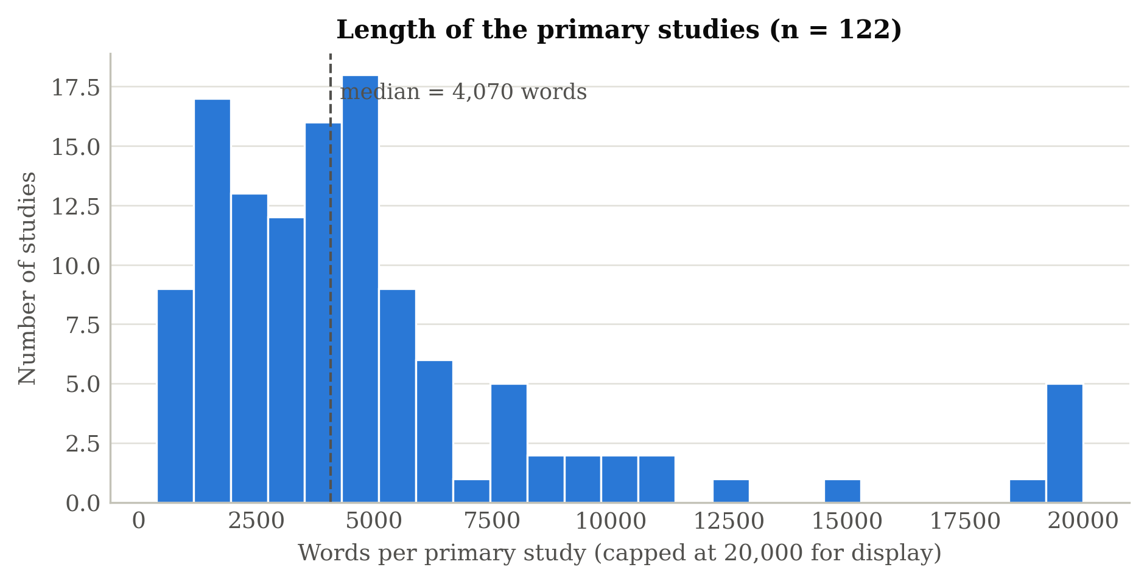
Figure 6: Distribution of primary-study length in words (n = 122).

4.11 Implementation Environment
The pipeline is implemented in Python 3.11 as one importable module organised in numbered sections (ingestion, labelling, gold-label handling and metrics, feature engineering and supervised classification, distribution benchmark, thematic module, orchestration) and driven by a Colab notebook that installs pinned dependencies, runs the whole study and generates the figures. PDF parsing uses pdfplumber with pytesseract and Tesseract 5 for OCR; features, classifiers, k-means and metrics use scikit-learn; dimensionality reduction and density-based clustering use umap-learn and hdbscan; embeddings and topic descriptors use sentence-transformers and BERTopic; the figures use Matplotlib. Ingestion, labelling and the supervised evaluation run on an ordinary CPU; the transformer components run on Google Colab. Random seeds are fixed, library versions are pinned (Appendix II), and an extraction cache lets the evaluation be repeated without re-reading the PDFs.

4.12 Functional and Non-Functional Requirements
The architecture realises the requirements derived in Section 3.14. Functionally, each requirement maps to a module: ingestion satisfies PDF intake, OCR and bibliographic recovery; the labelling and classification modules satisfy facet assignment; the thematic module satisfies theme induction; and the map-generation module satisfies portfolio export and visualisation. Non-functionally, modularity is achieved by the sectioned module design, reproducibility by fixed seeds, pinned versions and the single metrics file from which all reported numbers are drawn, transparency by the stored cue evidence and the confidence-based review flags, and efficiency by the extraction cache and the light-weight labeller, which processes a study in seconds.

4.13 Thematic and Map-Generation Algorithms
For completeness, the two less conventional modules are summarised algorithmically. The thematic module proceeds as in Algorithm 4.3, and the map-generation module as in Algorithm 4.4.
Algorithm 4.3: Thematic topic modelling
- Input: title and abstract of every study.
- Embed the documents with Sentence-BERT (all-MiniLM-L6-v2).
- For each UMAP setting in the grid: reduce the embeddings; for k = 2 to 10 fit k-means and compute the silhouette coefficient.
- Retain the (UMAP setting, k) with the highest silhouette; fit HDBSCAN on the same space for comparison.
- For each cluster, compute class-based TF–IDF to derive an interpretable label; compute confidence, diversity and coherence.
- Output: a theme assignment and confidence per study; the selection grid.
Algorithm 4.4: Map generation
- Input: per-study facet labels, confidences, review flags and theme assignments.
- Cross-tabulate contribution type against research type to obtain bubble counts.
- Compute category frequencies for each facet and the theme sizes.
- Render the bubble plot, bar charts and thematic chart; export the classified portfolio (one row per study) to a file.

4.14 Worked Example of the End-to-End Flow
To illustrate the pipeline concretely, consider the study shown in Figure 5, "Automated testing framework development based on social interaction and communication principles" (reference [95] of the reference mapping study). Ingestion recovers the title and abstract from the text layer and records 2,470 words on 4 pages. Preprocessing strips the reference list and lower-cases the body. The labelling module finds the cues a new×3 for the research type, implementation×17; framework×10; platform×1; system×5 for the contribution type and to demonstrate×1 for the evaluation method, and assigns Solution Proposal, Tool and Example with confidences 1.00, 0.70 and 1.00; all three agree with the gold labels (Solution Proposal; Tool; Example or Discussion). The supervised classifiers, trained on the other folds, independently predict Experience Papers, Method and Experience Report. The thematic module places the study in one of the induced clusters, and map generation increments the corresponding bubble in the contribution-by-research-type plot and writes the study's full row to the portfolio. The same flow, applied across the corpus, produces the complete map evaluated in Chapter Five.

4.15 Testing and Validation of the Pipeline
The pipeline was tested iteratively, module by module, before the end-to-end evaluation. Ingestion was checked by comparing recovered titles with the reference list of the reference mapping study during the title matching of Section 3.5, which also exposed the four files that had to be excluded and the three scanned documents that required OCR; the abstract cascade was checked by inspecting the strategy recorded for every document. The labelling module was checked by reading the stored cue evidence for a sample of studies; the supervised module by verifying that every study is predicted exactly once out of fold and that the pooled-category stratification leaves no fold without a category present in training; and the thematic module on a synthetic embedding before the encoder was available. Integration testing confirmed that the modules composed correctly, that the extraction cache was reused without corruption, and that the driver produced a complete portfolio, a metrics file and all figures from a directory of PDFs. Reproducibility was treated as a first-class concern: random seeds are fixed, library versions are pinned and the configuration is recorded (Appendix II), so that a given input directory yields the same portfolio on re-execution.

4.16 Output Data Schema
The pipeline writes one structured record per primary study to a tabular portfolio, which is the artefact from which every map and table in Chapter Five is derived. Defining this schema explicitly fixes the unit of analysis as the individual study and makes the output directly reusable by other researchers, who can query, filter or re-visualise the portfolio without re-running the pipeline. Table 4 summarises the schema; descriptive metadata fields populate the upper rows, analytical facets the middle rows, and provenance and evaluation fields the lower rows.
Table 4: Output data schema of the classified portfolio (sms_results.csv).
Field | Type | Description
paper_id | string | File name of the primary study (surrogate key).
title, abstract | string | Recovered title and abstract; abstract_strategy records which of the four strategies succeeded.
text_source, pages, word_count, extract_s | string / integer / float | Text layer or OCR; page and word counts; extraction time in seconds.
research_type, contribution_type, evaluation_method | categorical | Facet labels assigned by the lexicon-based labeller.
*_confidence | float (0–1) | Score margin of the labeller for each facet.
*_cues | string | Cue phrases (with counts) that produced each facet decision.
review_flag | boolean | True when any facet confidence is below the threshold.
bm_ref, *_gold | integer / string | Reference number and gold categories in Binamungu and Maro (2023); multiple categories joined by '|'.
*_supervised | categorical | Out-of-fold prediction of the best supervised classifier (evaluation file).
theme, theme_confidence | integer / float | Induced thematic cluster and assignment confidence.
The review_flag field operationalises the human-in-the-loop design: records for which any facet was labelled with confidence below the configured threshold are flagged for reviewer attention, so that scarce expert time is directed at the decisions the system is least sure of. The cue fields record, for each decision, the phrases that produced it, which is what makes an automated assignment auditable rather than opaque. Together, these fields ensure that the portfolio is not merely a set of predictions but a transparent, reviewable record of how each prediction was reached.

CHAPTER FIVE
FINDINGS AND DISCUSSION

5.1 Introduction
This chapter presents and discusses the findings obtained when the pipeline described in Chapter Four was applied to the corpus described in Chapter Three. It first reports the experimental setup and the dataset, then the results of metadata extraction, of the lexicon-based facet labelling and of the supervised facet classification against the gold standard, the thematic modelling, the systematic map, the comparison with the manual baseline in both distribution and time, and the evaluation of the human-in-the-loop flag. The chapter then discusses the findings, considers the threats to validity, analyses the errors, and relates the results to the literature and to practice. Every number reported here is taken from the evaluation file of a single execution of the released pipeline; the figures are generated from the same file.

5.2 Experimental Setup and Dataset
The primary-study folder contained 126 PDF files. Four were excluded before analysis: a complete XP 2018 conference-proceedings volume (315 pages) that is not a primary study, an exact duplicate of another file, and two papers that are not among the primary studies of the reference mapping study. The remaining 122 files were all processed successfully; 3 of them had no text layer and were read by OCR. All 122 carry gold labels from Binamungu and Maro (2023); one philosophical paper has no evaluation-method label in the reference study, so the evaluation-method facet is scored on 121 studies. Table 5 summarises the composition of the corpus by research type, the facet the reference study reports first, comparing the gold labels with the labels assigned by the pipeline, and Figure 7 shows the same comparison for all three facets.
Table 5: Composition of the corpus by research type: gold labels versus pipeline labels.
Research type | Gold labels (n, %) | Pipeline labels (n, %)
Solution Proposal | 54 (43.5%) | 53 (43.4%)
Validation Research | 40 (32.3%) | 25 (20.5%)
Evaluation Research | 19 (15.3%) | 39 (32.0%)
Experience Papers | 8 (6.5%) | 4 (3.3%)
Philosophical Papers | 3 (2.4%) | 1 (0.8%)
Opinion Papers | 0 (0.0%) | 0 (0.0%)
Total label assignments | 124 | 122
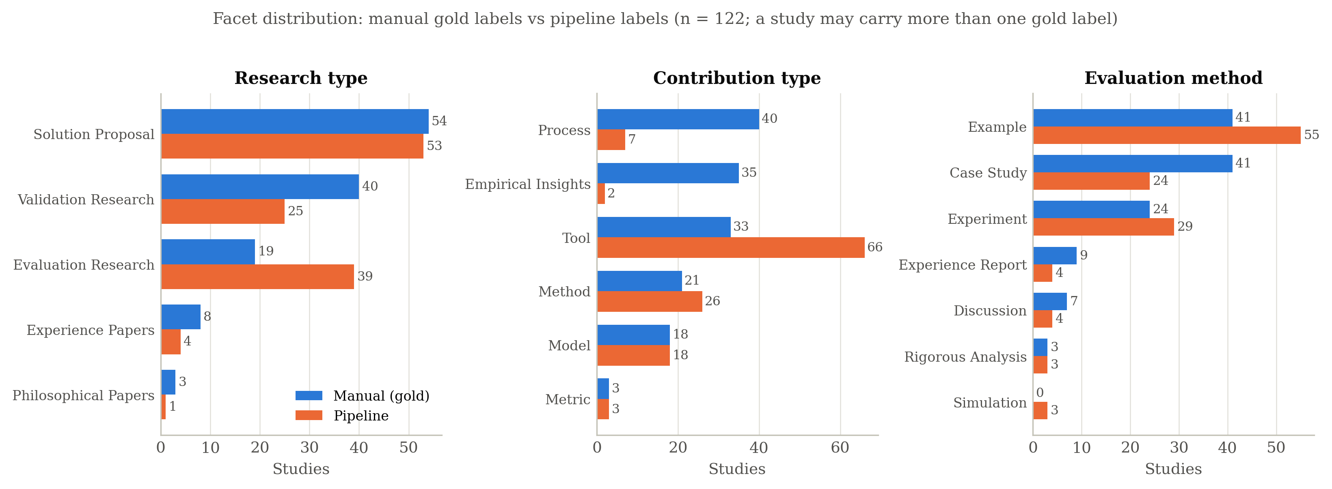
Figure 7: Distribution of primary studies across the three facets: gold labels versus pipeline labels (n = 122).
Two properties of the corpus visible in Figure 7 shape everything that follows. First, the categories are imbalanced: solution proposals (54) and validation research (40) dominate the research-type facet while philosophical papers number 3; on the contribution-type facet the metric category has 3 studies; on the evaluation-method facet rigorous analysis has 3. This imbalance is typical of software-engineering corpora and is the reason macro-averaged F1 is reported alongside micro-averaged F1. Second, the gold standard is multi-valued for a minority of papers, most often on the contribution-type facet, which the metrics of Section 3.16 accommodate.

5.3 Metadata Extraction Results
Extraction of descriptive metadata was performed for every study. The title and the word and page counts were recovered for all 122 studies. Abstract recovery, the field most likely to fail because of varied paper layouts, succeeded for every study: the strict heading-delimited strategy found the abstract in 10 papers, the liberal look-ahead in 96, the first-numbered-heading strategy in 5, and the fallback to the first 400 words of the body was needed for 11 papers, so that no study was left without text for the downstream stages. Table 6 reports the coverage of each field. Extraction took a median of 1.4 seconds per study from a text layer; the three OCR cases took between 95 and 145 seconds each.
Table 6: Descriptive metadata extraction coverage.
Metadata field | Coverage | Notes
Title | 100% | First substantive line of the first page.
Abstract | 100% | 10 strict, 96 liberal, 5 numbered-heading, 11 fallback.
Body text | 100% | 119 from the text layer, 3 by OCR.
Word count, page count | 100% | Computed from the extracted text and the PDF.
Reference number in the reference study | 100% | By title matching (Section 3.5).

5.4 Facet Labelling Results against the Gold Standard
The lexicon-based labeller was scored on every labelled study against the gold categories. Table 7 reports accuracy and macro-, micro- and weighted F1 per facet; Figure 8 plots the macro- and micro-F1 of the labeller next to those of the best supervised classifier of Section 5.5. The labeller places 45.9% of the studies in a correct research type, 36.9% in a correct contribution type and 49.6% in a correct evaluation method; all three facets are correct for 12.3% of the studies. Macro-F1 is lower than micro-F1 on every facet, and the gap locates the weakness in the rare categories: on the research-type facet the three philosophical papers are never recognised, and on the evaluation-method facet the seven discussion papers are never recognised.
Table 7: Agreement of the lexicon-based labeller with the gold labels, per facet.
Facet | n | Accuracy | Macro-F1 | Micro-F1
Research type | 122 | 0.459 | 0.331 | 0.455
Contribution type | 122 | 0.369 | 0.351 | 0.331
Evaluation method | 121 | 0.496 | 0.421 | 0.488
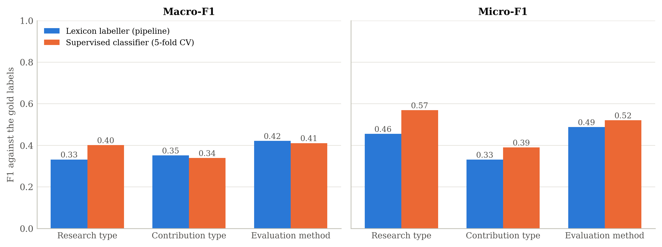
Figure 8: Macro- and micro-F1 against the gold labels: lexicon-based labeller and best supervised classifier, per facet.
Figure 9 shows the confusion matrix of the research-type facet. Its structure explains most of the shortfall. The labeller over-assigns evaluation research (predicted 39 times for 19 gold cases), because phrases such as "case study" and "in practice" occur in many validation-research and solution-proposal papers that merely mention them; and it confuses validation research with solution proposals (13 cases) and with evaluation research (13 cases), the boundary that the mapping guidelines themselves describe as the least crisp. Solution proposals, the largest category, are recognised with an F1 of 0.58. On the contribution-type facet the labeller over-assigns the tool category (predicted 66 times for 33 gold cases), because general words such as "framework", "system" and "implementation" are ubiquitous, and it almost never recognises empirical insights (recall 0.03) or process contributions (recall 0.10), which authors rarely announce with a fixed phrase. On the evaluation-method facet, example, case study and experiment reach F1 of 0.57, 0.49 and 0.49, and the main confusion is between case study and experiment. The per-class figures for all facets are given in Section 5.12.
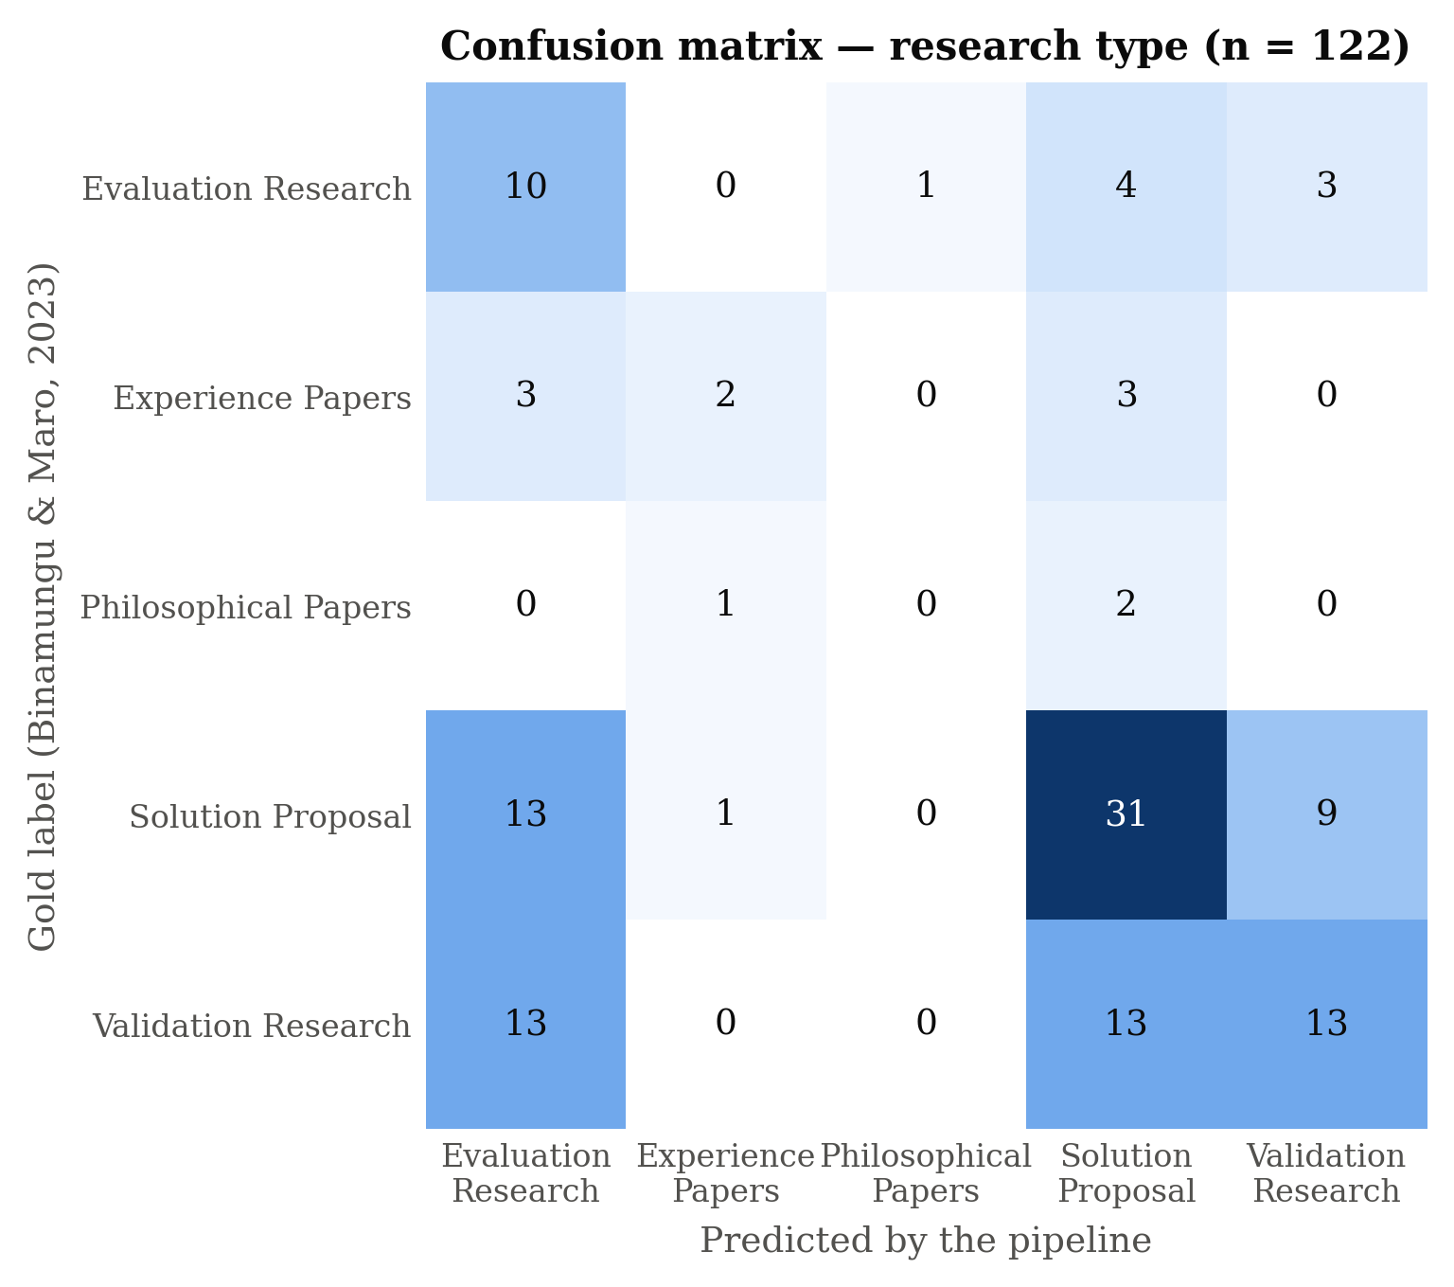
Figure 9: Confusion matrix of the lexicon-based labeller for the research-type facet (rows: gold label; columns: pipeline label).

5.5 Supervised Facet Classification Results
The supervised classifiers were trained on the gold labels and scored out of fold under stratified five-fold cross-validation, for every combination of the five classifiers and the feature sets of Section 3.8 (20 configurations per facet). Table 8 reports the best configuration per facet with its accuracy, macro- and micro-F1 and the mean and standard deviation of macro-F1 over five repeated cross-validations; Table 9 reports the best macro-F1 obtained with each feature set, which is the ablation of the representation, shown graphically in Figure 10. The best supervised model improves on the lexicon-based labeller in accuracy on every facet (0.57 against 0.46 for research type, 0.43 against 0.37 for contribution type and 0.53 against 0.50 for evaluation method), and in macro-F1 on the research-type facet; the differences are modest, and the repeated cross-validation shows standard deviations of 0.03 to 0.04, so the ranking of configurations should not be over-interpreted.
Table 8: Best supervised configuration per facet under stratified five-fold cross-validation.
Facet | Best classifier and features | Accuracy | Macro-F1 (repeated CV) | Micro-F1
Research type | SGD (hinge); tfidf[full] | 0.574 | 0.401 (0.371 ± 0.034) | 0.569
Contribution type | Nearest Centroid; tfidf[full] | 0.434 | 0.339 (0.341 ± 0.014) | 0.390
Evaluation method | Logistic Regression; tfidf[first3000]+cues+sect | 0.529 | 0.410 (0.370 ± 0.036) | 0.520
Table 9: Feature-set ablation: best macro-F1 over classifiers for each feature set and facet.
Feature set | Research type | Contribution type | Evaluation method
tfidf[first3000] | 0.392 | 0.327 | 0.401
tfidf[full] | 0.401 | 0.339 | 0.341
tfidf[full]+cues+sect | 0.387 | 0.292 | 0.409
tfidf[first3000]+cues+sect | 0.389 | 0.292 | 0.410
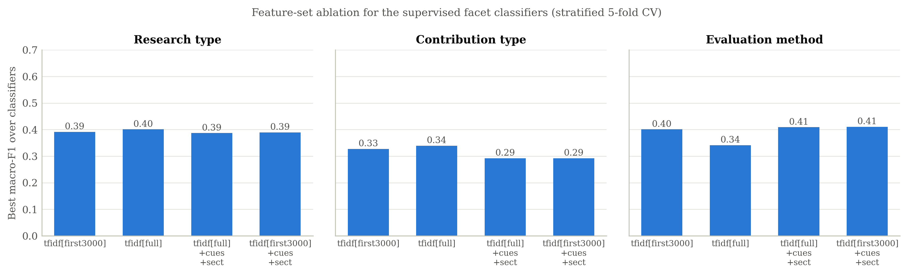
Figure 10: Feature-set ablation for the supervised facet classifiers (best macro-F1 over classifiers).
The ablation gives a nuanced picture. Whole-body TF–IDF is the strongest single representation for the research type, whereas the cue counts and section indicators help most on the evaluation-method facet, where the presence of an "evaluation" or "case study" section is informative in a way that individual words are not, and they hurt on the contribution-type facet, where the cue phrases are the same general words that mislead the labeller. Linear models with balanced class weights and the nearest-centroid classifier behave similarly; complement naive Bayes is consistently weaker. The overall level, macro-F1 around 0.3 to 0.4 from roughly a hundred training examples spread over five to seven categories, is the central quantitative finding of the study: with this much labelled data, learned classifiers do not yet approach expert consistency on individual papers.

5.6 Thematic Topic Modelling Results
The thematic module was executed on Google Colab, where the sentence-embedding model is available, over the title and abstract of every study. The run reported here (of 29 June 2026) used the density-based configuration of the earlier version of the module: it discovered 2 coherent thematic clusters together with 14 outlier studies that fit no cluster (11.4% of the corpus), with a mean cluster-assignment confidence of 0.82 (median 0.88), a silhouette coefficient of 0.19 in the 384-dimensional embedding space, topic diversity of 0.98 and C_v coherence of 0.15. Table 10 reports the cluster sizes and their leading descriptors, and Figure 11 shows the cluster sizes graphically. The first and much larger cluster groups studies concerned with test-driven and agile development and software testing; the second groups studies on specifications, requirements and architecture.
Table 10: Induced thematic clusters and their leading descriptors (thematic module, Colab run).
Cluster | Studies | Leading descriptors | Share
Topic 0 | 91 | test-driven development, software testing, agile software development | 74.0%
Topic 1 | 18 | specification requirements, BDD specifications, architecture | 14.6%
Outliers | 14 | no clear theme | 11.4%
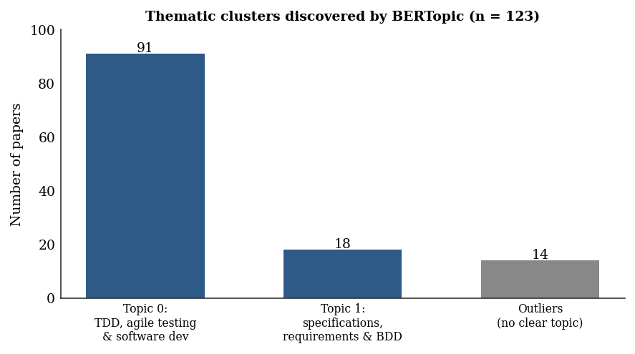
Figure 11: Thematic clusters discovered by the thematic module, with outliers shown separately (Colab run).
Two observations follow. The two-theme solution is coarse, reflecting the strong topical homogeneity of a single-topic corpus on behaviour-driven development, and its silhouette in the raw embedding space is low, which is why the module now selects the number of clusters explicitly by the silhouette method over k-means solutions and a grid of UMAP settings, and reports the silhouette in the clustered space as well as in the raw space (Section 4.8). Explicitly surfacing outliers, or equivalently low-confidence assignments, proved valuable: the flagged studies are the cross-cutting or atypical ones that a human mapper would set aside for individual judgement. The degree to which the induced clusters match the manual thematic categories of the reference study is a separate alignment question that is left to future work, because the reference study induces its themes by keywording rather than by clustering.

5.7 The Systematic Map
Combining the facet labels produced the systematic map itself. Figure 12 presents the characteristic bubble plot cross-tabulating contribution type against research type for the 122 studies, in which the size of each bubble encodes the number of studies. The map makes the structure of the corpus immediately legible: the largest cell is tool contributions presented as solution proposals (30 studies), tools and methods dominate the contribution facet, and the rarer research types and contributions (experience and philosophical papers; metrics and empirical insights) occupy the periphery. The reference study's own map shows the same headline pattern of many proposed solutions and comparatively few rigorously evaluated ones, with one important difference discussed in Section 5.8: the pipeline under-represents process and empirical-insight contributions, which are the categories its lexicon recognises least well. The map is nonetheless the interpretable, decision-supporting artefact that characterises a systematic map, produced without manual extraction.
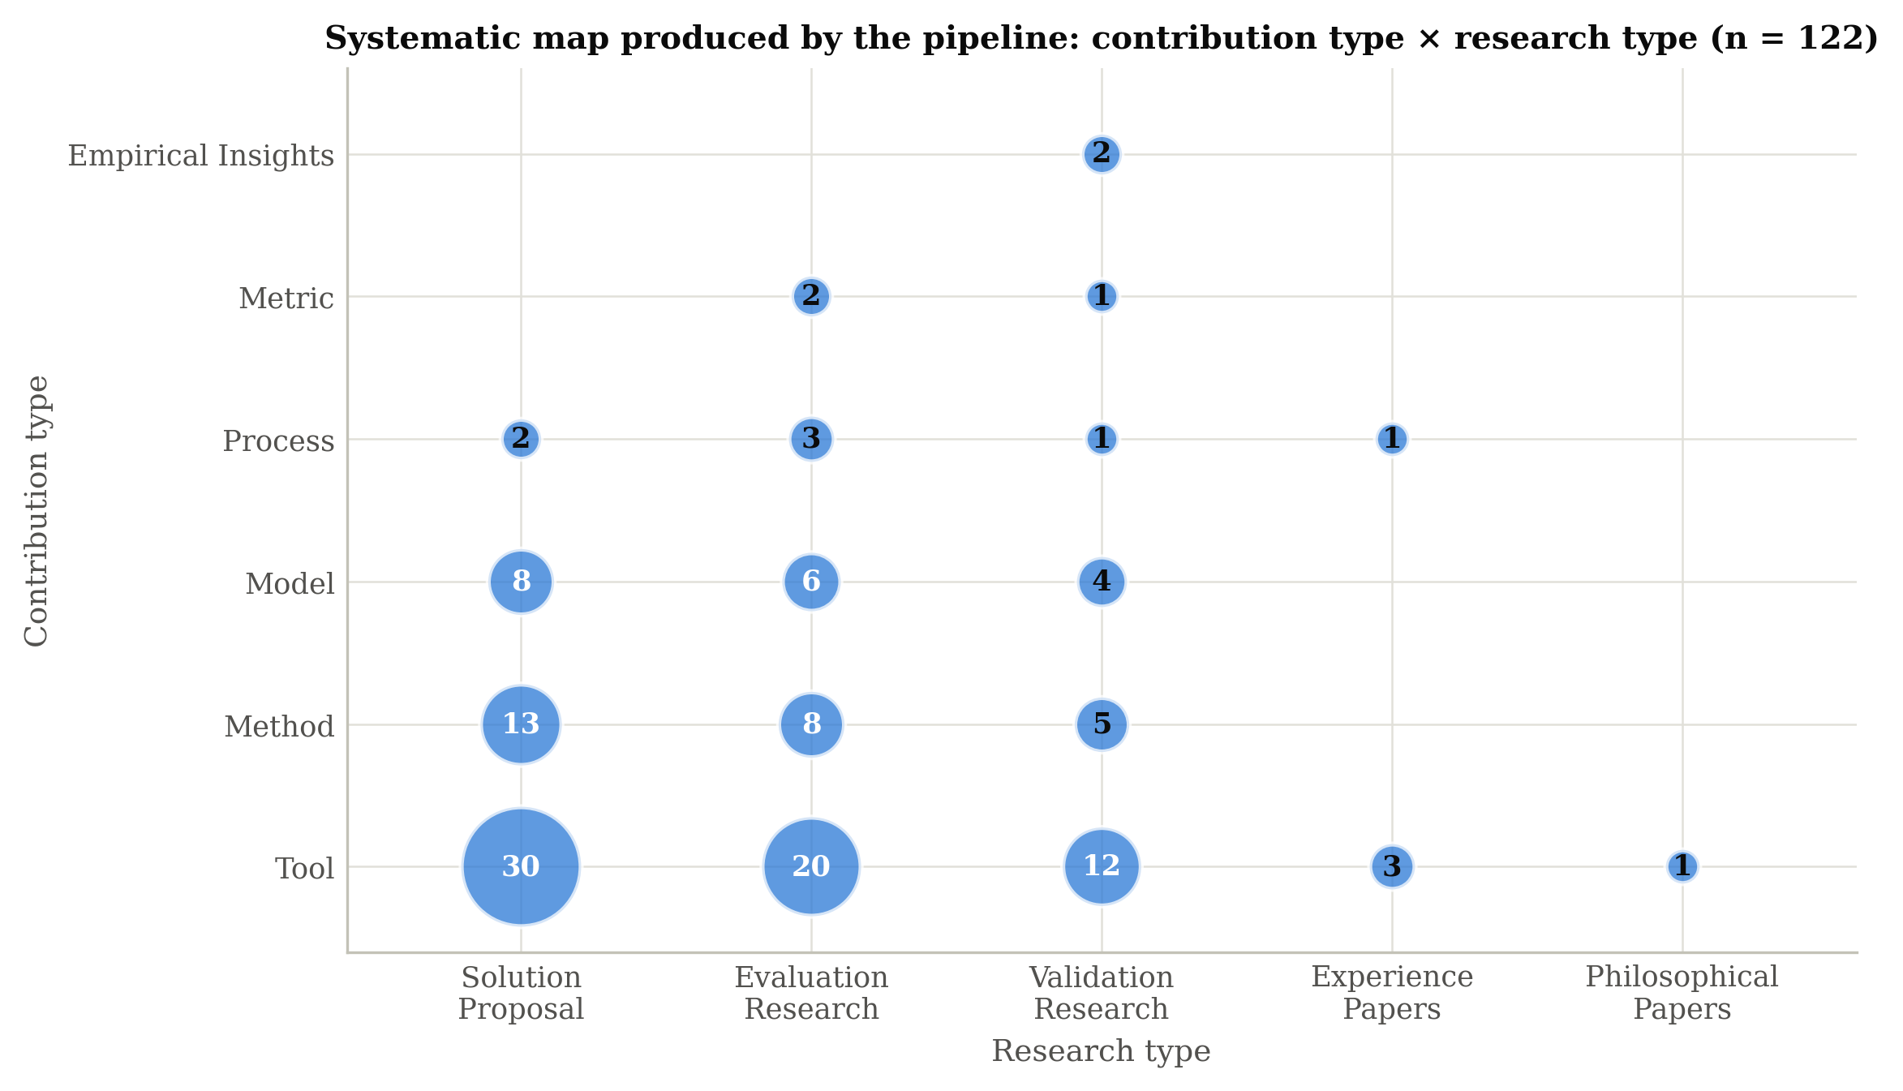
Figure 12: Automatically generated systematic map: contribution type versus research type (n = 122).

5.8 Comparison with the Manual Baseline
Two comparisons are made with the manual baseline: agreement of the facet distributions, and time. For each facet, the distribution of the pipeline's labels is compared with the distribution of the gold labels of the same 122 studies and with the distribution published for all 166 primary studies of the reference mapping study, using the mean absolute error of the category shares (summarised as a benchmark score of one minus the error) and the cosine similarity of the share vectors. Table 11 reports these figures. Agreement is high for the research-type and evaluation-method facets (benchmark scores of 0.933 and 0.935, cosine similarities of 0.935 and 0.938) and lower for the contribution-type facet (0.858 and 0.676), where the pipeline assigns 66 tool contributions against 33 in the gold labels and only 2 empirical-insight contributions against 35. In other words, the automated map has the right overall shape on two facets and a recognisable but distorted shape on the third.
Table 11: Distributional agreement between the pipeline's facet distribution and the manual classification of Binamungu and Maro (2023).
Facet | vs gold labels of the corpus: score / cosine | vs published map (166 studies): score / cosine | MAE of shares (vs gold)
Research type | 0.933 / 0.935 | 0.934 / 0.913 | 0.067
Contribution type | 0.858 / 0.676 | 0.847 / 0.644 | 0.142
Evaluation method | 0.935 / 0.938 | 0.939 / 0.958 | 0.065
The efficiency comparison is shown in Figure 13 and summarised in Table 12. The pipeline needed 5.6 seconds per study on average to ingest and label a study (0.094 minutes; median extraction 1.4 s, the mean being raised by the three OCR cases), against the manual single-reviewer benchmark of 107 minutes and the dual-extraction benchmark of 172 minutes reported by Felizardo et al. (2024), a reduction of 99.9%. This figure is the time of the fully automated pipeline and must be read with the accuracy figures of Sections 5.4 and 5.5: the relevant practical comparison is not machine against human but human alone against human assisted by the pipeline. Under the assisted mode of Section 3.19, in which a reviewer re-examines every flagged study at the manual rate, 69.7% of the studies are flagged and the estimated cost is 74.6 minutes per study, a reduction of 30.2%; because unflagged studies are still labelled correctly only about half of the time (Section 5.9), this estimate is an upper bound on the saving that preserves manual quality.
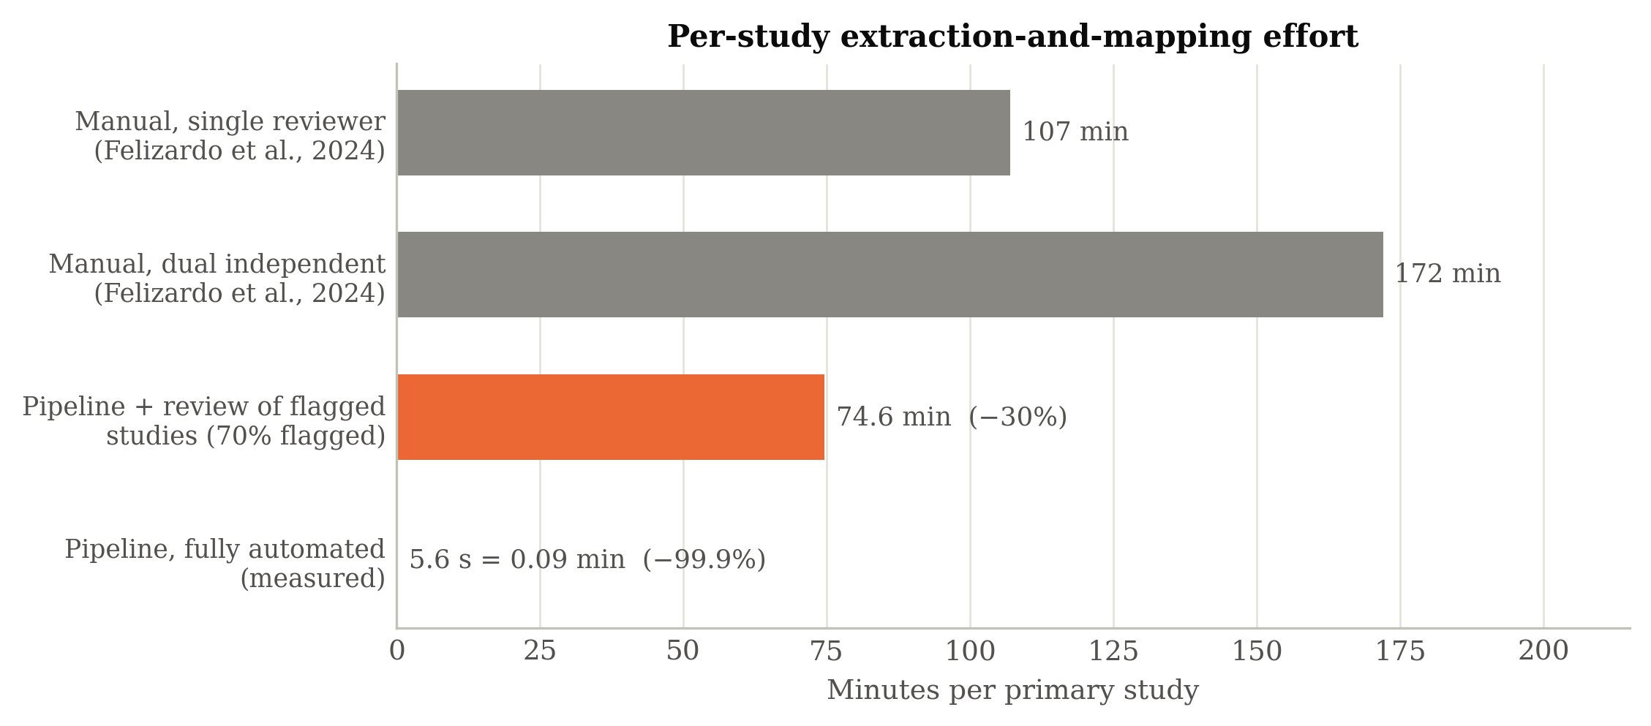
Figure 13: Per-study extraction-and-mapping effort: manual single-reviewer and dual extraction (Felizardo et al., 2024), the pipeline with review of flagged studies, and the fully automated pipeline (measured).
Table 12: Summary of the evaluation outcomes.
Criterion | Lexicon labeller | Best supervised classifier (CV) | Note
Per-paper accuracy — research type | 0.459 | 0.574 | n = 122
Per-paper accuracy — contribution type | 0.369 | 0.434 | n = 122
Per-paper accuracy — evaluation method | 0.496 | 0.529 | n = 121
Macro-F1 — research type | 0.331 | 0.401 | multi-label aware
Macro-F1 — contribution type | 0.351 | 0.339 | multi-label aware
Macro-F1 — evaluation method | 0.421 | 0.410 | multi-label aware
Distribution score — research type | 0.933 | — | vs gold labels of the corpus
Distribution score — contribution type | 0.858 | — | vs gold labels of the corpus
Distribution score — evaluation method | 0.935 | — | vs gold labels of the corpus
Time per study (automated) | 5.6 s | — | 99.9% below 107 min
Time per study (assisted) | 74.6 min | — | 30.2% below 107 min

5.9 Evaluation of the Human-in-the-Loop Flag
Table 13 tests the review flag: for each facet it compares the accuracy of the labels the pipeline flagged for review (confidence below 0.34) with the accuracy of the labels it did not flag. Flagged labels are indeed less accurate on every facet, so the confidence score carries real information; but the separation is small (0.37 against 0.50 for research type), and unflagged labels are still wrong about half of the time. The margin between cue scores is therefore a useful but weak signal of correctness, and a reviewer who checked only the flagged studies would leave many errors uncorrected. This is the honest boundary of the human-in-the-loop design as implemented, and it motivates the recommendation in Chapter Six to derive confidence from the supervised classifiers' probabilities as well.
Table 13: Accuracy of flagged versus unflagged labels of the lexicon-based labeller, per facet.
Facet | Flagged: n (accuracy) | Unflagged: n (accuracy) | No cue matched
Research type | 38 (0.37) | 84 (0.50) | 15
Contribution type | 41 (0.34) | 81 (0.38) | 4
Evaluation method | 38 (0.47) | 83 (0.51) | 11

5.10 Discussion
The findings show that the data-extraction-and-mapping step of a software-engineering mapping study can be automated end to end to produce the artefacts a mapping study requires: a classified corpus, thematic clusters, a systematic map and a review list. They also show, when the output is measured against the published expert classification rather than against the pipeline's own labels, that per-paper facet classification is far from solved. Four observations stand out.
The map is reproduced; individual papers are not. The strongest result is the distributional agreement with Binamungu and Maro (2023) on the research-type and evaluation-method facets (benchmark scores 0.933 and 0.935, Table 11): the automated map has the right shape. The weakest result is the per-paper accuracy of 0.46 to 0.50 for the labeller (Table 7) and 0.43 to 0.57 for the supervised classifiers (Table 8), with macro-F1 between 0.33 and 0.41. The two findings are consistent: errors that cancel at the level of proportions still mislabel individual papers, and a mapping study needs both.
The imbalance is in the labels, not only in the corpus. The confusion matrix of Figure 9 shows the labeller sending 13 of the 40 validation-research papers to evaluation research and 13 to solution proposal, and assigning the tool category to twice as many papers as the experts (Table 14). These are not artefacts of an imbalanced training set but of a lexicon whose general cues ("case study", "framework", "system") fire in papers that merely mention them. The supervised classifiers, trained with balanced class weights on the gold labels, reduce the bias on the research-type facet (solution-proposal F1 0.69, validation-research F1 0.53) but cannot overcome the small number of examples of the rare categories, which is why philosophical papers, metrics and rigorous analyses still reach an F1 of zero (Section 5.12).
Macro and micro reporting earn their place. Reporting both averages proved informative rather than ceremonial. The gap between them on every facet locates the residual weakness on the rare categories rather than letting a single accuracy figure conceal it, which is exactly the diagnostic the macro average exists to provide.
From labels to a map, with a human in the loop. The pipeline produced the SMS-specific outputs, the bubble plot, the thematic clusters and the review list, not just classification scores; this is the difference between a screening tool and a mapping tool, and it is the gap in the tool landscape (Tsou et al., 2020; Sundaram & Berleant, 2023) that this study set out to close. At the same time, Section 5.9 shows that the confidence signal of the lexicon is too weak to route human attention precisely. Taken together, the pipeline extends the proof-of-concept of Felizardo et al. (2024) into a complete, reproducible and gold-standard-evaluated system, and it addresses the three gaps of Section 2.6: a unified feature framework (Gap 1), a shared gold standard for heterogeneous mapping metadata (Gap 2), and an SMS-specific, software-engineering pipeline that produces evidence maps (Gap 3). It does so with strong distributional fidelity and with per-paper effectiveness that is reported without embellishment.
Interpreting the time saving. The measured 5.6 seconds per study is a saving of practically the entire manual cost, but it is a saving on the mechanical part of extraction only. Any realistic deployment keeps a reviewer in the loop, and the assisted-mode estimate of 74.6 minutes per study (30% saving) is the more honest planning figure; for a mapping study of a hundred or more primary studies it still compounds into several working days, which is the order of effort that prior surveys identified as the principal barrier to keeping maps current.

5.11 Threats to Validity
The threats to validity are discussed under the four headings customary in empirical software engineering: construct, internal and external validity, and reliability. For each, the threat, its likely effect on the results and the mitigation applied are stated.

5.11.1 Construct Validity
Construct validity concerns whether the metrics measure what is intended. The main threat is that the gold standard is itself a human classification whose reliability was not measured by its authors, so that some disagreements between pipeline and gold reflect the inherent ambiguity of adjacent categories rather than pipeline error. This is mitigated by using a peer-reviewed classification produced by two experienced researchers, by handling its multi-valued labels explicitly, and by reporting the confusion between adjacent categories as such in the error analysis. A second threat is that the distribution benchmark can be high while individual labels are wrong; it is therefore reported alongside, never instead of, the per-paper metrics.

5.11.2 Internal Validity
Internal validity concerns whether the results follow from the method. The lexicon and the review threshold were fixed before the gold labels were transcribed, so the labeller's results cannot have been fitted to the test data. The supervised results are out-of-fold predictions under stratified cross-validation, and the configuration search is reported in full, with the stability of the selected configuration checked by repeated cross-validation; the best configurations differ from their neighbours by less than the standard deviation across repetitions, so the choice of winner is not decisive. The title matching that links PDFs to gold labels was checked by hand for every non-exact match.

5.11.3 External Validity
External validity concerns generalisation. The corpus is anchored on a single behaviour-driven-development mapping study, which is topically homogeneous, reflected in the coarse thematic structure, so the findings, and especially the rare-category results, may not transfer unchanged to other domains. The lexicon was written for software-engineering facets and would need revision for another discipline; the supervised classifiers would need retraining. Validation on additional topics is left to future work.

5.11.4 Reliability
Reliability concerns reproducibility. The modular, openly described pipeline, the fixed seeds and pinned versions, the released gold-label file and the single metrics file from which every number and figure is generated are intended to make the study reproducible by others; the thematic component depends on a pre-trained model downloaded at run time, whose future versions could change the clusters, which is why the model name and version are recorded.

5.12 Detailed Per-Class Results
Per-class precision, recall and F1 expose performance below the facet level and explain the macro–micro gap. Tables 14 and 15 give the per-class results of the lexicon-based labeller for the contribution-type and evaluation-method facets, together with the F1 of the best supervised classifier, and Figure 14 shows the per-class F1 of both approaches for all three facets. Support (the number of studies carrying each gold category) is shown because it is decisive: categories with adequate support and a distinctive vocabulary are recognised, categories with a handful of studies or a diffuse vocabulary are not.
Table 14: Per-class results for the contribution-type facet (lexicon-based labeller; F1 of the best supervised classifier in the last column).
Class | Precision | Recall | F1 (support) | Supervised F1
Process | 0.571 | 0.100 | 0.170 (40) | 0.373
Empirical Insights | 0.500 | 0.029 | 0.054 (35) | 0.493
Tool | 0.333 | 0.667 | 0.444 (33) | 0.462
Method | 0.346 | 0.429 | 0.383 (21) | 0.154
Model | 0.389 | 0.389 | 0.389 (18) | 0.267
Metric | 0.667 | 0.667 | 0.667 (3) | 0.286
Table 15: Per-class results for the evaluation-method facet (lexicon-based labeller; F1 of the best supervised classifier in the last column).
Class | Precision | Recall | F1 (support) | Supervised F1
Case Study | 0.667 | 0.390 | 0.492 (41) | 0.507
Example | 0.500 | 0.659 | 0.568 (41) | 0.600
Experiment | 0.448 | 0.542 | 0.491 (24) | 0.538
Experience Report | 0.500 | 0.222 | 0.308 (9) | 0.706
Discussion | 0.000 | 0.000 | 0.000 (7) | 0.111
Rigorous Analysis | 0.667 | 0.667 | 0.667 (3) | 0.000
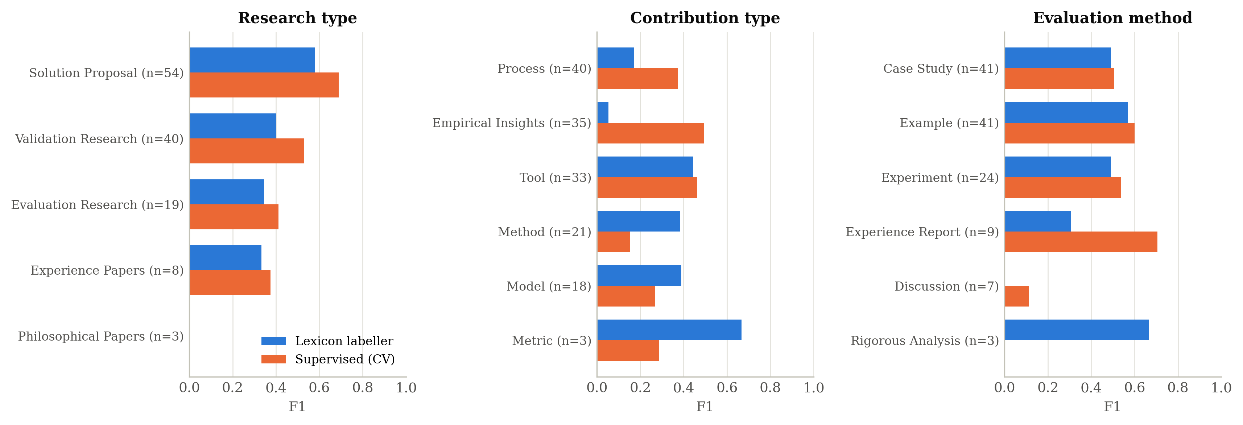
Figure 14: Per-class F1 against the gold labels for the lexicon-based labeller and the best supervised classifier, per facet.
The per-class tables confirm the pattern implied by the class imbalance and the lexicon design. Categories announced by fixed phrases are recognised: rigorous analysis ("we prove", "formal verification") reaches an F1 of 0.67 from only 3 studies, and metrics 0.67 from 3. Categories that authors describe in many different ways are not: empirical insights (F1 0.05 for the labeller, 0.49 supervised), process contributions (0.17 and 0.37) and discussion (0.00 and 0.11). The practical reading is that the pipeline's assignments in the phrase-marked categories can be trusted with a light confirmatory glance, whereas the diffuse categories are exactly where a reviewer's attention is needed, which is the actionable detail that a single accuracy figure would conceal.

5.13 Error Analysis
A qualitative review of the mislabelled studies in the per-paper evaluation file identified four recurrent patterns, summarised in Table 16. First, cue over-reach: a general phrase fires in a paper that merely mentions it ("case study" in a related-work section; "framework" for a conceptual framework rather than a software one), which explains most of the over-assignment of evaluation research and of tool contributions. Second, boundary confusion where the categories genuinely overlap, most often between validation and evaluation research and between example and case study; these are categories on which human reviewers also disagree, and the reference study itself assigns both categories to some papers. Third, vocabulary gaps: a paper states its contribution or evaluation implicitly, without any phrase in the lexicon, and falls to the default category with zero confidence (15, 4 and 11 studies on the three facets). Fourth, extraction artefacts: OCR noise and merged columns garble the relevant text; these are the most tractable because improved parsing removes them.
Table 16: Recurrent error patterns and their mitigation.
Error pattern | Description | Mitigation
Cue over-reach | A general cue fires in a paper that only mentions it (e.g. "case study" in related work) | Restrict cues to the abstract, introduction and evaluation sections; weight by position; supervised second opinion
Boundary confusion | Genuinely overlapping categories (validation vs evaluation research; example vs case study) | Clearer decision rules in the codebook; human review of flagged cases; accept multi-label output
Vocabulary gap | Contribution or evaluation stated without any lexicon phrase (default label, zero confidence) | Extend the lexicon from the gold-labelled corpus with a held-out check; embeddings and supervised classifiers
Extraction artefact | OCR noise or merged columns garble the relevant text | Higher OCR resolution; layout-aware parsing

5.13.1 Illustrative Cases
Three cases from the evaluation file make the patterns concrete. In the first, the study of Figure 5 states its contribution and evaluation with explicit phrases, and all three facets are labelled correctly with high confidence; this is the well-handled case that the automation disposes of without human effort. In the second, "A behavior-based ontology for supporting automated assessment of interactive systems" is labelled Evaluation Research on the strength of the cues case study×6, whereas the experts classified it as Validation Research: the phrases describe the setting of the work rather than its research type, a cue over-reach. In the third, "A behavior-driven approach to intent specification for software-defined infrastructure man" is labelled a tool contribution because of the cues we implemented×1; prototype×1; plugin×2; tool×8; implementation×1; framework×7, whereas the experts recorded Process; the words that fired are generic. Across such cases the pattern is consistent: the labeller is right when authors use the vocabulary of the classification scheme and wrong when they do not, and the supervised classifiers only partly close that gap. The practical consequence is that automated labels should be treated as a first pass to be confirmed, with the stored cue evidence making each confirmation a matter of seconds.

5.14 Comparison with the Literature
The pipeline can be situated against the prior work reviewed in Chapter Two. The proof-of-concept of Felizardo et al. (2024) reported that automated extraction with a large language model could approach manual quality for several facets while sharply reducing effort, with variability across data elements; the present study confirms both halves of that observation with a different technique and a full, published gold standard, finding near-total time savings and agreement that varies strongly with the category. Van Dinter et al. (2021) and Marshall and Wallace (2019) observed that automation in evidence synthesis has concentrated on screening, with extraction rarely evaluated end to end; the pipeline reported here is a direct response to that imbalance. Where Jonnalagadda et al. (2015) found that the absence of common gold standards prevented comparison between extraction systems, this study shows that the classifications published in a mapping study can serve as such a standard at no annotation cost, which is a reusable methodological step. The design choice of linear classifiers with balanced class weights over sparse features is grounded in the text-classification literature (Allam et al., 2025), and the use of an embedding-and-clustering approach for the thematic component follows Weißer et al. (2020). Two cautions temper the comparison: the studies cited differ in corpora and facets, so their figures are not directly commensurable, and the present figures rest on a single anchored corpus.

5.15 Implications for Practice
For researchers conducting mapping studies, the results suggest a practical division of labour. The pipeline can shoulder the mechanical extraction, produce a draft map in minutes and record the evidence for every label, while reviewers confirm the labels, concentrating on the diffuse categories (empirical insights, process, discussion) and on the validation–evaluation boundary where the pipeline is least reliable. This is augmentation rather than automation, and the error analysis of Section 5.13 shows precisely where human attention pays off. For the discipline, the reproducible pipeline and the gold-labelled corpus lower the barrier to comparing automation methods and to keeping maps current. For institutions in low-resource settings, the modest computational requirements of the ingestion, labelling and evaluation stages, which run on an ordinary computer, make adoption realistic; only the transformer components need a hosted environment such as Colab.

CHAPTER SIX
CONCLUSION AND RECOMMENDATIONS

6.1 Introduction
This chapter presents the conclusions drawn from the study, provides direct answers to the research questions, states the contributions of the work, acknowledges its limitations, and offers recommendations for future research and practice.

6.2 Conclusion
This study set out to design, develop and evaluate a machine learning pipeline for automating the data-extraction-and-mapping phase of systematic mapping studies, the costliest and least automated step of the systematic-mapping process. A modular pipeline was built that ingests full-text papers (reading scanned documents by OCR), extracts descriptive metadata, assigns each paper to the research-type, contribution-type and evaluation-method facets with a transparent lexicon-based labeller and with supervised classifiers, induces thematic categories with transformer embeddings and clustering, and assembles a classified portfolio and visual map. Applied to the 122 primary studies of the behaviour-driven-development mapping study of Binamungu and Maro (2023), and evaluated against the per-paper classification those authors published, the pipeline produced a complete systematic map whose facet distributions agree closely with the manual map on the research-type and evaluation-method facets (distribution scores 0.93 and 0.94) and less closely on the contribution-type facet (0.86). At the level of individual papers the agreement was modest: the labeller placed 45.9%, 36.9% and 49.6% of the studies in a correct category on the three facets, supervised classifiers trained on the gold labels reached 57.4%, 43.4% and 52.9%, and macro-F1 stayed between 0.33 and 0.41 because the rare categories have too few examples and too diffuse a vocabulary to learn. The pipeline processed a study in 5.6 seconds against a manual baseline of 107 minutes. The study therefore demonstrates that the data-extraction-and-mapping step can be automated end to end with strong distributional fidelity and near-total time savings on the mechanical work, while showing candidly that reliable per-paper classification against expert judgement, and a confidence signal sharp enough to target human review, remain to be achieved.

6.3 Answers to the Research Questions
Research Question 1: Which unified set of publication-metadata features can be used to extract and map data in a systematic mapping study?
The study defined a unified feature set organised into two groups: descriptive bibliographic metadata (title, abstract, length, page count and, from the reference record, venue and year) and analytical map-defining facets (research type, contribution type, evaluation method and thematic category), with the category sets of the reference mapping study, as set out in Table 2. Treating these as one connected framework, with the same document representation feeding every facet, answered the first question and addressed the absence of a unified extraction framework.
Research Question 2: How can a gold-standard dataset of full-text academic papers be collected, preprocessed and annotated to train and validate the models?
A corpus of 122 full-text software-engineering papers on behaviour-driven development was assembled from the primary studies of Binamungu and Maro (2023), and its gold labels were obtained without new annotation by transcribing the per-paper classification published in that study and matching it to the files by title. Three views of each document were prepared: the whole body for the labeller, TF–IDF with cue and section features for the classifiers, and the title and abstract for the sentence encoder. The approach, reusing the classification of a published mapping study as ground truth, is itself reusable for any field with a manually conducted map.
Research Question 3: How can an end-to-end machine learning pipeline be designed and implemented to automate SMS data extraction, facet classification and thematic mapping?
The pipeline was implemented as one sectioned Python module for ingestion (with OCR fallback), preprocessing, lexicon-based labelling with confidence and evidence, supervised classification trained on the gold labels, thematic modelling with the number of clusters chosen by the silhouette method, and map generation, driven by a notebook that also produces every figure. The modular design, described in Chapter Four, made each component independently testable and upgradeable and produced the SMS-specific outputs that distinguish a mapping tool from a screening tool.
Research Question 4: What is the performance of the pipeline compared with the manual approach?
The pipeline produces, for all 122 studies, the same kinds of output a manual mapping study produces, so it is functionally equivalent in output. On quality, at the level of the map it reproduced the manual facet distributions with benchmark scores of 0.933, 0.858 and 0.935; at the level of individual papers its labels agreed with the experts for 45.9% to 49.6% of the studies (supervised: 43.4% to 57.4%), well below expert consistency, with the rare and diffusely described categories the main source of error. On effort, it needed 5.6 seconds per study against 107 minutes manually, or an estimated 75 minutes when flagged studies are re-checked by a reviewer. The answer, then, is that the pipeline matches the manual approach well in the aggregate map and in speed, and not yet in the classification of individual papers.

6.4 Research Contributions
The study makes four contributions. First, it provides a unified feature framework that links publication metadata to the established mapping facets, closing the gap left by tools that address only isolated fields. Second, it delivers a gold-standard dataset of 122 behaviour-driven-development studies with per-paper labels for three facets, derived from a peer-reviewed mapping study, together with the method for deriving such datasets from any published map; this supports reproducible benchmarking where shared gold standards were previously absent. Third, it contributes a complete, reproducible, end-to-end pipeline that performs extraction, facet labelling and classification and thematic mapping and produces evidence maps, extending the proof-of-concept of Felizardo et al. (2024) into a full system with an OCR fallback, evidence-bearing labels and a review flag. Fourth, it provides an honest, gold-standard evaluation of that pipeline, distinguishing what automation already does well (the aggregate map, the mechanical extraction) from what it does not (rare and diffuse categories, targeting of human review), which is the evidence base the field needs to decide where to invest next.

6.5 Limitations of the Study
Several limitations qualify the present work. The corpus is anchored on a single behaviour-driven-development mapping study and remains within software engineering, so generalisation to other domains is not established, and the gold labels, though peer-reviewed, come with no measure of their own reliability. The lexicon was written by one person from the category definitions; a richer lexicon, or one built from a development split of the labelled corpus, might do better, at the cost of the clean a-priori evaluation reported here. The supervised classifiers were trained on roughly a hundred examples, too few for the rare categories, and the sentence-embedding feature sets could not be included in the reported run, which was executed on a machine without access to the pre-trained model; the notebook includes them for execution on Colab. The thematic results reported are those of an earlier, density-based configuration, and their alignment with the manual themes of the reference study was not measured. Finally, the pipeline assumes that screening has already been performed and begins from a curated set of relevant papers; it does not automate the earlier steps of the mapping process.

6.6 Recommendations for Future Work
Building on these results, five directions are recommended. First, the corpus should be extended to mapping studies in other domains and topics, using the same method of transcribing published classifications, to test external validity and to give the rare categories enough examples to learn. Second, the rarer and diffusely described categories should be strengthened: position-aware cues (weighting phrases in the abstract, introduction and evaluation sections above those in related work), a lexicon extended from a development split, sentence embeddings and fine-tuned transformer classifiers, and class-imbalance remedies such as oversampling, all with the multi-label metrics of this study. Third, the confidence signal should be improved by combining the labeller's margin with the probabilities of the supervised classifiers and re-evaluated as in Section 5.9, so that the human-in-the-loop mode routes attention where it is needed. Fourth, the thematic module should be run with the silhouette-selected k-means configuration on the full corpus and its clusters aligned with the manual themes of the reference study. Fifth, a usable interface should be developed so that researchers without programming expertise can apply the pipeline and maintain living maps.
Two further avenues deserve attention. The pipeline currently begins after study selection; integrating it with the screening-automation tools reviewed in Chapter Two would yield an end-to-end system from search results to finished map. In addition, the emergence of large language models for extraction, illustrated by Felizardo et al. (2024), suggests a hybrid design in which a language model proposes candidate facet labels that the lighter, auditable labeller and classifiers verify; such a design could combine the recall of generative models with the transparency and reproducibility that evidence synthesis requires, and the gold-standard dataset of this study is the benchmark on which it could be tested.

6.7 Recommendations for Stakeholders
The findings carry practical recommendations for several groups. For researchers conducting mapping studies, the pipeline is best adopted in its assisted mode, with the automated facet labels treated as a first pass that a reviewer confirms with the help of the stored cue evidence, so that the time savings of Chapter Five are realised without ceding final judgement; the codebook in Appendix IV provides a ready basis for consistent checking. For tool builders, the modular architecture of Chapter Four shows that descriptive metadata extraction, analytical facet classification and thematic discovery should be treated as separate components with separate quality targets, because each has a different error profile and a different appropriate technique. For the wider software-engineering research community, the study demonstrates that the classifications published in mapping studies can be turned into shared gold-standard datasets at no annotation cost, and it offers the dataset and configuration described here as a contribution toward that shared infrastructure. For supervisors and research-training programmes, the transparent, auditable design demonstrates that automation can be introduced into evidence synthesis without compromising the methodological rigour that examiners expect.

6.8 Concluding Remarks
This dissertation set out to address a specific, well-evidenced gap: that the data-extraction-and-mapping phase of systematic mapping studies in software engineering had no unified, reproducible and properly evaluated automation, even as the screening phase had attracted sustained attention. By designing a modular machine-learning pipeline, evaluating it against the published classification of a manually conducted mapping study, and reporting the results as measured, the study has shown that this phase can be automated to a level that reproduces the shape of the map and removes almost all of the mechanical effort, while keeping a human reviewer in control of the decisions that matter most. The contribution is deliberately modest in its claims and transparent in its limitations: the corpus is anchored on one sub-field, the per-paper agreement with the experts is moderate, and the boundary between adjacent facet categories will continue to challenge any classifier as it challenges human reviewers. Within those bounds, the work offers a concrete step toward making evidence maps in software engineering faster to build and easier to keep current, and it leaves behind reusable artefacts, a pipeline, a codebook and a gold-labelled dataset, on which others can build.

REFERENCES
Aliyu, M. B., Iqbal, R., & James, A. (2018). The canonical model of structure for data extraction in systematic reviews of scientific research articles. 2018 Fifth International Conference on Social Networks Analysis, Management and Security (SNAMS), 264–271. https://doi.org/10.1109/SNAMS.2018.8554896
Allam, H., Makubvure, L., Gyamfi, B., Graham, K. N., & Akinwolere, K. (2025). Text classification: How machine learning is revolutionizing text categorization. Information, 16(2), 130. https://doi.org/10.3390/info16020130
Binamungu, L. P., & Maro, S. (2023). Behaviour driven development: A systematic mapping study. Journal of Systems and Software, 203, 111749. https://doi.org/10.1016/j.jss.2023.111749
Büchter, R. B., Weise, A., & Pieper, D. (2020). Development, testing and use of data extraction forms in systematic reviews: A review of methodological guidance. BMC Medical Research Methodology, 20(1), 259. https://doi.org/10.1186/s12874-020-01143-3
Bui, D. D. A., Del Fiol, G., Hurdle, J. F., & Jonnalagadda, S. (2016). An extractive text summarization system to aid data extraction from full text in systematic review development. Journal of Biomedical Informatics, 64, 265–272. https://doi.org/10.1016/j.jbi.2016.10.014
Chernikova, O., Stadler, M., Melev, I., & Fischer, F. (2024). Using machine learning for continuous updating of meta-analysis in an educational context. Computers in Human Behavior, 156, 108215. https://doi.org/10.1016/j.chb.2024.108215
De La Torre-López, J., Ramírez, A., & Romero, J. R. (2023). Artificial intelligence to automate the systematic review of scientific literature. Computing, 105(10), 2171–2194. https://doi.org/10.1007/s00607-023-01181-x
Felizardo, K. R., Steinmacher, I., Lima, M. S., Deizepe, A., Conte, T. U., & Barcellos, M. P. (2024). Data extraction for systematic mapping study using a large language model—A proof-of-concept study in software engineering. Proceedings of the 18th ACM/IEEE International Symposium on Empirical Software Engineering and Measurement, 407–413. https://doi.org/10.1145/3674805.3690743
Goldfarb-Tarrant, S., Robertson, A., Lazic, J., Tsouloufi, T., Donnison, L., & Smyth, K. (2020). Scaling systematic literature reviews with machine learning pipelines. Proceedings of the First Workshop on Scholarly Document Processing, 184–195. https://doi.org/10.18653/v1/2020.sdp-1.21
Jonnalagadda, S. R., Goyal, P., & Huffman, M. D. (2015). Automating data extraction in systematic reviews: A systematic review. Systematic Reviews, 4(1), 78. https://doi.org/10.1186/s13643-015-0066-7
Kitchenham, B. A., Brereton, P., Turner, M., Niazi, M. K., Linkman, S., Pretorius, R., & Budgen, D. (2010). Refining the systematic literature review process—Two participant-observer case studies. Empirical Software Engineering, 15(6), 618–653. https://doi.org/10.1007/s10664-010-9134-8
Lame, G. (2019). Systematic literature reviews: An introduction. Proceedings of the Design Society: International Conference on Engineering Design, 1(1), 1633–1642. https://doi.org/10.1017/dsi.2019.169
Marshall, I. J., & Wallace, B. C. (2019). Toward systematic review automation: A practical guide to using machine learning tools in research synthesis. Systematic Reviews, 8(1), 163. https://doi.org/10.1186/s13643-019-1074-9
Nussbaumer-Streit, B., Ellen, M., Klerings, I., Sfetcu, R., Riva, N., Mahmić-Kaknjo, M., & Gartlehner, G. (2021). Resource use during systematic review production varies widely: A scoping review. Journal of Clinical Epidemiology, 139, 287–296. https://doi.org/10.1016/j.jclinepi.2021.05.019
Parashar, G., Chaudhary, A., & Rana, A. (2021). Systematic mapping study of AI/machine learning in healthcare and future directions. SN Computer Science, 2(6), 461. https://doi.org/10.1007/s42979-021-00848-6
Petersen, K., Feldt, R., Mujtaba, S., & Mattsson, M. (2008). Systematic mapping studies in software engineering. 12th International Conference on Evaluation and Assessment in Software Engineering (EASE). https://doi.org/10.14236/ewic/EASE2008.8
Petersen, K., Vakkalanka, S., & Kuzniarz, L. (2015). Guidelines for conducting systematic mapping studies in software engineering: An update. Information and Software Technology, 64, 1–18. https://doi.org/10.1016/j.infsof.2015.03.007
Rasheed, R. A., Kamsin, A., Abdullah, N. A., Zakari, A., & Haruna, K. (2019). A systematic mapping study of empirical MOOC literature. IEEE Access, 7, 124809–124827. https://doi.org/10.1109/ACCESS.2019.2938561
Sundaram, G., & Berleant, D. (2023). Automating systematic literature reviews with natural language processing and text mining: A systematic literature review. Proceedings of Eighth International Congress on Information and Communication Technology (Vol. 693, pp. 73–92). Springer Nature Singapore. https://doi.org/10.1007/978-981-99-3243-6_7
Tsou, A. Y., Treadwell, J. R., Erinoff, E., & Schoelles, K. (2020). Machine learning for screening prioritization in systematic reviews: Comparative performance of Abstrackr and EPPI-Reviewer. Systematic Reviews, 9(1), 73. https://doi.org/10.1186/s13643-020-01324-7
Van Dinter, R., Tekinerdogan, B., & Catal, C. (2021). Automation of systematic literature reviews: A systematic literature review. Information and Software Technology, 136, 106589. https://doi.org/10.1016/j.infsof.2021.106589
Wagner, G., Lukyanenko, R., & Paré, G. (2022). Artificial intelligence and the conduct of literature reviews. Journal of Information Technology, 37(2), 209–226. https://doi.org/10.1177/02683962211048201
Weißer, T., Saßmannshausen, T., Ohrndorf, D., Burggräf, P., & Wagner, J. (2020). A clustering approach for topic filtering within systematic literature reviews. MethodsX, 7, 100831. https://doi.org/10.1016/j.mex.2020.100831
Wewerka, J., & Reichert, M. (2023). Robotic process automation—A systematic mapping study and classification framework. Enterprise Information Systems, 17(2). https://doi.org/10.1080/17517575.2021.1986862
Wieringa, R., Maiden, N., Mead, N., & Rolland, C. (2006). Requirements engineering paper classification and evaluation criteria: A proposal and a discussion. Requirements Engineering, 11(1), 102–107. https://doi.org/10.1007/s00766-005-0021-6
Wolny, S., Mazak, A., Carpella, C., Geist, V., & Wimmer, M. (2020). Thirteen years of SysML: A systematic mapping study. Software and Systems Modeling, 19(1), 111–169. https://doi.org/10.1007/s10270-019-00735-y
Zhao, L., Alhoshan, W., Ferrari, A., Letsholo, K. J., Ajagbe, M. A., Chioasca, E.-V., & Batista-Navarro, R. T. (2021). Natural language processing for requirements engineering: A systematic mapping study. ACM Computing Surveys, 54(3), 1–41. https://doi.org/10.1145/3444689

APPENDICES

Appendix I: Facet Category Definitions
The following condensed definitions, adapted from Wieringa et al. (2006) and Petersen et al. (2008) as applied by Binamungu and Maro (2023), are the definitions from which the lexicon of the labeller and the codebook of Appendix IV were written. A study is a solution proposal when it proposes a novel technique and argues for its relevance with a small example; validation research when the technique is investigated in a laboratory or controlled setting; evaluation research when the technique is implemented and evaluated in practice; an experience paper when it reports the authors' experience; a philosophical paper when it offers a conceptual framework or taxonomy; and an opinion paper when it states a position. Contribution type is assigned by the principal artefact or knowledge delivered: tool, method, process, model, metric or empirical insights. Evaluation method records the strongest form of evaluation present: example, case study, experiment, experience report, discussion, rigorous analysis or simulation. The reference study assigns more than one category where a paper warrants it.

Appendix II: Pipeline Configuration Summary
Component | Configuration
PDF parsing | pdfplumber 0.11.9; Tesseract 5.3.4 OCR at 200 dpi for image-only PDFs
Corpus | 126 PDFs; 4 excluded with reasons; 122 processed (3 by OCR); gold labels for all 122
Lexicon labeller | Weighted cue phrases per category (Appendix IV); whole body text without references; confidence = score margin; review threshold 0.34; defaults: solution proposal / method / example
Lexical features | TF–IDF, unigrams + bigrams, min_df = 2, max 20,000 terms, sub-linear tf, English stop-words; first 3,000 words or whole body
Cue and section features | 19 log-weighted cue counts; 15 section-heading indicators + log length
Semantic features (Colab) | Sentence-BERT all-MiniLM-L6-v2 (384-d) on title + abstract; appended to the feature sets when available
Facet classifiers | One-vs-rest Linear SVM (C = 0.5), Logistic Regression (C = 2), SGD hinge (α = 1e-4), all balanced class weights; Complement NB (α = 0.5); Nearest centroid (cosine)
Validation | Stratified 5-fold CV on the first gold label (rare categories pooled); selection by macro-F1; 5 repeated CVs for the winner
Thematic module | UMAP (cosine, min_dist 0; grid: 2 or 5 components × 10/15/30 neighbours) → k-means, k = 2–10 by silhouette; HDBSCAN (min_cluster_size 4–15) for comparison; c-TF–IDF descriptors
Metrics | Multi-label-aware accuracy, precision, recall, macro/micro/weighted F1; confusion matrices; distribution score (1 − MAE) and cosine; silhouette, diversity, C_v coherence; per-study time
Environment | Python 3.11.15; scikit-learn 1.8.0; pandas 3.0.2; numpy 2.4.4; umap-learn 0.5.12; seeds fixed (42)

Appendix III: Mapping of Objectives to Research Gaps and Chapters
Objective | Gap addressed | Method | Results
1. Unified metadata features | Gap 1 (no unified framework) | §3.6, §3.8 | §5.3, §5.7
2. Gold-standard dataset | Gap 2 (heterogeneous metadata, no shared gold standard) | §3.5, §3.18 | §5.2
3. End-to-end pipeline | Gap 3 (no SMS-specific tool) | Ch. 4 | §5.4–5.7
4. Evaluation vs. baseline | All gaps (validation) | §3.10, §3.16, §3.19 | §5.4–5.9

Appendix IV: Facet Classification Codebook
The codebook below operationalises every category of the three facets as used by the lexicon-based labeller and as defined in the reference mapping study. For each facet it states the category, an operational definition, the decision rule applied when a study could plausibly fall into more than one category, and representative textual cues, which are the phrases of the labeller's lexicon. The codebook was written before the gold labels were transcribed and held fixed thereafter, so that the automated labels and the gold standard were judged against an identical standard.

Research Type Facet
Category | Operational definition | Typical cue / decision rule
Solution proposal | Proposes a novel technique, method or tool and argues its relevance, usually with a small illustrative example. | “We propose…”, “this paper introduces…”; choose this when no empirical evaluation beyond an example is present.
Validation research | Investigates a proposed technique in a controlled or laboratory setting before deployment in practice. | Experiments, simulations or prototypes evaluated by the authors; chosen over evaluation research when not yet used in real practice.
Evaluation research | Implements a technique in practice and evaluates its consequences in a real setting. | Case studies or field studies in industry; choose when practitioners other than the authors apply the technique.
Experience paper | Reports the author’s personal experience of applying something in practice, without formal evaluation. | “in our experience”, lessons-learned framing without a controlled design.
Opinion paper | Expresses the author’s position without empirical content or systematic argument. | Position statements, vision papers; chosen only when no data or technique is contributed.
Philosophical paper | Sketches a new way of looking at the field through a conceptual framework or taxonomy. | Taxonomies, conceptual models presented as the principal contribution.

Contribution Type Facet
Category | Operational definition | Typical cue / decision rule
Tool | A software artefact, prototype or implemented system is the principal contribution. | "we implemented", "prototype", "plugin", tool, implementation, framework, platform, system; chosen when the artefact is the headline deliverable.
Method / technique | A reusable procedure or algorithm is the principal contribution. | algorithm, method, technique, approach, procedure; chosen over "tool" when no implementation is delivered.
Process | An organised set of activities or a lifecycle is contributed. | "set of activities", workflow, lifecycle, process, methodology.
Model | A conceptual or formal representation of a phenomenon is contributed. | "formal model", "reference architecture", metamodel, ontology, model.
Metric | A measure or set of measures is the contribution. | "quality attribute", metric, indicator, measure.
Empirical insights | Knowledge about BDD practice obtained from data (surveys, interviews, mining, experiments) is the contribution. | "we observed", empirical, findings, insight, evidence.

Evaluation Method Facet
Category | Operational definition | Typical cue / decision rule
Experiment | Controlled study manipulating variables with quantitative analysis. | "controlled experiment", "empirical study", experiment, participants.
Case study | In-depth study of a phenomenon within its real context. | "case study", "case studies", "industrial case", "field study".
Simulation | Evaluation through a model that imitates the system of interest. | "synthetic workload", "we simulate", simulation, simulated.
Rigorous analysis | Formal or analytical argument establishing properties. | "formal verification", "mathematical proof", "complexity analysis", "formal proof", "we prove", theorem.
Discussion | Qualitative argument about strengths and weaknesses. | "qualitative analysis", "we discuss", "we argue", discussion.
Example | A worked example illustrates feasibility only. | "proof of concept", "worked example", "running example", "we demonstrate", illustrative, illustrate, example.
Experience report | Reflection on the authors' own use of BDD in practice. | "experience report", "lessons learned", "industrial experience".

Appendix V: Sample of Extraction Records with Gold Labels
The following table presents a sample of records from the actual pipeline output (gold_evaluation_per_paper.csv), illustrating the structured data the pipeline produces for each primary study next to the gold labels of the reference study. Titles are abbreviated for space; the identifier is the reference number in Binamungu and Maro (2023). A tick marks agreement with the gold label. The sample reflects the real distribution reported in Chapter Five and the real error pattern: agreement is common on the research type and evaluation method of phrase-marked studies and rarer on the contribution type.
Ref. | Title (abbreviated) | Research type (gold) | Contribution (gold) | Evaluation (gold)
3 | Maintaining behaviour driven developme… | Evaluation Research ✓ (Evaluation Research) | Process ✗ (Empirical Insights) | Experiment ✗ (Case Study)
12 | Behavior-driven development: A case st… | Evaluation Research ✓ (Validation Research|Evaluation Research) | Tool ✗ (Empirical Insights) | Experiment ✗ (Case Study)
14 | Combining STPA and BDD for safety anal… | Solution Proposal ✗ (Validation Research) | Process ✓ (Process) | Example ✓ (Example)
16 | Executable requirements in a safety-cr… | Experience Papers ✗ (Solution Proposal) | Tool ✓ (Tool) | Experience Report ✗ (Example)
17 | Scenarios in the loop: integrated requ… | Validation Research ✓ (Validation Research) | Model ✗ (Process) | Simulation ✗ (Example)
18 | Speed up BDD for safety verification i… | Validation Research ✓ (Validation Research) | Tool ✓ (Tool|Empirical Insights) | Experiment ✓ (Experiment)
19 | A formal ontology for describing inter… | Evaluation Research ✗ (Solution Proposal) | Model ✓ (Model) | Example ✓ (Example)
20 | A model-driven approach for behavior-d… | Validation Research ✗ (Evaluation Research) | Method ✗ (Process|Tool) | Experiment ✓ (Experiment)
22 | Augmented system verification using au… | Validation Research ✗ (Solution Proposal) | Tool ✗ (Method) | Example ✓ (Example)
23 | Behavior-driven development (BDD) Cucu… | Solution Proposal ✗ (Experience Papers) | Tool ✗ (Empirical Insights) | Discussion ✗ (Experience Report)
24 | Ensuring the consistency between user … | Evaluation Research ✗ (Validation Research) | Tool ✗ (Process) | Case Study ✓ (Case Study)
26 | Towards behavior-driven graphical user… | Validation Research ✗ (Evaluation Research) | Method ✗ (Tool) | Experiment ✓ (Experiment)
27 | SS-BDD: automated acceptance testing f… | Solution Proposal ✗ (Validation Research) | Tool ✗ (Process) | Example ✓ (Example)
28 | Behaviour-driven requirements engineer… | Solution Proposal ✓ (Solution Proposal) | Method ✗ (Model|Process) | Experiment ✗ (Discussion)
30 | Using behaviour-driven requirements en… | Evaluation Research ✗ (Validation Research) | Method ✗ (Process|Empirical Insights) | Experiment ✗ (Case Study)
33 | Legislation-driven development of a gi… | Solution Proposal ✗ (Evaluation Research) | Model ✓ (Model|Empirical Insights) | Example ✗ (Case Study)

Appendix VI: Hyperparameter Search Spaces
The supervised evaluation used the configurations below. Best configurations were selected by macro-averaged F1 under stratified five-fold cross-validation; the classifiers used fixed settings rather than an exhaustive grid search, so the "Used" column records the operative values and the ranges are offered as the space for future tuning. The thematic settings are those of the configuration search of Section 4.8.
Component | Hyperparameter | Range (future tuning) | Used
Linear SVM | C | 0.1, 0.5, 1, 10 | 0.5
Logistic regression | C / max_iter | 0.5, 1, 2, 5 / — | 2 / 3000
SGD (hinge) | alpha | 1e-5, 1e-4, 1e-3 | 1e-4
Complement NB | alpha | 0.1, 0.5, 1.0 | 0.5
All linear models | class_weight | none, balanced | balanced
TF–IDF | ngram_range / min_df / max_features | (1,1), (1,2) / 1, 2, 5 / 5k, 20k | (1,2) / 2 / 20,000
TF–IDF | text window | abstract, first 3,000 words, whole body | first 3,000 words and whole body
Lexicon labeller | review threshold | 0.2–0.5 | 0.34
UMAP | n_components / n_neighbors | 2, 5 / 10, 15, 30 | selected by silhouette
k-means | k | 2–10 | selected by silhouette
HDBSCAN (comparison) | min_cluster_size | 4, 6, 8, 10, 12, 15 | grid

Appendix VII: Corpus Composition Summary
The corpus comprises the 122 behaviour-driven-development primary studies of Binamungu and Maro (2023) for which a PDF was available and processable; four files were excluded (a proceedings volume, a duplicate and two papers outside the reference study). The table below summarises the corpus by the gold labels of each facet (a study with two categories is counted in both); the full per-study record, including titles, pipeline and gold labels, confidences and cue evidence, is held in the evaluation file (gold_evaluation_per_paper.csv) that accompanies the study.
Facet / category | Studies (gold) | Share
Research type: Solution Proposal | 54 | 43.5%
Research type: Validation Research | 40 | 32.3%
Research type: Evaluation Research | 19 | 15.3%
Research type: Experience Papers | 8 | 6.5%
Research type: Philosophical Papers | 3 | 2.4%
Contribution type: Process | 40 | 26.7%
Contribution type: Empirical Insights | 35 | 23.3%
Contribution type: Tool | 33 | 22.0%
Contribution type: Method | 21 | 14.0%
Contribution type: Model | 18 | 12.0%
Contribution type: Metric | 3 | 2.0%
Evaluation method: Case Study | 41 | 32.8%
Evaluation method: Example | 41 | 32.8%
Evaluation method: Experiment | 24 | 19.2%
Evaluation method: Experience Report | 9 | 7.2%
Evaluation method: Discussion | 7 | 5.6%
Evaluation method: Rigorous Analysis | 3 | 2.4%

Appendix VIII: Operational Definitions of Key Terms
The terms below are used throughout the dissertation with the specific meanings given here, to remove ambiguity between everyday and technical senses.
Term | Operational definition as used in this study
Systematic mapping study (SMS) | A secondary study that classifies a body of primary literature along predefined facets to reveal publication trends, clusters and gaps, as distinct from a systematic literature review, which synthesises findings to answer a focused question.
Data extraction and mapping | The phase of an SMS in which structured information is recovered from each primary study and used to position it within the map; the phase this study automates.
Facet | One of the predefined classification dimensions of a mapping study; here, research type, contribution type and evaluation method.
Publication metadata | The descriptive and analytical attributes of a paper, such as venue, year, research type and contribution type, that populate the map.
Gold standard | The per-paper classification published in a manually conducted mapping study, treated as ground truth for evaluating the pipeline and for training the supervised classifiers.
Lexicon-based labeller | The component that assigns a facet category by counting weighted cue phrases, with a confidence equal to the margin between the best and second-best category.
Macro-averaged F1 | The unweighted mean of the per-class F1-scores, used as the primary effectiveness measure because it treats rare and common categories equally.
Micro-averaged F1 | An F1-score computed by pooling decisions across all classes, reflecting overall instance-level performance and dominated by common categories.
Distribution score | One minus the mean absolute difference between the pipeline's and the reference's share of each category of a facet.
Human-in-the-loop | An operating mode in which facets labelled below a confidence threshold are routed to a human reviewer rather than being accepted automatically.
Pipeline | The integrated sequence of modules (ingestion, preprocessing, labelling, classification, thematic modelling and map generation) that together automate the extraction-and-mapping phase.
Per-study extraction time | The wall-clock time required to ingest and label a single primary study, used to measure efficiency against the manual baseline of 107 minutes.

