Treasure Box Braille

User Manual

(Version 0.00000001a)

Contents



1 Introduction 2

1.1 What is Braille? 3

1.2 What is Treasure Box Braille? 3

2 Getting Started 3

2.1 Installation 3

2.2 Creating a Scenario 4

2.3 Saving Scenarios 4

2.4 Loading Scenarios 4

3 Scenario Files 4

3.1 A Brief Overview of Scenario Files 4

3.2 Adding Text 4

3.3 Adding Sounds 4

3.4 Adding Delays 4

3.5 Recording Audio 4

4 Use Cases 5

4.1 Use Case 1: Developing a Scenario from Scratch 5

4.2 Use Case 2: Loading and modifying an existing scenario 5

4.3 Use Case 3: Reordering scenario events 5

# 1 Introduction

Treasure Box Braille (TBB) is a device that helps kids learn how to read Braille. TBB presents Braille characters/words to the user who then responds by pressing buttons. Educators can load different scenarios to teach different letters and keep the kids entertained.

We will write a piece of software to help educators create these scenarios. We will call it the Authoring App. The Authoring app will provide facilities to

* Create the flow of the scenario (ask questions, receive answers)
* Record audio
* Save the scenario in the appropriate format
* Test the scenario using the provided software

## 1.1 What is Braille?

Braille is a system of raised dots that can be read with the fingers by people who are blind or who have low vision. Teachers, parents, and others who are not visually impaired ordinarily read braille with their eyes. Braille is not a language. Rather, it is a code by which many languages—such as English, Spanish, Arabic, Chinese, and dozens of others—may be written and read. Braille is used by thousands of people all over the world in their native languages, and provides a means of literacy for all. (From: <http://www.afb.org/info/living-with-vision-loss/braille/what-is-braille/123>)

## 1.2 What is Treasure Box Braille?

A short description of the application, it’s user base, and purpose.

* The application of this product is as follows.
* Meant for teachers to do creative scenario building.
* Should be able to compile and run.

# 2 Getting Started

## 2.1 Installation

In order to install this software, it must first be built. To build this software there must be some code and blood sweat and tears. Follow instructions exactly:

1. Execute the file
2. Select a directory
3. Get ready for fun and excitement

## 2.2 Creating a Scenario

## 2.3 Saving Scenarios

aUt ac odio ac justo tincidunt sollicitudin. Sed iaculis in eros vel accumsan. Aenean ornare urna non libero ultrices, id luctus risus suscipit. Nam justo turpis, hendrerit in commodo non, consectetur ac tellus. Sed ut gravida massa. Integer placerat nulla dolor, sit amet dapibus neque mollis sit amet. In rutrum aliquam arcu sodales rutrum. Nam in lobortis elit. Quisque ante neque, bibendum ultrices commodo quis, congue at felis.

## 2.4 Loading Scenarios

AUt ac odio ac justo tincidunt sollicitudin. Sed iaculis in eros vel accumsan. Aenean ornare urna non libero ultrices, id luctus risus suscipit. Nam justo turpis, hendrerit in commodo non, consectetur ac tellus. Sed ut gravida massa. Integer placerat nulla dolor, sit amet dapibus neque mollis sit amet. In rutrum aliquam arcu sodales rutrum. Nam in lobortis elit. Quisque ante neque, bibendum ultrices commodo quis, congue at felis.

# Scenario Files

## A Brief Overview of Scenario Files



Ut ac odio ac justo tincidunt sollicitudin. Sed iaculis in eros vel accumsan. Aenean ornare urna non libero ultrices, id luctus risus suscipit. Nam justo turpis, hendrerit in commodo non, consectetur ac tellus. Sed ut gravida massa. Integer placerat nulla dolor, sit amet dapibus neque mollis sit amet. In rutrum aliquam arcu sodales rutrum. Nam in lobortis elit. Quisque ante neque, bibendum ultrices commodo quis, congue at felis.

## 3.2 Adding Text

asdfasdfasdf

## 3.3 Adding Sounds

asdfasdf

## 3.4 Adding Delays

asdfasdfasdf

## 3.5 Recording Audio

Asdfasdfas df

## 4 Use Cases

Describes major use cases

## Use Case 1: Developing a Scenario from Scratch

1. Add a new text node

## Use Case 2: Loading and modifying an existing scenario

1. Do the thing
2. Do it
3. Don’t do it
4. 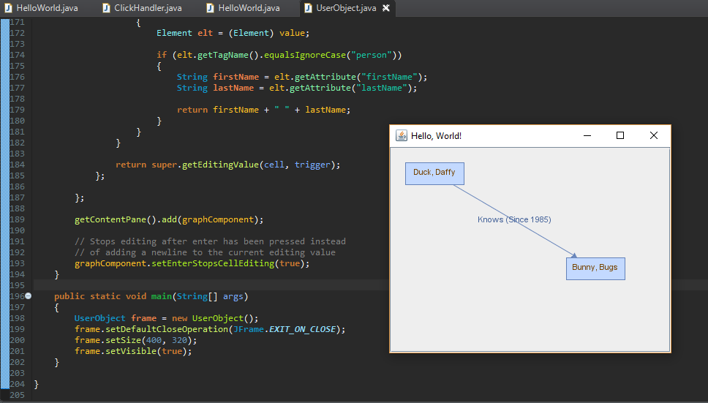

## Use Case 3: Reordering scenario events

1. Move that thing
2. Okay
3. Save the file.