Treasure Box Braille

User Manual

Contents

1 Introduction 3

1.1 What is Braille? 3

1.2 What is Treasure Box Braille? 3

2 Getting Started 4

2.1 Installation 4

2.2 Creating a Scenario 4

2.3 Saving Scenarios 6

2.4 Loading Scenarios 6

2.5 Keyboard Controls 6

3 Scenario Building 6

3.1 A Brief Overview of Scenario Files 6

3.2 Adding Text 6

3.3 Adding Sounds 7

3.4 Adding Pauses 7

3.5 Recording Audio 8

3.6 Braille Pins 8

4 Use Cases 10

4.1 Use Case 1: Developing a New Scenario 10

4.2 Use Case 2: Loading and modifying an existing scenario 12

4.3 Use Case 3: Recording Audio 14

# 1 Introduction

Treasure Box Braille (TBB) is a device that helps kids learn how to read Braille. TBB presents Braille characters/words to the user who then responds by pressing buttons. Educators can load different scenarios to teach different letters and keep the kids entertained.

We will write a piece of software to help educators create these scenarios. We will call it the Authoring App. The Authoring app will provide facilities to

* Create the flow of the scenario (ask questions, receive answers)
* Record audio
* Save the scenario in the appropriate format
* Test the scenario using the provided software

## 1.1 What is Braille?

Braille is a system of raised dots that can be read with the fingers by people who are blind or who have low vision. Teachers, parents, and others who are not visually impaired ordinarily read braille with their eyes. Braille is not a language. Rather, it is a code by which many languages—such as English, Spanish, Arabic, Chinese, and dozens of others—may be written and read. Braille is used by thousands of people all over the world in their native languages, and provides a means of literacy for all. (From: <http://www.afb.org/info/living-with-vision-loss/braille/what-is-braille/123>)

## 1.2 What is Treasure Box Braille?

Treasure Box Braille can create, edit and save scenarios into a file that can be simulated with a Treasure Box Braille simulator.

* This application is meant for teachers to create stories using braille, speech read text, sound, and physical buttons to dictate the story.
* Creative story building with accessibility in mind.
* Runs on Windows, Apple OS X, and Linux.

# 2 Getting Started

## 2.1 Installation

The computer system must have Java Runtime Environment installed to run this application. Download the latest version from <https://java.com/en/download/>.

1. Download and install Java Runtime Environment
2. Select the Treasure Box Braille (.jar) file and open it with Java Platform SE Binary.

The Windows 10 dialog option is as follows. Other operating systems may vary.

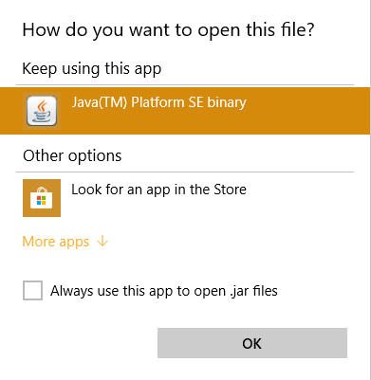

1. The Treasure Box Braille Welcome screen should appear:

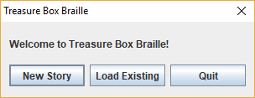

Congratulations! You are now ready to create a new scenario!

**Remark for NVDA users on Windows:** NVDA screen reader must both 32bit and 64bit versions of Java Runtime Environment. Java Access Bridge must also be enabled for both installations.

## 2.2 Creating a Scenario

To create a scenario, click on the ‘New Story’ button on the welcome screen. Enter the number of cells and buttons that the Braille device contains. An empty scenario will be created to begin story building.

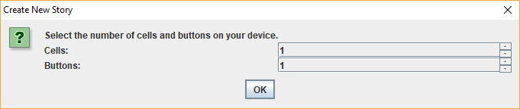

Press ‘OK’ to continue.

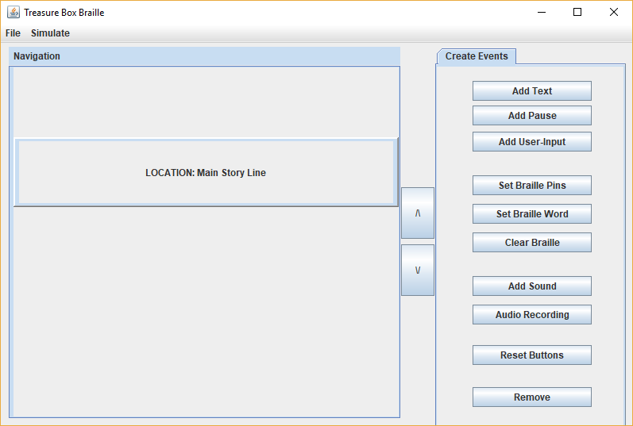

**Create Events buttons:**

Add Text: Add custom text to your story.

Add Pause: Add a pause duration to your story.

Add User-Input: (Phil can explain this)

Add Sound: Select a .wav file to add it to your story.

Set Braille Pins: Set the pins of a specific cell to an 8 character sequence of your choice. You can enter any char from a-z or write your own custom sequence.

Set Braille Word: Set braille to display a string of your choice.

Clear Braille: Clear the pins of a specific cell.

Reset Button: Reset the action listeners of all of the Buttons.

Remove: Remove the selected element in the story.

## 2.3 Saving Scenarios

To save a scenario, open the File Menu and click on ‘Save’. You will be prompted to select a save directory. It is recommended to save as a ‘.txt’ file format.

## 2.4 Loading Scenarios

To load a scenario, open the File Menu and click on ‘Open’. You will be prompted to load a scenario file. You may also load a scenario from the welcome screen by pressing ‘Load Existing Scenario’.

## 2.5 Keyboard Controls

All items throughout the application can be selected with TAB. To execute an operation, you can use the ENTER or SPACE keys.

To close the File Chooser window or any info box, you can use the ESC key.

To close the main application or the audio recording frame, you can use the shortcut CTRL + C

To save a story, you can use the shortcut CTRL + S

To open an existing story, you can use the shortcut CTRL + O

To start a new story, you can use the shortcut CTRL + N. This will discard your existing work so make sure you save first.

# Scenario Building

Scenario files store the story information and allows the Treasure Box Braille device to read text, play audio, and ask the student for input.

## A Brief Overview of Scenario Files

The scenario file can be easily edited in a text editor. However, it is recommended that the user uses this application to edit the scenario. Manually editing the scenario file may result in unintended scenario playback.

## 3.2 Adding Text

Text may be added to the storyline as long as the current position is not on a User-Input event. Enter the text in the dialog box as seen below and press ‘OK’.

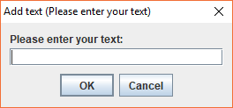

## 3.3 Adding Sounds

Existing sound files can be added to the scenario. Please ensure the audio file is located in the ‘/FactoryScenarios/Audio/’ directory for proper playback on the device.

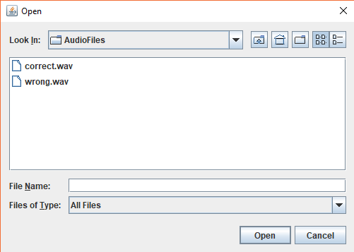

## 3.4 Adding Pauses

Add pauses to the scenario by pressing the pause button. Specify the duration of the pause in seconds.

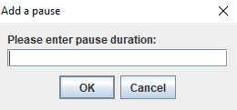

## 3.5 Recording Audio

To add a voice recording to your story, click on the Audio Recording button, this opens an audio recording application along side the base application.

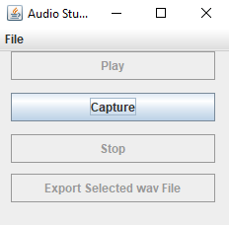

To get started, click the 'Capture' button. This will bring up a pop up message to let you know audio recording has begun, click 'ok'

Now record the audio of your desired length and when you are completed click the 'Stop' button.

To hear your newly recorded recording, click the 'Play' button and you'll have your audio played back to you. At the end of your recording , you will be prompted if you would like to save the recording, if so enter your desired name and save to the directory opened up by the file dialog box (saving it to this directory is necessary for exporting). Next you will be prompted if you would like to export the file to your story, if so, congratulations!

## 3.6 Braille Pins

Set the pins of a specific cell to an 8 digit sequence of your choice. You can enter any char from a-z or write your own custom sequence. Press the ‘Set Braille Pins’ and select the Braille cell you wish to change. Press ‘OK’.

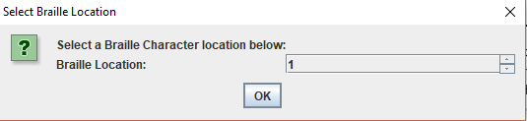

Next, enter a letter OR 8 digit sequence to set the pins. Press ‘OK’.

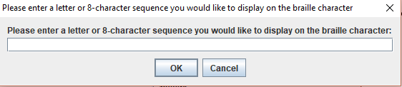

You have now successfully added a set pin event to the scenario!

# 4 Use Cases

## Use Case 1: Developing a New Scenario

1. Open the application and select ‘New Story’ from the welcome screen.

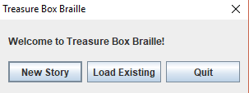

1. Specify the number of cells and buttons on your Braille device and press ‘OK’.

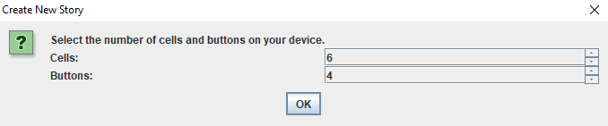

1. You will now be able to create an event using the buttons on the right panel.

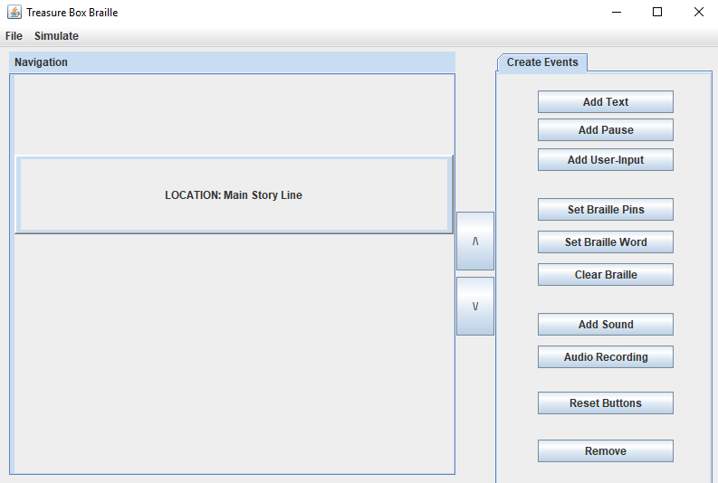

1. For example, you may wish to add text to the scenario. Click on the ‘Add Text’ button to add text. Type in your text in the text field and press ‘OK’.

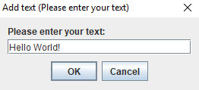

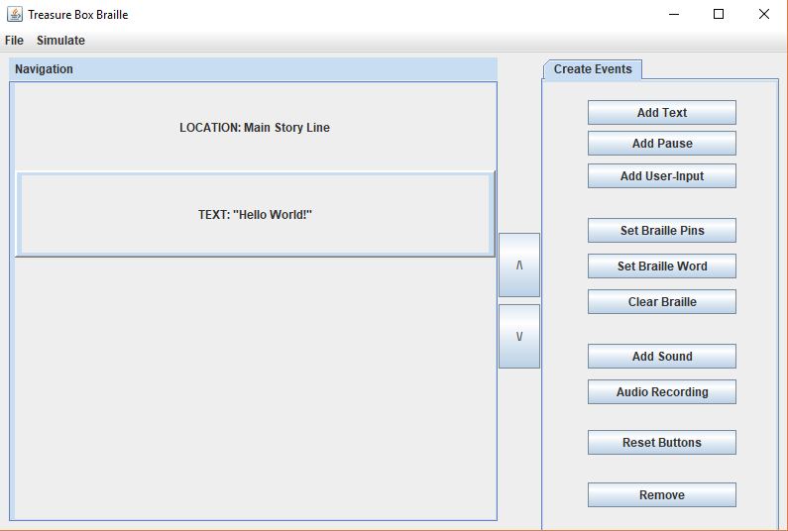

1. Congratulations! You have successfully created a new scenario and used the create event feature.

## Use Case 2: Loading and modifying an existing scenario

1) Open the application and select ‘Load Existing’ from the welcome screen.



1. Select an existing scenario file. Press ‘Open’ to load the scenario.

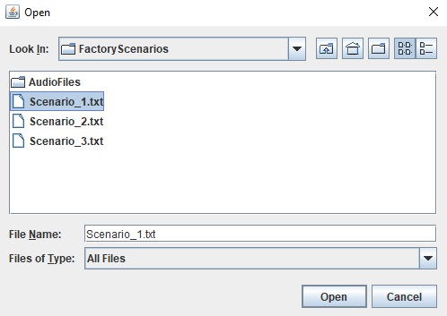

1. The application has loaded the scenario file and we may begin modifying the story.

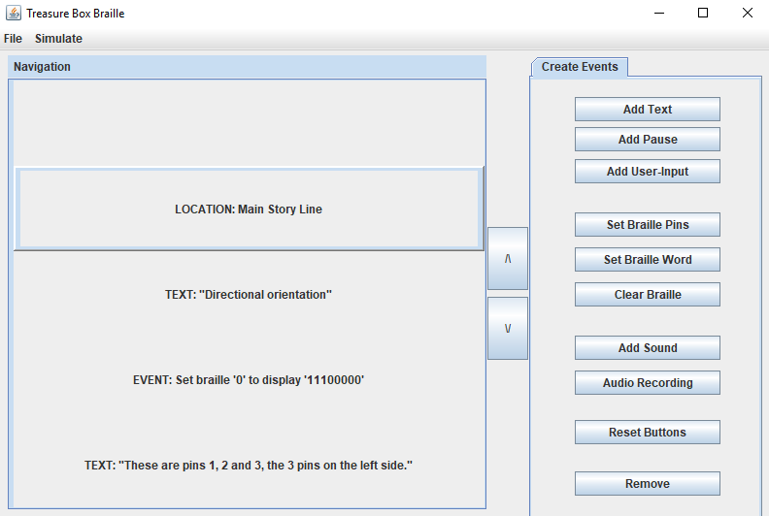

1. Press the ‘Next’ button to navigate to a TEXT event. Press remove to delete the current event.
2. The current event will be deleted. We will add a TEXT event as in the previous case study.

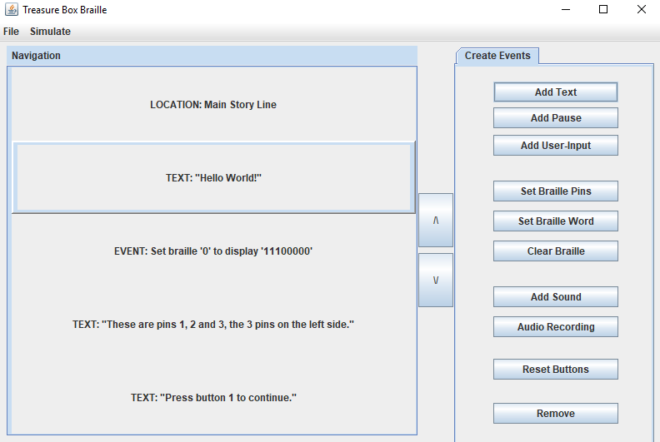

You have now successfully loaded a scenario and modified an event!

## Use Case 3: Recording Audio

1. To record an audio file and add it to the scenario press the ‘Audio Recording’ button under the ‘Create Events’ panel.
2. Press ‘Capture’ to begin recording.

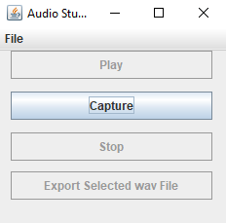

1. Press ‘Stop’ to end the recording.

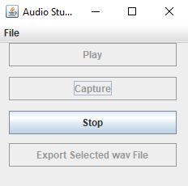

1. Press ‘Play’ to play the recording and save the recording if you wish to add it to the scenario.

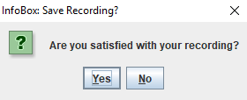

1. Save the file recording. Press ‘Save’ to continue.

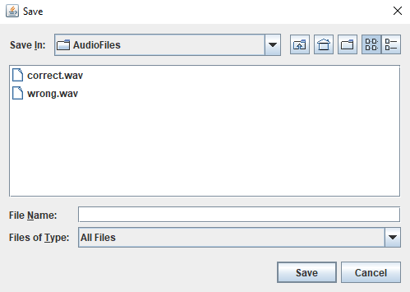

Press ‘Yes’ to continue.

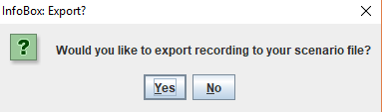

After confirming, the audio file will be added to the scenario.

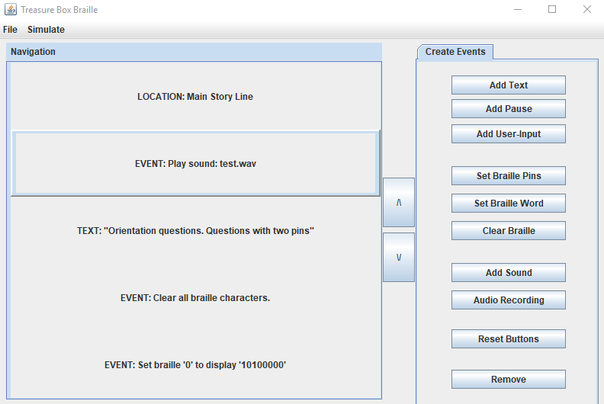

You have now successfully recorded the audio file and added it to the scenario!