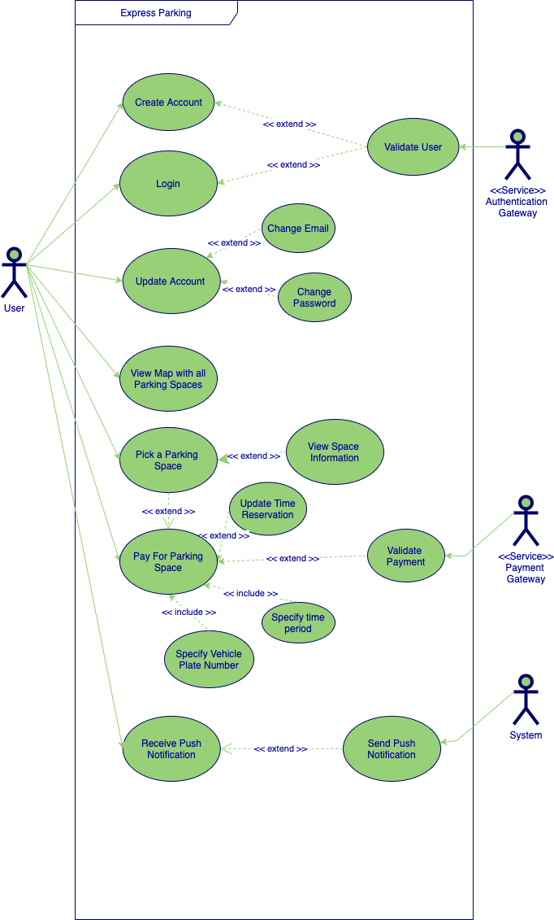

Figure 1: Use Case diagram for User interactions with Express Parking

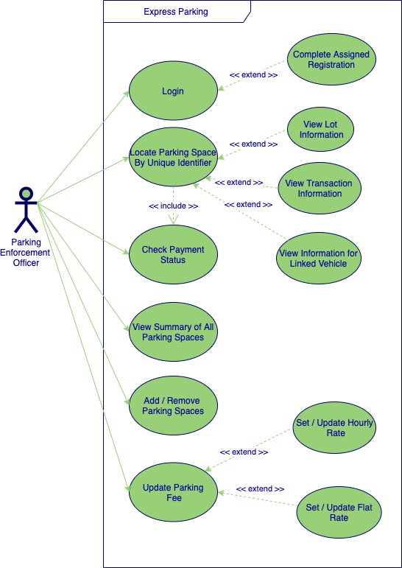

Figure 2: Use Case diagram for Parking Enforcement Officer interactions with Express Parking

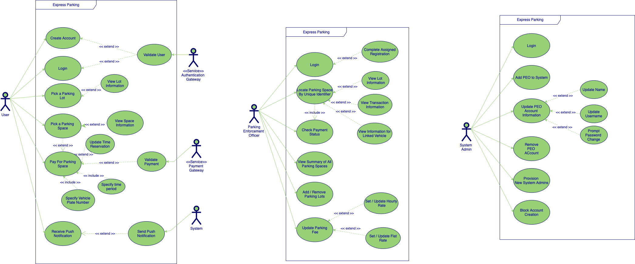

Figure 3: Use Case diagram for System Administrator interactions with Express Parking