# Curve/ Bend Shader Effect

Now it's easy to achieve a curve/bend horizon effect like in subway surfer, Talking tom gold run and more similar games.   
The package comes with a simple script that sets the public values of shader and you can change the bending on the go through animation so it'll look seamless.   
The asset is tested on mobile and it works good on almost all kind of devices.   
  
*Package doesn't include any of the models shown in promo*

Shader source code is provided. By looking at the code, you can custom more shaders as well. The shader doesn’t support Terrain Asset material yet. We have included script for items being culled incorrectly as well. If you are handling stuff with Raycasting, you might then need to do a bit more work for getting this shader work correctly for you.

The project is in its infancy and more features should be suggested and expected.

# Testing the demo

In the root of the imported project i.e., Curve\_Bend\_Shader there is a scene called “demo” Open the scene and press the play button on Unity editor.

The on screen Next previous button let you traverse through all the 4 examples. The four examples contains effect like curving horizon, living on the globe, more detailed curve with independently curving the x and z values with different values as well as handling intensity of the curve.

# C:\Users\GS\AppData\Local\Microsoft\Windows\INetCache\Content.Word\Screenshot_3.pngCurve Styles

There are three different Curve Modes

* Basic
* Globe
* Planer

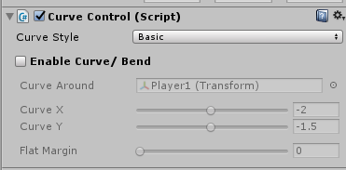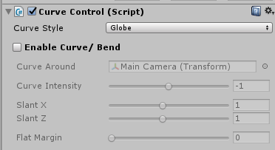

## CurveController

The code in this script does the run time magic. The demo scenes included also make use of public properties through this script. The animation for each of the example is just a little bit different and handled through public properties of this script.

Curve Style : This property sets the current curve mode. All other property values depends on the mode selected. When the Curve Mode is changed then properties values also get different meaning e.g. The Curvature in Simple mode doesn’t do anything in spherical mode, BiasX and BiasZ works only in Spherical Mode, Flatness2 does nothing in Spherical Mode etc.

CurveOn: This enables or disables Curve. This helps during testing by turning off curve for working in scene mode. This also can be handled through script.

Curve Intensity: This Parameter Defines how much curve the world will get. Negative value will curve the world in opposite direction. This property works in Simple and Planer Mode whereas Curve is determined by First curve and Second Curve property in Spherical Mode.

Curve X: This parameter determines curve in Simple and curve favor in Planer mode. It doesn’t affect curve in Spherical Mode.

Flat Margin X: This property defines falls out or flatness margin in simple and spherical Mode whereas in Planer Mode this defines Flatness of first curve i.e. of X Axis.

Slant X: This property is relevant in Spherical Mode only. It defines inclination of first curve i.e. X axis curve

Curve Z: This property handles second curve effect which is Y Axis in Simple mode and Z Axis in Planer Mode. This property doesn’t matter in Spherical Mode.

Flat Margin Z: This property defines fall out or flatness margin of Second Curve i.e., Z Axis in Planer Mode. It does nothing in Simple and Spherical Mode.

Slant Z: This property is relevant in Spherical Mode only. It defines inclination of Second Curve i.e Z axis curve.

# Support information

I have tried to add as many comments and information as I can. If you still find something ambiguous or want more elaboration in terms of code, logic or functionality then you are always welcome to contact me. Also we do create all of these assets by investing allot of time and effort. If you like this asset, I would request to kindly take a minute and leave a review on the asset store page at   
http://u3d.as/14L7

Facebook Page: [fb.com/curioasset](https://www.facebook.com/CurioAssets)

Twitter: twitter.com/curiologix  
Support Email: info.curioassets@gmail.com