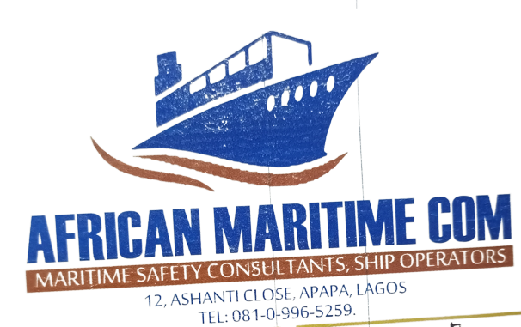

**REF: AMCON/AD/02 Date: 7TH OCTOBER, 2022**

The General Manager, (Operation) LTT

Continental Shipyard NPA Dockyard

Apapa Port Complex

Lagos..

Dear Sir.

**REQUEST FOR WRECKAGE REMOVAL OF SUNKEN BARGE AT NPA DOCKYARD, APAPA**

We humbly request for your services to evacuate the wreckage of FC KUGBO Barge lying at your neighboring NPA Dockyard.

The sunken floating crane was auctioned by NPA, and we have been able to remove

the top crane leaving the barge underwater.

All our efforts to engage the services of underwater divers and marine engineers to cut the barge inside water for the crane to remove them have failed to achieve the desired result.

We require your expertise and professional! know how to save us from financial wastages by using your marine equipment and human resources to cut the barge into pieces or smaller sizes for the crane to carry out of the water.

We are ready to comply with your terms and conditions if our request is granted. Thanks for your efforts at ensuring safe maritime transport in Nigeria through prompt removals of marine wreckages in Lagos port channels.

God bless your management.

Yours Faithfully,

**Mohammed Abubakar**

Safety Manager