BCSE307P Compiler Design Lab
Innovative Project

AI-BASED COMPILER OPTIMIZATION FOR MINIC
Static-Feature-Driven Pass Selection Using Machine Learning

by
Reg No  24BCT0301  24BAI0243  23BCE2091 | Team Member Names  Ashmit Verma  S Karthik Sudharsan  Mohammed Nadeem

Under the Supervision of
Prof. MUTHUNAGAI S U
Assistant Professor Sr. Grade-2
School of Computer Science Engineering and Information Systems


November 2026

TABLE OF CONTENTS
1. Abstract 5
2. Introduction 7
2.1 Background 7
2.2 Problem Statement 7
2.3 Motivation 7
2.4 Objectives 8
2.5 Scope and Assumptions 8
2.6 Team and Contributions 9
2.7 Organisation of the Report 9
3. Novelty in Project 9
3.1 An Alias-Free Language Designed for Sound Optimisation 9
3.2 Measured, Not Modelled — with a Correctness Gate 10
3.3 Opportunity Features 10
3.4 Risk-Aware and Size-Aware Recommendation 10
3.5 Leak-Free Evaluation 10
3.6 Learning Directly from the IR 10
3.7 Empirical Pass-Interaction and Non-Additivity Analysis 11
4. Proposed Work 12
4.1 System Architecture 12
4.2 The MiniC Language 12
4.3 Front End 13
4.4 Three-Address Code and Control-Flow Analysis 13
4.5 Static Feature Extraction 14
4.6 Optimisation Passes 15
4.7 Pass Manager, Fixed-Point Iteration and Determinism 17
4.8 Value-Semantics Code Generation 17
4.9 Measurement Methodology and Noise Analysis 18
4.10 Benchmark Corpus 18
4.11 Learning Formulation and Size-Aware Selection 19
4.12 Model Comparison Design 20
5. Implementation & Screenshots 21
5.1 Technology Stack and Environment 21
5.2 Repository Structure 21
5.3 Unified Entry Point (minic.py) and Running the System 21
5.4 Screenshots: Redesigned Playground, CLI and Visual Results Page 22
5.5 Experimental Results 28
5.6 Testing and Verification 36
6. Conclusion 36
6.1 Summary 36
6.2 Key Findings 37
6.3 Limitations 37
6.4 Future Work 38
7. Project Repository Link 38
References 38

LIST OF FIGURES
Figure 1: End-to-end architecture of the MiniC optimiser and recommender 12
Figure 2: Three-address code generated for the running example (no optimisation) 13
Figure 3: Basic blocks and loop structure of the running example 14
Figure 4: Feature vector extracted for the running example 14
Figure 5: The six passes and their bits in the combination mask 15
Figure 6: Combination 21 (CF + CSE + SR): both multiplications replaced by an accumulator 16
Figure 7: Combination 9 (CF + LICM) on licm_arith: invariant products folded and hoisted 16
Figure 8: Combination 32 (LU): four-way unrolled loop with remainder loop 16
Figure 9: Generated value-semantics C for canonical_example.mc (combo 63, excerpt) 18
Figure 10: Self-verification and smoke test via python minic.py check 22
Figure 11: Redesigned browser playground (Result tab): ×1.84 speedup, 46% time-saved ring, interactive pass switches, and live build race 23
Figure 12: Redesigned browser playground (Code before / after tab): GitHub-style per-function unified TAC diff showing unrolled prologue and LICM pre-header 24
Figure 13: Interactive visual results dashboard (docs/results.html): hero summary of the 57,600 timed builds 24
Figure 14: Interactive visual results dashboard (docs/results.html): per-program log-scale scatter (Best combo vs. ML pick toggle) and speedup distribution 25
Figure 15: Struct-distance benchmark: TAC diff before (combo 0) and after (combo 63) 25
Figure 16: Struct-distance benchmark: passes applied, per-pass effect and static features 26
Figure 17: Struct-distance benchmark: ×2.52 speedup (190.57 ms → 75.49 ms); both return 130 26
Figure 18: Loop-invariant arithmetic benchmark: TAC diff view 26
Figure 19: Loop-invariant arithmetic benchmark: per-pass breakdown and feature inspection 27
Figure 20: Loop-invariant arithmetic benchmark: ×1.93 speedup (200.64 ms → 104.10 ms) 27
Figure 21: CLI recommendation for licm_arith: predicted ×1.68, measured ×1.70 (168.92 ms → 99.62 ms) 27
Figure 22: canonical_example.mc optimised with all six passes returns expected exit code 83 28
Figure 23: Distribution of the best-combination speedup over 900 programs 28
Figure 24: Geometric-mean speedup by category, best combination vs all passes 29
Figure 25: All-on speedup vs best-combination speedup, one point per program 29
Figure 26: Share of programs whose best combination includes each pass 30
Figure 27: The fifteen programs with the largest speedups 30
Figure 28: Per-pass standalone vs. marginal speedup (left) and share of programs helped vs. hurt (right) 31
Figure 29: Speedup vs. compile-time search cost across 900 programs 32
Figure 30: Held-out performance of the recommender compared with fixed policies on the same arithmetic-mean metric 33
Figure 31: Effect of the abstain margin on regressions and captured gain 34
Figure 32: Recommendation quality of the eight models, with and without the regression cap 35
Figure 33: Fast test suite (python minic.py test --quick): 30 unit, determinism and ML plumbing tests pass 36
LIST OF TABLES
Table 1: Team members and areas of contribution 9
Table 2: The 27 static features (19 structural + 8 opportunity) 14
Table 3: Summary of the optimisation passes 15
Table 4: Composition of the 900-program benchmark corpus 19
Table 5: Models in the comparison (neural models share a 6-bit pass input and a 64-unit prediction head) 20
Table 6: Implementation technology and experimental environment 21
Table 7: Subcommands provided by the unified minic.py entry point 22
Table 8: Headline results of the 900-program sweep 28
Table 9: Per-pass behaviour across 900 programs: alone vs. averaged over all 32 contexts of the other five passes 30
Table 10: Search cost vs. speedup across the 900-program corpus 31
Table 11: Selected rows of the cross-validated strategy bake-off (900 programs, 5 folds) 33
Table 12: Eight-model comparison at each model's best margin under the 10% regression cap 34
Table 13: Evolution of the project across Review-1, Review-2 and Review-3 35

1. Abstract
Production compilers such as GCC and LLVM expose optimisation through a handful of fixed levels (-O1, -O2, -O3), each of which applies the same pass sequence to every program. Optimisation passes, however, interact: one pass can create or destroy the opportunities of another, and a pass that speeds up one program can slow another down. Choosing which passes to run for a particular program is therefore a per-program decision that a fixed level cannot make.
This project builds a complete optimising compiler for MiniC, a small, statically typed, pointer-free subset of C, and a machine-learning recommender that decides which of its six optimisation passes to enable for a program it has never executed. The compiler consists of a hand-written lexer and recursive-descent parser, a semantic analyser, lowering to three-address code (TAC), control-flow-graph and loop analysis, six independently switchable passes (constant folding, dead-code elimination, common-subexpression elimination, loop-invariant code motion, strength reduction and loop unrolling, giving 2⁶ = 64 combinations) iterated deterministically to a fixed point, and a C code generator that preserves MiniC's value semantics. Because MiniC has no pointers, there is no aliasing, which makes every pass provably sound without alias analysis.
Every result in this report is measured rather than modelled. Each of 900 benchmark programs (30 hand-written and 870 generated) was compiled at all 64 pass combinations, built with gcc -O0 so that the C compiler contributes no optimisation of its own, and timed on real hardware: 57,600 timed configurations, every one verified to return the same result as the unoptimised program. Choosing the best combination per program gives a geometric-mean speedup of ×1.31 (arithmetic mean ×1.33, up to ×4.37), while simply enabling all six passes gives ×1.19 geomean (×1.22 arithmetic mean) and is not the best choice for 715 of the 900 programs. Across all 57,600 measurements, pass effects are strongly non-additive (multiplying single-pass speedups predicts ×1.099 vs. ×1.190 measured, missing by >10% on 680/900 programs), and 25% of all non-empty configurations make the program >2% slower than doing nothing.
From 27 static features of a program's TAC, a size-aware strategy bake-off selects Histogram Gradient Boosting (HistGBT) with a risk-aware abstain margin of 0.05. The model is only 2 MB (300× smaller than the 613 MB Random Forest it ties in accuracy, training automatically on first use in ~15 s) and achieves a mean speedup of ×1.21 on held-out programs, capturing 62–63% of the oracle gain with zero timing runs while cutting regressions from 12.4% (all passes on) to 9%. An eight-model comparison (linear, Random Forest, HistGBT, MLP, 1D-CNN and GRU over raw TAC, and hybrids) shows that tree ensembles over engineered features perform best, while a 1D-CNN reading only the raw TAC sequence comes within 1% of them. The system is packaged behind a single unified minic.py entry point, a redesigned browser playground with live build races and 64-combination heatmaps, and an interactive visual results dashboard.
Keywords: compiler optimisation, pass selection, pass interaction, non-additivity, three-address code, machine learning, gradient boosting, random forest, MiniC.

2. Introduction

2.1 Background
An optimising compiler translates a program into an intermediate representation (IR) and applies a sequence of passes, each of which rewrites the IR into an equivalent but cheaper form. Classic passes include constant folding, which evaluates expressions whose operands are known at compile time; dead-code elimination, which removes computations whose results are never used; common-subexpression elimination, which computes a repeated expression only once; loop-invariant code motion, which hoists computations that do not change inside a loop to just before it; strength reduction, which replaces an expensive operation such as a multiplication by a cheaper addition; and loop unrolling, which replicates a loop body to reduce branch overhead [1], [2], [12].
Real compilers ship dozens of such passes and expose them to users as a few optimisation levels. The levels are chosen by compiler engineers to perform well on average over a benchmark suite, and every program compiled at a given level receives the same passes in the same order.

2.2 Problem Statement
Two related problems make a fixed level sub-optimal. The pass-selection problem asks which subset of passes to apply to a given program; the phase-ordering problem asks in which order to apply them [7]. Passes interact in both directions. Constant folding can turn i * scale into i * 8, which is exactly the form strength reduction needs; on the other hand, unrolling a small loop increases code size and can make it slower, and strength reduction can replace a multiplication that was already cheap by additional loop-carried work. The best subset is therefore program-dependent.
The goal of this project is to answer, for an unseen MiniC program, the question: which of the six available optimisation passes should be enabled? The answer must be produced statically, without running the program, and must be measurably safer than blindly enabling everything while capturing most of the available speedup.

2.3 Motivation
Searching all combinations of passes for every program (iterative compilation) finds the best configuration but requires compiling and running the program 64 times — or an average of 16.4 times even with greedy forward search, which still misses the optimum on more than half of all programs. Machine learning offers a middle path: learn, from programs that have been measured exhaustively, a mapping from static program properties to the expected benefit of each configuration, and apply it to new programs at compile time in under a millisecond [3], [7]. This project studies that idea end-to-end in a setting small enough to measure every configuration exactly, so that pass interactions, non-additivity, measurement noise, and the recommender can all be evaluated against the true optimum rather than an estimate.

2.4 Objectives
1. Design and implement a complete compiler front end, TAC IR and value-semantics C back end for MiniC.
2. Implement six independently switchable, provably sound, deterministic optimisation passes and a pass manager that iterates them to a fixed point without duplicate transformations.
3. Extract a 27-dimensional static feature vector from each program that describes both its structure (19 features) and its per-pass optimisation opportunities (8 features).
4. Build a 900-program benchmark corpus and a parallel timing harness that measures every program at all 64 pass combinations (57,600 runs), with an exit-code correctness gate on every build.
5. Quantify per-pass marginal effects, non-additivity, search cost, and measurement noise across the full factorial dataset (PERF_ANALYSIS.md).
6. Train and validate a compact, risk-aware recommender that selects a pass combination for unseen programs while keeping regressions under 10%, and auto-trains on first use.
7. Compare eight classical and neural models, including 1D-CNN and GRU models that read the raw TAC instruction sequence directly.
8. Provide a single unified CLI (minic.py), a redesigned browser playground with live build races and 64-combo heatmaps, and an interactive visual results dashboard (docs/results.html).

2.5 Scope and Assumptions
The optimiser works at the TAC level and emits C99; the C is compiled with gcc -O0. Pinning the C compiler at -O0 is deliberate: at that level GCC performs essentially no optimisation, so the difference between two builds is attributable entirely to this project's passes. gcc -O2 is reported in the playground and CLI as a reference point. The passes are intra-procedural; inter-procedural optimisation and function inlining are outside the scope of this work. All 57,600 measurements were recorded on a single Windows 11 machine.

2.6 Team and Contributions
Table 1: Team members and areas of contribution
Member | Reg. No. | Area of contribution
Ashmit Verma | 24BCT0301 | Front end (lexer, recursive-descent parser, AST, semantic analysis), TAC lowering, CFG / dominator / loop analysis, 19 structural features.
S Karthik Sudharsan | 24BAI0243 | Six optimisation passes, deterministic temp allocation & LU+LICM remainder-loop fix, 64-combo fixed-point pass manager, value-semantics C code generator.
Mohammed Nadeem | 23BCE2091 | Timing harness & correctness oracle, 900-program corpus & generator, performance & non-additivity analysis, 8 opportunity features, ML recommender & 8-model comparison, unified minic.py CLI, redesigned web playground & interactive results page.

2.7 Organisation of the Report
Section 3 describes what is novel in the approach. Section 4 presents the proposed work: the architecture, the MiniC language, every compiler stage, the deterministic fixed-point pass manager, the measurement methodology and noise analysis, the corpus, and the learning formulation. Section 5 covers the implementation, the unified CLI, screenshots of the redesigned playground and interactive results page, the experimental results including the per-pass interaction and non-additivity study, and the progression across Review-1, Review-2, and Review-3. Section 6 concludes with honest limitations and future work, and Section 7 gives the repository link.

3. Novelty in Project
Machine-learning-guided compilation has been studied for over a decade, from MILEPOST GCC, which predicted good optimisation flags from static program features [3], to reinforcement-learning environments for phase ordering such as CompilerGym and AutoPhase [4], [5] and to production use in LLVM's MLGO framework for inlining and register-allocation decisions [6]. This project does not claim a new learning algorithm. Its contribution is a complete, small, fully measured system in which every design choice serves the trustworthiness of the final number. The following seven aspects distinguish it.

3.1 An Alias-Free Language Designed for Sound Optimisation
MiniC was designed around a single invariant: no two variables can ever refer to the same memory. It excludes pointers, dynamic allocation, unions and function pointers, and gives arrays, structs and strings value semantics (assignment and parameter passing copy them). Alias analysis is one of the hardest problems in real optimisers; removing aliasing at the language level makes every pass in this project provably sound with straightforward data-flow reasoning, so that the measured speedups can never come from an incorrect transformation.

3.2 Measured, Not Modelled — with a Correctness Gate
The dataset is not produced by a cost model or a simulator. Every program is built and run at all 64 configurations, and a timing is recorded only if the optimised binary returns exactly the same value as the unoptimised one. Across 57,600 builds, no configuration failed this check. The ground truth is therefore an exhaustive, verified search, which allows the recommender to be scored against the true per-program optimum (the oracle).

3.3 Opportunity Features
Besides 19 conventional structural features (instruction counts, loop depth, branch density and so on), the compiler computes eight opportunity features: cheap static estimates of what each pass would actually change, such as the number of foldable constant expressions, hoistable loop-invariant instructions or redundant subexpressions, and an estimate of the dynamic instruction count. They give the model a preview of each pass's pay-off without running anything.

3.4 Risk-Aware and Size-Aware Recommendation
A regressor that simply picks the configuration with the highest predicted speedup makes confident mistakes: on this corpus, plain argmax slows down 12–14% of programs. The recommender therefore abstains — recommends no passes — unless the best predicted speedup exceeds a margin. Both the margin, the model family and the selection rule are chosen by cross-validation under a 10% regression cap. Furthermore, because held-out speedups within 0.01× are indistinguishable from timing noise, the selector breaks ties in favour of model compactness — picking a 2 MB Histogram Gradient Boosting model over a 613 MB Random Forest and training it automatically on first use in ~15 seconds on any fresh clone.

3.5 Leak-Free Evaluation
A program contributes 64 rows to the dataset, all with identical static features. A random row-level split would place rows of the same program in both training and test sets and grossly overstate accuracy. All evaluation in this project uses GroupKFold by program: an entire program is held out, so every reported number describes programs the model has never seen.

3.6 Learning Directly from the IR
In addition to feature-based models, the project tokenises each program's TAC into an opcode/operand-kind sequence and trains 1D convolutional and recurrent (GRU) networks on it. All eight models are scored on one shared split with the same recommendation rule, which makes the comparison between hand-engineered features and learned representations direct.

3.7 Empirical Pass-Interaction and Non-Additivity Analysis
Because all 2⁶ = 64 combinations are timed for every program, the dataset forms a complete 6-factor factorial design replicated across 900 programs. That allows us to measure each pass's exact marginal effect across all 2⁵ = 32 contexts of the other five passes, prove quantitatively that pass speedups are non-additive (off by >10% on 680/900 programs), and benchmark zero-run ML recommendation directly against multi-run greedy search on the real clock.

4. Proposed Work

4.1 System Architecture
Figure 1 shows the end-to-end pipeline. A MiniC source file passes through the front end into three-address code, from which the control-flow graph and the 27 features are computed. At compile time the 2 MB Histogram Gradient Boosting recommender scores all 64 pass combinations from those features and selects one (or abstains to combination 0 if no combination exceeds the ×1.05 threshold); the pass manager applies the selected passes deterministically to a fixed point; the code generator emits C99, which is compiled with gcc -O0. Offline, the same pipeline runs every program at every combination to produce the training dataset, performance analysis (PERF_ANALYSIS.md) and interactive results page (docs/results.html).
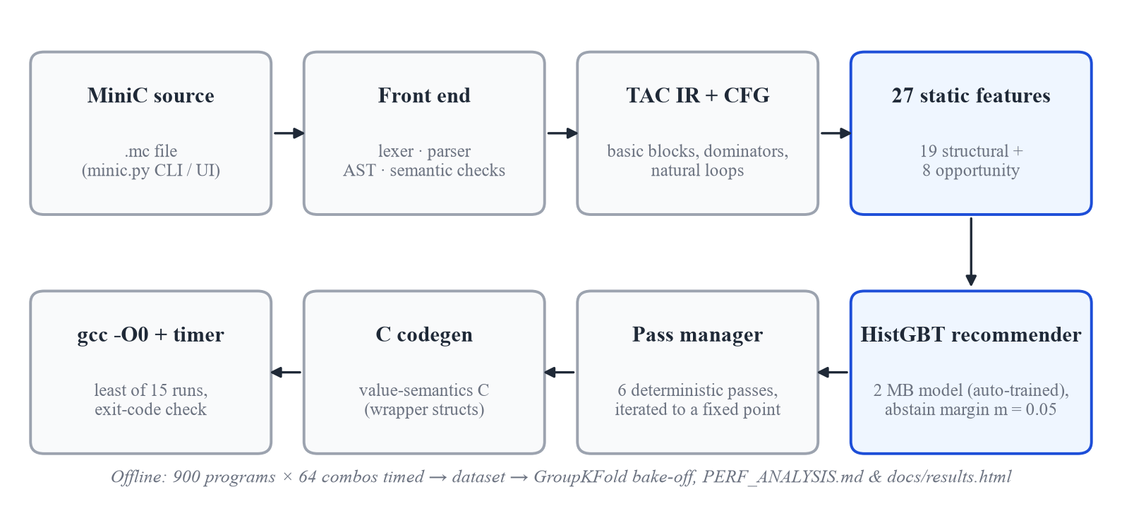
Figure 1: End-to-end architecture of the MiniC optimiser and recommender

4.2 The MiniC Language
MiniC supports int, float and char; fixed-size one- and two-dimensional arrays; non-recursive structs (which may contain arrays and other structs); fixed-size strings (char arrays with compile-time length checks); functions and recursion; if/else, while and for; block scoping; and the usual arithmetic, relational and logical operators. Pointers, dynamic memory, goto, switch, unions, variadic functions and the preprocessor are excluded. A program has no I/O: its observable result is the value returned by main(). An abridged grammar is shown below.
program → (struct_decl | func_decl | var_decl)*
struct_decl → 'struct' IDENT '{' field_decl+ '}' ';'
var_decl → type_spec IDENT array_suffix? ('=' expr)? ';'
array_suffix→ '[' INT_LIT ']' ('[' INT_LIT ']')?
func_decl → type_spec IDENT '(' param_list? ')' block
stmt → var_decl | expr_stmt | if_stmt | while_stmt | for_stmt | return_stmt | block
expr → assignment ; assignment → postfix '=' assignment | logic_or
logic_or → logic_and ('||' logic_and)* ; logic_and → equality ('&&' equality)*
additive → multiplicative (('+'|'-') multiplicative)*
unary → ('-'|'!') unary | postfix

4.3 Front End
The lexer (frontend/lexer.py) converts source text into tokens tagged with kind and line number. The parser (frontend/parser.py) is a hand-written recursive-descent parser with one function per grammar rule, producing an abstract syntax tree of typed nodes (Program, FuncDecl, StructDecl, WhileStmt, BinaryExpr, ArrayAccessExpr and others). The semantic analyser (frontend/sema.py) then checks declarations before use, function arity, operand types, integer array subscripts, valid l-values, non-recursive struct sizes, missing returns and duplicate declarations, reporting errors with line, column and a caret under the offending token.

4.4 Three-Address Code and Control-Flow Analysis
The IR generator lowers the AST into TAC: a flat list of instructions with at most one operator each, explicit temporaries and explicit control flow through labels, goto and ifFalse. Figure 2 shows the TAC of the running example docs/walk.mc, a loop that accumulates i * scale twice per iteration. Nested aggregate assignments such as a[i].f = v are lowered to a load / modify-copy / store-back chain so that value semantics are preserved.
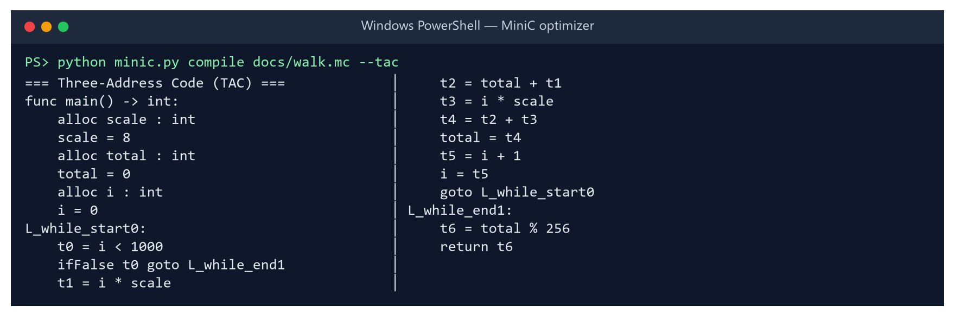
Figure 2: Three-address code generated for the running example (no optimisation)
The CFG builder (ir/cfg.py) partitions the TAC into basic blocks, connects them with edges, computes dominators and identifies natural loops from back edges (Figure 3). Loop-invariant code motion, strength reduction and unrolling all depend on this loop structure.
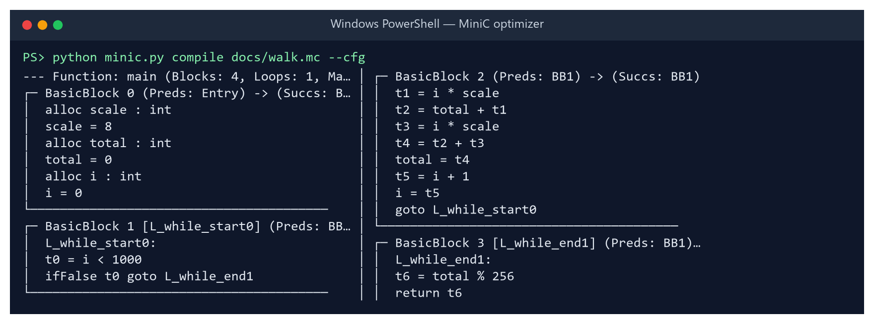
Figure 3: Basic blocks and loop structure of the running example

4.5 Static Feature Extraction
For every program the compiler computes a 27-dimensional feature vector without executing it (Table 2). The 19 structural features describe size, control flow and the instruction mix; the 8 opportunity features estimate how much each pass could change the program. Figure 4 shows the vector for the running example; note opp_cse_redundant = 1, the repeated i * scale.
Table 2: The 27 static features (19 structural + 8 opportunity)
Group | Features
Size & control flow | totalinstructions, basicblockcount, loopcount, maxloopdepth, branchcount, branchdensity, cyclomatic_complexity
Instruction mix | arithmeticopscount, multiplicationcount, constantloadcount, functioncallcount, recursivecallcount, stringops_count
Data access | arrayaccesscount, array2daccesscount, structaccesscount, namedvariablecount, tempvariablecount, instructiondensityinloops
Opportunity (8) | oppconstfoldable, oppcseredundant, opplicmhoistable, oppsrreducible, oppunrollableloops, opploopbodyinsts, opphotinvariantfrac, oppestdynkiloinsts

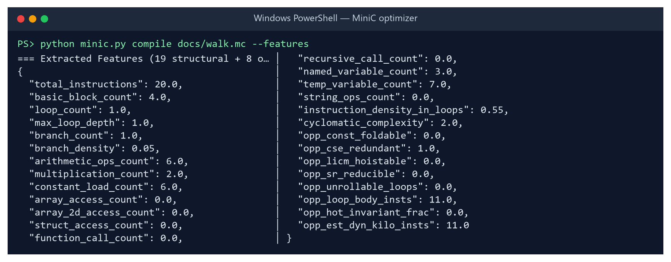
Figure 4: Feature vector extracted for the running example

4.6 Optimisation Passes
Each pass is a function from TAC to TAC and is controlled by one bit of a 6-bit mask (Figure 5); a combination is identified by the integer value of the mask, from 0 (no passes) to 63 (all six). Table 3 summarises the passes.
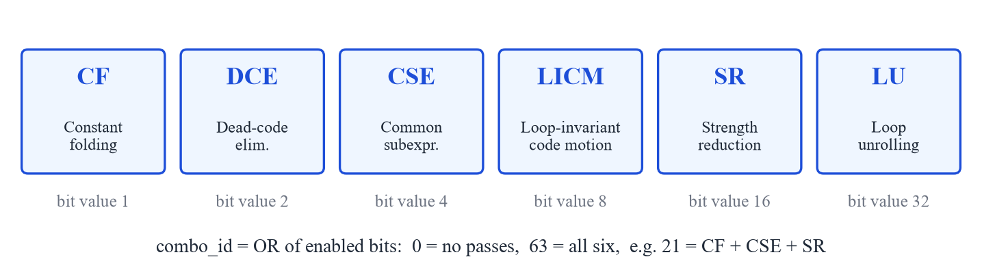
Figure 5: The six passes and their bits in the combination mask
Table 3: Summary of the optimisation passes
Bit | Pass | Transformation
1 | Constant folding (CF) | Evaluates constant expressions with 32-bit C semantics, propagates single-assignment constants across the function, applies algebraic identities and removes constant branches.
2 | Dead-code elimination (DCE) | Removes instructions whose results are never used, unreachable blocks and unused allocations (backward liveness).
4 | Common-subexpression elim. (CSE) | Local value numbering with copy propagation: a repeated expression is computed once and reused.
8 | Loop-invariant code motion (LICM) | Hoists instructions whose operands do not change in the loop into a labelled pre-header.
16 | Strength reduction (SR) | Replaces i * k for an induction variable i with an accumulator updated by + k each iteration.
32 | Loop unrolling (LU) | Replicates a counted loop body four times under a guard and keeps the original loop as a remainder loop.

Passes enable each other. On the running example, strength reduction alone does nothing because the multiplier scale is a variable; after constant folding has propagated scale = 8, SR can replace both multiplications with a single accumulator __sr7 that grows by 8 each iteration, and CSE makes both uses share it (Figure 6).
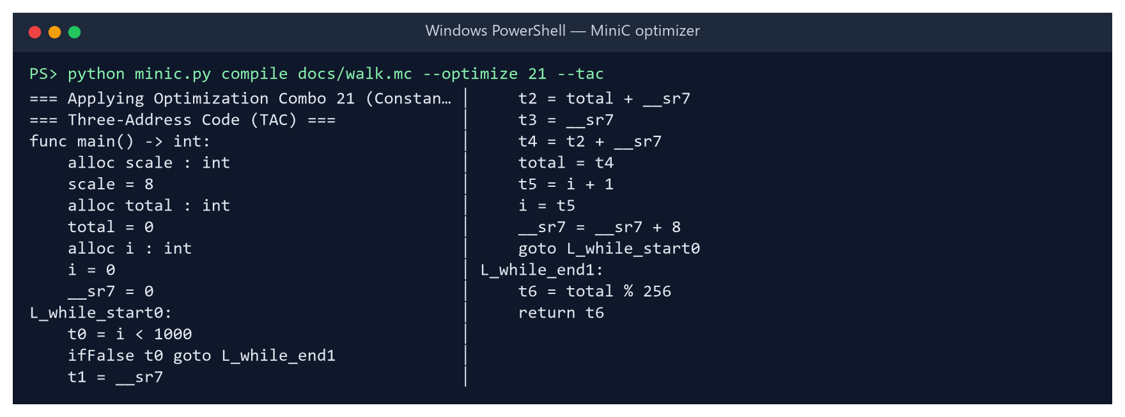
Figure 6: Combination 21 (CF + CSE + SR): both multiplications replaced by an accumulator
Figure 7 shows LICM and CF on the benchmark licm_arith, whose loop body consists entirely of invariant products of a, b and c. All six products are folded to constants and hoisted out of the loop, leaving only additions inside it. Figure 8 shows loop unrolling: the body is replicated four times under a guard i < 997, followed by the original loop for the remaining iterations.
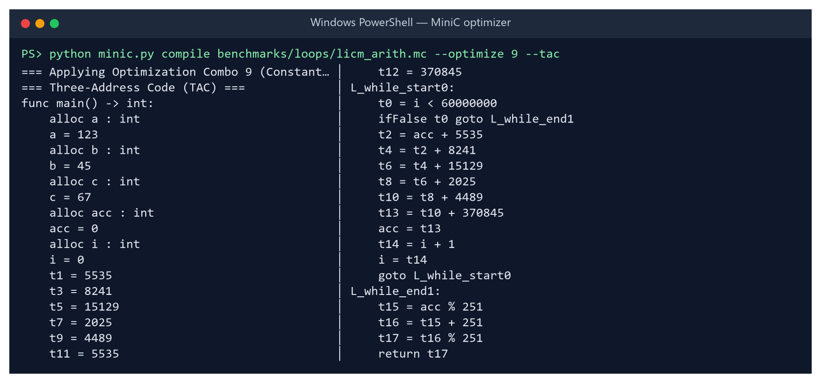
Figure 7: Combination 9 (CF + LICM) on licm_arith: invariant products folded and hoisted
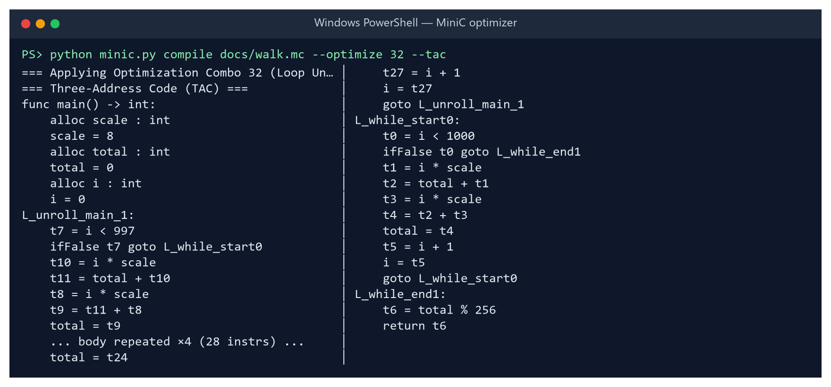
Figure 8: Combination 32 (LU): four-way unrolled loop with remainder loop

4.7 Pass Manager, Fixed-Point Iteration and Determinism
The pass manager (optimizer/pass_manager.py) applies the enabled passes in the canonical order CF → CSE → LU → LICM → SR → DCE and repeats the whole sequence until the program stops changing (a fixed point). Iteration lets each pass clean up after the others: for example, DCE removes the temporaries that CSE and SR leave unused, and CF can fold expressions that LICM has just hoisted. The order is fixed so that the 64 combinations define a clean pass-selection problem.
Two subtle multi-pass engineering bugs discovered during the Review-3 audit were resolved in the pass manager and loop unroller (optimizer/loop_unroll.py):
• Preventing duplicate remainder-loop unrolling under LU + LICM: When LU unrolls a loop, it emits an unroll prologue (L_unroll_*) whose guard exits into the original loop (head_label) as the 0..3-iteration remainder handler. When LICM runs after LU in the same fixed-point round, it can insert a pre-header (L_licm_pre_*) between the unroll guard's exit and head_label. In the next fixed-point round, _already_unrolled() previously checked only whether L_unroll_* jumped directly to head_label, failed to recognise the remainder loop, and unrolled the remainder loop a second time (dead code, since at most 3 iterations reach it, but doubling code size). _already_unrolled() now walks forward through straight-line pre-header instructions from the guard's exit target to head_label, guaranteeing every loop is unrolled at most once.
• Process-deterministic temporary allocation: Loop unrolling previously collected body temporaries into a Python set before renaming them for each of the four copies. Because Python randomises PYTHONHASHSEED per process, temporary numbering in the emitted TAC and C varied from run to run. Replacing set iteration with a program-order _TempAllocator makes the compiler strictly deterministic across processes.

4.8 Value-Semantics Code Generation
The C emitter (codegen/c_emitter.py) produces C99 that any GCC can compile. To keep MiniC's copy semantics, arrays and strings are wrapped in one-field structs (arr_int_3_3, str_6), so that C assignment and parameter passing copy them instead of decaying to pointers; struct typedefs are emitted in dependency order. Figure 9 shows part of the output for canonical_example.mc, the program that exercises every language feature.
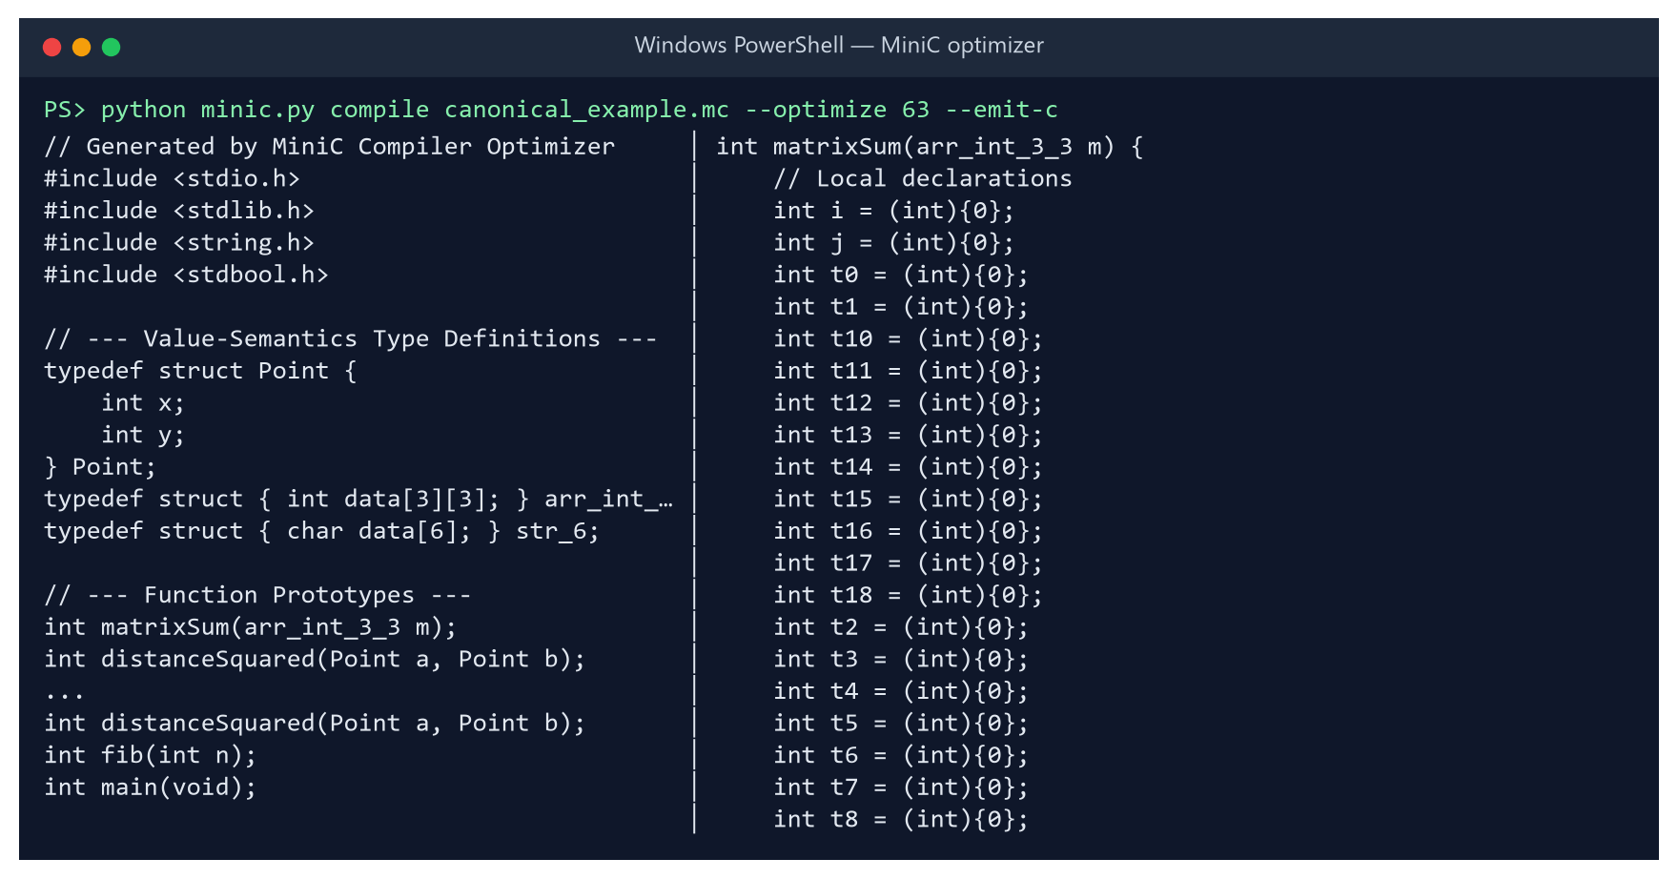
Figure 9: Generated value-semantics C for canonical_example.mc (combo 63, excerpt)

4.9 Measurement Methodology and Noise Analysis
The harness (harness/) compiles each emitted C file with gcc -O0 -std=c99 and runs the binary after four warm-up runs, keeping the minimum of 15 wall-clock runs. Unoptimised run times across the 900 programs span 5.6–210.5 ms (median 12.1 ms). The speedup of combination c for program p is defined as
speedup(p, c) = time(p, combo 0) / time(p, c) (> 1 means faster)

Before a timing is recorded, the binary's exit code must equal that of combination 0 (the correctness gate). The full sweep of 900 programs (57,600 builds) took 3 hours 20 minutes on eight parallel workers. Because eight workers run simultaneously, OS scheduling and cache contention add positive upward skew to individual timings: across all 57,600 configurations (PERF_ANALYSIS.md), the ratio median_time_ms / min_time_ms has a median of 1.102 and a 95th percentile of 1.411 (10–40% interference on the median). Recording the minimum of 15 runs after 4 warm-ups isolates the least-interfered hardware execution time.

4.10 Benchmark Corpus
The corpus contains 30 hand-written programs in five categories and 870 programs produced by a parametric generator (harness/gen_corpus.py). The generator instantiates single-pattern programs that target one pass each, with randomised constants, trip counts and loop forms, and weighted composites that combine several patterns in one program. A manifest records each program's pattern so that results can be broken down by program type (Table 4).
Table 4: Composition of the 900-program benchmark corpus
Source | Category / pattern | Programs | Purpose
Hand-written | loops | 15 | LICM, CSE, constant propagation, polynomial evaluation
Hand-written | numeric | 6 | array kernels: convolution, dot product, histogram, matrix multiply, stencil, vector scale
Hand-written | structs | 4 | bounding boxes, complex arithmetic, distance accumulation, particle simulation
Hand-written | recursion | 3 | Fibonacci, Ackermann, Takeuchi
Hand-written | strings | 2 | Caesar cipher, vowel counting
Generated | cf, cse, licm, sr, div, struct, unroll | 32 each | one optimisation opportunity per program
Generated | branch, nested, recur, neutral | 31 each | branchy code, nested loops, recursion, no opportunity (control)
Generated | composite | 522 | 2–4 patterns combined in one program
Total |  | 900 | 57,600 (program, combination) measurements

4.11 Learning Formulation and Size-Aware Selection
Each (program, combination) pair is one training row: the 27 features of the program, the 6 bits of the combination, and the measured speedup as the regression target. A regressor f therefore predicts the speedup of any combination for any program. For a new program the recommender evaluates all 64 combinations and applies the risk-aware selection rule
c* = argmax_c f(x_p, c)
recommend c* if f(x_p, c*) > 1 + m
recommend combo 0 (no passes) otherwise m = abstain margin

Three regressors were considered for the production recommender: Random Forest (400 trees), Extra Trees (500 trees) and Histogram Gradient Boosting (600 iterations, learning rate 0.05) [8], [10], [11]. Each was combined with plain argmax, with margins m ∈ {0.03, 0.05, 0.08, 0.12, 0.18}, and a per-pass classifier alternative. Every strategy was scored by 5-fold GroupKFold on: the mean true speedup of the recommended combination; the fraction of the oracle's gain it captures; and the fraction of programs it makes more than 2% slower. Among strategies whose regression rate is at most 10%, held-out speedups within 0.01× are within timing noise and are treated as a tie, preferring the compact Histogram Gradient Boosting model (2 MB on disk, vs. 613 MB for Random Forest). If data/trained_model.pkl is absent on a fresh clone or was saved by a different scikit-learn version, ml/predictor.py automatically trains this 2 MB HistGBT model from data/benchmark_dataset.csv on first use (~15 seconds).

4.12 Model Comparison Design
To test whether learned program representations can replace engineered features, eight models were compared under identical conditions (Table 5). Sequence models read each program's unoptimised TAC converted to tokens (opcode plus operand kind, with names and values dropped; median length 284, capped at 640). Neural models are trained program-batched: a program is encoded once and its encoding is combined with each of the 64 pass vectors by a small prediction head. Every model is evaluated on the same five folds, using the same margin sweep and the same 10% regression cap.
Table 5: Models in the comparison (neural models share a 6-bit pass input and a 64-unit prediction head)
Model | Input | Architecture
Linear (Ridge) | features | standardised features + pass bits, L2-regularised linear regression
Random Forest | features | 400 trees, min. 2 samples per leaf
HistGradient Boosting | features | 600 boosting iterations, 31 leaves, learning rate 0.05
MLP | features | 27 → 128 → H encoder, ReLU, dropout 0.1
1D-CNN | TAC sequence | token embedding → 3 × Conv1d (kernel 5; 64, 64, 128 channels) → pooling
GRU | TAC sequence | token embedding → 1-layer GRU, sequence capped at 320 tokens
1D-CNN + features | both | CNN encoding concatenated with a 64-unit feature encoder
GRU + features | both | GRU encoding concatenated with a 64-unit feature encoder

5. Implementation & Screenshots

5.1 Technology Stack and Environment
Table 6: Implementation technology and experimental environment
Component | Technology
Compiler, harness, ML, CLI | Python 3.13 / 3.14 (≈ 10,000 lines including tests and UI templates)
C compiler | GCC 16.2.0 (WinLibs MinGW-w64, UCRT), pinned at -O0 -std=c99 for measurement
Classical ML | scikit-learn 1.9, NumPy 2.5, pandas 3.0 (requirements.txt)
Neural models (optional) | PyTorch 2.14 CPU (requirements-models.txt, only for --compare-models)
Web playground & results | Flask 3.1.3 single-page app + interactive HTML/SVG dashboard (docs/results.html)
Plots & report generation | Matplotlib 3.11, python-docx, pypdf, LibreOffice headless
Testing | pytest 9.1.1 (51 test functions + sub-tests, --quick marker support)
Platform | Windows 11, 16 logical CPUs, sweep on 8 parallel workers

5.2 Repository Structure
minic.py single unified entry point (check, compile, recommend, benchmark,
playground, results, analyze, experiment, test [--quick])
src/minic/
frontend/ lexer.py parser.py ast_nodes.py sema.py
ir/ tac.py ir_generator.py cfg.py
features/ extractor.py (19 structural) opportunity.py (8 opportunity)
optimizer/ constant_folding.py dce.py cse.py licm.py
strength_reduction.py loop_unroll.py pass_manager.py
codegen/ c_emitter.py
harness/ compiler.py timer.py sweeper.py gen_corpus.py
report.py perf_analysis.py gen_resultspage.py
ml/ dataset.py model.py train.py predictor.py
sequences.py models_torch.py models_compare.py
driver.py command-line compiler
demo/ cli.py (recommend | benchmark) app.py + static/index.html
benchmarks/ 30 hand-written programs + generated/ (870 programs)
data/ benchmark_dataset.csv (57,600 rows) results_summary.json
docs/ results.html results_template.html WALKTHROUGH.md spec/
reports/ course reports (Review 1, Review 2, Review 3 / Final) + generators
tests/ 51 pytest tests (front end, IR, passes, determinism, harness, ML)

5.3 Unified Entry Point (minic.py) and Running the System
To ensure a clean out-of-the-box experience on a fresh clone, all workflows are consolidated under a single root script, minic.py (Table 7). Running python minic.py check verifies the Python version, required packages, gcc availability on PATH, the 57,600-row dataset, and the trained model, and then compiles and executes canonical_example.mc at --optimize 63 as a smoke test (Figure 10).
Table 7: Subcommands provided by the unified minic.py entry point
Command (python minic.py ...) | Action
check | Verifies Python, packages, gcc and dataset; runs an end-to-end compile+run smoke test.
compile FILE.mc [--optimize 0..63] [--run] | Compiles a MiniC file; prints AST/TAC/CFG/features/C or runs via gcc.
recommend FILE.mc [--verify] | Predicts the best pass combo (auto-trains 2 MB HistGBT on first use) and times it.
benchmark FILE.mc | Times the program with each pass alone, all passes on, and gcc -O2.
playground [--port PORT] | Launches the interactive browser playground on http://127.0.0.1:5005.
results [--recompute] | Rebuilds the interactive docs/results.html dashboard and opens it.
analyze | Computes per-pass marginal effects, non-additivity and noise into PERF_ANALYSIS.md.
experiment [--full] [--compare-models] | Runs the strategy bake-off, trains the model, and writes RESULTS.md.
test [--quick] | Runs the full pytest suite or skips the 6 slow 64-combination sweep tests.

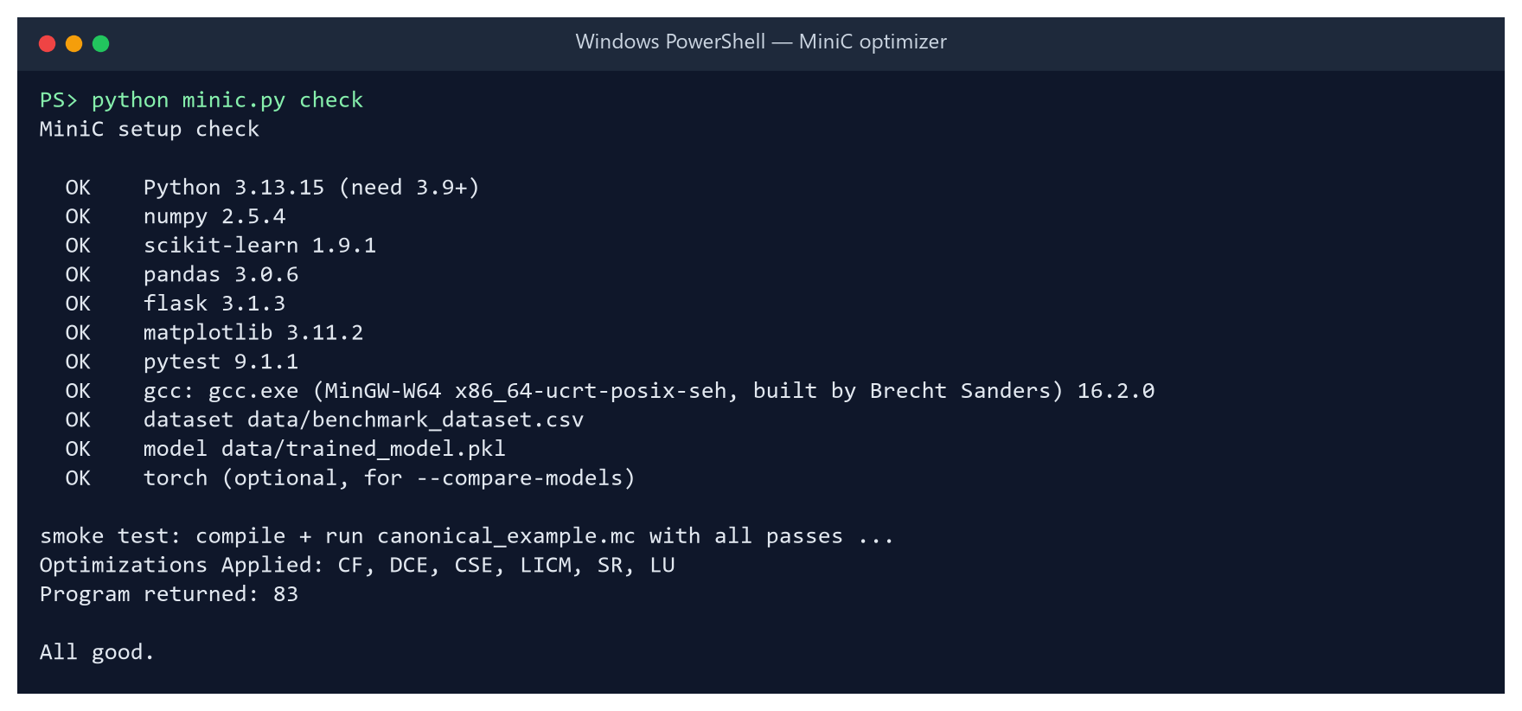
Figure 10: Self-verification and smoke test via python minic.py check

5.4 Screenshots: Redesigned Playground, CLI and Visual Results Page
The browser playground (demo/app.py, demo/static/index.html) was completely redesigned for Review-3 into four focused views: Result, Why this combo, What the passes did, and Code before / after. While a build runs, a live stage tracker shows progress. Once complete, the Result tab displays the measured speedup, a time-saved ring, interactive switches for the six passes, and a visual build race that animates the unoptimised -O0, ML-optimised -O0, and reference gcc -O2 builds at their real relative speeds alongside every individual timing sample (Figure 11). The Why this combo tab plots the model's predicted speedups for all 64 combinations as a heatmap and lists detected static/opportunity features ahead of absent ones. The Code before / after tab renders a GitHub-style per-function unified TAC diff with changed functions first and unchanged regions folded (Figure 12).
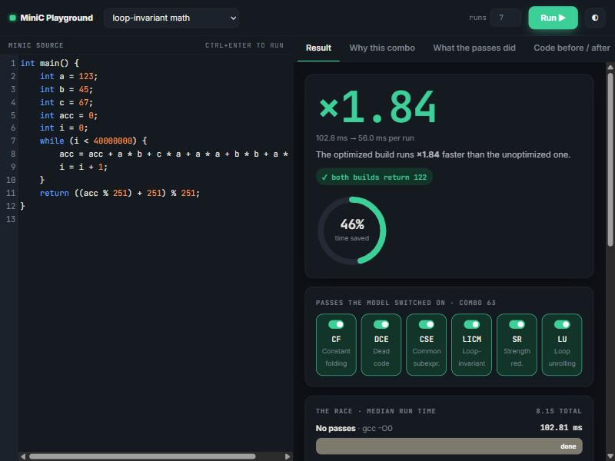
Figure 11: Redesigned browser playground (Result tab): ×1.84 speedup, 46% time-saved ring, interactive pass switches, and live build race
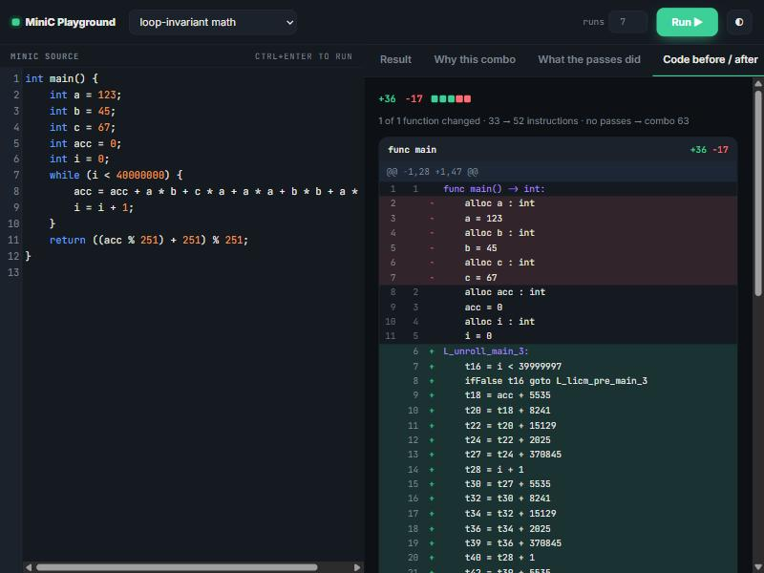
Figure 12: Redesigned browser playground (Code before / after tab): GitHub-style per-function unified TAC diff showing unrolled prologue and LICM pre-header
Figures 13–14 show the rebuilt interactive visual results page (docs/results.html, generated from docs/results_template.html and data/results_summary.json by python minic.py results), which provides animated interactive charts of all 64 combinations, every benchmark program on a log-scale scatter plot, program families, pass interactions, and an honest strategy comparison.
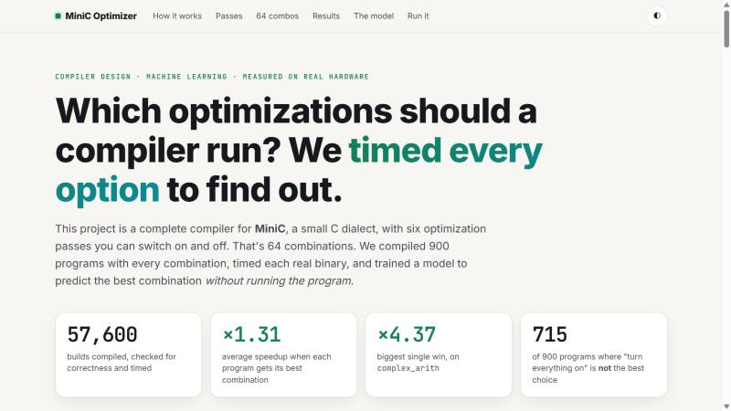
Figure 13: Interactive visual results dashboard (docs/results.html): hero summary of the 57,600 timed builds
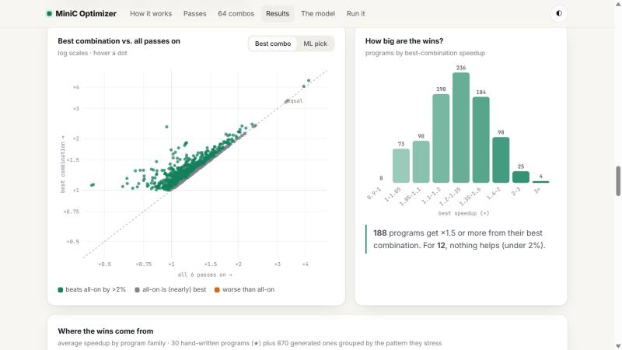
Figure 14: Interactive visual results dashboard (docs/results.html): per-program log-scale scatter (Best combo vs. ML pick toggle) and speedup distribution
Figures 15–20 show detailed multi-tab runs of the struct-distance (×2.52 speedup, returning 130) and loop-invariant arithmetic (×1.93 speedup) benchmarks, and Figures 21–22 show the CLI recommend --verify and compile --run outputs.
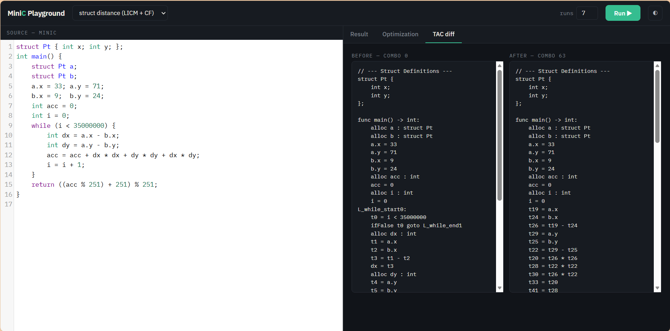
Figure 15: Struct-distance benchmark: TAC diff before (combo 0) and after (combo 63)
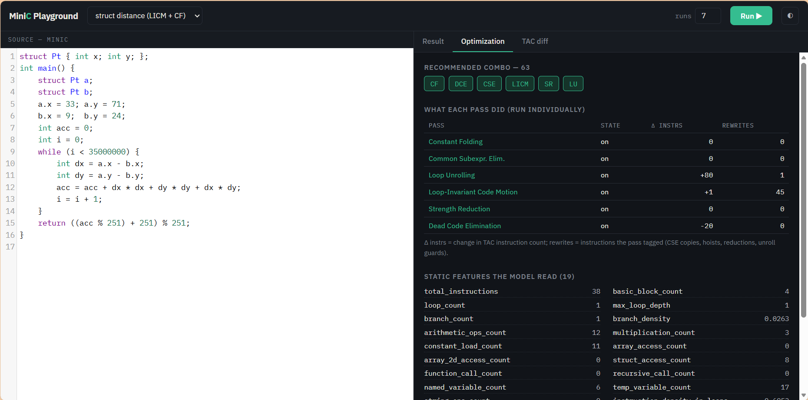
Figure 16: Struct-distance benchmark: passes applied, per-pass effect and static features
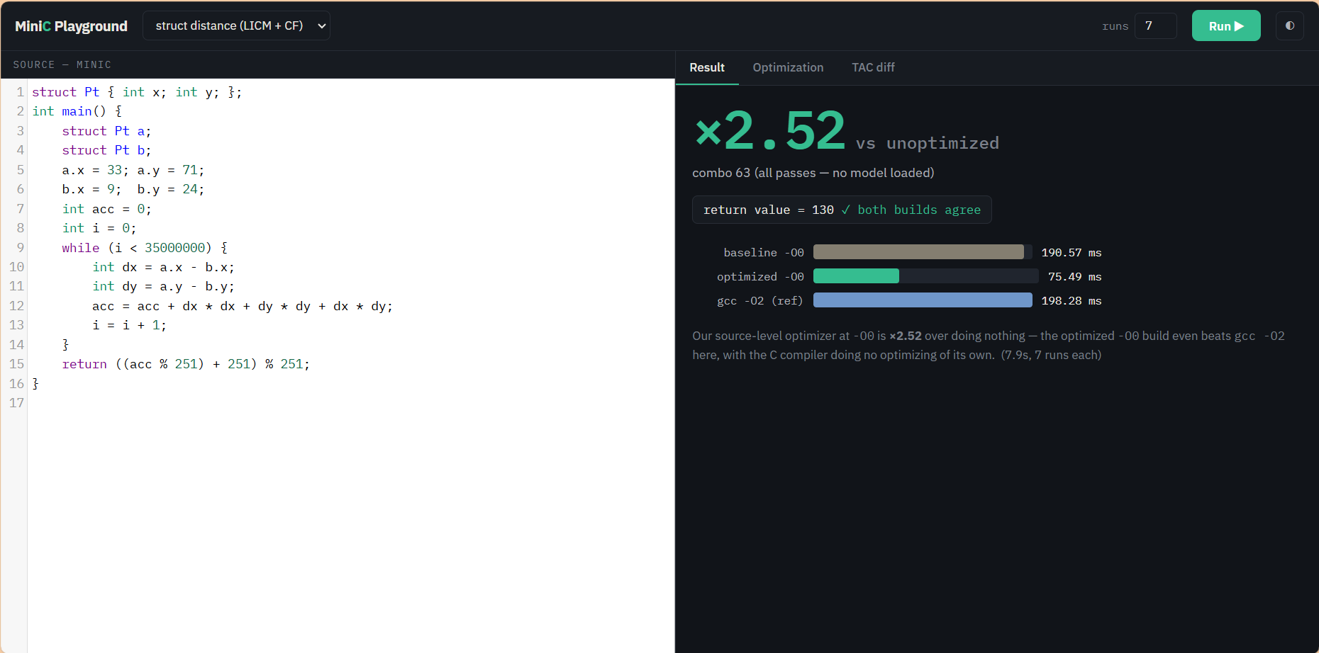
Figure 17: Struct-distance benchmark: ×2.52 speedup (190.57 ms → 75.49 ms); both return 130
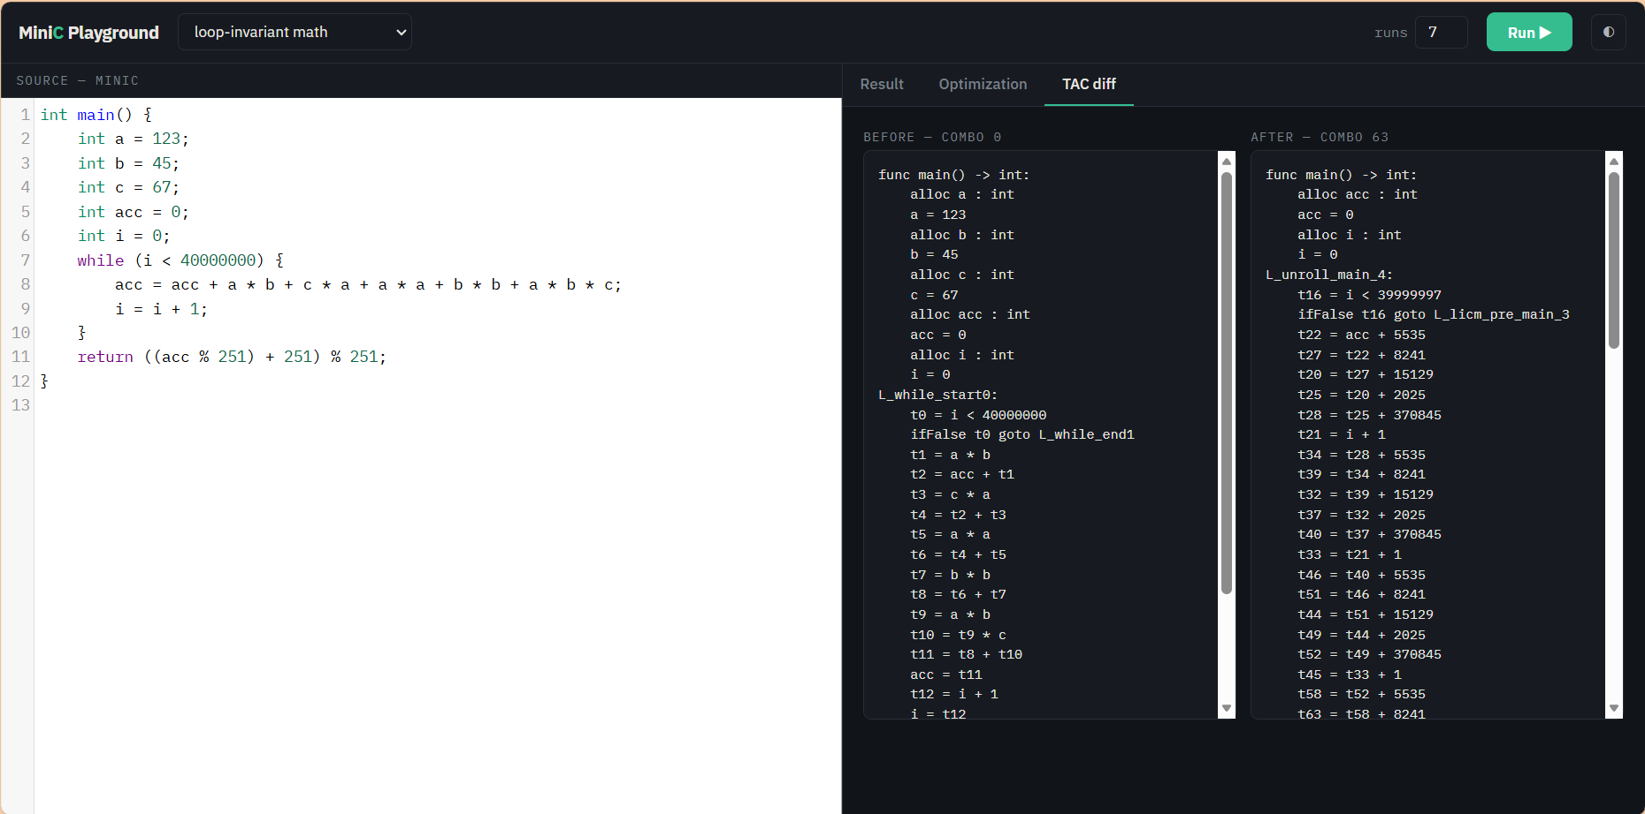
Figure 18: Loop-invariant arithmetic benchmark: TAC diff view
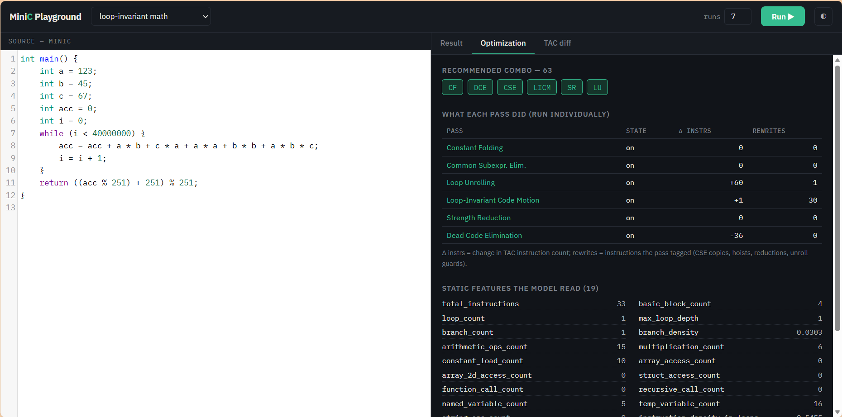
Figure 19: Loop-invariant arithmetic benchmark: per-pass breakdown and feature inspection
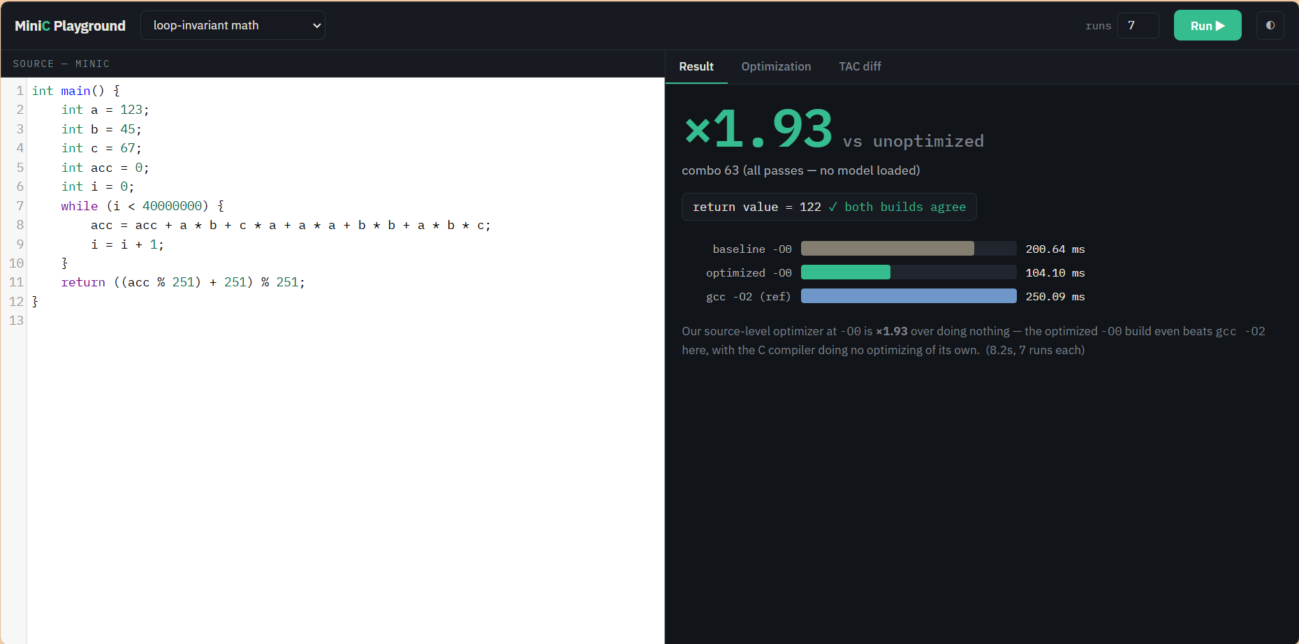
Figure 20: Loop-invariant arithmetic benchmark: ×1.93 speedup (200.64 ms → 104.10 ms)
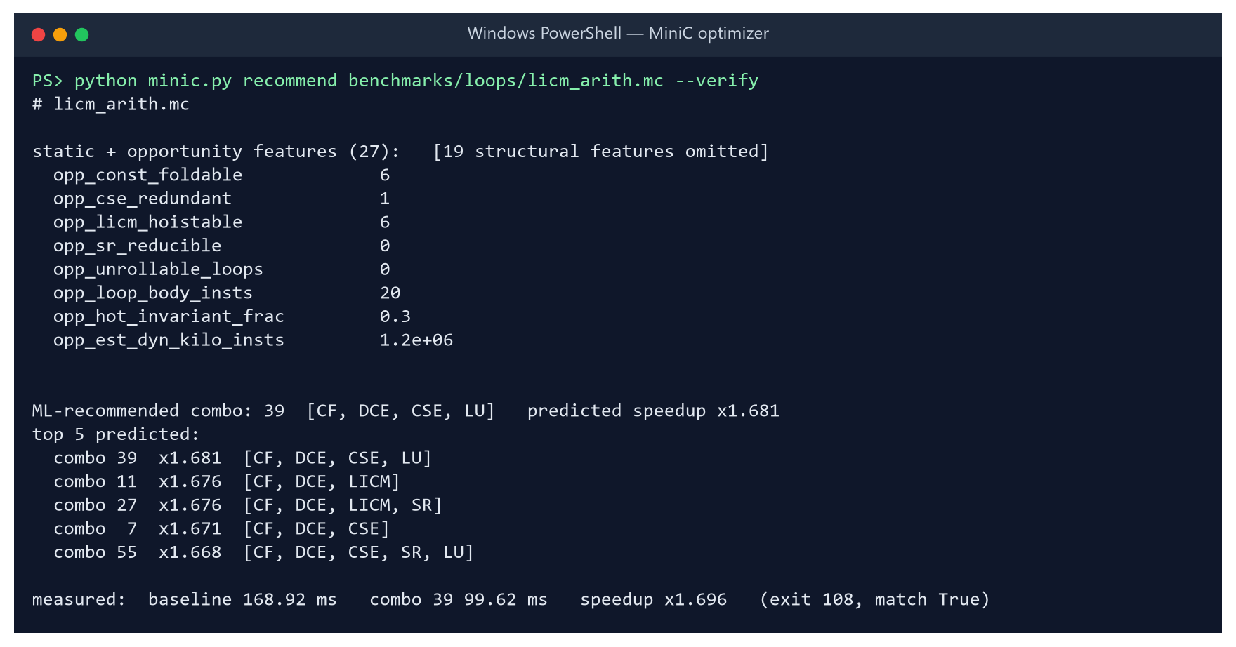
Figure 21: CLI recommendation for licm_arith: predicted ×1.68, measured ×1.70 (168.92 ms → 99.62 ms)
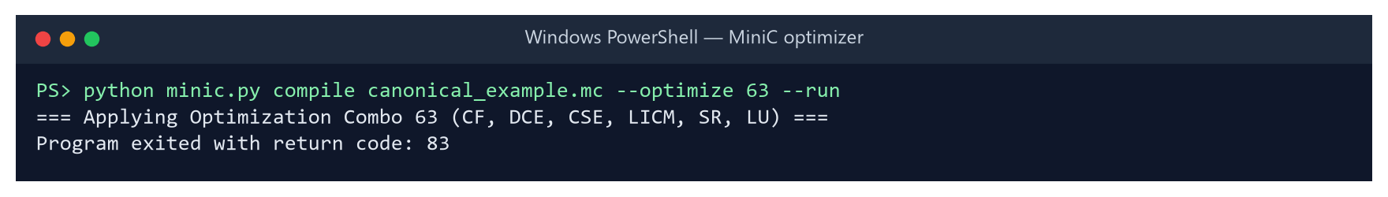
Figure 22: canonical_example.mc optimised with all six passes returns expected exit code 83

5.5 Experimental Results

5.5.1 Overview of the sweep
Table 8: Headline results of the 900-program sweep
Measure | Value
Programs × combinations | 900 × 64 = 57,600 timed configurations
Configurations failing the correctness gate | 0
Unoptimised runtime per program (combo 0) | 5.6 ms – 210.5 ms (median 12.1 ms)
Best combination per program (oracle) | ×1.31 geomean / ×1.33 mean (max ×4.37, complex_arith)
All six passes on (combo 63) | ×1.19 geomean / ×1.22 mean (worst case 2.3× slower than combo 0)
Programs where all-on is not the best (>2% behind) | 715 / 900 (79.4%)
Programs made >2% slower by all-on | 112 / 900 (12.4%)
Share of all non-empty configs that regress >2% | 25% (14,175+ configurations)
Fixed non-empty combination that never regresses >3% | none — only combo 0 is universally safe

The optimiser helps almost every program, but by very different amounts (Figure 23). About 39% of programs gain less than ×1.2 from even their best combination, while 127 gain more than ×1.6.
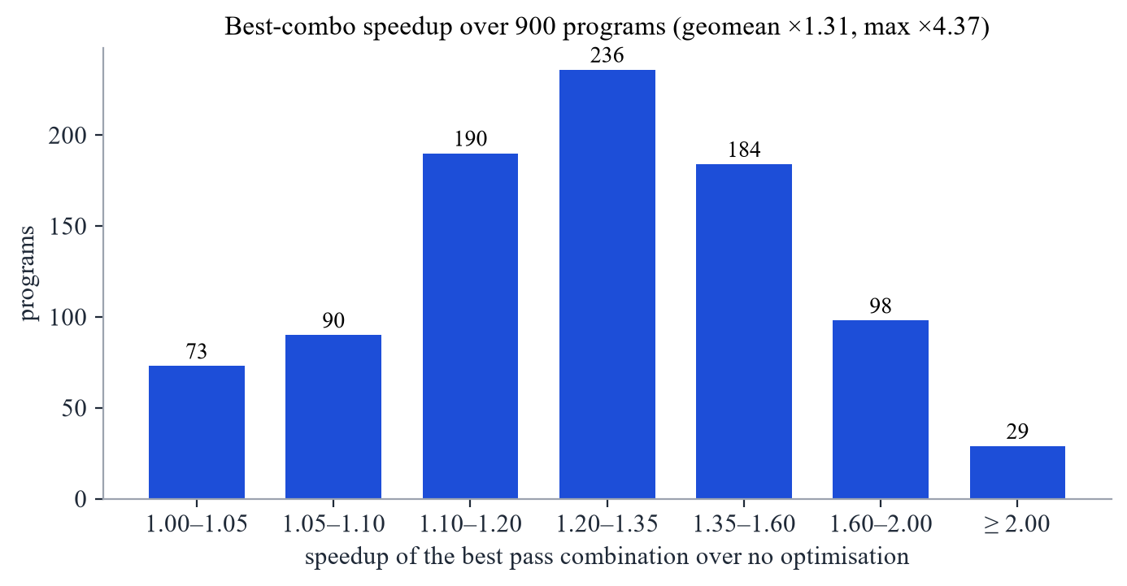
Figure 23: Distribution of the best-combination speedup over 900 programs

5.5.2 Results by category
Struct-heavy programs benefit most (×2.70 geomean): value semantics make the unoptimised code copy and re-load struct fields repeatedly, and CSE, LICM and DCE remove most of that work. Loop-dominated programs follow at ×1.75. Recursive programs gain least (×1.13), because their cost lies in calls, which the intra-procedural passes do not touch (Figure 24).
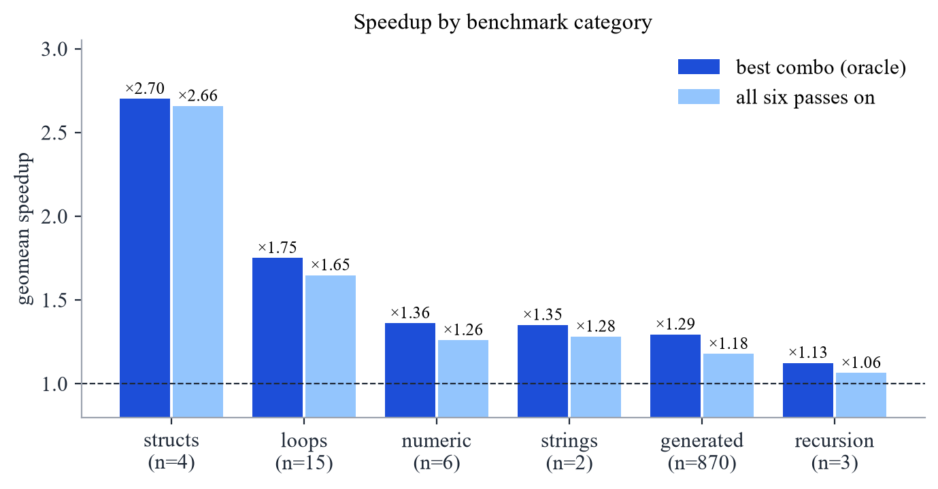
Figure 24: Geometric-mean speedup by category, best combination vs all passes

5.5.3 No single combination is best
Figure 25 compares, for every program, the speedup of enabling everything with the speedup of the best combination. Points on the diagonal are programs for which all-on is optimal; most programs lie well above it, and 112 lie left of the dashed line, where all-on is slower than doing nothing. Figure 26 shows that no pass belongs to every program's best combination, and Figure 27 lists the programs with the largest gains.
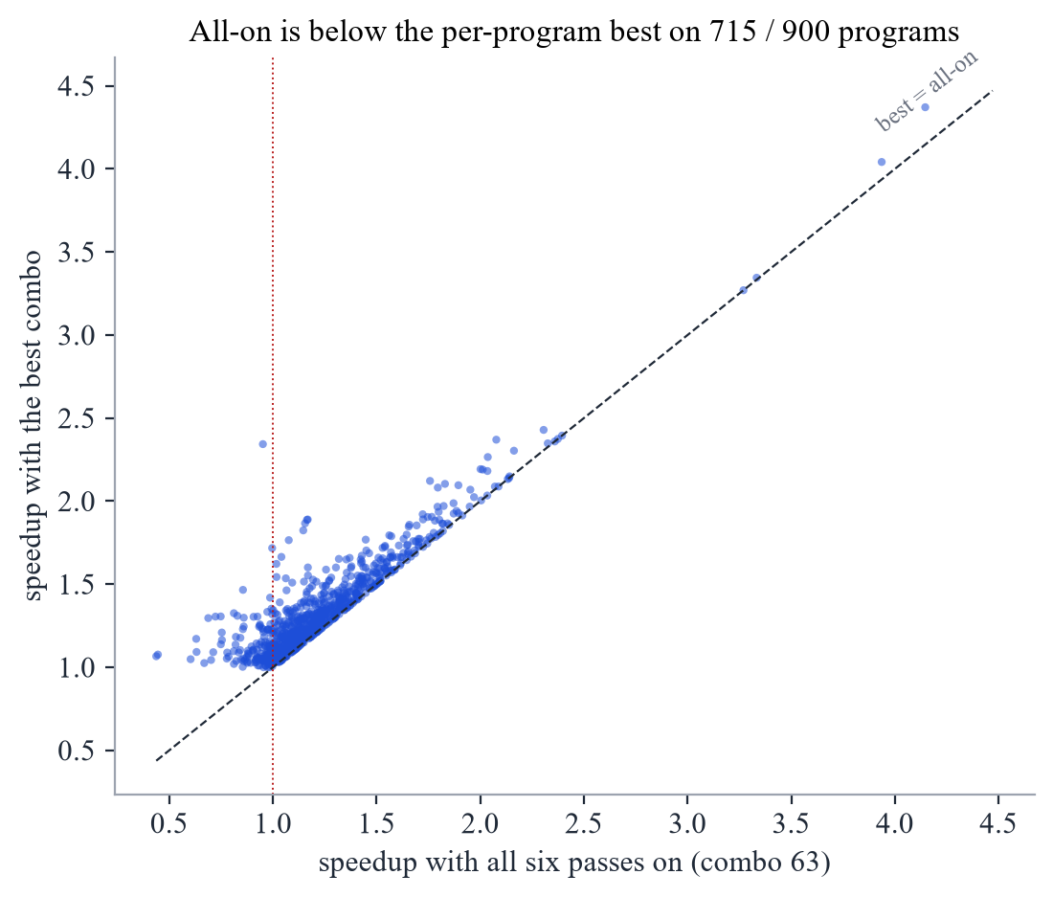
Figure 25: All-on speedup vs best-combination speedup, one point per program
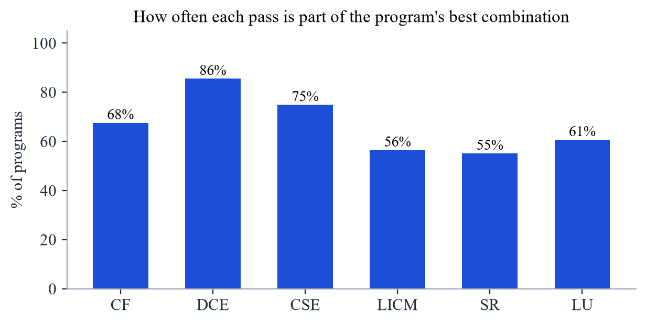
Figure 26: Share of programs whose best combination includes each pass
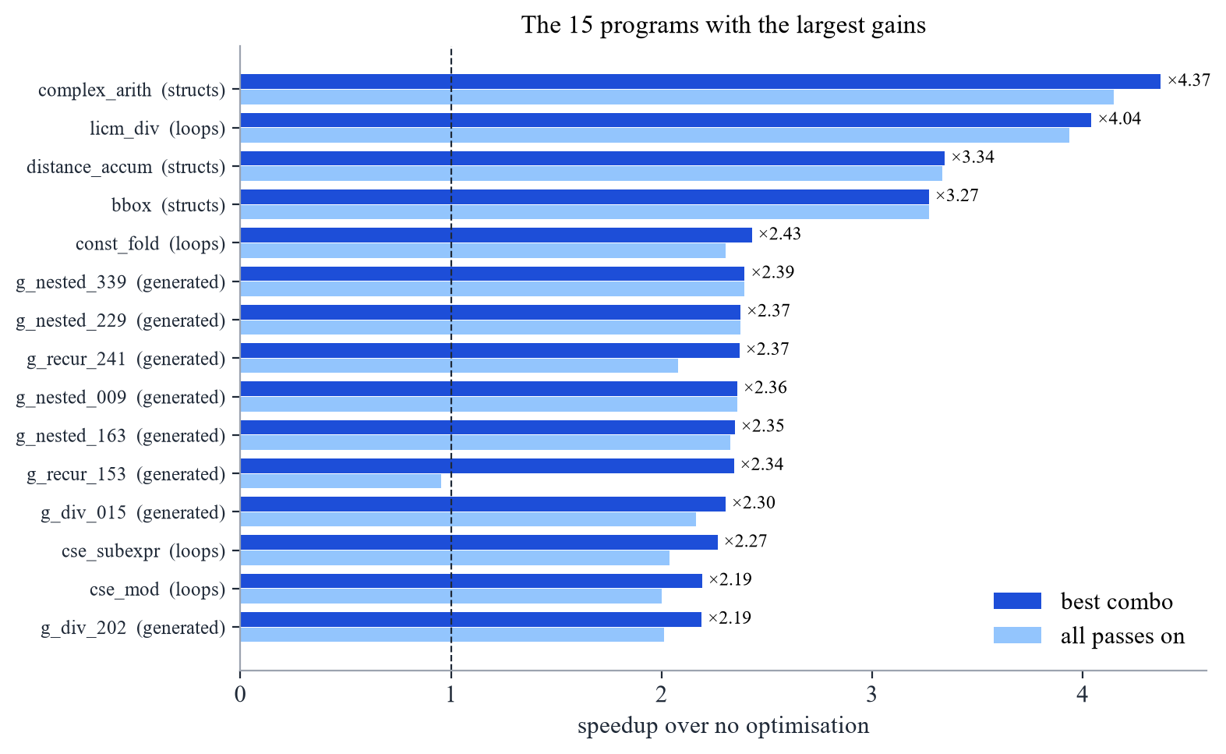
Figure 27: The fifteen programs with the largest speedups

5.5.4 Per-pass marginal effects, non-additivity and search cost
A central addition after Review-2 (src/minic/harness/perf_analysis.py → PERF_ANALYSIS.md) exploits the full 2⁶ factorial structure of the 57,600 timed runs to separate each pass's standalone effect from its effect in the presence of other passes (Table 9, Figure 28).
Table 9: Per-pass behaviour across 900 programs: alone vs. averaged over all 32 contexts of the other five passes
Pass | Alone (geomean) | Marginal (32 contexts) | Context range | Helps (>2%) | Hurts (>2%)
CF (Constant Folding) | ×1.043 | ×1.042 | ×1.006 – ×1.093 | 45% | 5%
DCE (Dead-Code Elim.) | ×0.997 | ×1.035 | ×0.994 – ×1.104 | 64% | 3%
CSE (Common Subexpr.) | ×1.034 | ×1.055 | ×1.010 – ×1.130 | 63% | 4%
LICM (Loop-Invariant) | ×1.018 | ×1.029 | ×0.994 – ×1.050 | 45% | 9%
SR (Strength Reduction) | ×0.983 | ×0.995 | ×0.975 – ×1.013 | 16% | 25%
LU (Loop Unrolling) | ×1.021 | ×1.034 | ×1.019 – ×1.047 | 35% | 17%

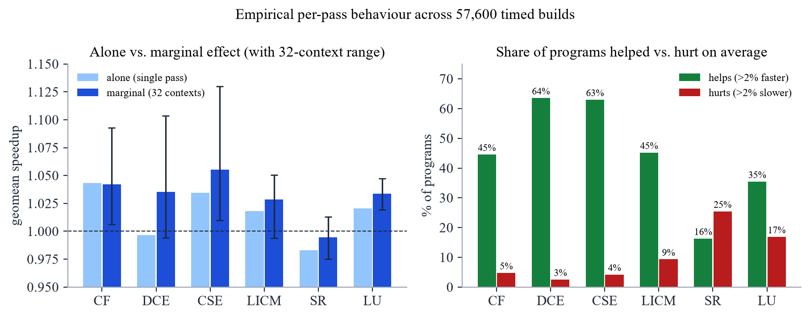
Figure 28: Per-pass standalone vs. marginal speedup (left) and share of programs helped vs. hurt (right)
Three findings stand out from Table 9:
• DCE is pure synergy: Enabled alone, DCE gives ×0.997 because the front end emits almost no dead code. Averaged over all 32 contexts of the other passes, however, DCE yields ×1.035 (and up to ×1.104 in the best context), helping 64% of programs and hurting only 3%, because it removes the dead temporaries left behind by CF, CSE and SR.
• Pass effects are strongly super-additive: Multiplying the six single-pass speedups predicts an all-on geomean of ×1.099, whereas the measured all-on geomean is ×1.190. Per program, an additive model is off by a median of 24% and errs by more than 10% on 680 / 900 programs. This proves empirically that per-pass additive cost models cannot capture pass interactions, and justifies scoring whole (program, combination) pairs.
• SR and LU are high-variance passes: Adding SR hurts 25% of programs (and helps 16%), while LU hurts 17% (and helps 35%). Moreover, 25% of all non-empty configurations across the corpus make the program >2% slower than doing nothing.
Table 10 and Figure 29 compare the compile-time search cost (number of real hardware timing runs required per unseen program) against the resulting speedup. Even a greedy forward search that times an average of 16.4 builds per program still misses the best combination by >2% on 486 / 900 programs. The ML recommender requires zero timing runs.
Table 10: Search cost vs. speedup across the 900-program corpus
Strategy | Timed runs / program | Arithmetic mean speedup | Geometric mean speedup | Regressions (>2% slower)
No passes (combo 0) | 1 (baseline) | ×1.000 | ×1.000 | 0%
All 6 passes (combo 63) | 1 | ×1.222 | ×1.190 | 12.4% (worst: 2.3× slower)
ML recommender (HistGBT, m=0.05) | 0 | ×1.210 | ×1.190 | 9.0%
Greedy forward search (real clock) | 16.4 | ×1.280 | ×1.253 | misses best on 486/900
Exhaustive search (oracle) | 64 | ×1.333 | ×1.305 | 0%

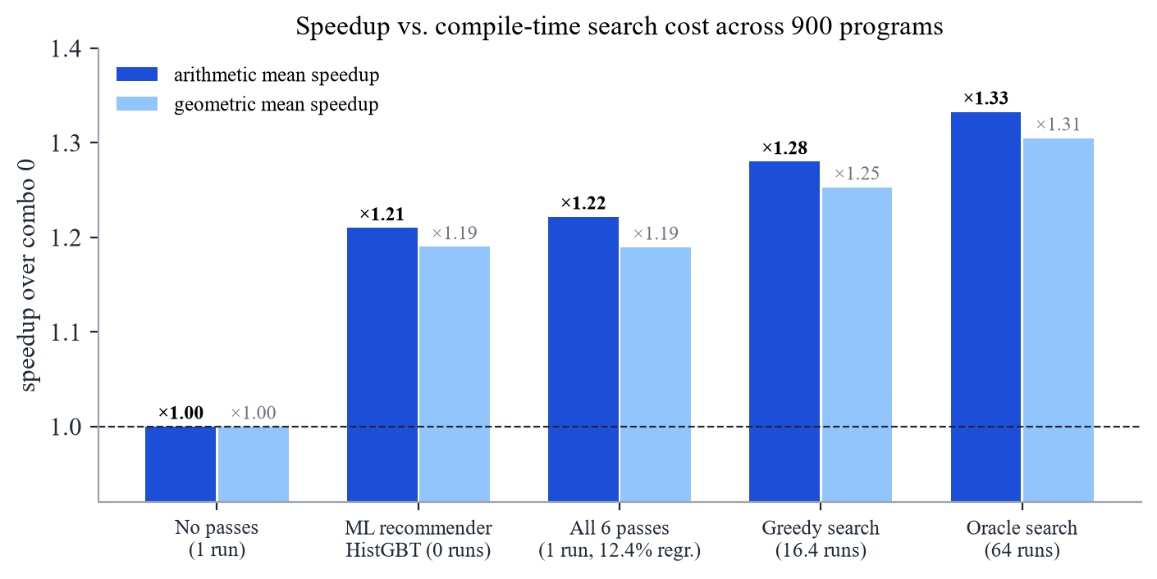
Figure 29: Speedup vs. compile-time search cost across 900 programs

5.5.5 The recommender and honest comparison with 'all passes on'
With size-aware tie-breaking (treating held-out speedups within 0.01× as ties and preferring the smaller model), the strategy bake-off selects Histogram Gradient Boosting with an abstain margin of 0.05: a combination is recommended only if its predicted speedup exceeds ×1.05. On held-out programs it achieves an arithmetic-mean speedup of ×1.21 against ×1.33 for the oracle, capturing 62% of the achievable gain, while 9% of its recommendations slow the program down; the speedup-prediction MAE is 0.105 and the serialised model is only 2.0 MB (Figure 30, Table 11).
Comparing the recommender with 'all six passes on' on the same arithmetic-mean metric shows an important, honest result: all-on achieves ×1.222 arithmetic mean (×1.190 geomean) but slows down 12.4% of programs (and makes the worst program 2.3× slower than no optimisation). The ML recommender roughly matches all-on in average speed (×1.21) with zero timing runs while reducing the regression rate by a quarter (from 12.4% to 9.0%). The remaining gap to the ×1.33 oracle reflects intricate multi-pass interactions that static counts only partially capture.
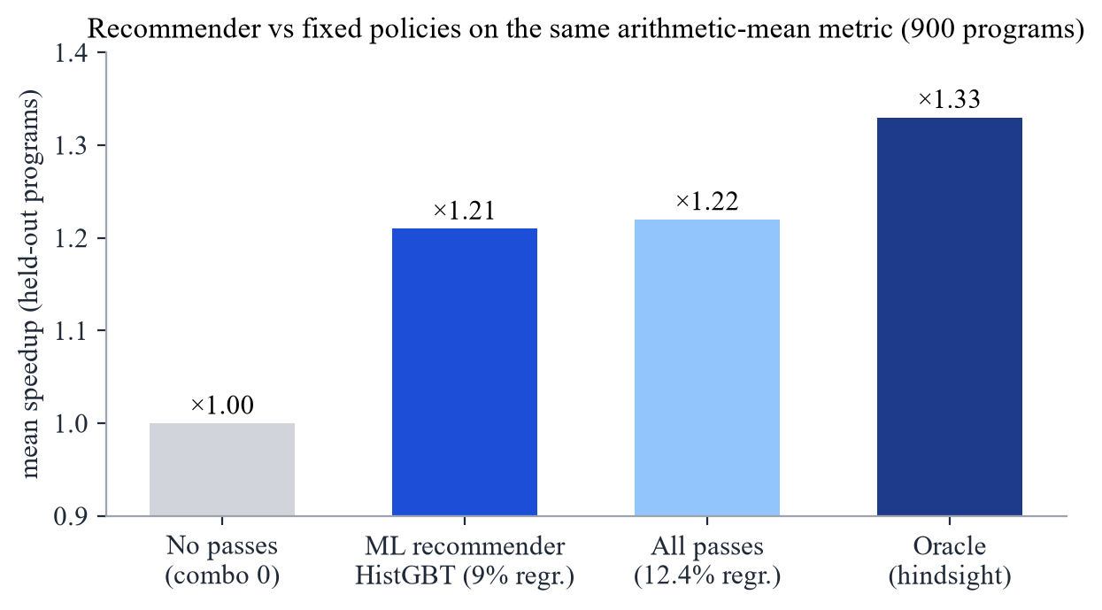
Figure 30: Held-out performance of the recommender compared with fixed policies on the same arithmetic-mean metric
Table 11: Selected rows of the cross-validated strategy bake-off (900 programs, 5 folds)
Strategy | Model | Model size | Reco. speedup | Capture | Regressions
argmax | HistGradient Boosting | 2.0 MB | ×1.21 | 63% | 14%
argmax | Random Forest | 612.9 MB | ×1.21 | 64% | 12%
per-pass classifiers | HistGB classifier | 1.8 MB | ×1.22 | 65% | 11%
margin 0.03 | HistGradient Boosting | 2.0 MB | ×1.21 | 63% | 10%
margin 0.05 (selected) | HistGradient Boosting | 2.0 MB | ×1.21 | 62% | 9%
margin 0.05 | Random Forest | 612.9 MB | ×1.21 | 63% | 9%
margin 0.08 | HistGradient Boosting | 2.0 MB | ×1.20 | 60% | 6%
margin 0.12 | Random Forest | 612.9 MB | ×1.20 | 60% | 4%
margin 0.18 | HistGradient Boosting | 2.0 MB | ×1.18 | 53% | 2%

Figure 31 shows the trade-off the margin controls. Raising it lowers the regression rate steeply while the captured gain falls only slowly, because most of the risky recommendations are those with small predicted gains. The features the model relies on most are multiplication_count, opp_est_dyn_kilo_insts, opp_const_foldable, branch_density, opp_loop_body_insts and instruction_density_in_loops — precisely the properties that determine whether CF, SR and LICM can pay off.
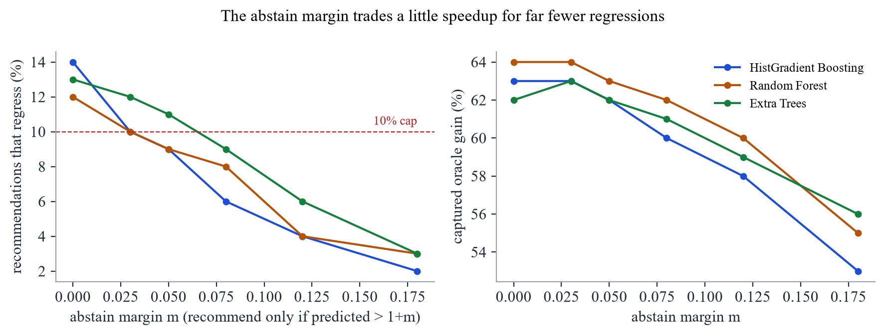
Figure 31: Effect of the abstain margin on regressions and captured gain

5.5.6 Eight-model comparison
Table 12: Eight-model comparison at each model's best margin under the 10% regression cap
Model | Input | Reco. | Capture | Regress. | MAE | Size
HistGradient Boosting | features | ×1.209 | 63% | 10% | 0.105 | 2.0 MB
Random Forest | features | ×1.206 | 62% | 10% | 0.107 | 612.9 MB
1D-CNN | TAC sequence | ×1.197 | 59% | 8% | 0.131 | 365 KB
Linear (Ridge) | features | ×1.186 | 56% | 5% | 0.136 | 2 KB
1D-CNN + features | both | ×1.064 | 19% | 4% | 1.179 | 434 KB
GRU + features | both | ×1.058 | 18% | 7% | 0.779 | 162 KB
GRU (RNN) | TAC sequence | ×1.035 | 11% | 2% | 0.147 | 94 KB
MLP | features | ×1.024 | 7% | 10% | 0.703 | 92 KB

Histogram Gradient Boosting wins the comparison at ×1.209 and is also among the smallest models (2.0 MB, 0.36 ms to score all 64 combinations). The Random Forest scores almost the same (×1.206) but its serialised model is 612.9 MB. The most interesting result is the 1D-CNN: reading only the raw TAC tokens, with none of the engineered features, it reaches ×1.197, within 1% of the best feature model (Figure 32).
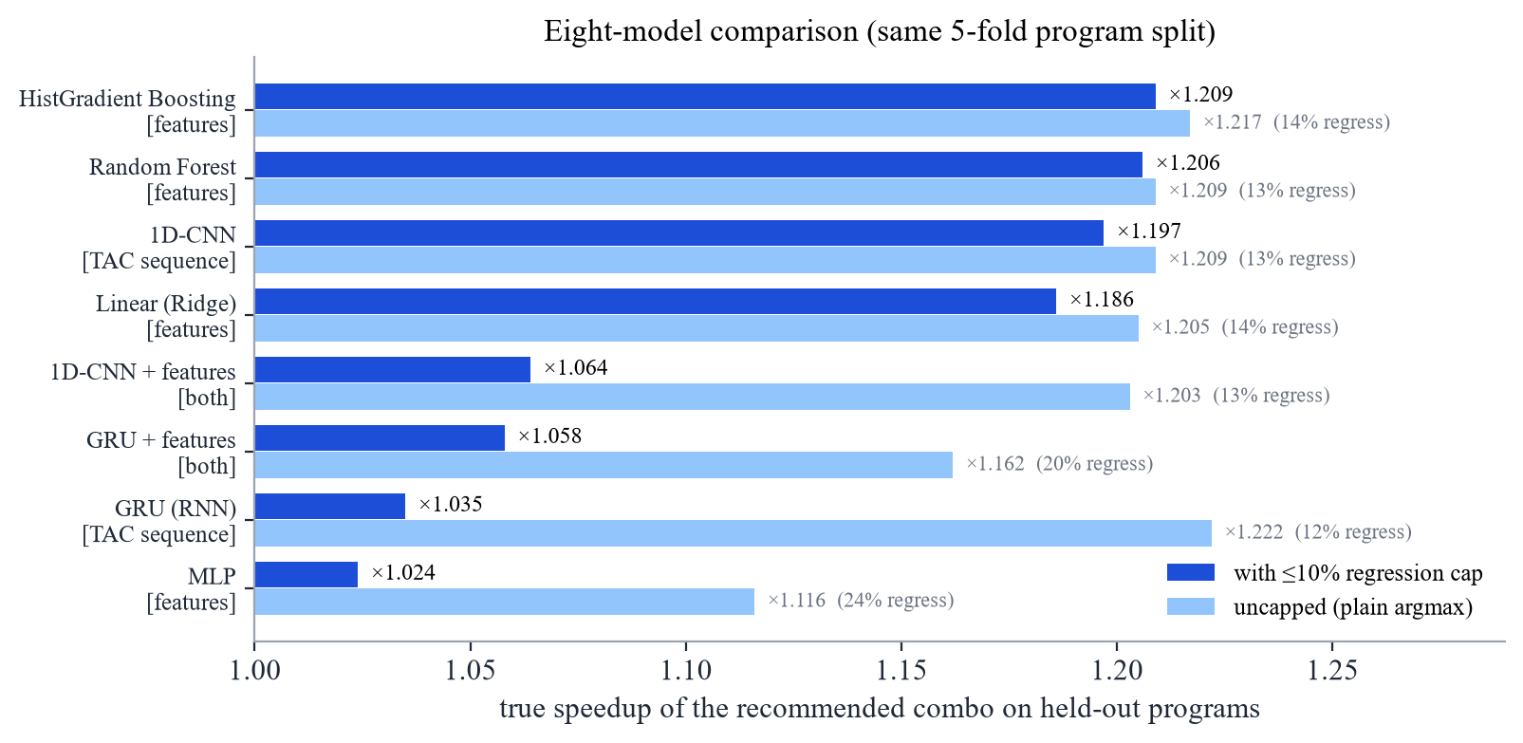
Figure 32: Recommendation quality of the eight models, with and without the regression cap
Without the cap, the GRU is actually the strongest model (×1.222, 67% capture), but 12% of its picks regress. Its predicted speedups are poorly calibrated: the gains it predicts for good and bad choices are similar, so no margin can filter the bad ones without discarding almost all the good ones, and under the cap it collapses to ×1.035. The hybrid models and the MLP show the same behaviour, which points to a calibration and data-volume bottleneck rather than a lack of signal in their inputs.

5.5.7 Progression across Review-1, Review-2 and Review-3 (Final)
Table 13: Evolution of the project across Review-1, Review-2 and Review-3
Aspect / Measure | Review-1 (270 programs) | Review-2 (900 programs) | Review-3 / Final (900 programs)
Timed configurations | 17,280 | 57,600 | 57,600 (+ factorial perf analysis)
Oracle speedup (geomean / mean) | ×1.50 / — | ×1.31 / ×1.33 | ×1.31 / ×1.33 (max ×4.37)
All-on speedup (geomean / mean) | ×1.21 / — | ×1.19 / — | ×1.19 / ×1.22 (12.4% regress)
Selected production model | HistGBT (m=0.12) | Random Forest (m=0.05, 613 MB) | HistGBT (`m=0.05`, 2 MB, auto-trains)
Held-out speedup / capture / regr. | ×1.23 / 44% / 9% | ×1.21 / 63% / 9% | ×1.21 / 62% / 9%
Models compared | 3 tree ensembles | 8 (incl. CNN, GRU, hybrids) | 8 (torch optional in requirements-models.txt)
Pass-interaction & noise study | None | None | `PERF_ANALYSIS.md`: marginal, non-additivity, greedy vs. oracle, noise
Optimizer determinism & LU+LICM | Initial 6 passes | LU+LICM double-unrolled remainder; set hash order | Fixed LU+LICM remainder guard & deterministic temp allocation
CLI & interactive UI | Separate -m scripts; basic playground | Separate -m scripts; basic playground | Unified `minic.py` CLI, redesigned playground & `docs/results.html`

5.6 Testing and Verification
Correctness is enforced at two levels. The pytest suite (51 test functions plus 17 sub-tests) covers the lexer, parser, semantic analyser, IR generator, features, each pass individually and in all 64 combinations, regression cases for previously found miscompilations, nested aggregates, the timing harness and the ML data plumbing. Two new tests added for Review-3 verify the compiler fixes: test_lu_with_licm_unrolls_only_once confirms that running LU + LICM to a fixed point never unrolls the remainder loop a second time, and test_output_is_deterministic_across_processes spawns three sub-processes with PYTHONHASHSEED set to 1, 2 and 3 and checks that the emitted TAC and C are byte-for-byte identical. In addition, every one of the 57,600 builds in the experiment reproduced the unoptimised program's return value. Figure 33 shows the fast test suite (python minic.py test --quick).
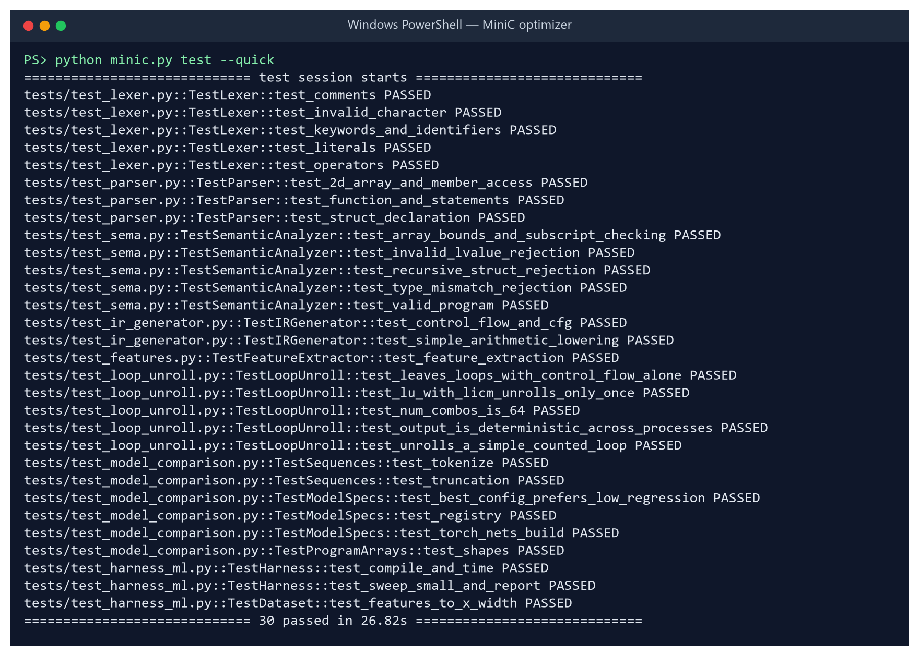
Figure 33: Fast test suite (python minic.py test --quick): 30 unit, determinism and ML plumbing tests pass

6. Conclusion

6.1 Summary
This project delivered a complete optimising compiler for MiniC — front end, three-address IR, control-flow analysis, six provably sound and deterministic optimisation passes with a fixed-point pass manager, and a value-semantics C back end — together with a 57,600-run measurement harness, a 900-program benchmark corpus, a full factorial pass-interaction and non-additivity analysis, a 2 MB auto-training Histogram Gradient Boosting pass recommender, an eight-model classical/neural comparison, a unified minic.py CLI, a redesigned browser playground, and an interactive visual results dashboard.

6.2 Key Findings
• Pass selection matters and is program-specific: the best combination gives ×1.31 geomean (×1.33 mean) and up to ×4.37, whereas enabling everything is sub-optimal for 79% of programs, harmful for 12.4%, and up to 2.3× slower on the worst program.
• Pass effects are strongly non-additive: multiplying single-pass speedups predicts ×1.099 vs. the measured ×1.190 all-on geomean, erring by >10% on 680 of the 900 programs. Passes such as DCE (×0.997 alone vs. ×1.035 marginally, helping 64% of programs) derive their value almost entirely from cleaning up after other passes.
• Blind or greedy search is expensive and risky: 25% of all non-empty configurations regress >2%, and even a 16.4-run greedy search on the real clock misses the best combination on 486/900 programs.
• A 2 MB Histogram Gradient Boosting recommender with an abstain margin of 0.05 achieves ×1.21 mean speedup on unseen programs with zero timing runs — roughly matching all-on in speed while cutting regressions from 12.4% to 9.0% and reducing model size by 300× compared with a Random Forest.
• Tree ensembles over engineered features perform best under the 10% regression cap (×1.209), while a 1D-CNN reading only the raw TAC token sequence comes within 1% of them (×1.197).

6.3 Limitations
• Speedups are measured with gcc -O0 to isolate the project's passes; the gains on top of an already-optimising C compiler (-O2) would be smaller.
• On the same arithmetic-mean metric, the zero-run recommender (×1.21, 9% regressions) makes compilation safer than enabling all passes (×1.22, 12.4% regressions), but does not yet beat all-on in raw mean speed; capturing the remaining gap to the ×1.33 oracle requires richer interaction features.
• All timings come from one Windows 11 machine; absolute speedups depend on the processor and OS load.
• The passes are intra-procedural and their canonical order is fixed, so recursive programs and phase ordering are only partly addressed.

6.4 Future Work
• Add pairwise pass-interaction features (e.g. how many SR opportunities appear only after CF) so the regressor can close more of the gap between ×1.21 and the ×1.33 oracle.
• Calibrate the sequence models (for example with quantile or ranking losses) so that the GRU's strong uncapped advantage (×1.222, 67% capture) survives the 10% regression cap.
• Treat pass ordering as a sequential decision problem and apply reinforcement learning, as in CompilerGym and AutoPhase [4], [5].
• Add inter-procedural optimisation, in particular function inlining, to help recursive and call-heavy programs.
• Augment static features with hardware performance counters, and target LLVM IR to evaluate the approach on top of a production optimiser.

7. Project Repository Link
The complete source code, benchmark corpus, measured dataset, trained-model pipeline, performance analysis, interactive results page and this report's generator are available at:
https://github.com/AkineHime/AI-based-compiler-optimization
Key files: minic.py (unified entry point), RESULTS.md (measured results), PERF_ANALYSIS.md (per-pass marginal effects, non-additivity, search cost and noise), MODEL_COMPARISON.md (eight-model comparison), docs/WALKTHROUGH.md (one program traced through every stage), docs/results.html (interactive visual report) and run_experiment.py (reproduces the whole experiment).

References
[1] A. V. Aho, M. S. Lam, R. Sethi and J. D. Ullman, Compilers: Principles, Techniques, and Tools, 2nd ed. Boston, MA, USA: Addison-Wesley, 2006.
[2] K. D. Cooper and L. Torczon, Engineering a Compiler, 2nd ed. San Francisco, CA, USA: Morgan Kaufmann, 2011.
[3] G. Fursin et al., "Milepost GCC: Machine learning enabled self-tuning compiler," International Journal of Parallel Programming, vol. 39, no. 3, pp. 296–327, 2011.
[4] C. Cummins et al., "CompilerGym: Robust, performant compiler optimization environments for AI research," in Proc. IEEE/ACM Int. Symp. Code Generation and Optimization (CGO), 2022.
[5] A. Haj-Ali et al., "AutoPhase: Juggling HLS phase orderings in random forests with deep reinforcement learning," in Proc. Machine Learning and Systems (MLSys), 2020.
[6] M. Trofin, Y. Qian, E. Brevdo, Z. Lin, K. Choromanski and D. Li, "MLGO: A machine learning guided compiler optimizations framework," arXiv:2101.04808, 2021.
[7] A. H. Ashouri, W. Killian, J. Cavazos, G. Palermo and C. Silvano, "A survey on compiler autotuning using machine learning," ACM Computing Surveys, vol. 51, no. 5, 2018.
[8] F. Pedregosa et al., "Scikit-learn: Machine learning in Python," Journal of Machine Learning Research, vol. 12, pp. 2825–2830, 2011.
[9] A. Paszke et al., "PyTorch: An imperative style, high-performance deep learning library," in Advances in Neural Information Processing Systems 32 (NeurIPS), 2019.
[10] G. Ke et al., "LightGBM: A highly efficient gradient boosting decision tree," in Advances in Neural Information Processing Systems 30 (NIPS), 2017.
[11] L. Breiman, "Random forests," Machine Learning, vol. 45, no. 1, pp. 5–32, 2001.
[12] S. S. Muchnick, Advanced Compiler Design and Implementation. San Francisco, CA, USA: Morgan Kaufmann, 1997.

