BCSE307P Compiler Design Lab
Innovative Project

AI-BASED COMPILER OPTIMIZATION FOR MINIC
Static-Feature-Driven Pass Selection Using Machine Learning

by
Reg No  24BCT0301  24BAI0243  23BCE2091 | Team Member Names  Ashmit Verma  S Karthik Sudharsan  Mohammed Nadeem

Under the Supervision of
Prof. MUTHUNAGAI S U
Assistant Professor Sr. Grade-2
School of Computer Science Engineering and Information Systems


November 2026

TABLE OF CONTENTS
1. Abstract 4
2. Introduction 5
2.1 Background 5
2.2 Problem Statement 5
2.3 Motivation 5
2.4 Objectives 6
2.5 Scope and Assumptions 6
2.6 Team and Contributions 6
2.7 Organisation of the Report 7
3. Novelty in Project 7
3.1 An Alias-Free Language Designed for Sound Optimisation 7
3.2 Measured, Not Modelled — with a Correctness Gate 7
3.3 Opportunity Features 7
3.4 Risk-Aware Recommendation 8
3.5 Leak-Free Evaluation 8
3.6 Learning Directly from the IR 8
4. Proposed Work 9
4.1 System Architecture 9
4.2 The MiniC Language 9
4.3 Front End 10
4.4 Three-Address Code and Control-Flow Analysis 10
4.5 Static Feature Extraction 11
4.6 Optimisation Passes 12
4.7 Pass Manager 14
4.8 Value-Semantics Code Generation 14
4.9 Measurement Methodology 14
4.10 Benchmark Corpus 15
4.11 Learning Formulation 15
4.12 Model Comparison Design 16
5. Implementation & Screenshots 17
5.1 Technology Stack and Environment 17
5.2 Repository Structure 17
5.3 Running the System 17
5.4 Screenshots 17
5.5 Experimental Results 20
5.6 Testing and Verification 26
6. Conclusion 26
6.1 Summary 26
6.2 Key Findings 27
6.3 Limitations 27
6.4 Future Work 27
7. Project Repository Link 28
References 28

LIST OF FIGURES
Figure 1: End-to-end architecture of the MiniC optimiser and recommender 9
Figure 2: Three-address code generated for the running example (no optimisation) 10
Figure 3: Basic blocks and loop structure of the running example 11
Figure 4: Feature vector extracted for the running example 11
Figure 5: The six passes and their bits in the combination mask 12
Figure 6: Combination 21 (CF + CSE + SR): both multiplications replaced by an accumulator 13
Figure 7: Combination 9 (CF + LICM) on licm_arith: invariant products folded and hoisted 13
Figure 8: Combination 32 (LU): four-way unrolled loop with remainder loop 13
Figure 9: Generated value-semantics C for canonical_example.mc (combo 63, excerpt) 14
Figure 10: Playground, TAC diff tab: struct-distance program before (combo 0) and after (combo 63) 18
Figure 11: Playground, Optimization tab: passes applied, per-pass effect and the static features read by the model 18
Figure 12: Playground, Result tab: ×2.52 speedup (190.57 ms → 75.49 ms); both builds return 130 18
Figure 13: Playground, TAC diff tab: loop-invariant arithmetic program 19
Figure 14: Playground, Optimization tab for the loop-invariant program 19
Figure 15: Playground, Result tab: ×1.93 speedup (200.64 ms → 104.10 ms) 19
Figure 16: Recommendation for licm_arith: predicted ×1.68, measured ×1.70 (168.92 ms → 99.62 ms) 20
Figure 17: canonical_example.mc optimised with all passes still returns 83 20
Figure 18: Distribution of the best-combination speedup over 900 programs 21
Figure 19: Geometric-mean speedup by category, best combination vs all passes 21
Figure 20: All-on speedup vs best-combination speedup, one point per program 22
Figure 21: Share of programs whose best combination includes each pass 22
Figure 22: The fifteen programs with the largest speedups 23
Figure 23: Held-out performance of the recommender compared with fixed policies 23
Figure 24: Effect of the abstain margin on regressions and captured gain 24
Figure 25: Recommendation quality of the eight models, with and without the regression cap 25
Figure 26: Verbose run of the fast (non-compiling) part of the test suite: 25 tests pass 26
LIST OF TABLES
Table 1: Team members and areas of contribution 6
Table 2: The 27 static features (19 structural + 8 opportunity) 11
Table 3: Summary of the optimisation passes 12
Table 4: Composition of the 900-program benchmark corpus 15
Table 5: Models in the comparison (neural models share a 6-bit pass input and a 64-unit prediction head) 16
Table 6: Implementation technology and experimental environment 17
Table 7: Headline results of the 900-program sweep 20
Table 8: Selected rows of the cross-validated strategy bake-off (900 programs, 5 folds) 23
Table 9: Eight-model comparison at each model's best margin under the 10% regression cap 24
Table 10: Results at Review-1 and in the final evaluation 25

1. Abstract
Production compilers such as GCC and LLVM expose optimisation through a handful of fixed levels (-O1, -O2, -O3), each of which applies the same pass sequence to every program. Optimisation passes, however, interact: one pass can create or destroy the opportunities of another, and a pass that speeds up one program can slow another down. Choosing which passes to run for a particular program is therefore a per-program decision that a fixed level cannot make.
This project builds a complete optimising compiler for MiniC, a small, statically typed, pointer-free subset of C, and a machine-learning recommender that decides which of its six optimisation passes to enable for a program it has never executed. The compiler consists of a hand-written lexer and recursive-descent parser, a semantic analyser, lowering to three-address code (TAC), control-flow-graph and loop analysis, six independently switchable passes (constant folding, dead-code elimination, common-subexpression elimination, loop-invariant code motion, strength reduction and loop unrolling, giving 2⁶ = 64 combinations) and a C code generator that preserves MiniC's value semantics. Because MiniC has no pointers, there is no aliasing, which makes every pass provably sound without alias analysis.
Every result in this report is measured rather than modelled. Each of 900 benchmark programs (30 hand-written and 870 generated) was compiled at all 64 pass combinations, built with gcc -O0 so that the C compiler contributes no optimisation of its own, and timed on real hardware: 57,600 timed configurations, every one verified to return the same result as the unoptimised program. Choosing the best combination per program gives a geometric-mean speedup of ×1.31 (up to ×4.37), while simply enabling all six passes gives ×1.19 and is not the best choice for 715 of the 900 programs. No fixed non-empty combination avoids slowing at least one program down.
From 27 static features of a program's TAC, a Random Forest recommender with a risk-aware abstain margin achieves ×1.21 on held-out programs, capturing 63% of the speedup an oracle could obtain, while only 9% of its recommendations make the program slower. An eight-model comparison (linear, Random Forest, Histogram Gradient Boosting, MLP, 1D-CNN and GRU over raw TAC, and hybrids) shows that tree ensembles over engineered features perform best, and that a CNN reading only the raw instruction sequence comes within 1% of them.
Keywords: compiler optimisation, pass selection, phase ordering, three-address code, machine learning, gradient boosting, random forest, MiniC.

2. Introduction

2.1 Background
An optimising compiler translates a program into an intermediate representation (IR) and applies a sequence of passes, each of which rewrites the IR into an equivalent but cheaper form. Classic passes include constant folding, which evaluates expressions whose operands are known at compile time; dead-code elimination, which removes computations whose results are never used; common-subexpression elimination, which computes a repeated expression only once; loop-invariant code motion, which hoists computations that do not change inside a loop to just before it; strength reduction, which replaces an expensive operation such as a multiplication by a cheaper addition; and loop unrolling, which replicates a loop body to reduce branch overhead [1], [2], [12].
Real compilers ship dozens of such passes and expose them to users as a few optimisation levels. The levels are chosen by compiler engineers to perform well on average over a benchmark suite, and every program compiled at a given level receives the same passes in the same order.

2.2 Problem Statement
Two related problems make a fixed level sub-optimal. The pass-selection problem asks which subset of passes to apply to a given program; the phase-ordering problem asks in which order to apply them [7]. Passes interact in both directions. Constant folding can turn i * scale into i * 8, which is exactly the form strength reduction needs; on the other hand, unrolling a small loop increases code size and can make it slower, and strength reduction can replace a multiplication that was already cheap by additional loop-carried work. The best subset is therefore program-dependent.
The goal of this project is to answer, for an unseen MiniC program, the question: which of the six available optimisation passes should be enabled? The answer must be produced statically, without running the program, and must be measurably better than both doing nothing and enabling everything, without making programs slower.

2.3 Motivation
Searching all combinations of passes for every program (iterative compilation) finds the best configuration but requires compiling and running the program many times, which is impractical in a normal build. Machine learning offers a middle path: learn, from programs that have been measured exhaustively, a mapping from static program properties to the expected benefit of each configuration, and apply it to new programs at compile time [3], [7]. The project studies this idea end-to-end in a setting small enough to measure every configuration exactly, so that the recommender can be compared against the true optimum rather than an estimate.

2.4 Objectives
1. Design and implement a complete compiler front end, IR and C back end for MiniC.
2. Implement six independently switchable, provably sound optimisation passes and a pass manager that iterates them to a fixed point.
3. Extract a static feature vector from each program that describes both its structure and its optimisation opportunities.
4. Build a benchmark corpus and a timing harness that measures every program at every pass combination, with a correctness check on every build.
5. Train and validate a recommender that selects a pass combination for unseen programs while keeping the rate of slowdowns under 10%.
6. Compare classical and neural models, including models that read the raw TAC instruction sequence instead of engineered features.
7. Provide a command-line tool and a browser playground that demonstrate the full pipeline.

2.5 Scope and Assumptions
The optimiser works at the TAC level and emits C; the C is compiled with gcc -O0. Pinning the C compiler at -O0 is deliberate: at that level GCC performs essentially no optimisation, so the difference between two builds is attributable entirely to this project's passes. gcc -O2 is reported only as a reference point. The passes are intra-procedural; inter-procedural optimisation and inlining are outside the scope of this work. All measurements were taken on a single Windows 11 machine.

2.6 Team and Contributions
Table 1: Team members and areas of contribution
Member | Reg. No. | Area of contribution
Ashmit Verma | 24BCT0301 | Front end (lexer, recursive-descent parser, AST, semantic analysis), TAC lowering, CFG / dominator / loop analysis, 19 structural features.
S Karthik Sudharsan | 24BAI0243 | Six optimisation passes, 64-combination pass manager with fixed-point iteration, value-semantics C code generator.
Mohammed Nadeem | 23BCE2091 | Timing harness and correctness oracle, benchmark corpus and generator, opportunity features, ML recommender and model comparison, CLI and web playground.

2.7 Organisation of the Report
Section 3 describes what is novel in the approach. Section 4 presents the proposed work: the architecture, the MiniC language, every compiler stage, the measurement method, the corpus and the learning formulation. Section 5 covers the implementation, screenshots of the working system and the experimental results. Section 6 concludes with limitations and future work, and Section 7 gives the repository link.

3. Novelty in Project
Machine-learning-guided compilation has been studied for over a decade, from MILEPOST GCC, which predicted good optimisation flags from static program features [3], to reinforcement-learning environments for phase ordering such as CompilerGym and AutoPhase [4], [5] and to production use in LLVM's MLGO framework for inlining and register-allocation decisions [6]. This project does not claim a new learning algorithm. Its contribution is a complete, small, fully measured system in which every design choice serves the trustworthiness of the final number. The following aspects distinguish it.

3.1 An Alias-Free Language Designed for Sound Optimisation
MiniC was designed around a single invariant: no two variables can ever refer to the same memory. It excludes pointers, dynamic allocation, unions and function pointers, and gives arrays, structs and strings value semantics (assignment and parameter passing copy them). Alias analysis is one of the hardest problems in real optimisers; removing aliasing at the language level makes every pass in this project provably sound with straightforward data-flow reasoning, so that the measured speedups can never come from an incorrect transformation.

3.2 Measured, Not Modelled — with a Correctness Gate
The dataset is not produced by a cost model or a simulator. Every program is built and run at all 64 configurations, and a timing is recorded only if the optimised binary returns exactly the same value as the unoptimised one. Across 57,600 builds, no configuration failed this check. The ground truth is therefore an exhaustive, verified search, which allows the recommender to be scored against the true per-program optimum (the oracle).

3.3 Opportunity Features
Besides 19 conventional structural features (instruction counts, loop depth, branch density and so on), the compiler computes eight opportunity features: cheap static estimates of what each pass would actually change, such as the number of foldable constant expressions, hoistable loop-invariant instructions or redundant subexpressions, and an estimate of the dynamic instruction count. They give the model a preview of each pass's pay-off without running anything.

3.4 Risk-Aware Recommendation
A regressor that simply picks the configuration with the highest predicted speedup makes confident mistakes: on this corpus, plain argmax slows down 12–14% of programs. The recommender therefore abstains — recommends no passes — unless the best predicted speedup exceeds a margin. Crucially, the margin, the model family and the selection rule (argmax, margin or per-pass classifiers) are themselves chosen by cross-validation, as the most useful strategy whose held-out regression rate stays under 10%.

3.5 Leak-Free Evaluation
A program contributes 64 rows to the dataset, all with identical static features. A random row-level split would place rows of the same program in both training and test sets and grossly overstate accuracy. All evaluation in this project uses GroupKFold by program: an entire program is held out, so every reported number describes programs the model has never seen.

3.6 Learning Directly from the IR
In addition to feature-based models, the project tokenises each program's TAC into an opcode/operand-kind sequence and trains 1D convolutional and recurrent (GRU) networks on it. All eight models are scored on one shared split with the same recommendation rule, which makes the comparison between hand-engineered features and learned representations direct.

4. Proposed Work

4.1 System Architecture
Figure 1 shows the end-to-end pipeline. A MiniC source file passes through the front end into three-address code, from which the control-flow graph and the 27 features are computed. At compile time the recommender scores all 64 pass combinations from those features and selects one; the pass manager applies it; the code generator emits C, which is compiled with gcc -O0. Offline, the same pipeline runs every program at every combination to produce the training data.
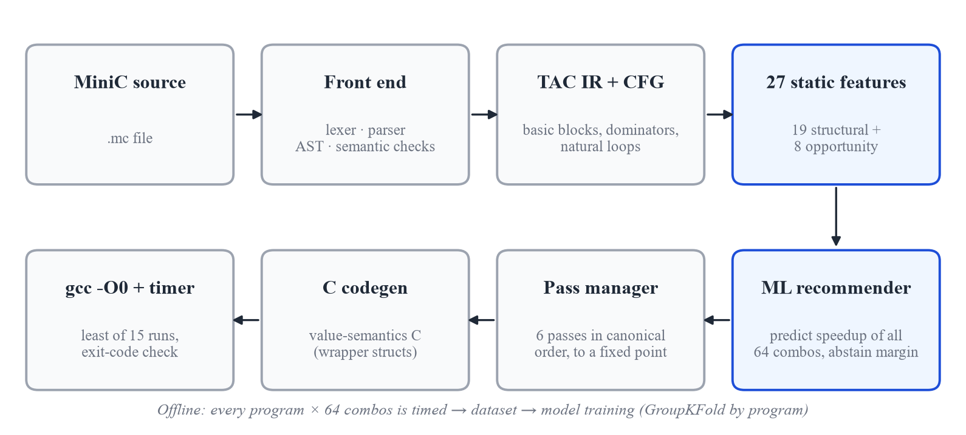
Figure 1: End-to-end architecture of the MiniC optimiser and recommender

4.2 The MiniC Language
MiniC supports int, float and char; fixed-size one- and two-dimensional arrays; non-recursive structs (which may contain arrays and other structs); fixed-size strings (char arrays with compile-time length checks); functions and recursion; if/else, while and for; block scoping; and the usual arithmetic, relational and logical operators. Pointers, dynamic memory, goto, switch, unions, variadic functions and the preprocessor are excluded. A program has no I/O: its observable result is the value returned by main(). An abridged grammar is shown below.
program → (struct_decl | func_decl | var_decl)*
struct_decl → 'struct' IDENT '{' field_decl+ '}' ';'
var_decl → type_spec IDENT array_suffix? ('=' expr)? ';'
array_suffix→ '[' INT_LIT ']' ('[' INT_LIT ']')?
func_decl → type_spec IDENT '(' param_list? ')' block
stmt → var_decl | expr_stmt | if_stmt | while_stmt | for_stmt | return_stmt | block
expr → assignment ; assignment → postfix '=' assignment | logic_or
logic_or → logic_and ('||' logic_and)* ; logic_and → equality ('&&' equality)*
additive → multiplicative (('+'|'-') multiplicative)*
unary → ('-'|'!') unary | postfix

4.3 Front End
The lexer (frontend/lexer.py) converts source text into tokens tagged with kind and line number. The parser (frontend/parser.py) is a hand-written recursive-descent parser with one function per grammar rule, producing an abstract syntax tree of typed nodes (Program, FuncDecl, StructDecl, WhileStmt, BinaryExpr, ArrayAccessExpr and others). The semantic analyser (frontend/sema.py) then checks declarations before use, function arity, operand types, integer array subscripts, valid l-values, non-recursive struct sizes, missing returns and duplicate declarations, reporting errors with line, column and a caret under the offending token.

4.4 Three-Address Code and Control-Flow Analysis
The IR generator lowers the AST into TAC: a flat list of instructions with at most one operator each, explicit temporaries and explicit control flow through labels, goto and ifFalse. Figure 2 shows the TAC of the running example docs/walk.mc, a loop that accumulates i * scale twice per iteration. Nested aggregate assignments such as a[i].f = v are lowered to a load / modify-copy / store-back chain so that value semantics are preserved.
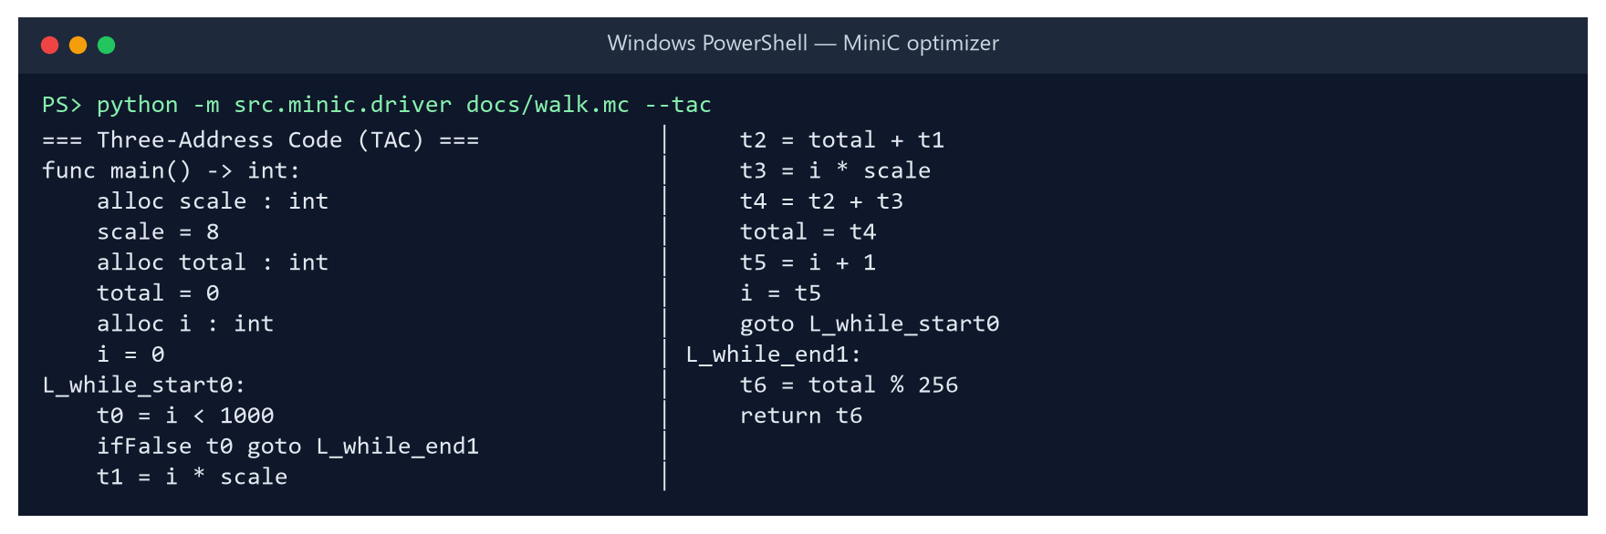
Figure 2: Three-address code generated for the running example (no optimisation)
The CFG builder (ir/cfg.py) partitions the TAC into basic blocks, connects them with edges, computes dominators and identifies natural loops from back edges (Figure 3). Loop-invariant code motion, strength reduction and unrolling all depend on this loop structure.
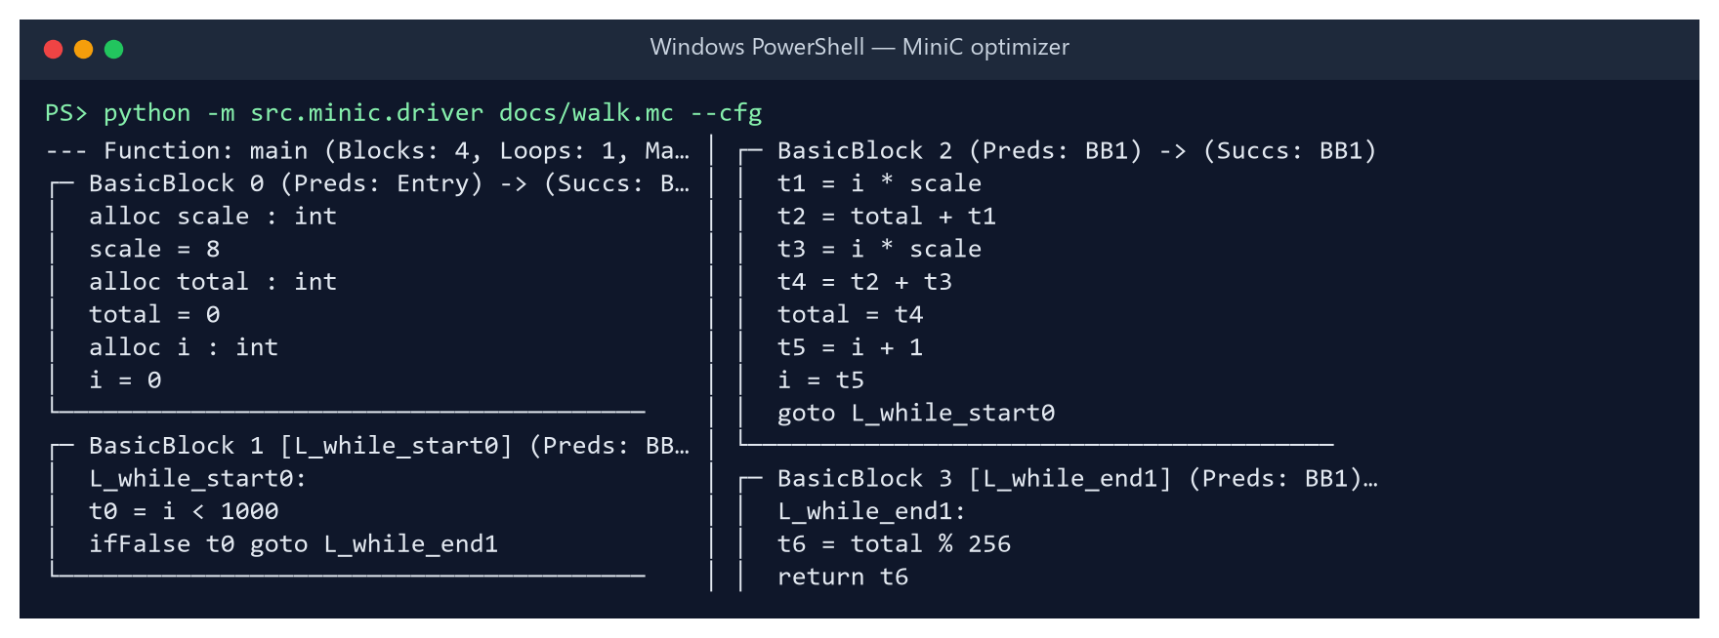
Figure 3: Basic blocks and loop structure of the running example

4.5 Static Feature Extraction
For every program the compiler computes a 27-dimensional feature vector without executing it (Table 2). The 19 structural features describe size, control flow and the instruction mix; the 8 opportunity features estimate how much each pass could change the program. Figure 4 shows the vector for the running example; note opp_cse_redundant = 1, the repeated i * scale.
Table 2: The 27 static features (19 structural + 8 opportunity)
Group | Features
Size & control flow | totalinstructions, basicblockcount, loopcount, maxloopdepth, branchcount, branchdensity, cyclomatic_complexity
Instruction mix | arithmeticopscount, multiplicationcount, constantloadcount, functioncallcount, recursivecallcount, stringops_count
Data access | arrayaccesscount, array2daccesscount, structaccesscount, namedvariablecount, tempvariablecount, instructiondensityinloops
Opportunity (8) | oppconstfoldable, oppcseredundant, opplicmhoistable, oppsrreducible, oppunrollableloops, opploopbodyinsts, opphotinvariantfrac, oppestdynkiloinsts

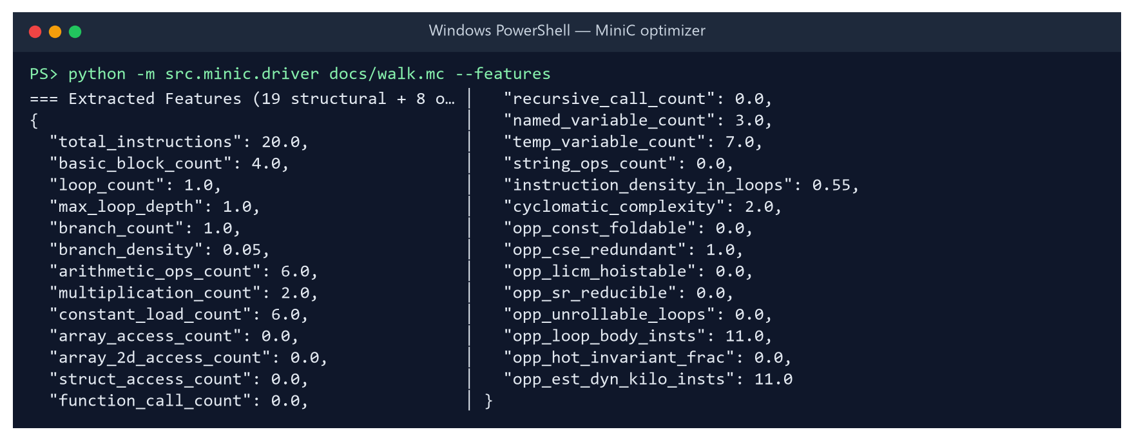
Figure 4: Feature vector extracted for the running example

4.6 Optimisation Passes
Each pass is a function from TAC to TAC and is controlled by one bit of a 6-bit mask (Figure 5); a combination is identified by the integer value of the mask, from 0 (no passes) to 63 (all six). Table 3 summarises the passes.
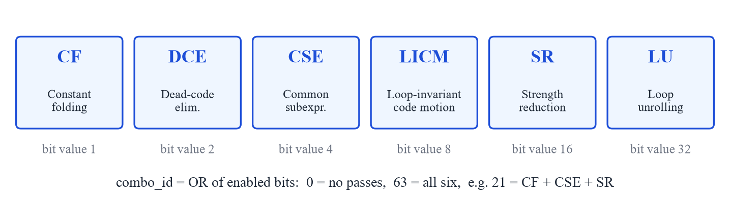
Figure 5: The six passes and their bits in the combination mask
Table 3: Summary of the optimisation passes
Bit | Pass | Transformation
1 | Constant folding (CF) | Evaluates constant expressions with 32-bit C semantics, propagates single-assignment constants across the function, applies algebraic identities and removes constant branches.
2 | Dead-code elimination (DCE) | Removes instructions whose results are never used, unreachable blocks and unused allocations (backward liveness).
4 | Common-subexpression elim. (CSE) | Local value numbering with copy propagation: a repeated expression is computed once and reused.
8 | Loop-invariant code motion (LICM) | Hoists instructions whose operands do not change in the loop into a labelled pre-header.
16 | Strength reduction (SR) | Replaces i * k for an induction variable i with an accumulator updated by + k each iteration.
32 | Loop unrolling (LU) | Replicates a counted loop body four times and keeps the original loop as a remainder loop.

Passes enable each other. On the running example, strength reduction alone does nothing because the multiplier scale is a variable; after constant folding has propagated scale = 8, SR can replace both multiplications with a single accumulator __sr7 that grows by 8 each iteration, and CSE makes both uses share it (Figure 6).
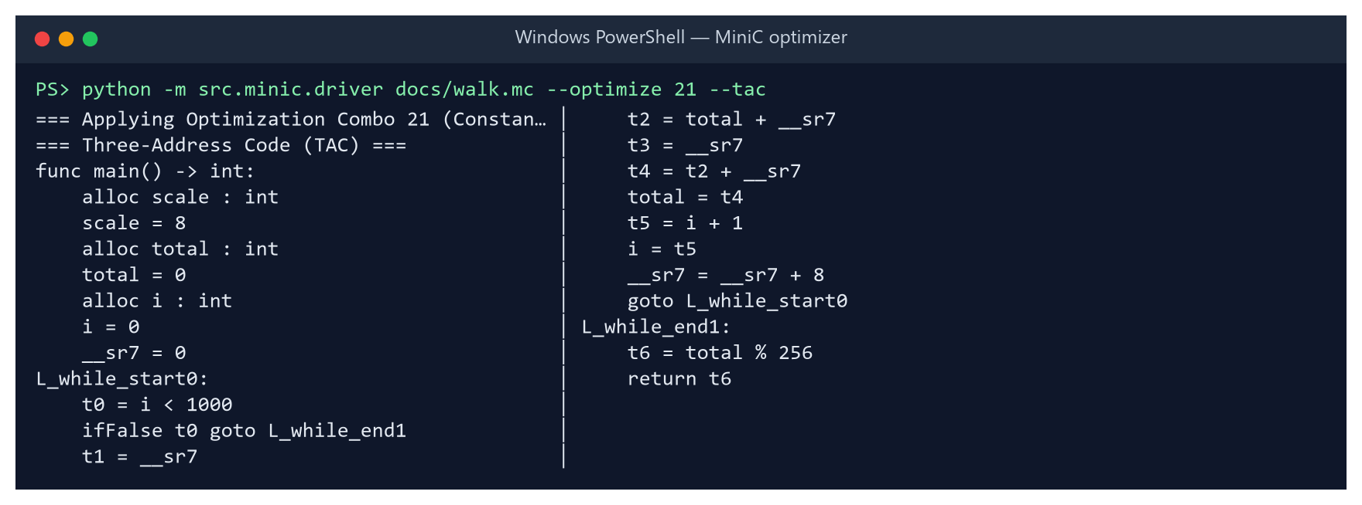
Figure 6: Combination 21 (CF + CSE + SR): both multiplications replaced by an accumulator
Figure 7 shows LICM and CF on the benchmark licm_arith, whose loop body consists entirely of invariant products of a, b and c. All six products are folded to constants and hoisted out of the loop, leaving only additions inside it. Figure 8 shows loop unrolling: the body is replicated four times under a guard i < 997, followed by the original loop for the remaining iterations.
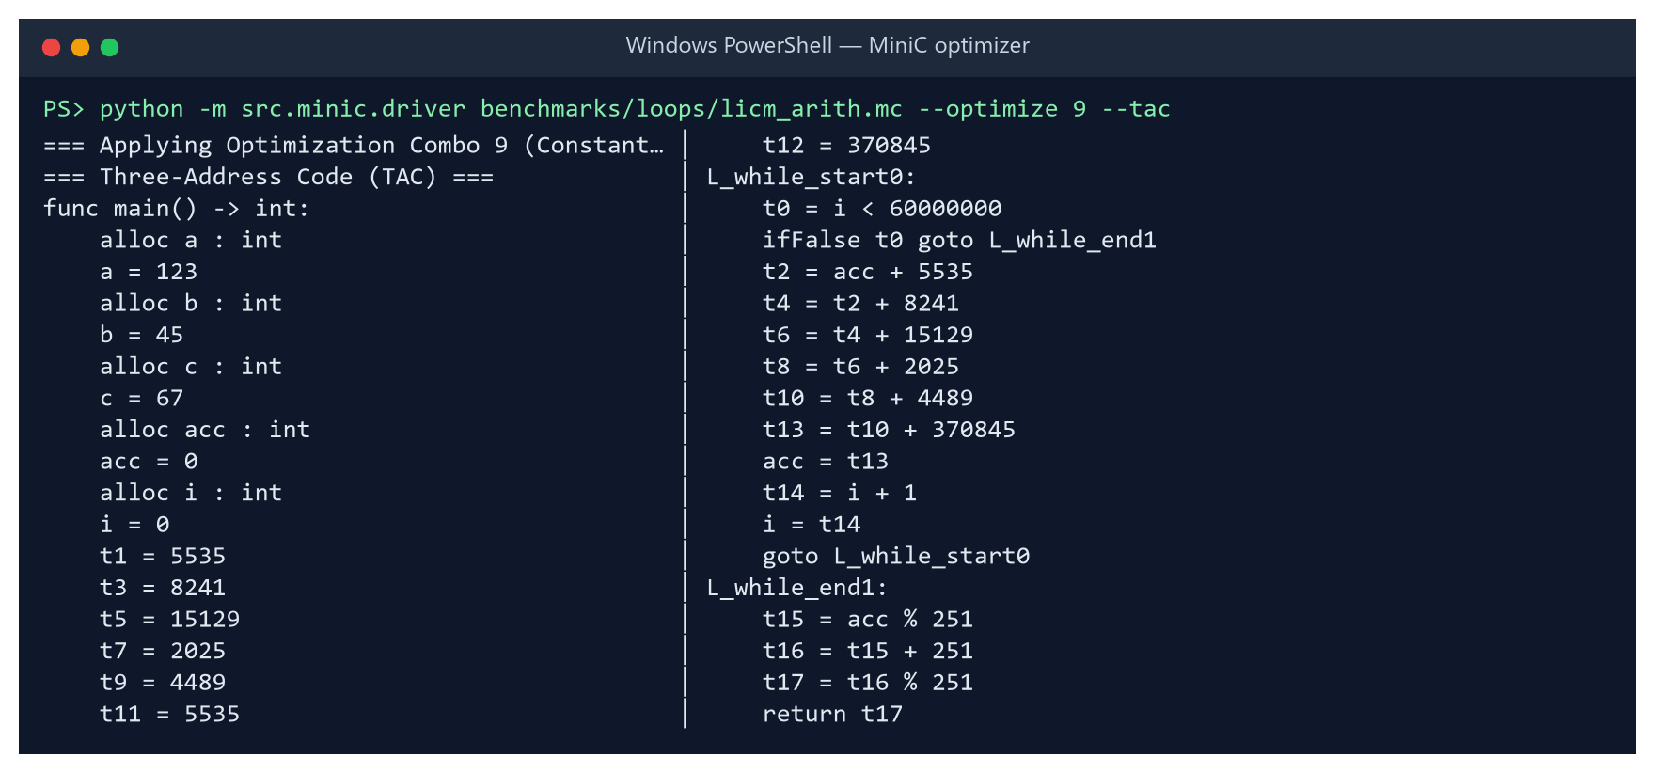
Figure 7: Combination 9 (CF + LICM) on licm_arith: invariant products folded and hoisted
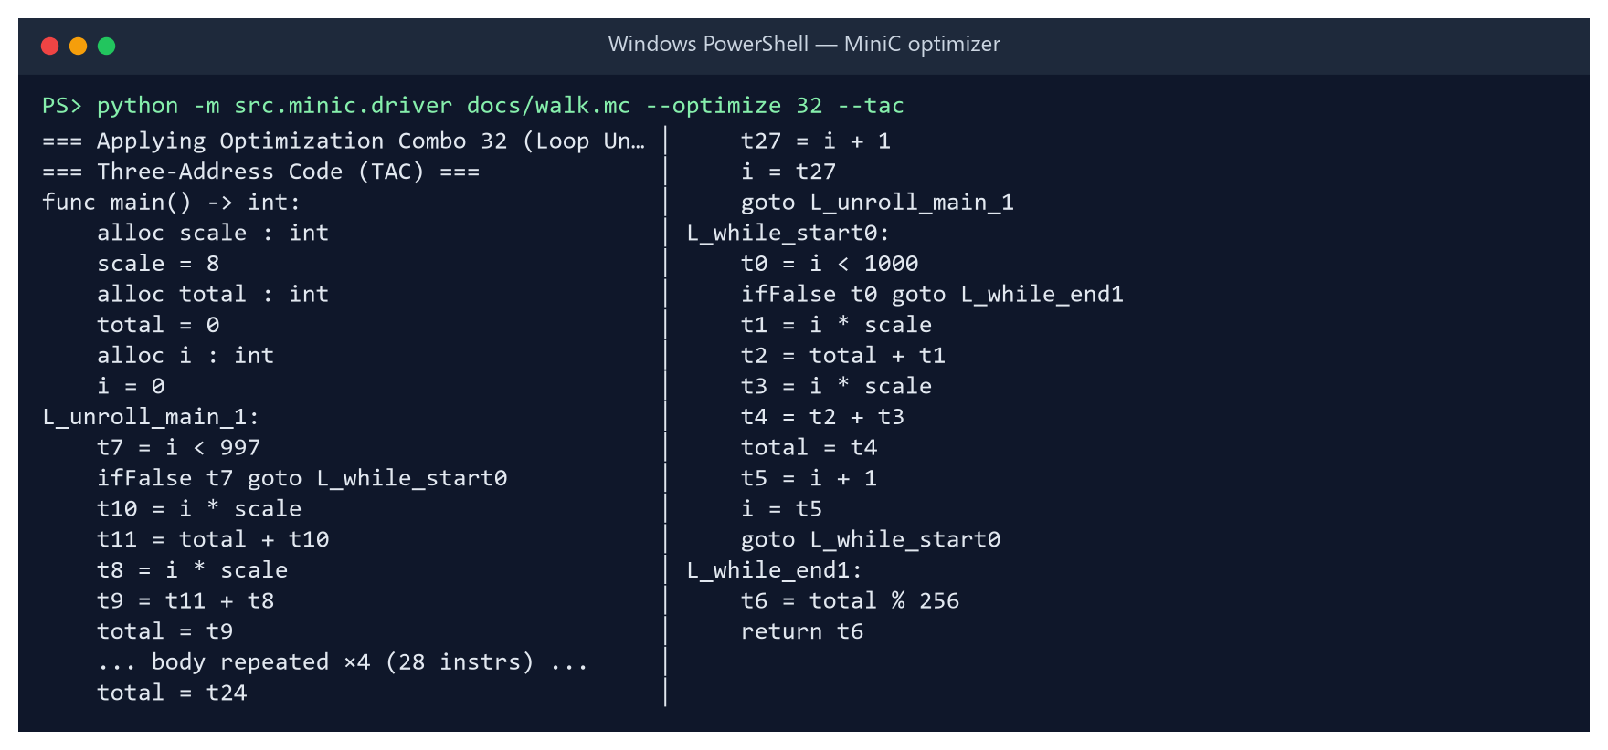
Figure 8: Combination 32 (LU): four-way unrolled loop with remainder loop

4.7 Pass Manager
The pass manager (optimizer/pass_manager.py) applies the enabled passes in the canonical order CF → CSE → LU → LICM → SR → DCE and repeats the whole sequence until the program stops changing (a fixed point). Iteration lets each pass clean up after the others: for example, DCE removes the temporaries that CSE and SR leave unused, and CF can fold expressions that LICM has just hoisted. The order is fixed so that the 64 combinations are a clean pass-selection problem.

4.8 Value-Semantics Code Generation
The C emitter (codegen/c_emitter.py) produces C99 that any GCC can compile. To keep MiniC's copy semantics, arrays and strings are wrapped in one-field structs (arr_int_3_3, str_6), so that C assignment and parameter passing copy them instead of decaying to pointers; struct typedefs are emitted in dependency order. Figure 9 shows part of the output for canonical_example.mc, the program that exercises every language feature.
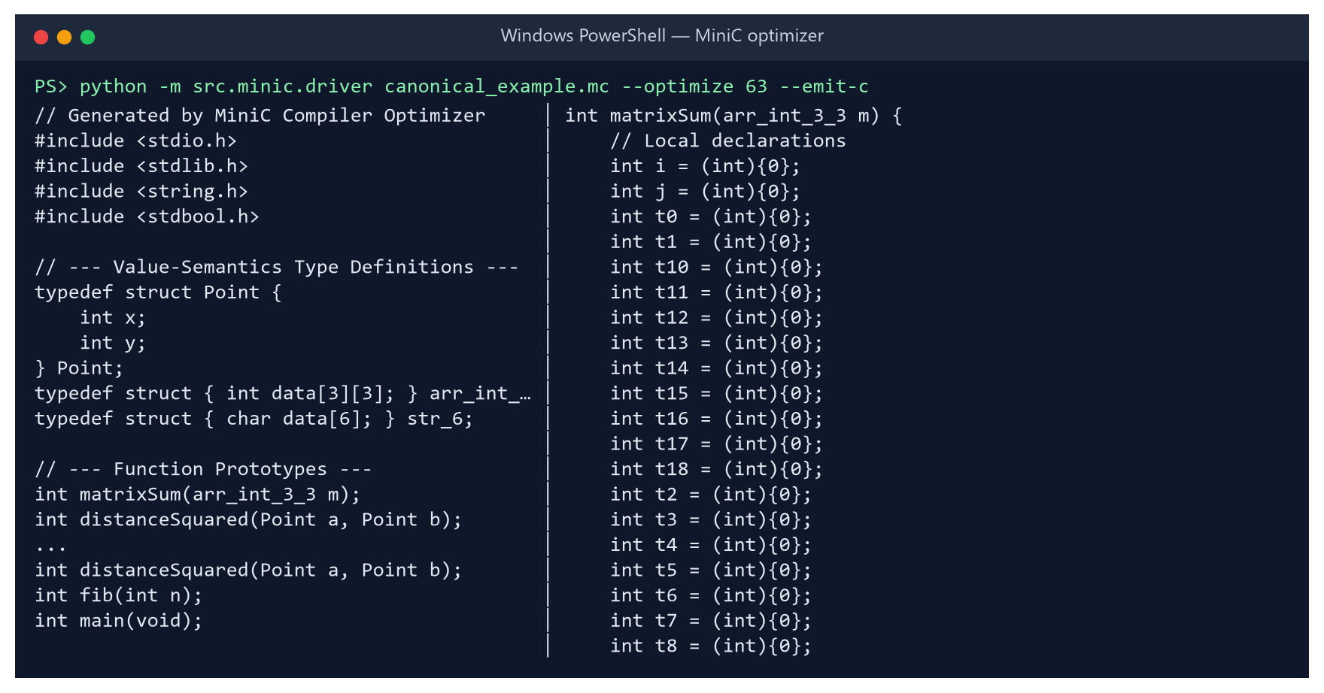
Figure 9: Generated value-semantics C for canonical_example.mc (combo 63, excerpt)

4.9 Measurement Methodology
The harness (harness/) compiles each emitted C file with gcc -O0 -std=c99 and runs the binary after four warm-up runs, keeping the minimum of 15 wall-clock runs. The sweep runs eight programs in parallel; the minimum is the least-interfered sample under that load. The speedup of combination c for program p is defined as
speedup(p, c) = time(p, combo 0) / time(p, c) (> 1 means faster)

Before a timing is recorded, the binary's exit code must equal that of combination 0 (the correctness gate). The full sweep of 900 programs took 3 hours 20 minutes on eight workers.

4.10 Benchmark Corpus
The corpus contains 30 hand-written programs in five categories and 870 programs produced by a parametric generator (harness/gen_corpus.py). The generator instantiates single-pattern programs that target one pass each, with randomised constants, trip counts and loop forms, and weighted composites that combine several patterns in one program. A manifest records each program's pattern so that results can be broken down by program type (Table 4).
Table 4: Composition of the 900-program benchmark corpus
Source | Category / pattern | Programs | Purpose
Hand-written | loops | 15 | LICM, CSE, constant propagation, polynomial evaluation
Hand-written | numeric | 6 | array kernels: convolution, dot product, histogram, matrix multiply, stencil, vector scale
Hand-written | structs | 4 | bounding boxes, complex arithmetic, distance accumulation, particle simulation
Hand-written | recursion | 3 | Fibonacci, Ackermann, Takeuchi
Hand-written | strings | 2 | Caesar cipher, vowel counting
Generated | cf, cse, licm, sr, div, struct, unroll | 32 each | one optimisation opportunity per program
Generated | branch, nested, recur, neutral | 31 each | branchy code, nested loops, recursion, no opportunity (control)
Generated | composite | 522 | 2–4 patterns combined in one program
Total |  | 900 | 57,600 (program, combination) measurements

4.11 Learning Formulation
Each (program, combination) pair is one training row: the 27 features of the program, the 6 bits of the combination, and the measured speedup as the regression target. A regressor f therefore predicts the speedup of any combination for any program. For a new program the recommender evaluates all 64 combinations and applies the selection rule
c* = argmax_c f(x_p, c)
recommend c* if f(x_p, c*) > 1 + m
recommend combo 0 (no passes) otherwise m = abstain margin

Three regressors were considered for the production recommender: Random Forest (400 trees), Extra Trees (500 trees) and Histogram Gradient Boosting (600 iterations, learning rate 0.05) [8], [10], [11]. Each was combined with plain argmax, with margins m ∈ {0.03, 0.05, 0.08, 0.12, 0.18}, and a per-pass classifier alternative. Every strategy was scored by 5-fold GroupKFold on: the mean true speedup of the recommended combination; the fraction of the oracle's gain it captures; and the fraction of programs it makes more than 2% slower. The winner is the strategy with the highest useful gain whose regression rate is at most 10%.

4.12 Model Comparison Design
To test whether learned program representations can replace engineered features, eight models were compared under identical conditions (Table 5). Sequence models read each program's unoptimised TAC converted to tokens (opcode plus operand kind, with names and values dropped; median length 284, capped at 640). Neural models are trained program-batched: a program is encoded once and its encoding is combined with each of the 64 pass vectors by a small prediction head. Every model is evaluated on the same five folds, using the same margin sweep and the same 10% regression cap.
Table 5: Models in the comparison (neural models share a 6-bit pass input and a 64-unit prediction head)
Model | Input | Architecture
Linear (Ridge) | features | standardised features + pass bits, L2-regularised linear regression
Random Forest | features | 400 trees, min. 2 samples per leaf
HistGradient Boosting | features | 600 boosting iterations, 31 leaves, learning rate 0.05
MLP | features | 27 → 128 → H encoder, ReLU, dropout 0.1
1D-CNN | TAC sequence | token embedding → 3 × Conv1d (kernel 5; 64, 64, 128 channels) → pooling
GRU | TAC sequence | token embedding → 1-layer GRU, sequence capped at 320 tokens
1D-CNN + features | both | CNN encoding concatenated with a 64-unit feature encoder
GRU + features | both | GRU encoding concatenated with a 64-unit feature encoder

5. Implementation & Screenshots

5.1 Technology Stack and Environment
Table 6: Implementation technology and experimental environment
Component | Technology
Compiler, harness, ML | Python 3.13.15 (≈ 9,300 lines including tests)
C compiler | GCC 16.2.0 (WinLibs MinGW-w64, UCRT), always at -O0 for measurement
Classical ML | scikit-learn 1.9.1, NumPy 2.5.4, pandas 3.0.6
Neural models | PyTorch 2.14.1 (CPU)
Web playground | Flask 3.1.3 with a single-page HTML/JavaScript front end
Plots & report | Matplotlib 3.11.2, python-docx
Testing | pytest 9.1.1
Platform | Windows 11, 16 logical CPUs, sweep on 8 parallel workers

5.2 Repository Structure
src/minic/
frontend/ lexer.py parser.py ast_nodes.py sema.py
ir/ tac.py ir_generator.py cfg.py
features/ extractor.py (19 structural) opportunity.py (8 opportunity)
optimizer/ constant_folding.py dce.py cse.py licm.py
strength_reduction.py loop_unroll.py pass_manager.py
codegen/ c_emitter.py
harness/ compiler.py timer.py sweeper.py gen_corpus.py report.py
ml/ dataset.py model.py train.py predictor.py
sequences.py models_torch.py models_compare.py
driver.py command-line compiler
demo/ cli.py (recommend | benchmark) app.py (browser playground)
benchmarks/ 30 hand-written programs + generated/ (870 programs)
tests/ pytest suite: front end, IR, every pass, 64-combo sweeps, harness, ML
run_experiment.py sweep → dataset → strategy bake-off → train → RESULTS.md

5.3 Running the System
pip install -r requirements.txt
python -m src.minic.driver prog.mc --tac --features # inspect TAC and features
python -m src.minic.driver prog.mc --optimize 63 --run # optimise, compile, run
python -m demo.cli recommend prog.mc --verify # ML pick + measured speedup
python -m demo.app # playground, port 5005
python run_experiment.py --compare-models # full experiment

5.4 Screenshots
The browser playground (demo/app.py) runs the whole pipeline interactively: the user edits a MiniC program, the server compiles it unoptimised and optimised, times both builds, checks that they return the same value and shows the speedup, a per-pass report and a side-by-side TAC diff. Figures 10–12 show the struct-distance example.
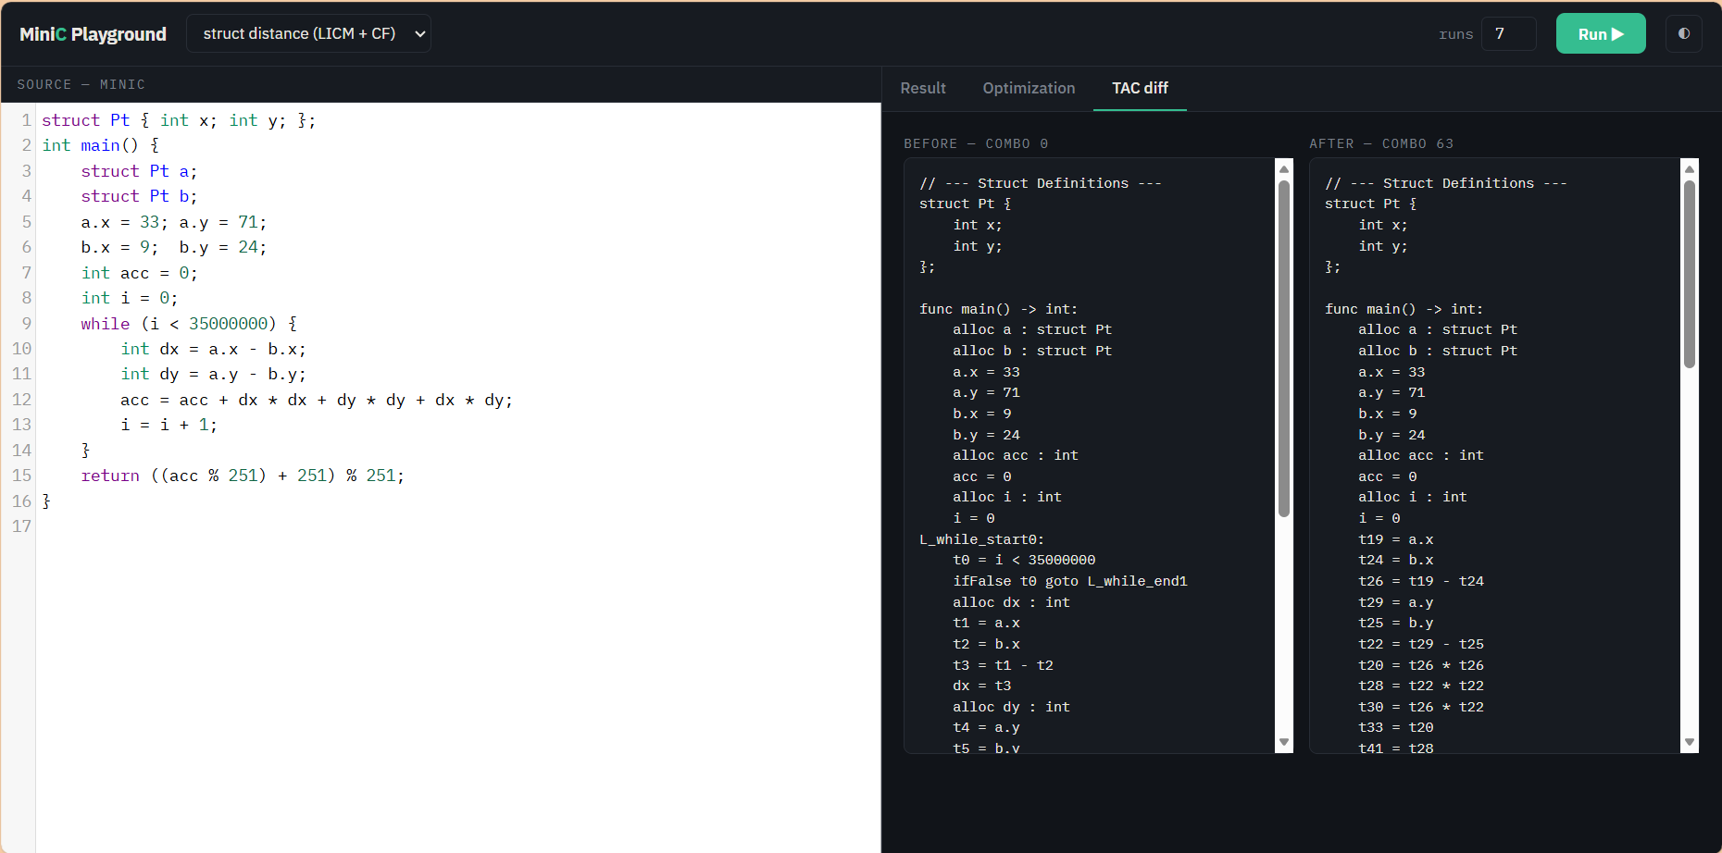
Figure 10: Playground, TAC diff tab: struct-distance program before (combo 0) and after (combo 63)
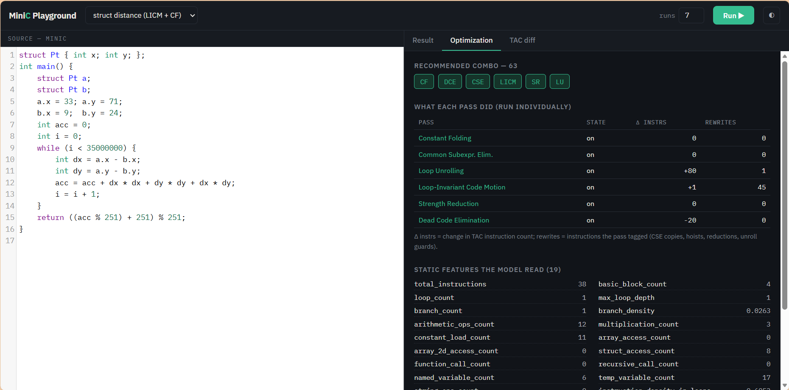
Figure 11: Playground, Optimization tab: passes applied, per-pass effect and the static features read by the model
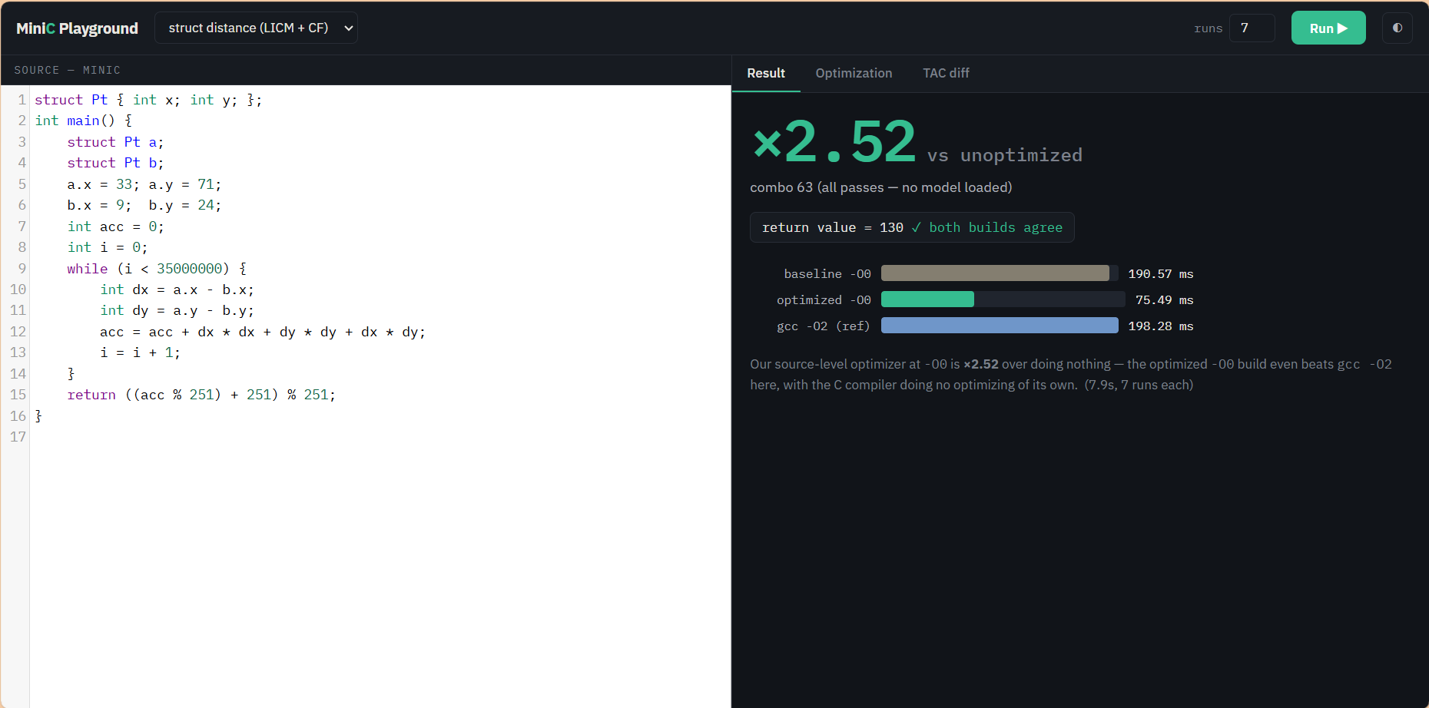
Figure 12: Playground, Result tab: ×2.52 speedup (190.57 ms → 75.49 ms); both builds return 130
Figures 13–15 show the loop-invariant arithmetic example. Unrolling and LICM replace the six multiplications in the loop body with additions of folded constants, and the optimised -O0 build runs ×1.93 faster than the unoptimised one — faster, in this case, than GCC's own -O2 build of the unoptimised C.
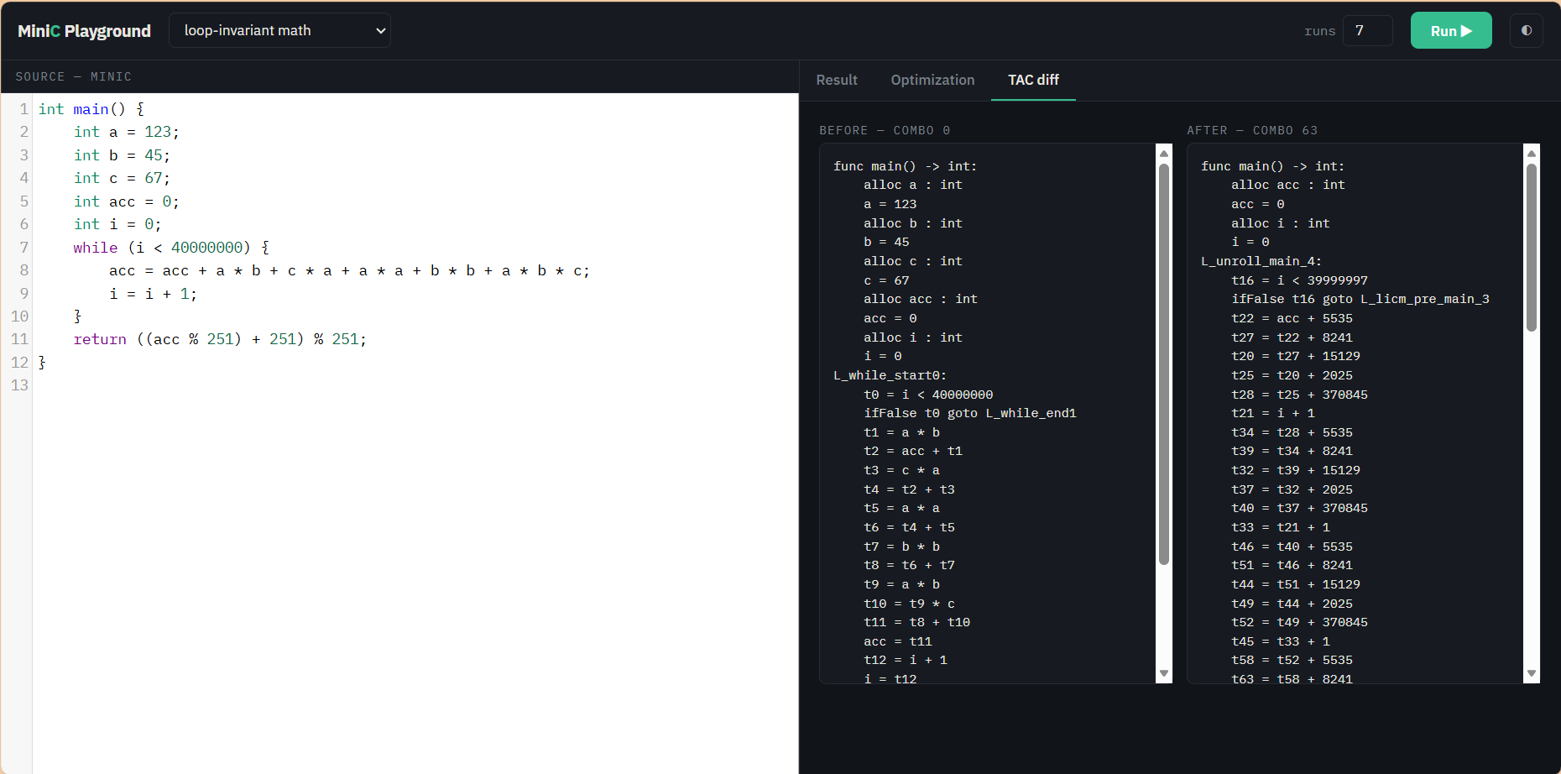
Figure 13: Playground, TAC diff tab: loop-invariant arithmetic program
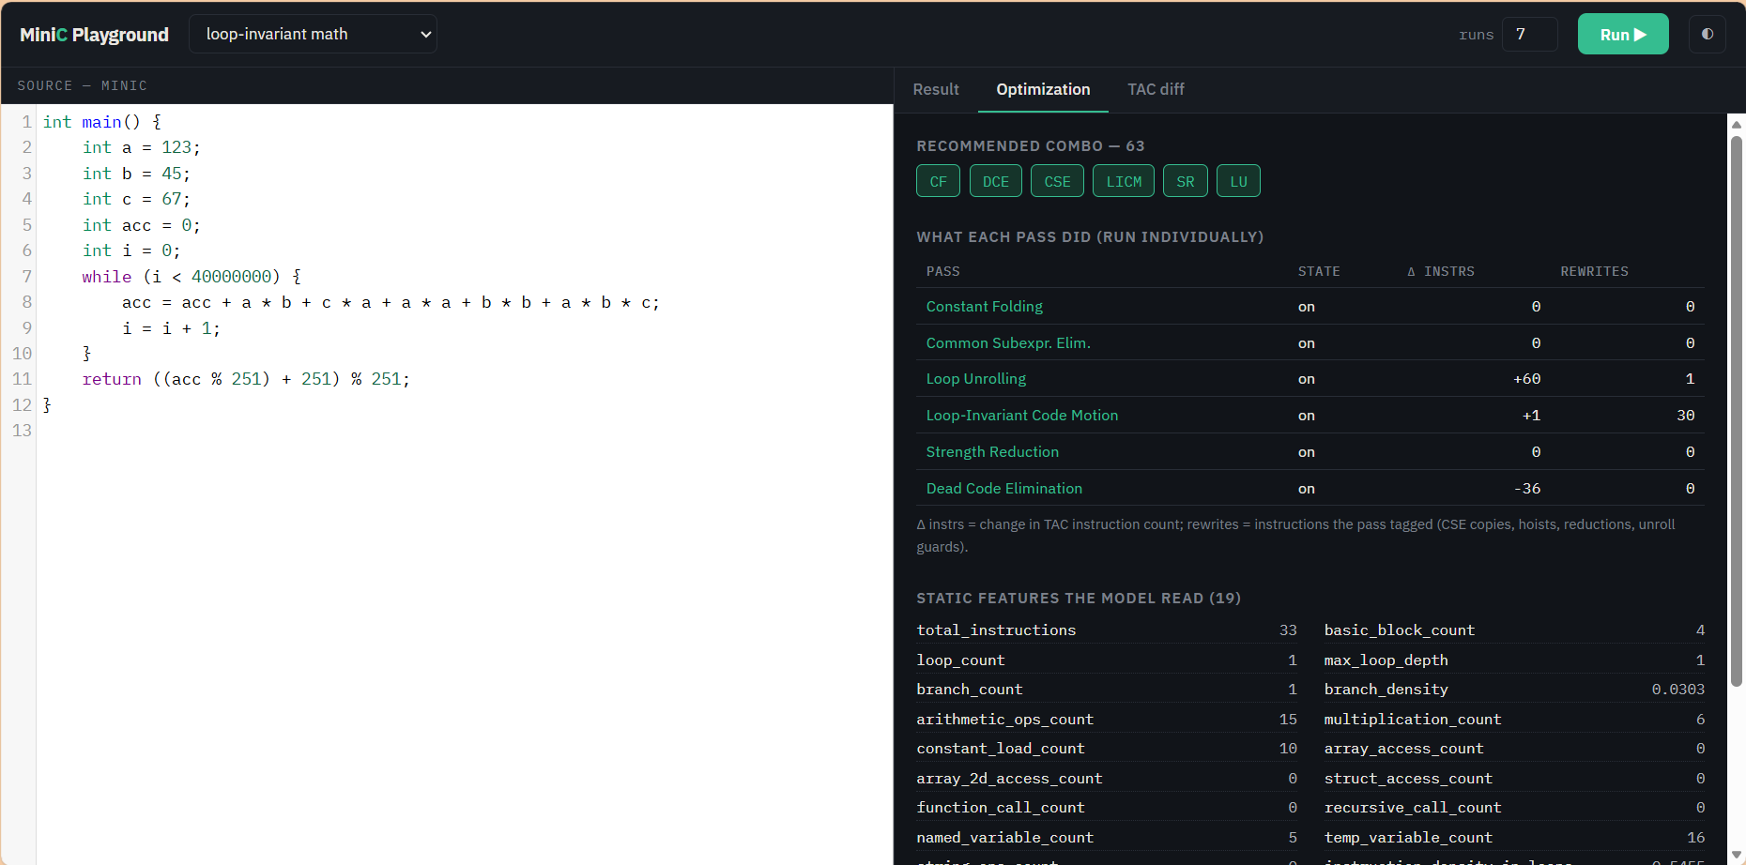
Figure 14: Playground, Optimization tab for the loop-invariant program
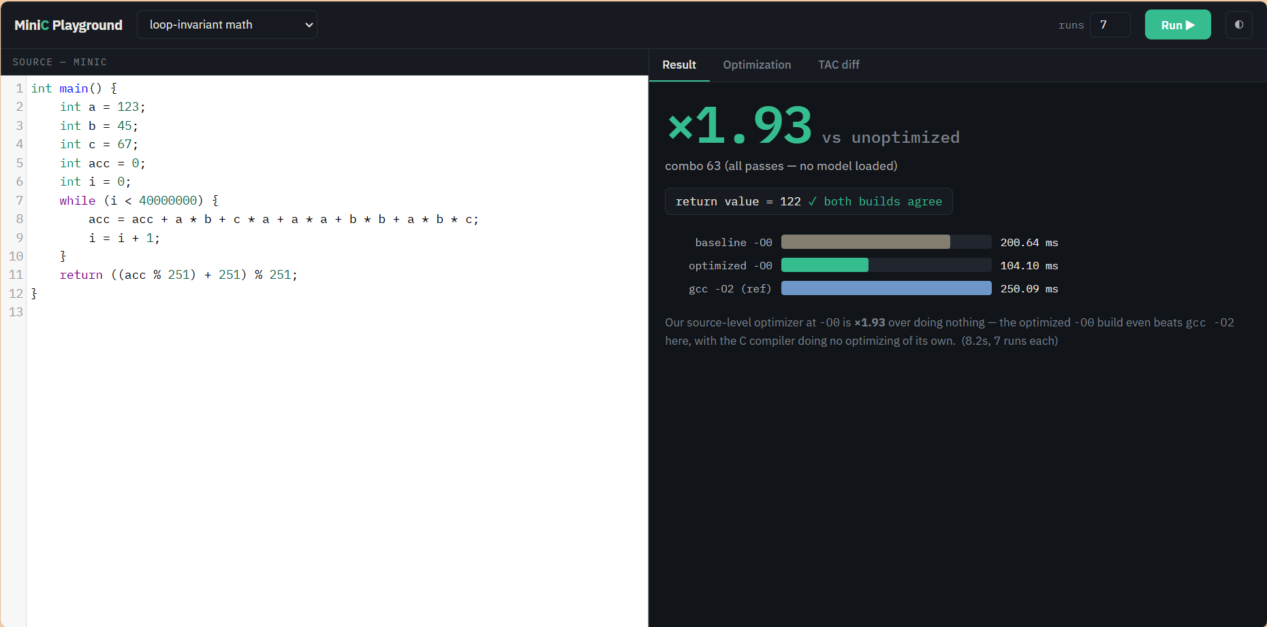
Figure 15: Playground, Result tab: ×1.93 speedup (200.64 ms → 104.10 ms)
The command-line tool reports the model's recommendation for a program together with its top five predicted combinations, and with --verify it builds and times the program to confirm the prediction (Figure 16). Figure 17 shows the canonical example, which uses every MiniC feature, returning its expected value 83 with all six passes enabled.
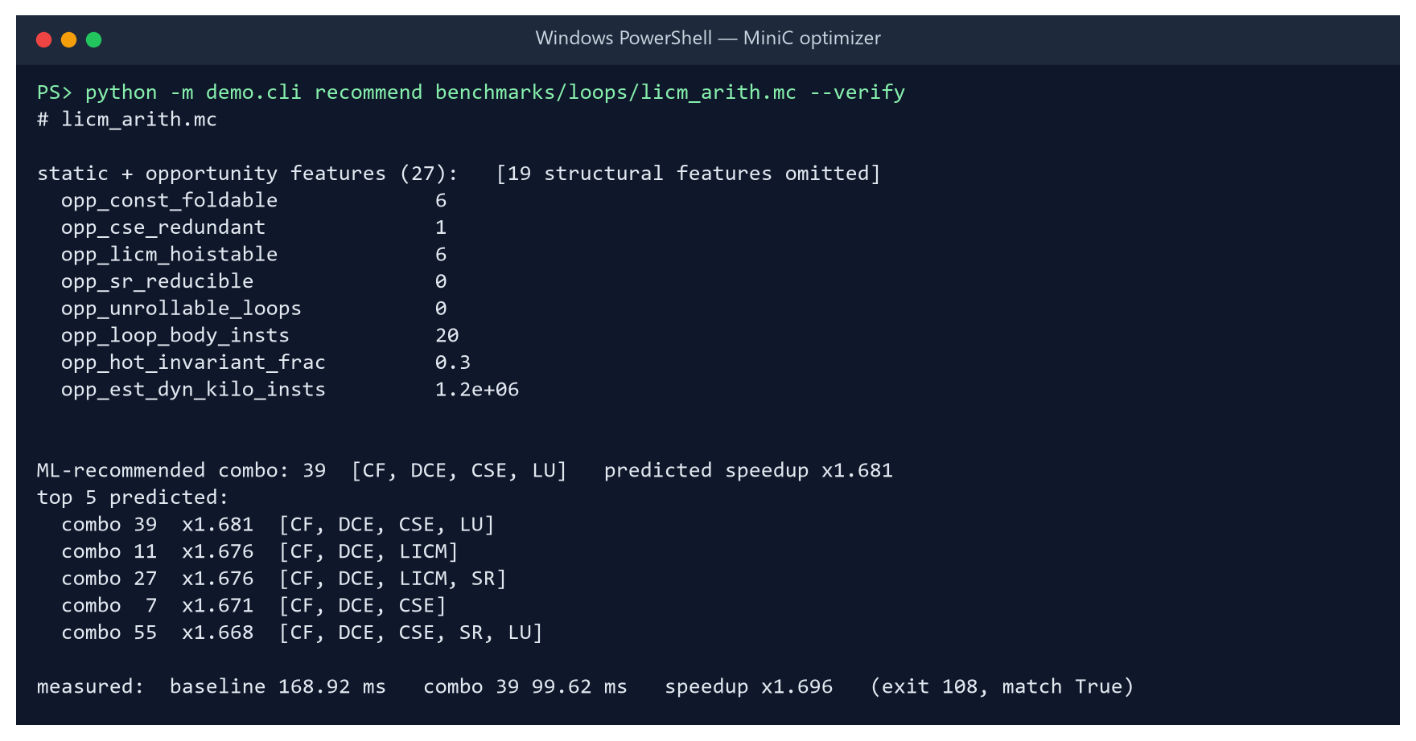
Figure 16: Recommendation for licm_arith: predicted ×1.68, measured ×1.70 (168.92 ms → 99.62 ms)
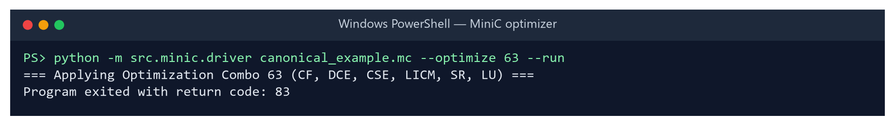
Figure 17: canonical_example.mc optimised with all passes still returns 83

5.5 Experimental Results

5.5.1 Overview of the sweep
Table 7: Headline results of the 900-program sweep
Measure | Value
Programs × combinations | 900 × 64 = 57,600 timed configurations
Configurations failing the correctness gate | 0
Best combination per program (oracle), geometric mean | ×1.31 (maximum ×4.37, complex_arith)
All six passes on (combo 63), geometric mean | ×1.19
Programs where all-on is not the best (>2% behind) | 715 / 900
Programs made >2% slower by all-on | 112 / 900
Fixed non-empty combination that never regresses >3% | none — only combo 0 is safe

The optimiser helps almost every program, but by very different amounts (Figure 18). About 39% of programs gain less than ×1.2 from even their best combination, while 127 gain more than ×1.6.
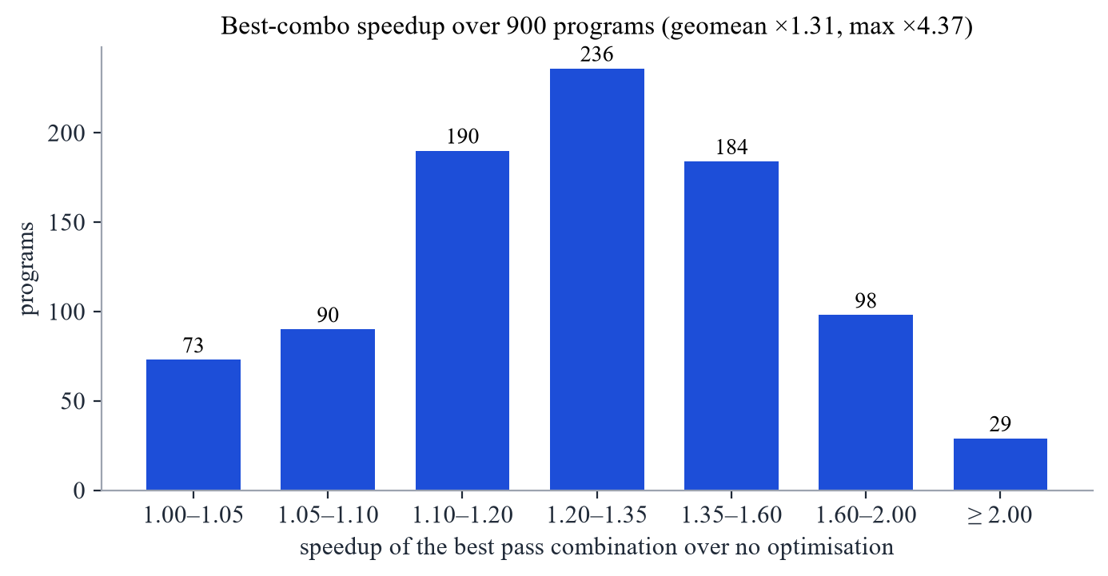
Figure 18: Distribution of the best-combination speedup over 900 programs

5.5.2 Results by category
Struct-heavy programs benefit most (×2.70 geomean): value semantics make the unoptimised code copy and re-load struct fields repeatedly, and CSE, LICM and DCE remove most of that work. Loop-dominated programs follow at ×1.75. Recursive programs gain least (×1.13), because their cost lies in calls, which the intra-procedural passes do not touch (Figure 19).
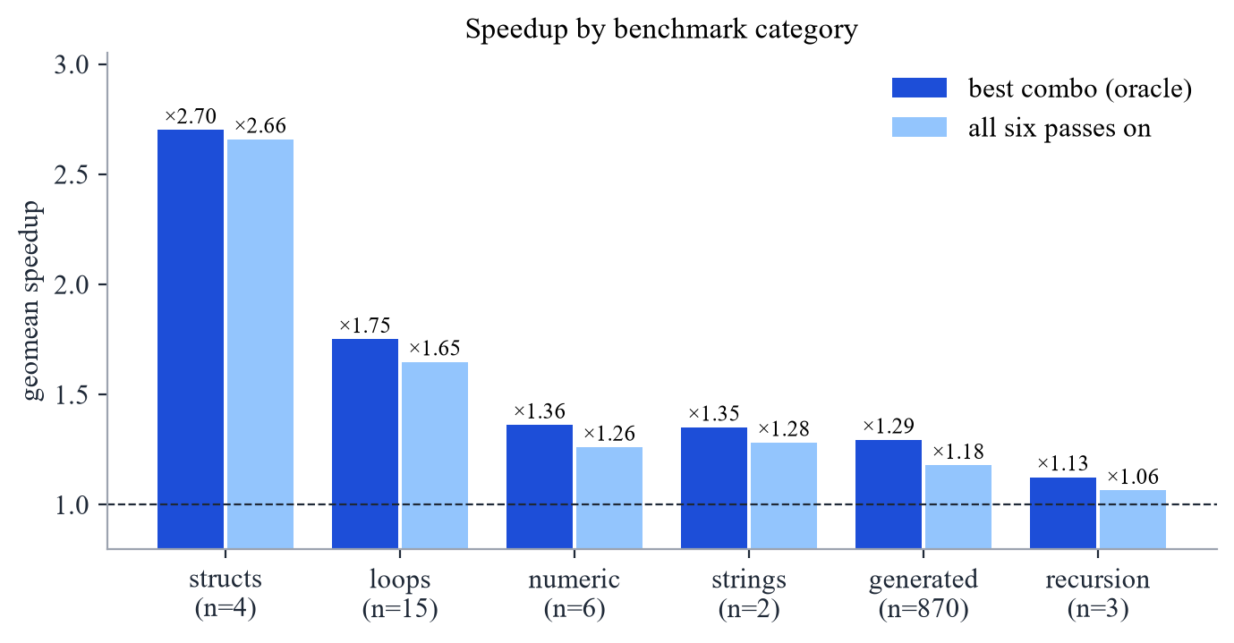
Figure 19: Geometric-mean speedup by category, best combination vs all passes

5.5.3 No single combination is best
Figure 20 compares, for every program, the speedup of enabling everything with the speedup of the best combination. Points on the diagonal are programs for which all-on is optimal; most programs lie well above it, and 112 lie left of the dashed line, where all-on is slower than doing nothing. Figure 21 shows that no pass belongs to every program's best combination, and Figure 22 lists the programs with the largest gains.
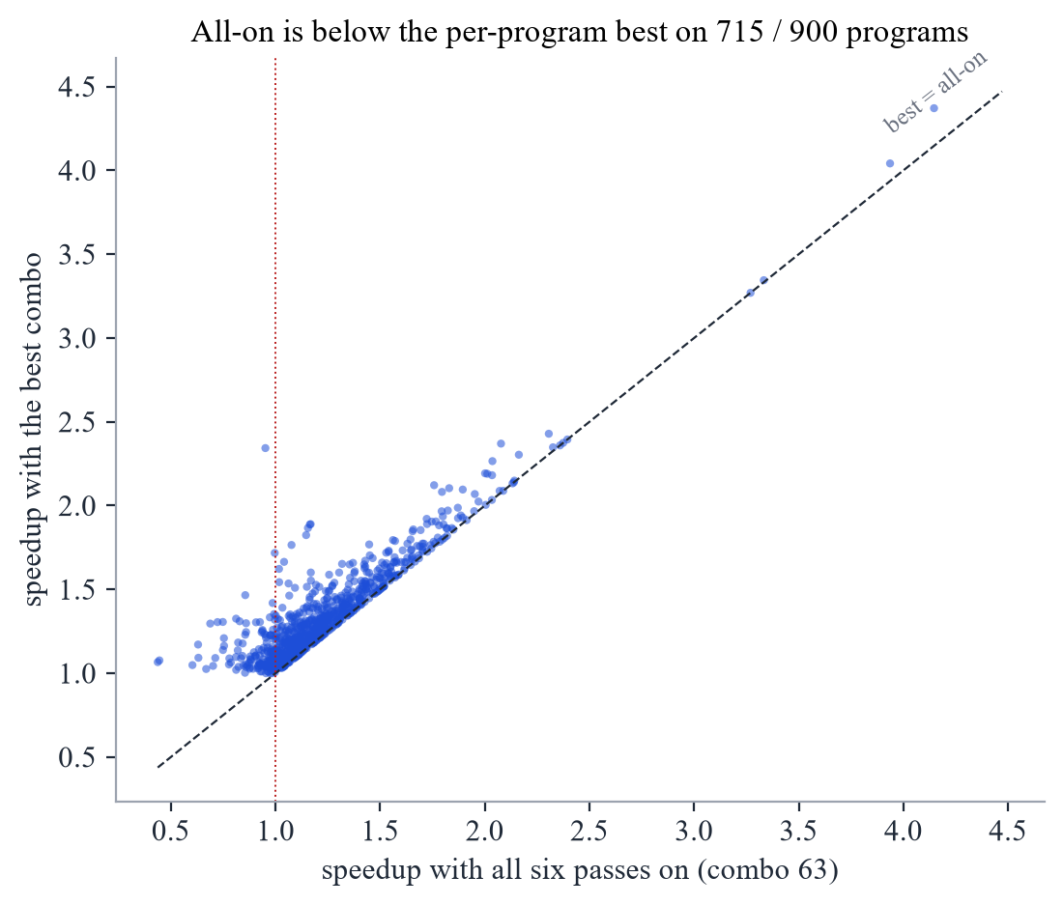
Figure 20: All-on speedup vs best-combination speedup, one point per program
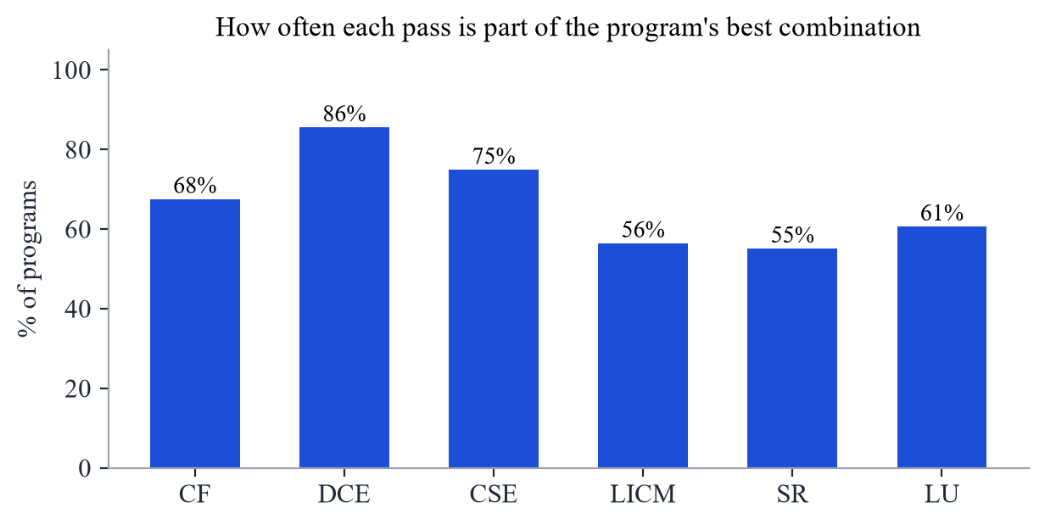
Figure 21: Share of programs whose best combination includes each pass
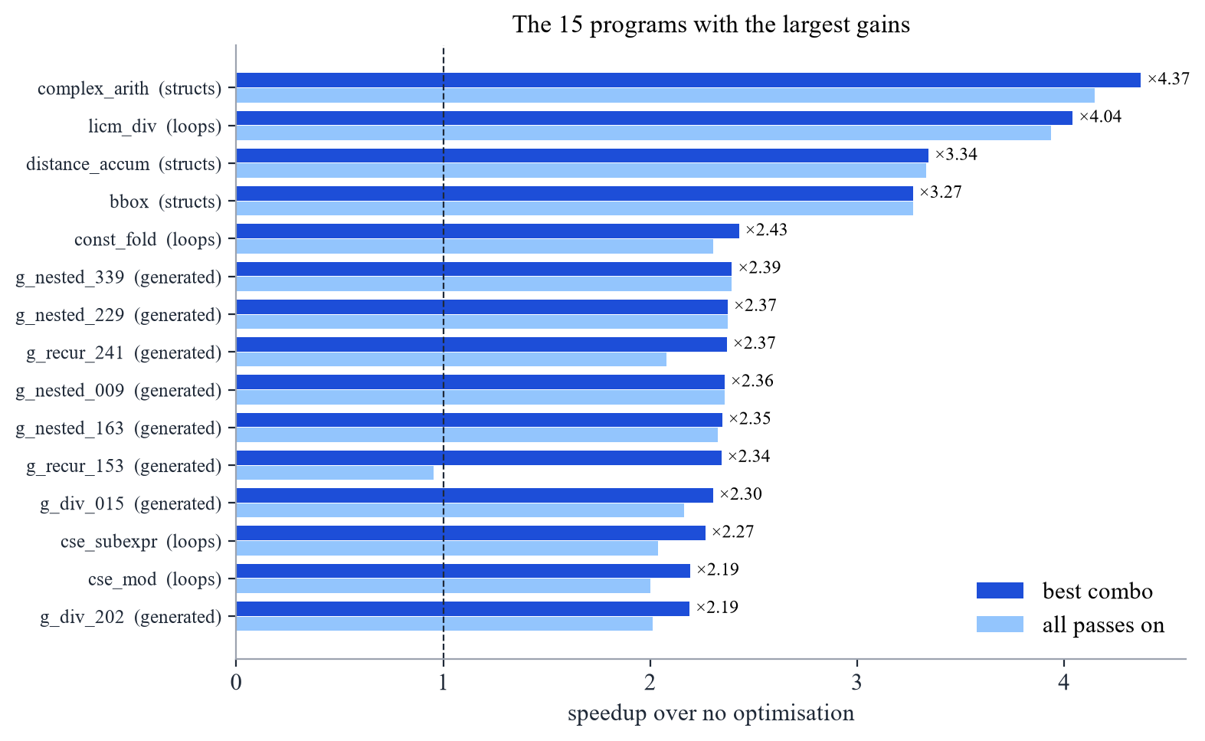
Figure 22: The fifteen programs with the largest speedups

5.5.4 The recommender
The strategy bake-off selected a Random Forest with an abstain margin of 0.05: a combination is recommended only if its predicted speedup exceeds ×1.05. On held-out programs it achieves a mean speedup of ×1.21 against ×1.33 for the oracle, capturing 63% of the achievable gain, while 9% of its recommendations slow the program down; the speedup-prediction mean absolute error is 0.105 (Figure 23, Table 8). Histogram Gradient Boosting was within 0.01 of it.
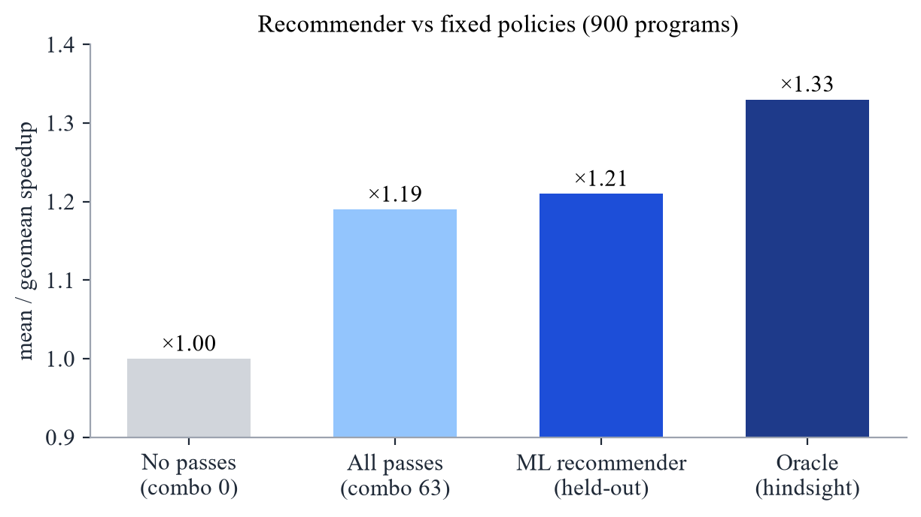
Figure 23: Held-out performance of the recommender compared with fixed policies
Table 8: Selected rows of the cross-validated strategy bake-off (900 programs, 5 folds)
Strategy | Model | Reco. speedup | Capture | Regressions
argmax | HistGradient Boosting | ×1.21 | 63% | 14%
argmax | Random Forest | ×1.21 | 64% | 12%
per-pass classifiers | HistGB classifier | ×1.22 | 65% | 11%
margin 0.03 | Random Forest | ×1.21 | 64% | 10%
margin 0.05 (selected) | Random Forest | ×1.21 | 63% | 9%
margin 0.05 | HistGradient Boosting | ×1.21 | 62% | 9%
margin 0.08 | HistGradient Boosting | ×1.20 | 60% | 6%
margin 0.12 | Random Forest | ×1.20 | 60% | 4%
margin 0.18 | HistGradient Boosting | ×1.18 | 53% | 2%

Figure 24 shows the trade-off the margin controls. Raising it lowers the regression rate steeply while the captured gain falls only slowly, because most of the risky recommendations are those with small predicted gains. The features the model relies on most are the multiplication count, the estimated dynamic instruction count, the number of foldable constants, branch density, loop body size and instruction density inside loops — precisely the properties that determine whether CF, SR and LICM can pay off.
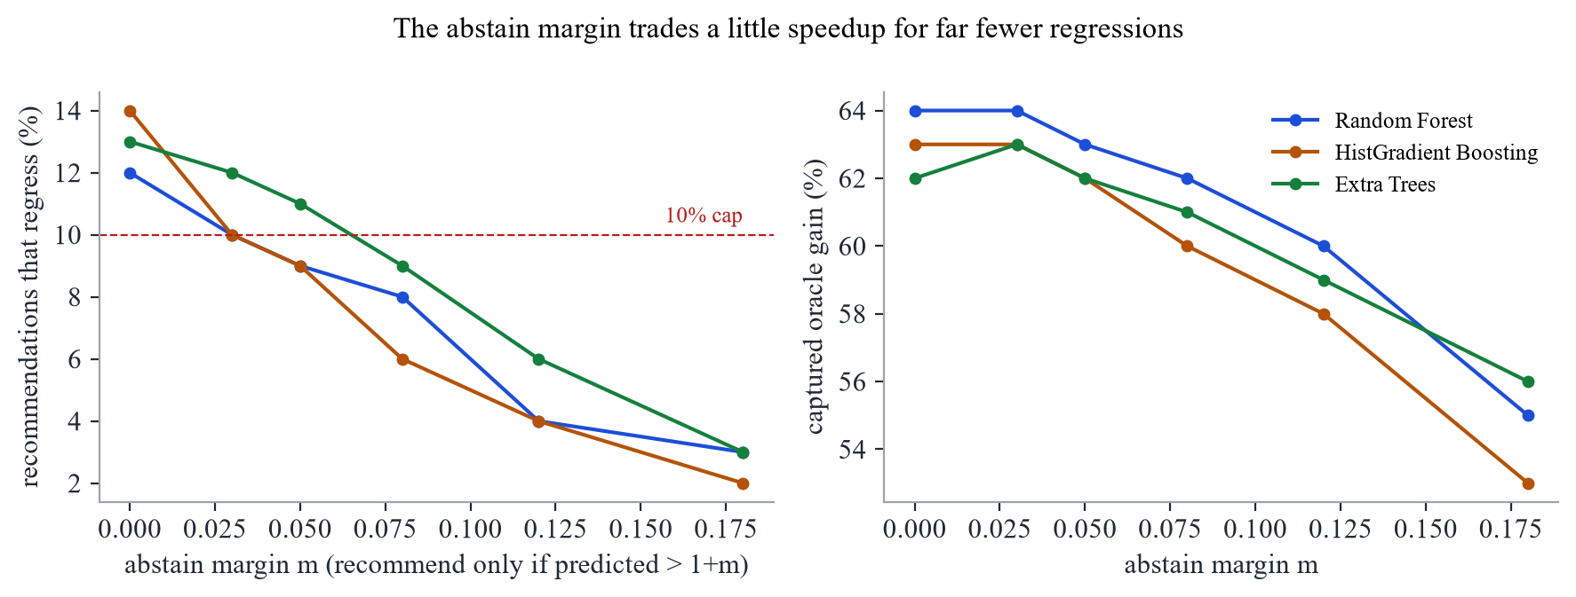
Figure 24: Effect of the abstain margin on regressions and captured gain

5.5.5 Model comparison
Table 9: Eight-model comparison at each model's best margin under the 10% regression cap
Model | Input | Reco. | Capture | Regress. | MAE | Size
HistGradient Boosting | features | ×1.209 | 63% | 10% | 0.105 | 2.0 MB
Random Forest | features | ×1.206 | 62% | 10% | 0.107 | 612.9 MB
1D-CNN | TAC sequence | ×1.197 | 59% | 8% | 0.131 | 365 KB
Linear (Ridge) | features | ×1.186 | 56% | 5% | 0.136 | 2 KB
1D-CNN + features | both | ×1.064 | 19% | 4% | 1.179 | 434 KB
GRU + features | both | ×1.058 | 18% | 7% | 0.779 | 162 KB
GRU (RNN) | TAC sequence | ×1.035 | 11% | 2% | 0.147 | 94 KB
MLP | features | ×1.024 | 7% | 10% | 0.703 | 92 KB

Histogram Gradient Boosting wins the comparison at ×1.209 and is also among the smallest models (2 MB, 0.36 ms to score all 64 combinations). The Random Forest scores almost the same but its serialised model is 613 MB. The most interesting result is the 1D-CNN: reading only the raw TAC tokens, with none of the engineered features, it reaches ×1.197, within 1% of the best feature model (Figure 25).
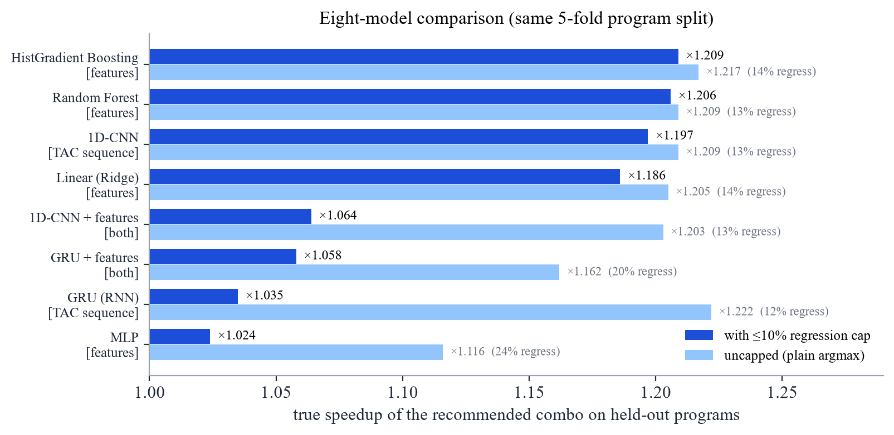
Figure 25: Recommendation quality of the eight models, with and without the regression cap
Without the cap, the GRU is actually the strongest model (×1.222, 67% capture), but 12% of its picks regress. Its predicted speedups are poorly calibrated: the gains it predicts for good and bad choices are similar, so no margin can filter the bad ones without discarding almost all the good ones, and under the cap it collapses to ×1.035. The hybrid models and the MLP show the same behaviour, which points to a training problem (calibration and data volume) rather than a lack of signal in their inputs.

5.5.6 Comparison with Review-1
Table 10: Results at Review-1 and in the final evaluation
Measure | Review-1 (270 programs) | Final (900 programs)
Timed configurations | 17,280 | 57,600
Oracle geomean speedup | ×1.50 | ×1.31
All-on geomean speedup | ×1.21 | ×1.19
All-on not best | 243 / 270 | 715 / 900
Recommender held-out speedup | ×1.23 (HistGBT, margin 0.12) | ×1.21 (Random Forest, margin 0.05)
Captured oracle gain | 44% | 63%
Regressions (recommender / argmax) | 9% / 21% | 9% / 12%
Models compared | 3 tree ensembles | 8 (incl. CNN, GRU, hybrids)

The oracle speedup fell because the 870 generated programs include branch-heavy, nested-loop and recursive patterns where the passes have less to work with; the larger corpus is more representative. On it, the recommender captures a much larger share of the available gain (63% against 44%) with the same 9% regression rate, which shows the value of the additional training data.

5.6 Testing and Verification
Correctness is enforced at two levels. The pytest suite (49 tests plus 17 sub-tests) covers the lexer, parser, semantic analyser, IR generator, features, each pass individually and in all 64 combinations, regression cases for previously found miscompilations, nested aggregates, the timing harness and the ML data plumbing; the full suite passes. In addition, every one of the 57,600 builds in the experiment had to reproduce the unoptimised program's return value. Figure 26 shows the fast part of the suite.
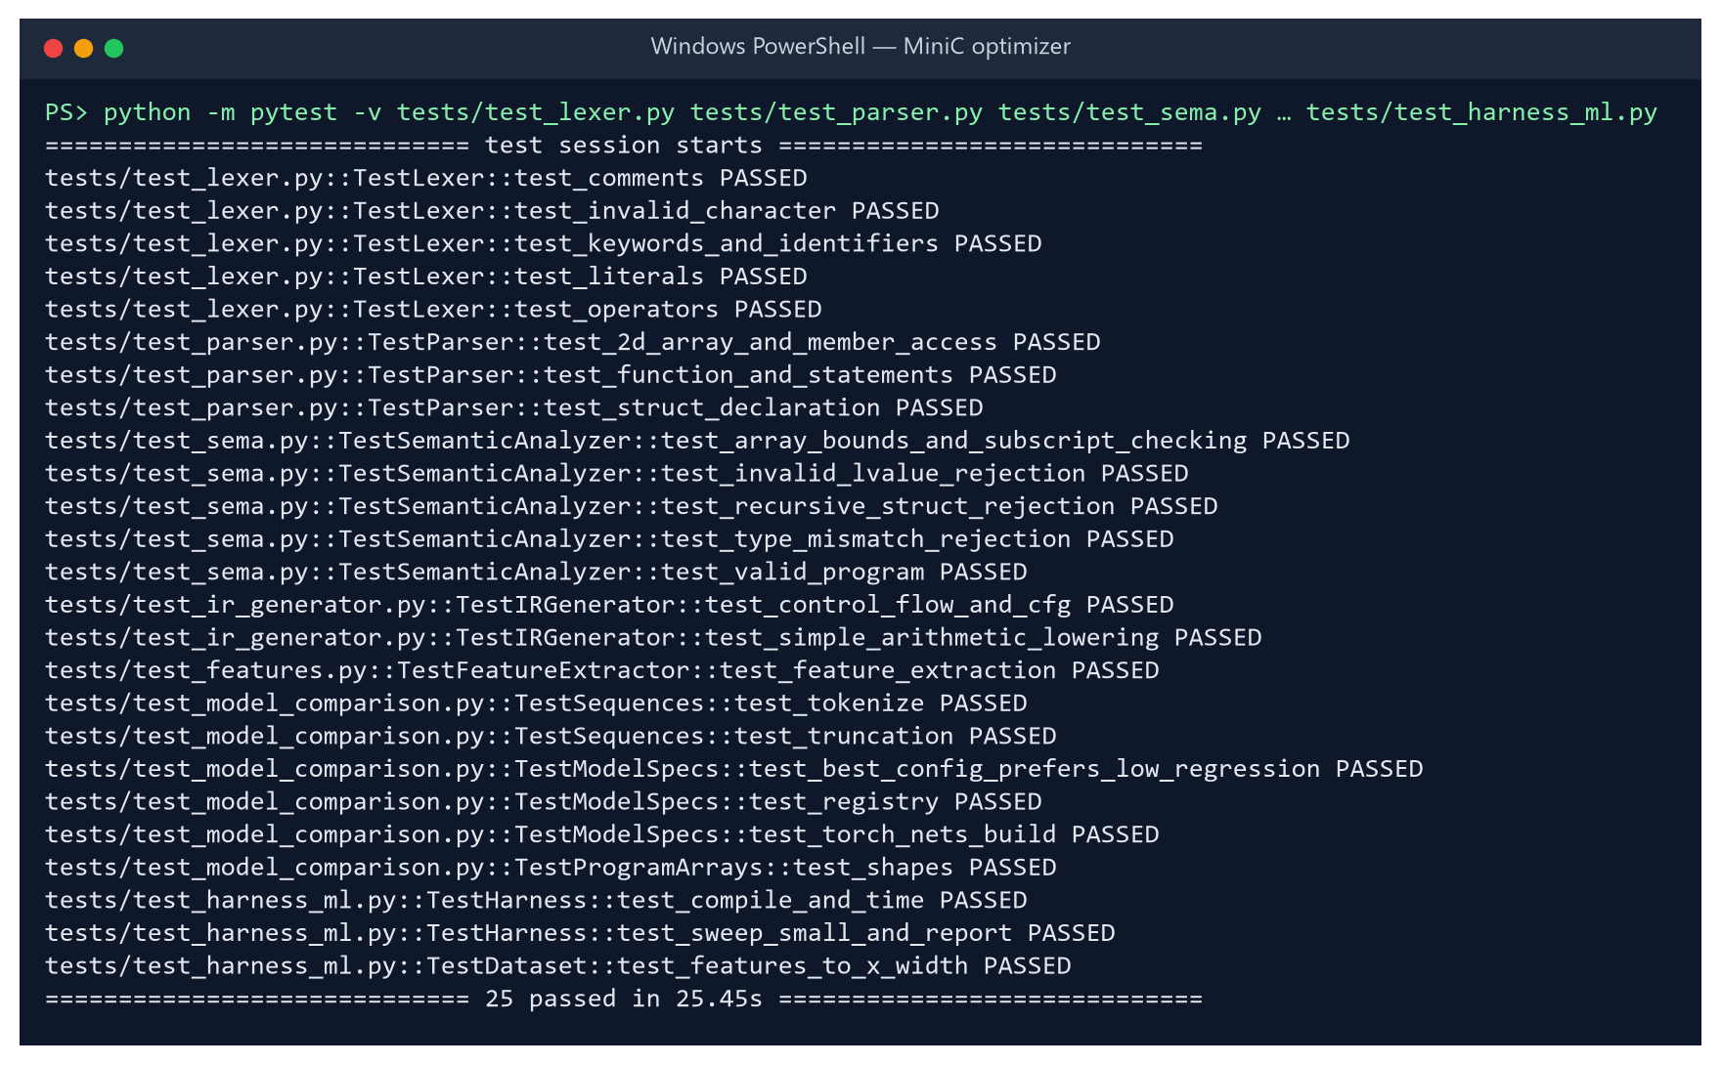
Figure 26: Verbose run of the fast (non-compiling) part of the test suite: 25 tests pass

6. Conclusion

6.1 Summary
This project delivered a complete optimising compiler for MiniC — front end, three-address IR, control-flow analysis, six provably sound optimisation passes with a fixed-point pass manager, and a value-semantics C back end — together with a measurement harness, a 900-program benchmark corpus, a machine-learning pass recommender, a command-line tool and a browser playground.

6.2 Key Findings
• Pass selection matters and is program-specific: the best combination gives ×1.31 on average and up to ×4.37, but enabling everything is sub-optimal for 79% of programs and harmful for 12%.
• Every fixed non-empty combination slows at least one program down, so a per-program decision is required to be both fast and safe.
• A Random Forest over 27 static features, with an abstain margin, achieves ×1.21 on unseen programs and captures 63% of the achievable gain with only 9% regressions.
• Risk control is as important as accuracy: the abstain margin cut regressions from 12% to 9% at almost no cost in speedup.
• Tree ensembles over engineered features perform best, but a CNN over the raw TAC sequence comes within 1% of them, showing that useful program representations can be learned directly from IR.

6.3 Limitations
• Speedups are measured with gcc -O0 to isolate the project's passes; the gains on top of an optimising C compiler would be smaller.
• All timings come from one machine; absolute speedups depend on the processor and memory system.
• The passes are intra-procedural and their order is fixed, so recursive programs and phase ordering are only partly addressed.
• The generated programs, although varied, follow known patterns and may be easier to predict than arbitrary real-world code.
• The selected Random Forest is large (613 MB serialised); the comparison shows a 2 MB gradient boosting model performs at least as well.

6.4 Future Work
• Ship Histogram Gradient Boosting as the default recommender for its size and speed.
• Calibrate the sequence models (for example with quantile or ranking losses) so that the GRU's uncapped advantage can be used safely.
• Treat pass ordering as a sequential decision problem and apply reinforcement learning, as in CompilerGym and AutoPhase [4], [5].
• Add inter-procedural optimisation, in particular function inlining, to help recursive and call-heavy programs.
• Augment static features with hardware performance counters, and target LLVM IR to evaluate the approach on top of a production optimiser.

7. Project Repository Link
The complete source code, benchmark corpus, measured dataset, trained-model pipeline, results and this report's generator are available at:
https://github.com/AkineHime/AI-based-compiler-optimization
Key files: RESULTS.md (measured results), MODEL_COMPARISON.md (eight-model comparison), docs/WALKTHROUGH.md (one program traced through every stage), docs/results.html (visual report) and run_experiment.py (reproduces the whole experiment).

References
[1] A. V. Aho, M. S. Lam, R. Sethi and J. D. Ullman, Compilers: Principles, Techniques, and Tools, 2nd ed. Boston, MA, USA: Addison-Wesley, 2006.
[2] K. D. Cooper and L. Torczon, Engineering a Compiler, 2nd ed. San Francisco, CA, USA: Morgan Kaufmann, 2011.
[3] G. Fursin et al., "Milepost GCC: Machine learning enabled self-tuning compiler," International Journal of Parallel Programming, vol. 39, no. 3, pp. 296–327, 2011.
[4] C. Cummins et al., "CompilerGym: Robust, performant compiler optimization environments for AI research," in Proc. IEEE/ACM Int. Symp. Code Generation and Optimization (CGO), 2022.
[5] A. Haj-Ali et al., "AutoPhase: Juggling HLS phase orderings in random forests with deep reinforcement learning," in Proc. Machine Learning and Systems (MLSys), 2020.
[6] M. Trofin, Y. Qian, E. Brevdo, Z. Lin, K. Choromanski and D. Li, "MLGO: A machine learning guided compiler optimizations framework," arXiv:2101.04808, 2021.
[7] A. H. Ashouri, W. Killian, J. Cavazos, G. Palermo and C. Silvano, "A survey on compiler autotuning using machine learning," ACM Computing Surveys, vol. 51, no. 5, 2018.
[8] F. Pedregosa et al., "Scikit-learn: Machine learning in Python," Journal of Machine Learning Research, vol. 12, pp. 2825–2830, 2011.
[9] A. Paszke et al., "PyTorch: An imperative style, high-performance deep learning library," in Advances in Neural Information Processing Systems 32 (NeurIPS), 2019.
[10] G. Ke et al., "LightGBM: A highly efficient gradient boosting decision tree," in Advances in Neural Information Processing Systems 30 (NIPS), 2017.
[11] L. Breiman, "Random forests," Machine Learning, vol. 45, no. 1, pp. 5–32, 2001.
[12] S. S. Muchnick, Advanced Compiler Design and Implementation. San Francisco, CA, USA: Morgan Kaufmann, 1997.

