**Access Control Software**

**Database hierarchy**

* Multicompany software
* Each Company (customer), may have different locations (establishment)
* Each Location, may have different devices for check-in and check-out (scanners, RFID readers, manual check-in/out).

**Functionality**

* Include check-in and check-out date-time
* Ability to select manually ***check-in*** or ***check-out*** when check at the front desk.
* Ability to define a device (scanner, QR reader) as check-in device or check-out device
* Ability to grant user access by location, days and hours
* Display the user information (with picture) in the local PC screen, when a user check-in/check- out
* Add Host Person table (the person who receive the Visitor) and Status if the visitor is still inside or leave the location, something like this:

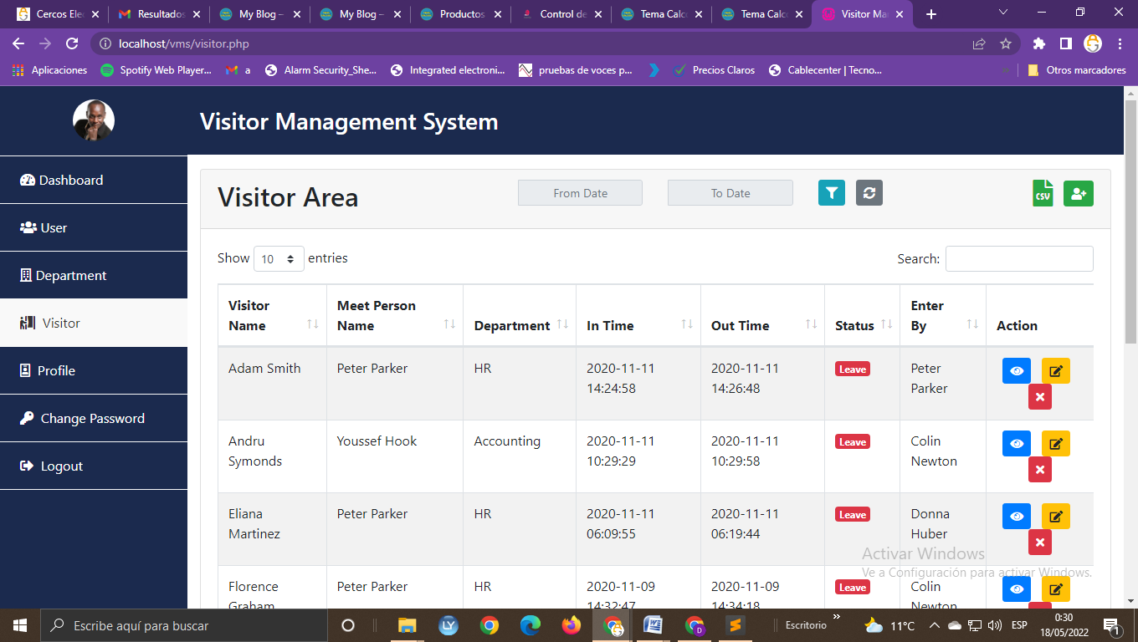

* Pre-registers
* Employees
* Visitors
* Host

**Roles**

1. General administrator for the software
2. Company administrator (customer admin): can manage his company only: locations, devices and user for his Company. Reports by locations, between dates, and search filter
3. Company user: Check-in/out for each location. Reports for his location, between dates, and search filter (by user, by dates etc.)
4. Admin
5. Employees
6. Visitors
7. Host
8. Recepcionist

**Users/Visitors**

* Add User status button: “Enabled” or “Disabled”

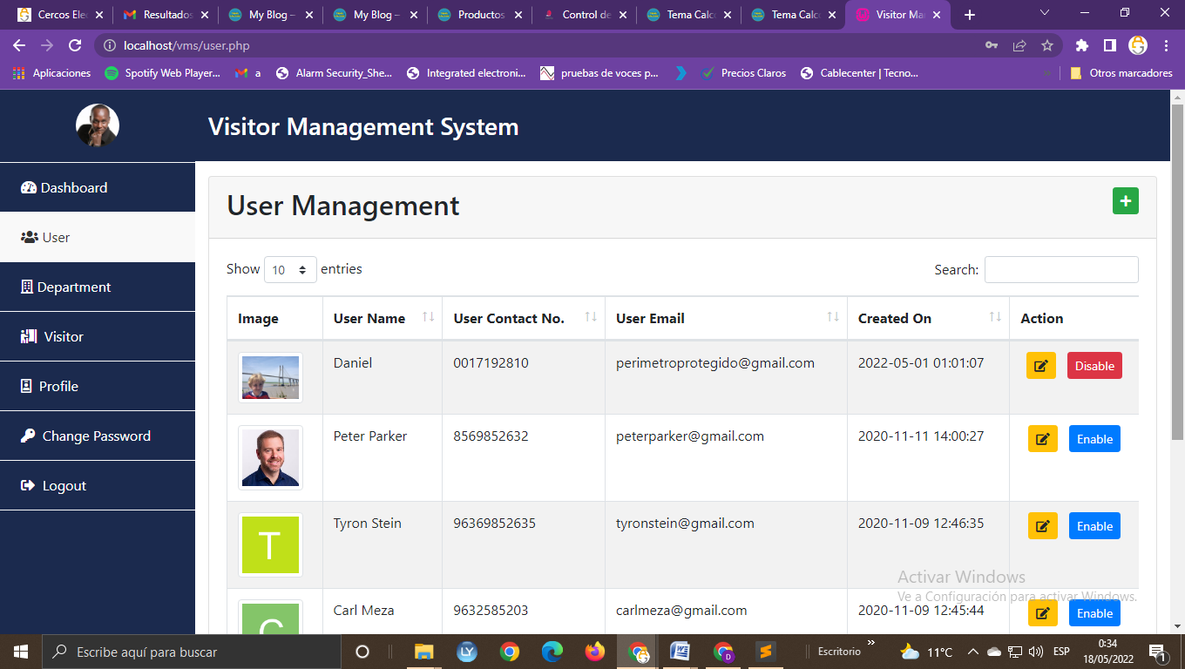

* Take a picture with webcam and browse a picture
* Send to the User an email and WhatsApp with QR-Code and the “Electronic Person's CTS Card", also to have the ability to print it.