Temporal Analysis Report
Telecom Ethnography — "A Day in the Life" Diary Study
Lagos, Nigeria • April 16–22, 2026 • 11 Respondents • 65 Diary Entries

1. Daily Rhythm: When Does Life Happen?
This analysis maps the 1,499 coded responses against the natural rhythm of respondents’ days. By tracking which code families peak at which time of day, we can identify the optimal windows for brand engagement and the critical moments where infrastructure failure has the highest cost.
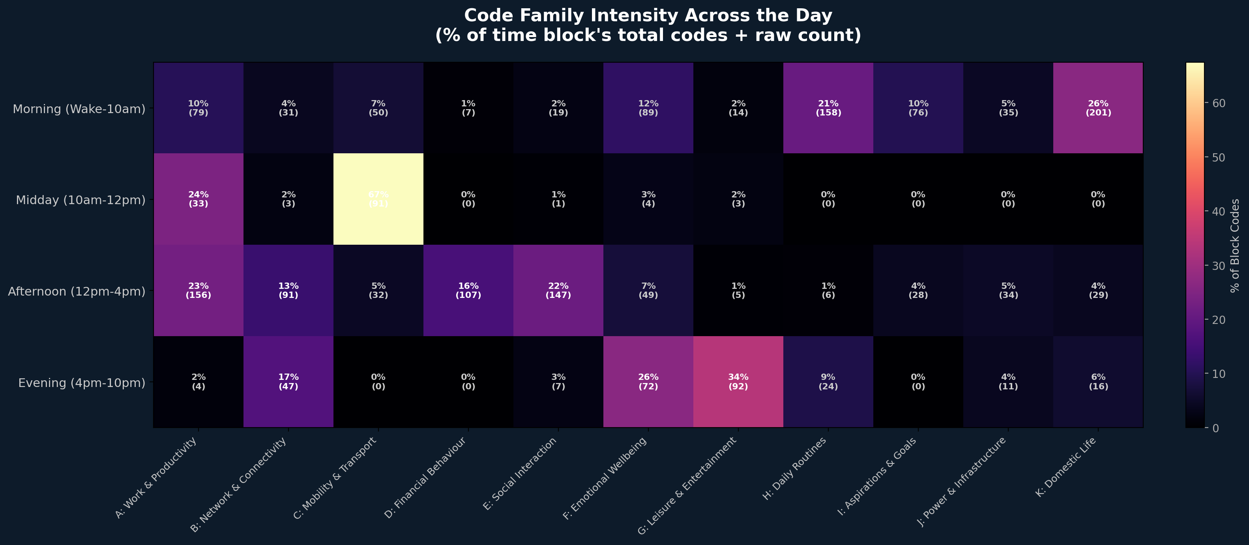

Key Findings
• Morning is dominated by H (Routines) and K (Domestic Life) — prayer, chores, bathing, and preparing for work. This is the "foundation-setting" period.
• Midday sees the rise of A (Work) and B (Network) — respondents arrive at offices/shops and begin using their phones for business. C (Mobility) also peaks here as commutes end.
• Afternoon is the crisis window: J (Power) peaks as phones die without electricity. F (Emotional) codes shift negative. D (Financial) spending decisions cluster here.
• Evening belongs to G (Leisure) and E (Social) — TikTok, comedy, movies, music, and gisting with friends. This is the only period where respondents report genuine relaxation.

2. Emotional Arc: The Shape of a Lagos Day
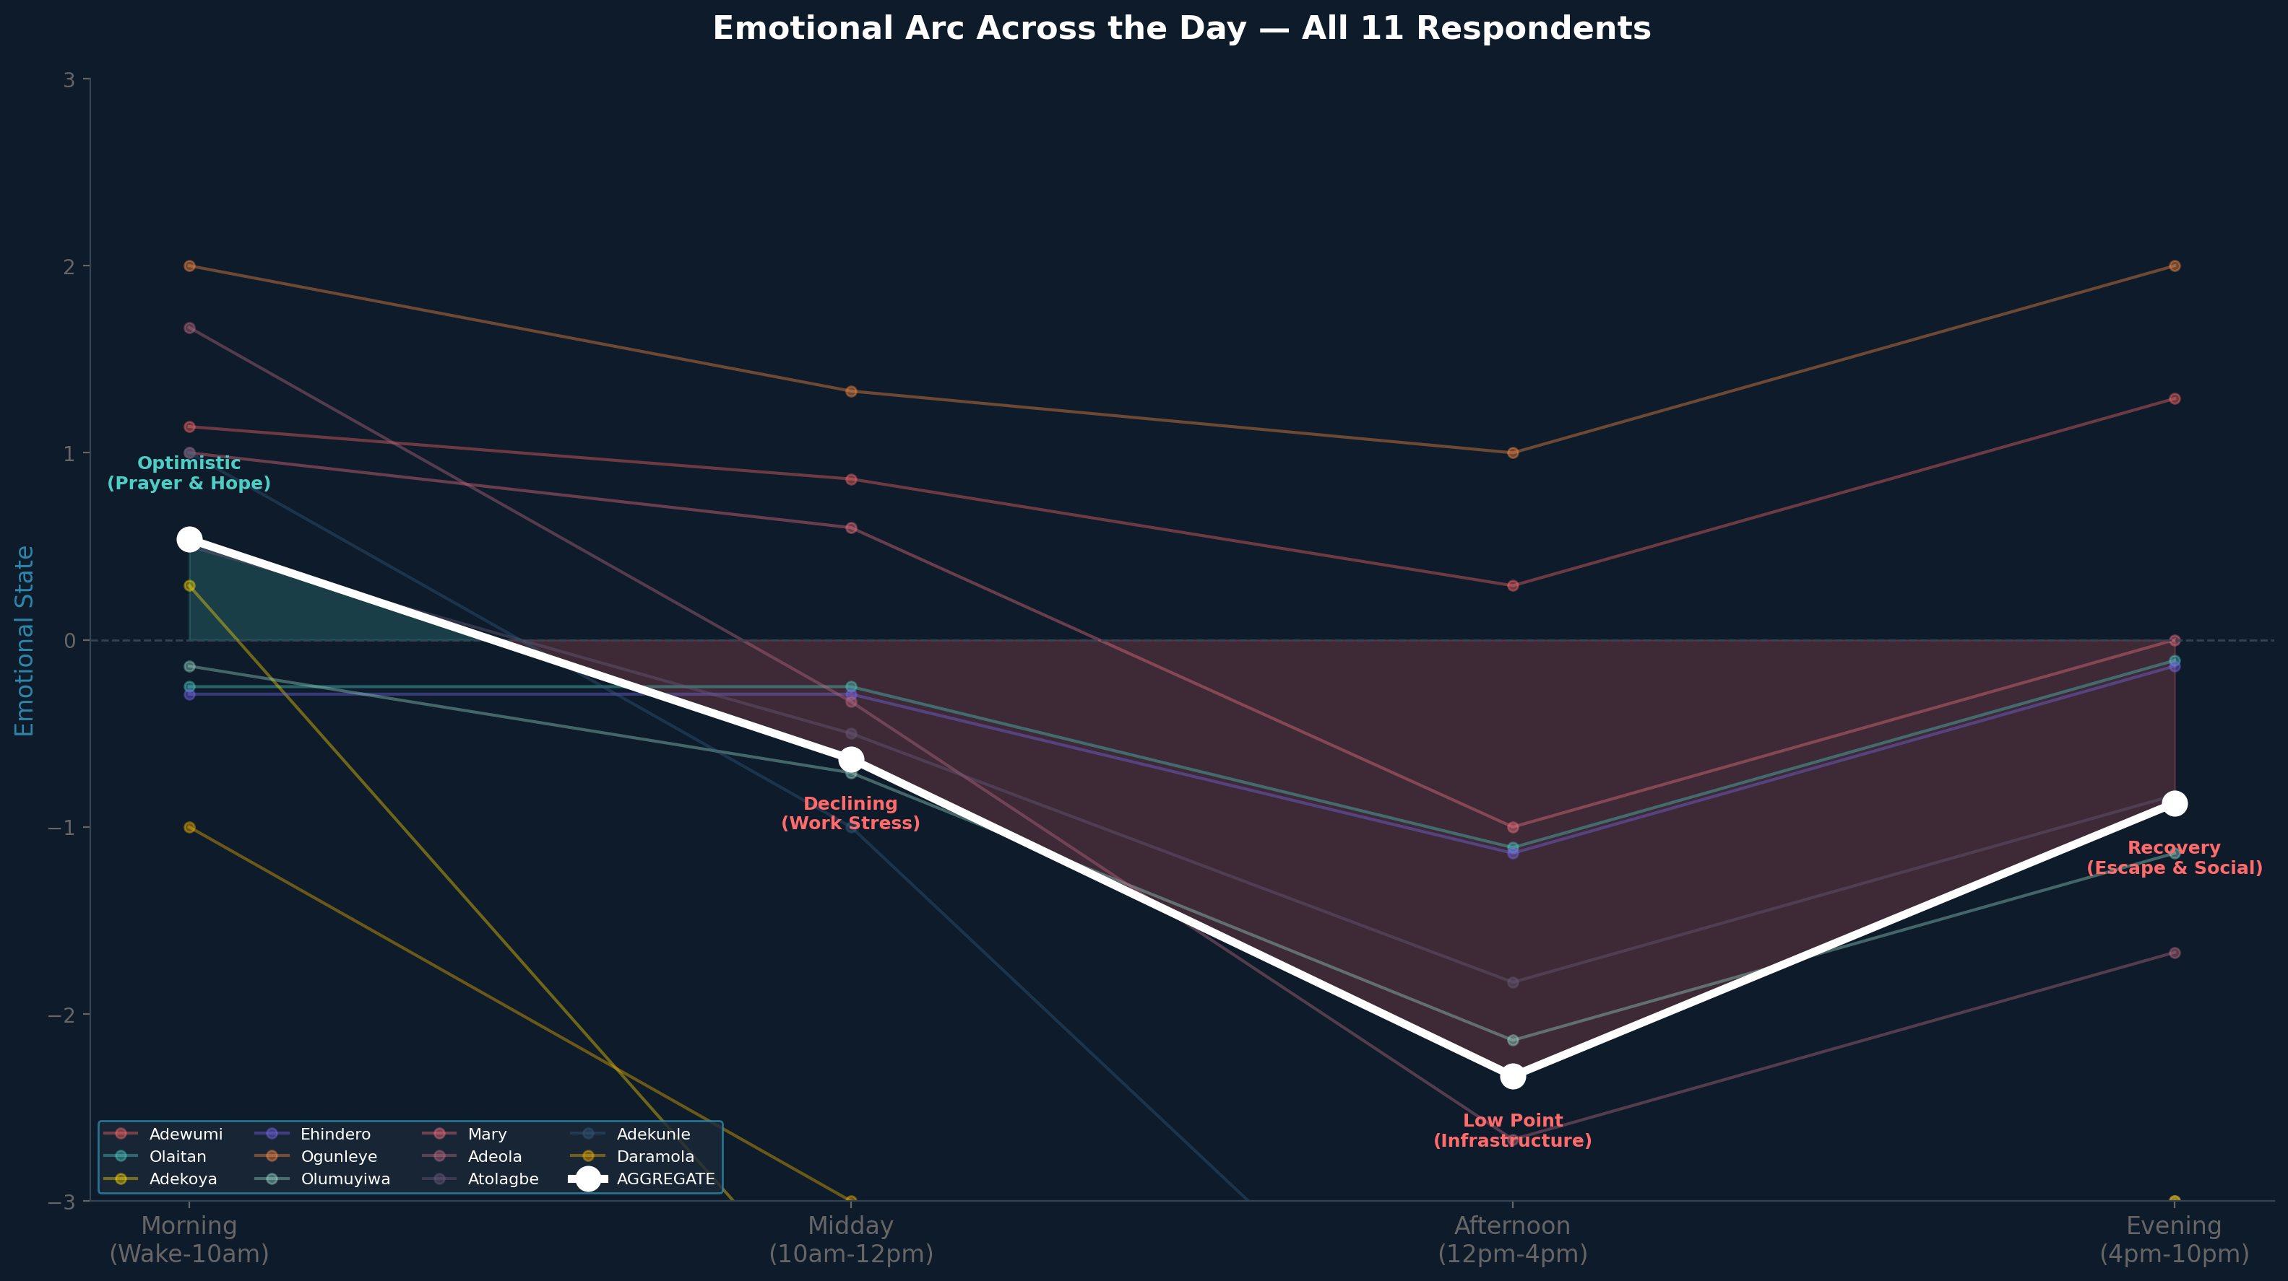

The aggregate emotional arc across all 11 respondents reveals a consistent pattern: optimism at dawn, declining through the work day, hitting a low point in the afternoon, and recovering in the evening through digital entertainment and social connection.
This "U-shaped" emotional curve has direct implications for brand strategy:
• Morning (high mood): Ideal for aspirational messaging — respondents are hopeful and open.
• Midday (declining): Avoid friction — network issues here cause disproportionate frustration.
• Afternoon (low point): This is when empathy-driven messaging resonates. Offers that solve infrastructure problems (free charging, data bonuses) would be most valued.
• Evening (recovery): Entertainment and social content drives engagement. Data bundles optimised for streaming/social would align with natural behaviour.

3. Wake-Up Patterns
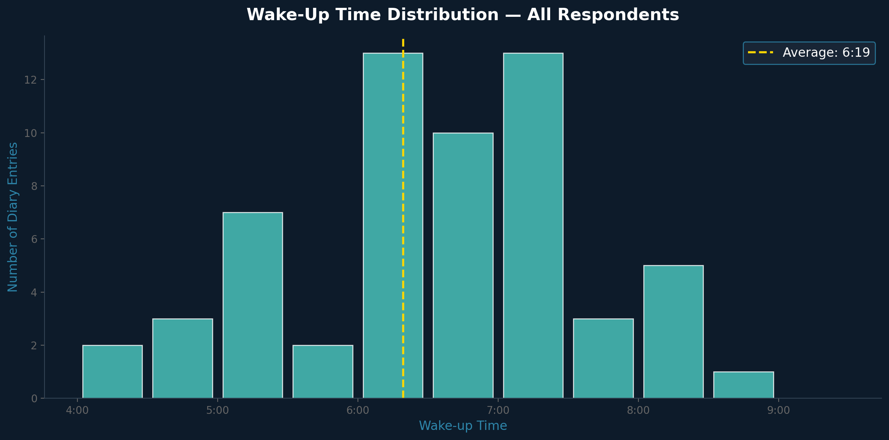

The average wake-up time across all entries is 6:19 AM. Most respondents wake between 5:00 and 7:30 AM, with prayer as the near-universal first act. Phone usage immediately follows: checking time, torch light, or messages.

4. Respondent Activity Density
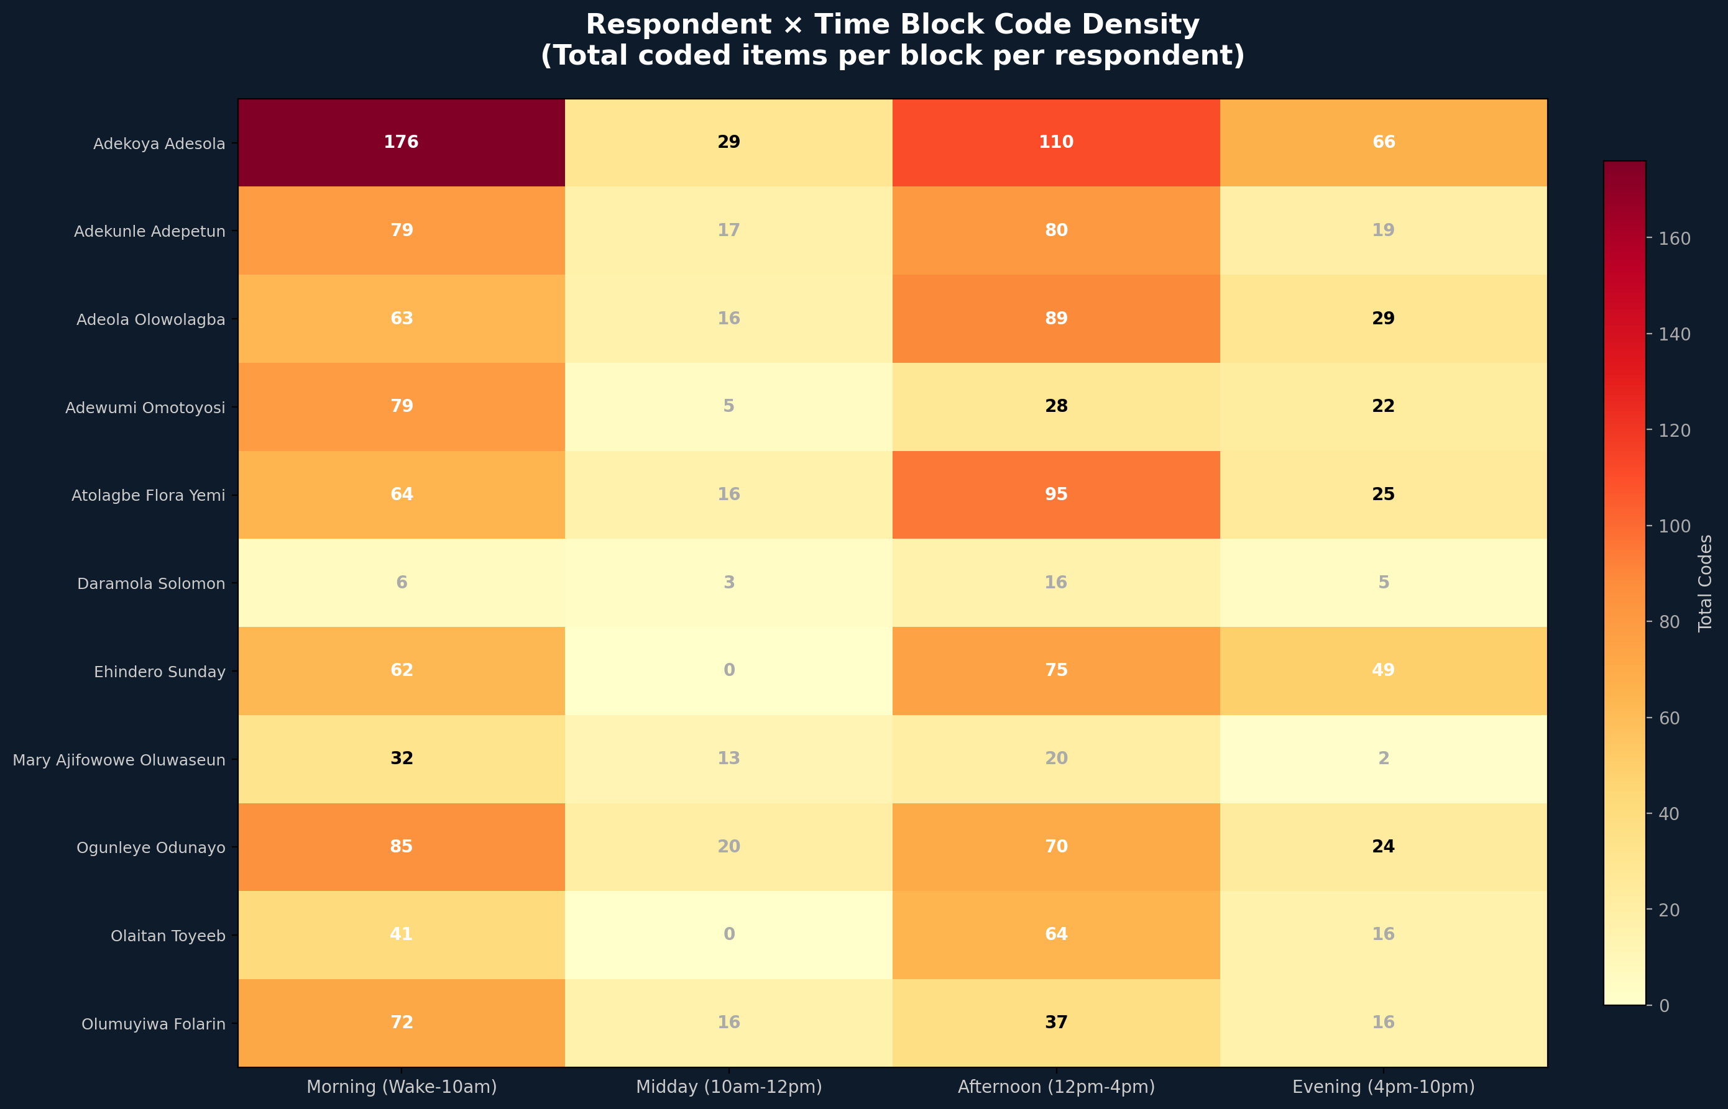

This matrix reveals how each respondent’s coded activity distributes across the day. High-density respondents (Adekoya: 269 codes) show rich detail across all time blocks, while snapshot respondents (Daramola: 27 codes) show concentrated activity.

5. Strategic Implications

The 24-Hour Opportunity Map
Time Window | Dominant Themes | User Mood | Brand Opportunity
5:00–8:00 AM | H (Routine), K (Domestic), Prayer | Optimistic, Spiritual | Morning data bundles; Torch-light reliability; Bible/devotional partnerships
8:00–10:00 AM | C (Mobility), A (Work), Commute | Stressed, Rushed | Transit-optimised streaming; Low-data music apps; Commute loyalty rewards
10:00 AM–2:00 PM | A (Work), B (Network), Business | Productive but anxious | Business WhatsApp bundles; Transaction SMS reliability; Ultra-low-latency calls
2:00–6:00 PM | J (Power), F (Emotional), D (Financial) | Frustrated, Depleted | Emergency charging partnerships; "Afternoon survival" data packs; Empathy messaging
6:00–10:00 PM | G (Leisure), E (Social), Recovery | Relieved, Social | Evening streaming bundles; Social data bonuses; Family calling plans

Individual Emotional Arcs
Respondent | Morning | Midday | Afternoon | Evening
Adekoya Adesola | +0.3 ↔ | -3.7 ↓ | -7.7 ↓ | -3.0 ↓
Adekunle Adepetun | +1.0 ↑ | -1.0 ↓ | -4.3 ↓ | -3.0 ↓
Adeola Olowolagba | +1.7 ↑ | -0.3 ↔ | -2.7 ↓ | -1.7 ↓
Adewumi Omotoyosi | +1.1 ↑ | +0.9 ↑ | +0.3 ↔ | +1.3 ↑
Atolagbe Flora Yemi | +0.5 ↔ | -0.5 ↔ | -1.8 ↓ | -0.8 ↓
Daramola Solomon | -1.0 ↓ | -3.0 ↓ | -5.0 ↓ | -3.0 ↓
Ehindero Sunday | -0.3 ↔ | -0.3 ↔ | -1.1 ↓ | -0.1 ↔
Mary Ajifowowe Oluwaseun | +1.0 ↑ | +0.6 ↑ | -1.0 ↓ | +0.0 ↔
Ogunleye Odunayo | +2.0 ↑ | +1.3 ↑ | +1.0 ↑ | +2.0 ↑
Olaitan Toyeeb | -0.2 ↔ | -0.2 ↔ | -1.1 ↓ | -0.1 ↔
Olumuyiwa Folarin | -0.1 ↔ | -0.7 ↓ | -2.1 ↓ | -1.1 ↓

