Strategic Theme Clustering Report
Telecom Ethnography — "A Day in the Life" Diary Study
Lagos, Nigeria • April 16–22, 2026 • 11 Respondents • 65 Diary Entries

1. Methodology
This analysis examines the co-occurrence patterns of 11 thematic code families across 65 diary entries from 11 respondents. Two codes are said to "co-occur" when both appear in the same diary entry, indicating that the respondent experienced both themes within the same day. High co-occurrence suggests that two themes are structurally linked in the respondent’s lived experience — they are not independent problems but parts of the same daily reality.

2. Overall Co-Occurrence Matrix
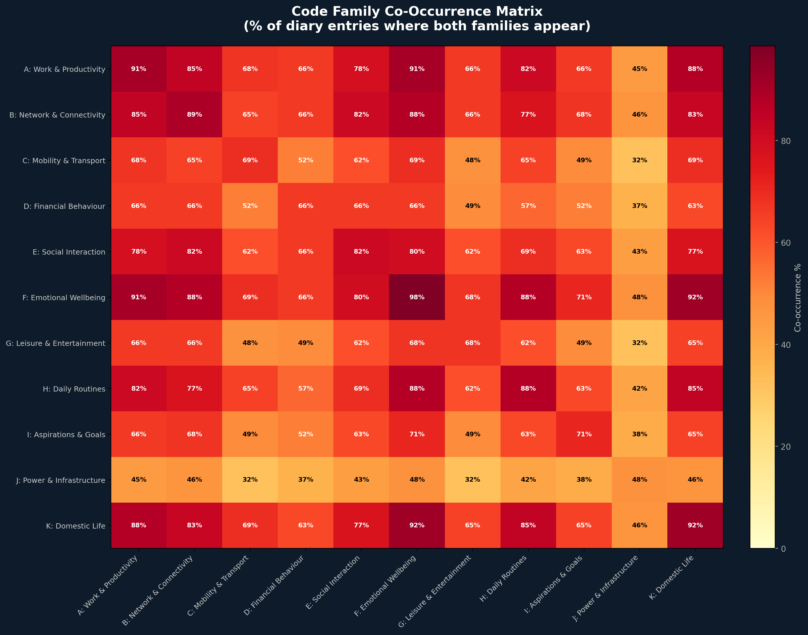

Top 10 Co-Occurring Family Pairs
Rank | Family 1 | Family 2 | Co-occurrence %
1 | F: Emotional Wellbeing | K: Domestic Life | 92.3%
2 | A: Work & Productivity | F: Emotional Wellbeing | 90.8%
3 | A: Work & Productivity | K: Domestic Life | 87.7%
4 | B: Network & Connectivity | F: Emotional Wellbeing | 87.7%
5 | F: Emotional Wellbeing | H: Daily Routines | 87.7%
6 | A: Work & Productivity | B: Network & Connectivity | 84.6%
7 | H: Daily Routines | K: Domestic Life | 84.6%
8 | B: Network & Connectivity | K: Domestic Life | 83.1%
9 | A: Work & Productivity | H: Daily Routines | 81.5%
10 | B: Network & Connectivity | E: Social Interaction | 81.5%

3. Strategic Theme Clusters
Based on the co-occurrence analysis, the 11 code families collapse into the following strategic theme clusters. Each cluster represents a coherent "story" that recurs across multiple respondents and diary entries.

Cluster 1: The Infrastructure-Productivity Loop
Core Codes: A (Work) + H (Routine) + J (Power) + B (Network)
Work productivity, daily routines, power outages, and network connectivity form the tightest cluster in the data. When NEPA fails, phones die. When phones die, business calls are missed. When calls are missed, sales drop. This is not four separate problems — it is one systemic failure with four symptoms.
Key Respondents: Adekunle (highest J-codes), Adeola, Flora, Adekoya

Cluster 2: The Domestic-Work Double Burden
Core Codes: K (Domestic) + A (Work) + H (Routine)
Domestic responsibilities (cooking, cleaning, childcare) and work demands constantly compete for the same morning hours. Respondents must complete household duties before leaving for work, creating a daily race against time that determines their entire day.
Key Respondents: Ogunleye, Flora, Adeola, Mary

Cluster 3: The Commute Burden
Core Codes: C (Mobility) + F (Emotion) + D (Financial)
Transport stress, emotional strain, and financial cost form a tight triangle. Every commute costs money (bike, keke, bus), causes stress (traffic, rain, lateness), and consumes time that could be spent earning. The commute is both a financial drain and an emotional weight.
Key Respondents: Mary (multi-modal), Ogunleye, Adekoya, Daramola

Cluster 4: Survival Economics
Core Codes: D (Financial) + A (Work) + K (Domestic)
Spending, earning, and feeding form an inseparable cycle. Money flows out daily on food, transport, and airtime. It can only be replenished through sales or wages. When sales fail, respondents literally cannot eat well. Financial behaviour is not a separate domain — it is the arithmetic of daily survival.
Key Respondents: Adeola ("replacement economics"), Adekunle, Flora, Olaitan

Cluster 5: Connection as Lifeline
Core Codes: E (Social) + B (Network) + F (Emotion)
Social interaction, network availability, and emotional wellbeing co-occur because human connection IS the coping mechanism. Respondents who gist with friends, call family, or visit neighbours report higher emotional resilience. When network fails and calls drop, isolation follows.
Key Respondents: Ehindero, Adekoya, Ogunleye, Adewumi

Cluster 6: The Escape Economy
Core Codes: G (Leisure) + F (Emotion) + B (Network)
Entertainment (TikTok, comedy, movies, music) is not leisure — it is stress management. It co-occurs with emotional codes because respondents explicitly use digital entertainment to "relax" and "escape stress." This requires data, making network reliability a mental health issue.
Key Respondents: Adekunle (TikTok), Ehindero (Instagram), Ogunleye (music), Adekoya (comedy)

4. Session-Level Analysis
The same co-occurrence patterns shift dramatically across the three diary sessions. Morning is dominated by the Domestic-Work Double Burden. Afternoon is the peak of the Infrastructure-Productivity Loop. Evening belongs to the Escape Economy.
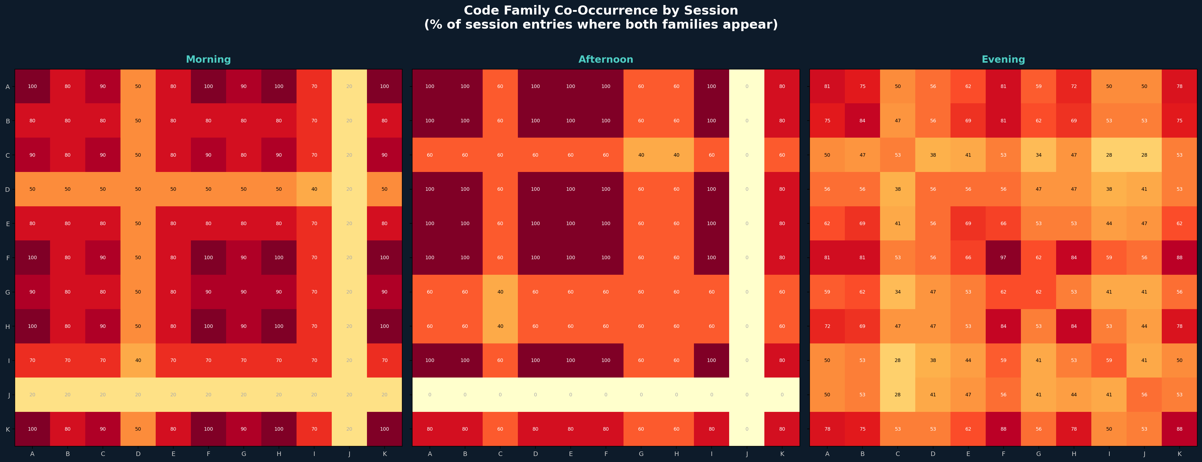

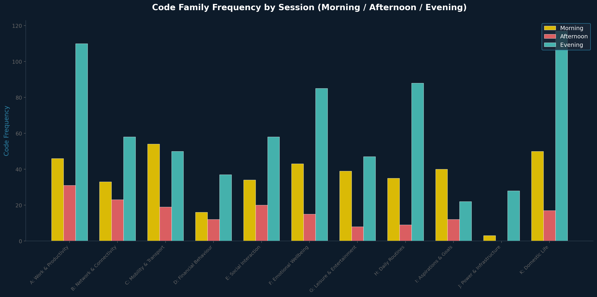

Morning
The morning session is dominated by H (Routine), K (Domestic), and A (Work). Respondents wake between 4:30 and 8:00 AM, pray, do house chores, cook, bathe, and prepare for work. The phone is used primarily as a utility (alarm, torch, time check) rather than for business. Emotional codes are generally positive (prayer, happiness, energy). The key tension is the race to complete domestic duties before leaving for work.

Afternoon
The afternoon is the peak business period. A (Work) and B (Network) dominate as respondents attend to customers, make calls, confirm payments, and manage their businesses. J (Power) peaks here because this is when phones run out of charge after a full morning of use without access to electricity. F (Emotional) codes shift negative — frustration, stress, and anxiety replace the morning’s optimism.

Evening
The evening belongs to G (Leisure), E (Social), and K (Domestic). Respondents close from work, cook dinner, choose clothes for tomorrow, and finally have time to relax. Phone usage shifts to entertainment: TikTok, comedy, movies, Instagram, music. Social calls to friends and family peak here. This is the only session where respondents report "escape" and "relaxation."

5. Respondent × Code Family Distribution
