**ADDIDAS SALES ANALYSIS: 2020-2021 REPORT**

**INTRODUCTION**

Adidas is a global clothing brand with products sold through various retail outlets worldwide. This report focuses on sales performance across retail stores in the United States. The goal is to uncover trends in revenue, customer purchase preferences, and regional performance across the 2020–2021 period.

**Objectives**

My objective is to analyze the revenue patterns, sales trends, and evaluate the performances of different products, customer preferences, regional performances.

**Problems being addressed**

My goal is to provide answers to the following questions;

1. Which product performed well in revenue and profit generation?
2. Which region generated the most revenues in sales?
3. The retailer with the most sales.
4. Which products was purchased most in units.
5. Which sales method contributed highly to revenue
6. The states with outstanding sales performance.

**Stakeholders**

The CEOs, sales and marketing team, inventory management, and the finance department at Addidas and retailer representatives across the country.

**Industry type**

This dataset of a global brand sold in different retail stores.

**Story of the data**

The dataset contains product sales information (name, category, price), purchase dates, units sold and regions.

**Success to the company**

Generating more revenues and improving customer loyalty.

**DATA PROCESSING AND CLEANING**

**Data structure**

* Data volume is 13 columns and 9648 rows.
* The data contains sales information spanning from 2020 to 2021
* Each record of sales includes product details, quantity, total revenue, region, profits, retail stores.

**Data cleaning**

* I removed duplicated entries to ensure each record is unique which improved the accuracy of the analysis
* I removed empty cells and replaced some where appropriate
* I standardized each column headers to ensure consistency and uniformity.
* I formatted the dataset into a standard excel table to improve navigation and sorting during analysis
* I applied consistent font styles and colors for better readability and clarity.

**Key variables in the dataset**

* **Product:** The different brands sold across the various retail stores.
* **Total sales:** This column shows the total revenue from each sale.
* **Unit price:** Contains the selling price for each product.
* **Payment method:** The payment method used for each sale.
* **Retailer:** The various retailers.
* **Profits:** The profits made from each sale.

**Data splitting**

The columns were split into two categories-Independent and Dependent values

1. **Category one-Independent values:**  These are data that do make sense on their own without depending on any data. They include product name, region, retailer store, date.
2. **Category two-dependent values:** These are values that do not make sense on their but depend on independent values to make sense. For example, revenue, unit price, unit sold, profits.

**PRE-ANALYSIS**

This chapter includes my preliminary observations and insights before I did any statistical analysis.

**Potential observations**

* Some states have more retail stores than others and tend to have higher sales in return.
* Certain products contributed to the overall revenue during this period indicating the products needs to be monitored closely.
* Certain products were purchased more indicating product preference.
* Certain regions have more states than the other and hence will have more sales.
* Sales tends to increase in 2021.

**Potential recommendations**

* Consider expansion to regions with lower sales to create more outlets and presence
* The region with most revenue generation should can be considered to house the sub-headquarters.
* The products with the most purchase indicate its high demand rate and should be stocked regularly so as not to lose customers due to unavailability of products.
* The products with lower purchase rate can be paired with higher purchased ones as complementary products or consider price reductions to encourage purchase.
* The products with more revenue generation stocking should be monitored carefully to ensure its constant availability.

**IN-ANALYSIS OBSERVATIONS**

**Top products by sales**

* Men’s street footwear generated a total of $208.8m in sales making it the top performing product
* Women’s apparel followed with $179m. Men’ athletic footwear generated $153.7m taking the 3rd spot.
* Women’s street footwear, Men’s apparel and women’s athletic footwear generated $128m, $123.7m and $106.6m respectively.

**Recommendations**

* These high-revenue products should be prioritized for stock replenishment, marketing, and trend analysis.

**Sales trends**

* In 2020, Q1 made $48.9m in sales, which increased to $50.4m in Q2. Q3 made $55.3m and dropped to $27.5m in Q4.
* In 2021, Sales skyrocketed to $140.5m in Q1 and another increase to $177.2m in Q2. It the increased to $210m in Q3 and then dropped to $190.1m

**Recommendation**

* Observe the reasons for sales drop in Q4 and implement strategies to improve sales in the coming year.

**Sales by region**

* West region generated the most revenue from sales with a total of $269.9m making it the best performing region.
* The northeastern region generated $186.3m taking the second spot
* Southeast, Southern, and the Midwestern region had a total of $163.2m, $144.7m and $135.8m respectively.

**Recommendations**

* The western region looking like a perfect location for targeted promotions.
* Regions with lesser sales can be due to lesser stores an advertisement can be recommended.

**Sales by state**

* New York had the highest sales with $64.2m toping the best performing states.
* California had a total of $60.2m and Florida had $59.3m taking the 2nd and 3rd spot respectively.
* Texas and South Carolina had a lesser sale of $46.4m and $29.3m respectively amongst the top 5 best performing states.

**Recommendations**

* Focus state-level promotions in New York, California, and Florida. These states have proven strong demand and should remain inventory and logistics priorities.

**Top 5 products by units sold**

* Men’s street footwear was the most sold products with 593.3k units sold. Men’s athletic footwear came second with 435.5k units sold while 433.8k units was sold taking the 3rd spot.
* Women’s athletic footwear and Men’s apparel had just 317.2k and 306.7k units sold respectively.

**Recommendation**

* Increase the production of Men’s Street footwear due to higher demand.
* Other products with lesser products can be advertised more or consider pair sales.

**Sales by retailers**

* West gear stores had a larger sale of $243.0m sales across all branches in the country making it the best performing retailer
* Foot locker generated $220.1m in sakes taking the 2nd spot while sports direct had $182.5m in the 3rd spot.
* Kohl’s, amazon, and Walmart had $102.1m, $77.7m and $74.6m in sales respectively.

**Recommendations**

* Provide a form of promotion for top performing retailers.

**DASHBOARD**

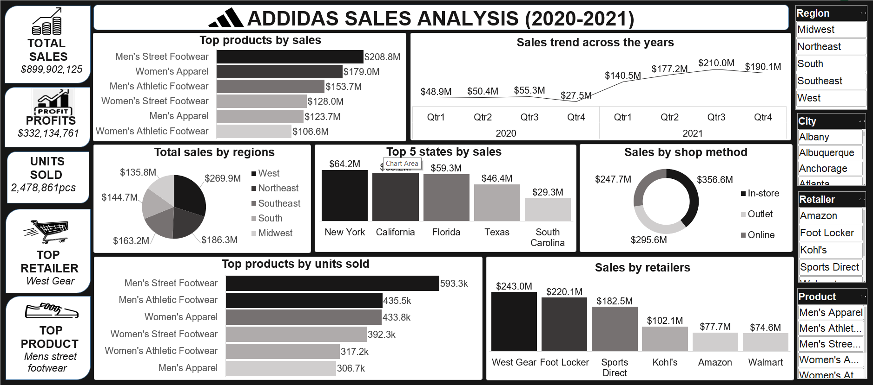

**FINAL OBSERVATIONS AND INGHTS**

* Footwear and apparel lead both in unit sales and revenue, with men’s products showing higher demand overall.
* Sales increased significantly from 2020 to 2021, highlighting business recovery and consumer interest.
* The Western region and large urban states (NY, CA, FL) are consistent revenue drivers.
* Some regions remain underutilized, likely due to limited retail presence.
* Retailers like West Gear Stores and Foot Locker play a significant role in overall performance.

**DATA-DRIVEN RECOMMENDATIONS**

**Product Sub-Categories**

* These high-revenue products should be prioritized for stock replenishment, marketing, and trend analysis. Promotional efforts should emphasize these high-ticket product categories through bundled deals or flash sales, especially in tech-savvy regions.
* Lower-performing products could be paired with bestsellers encourage add-on purchases and improve turnover.

**Sales growth**

* Investigate causes behind Q4 sales decline—could be seasonal factors or supply chain issues. Plan early campaigns to sustain Q4 performance.

**Region**

* Prioritize marketing and promotional efforts in the Western region. Consider increasing retail presence in regions with lower sales.

**State-level sales**

* Focus state-level promotions in New York, California, and Florida. These states have proven strong demand and should remain inventory and logistics priorities.

**Product unit sales**

* Increase production for high-demand products. Products with lower unit sales should be supported with targeted campaigns or promotional bundles.

**Retailers**

* Continue strong partnerships with top-performing retailers. Offer performance-based incentives to motivate even higher sales volumes.

**Conclusion**

The Adidas sales performance from 2020 to 2021 shows a strong upward trajectory, especially in 2021. High-demand products like men’s footwear and women’s apparel are driving both revenue and volume. Certain regions and states consistently outperform others and should be the focus of marketing and logistics efforts. By acting on the insights from this report—particularly in inventory planning, regional expansion, and retail partnerships—Adidas can further strengthen its market position and drive continued growth.