THE UNIVERSITY OF DA NANG
VNUK INSTITUTE FOR RESEARCH AND EXECUTIVE EDUCATION
Introduction to Human-Computer Interaction
Final Project Report
Opportunities
A note-taking app for mobile and web
Capture fast. Organize clearly. Find it again.
Trần Ngọc Quân · Student ID [Student ID]
Ngô Hoàng Nhật Khang · Student ID [Student ID]
Class [Class]
Lecturer: Nguyen Thi Diem Chi
Submitted [submission date]
Table of Contents
Part 1: Essay 3
I. Brief 3
Background 3
A. Project 3
B. Brand 3
C. Client 3
D. Project deliverables 3
E. Budget 3
F. Brand background 3
G. Target audience 3
H. Coverage 4
I. Timing 4
J. Description 4
K. Objective 4
II. Analyze 5
A. Scenarios 5
B. Persona 5
C. Sympathy map 8
D. Feature list 8
III. Produce 10
A. Flow chart 10
B. UX wireframe 18
IV. Test cases 21
Usability test plan 22
Heuristic self-evaluation 22
Part 2: Prototype 23
I. Mobile 23
Visual design 23
App map 23
Key screens 24
Changes after lecturer review 28
II. Web 29

Part 1: Essay

I. Brief

Background
- People keep notes in many places at once: a phone, a laptop, a paper notebook, chat apps. When they need one note, they lose time searching across all of them.
- Handwriting, screenshots and scanned pages cannot be searched, and typing is slow when someone is busy or on the move.
- People also forget deadlines, lose work when offline, and give up on tools that demand Markdown or LaTeX knowledge up front.
- Opportunities brings text, voice, photos and scans, checklists, tables and formulas into one note app. The guiding question: how might we help people capture, organize and find notes again, without having to learn Markdown first?

A. Project
Opportunities: a Markdown-first, offline-first note-taking application for mobile and web.

B. Brand
Opportunities. The logo is a violet cube (#A882FF) on charcoal.

C. Client
This is a course project with no external client. It is designed for students, tutors and knowledge workers who take notes every day.

D. Project deliverables
- Brand introduction and logo
- Research: scenarios, two personas, sympathy map
- Flow charts and UX wireframes
- Design system with Dark and Light themes
- Interactive mobile prototype and web prototype in Figma
- Test cases and a usability test plan
- This report and presentation slides

E. Budget
N/A (academic project).

F. Brand background
- Created in 2026 by Trần Ngọc Quân and Ngô Hoàng Nhật Khang for the VNUK Human-Computer Interaction module.
- Motto: “Capture fast. Organize clearly. Find it again.”
- Visual language: charcoal neutrals with one violet accent, the Inter typeface and line icons, inspired by Obsidian.

G. Target audience
- Primary: students and tutors with everyday tech skills, who capture on a phone and need to find things quickly.
- Secondary: power users such as developers and researchers, who write Markdown and LaTeX and want to own their data.

H. Coverage
Vietnamese-speaking users first, with Vietnamese as the default interface language and English as the second. Target platforms are iOS 16+, Android 10+ and web (Chrome, Edge, Safari, Firefox).

I. Timing
- 27 October 2026: version 5, full redesign of the mobile prototype.
- 1 November 2026: version 6, lecturer feedback applied.
- Final submission: [submission date].

J. Description
The core flow is capture, organize, find, act on reminders, then share or export. One editor serves both people who only tap buttons and people who type Markdown or LaTeX. Mobile navigation has five items: Notes, Review, Create (+), Reminders and Profile.

K. Objective
- Give one place for every kind of note, so nothing is scattered across apps.
- Make any note easy to find again, including text inside photos and scans.
- Keep the app simple for casual users while staying powerful for Markdown and LaTeX users.
- Protect user data through auto-save, offline work, a 30-day trash and version history.

II. Analyze

A. Scenarios
Scenario 1: a day with Trần Minh Thư. Each step maps to a real screen in the mobile prototype.
Step | Situation | What Thư does | Screens
1 | 07:55, on the bus | Taps + then Voice. Speech is written into a meeting note as she talks. | 2.1, 3.2
2 | 09:40, in class | Scans the whiteboard. The app detects the edges and captures two pages. She checks the recognized text and fixes two flagged words. | 3.3, 3.4
3 | 09:45, writing a formula | Types \fr and picks Fraction from the suggestions, without leaving the editor. | 2.8
4 | 12:30, no network | A banner says she is offline. Her note stays on the device and changes wait to sync. | 7.1
5 | 17:30, tuition reminder | A lock screen notification appears. She opens Reminders and marks room 3 as collected. | 5.3, 5.8
6 | 20:30, on her laptop | A note was edited in two places. She compares the versions and keeps both, so no line is lost. | 7.2, 7.4
7 | 21:00, sharing with the group | Opens the note ⋯ menu, confirms a public link for 7 days, and sends the QR code. | 2.9, 6.1, 6.2
8 | 23:00, revising for the exam | Searches “persona” and finds it inside this morning’s scan, reads in Focus mode, then reviews flashcards. | 4.2, 2.31, 2.11, 11.1

Scenario 2: Phạm Đức Anh writes a thesis note.
Step | Situation | What Đức Anh does | Screens
1 | Starting a thesis note | Taps + then Note, and switches to Markdown source from the mode box. | 2.1, 2.2, 2.31, 2.5
2 | Writing an equation | Types LaTeX with autocomplete and sees it rendered in place. | 2.8
3 | Linking ideas | Types [[ to link a paper summary, using the suggestion list. | 2.7
4 | Grouping thesis notes | Opens the ☰ menu, manages folders, and creates a smart folder filtered by tag. | 1.28, 4.4, 12.1, 12.4
5 | Sending to the advisor | Exports the note as PDF with the chosen page size and text size. | 6.3, 6.9
6 | Going back to an old draft | Opens version history and restores an earlier version without losing the current one. | 7.3, 7.7

B. Persona
We created two personas: a primary everyday user and a power user. Together they cover the range from people who only tap buttons to people who type Markdown.
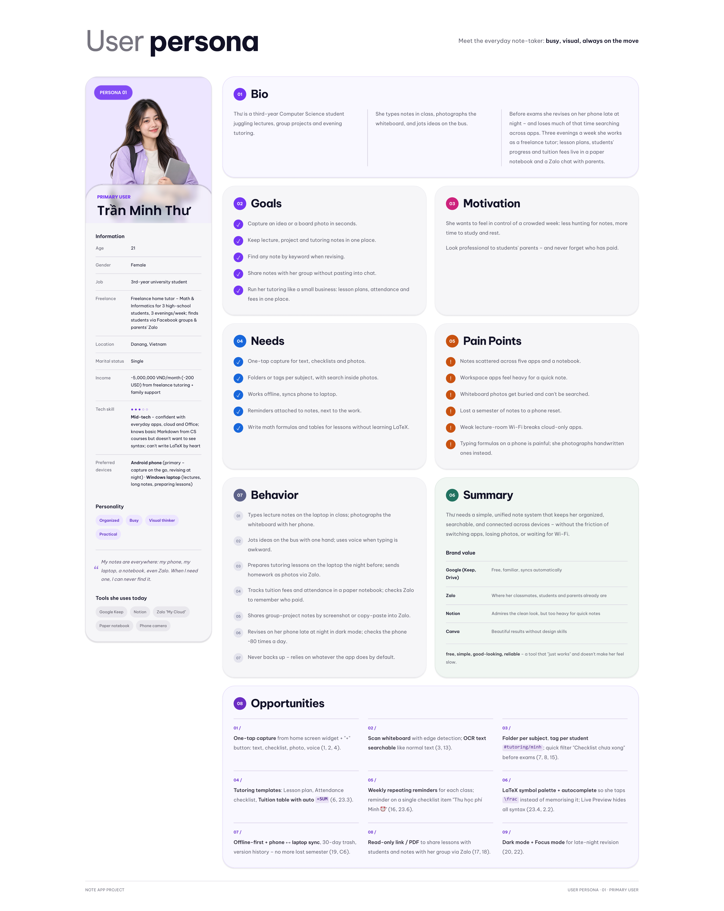
Figure 1. Persona 1: Trần Minh Thư, primary user
Trần Minh Thư, 21 | Summary
Goals | Capture an idea or board photo in seconds. Keep lecture, project and tutoring notes in one place. Find any note by keyword when revising.
Pain points | Notes scattered across five apps and a notebook. Whiteboard photos cannot be searched. Weak lecture-room Wi-Fi breaks cloud-only apps. Typing formulas on a phone is painful.
What Opportunities gives her | One-tap capture, scan with searchable text, offline work with sync, reminders next to the work, tutoring templates.
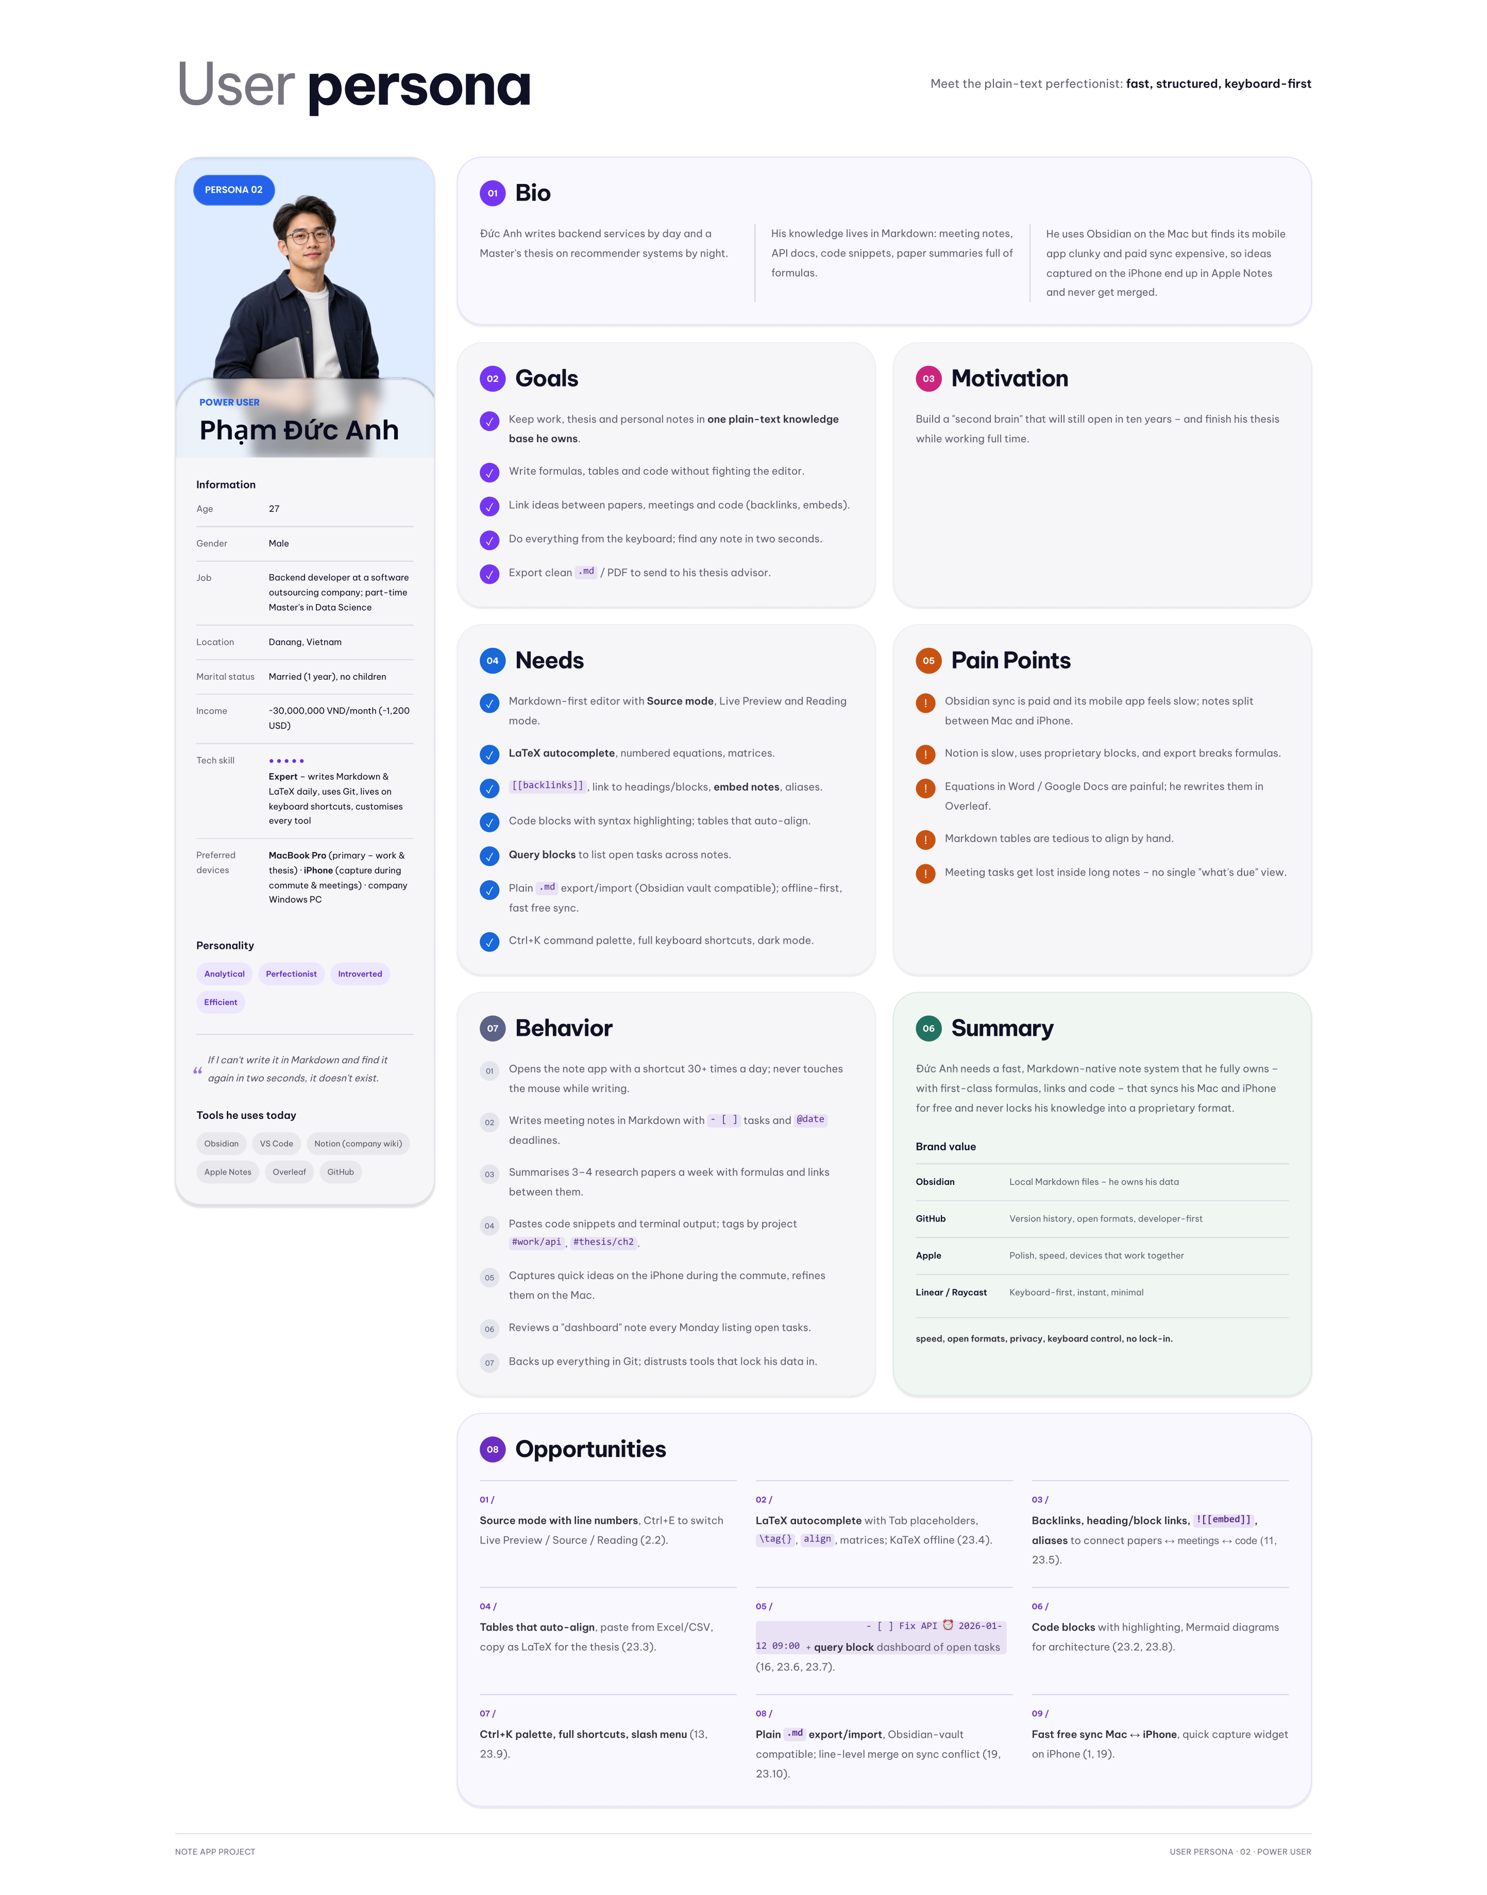
Figure 2. Persona 2: Phạm Đức Anh, power user
Phạm Đức Anh, 27 | Summary
Goals | Write formulas, tables and code without fighting the editor. Link ideas with backlinks. Find any note in two seconds. Export clean Markdown or PDF for his advisor.
Pain points | Paid sync and a slow mobile app in his current tool. Export breaks formulas in other tools. Meeting tasks get lost inside long notes.
What Opportunities gives him | Markdown source mode, LaTeX autocomplete, wiki-links, plain .md export, smart folders, keyboard shortcuts on web.

C. Sympathy map
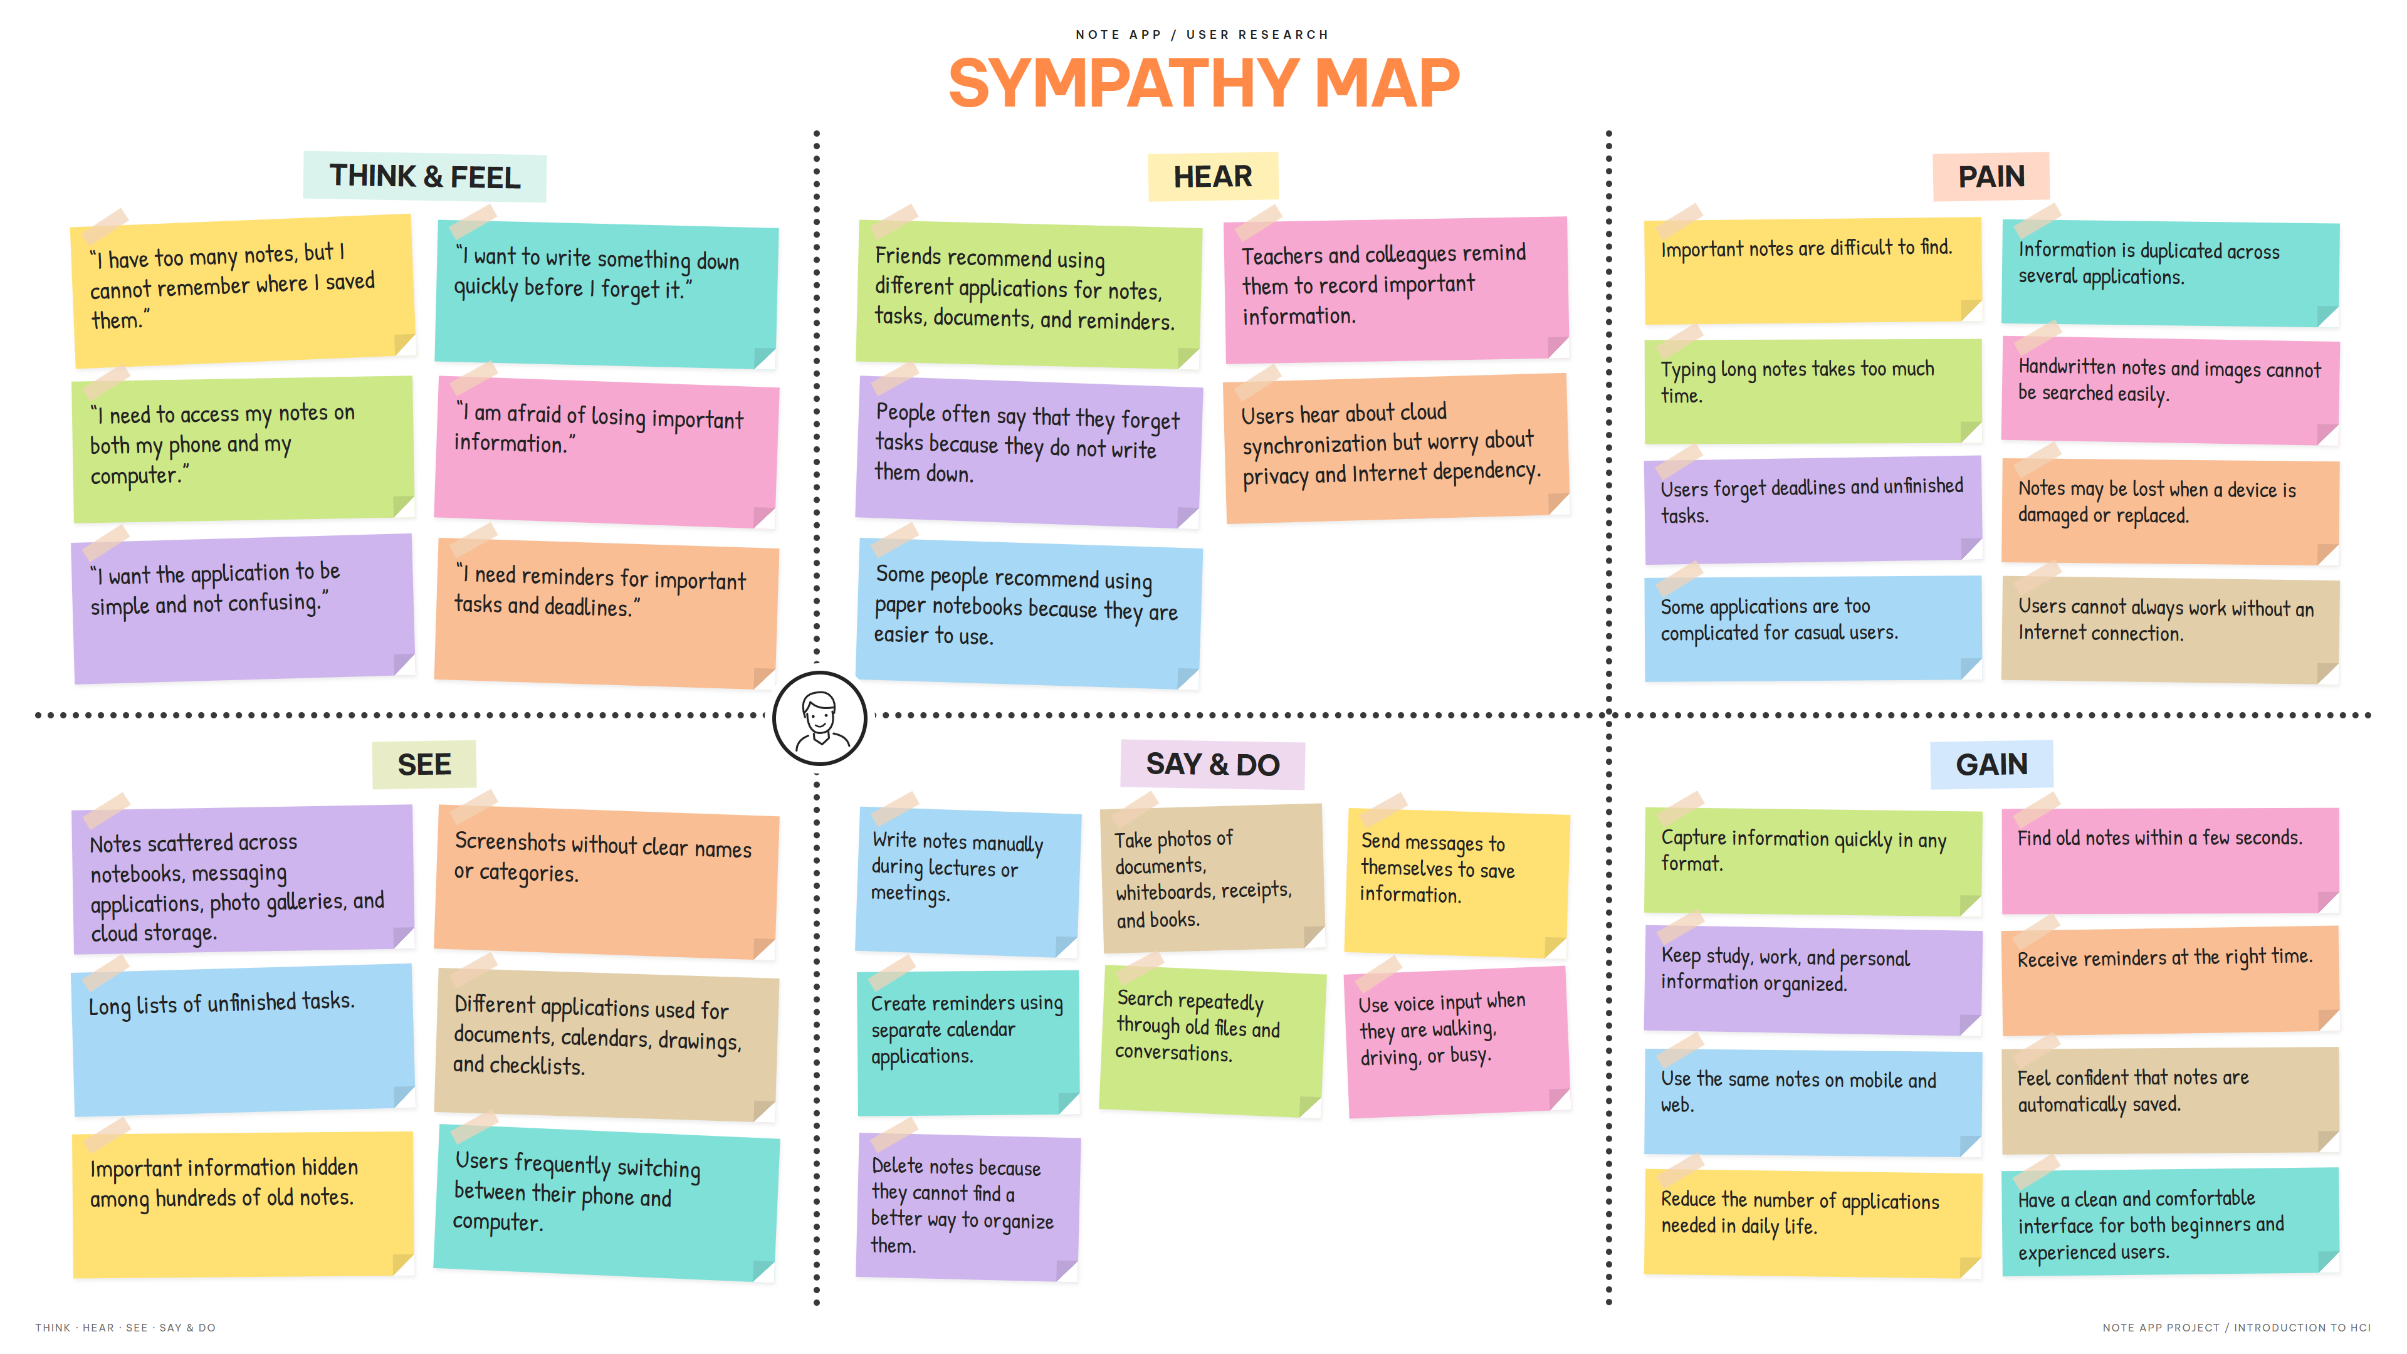
Figure 3. Sympathy map
Key insights from the map:
- Important notes are hard to find, and people switch between many apps to look for them.
- Typing long notes takes too much time, so people want to capture in any format.
- People forget deadlines and unfinished tasks, so reminders must sit next to the work.
- Some apps are too complicated for casual users, so advanced features must stay out of the way.

D. Feature list
Functional requirements
Area | Features
Getting started | Sign in, sign up, password recovery, guided tour, sample note, help and syntax cheat sheet.
Browse | Grid, List, Calendar, Kanban and link graph views. Sort, filter and quick chips. Pin, move, color, remind, duplicate, share, archive, delete. Multi-select.
Write | Preview, Markdown source, Read only and Focus modes. Slash menu, wiki-links, formula suggestions. Note color, tags and custom properties. Find in note. Lock note.
Capture | Note, checklist, voice, photo, scan, drawing, template. Scan images or PDFs from the device. Text recognition with review. Attach PDF or DOCX.
Find and organize | Search including text inside photos. Nested folders, smart folders, tags, attachment library.
Remind and revise | Reminders by due date, snooze, notifications, quiet hours. Flashcard review with spaced repetition.
Share and sync | Public link with QR, revoke. Export PDF and Markdown. Offline work, conflict resolution, version history.
Safety and settings | Undo, 30-day trash, archive. Dark and Light themes, text size, paper style, language, note lock, devices, import and export.
Templates | Built-in templates, save a note as a template, edit, rename, duplicate, delete.

Non-functional requirements (design targets)
Category | Target
Performance | Open the app in 2 s or less. Open a note in 0.5 s or less. Search in 300 ms or less across 1,000 notes.
Offline | Everything works offline except first sign-in and creating share links.
Data integrity | Continuous auto-save, 30-day trash, no data loss on sudden close, full export as ZIP.
Security | HTTPS, passwords of 8 or more characters, revocable random share links, remote sign-out.
Accessibility | Touch targets of 48×48 px or more, WCAG AA contrast, labels or tooltips on icons, screen reader support, full keyboard use on web, never rely on color alone.
Compatibility | iOS 16+, Android 10+, the latest two versions of Chrome, Edge, Safari and Firefox. Vietnamese and English.

III. Produce

A. Flow chart
Diagram labels are in Vietnamese, matching the app interface. The full editable set is in the project’s draw.io file.
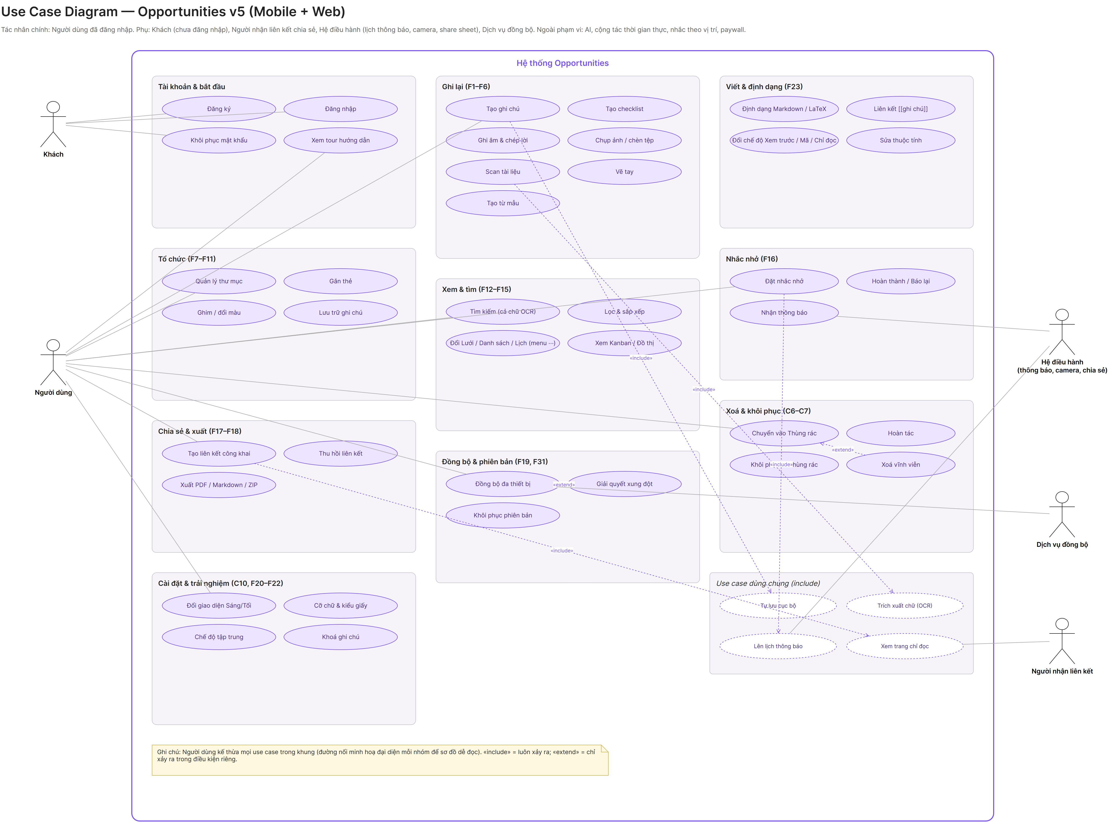
Figure 4. Use case diagram
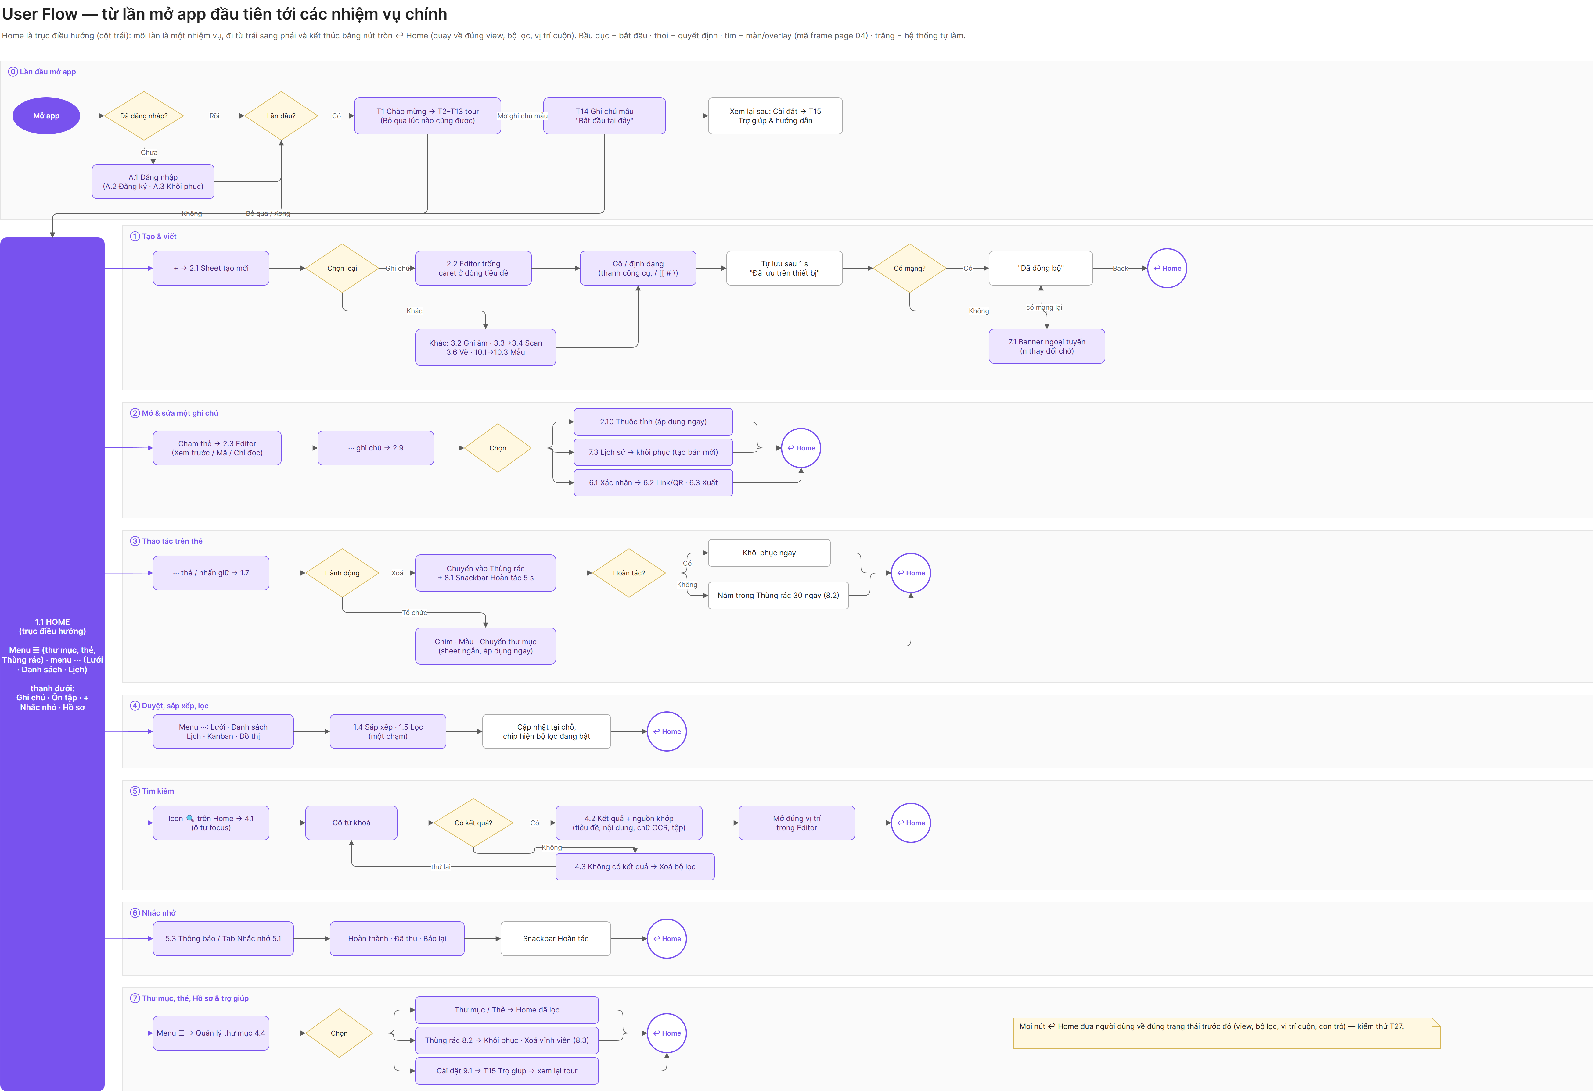
Figure 5. User flow, from first open to each main task
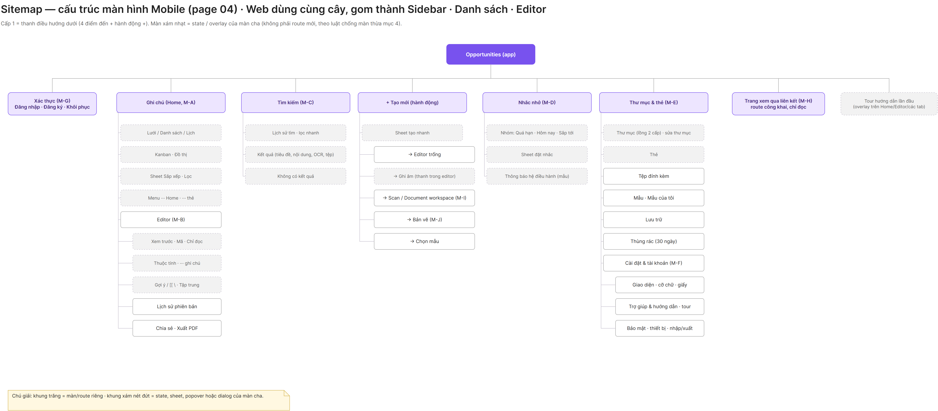
Figure 6. Sitemap of the mobile app
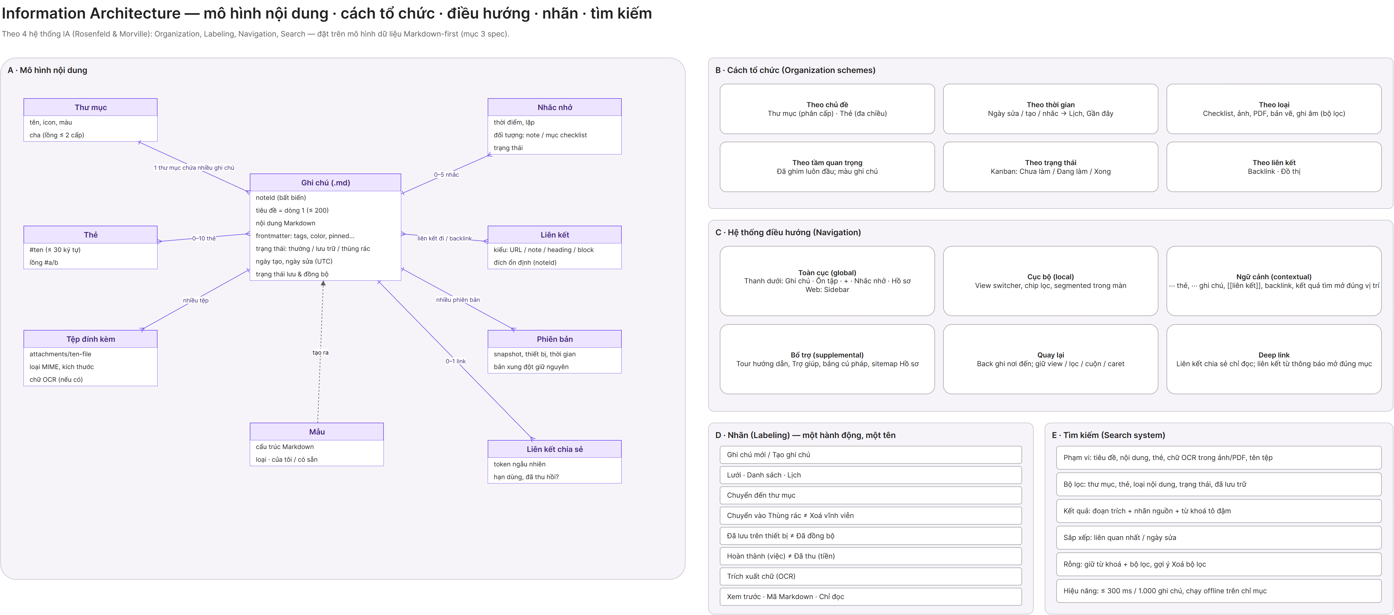
Figure 7. Information architecture
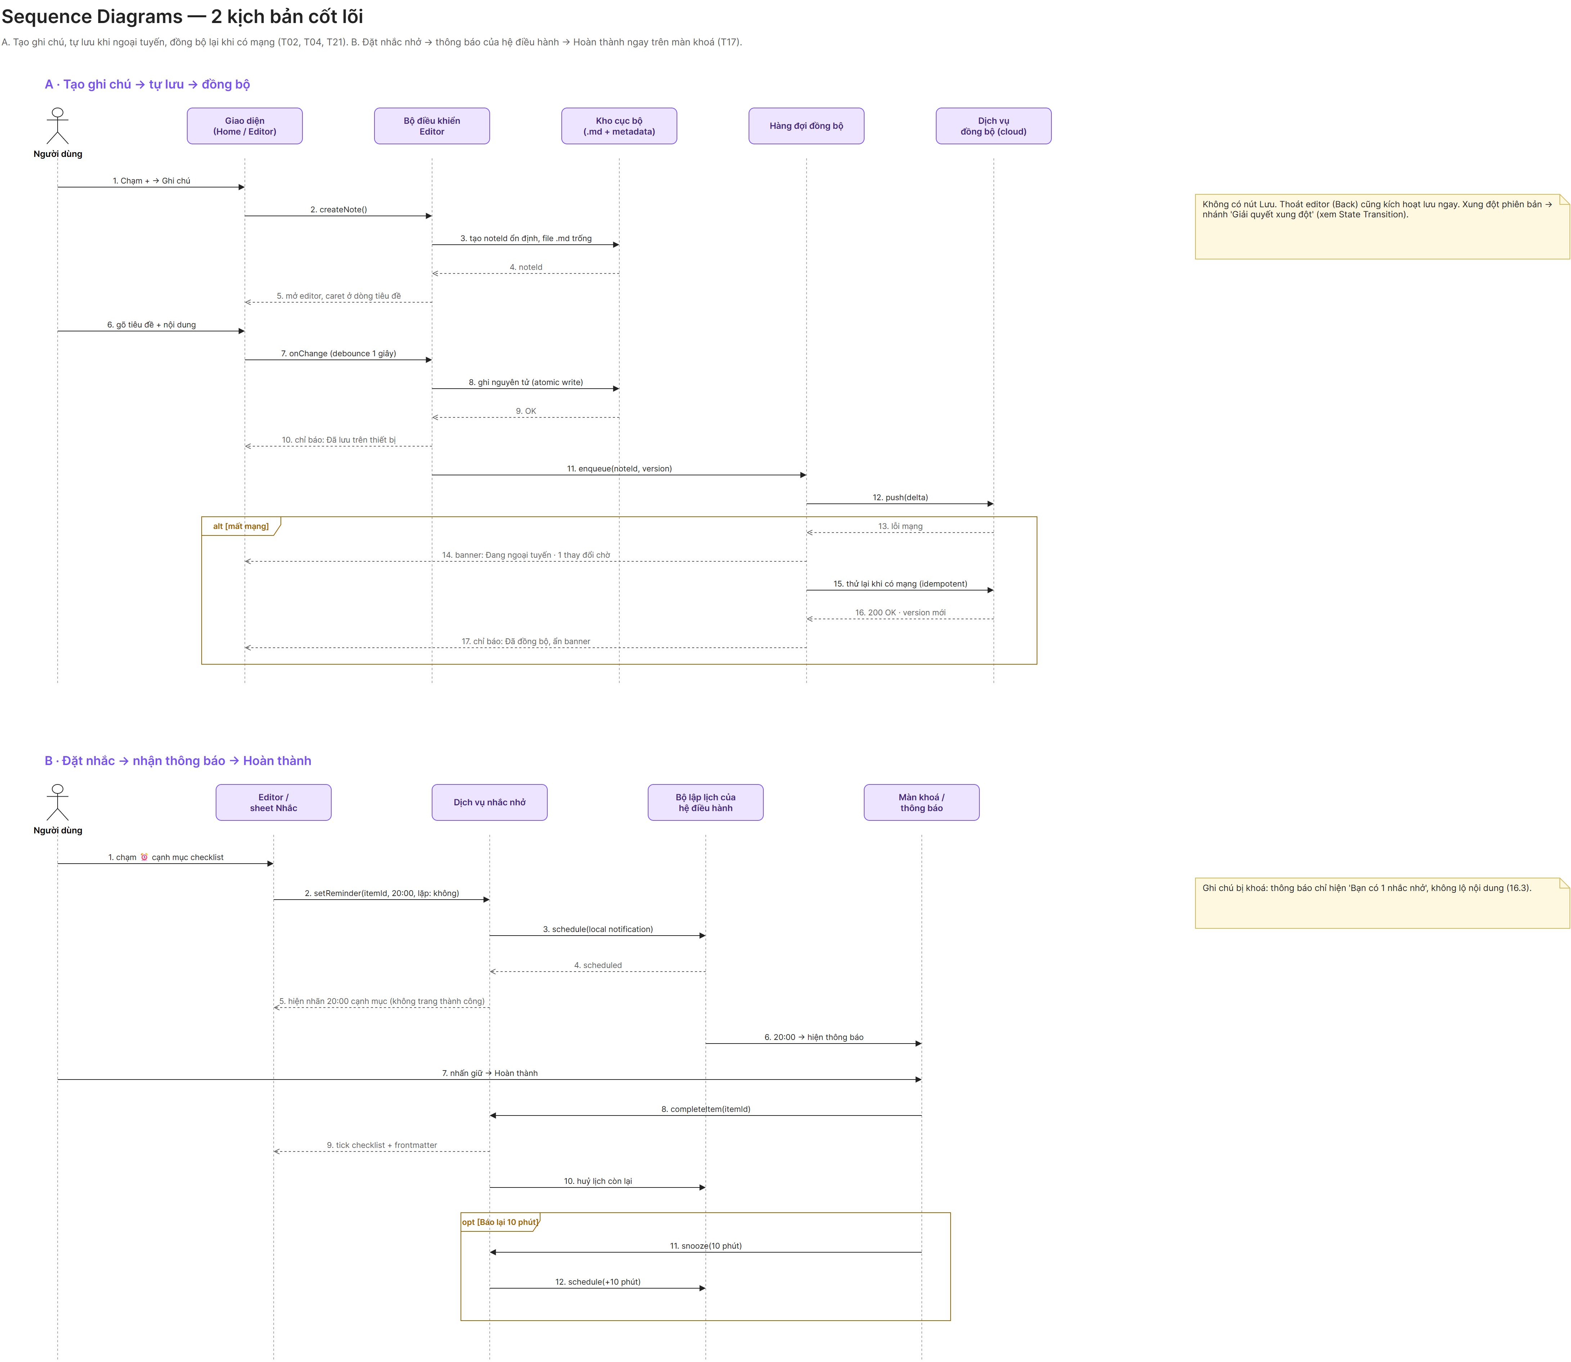
Figure 8. Sequence diagrams for two core scenarios
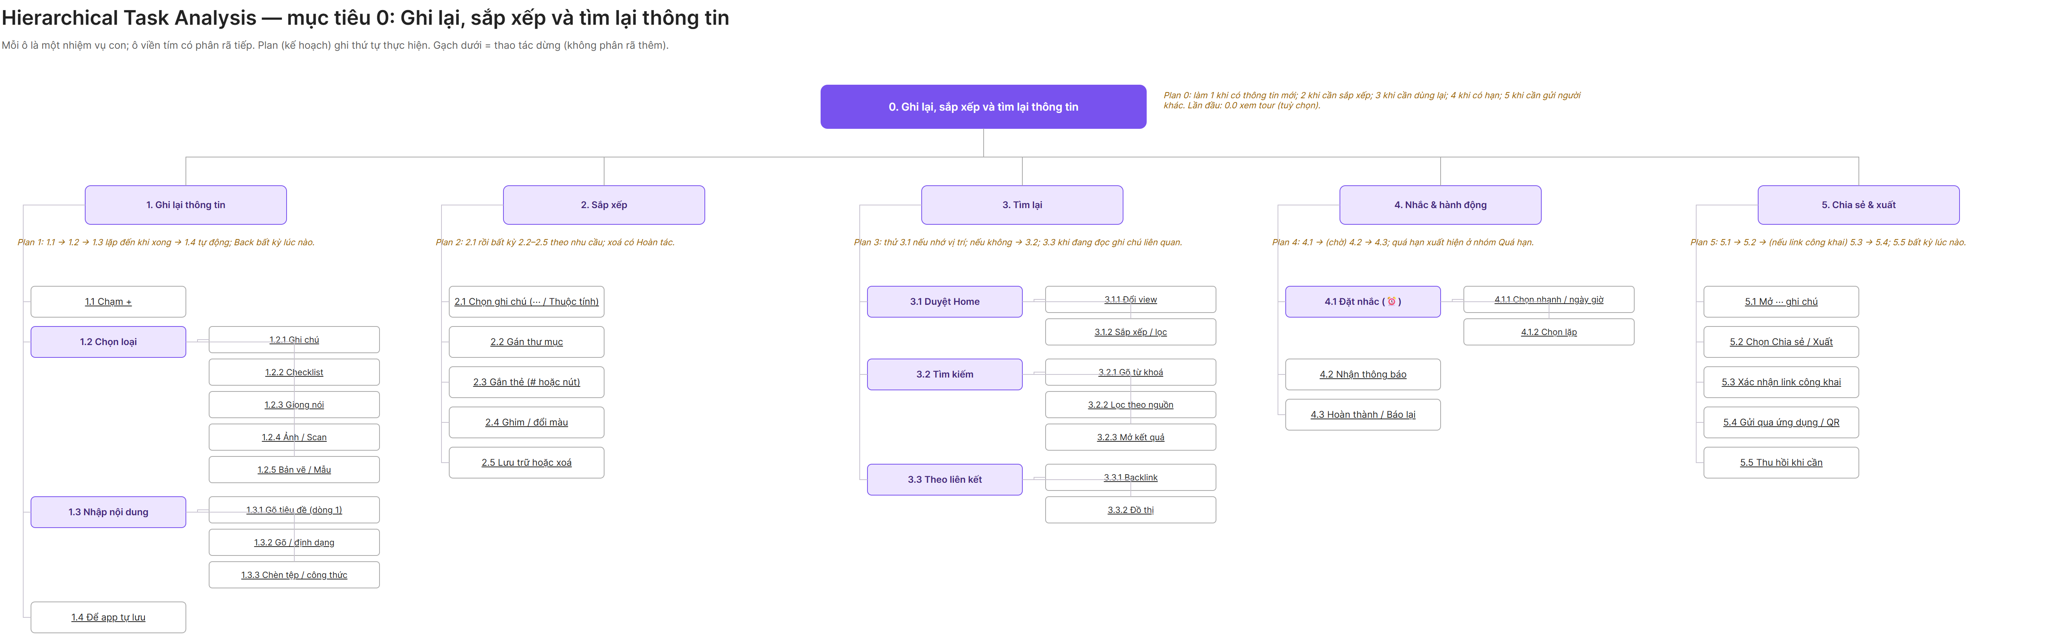
Figure 9. Hierarchical task analysis
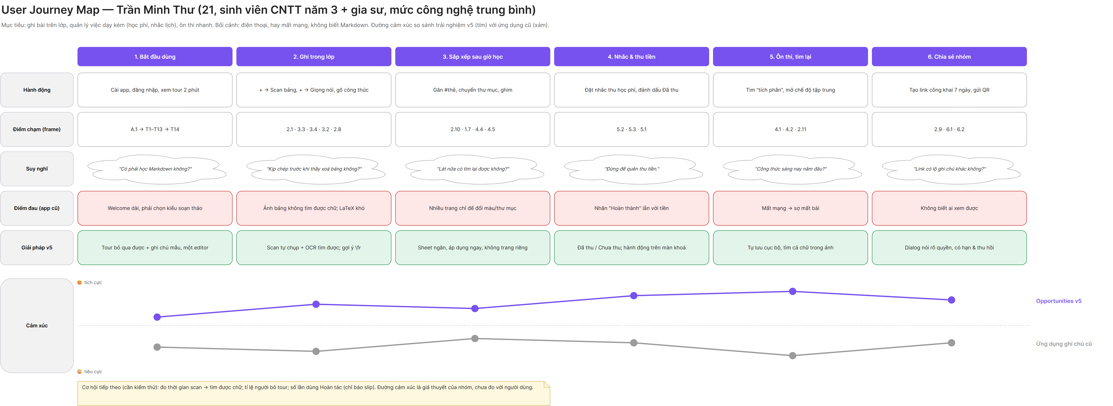
Figure 10. User journey map of Trần Minh Thư
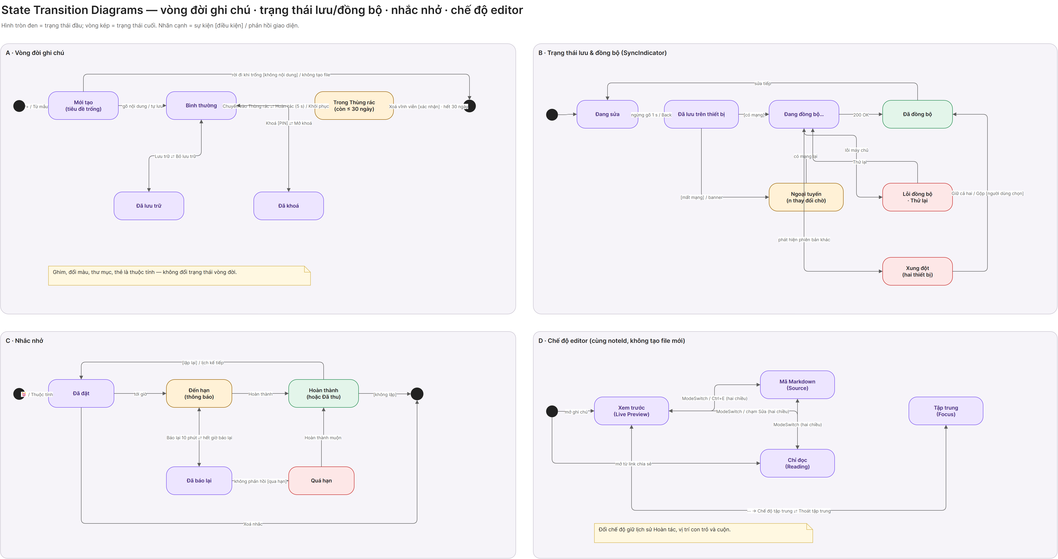
Figure 11. State transition diagrams

B. UX wireframe
Wireframes use gray blocks only, with no icons or real data, so the review stays on structure. Every screen in the main sections has one, each with a note on the HCI principle and the design decision. Below are the key screens, with the principle first and the decision second.
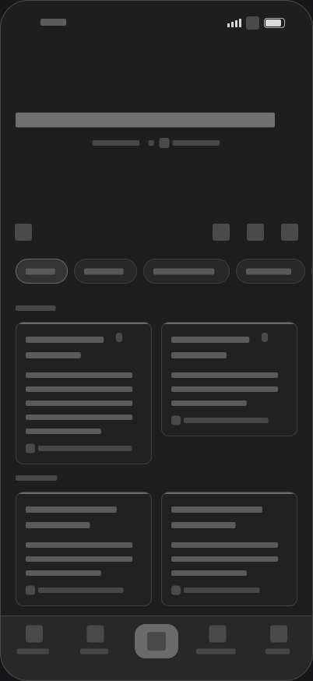  1.1 Home  Recognition over recall, minimal design  Spacious header, ☰, search and ⋯ in one row, quick chips, pinned notes first | 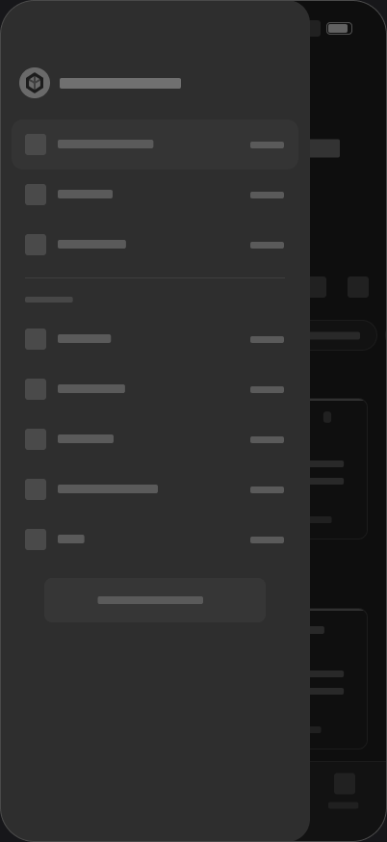  1.28 Side menu  Grouping by purpose  Secondary navigation moves into ☰ so Home stays clean | 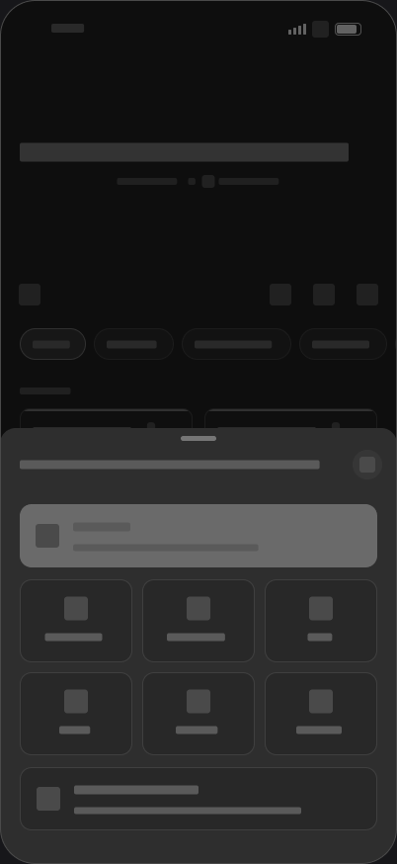  2.1 Create sheet  Fewer steps, large targets (Fitts’s law)  + is an action; Note is the main button, other tiles go straight to the tool
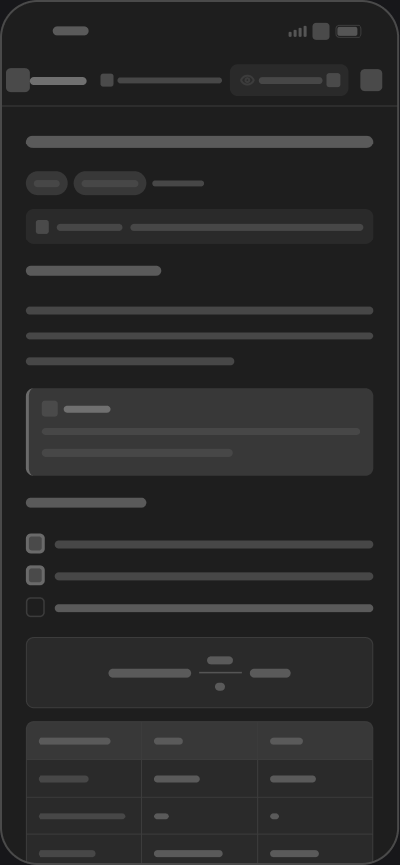  2.3 Editor  Content first  One editor; Markdown marks show only on the line with the caret | 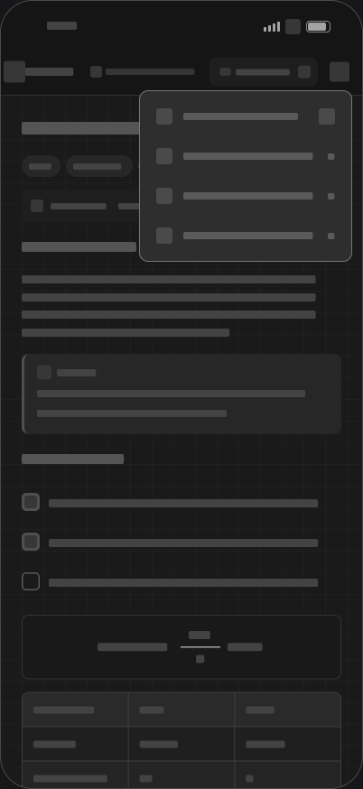  2.31 Mode dropdown  Grouping, recognition over recall  All four modes sit together in the mode box; a tick marks the current one | 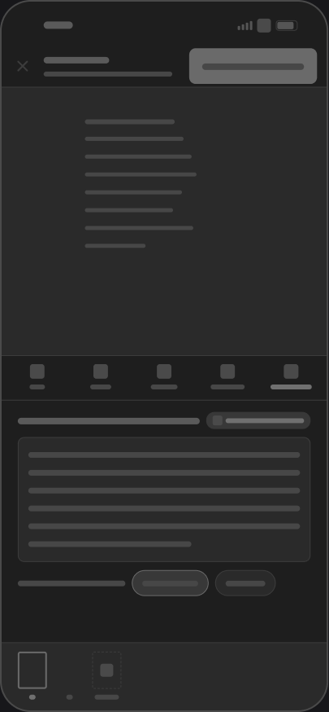  3.4 Text review  Error prevention  Review and fix recognized text; doubtful words are flagged; the original is kept
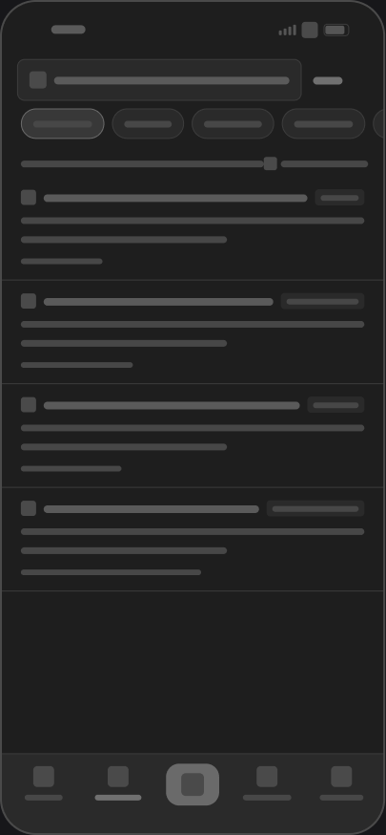  4.2 Search results  Visibility of why it matched  Labels show the match source: title, content, text in photo, file | 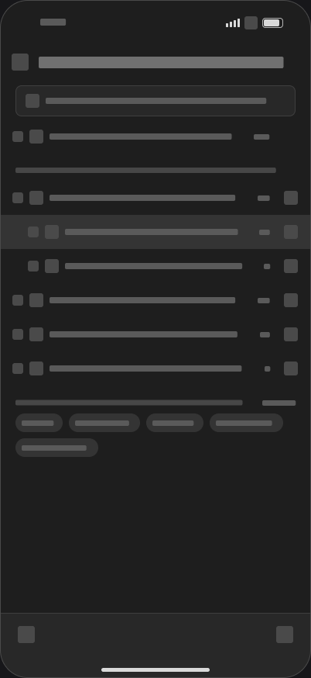  4.4 Folders  Clear hierarchy  Own screen like Apple Notes: search, nested folders, tags, new folder and note | 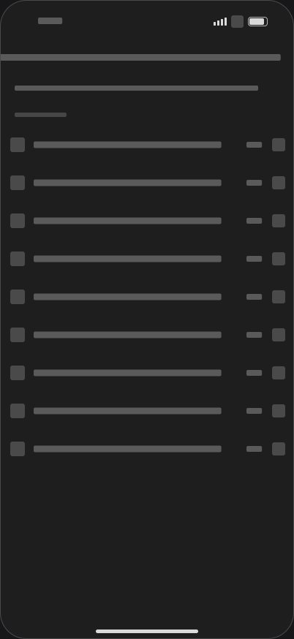  12.1 Smart folder filters  Safe defaults  Filter by tag, date or type; every filter starts off
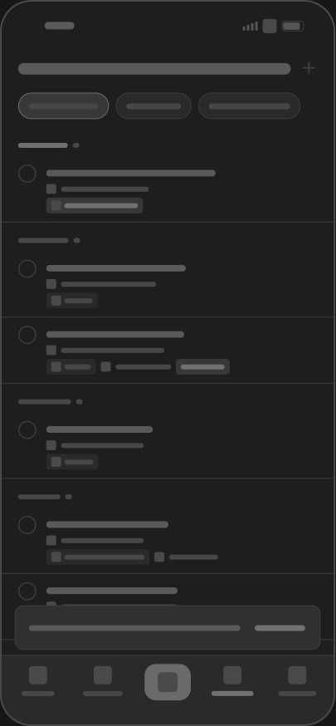  5.1 Reminders  Grouping by time  Overdue, today, tomorrow, upcoming, with wording that fits the task | 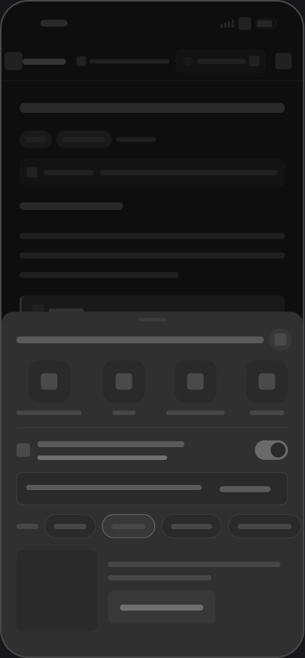  6.2 Share  User control  Link has an expiry and can be revoked; QR matches the link |   7.2 Conflict  No data loss, safe default  Compare two versions; Keep both is the default
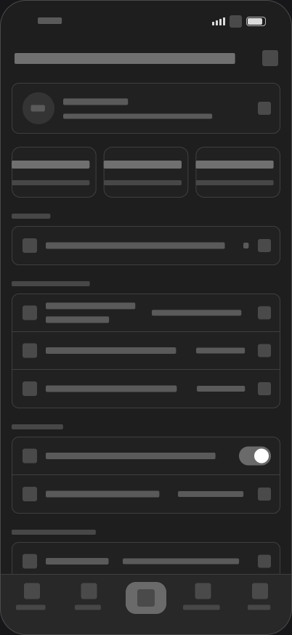  9.1 Profile  One grouped list  All settings on one scrolling screen, no separate page for a single switch | 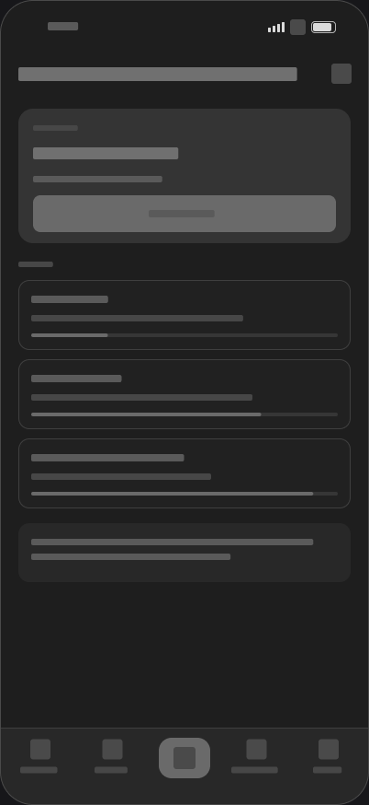  11.1 Review  One main action  Cards due today and a single Start button

IV. Test cases
These test cases describe the expected behavior of the design, and the prototype implements each path. They have not yet been run with real users, so no pass or fail results are reported here.
ID and feature | Precondition | Steps | Expected result
TC-01  Sign in | Valid test account | 1. Open the app.  2. Enter email and password.  3. Tap Sign in. | Home opens with no welcome pages.
TC-02  Sign-up validation | On sign-up screen | 1. Enter an invalid password.  2. Leave the field. | An inline error explains the problem before submit (A.2).
TC-03  Create a note | Signed in | 1. Tap +.  2. Tap Note. | Editor opens directly with the caret on the title (2.2).
TC-04  Auto-save | Note open | 1. Type text.  2. Wait 1 second.  3. Go back and reopen. | Text is still there. No Save button is needed.
TC-05  Change view | On Home | 1. Tap ⋯.  2. Tap List.  3. Tap ⋯ again. | Home shows List (1.2). The tick moves to List (1.6b).
TC-06  Editor modes | Note open | 1. Tap the mode box.  2. Tap Markdown source.  3. Open ⋯. | Source view opens (2.5). The ⋯ menu lists no modes.
TC-07  Scan a document | Camera allowed | 1. Tap +, then Scan.  2. Capture a page.  3. Review, then create. | A new note holds the scan and its text (2b.9).
TC-08  Scan from device | Image on the device | 1. Tap +, then Scan from device.  2. Pick an image.  3. Review the text and create. | Review appears before the note is created (12.7).
TC-09  Search text in a photo | A scanned note exists | 1. Tap search on Home.  2. Type a word from the scan. | The result opens the note and shows the match source (4.2).
TC-10  Smart folder | On Folders | 1. Tap New folder.  2. Make it a smart folder.  3. Turn on a tag filter, tap Done. | The smart folder appears in the list with a confirmation (12.4).
TC-11  Folder actions | On Folders | 1. Tap ⋯ on a folder.  2. Edit and save.  3. Tap ⋯, delete, confirm. | Each action ends on an updated list with a snackbar (4b.3, 4b.5).
TC-12  Reminder | On Reminders | 1. Tap +.  2. Fill in and save.  3. Open it and mark done. | It appears in the list, then moves to completed (5.7, 5b.8).
TC-13  Flashcard review | On Review | 1. Tap Start.  2. Rate each card.  3. Tap Back to Review. | Summary shows the ratings (11.5). Review shows nothing due (11.2).
TC-14  Share and revoke | Note open | 1. Open ⋯, then Share.  2. Confirm the public link.  3. Revoke it. | Link and QR appear (6.2). After revoking, the state updates (6.8).
TC-15  Export PDF | Note open | 1. Open ⋯, then Export.  2. Change page size.  3. Export. | Preview updates and the export is confirmed (6.10, 6.9).
TC-16  Offline and conflict | Same note edited on two devices | 1. Reconnect.  2. Open the conflict.  3. Tap Keep both. | Both versions are kept, with no text lost (7.4).
TC-17  Delete and restore | Note exists | 1. Delete the note.  2. Tap Undo, or open Trash from ☰.  3. Tap Restore. | The note returns to its original folder (8.5).
TC-18  Lock a note | Note open | 1. Open ⋯, then Lock.  2. Confirm. | The note is locked (2.29). Its content is hidden from search, widgets and notifications.
TC-19  Use a template | On the create sheet | 1. Tap Template.  2. Preview one.  3. Use it. | Editor opens with the template filled in (10.3).
TC-20  Settings and sign-out | On Profile | 1. Change the language.  2. Scroll down.  3. Tap Sign out. | The new value shows at once (9.15). Sign out returns to A.1.

Usability test plan
Method: 5 participants per persona, think-aloud, and a SUS questionnaire after the tasks. Any task under 80% success goes into the next design iteration. These are planned targets, not measured results.
Task for the participant | Persona | Success criterion | Target
Save this whiteboard photo so you can find it later | Thư | Note saved with text | 4 taps, 20 s or less
Find the note that mentions a word inside a photo | Both | Correct result opened | 3 actions, 10 s or less
Remind yourself to collect a fee tonight | Thư | Reminder set on the item | 4 taps or fewer
Insert a formula without typing code | Thư | Formula inserted correctly | 0 errors
Write the formula in source mode and export .md | Đức Anh | Valid .md with LaTeX | 60 s or less
You deleted a note by mistake. Get it back | Both | Note restored | 2 taps or fewer

Heuristic self-evaluation
This is our own review against Nielsen’s 10 heuristics, not a result from user testing. Severity: 0 none, 1 cosmetic, 2 minor, 3 major.
Heuristic | Evidence in the design | Severity
1. Visibility of system status | Sync indicator, offline and conflict banners, snackbars, loading skeleton | 0
2. Match with the real world | Paper grid, Trash, wording such as collected or not collected | 0
3. User control and freedom | 5-second undo, 30-day trash, non-destructive version restore | 0
4. Consistency and standards | Shared components, one name per action, same sheet structure | 0
5. Error prevention | Password check on leaving the field, confirmation for destructive actions, flagged OCR words | 0
6. Recognition over recall | Suggestions for [[, \ and #, visible filter chips, recent searches | 0
7. Flexibility and efficiency | Markdown and LaTeX for experts, buttons for beginners. Keyboard shortcuts exist on web only | 1
8. Minimalist design | Flat surfaces, one violet action per area, secondary actions in ⋯ and ☰ | 0
9. Help with errors | Specific messages with an action, such as retry or clear filters | 0
10. Help and documentation | Guided tour, sample note, help screen, syntax cheat sheet | 0

Part 2: Prototype

I. Mobile
Prototype link: Open the mobile prototype
Figma file: Page 04 · UI Prototype
The prototype has 297 screens in each of the Dark and Light themes. Named flows in the Figma side panel start from sign-in, sign-up, the guided tour and Home. The sun icon on Home switches theme.

Visual design
- Color: charcoal neutrals with one violet accent, plus semantic colors for success, warning and error. All colors come from shared tokens for Dark and Light.
- Type and icons: Inter, with line icons from the Lucide set.
- Resources: the layout language is inspired by the Obsidian UI kit. No other screens or content were copied.

App map
Section | Content | Screens
00 | Sign-in and first run | 3
01 | Entry and browse | 28
01b | First-run guided tour | 18
01c | Side menu ☰ | 5
02 | Create, write and organize | 30
02b | New note by type | 22
02c | Editor mode dropdown | 3
03 | Capture files, handwriting and voice | 14
04 | Search, folders and tags | 17
04b | Folder actions | 40
05 | Tasks, reminders and notifications | 9
05b | Reminder details | 20
06 | Share and export | 13
07 | Sync, conflict and version recovery | 8
08 | Delete, undo and restore | 10
09 | Profile, settings and writing comfort | 21
10 | Templates | 10
10b | Built-in and saved templates | 14
11 | Flashcard review | 5
12 | Smart folders and scan from device | 7
Total | 20 sections | 297

Key screens
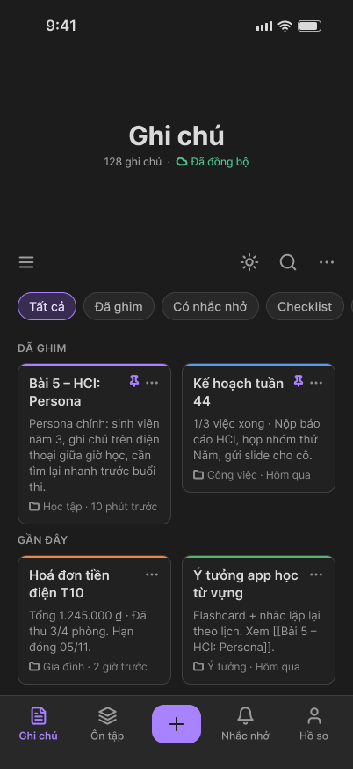  1.1 Home | 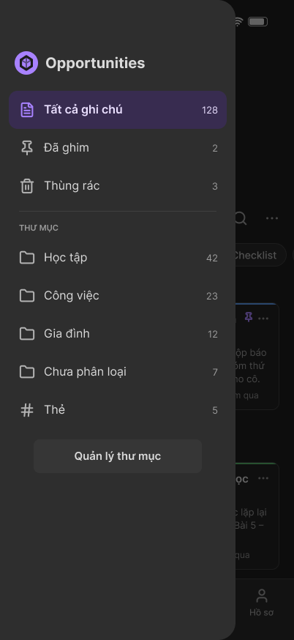  1.28 Side menu | 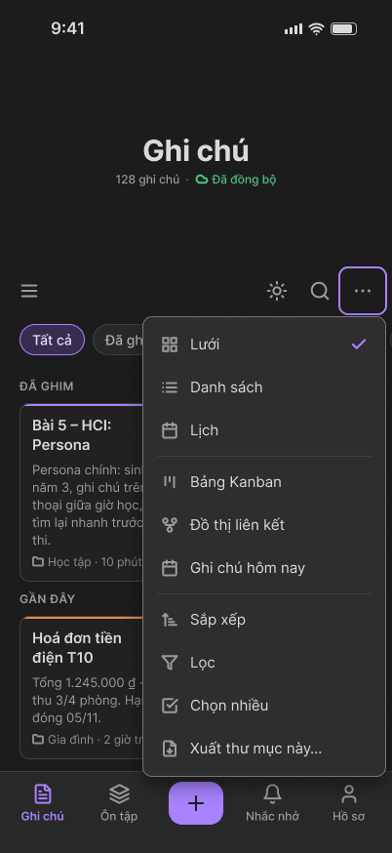  1.6 ⋯ menu
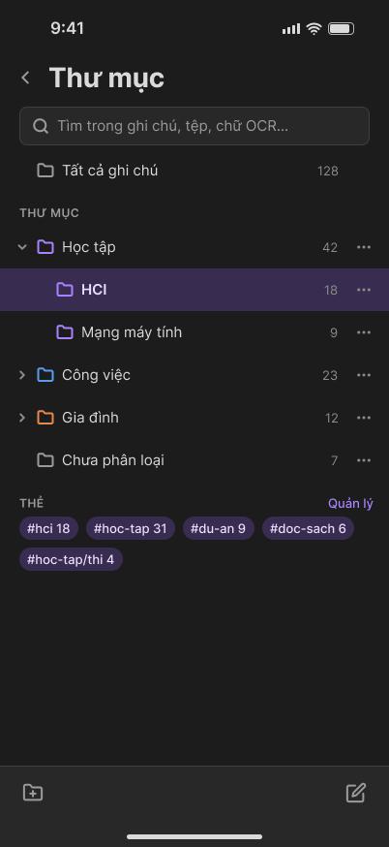  4.4 Folders | 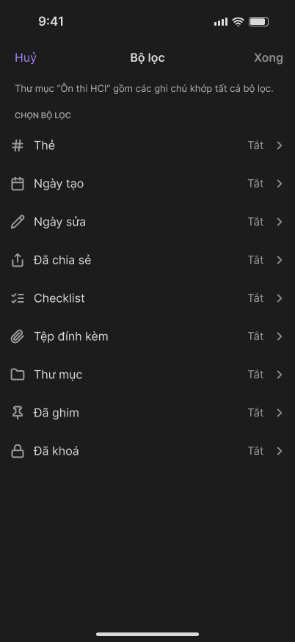  12.1 Smart folder filters | 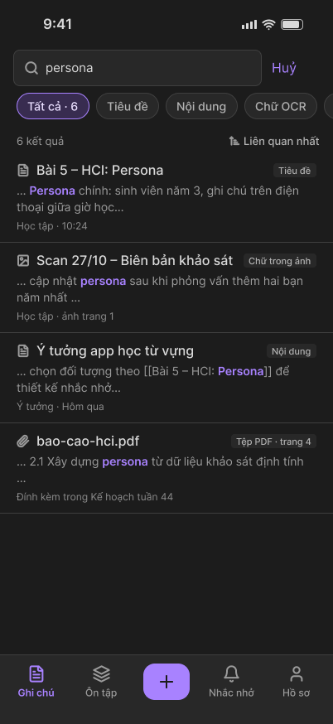  4.2 Search
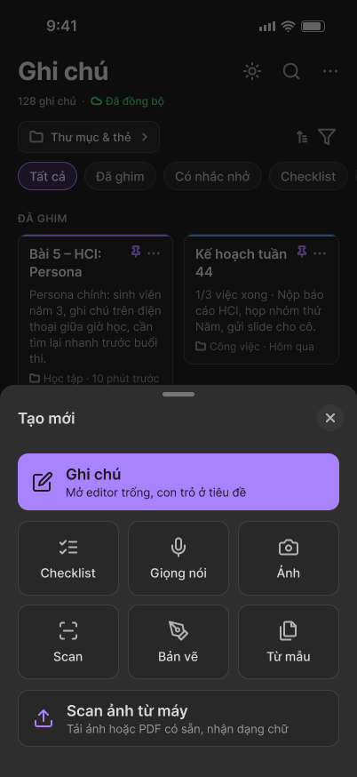  2.1 Create | 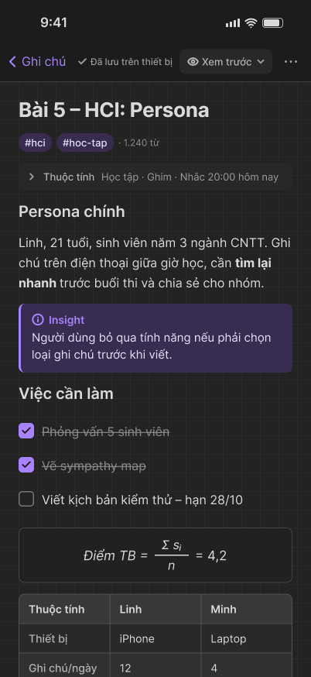  2.3 Editor | 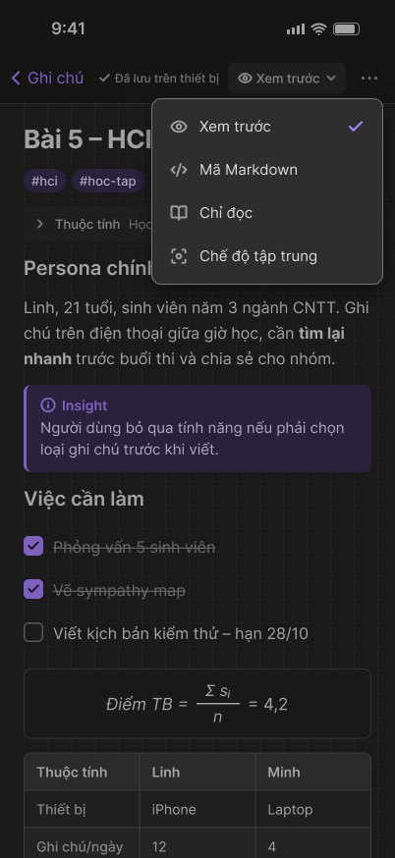  2.31 Mode dropdown
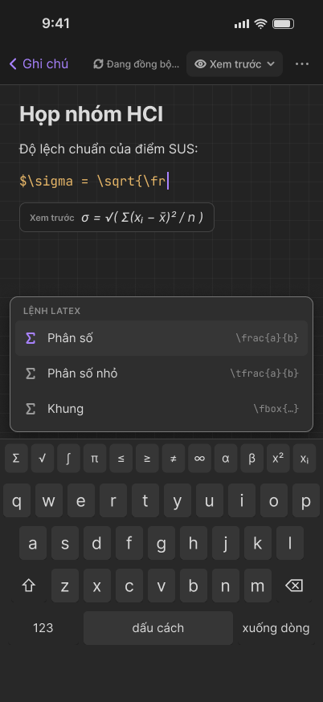  2.8 Formula | 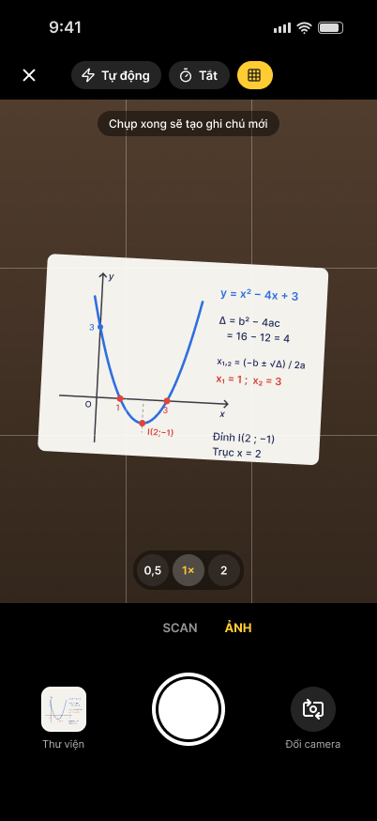  2b.5 Camera | 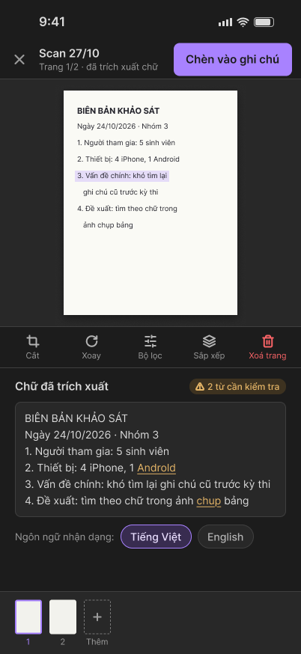  3.4 Text review
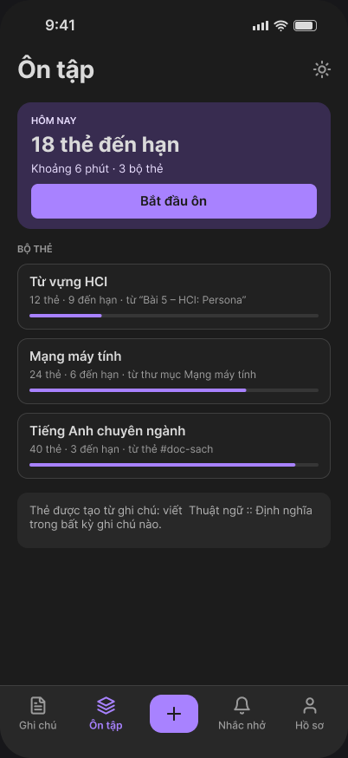  11.1 Review | 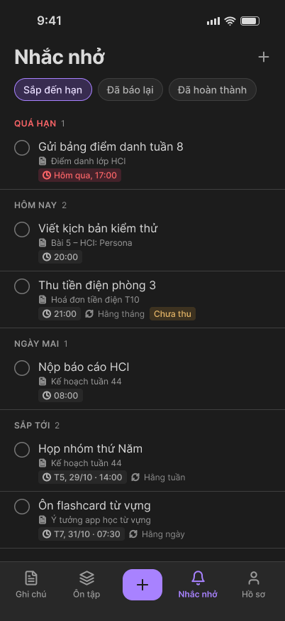  5.1 Reminders | 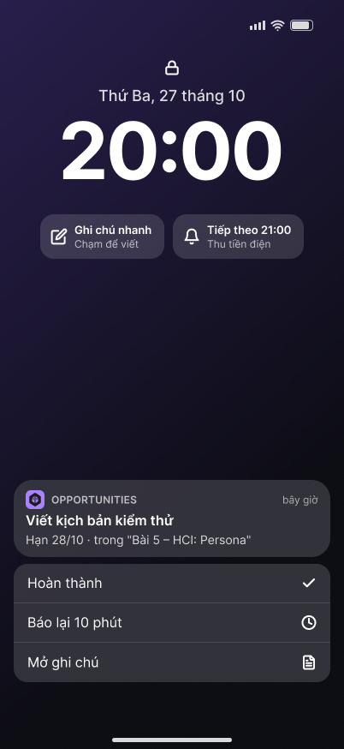  5.3 Notification
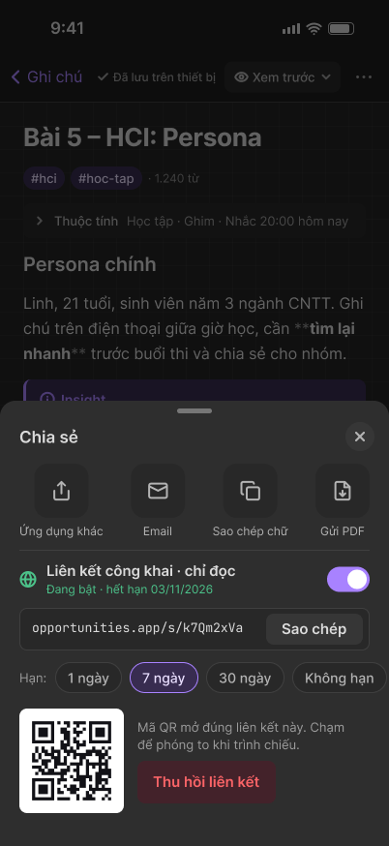  6.2 Share | 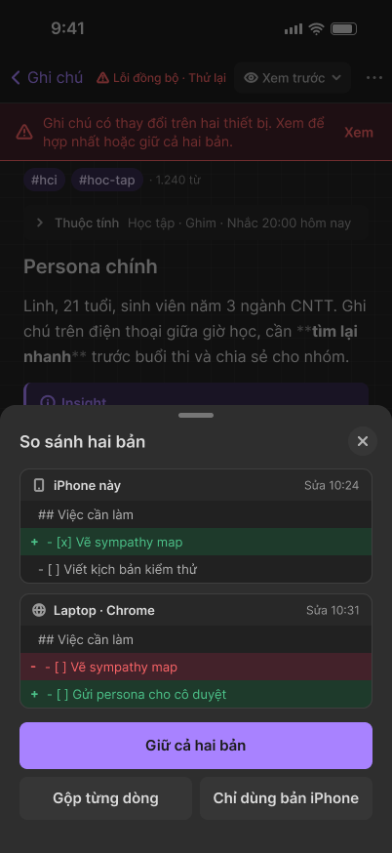  7.2 Conflict | 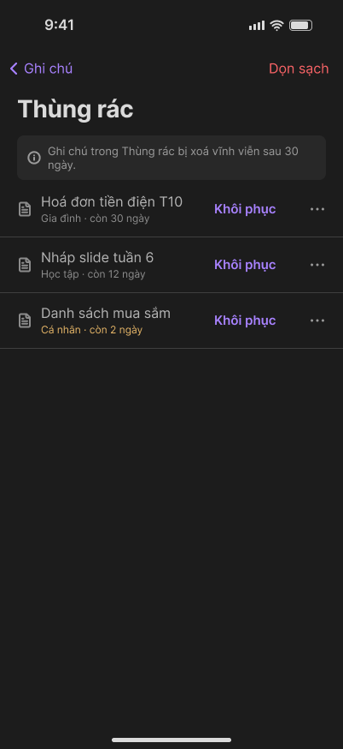  8.2 Trash
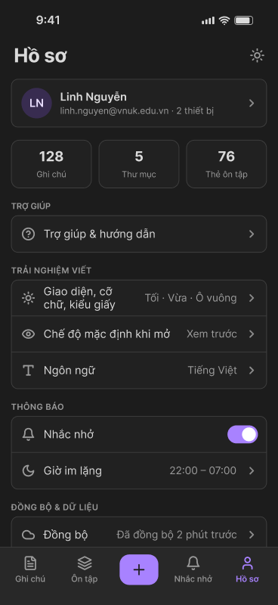  9.1 Profile | 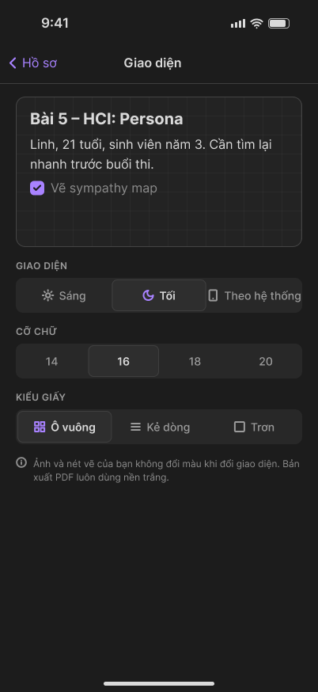  9.2 Appearance | 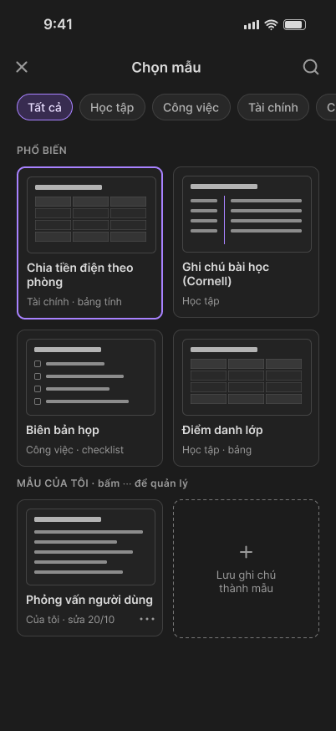  10.1 Templates
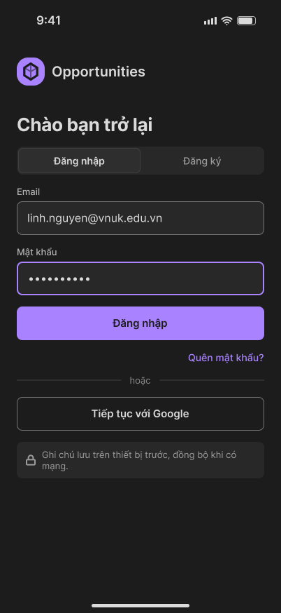  A.1 Sign in | 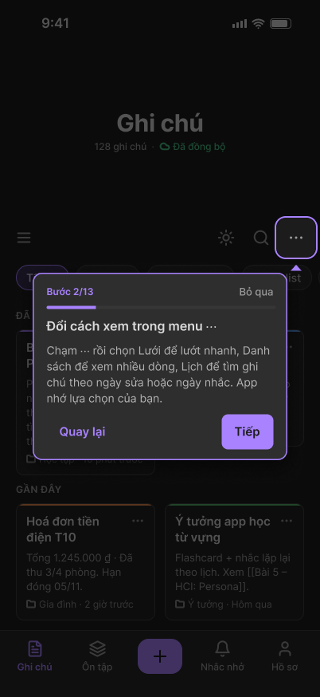  T3 Guided tour | 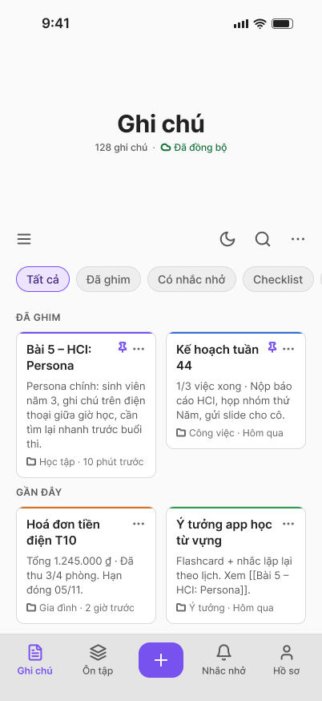  1.1 Home, Light theme

Changes after lecturer review
Lecturer feedback | What changed
Move Grid, List and Calendar into the ⋯ button on Home | The switcher is gone from Home. The views are the first items in ⋯, with the current one ticked.
Replace the Search tab with flashcard review | New Review tab with today’s cards, decks, a session and a summary. Search stays on Home.
Move folders and tags to Home; Profile takes the freed tab; remove account management and trash from the list; rename the rest | New Profile tab holding all settings on one scrolling screen. Attachments, Templates and Archive sit under Other settings. Trash moved to the side menu.
Recolor the lock icon to match the palette | The lock dialog now uses the violet accent instead of orange.
Put folder, note and tag management on one screen, like Apple Notes | New Folders screen with search, all notes, folders, tags and a bottom toolbar, plus smart folders with filters.
Add scanning of uploaded images when adding a note | New Scan from device option in the Create sheet: pick an image or PDF, review the text, create the note.

We also refined the design after this review. The Home header now follows the spacing of Samsung Notes, with a side menu ☰. The four editor modes moved from ⋯ into one dropdown on the mode box.

II. Web
Prototype link: Open the web prototype
The web app is designed for 1440 px desktop screens, in Light and Dark. It uses a sidebar instead of a bottom bar, and adds keyboard shortcuts and split view. Its navigation was not changed in version 6, so aligning it with the updated mobile navigation is the next step.
Main flows in the web prototype:
- Browse and search notes in Grid, List and Calendar
- Edit and view a note, write in Focus mode
- PDF, voice and drawing inside one note; scan and text recognition
- Template to invoice to PDF export; checklist to reminder; link graph
- Version history, offline sync and conflict resolution
- Folders and tags, sharing with link and QR, archive and restore, account and settings

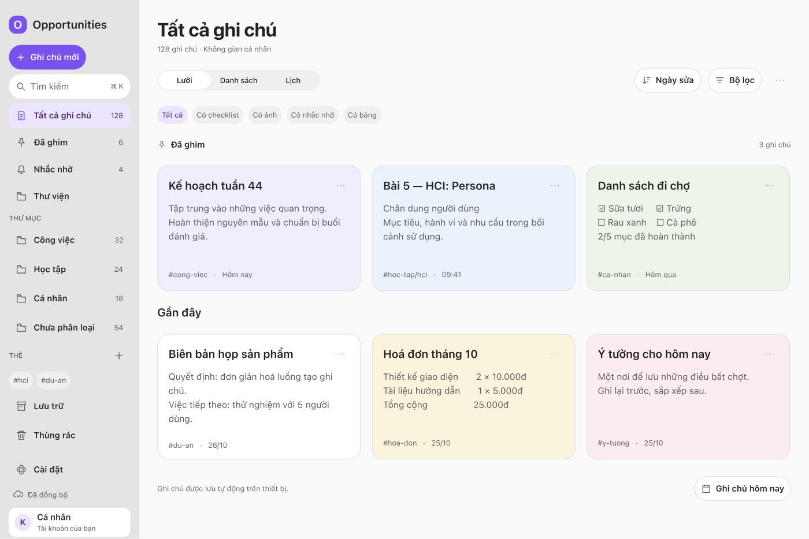
Figure 12. W01 All notes, Grid view
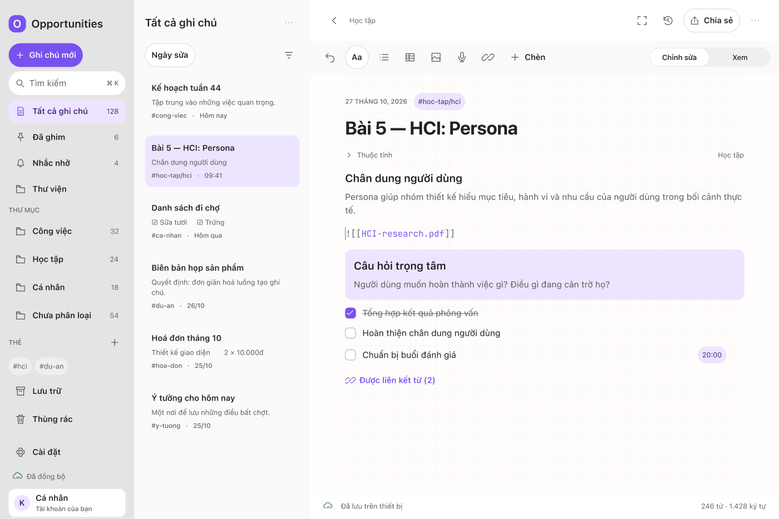
Figure 13. W04 Editor
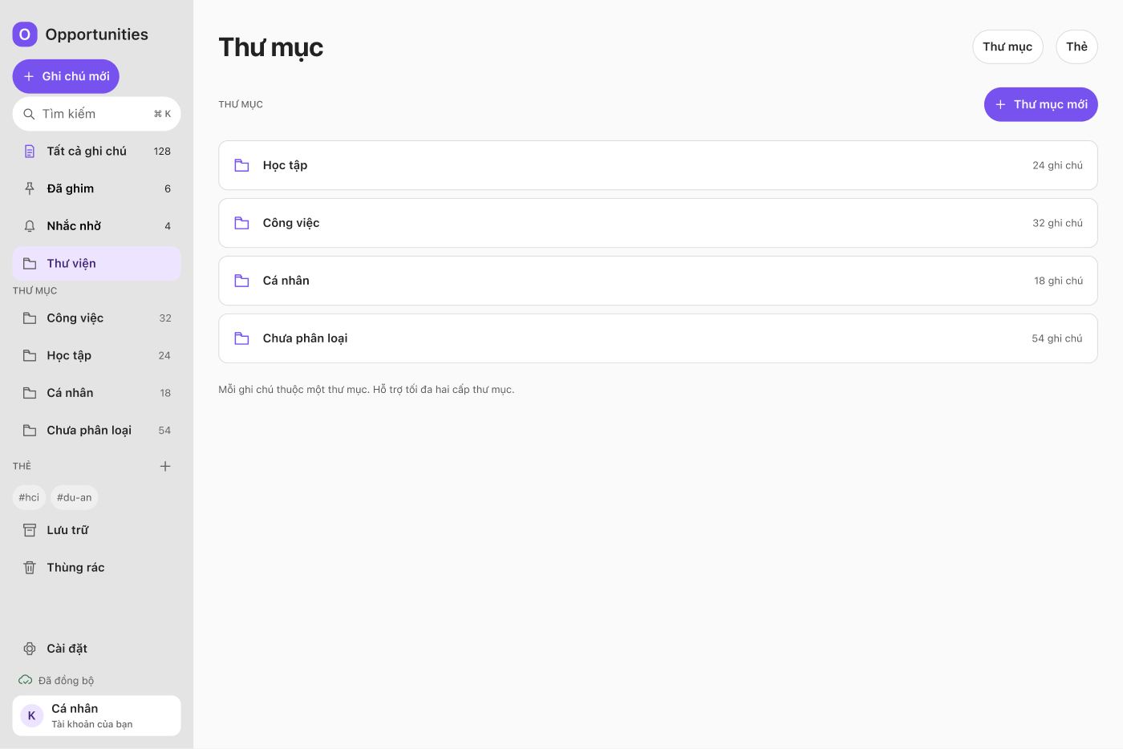
Figure 14. F9.01 Folders
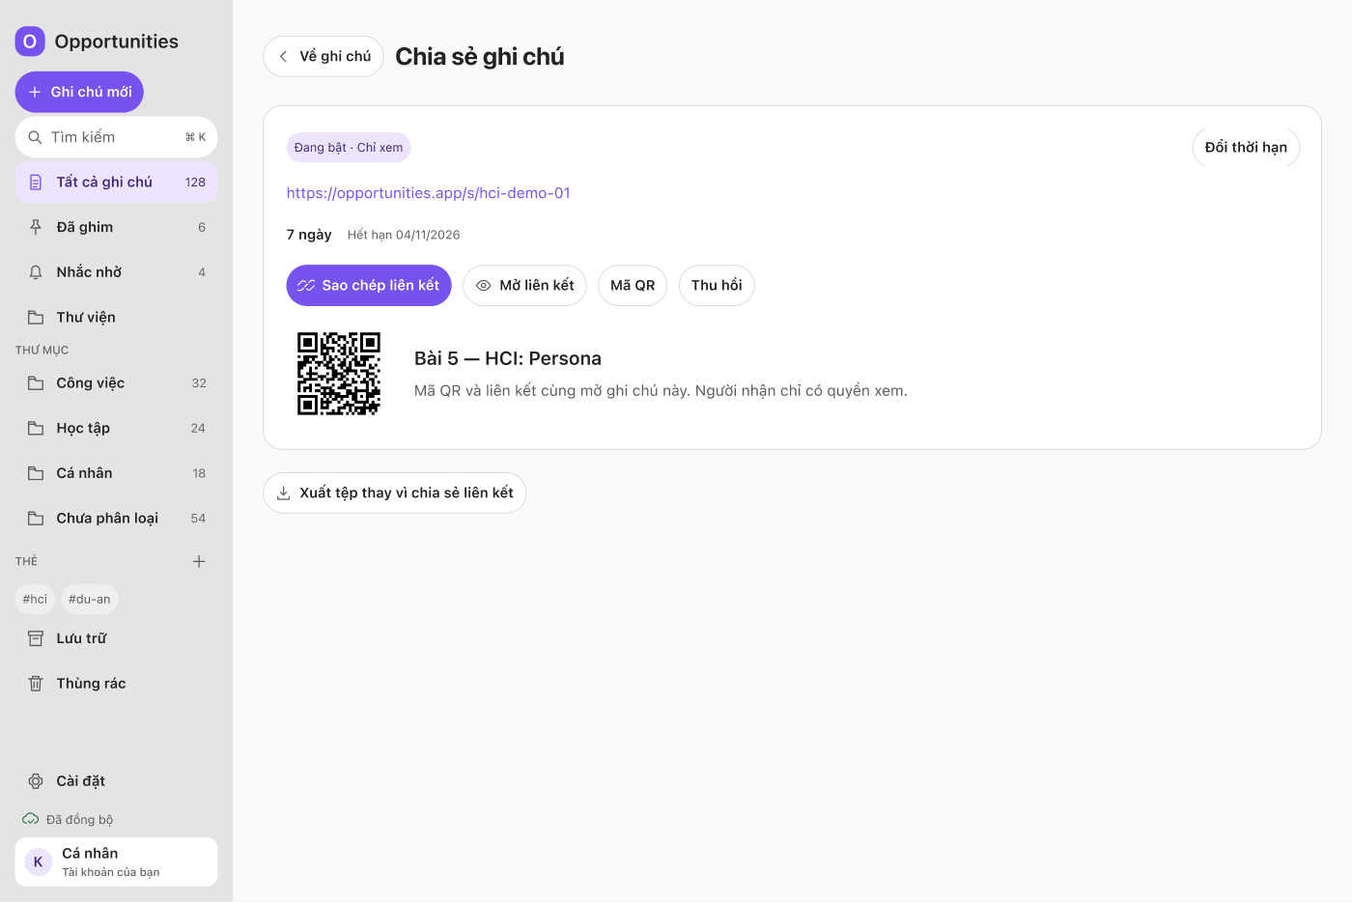
Figure 15. F11.03 Share link created

