THE UNIVERSITY OF DA NANG
VNUK INSTITUTE FOR RESEARCH AND EXECUTIVE EDUCATION
Introduction to Human-Computer Interaction
Final Project
Opportunities
Project Brief
Capture fast. Organize clearly. Find it again.
Trần Ngọc Quân · Student ID [Student ID]
Ngô Hoàng Nhật Khang · Student ID [Student ID]
Lecturer: Nguyen Thi Diem Chi
Version 6 · 1 November 2026

Background
- People keep notes in many places at once: a phone, a laptop, a paper notebook, chat apps. When they need one note, they lose time searching across all of them.
- Handwriting, screenshots and scanned pages cannot be searched, and typing is slow when someone is busy or on the move.
- People also forget deadlines, lose work when offline, and give up on tools that demand Markdown or LaTeX knowledge up front.
- Opportunities brings text, voice, photos and scans, checklists, tables and formulas into one note app. The guiding question: how might we help people capture, organize and find notes again, without having to learn Markdown first?

Brief

A. Project
Opportunities: a Markdown-first, offline-first note-taking application for mobile and web.

B. Brand
Opportunities. The logo is a violet cube (#A882FF) on charcoal.

C. Client
This is a course project with no external client. It is designed for students, tutors and knowledge workers who take notes every day.

D. Project deliverables
- Brand introduction and logo
- Research: scenarios, two personas, sympathy map
- Flow charts and UX wireframes
- Design system with Dark and Light themes
- Interactive mobile prototype and web prototype in Figma
- Test cases and a usability test plan
- Final report and presentation slides

E. Budget
N/A (academic project).

F. Brand background
- Created in 2026 by Trần Ngọc Quân and Ngô Hoàng Nhật Khang for the VNUK Human-Computer Interaction module.
- Motto: “Capture fast. Organize clearly. Find it again.”
- Visual language: charcoal neutrals with one violet accent, the Inter typeface and line icons, inspired by Obsidian.

G. Target audience
Persona | Who | What they need
Trần Minh Thư, 21 (primary) | Third-year Computer Science student and freelance tutor. Android and Windows, mid-level tech skills. | One-tap capture, search inside photos, offline work with sync, reminders, formulas and tables without writing LaTeX, flashcard revision before exams.
Phạm Đức Anh, 27 (power user) | Backend developer and Master’s student. Mac and iPhone, expert, keyboard-first. | Markdown source mode, LaTeX autocomplete, backlinks and embeds, plain .md export with no lock-in, fast sync between devices.

H. Coverage
Vietnamese-speaking users first, with Vietnamese as the default interface language and English as the second. Our personas are based in Da Nang, Vietnam. Target platforms are iOS 16+, Android 10+ and web (Chrome, Edge, Safari, Firefox).

I. Timing
- 27 October 2026: version 5, full redesign of the mobile prototype.
- 1 November 2026: version 6, lecturer feedback applied.
- Final submission: [submission date].

J. Description
Core flow: capture, organize, find, act on reminders, then share or export. One editor serves both people who only tap buttons and people who type Markdown or LaTeX.
Area | Main features
Capture | Text, voice to text, camera photos, document scan with text recognition, scan from images or PDFs already on the device, checklists, drawing, templates.
Organize | Folders nested two levels, smart folders built from filters, tags, pins, note colours, wiki-links and backlinks.
Find and view | Search that includes text inside photos and PDFs; Grid, List and Calendar views; sort and quick filters.
Revise | Flashcard review tab with spaced repetition; cards are created from notes.
Remind | Reminders grouped by due date, with notifications.
Share and sync | Share links, PDF and Markdown export, offline work, sync with conflict resolution, version history.
Comfort | Dark and Light themes, focus mode, text size, a first-run guided tour.

Mobile navigation: Notes · Review · Create (+) · Reminders · Profile. A side menu (☰) on Home, in the style of Samsung Notes, opens Pinned, Trash, folders and tags. Folder management is a dedicated screen in the style of Apple Notes. Views, sort and filter sit in the ⋯ menu.
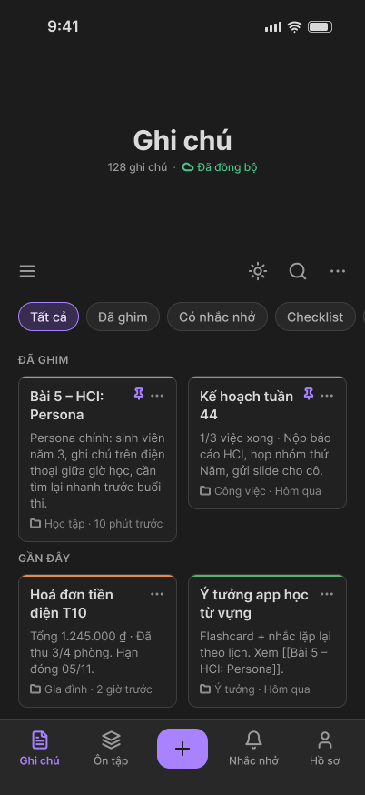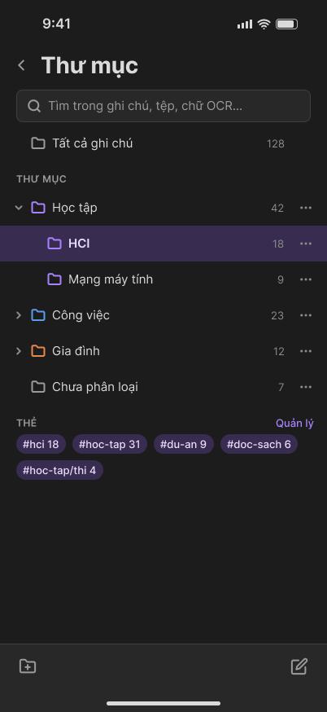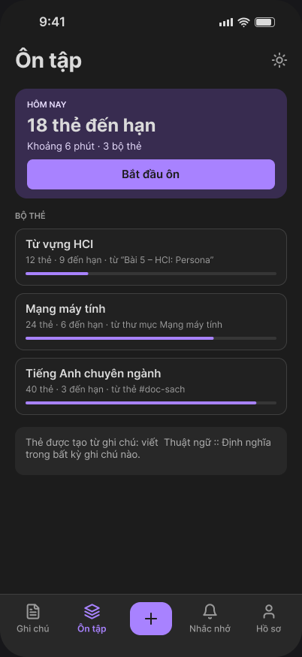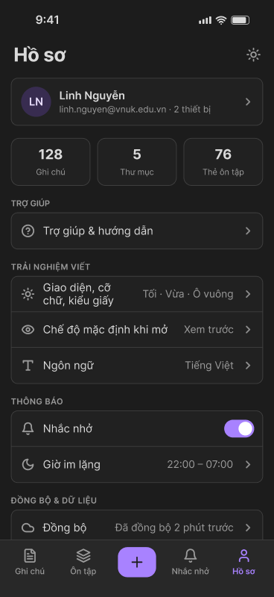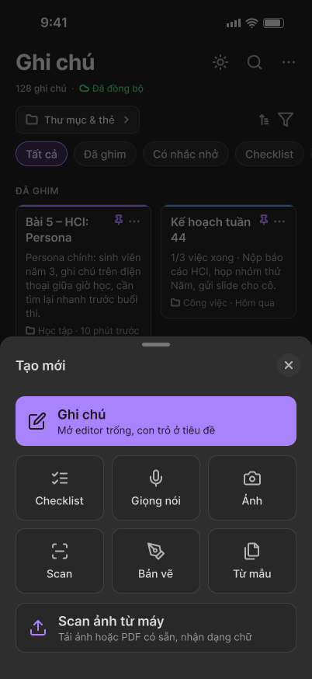
Figure 1. Home, Folders, Review, Profile and Create in the version 6 prototype.
Prototype: Figma file, page 04 · UI Prototype

K. Objective
- Give one place for every kind of note, so nothing is scattered across apps.
- Make any note easy to find again, including text inside photos and scans.
- Keep the app simple for casual users while staying powerful for Markdown and LaTeX users.
- Protect user data through auto-save, offline work, a 30-day trash and version history.
Target metrics for usability testing (planned, not yet measured):
Measure | Target
Capture a note | 2 taps or fewer
Find any note | 2 seconds and 3 actions or fewer
Notes lost | 0
System Usability Scale (SUS) score | 80 or higher

Changes after lecturer review (version 6)
Lecturer feedback | What changed
Move Grid / List / Calendar into the ⋯ button on Home | Switcher removed from Home; the three views are now the first items in the ⋯ menu, with the current one ticked.
Replace the Search tab with flashcard review | New Review tab with today’s cards, decks, a session and a results screen. Search stays on Home.
Move folders and tags to Home; Profile takes the freed tab; remove account management and trash; rename the rest | New Profile tab that holds all settings on one scrolling screen. Attachments, Templates and Archive sit under “Other settings” (Cài đặt khác). Trash moved to the side menu (☰) on Home.
Recolour the lock icon to match the palette | Lock dialog now uses the violet accent instead of orange.
Put folder, note and tag management on one screen, like Apple Notes | Side menu (☰) on Home opens a new Folders screen with search, all notes, folders, tags and a bottom toolbar, plus smart folders with filters.
Add scanning of uploaded images when adding a note | New “Scan from device” option in the Create sheet: pick an image or PDF, review the recognized text, create the note.

