Segment Based Movie Promotion and Content Discovery Strategy
MovieLens 10M decision support project
Field | Details
Course | Big Data Analytics
Deliverable | Final project report and Week 4 research paper
Dataset | MovieLens 10M from GroupLens Research
Analytical stack | MySQL 8.0, KNIME Analytics Platform and Power BI
Models | K Means audience segmentation and Logistic Regression
Report date | 16 October 2026

Student name and ID
____________________________________________________________

Academic Integrity Declaration
I certify that this submission represents the project team's work. Sources, software, and AI assistance are acknowledged. The team remains responsible for the SQL execution, KNIME workflows, model evaluation, dashboard, interpretations, and recommendations.
Signature __________________________________ Date __________________

Abstract
This project builds an end-to-end decision-support pipeline for segment-specific movie promotion using MovieLens 10M. The solution loads 10,000,054 ratings into MySQL, performs reproducible quality checks and chronological splitting, engineers TRAIN-only behavioural features, and uses KNIME to create four K-Means audience segments and a Logistic Regression model for positive ratings. The classifier achieved 69.26% accuracy and 75.83% ROC-AUC on 76,633 eligible TEST rows, compared with a 59.32% majority baseline. The Power BI model converts these outputs into segment profiles and a content-opportunity matrix. The strongest immediate use is controlled curation for warm-start users, not a claim of viewing or revenue uplift.
Keywords MovieLens, audience segmentation, K Means, Logistic Regression, MySQL, KNIME, Power BI, content strategy

1 Introduction and Problem Definition
A movie platform must decide which titles and genres to surface to different users. A single popularity ranking ignores variation in taste and can over-promote titles that are broadly known but poorly matched to a particular audience. This project supports the Content Programming and Personalization Manager by identifying behavioural segments and estimating whether a warm-start user will give a movie at least four stars. The predicted outcome is positive rating behaviour. It is not a prediction of viewing, revenue, retention, or subscription conversion.
The central decision is which movies or genres should receive more, equal, or less promotional priority within each segment. The analysis answers four measurable questions.
Decision question | Evidence used
How do rating behaviour and genre preferences differ? | User statistics and segment genre profiles
Which audience segments are interpretable and large enough to use? | K Means profiles, sizes and silhouette
What is the probability of a positive rating? | Logistic Regression probability and TEST metrics
Which lower-popularity titles merit a controlled promotion test? | Segment movie support, TRAIN popularity and predicted probability

The project follows the required flow Dataset to MySQL to KNIME to MySQL to interactive dashboard to recommendations. The repository contains runnable SQL and Python pipeline scripts, exported KNIME workflows, Power BI project files, query results, and implementation evidence.

2 Related Work
MovieLens records explicit user preferences as user, item, rating, and timestamp tuples and is widely used for recommendation research [1], [2]. These ratings are useful for modelling stated preferences but do not reveal whether a user was exposed to a title or chose to watch it. The report therefore treats a rating of at least 4.0 as a positive-engagement proxy and keeps business claims within that definition.
K-Means provides a transparent way to group users around behavioural centroids [3]. Logistic Regression complements segmentation by producing an interpretable probability for a binary outcome. ROC-AUC is used as a ranking measure alongside threshold-dependent metrics such as accuracy, precision, recall, and F1 [8]. KNIME supplies the visual workflow and database nodes used for read and write-back operations [4], [5].

3 Dataset and Data Quality

3.1 Dataset Description
MovieLens 10M was released in January 2009 by GroupLens Research. Its README reports 10,000,054 ratings and 95,580 tag applications across 10,681 movies and 71,567 users [1]. The project database contains 69,878 users with at least one rating. The difference is expected because the README user total includes people represented only in the tags file. Every sampled rating user has at least 20 ratings, user identifiers are anonymised, and no demographic fields are supplied.
Entity | Rows | Role
ratings | 10,000,054 | User movie rating and timestamp
movies | 10,681 | Title and pipe-separated genres
tags | 95,580 | User-generated tag applications
movie_genres | 21,564 | Normalised movie genre bridge
rating users | 69,878 | Users with at least one rating

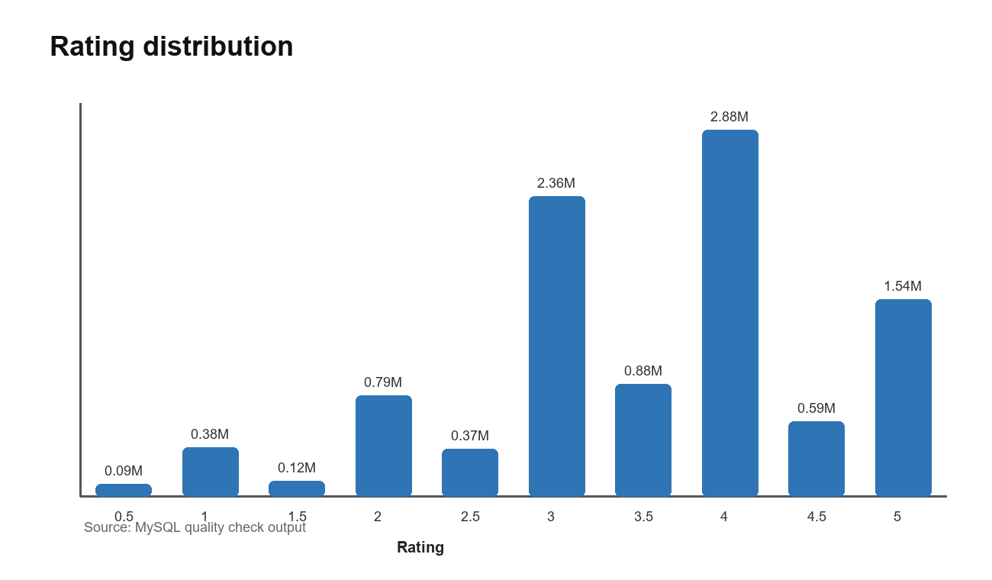
Figure 1 Distribution of the 10,000,054 ratings

3.2 Quality Assessment and Cleaning
The SQL checks covered completeness, uniqueness, validity, consistency, and plausible coverage. No orphan ratings or tags were found, no invalid rating or zero timestamp was found, no duplicate user-movie pair was returned, and every rating user met the 20-rating minimum. Four catalogue movies had no rating because 10,677 of 10,681 movie IDs appeared in the ratings table. They were retained as valid catalogue records.
Check | Before | After
Rating rows | 10,000,054 | 10,000,054
Rating range | 0.5 to 5.0 | 0.5 to 5.0
Orphan ratings | 0 | 0
Orphan tags | 0 | 0
Invalid ratings or timestamps | 0 | 0
Users below 20 ratings | 0 | 0

The raw data did not require row deletion or imputation for these checks, so the before and after counts are identical. Reproducible transformations created the genre bridge, chronological split, TRAIN-only user and movie aggregates, user-genre profiles, model features, and dashboard marts. Low-support movies were not deleted from storage; minimum-support filters are applied when making decisions.

4 Methodology and System Architecture
MySQL stores both source data and model outputs. KNIME reads directly from MySQL, performs reproducible transformations and modelling, and writes segments, predictions, and model metrics back to MySQL. Power BI imports compact views rather than the 10-million-row ratings table. This design makes the dashboard responsive and preserves a traceable chain from source rows to recommendations.
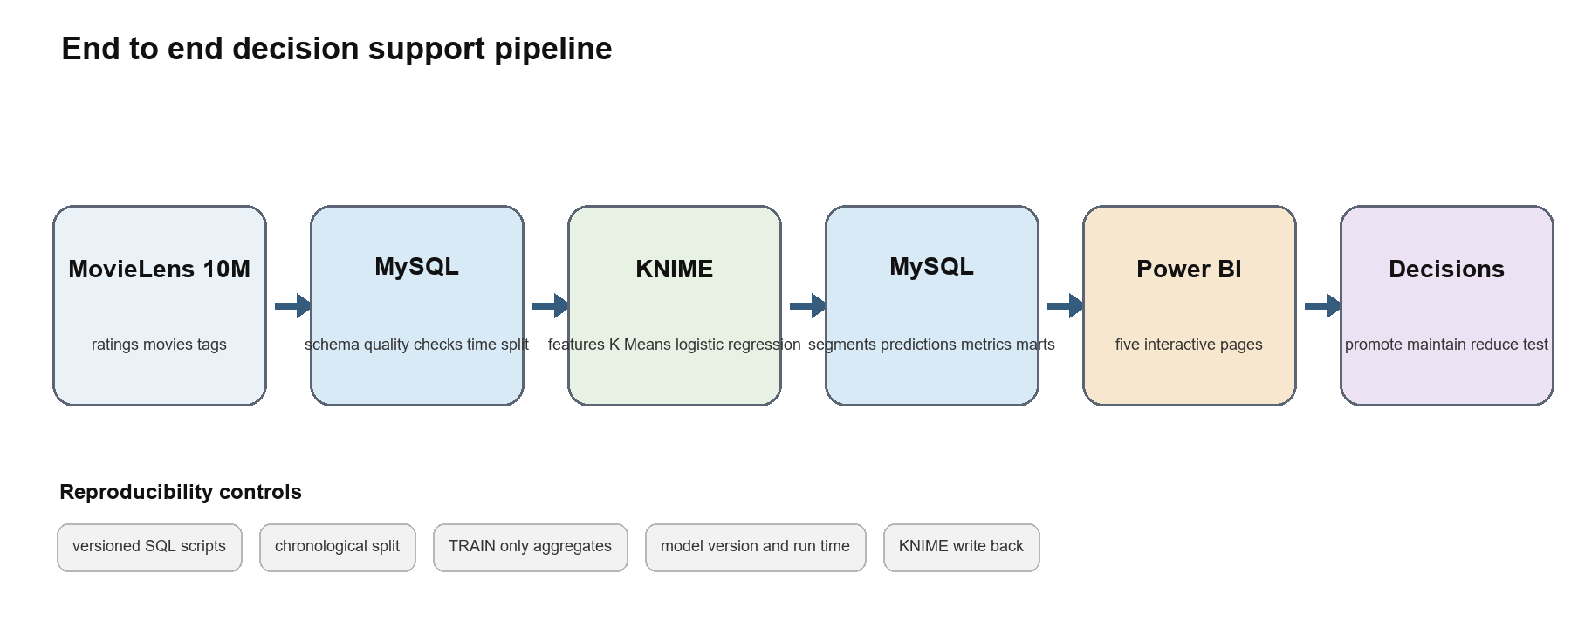
Figure 2 Required system architecture and result write-back
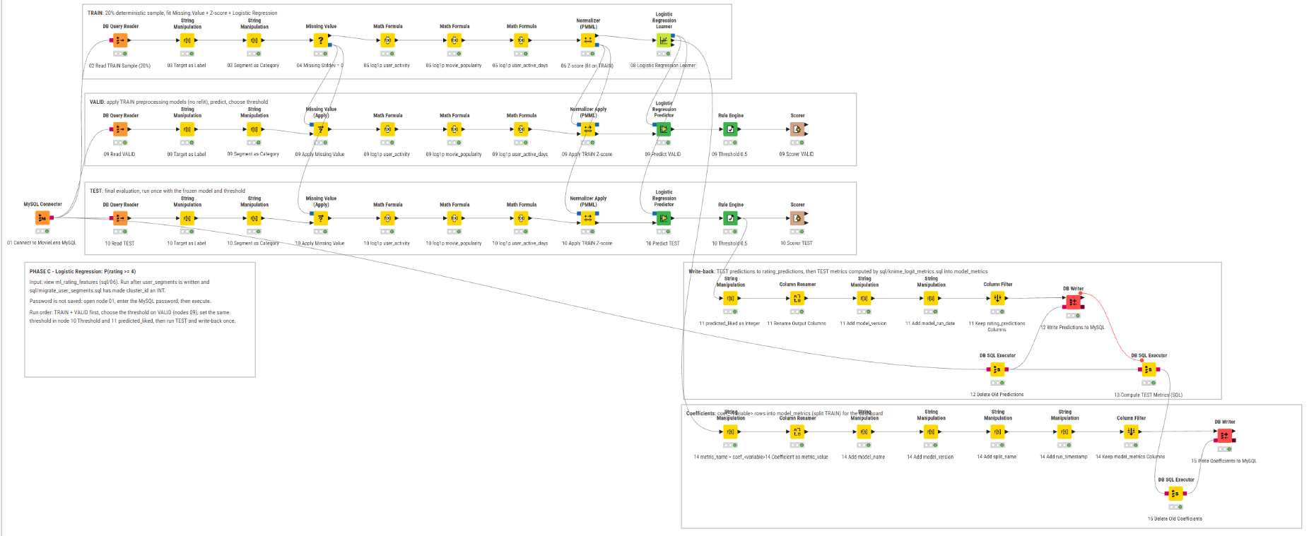
Figure 3 KNIME Logistic Regression workflow with TRAIN VALID TEST branches and MySQL write-back

4.1 Data Products and Ownership
Data product | Created by | Primary consumer | Purpose
rating_split | MySQL step 04 | Feature SQL and governance page | Chronological TRAIN VALID TEST assignment
train user movie and genre statistics | MySQL step 05 | Both KNIME workflows | Leakage-controlled behavioural history
user_segments | KNIME K Means | Logistic features and dashboard | Segment label version and run date
rating_predictions | KNIME Logistic Regression | Metric SQL and opportunity view | TEST probability class and actual label
model_metrics | KNIME and MySQL | Model and governance pages | TEST metrics coefficients and silhouette
dashboard views | MySQL step 07 | Power BI | Compact decision-facing aggregates

4.2 MySQL Design
The schema separates source tables from derived tables. Primary keys protect entity identity, while indexes on rating user, movie, and timestamp support aggregation and chronological access. Bulk loading uses MySQL LOAD DATA, which is appropriate for delimited files [6]. Large derived tables are built in staging tables and atomically renamed, leaving a rollback copy. The Python runner enforces step order and waits for KNIME write-back before continuing.
The chronological 70/15/15 split sorts by rating timestamp and rating ID. TRAIN contains 7,000,042 rows through 2 April 2005, VALID contains 1,500,006 rows through 28 December 2006, and TEST contains 1,500,006 rows through 5 January 2009. This split is more credible than a random split for a future-facing decision question.
Split | Rows | Period
TRAIN | 7,000,042 | 1995-01-09 to 2005-04-02
VALID | 1,500,006 | 2005-04-02 to 2006-12-28
TEST | 1,500,006 | 2006-12-28 to 2009-01-05

4.3 Feature Engineering and Leakage Control
User statistics, movie statistics, and user-genre profiles are calculated from TRAIN only. For TRAIN model rows, the row's own rating is removed from user and movie average and positive-rate features. VALID and TEST use frozen TRAIN aggregates. User ID and movie ID remain identifiers and are not treated as continuous predictors. The model includes behavioural histories, activity measures, movie popularity, cluster category, and genre indicators.
The view requires both the user and movie to have TRAIN history. This warm-start rule preserves feature meaning but sharply reduces future coverage. The feature view retained 6,999,878 TRAIN rows, 244,169 VALID rows, and 76,633 TEST rows. TEST coverage is 5.11%, so the headline metrics apply only to the eligible subset.

5 Experiments and Results

5.1 Exploratory Findings
The average rating is 3.512 and the positive-rating rate is 50.06%. Ratings of 4.0 are most common at 2,875,850 records. Drama has the largest genre rating volume at 4,344,198 and a 56.52% positive rate. Film-Noir has a 71.95% positive rate but far lower support, illustrating why both preference and popularity are needed when selecting content.

5.2 K Means Segmentation
The KNIME workflow joins user statistics with pivoted genre averages, converts genre ratings to user-relative affinity values, handles missing values and numerical outliers, standardises model features, and compares K from 3 through 7. Mean silhouette rose from 0.0602 at K=3 to 0.0686 at K=4 and 0.0692 at K=5. K=4 was retained because the 0.00055 gain at K=5 did not justify an additional segment for the business workflow. The low absolute silhouette values show that the groups overlap and should be used as descriptive personas rather than natural categories.
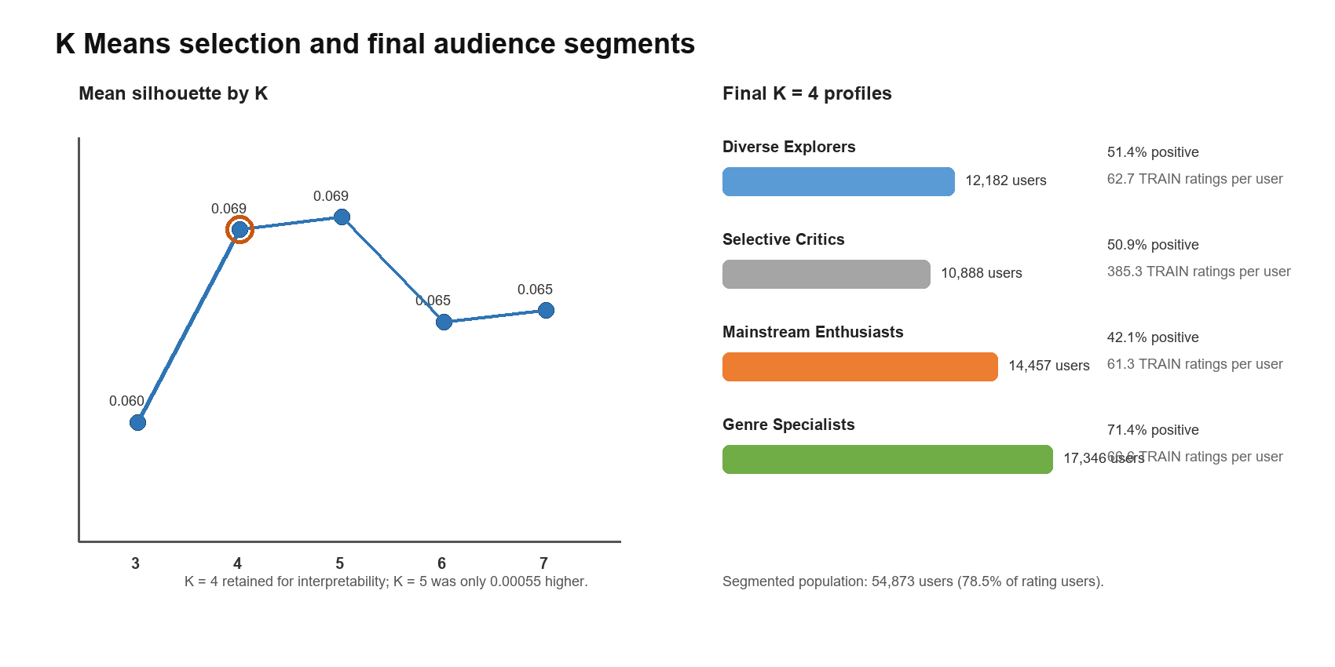
Figure 4 Cluster selection and final K equals 4 segment profiles
Segment | Users | Positive rate | Interpretation
Genre Specialists | 17,346 | 71.43% | Highest positive tendency and largest segment
Mainstream Enthusiasts | 14,457 | 42.06% | Lower positive tendency; family genres stand out relatively
Diverse Explorers | 12,182 | 51.38% | Stronger relative affinity for thriller action mystery
Selective Critics | 10,888 | 50.88% | Much higher activity and longest observed history

5.3 Logistic Regression
The target is liked equals one when rating is at least 4.0. KNIME trains a Logistic Regression model on a deterministic 20% sample of the eligible TRAIN feature view, fits missing-value and z-score preprocessing on TRAIN, applies the frozen transformations to VALID and TEST, and uses a 0.5 decision threshold. Predictions are written to rating_predictions, while SQL recomputes the final TEST metrics from the stored predictions.
On 76,633 eligible TEST rows, the model achieved 69.26% accuracy, 60.58% precision, 69.94% recall, 64.92% F1, and 75.83% ROC-AUC. Accuracy exceeds the 59.32% majority baseline by 9.93 percentage points. The confusion matrix contains 31,273 true negatives, 21,802 true positives, 14,189 false positives, and 9,369 false negatives. The model therefore ranks positive outcomes materially better than chance, but its probability calibration and coverage must be considered before use.
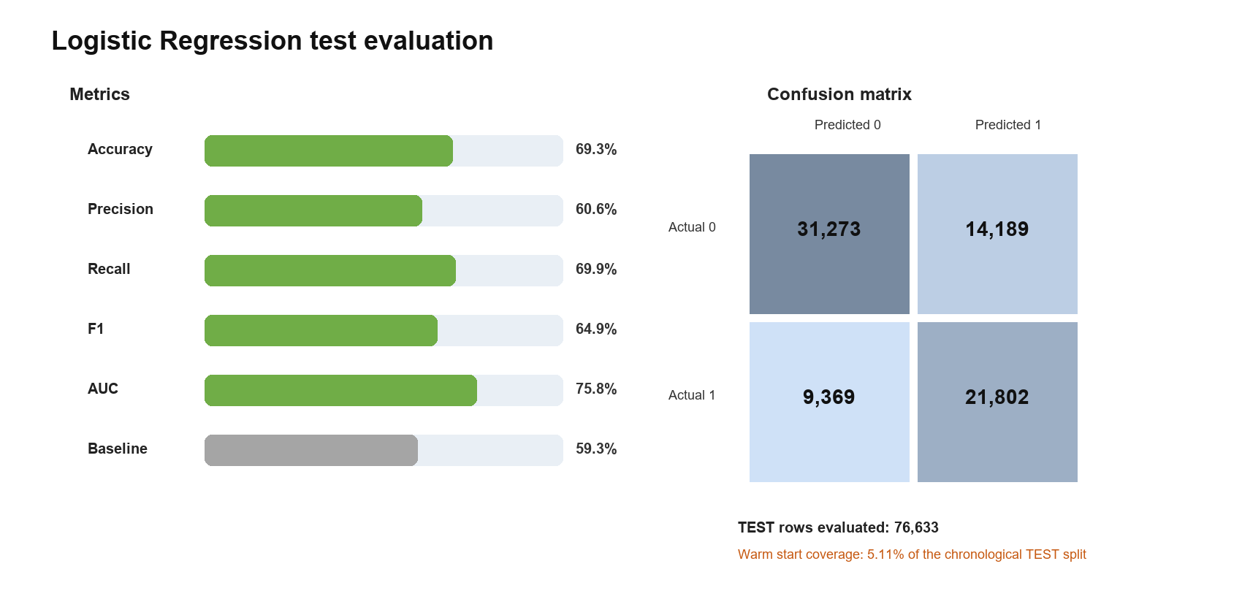
Figure 5 Logistic Regression TEST metrics and confusion matrix

5.4 Dashboard Implementation
The Power BI project is stored as both PBIX and PBIP artifacts. Its semantic model imports compact MySQL views for headline KPIs, rating distribution, genre KPIs, movie popularity, chronological splits, segment profiles, segment-genre statistics, content opportunities, the confusion matrix, and model metrics. Microsoft documents MySQL as a supported Power BI Desktop data source [7].
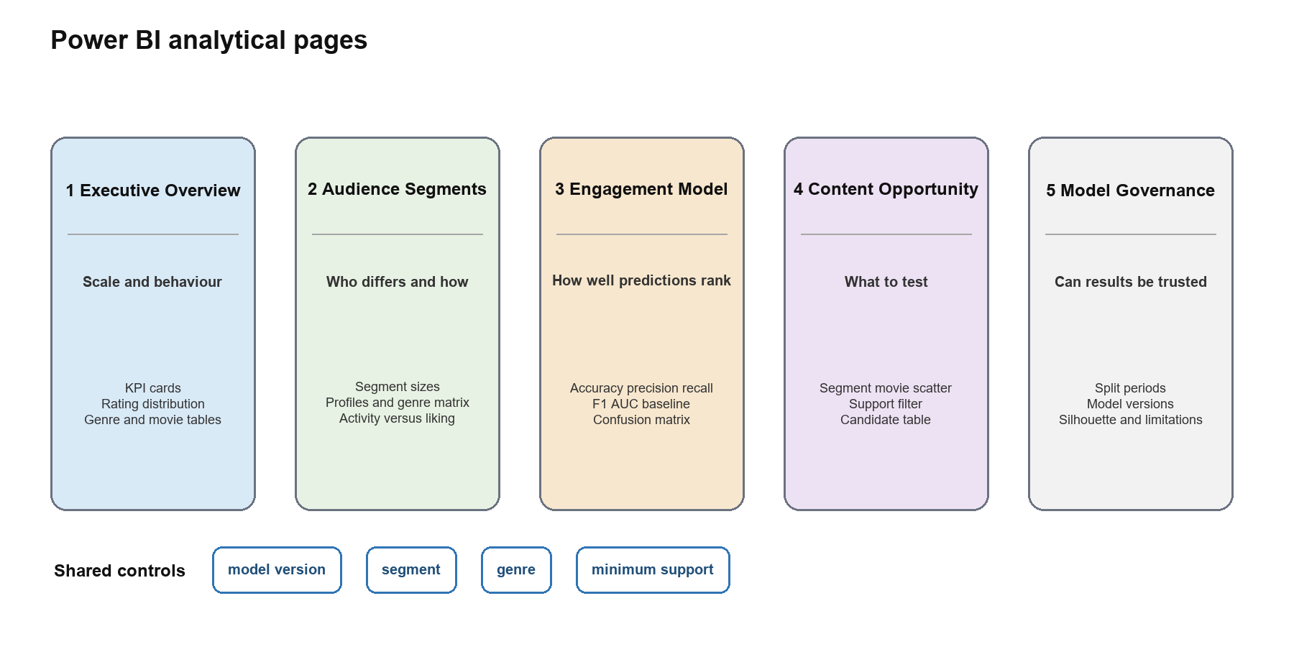
Figure 6 Purpose and evidence on the five Power BI pages
Dashboard page | Decision use | Primary interaction
Executive Overview | Establish dataset scale and overall rating behaviour | Top N movie view and genre comparison
Audience Segments | Compare segment size, activity, positive rate, and genre preference | Segment and genre slicers
Positive Engagement Model | Compare the model with baseline and inspect errors | Single-select model version
Content Opportunity Matrix | Find lower-popularity titles with high predicted liking | Model, segment, genre, and support filters
Model Governance | Review split periods, versions, silhouette, and limits | No incompatible shared model slicer

The opportunity matrix uses TRAIN popularity on a logarithmic x-axis, predicted like probability on the y-axis, and TEST support as bubble size. Median lines separate four decision regions. Because predictions from multiple runs would otherwise double support, every model-result visual must filter a single model_version. The minimum-support control protects decisions from unstable movie-segment cells.

6 Dashboard Insights and Decisions
The Power BI project contains five pages: Executive Overview, Audience Segments, Positive Engagement Model, Content Opportunity Matrix, and Model Governance. The semantic model reads MySQL views for KPIs, split dates, segment profiles, confusion-matrix counts, model metrics, and segment-movie opportunities. Filters for model version, segment, genre, and minimum support prevent incompatible runs or weak evidence from being mixed.
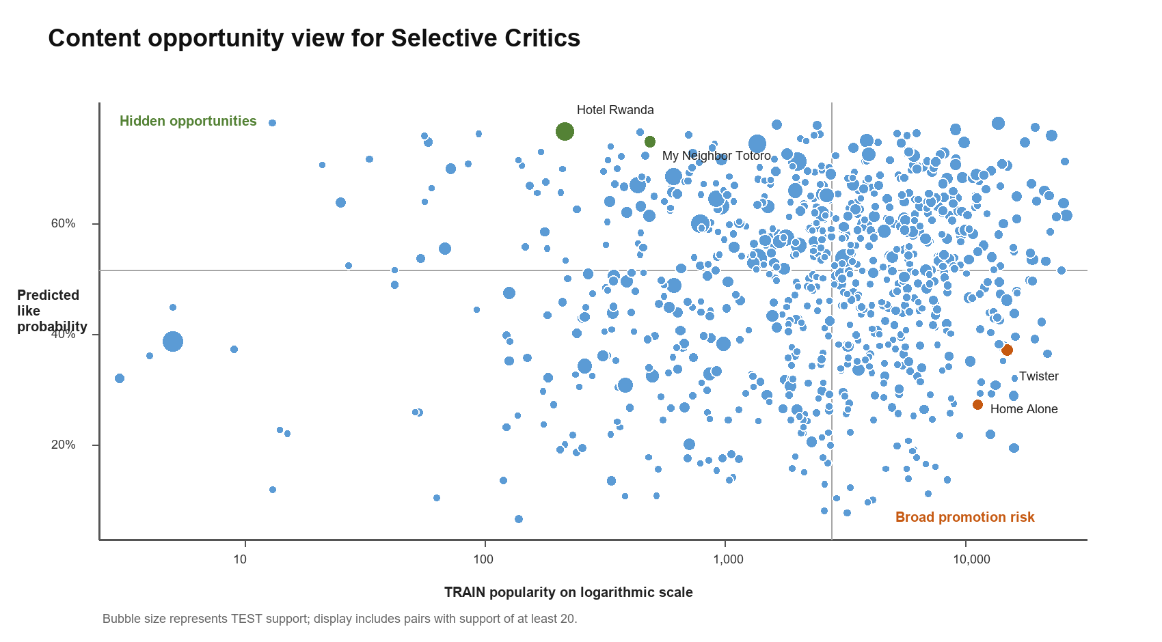
Figure 7 Reconstructed content opportunity matrix from the MySQL dashboard view
Only Selective Critics produced movie-segment pairs with TEST support of at least 50. The other segments had maximum support between 18 and 30 because the chronological warm-start rule left few eligible rows. Operational recommendations should therefore begin with Selective Critics and use lower-support results for exploration only.

6.1 Evidence Based Recommendations
Action | Evidence | Expected benefit and control
Test a Selective Critics collection led by Hotel Rwanda and My Neighbor Totoro | Hotel Rwanda: 108 TEST ratings, 76.72% predicted and 77.78% actual positive rate, 215 TRAIN ratings. My Neighbor Totoro: 58 TEST ratings, 74.87% predicted and 74.14% actual positive rate, 487 TRAIN ratings. | Improve discovery of lower-popularity titles. Run an A/B test and track click-through, play-start, completion, and post-view rating before expanding.
Reduce segment-specific priority for Home Alone, Twister, and The Mask | All have at least 51 TEST ratings and high TRAIN popularity. Predicted positive rates are 27.30%, 37.19%, and 37.74%; observed positive rates are 17.65%, 10.17%, and 5.66%. | Reduce mismatch within Selective Critics while keeping the titles available elsewhere. Monitor engagement loss and catalogue diversity.
Use segment-aware ranking only for warm-start users | The classifier covers 76,633 of 1,500,006 TEST rows, or 5.11%. Segment write-back covers 54,873 of 69,878 rating users, or 78.5%. | Avoid unsupported predictions. Use popularity or editorial rules as fallback and measure coverage as a deployment KPI.
Prioritise the Genre Specialists segment for curated pilots | This is the largest segment at 17,346 users and has the highest mean positive rate at 71.43%. | Concentrate initial editorial effort where expressed liking is highest, while testing titles within the segment rather than promoting all genres equally.

7 Conclusion and Limitations
The project meets the required technical pattern: a documented public dataset is loaded into MySQL; KNIME reads the database, prepares features, trains two approved model types, and writes results back; Power BI consumes MySQL views; and recommendations are tied to observed support, model probabilities, and segment profiles. The main decision value is a transparent shortlist for controlled content discovery tests.
The evidence does not justify claims about viewing, revenue, churn, or causal uplift. MovieLens 10M reflects behaviour collected no later than January 2009 and excludes demographic, exposure, impression, click, watch-time, licensing-cost, and revenue data. Users have at least 20 ratings, so the population overrepresents active raters. Missing ratings cannot distinguish an unseen title from indifference.
Model coverage is the most important technical limitation. The TRAIN-only warm-start join excludes 94.89% of chronological TEST rows, and high-support movie-level recommendations are concentrated in Selective Critics. Segment separation is also weak in absolute silhouette terms. Future work should add cold-start handling, probability calibration, stronger temporal evaluation, ranking metrics, exposure-aware data, and online experiments.

References
[1] GroupLens Research, MovieLens 10M Dataset and README, 2009. https://grouplens.org/datasets/movielens/10m/ and https://files.grouplens.org/datasets/movielens/ml-10m-README.html. Accessed 16 October 2026.
[2] F. M. Harper and J. A. Konstan, The MovieLens Datasets History and Context, ACM Transactions on Interactive Intelligent Systems, vol. 5, no. 4, article 19, 2015. doi:10.1145/2827872.
[3] S. P. Lloyd, Least Squares Quantization in PCM, IEEE Transactions on Information Theory, vol. 28, no. 2, pp. 129-137, 1982. doi:10.1109/TIT.1982.1056489.
[4] KNIME AG, Connect to a Database Using a Dedicated Connector Node, KNIME Analytics Platform Documentation. https://docs.knime.com/ap/latest/databases/connect-dedicated. Accessed 16 October 2026.
[5] KNIME AG, Insert Update or Merge Data, KNIME Analytics Platform Documentation. https://docs.knime.com/ap/latest/databases/insert-update-merge. Accessed 16 October 2026.
[6] Oracle, MySQL 8.0 Reference Manual, Loading Data into a Table. https://dev.mysql.com/doc/refman/8.0/en/loading-tables.html. Accessed 16 October 2026.
[7] Microsoft, Data Sources in Power BI Desktop. https://learn.microsoft.com/power-bi/connect-data/desktop-data-sources. Accessed 16 October 2026.
[8] T. Fawcett, An Introduction to ROC Analysis, Pattern Recognition Letters, vol. 27, no. 8, pp. 861-874, 2006. doi:10.1016/j.patrec.2005.10.010.
[9] G. James, D. Witten, T. Hastie, and R. Tibshirani, An Introduction to Statistical Learning, 2nd ed., Springer, 2021. doi:10.1007/978-1-0716-1418-1.

Appendix A Reproducibility Guide
A reviewer can reproduce the pipeline in the following order. Credentials belong in the ignored python_sql_scripts .env file or in KNIME credential configuration and must never be committed.
- Download MovieLens 10M from GroupLens and verify the supplied checksum.
- Run SQL or Python steps 01 through 05 to create the schema, load data, run checks, create the split, and build TRAIN features.
- Open movielens_audience_segmentation.knwf, configure the MySQL Connector, execute K-Means evaluation, retain K equals 4, and write user_segments.
- Run step 06 to create ml_rating_features.
- Open movielens_like_prediction.knwf, execute TRAIN and VALID, freeze the threshold, execute TEST, and write rating_predictions and model_metrics.
- Run step 07 to create dashboard views, then refresh movielens_content_strategy.pbix or the PBIP project.
- Confirm row counts, model version logit_v1, split dates, metrics, and recommendation evidence against the report.

Appendix B AI Use Statement
Generative AI was used to support project planning, explain technical concepts, review SQL and workflow structure, draft and format this report, and prepare charts from verified project outputs. Dataset selection, SQL execution, KNIME workflow construction, model evaluation, dashboard development, interpretations, and recommendations remain the responsibility of the project team. AI-generated wording and suggestions were checked against repository files, database results, and official documentation and were not treated as independent evidence.

Appendix C Weekly Presentation Alignment
The repository now contains the evidence required for the four weekly presentations. The table below maps each week's requested focus to the artifacts and results available for demonstration.
Week | Required focus | Project evidence | Presentation emphasis
1 | Problem, dataset, decision questions, architecture, plan | Project plan, four decision questions, MovieLens source, required pipeline | Explain the stakeholder decision and why ratings support only preference claims
2 | Quality, MySQL, KNIME integration, early KPI | Schema and load scripts, quality-check workbook, split and feature tables, SQL screenshots | Show zero invalid or orphan rows and direct database access
3 | Features, model evaluation, write-back, dashboard draft | Two KNIME workflows, K files, TEST metrics, user_segments, rating_predictions, model_metrics | Lead with leakage control, K selection, baseline comparison, and write-back
4 | Final dashboard, decisions, report, plan versus actual | Five-page PBIX and PBIP, recommendation evidence, reproducibility guide, final DOCX | State warm-start coverage and present recommendations as controlled tests

Submission Readiness
Deliverable | Available artifact | Final check
SQL and schema | sql 01 through 07 plus knime_logit_metrics | Run from a clean schema or retain exported result workbooks
KNIME | Audience segmentation and like prediction KNWF files | Confirm credentials are removed and nodes execute without cached-only results
Dashboard | PBIX, full PBIX, and PBIP project | Refresh against the intended MySQL instance and replace instructional text boxes
Report | This editable DOCX | Add student names, IDs, signatures, and export the approved copy to PDF
README and supporting statements | Repository files exist | Populate setup, contribution, data-source, and AI-use text before submission

