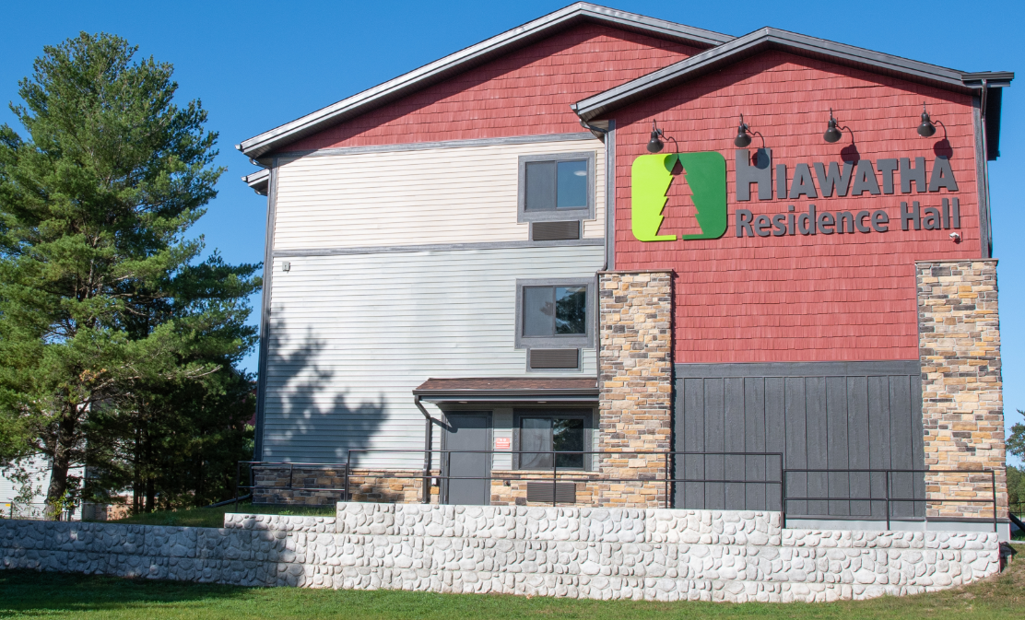

**Welcome to Hiawatha Residence Hall!**

STUDENT HOUSING HANDBOOK AND CONTRACT

Our Mission:

To care for you the same way we care for our own family members.

We are proud to be the #1 home-away-from-home housing for Exchange Visitor Students.

**Important Numbers**

|  |  |
| --- | --- |
| **Emergency Numbers** | |
| **Emergency Police** | **911** then call HRH Security 1-(608) 415-8509 |
| **Emergency Fire** | **911** then call HRH Security 1-(608) 415-8509 |
| **Medical Emergency** | **911** then call HRH Security 1-(608) 415-8509 |
| **Security** | **1-(608) 415-8509** |
| **Poison Control** | **1-(800) 222-1222** |
| **Police Dept. Non – Emergency** | 1-(608) 254-8331 |

|  |  |
| --- | --- |
| **Hiawatha Residence Hall** | |
| **Office** | 1-(608) 253-0200 |
| **General Manager** | 1-(608) 963-0973 |
| **Assistant Manager** | 1-(608) 963-0973 |

|  |  |
| --- | --- |
| **VISA Sponsor Number** | |
| **INTRAX** – Stacie Tollaksen | 1-(888) 224-0450 |
| **AAG** | 1-(800) 904-1125 |

|  |  |
| --- | --- |
| **Taxi Services** | |
| **HRH Van Express** | 1-(608) 415-8509 |
| **Wisconsin Dells Taxi** | 1-(608) 253-7433 |
| **City Taxi** | 1-(608) 253-7433 |

**General Information**

***This handbook will refer to Hiawatha Residence Hall as HRH.

Transportation

All **bicycles** must be parked in the provided bike racks. Padlocks are available at the HRH Management Office for $10.00. HRH will not be held responsible for any lost, stolen, destroyed and/or damaged bicycles under any circumstances.

All **vehicles** must be registered with HRH Management Office. You will also be required at time of Registration to provide Proof of Insurance and purchase a $20.00 parking permit, which can be paid in Cash or by Credit/Debit Card. Park in designated areas only. Any vehicle that is not registered at the office or parked illegally will receive a ticket from the police department and will be towed away at owner’s expense ($250 or more).

Nearest Grocery Stores

|  |  |
| --- | --- |
| Lake Delton Wal-Mart Super Center | 130 Commerce St. Wisconsin Dells, WI |
| Maurer’s Market | 216 Washington Ave. Wisconsin Dells, WI |
| Dollar Tree | 121 Commerce St. Wisconsin Dells, WI |

Mail & Packages

Mail and packages will be delivered to the office. You must present a photo ID to pick up packages. Please provide the following address for mail or packages…

[You’re Name]  
200 West Hiawatha Drive  
[You’re Room Number]  
Wisconsin Dells, WI 53965

Visitors

Visitors are welcome in the community area until 11 pm. You are responsible for your guests and guests are not allowed on property without you present.

Quiet Hours

Quiet Hours are from 11 pm—8 am.

**Emergency Situation**

In an emergency situation, YOUR SAFETY is most important, and not the safety of your belongings. For your convenience each room has a removable Emergency Action Plan located on the back of your door. Please review and follow the guidelines.

Please note: there are security cameras located in all indoor and outdoor common areas. For your safety, security personnel and the local Lake Delton Police Department patrol the property.

Severe Weather Emergency

**Stay inside and take shelter**. **Move to a ‘Safe Zone’**. The first floor hallways, kitchen, and public bathrooms have been designated the ‘Safe Zone’ for this building. In a lightning storm, avoid contact with water or electrical power. Keep yourself informed by watching the local news or the weather channel.

**Watch:** Bad weather conditions are possible in the specified area

**Warning:** Bad weather conditions are expected

Fire Alarms and Fire Evacuation

**If you Notice a Fire:**

· Pull the closest alarm!  
· Yell for help!  
· Evacuate out the nearest exit and wait for instructions before re-entering the building.  
· If safe to do so, use the fire extinguisher to put out the fire.  
· **Notify Emergency Police and Fire by dialing 911 then call 1-(608) 415-8509.**

**If the Fire Alarm Sounds:**

· Evacuate out the nearest exit and wait for instructions before re-entering the building.  
**· If you notice open flame call Emergency Police & Fire: Dial 911 then call 1-(608) 415-8509.**

Power Failure/Outage

· After hours notify Hiawatha Residence Hall Security at 1-(608) 415-8509.  
· Stay in your room or meet in public space.  
· HRH Housing Staff or Security will be present in community area with updates.  
· You may use flashlights or cell phones for light. **DO NOT** use an open flame such as a candle for light.

Active Shooter

· **When safe to do so call** **Police: Dial 911 then call 1-(608) 415-8509.**  
· Evacuate the area if there is a safe path.  
· If you are in a room, stay there and secure the door and windows.  
· Hide in an area out of the shooters view.  
· Silence your cell phone and/or pager.  
· As a LAST RESORT, to protect yourself, attempt to take the active shooter down. According to Homeland  
 Security your best chance of survival is to incapacitate the active shooter until police can arrive.

Bomb Threat

If you notice an unattended suspicious package or receive a bomb threat (by phone, text, e-mail, etc.) take the following steps:

· Immediately move away from the area—evacuate the building– go to the evacuation meet up location.  
· Silence all radios and cell phones while leaving the building.  
· When at the evacuation location—**if you can safely do so call 911**.

Role of the Housing Safety Department

· Protection of lives and property  
· Prevention of crime and disorder  
· Training  
· Administration – reports, policies, and procedures

Housing Safety Team

· Security Officers  
· Site Safety Monitors  
· Security Camera Surveillance System  
· **You**

**Housing Procedures**

Check-In

Two weeks of housing fees and security deposit is due prior to checking into your room and can be paid in Cash or by Credit/Debit Card.

Upon move in, you will be provided with one set of bed linens, a blanket, a pillow and one towel. You will be given a key ID to your unit.

You must keep your key with you at all times. **Do Not** share, borrow, or let anyone use your key ID.

Check Out

A 7 day notice is required, before move out. Final inspection of your unit will be performed. To receive your deposit refund, your room and bathroom must be clean and you must return the towel and bedding you were provided at the time of check-in. Any personal property left in your unit will be discarded.   
**You will not be eligible for a deposit refund if your room is not clean or you do not return the items assigned to you at check-in.**

Deposit Fee

$300 is due at check in. $50 of that fee, is a non-refundable administrative fee. HRH Housing will hold the balance as a deposit fee, and may apply it toward any damage caused to the unit beyond normal wear and tear, including additional cleaning necessary to restore unit to an acceptable condition, rules violations, or other amounts owed to HRH Housing pursuant to this agreement. Deposit fee and any prepaid housing fees will **NOT** be refunded to you if you leave HRH Housing for any reason before the contractual agreed upon end date.

Eviction

HRH Housing can evict you, without notice or refund, from your unit and the property if you violate any Rules and Regulations or any local, state and federal laws. If you are evicted from HRH Housing, your sponsor and employer will be notified immediately. Additionally, you will no longer be permitted on property/premises.

Room Entry

HRH Management, Security and HRH Maintenance reserves the right to enter your room in the interest of health, safety, security, and building maintenance. When possible, advance notice of room entry will be given. HRH Management and Security employees are required to report any violations of housing regulations and/or terms of this contract observed while in your room.

HRH Housing, however, reserves the right to make periodic administrative entrance and inspections of rooms (whether or not the residents of the room are present) whenever:

A. There is a threat to the safety or well-being of the room’s occupants or other residents. Examples  
 include but not limited to: a report of self-harm, faulty equipment, suspicion of imminent  
 danger/hazard, and smell of or visible smoke, etc.

B. Disruptive noise that impedes a member of the communities’ ability to sleep or read, etc.

C. To address any necessary custodial services, maintenance and repair services.

D. Assess for any damages of a current resident or after a resident has vacated or been evicted.

E. Premises may be searched, and your personal property may be removed by HRH Management and Security, if /when:

• It constitutes an imminent danger/hazard.  
 • It is the property of HRH.   
 • Illegal drugs are found, this is a direct violation of HRH Rules and Regulations.

Room Consolidation

HRH Housing will have ongoing efforts to maximize occupancy in each room. As such, each resident could be subject to move during their stay. You will receive a 24-hour notice to transfer rooms. Thank you for being cooperative during this time.

**In the event of an empty bed(s) in the room, residents must:**   
Keep the unoccupied bed(s) and that portion of the unit free and clear of any personal items. This space is property of HRH Housing and should remain in a condition that allows the new resident to check in at any time. Please be ready and willing to accept your new roommate, for a positive experience for everyone. The right of final assignment lies with the Manager of HRH Housing.

Room Changes

If you wish to move, contact HRH Housing Management/Staff immediately. Room changes are not guaranteed, and all changes must be approved by HRH Management/Staff prior to changing rooms. A $75.00 Moving Fee will be charged.

|  |  |
| --- | --- |
| **Rules & Regulations** | |
| **By my initials, I acknowledge that I read, understand, and agree to the following**  **Rules and Regulations:** | **Initials Here** |
| All local, state, and federal laws must be adhered to. |  |
| Residents must keep room doors closed at all times. |  |
| You are responsible for all of your personal possessions and valuables. HRH Housing recommends that you purchase and install a pad lock for your lockable closet door & bike. Pad locks can be purchased at the HRH office for $10.00. HRH Housing shall not, under any circumstance, be liable for any damage, loss or theft of any property, money, or other items. Purchase of Personal Property Insurance policy is recommended. |  |
| No tampering with any piece of fire safety equipment, including but not limited to, fire alarms, smoke detectors, carbon monoxide detectors, extinguishers, and fire doors. |  |
| Residents are expected to wear proper clothing at all times while in public areas, this includes shirts and shoes. |  |
| No hot plates, rice cookers, electric tea kettles, irons without ironing boards, open flames (candles, incense, fireworks, hookah, fires, camp fires, etc.). |  |
| Delivery Drivers may NOT go to any room. If you order delivery of food from a restaurant, tell the driver to meet you at the main entrance. Give your name and cell phone number so the driver can contact you directly when they arrive. |  |
| No Weapons of any kinds (guns, knives, air gun, dart gun etc.) are allowed. This list is not all inclusive and may include any other item deemed inappropriate or dangerous by HRH Management/Staff at its sole discretion. Please pre-check any items you may want to purchase with the Housing Manager PRIOR to the purchase to deem acceptable for HRH Housing. |  |
| Soliciting (selling products or services) is not allowed. |  |
| Viewing (in print or via internet) or possession of pornographic materials is prohibited. |  |
| Bicycles, roller-blades, roller-skates, scooters, hoover boards, etc. are not allowed to be used inside any and all buildings on premises. |  |
| Alcohol is only allowed in your room and no person under 21 years of age may have or consume alcoholic beverages. Drugs are NOT permitted anywhere on property/premises, including dorm rooms, the community areas, or outside. The possession, evidence of use, sale, or paraphernalia of illegal drugs on HRH Housing premises is expressly prohibited. |  |
| Fighting is not allowed. It is never okay to put your hands on another HRH resident and /or employee and is grounds for eviction and termination. |  |
| Retaliation is not allowed. No one may retaliate in any way against anyone who has complained about harassment or discrimination, whether that concern relates to harassment of or discrimination against, the individual raising the concern or against another individual. |  |
| Lockers are for the assigned resident only. Do not store another person’s items in your locker. |  |
| Pets of any kind are not allowed. |  |
| Violations of the Rules and Regulations may result in immediate eviction, fines, forfeiture of all or part of the deposit fee. |  |

**General Residence Policies**

Preventative Cleaning Services

You are responsible to keep your room clean. You are responsible to clean up after yourself if you use any of the public areas.  
  
Laundry room is located in the community building. You are responsible for doing all of your own laundry, including washing bedding and towels at least every two weeks. Cleaning supplies are your own responsibility.  
  
You will be held responsible for a housekeeping fee starting at $25 if additional cleaning is required to clean up a mess that you are responsible for.  
  
You are responsible to dispose of any trash/garbage from your room. Dumpsters are provided for your convenience and are located outside, next to the building. Do not put your trash in the public trash can.

Room Inspections

Your room will be inspected regularly by HRH staff. All roommates will be responsible to maintain the condition of the room. Fees will be assessed for any damages to furniture, walls, doors, odors (including smoke), excessive cleaning etc. Please follow instructions if you receive notice that your room did not pass inspection. Failure to comply with notice or repeat failed inspection will result in additional cleaning fees.  
Toilet Paper is the ONLY thing allowed to be flushed down the toilet. All other products must be thrown in the garbage. This means NO tampons, pads, condoms, or flushable wipes.

Locked Out

If locked out during regular hours notify HRH Housing staff. You may borrow a key from the office to let you into your room but it must be returned right away. A $20.00 fee will be charged for key replacement.  
If locked out during afterhours notify **Security 1- (608) 415-8509** to let you in. You will be required to provide identification.

Furniture and Amenities

All furniture must remain in the room at all times. Furniture CANNOT be taken outside. You will be charged for any damages to furnishings or missing furnishings.

**By my initials, I acknowledge that I read, understand, and agree to the General Residence Policies above:**

**___________**

**Disciplinary and Eviction Process**

Failure to comply with the Rules and Regulations will result in the following disciplinary process.

Sanctions will be administered based on severity of the offense as determined by HRH Housing Management.

|  |  |
| --- | --- |
| **By my initials, I acknowledge that I read, understand, and agree to the following**  **Disciplinary and Eviction Process:** | **Initials Here** |
| **VERBAL WARNING** – issued by either HRH Housing Staff or Security. Review of the violation will take place. |  |
| **1ST STRIKE** – First Offense — $50.00 FINE WILL BE CHARGED by HRH Housing Staff or Security. Violator will again review the offense with property management and sign an agreement that they understand what will happen if the same choice is made again. |  |
| **2ND STRIKE** – Second Offense — $100.00 FINE WILL BE CHARGED by either HRH Housing Staff or Security. Violator will be required to attend a meeting with the Manager of the property, then sign a written warning stating that they understand that they will be evicted from housing and possibly terminated by employer if they violate another policy or rule. Sponsor and employer will be notified of the violations. |  |
| **3RD STRIKE** – Third Offense — YOU’RE OUT — issued by either HRH Housing Staff or Security. Effective immediately you will be evicted from housing and possibly terminated by employer. |  |
| **EVICTION:** Your sponsor and employer will be notified immediately. If issued by security after hours, your eviction will be processed the following morning. You must return key ID, and return all items given to you at check in. Prepaid rent and deposit will not be refunded to you. |  |