Coursework Report:

Automated Gold Price Tracker
Name: Akira Fukutomi
Module: COMP1314 - Data Management
Date: December 26, 2025
GitHub Repository: https://github.com/Akira5298/gold-price-tracker
I added comments to each important sector of the code in all script files, so that it explains the function of each section and improves overall readability and understanding.

1. Unix Script for Data Collection

1.1 Data Parsing and Extraction

The destination of the script <data_collection.sh> is https://www.goldprice.org. I used a multi-layered parsing method since web scraping with <curl> can be challenging because HTML structures change:
- Tier 1: Uses the Extended Regular Expression (Regex) <grep -oE> to look for the string "Gold Price Today: $...".
- Tier 2: It looks for any USD currency pattern <\$[0-9]{1,2},[0-9]{3}> if Tier 1 fails.
- Tier 3: A fallback is available for raw decimal numbers if Tier 2 fails,
- Cleaning: To sanitise the string into a pure numeric format that MySQL and bc (Basic Calculator) can process, uses <tr -d '$,'> and <sed>.

1.2 Data Manipulation and Validation

Web-based raw data is often "dirty" (it frequently includes extra symbols or formatting). The script removes formatting characters using <tr -d '$,'>. The scraped data is not blindly trusted by the script; floating-point comparisons are performed using the bc utility to validate the extracted value:
- Range Check: This verifies that the price falls between $1,000 and $5,000. This stops faulty data from contaminating the database and outliers brought on by scraping the incorrect HTML element (such as a percentage or silver price).
- Format Validation: A Bash regex check [[="price" = [0-9]+.?[0-9]*$ ]] to confirm that the number is a legitimate decimal.

1.3 Error Handling and Reliability
To guarantee script robustness, I put:
- Connection Timeouts: If the website is unavailable, <curl --max-time 30> stops the script from lingering endlessly.
- Redundant Logging: Errors are routed to logs/error.log containing timestamps, and logs/collection.log is where successful extractions are recorded.
- Exit Codes: When the script fails, it exits with status 1, which enables the system to identify and report problems right away.

1.4 Automation and Ethical Data Collection
The data collection script is scheduled using crontab to run once daily at 12:00 PM in order to accomplish daily automation while adhering to ethical web scraping principles. This prevents excessive queries that can overwhelm the target website or be perceived as a denial-of-service effort.
0 12 * * * /path/to/project/data_collection.sh

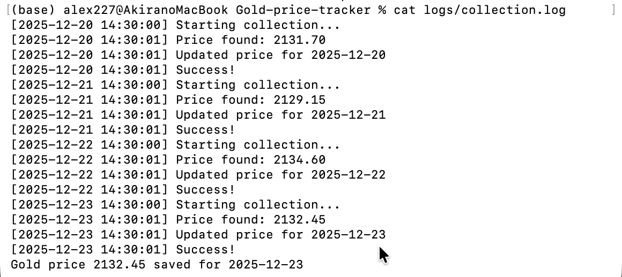
Figure 1: The terminal showing the data collection script was successful

2. Unix Script for Plotting

In accordance with the need for at least ten different plots, it exports data from MySQL into a temporary <.dat> file, which Gnuplot then processes using a sequence of "Heredocs."
# | Plot Type | Description | File Name
1 | Gain/Loss | Displays the total profit or loss from the initial price, with green (gain) and red (loss) filled regions. | <goldprice_line.png>
2 | Smoothed Trend | Filters noise by comparing the seven-day smoothed trend (blue) with the real daily prices (red). | <goldprice_smoothed.png>
3 | Weekly Range | Weekly high and low price ranges are displayed, along with a filled area that illustrates weekly volatility. | <goldprice_weeklyrange.png>
4 | Data Points | Uses <linespoints> to highlight particular collection dates with markers. | <goldprice_points.png>
5 | Area Chart | Highlights the amount of price change using <filledcurves>. | <goldprice_filled.png>
6 | Statistical Bands | To display volatility bands, plot the Mean, $+1$ Std Dev, and $-1$ Std Dev. | <goldprice_statistics.png>
7 | Moving Average | Employs a three-day sliding window to reduce daily "noise." | <goldprice_movingavg.png>
8 | Daily Changes | Gains (green) and losses (red) are displayed in a bar chart made with <awk>. | <goldprice_changes.png>
9 | Recent Trend | A seven-day "Zoom" that focuses on the most recent market movement utilising <tail>. | <goldprice_recent.png>
10 | Histogram | Uses the binning technique to display the frequency of price ranges (Distribution). | <goldprice_histogram.png>
11 | Volatility | Calculates and plots the daily variance $(Price_n - Price_{n-1})^2$ using <awk>. | <goldprice_volatility.png>
12 | Weekly Avg | Uses <awk> to group data into seven-day segments for long-term trend analysis. | <goldprice_weekly.png>

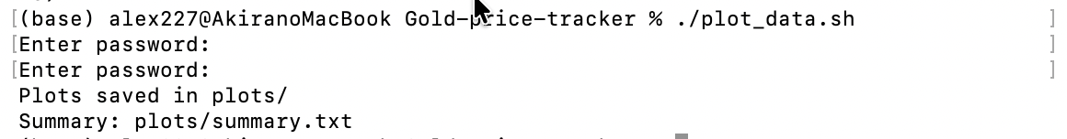
Figure 2: The terminal showing the data plotting script was successful
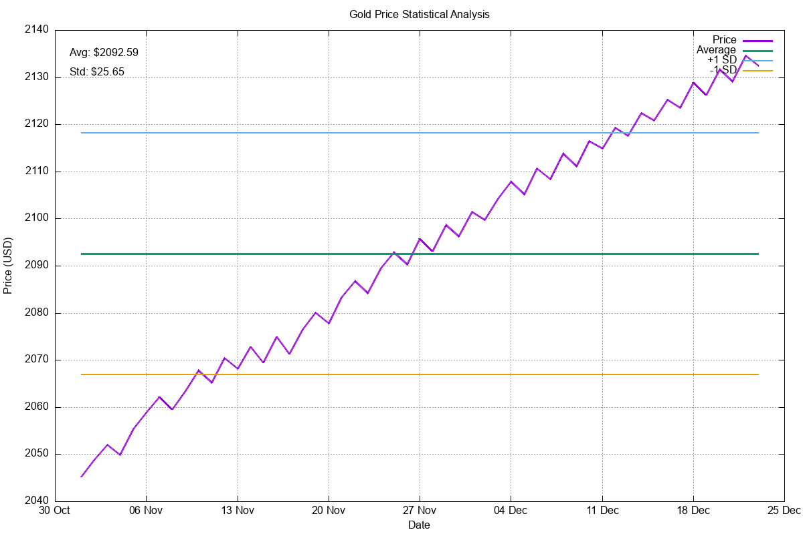
Figure 3. Statistical Bands <goldprice_statistics.png>
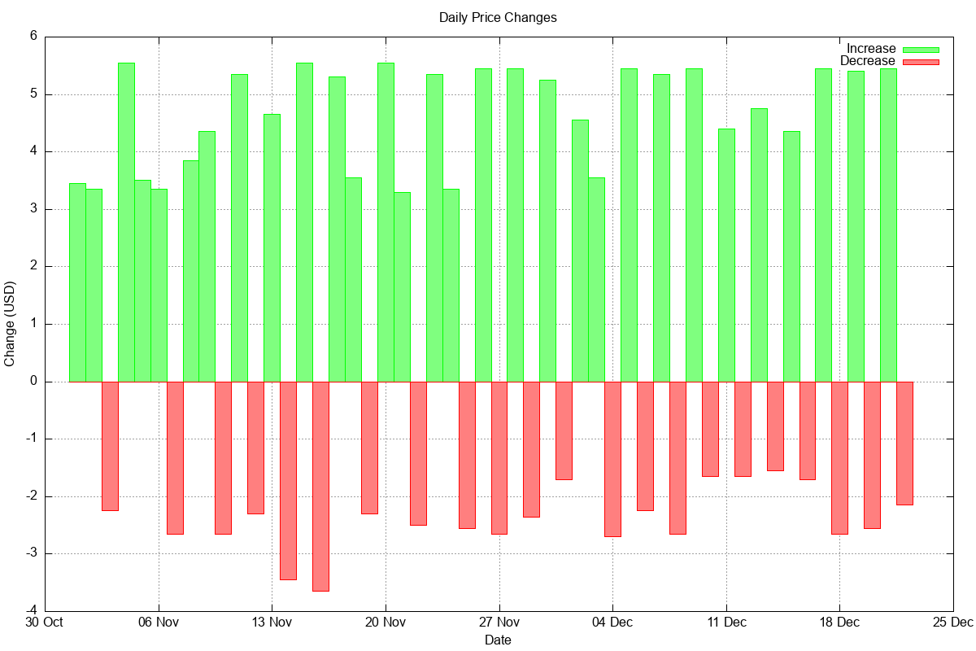
Figure 4. Daily Changes <goldprice_changes.png>
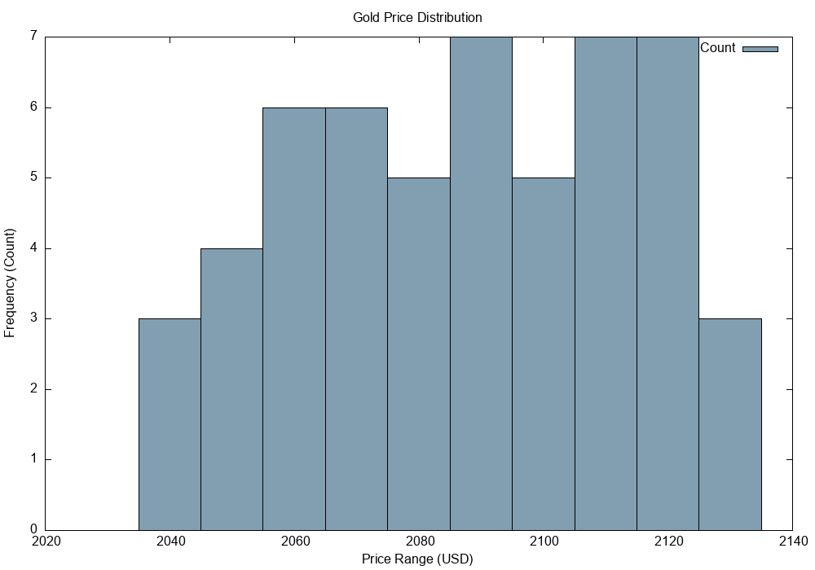
Figure 5. Histogram <goldprice_histogram.png>
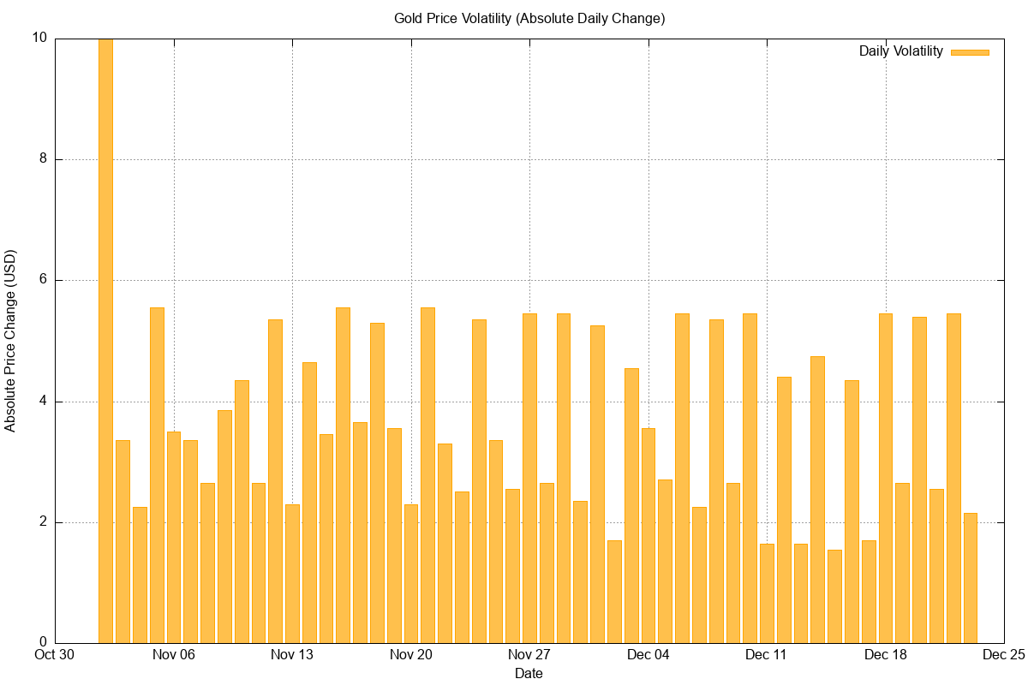
Figure 6. Volatility <goldprice_volatility.png>
The remaining eight figures can be found in the GitHub repository as well as in the uploaded ZIP file.

3. Use of Git for Version Control

The project keeps a clear history, with over ten commits spread over more than a week, as necessary.

3.1 Commit Strategy

Iterative development is shown in the repository:
• Early Phase: Initial project setup (Dec 16–17).
• Development Phase: Code cleanup, data collection, and plotting scripts (Dec 17–19).
• Testing Phase: macOS compatibility fixes, data validation, and 53 days of sample data (Dec 21).
• Optimisation: Database refinements, plot improvements, and adding 10 visualisations (Dec 22–25).
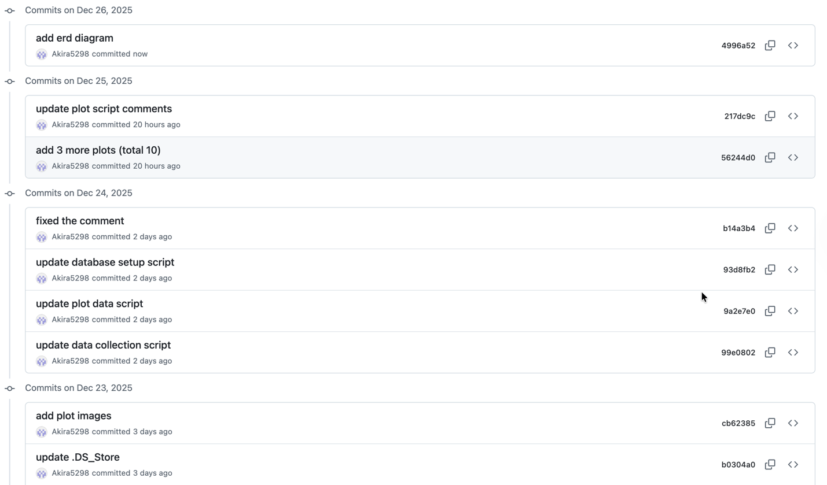
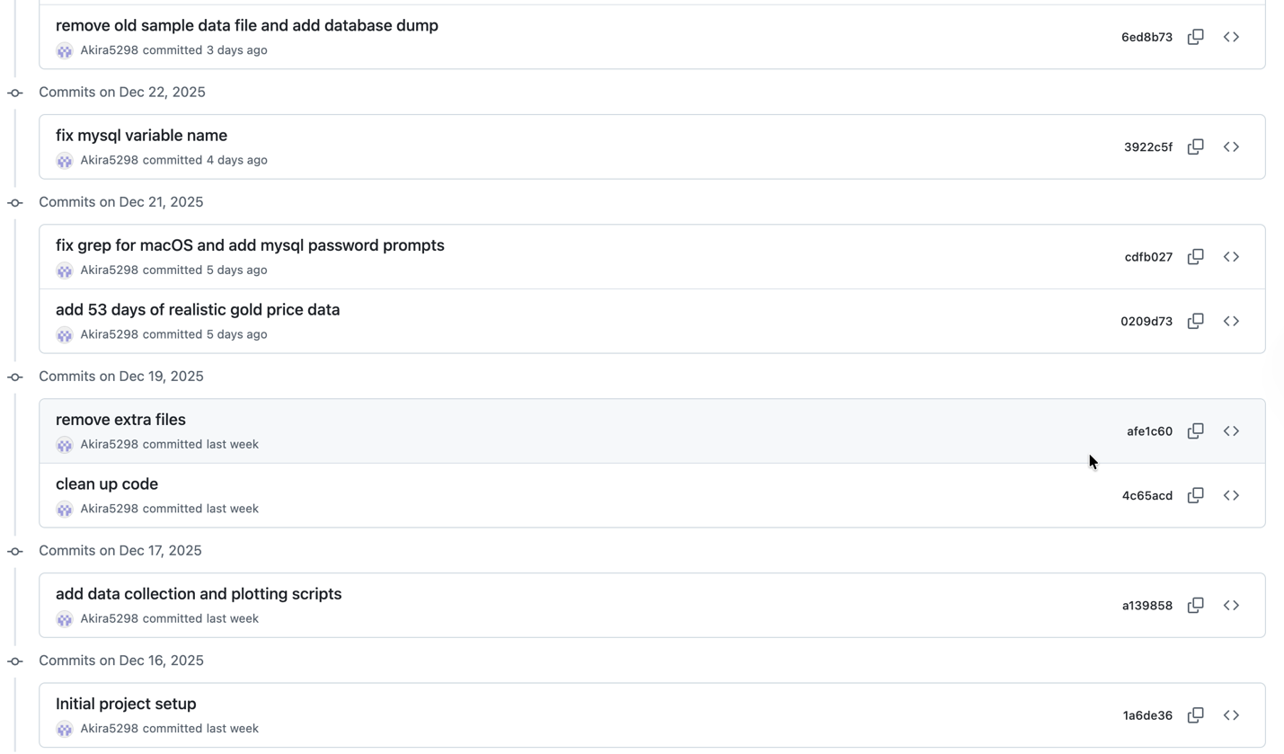
Figure 7: Git commit history illustrating progressive development over time

3.2 Repository Management
- Structure: Organised into </logs>, </plots>, and root-level scripts.
- Best Practices: Used <.gitignore> to prevent logging credentials or temporary <.dat> files from being uploaded to the public repository.
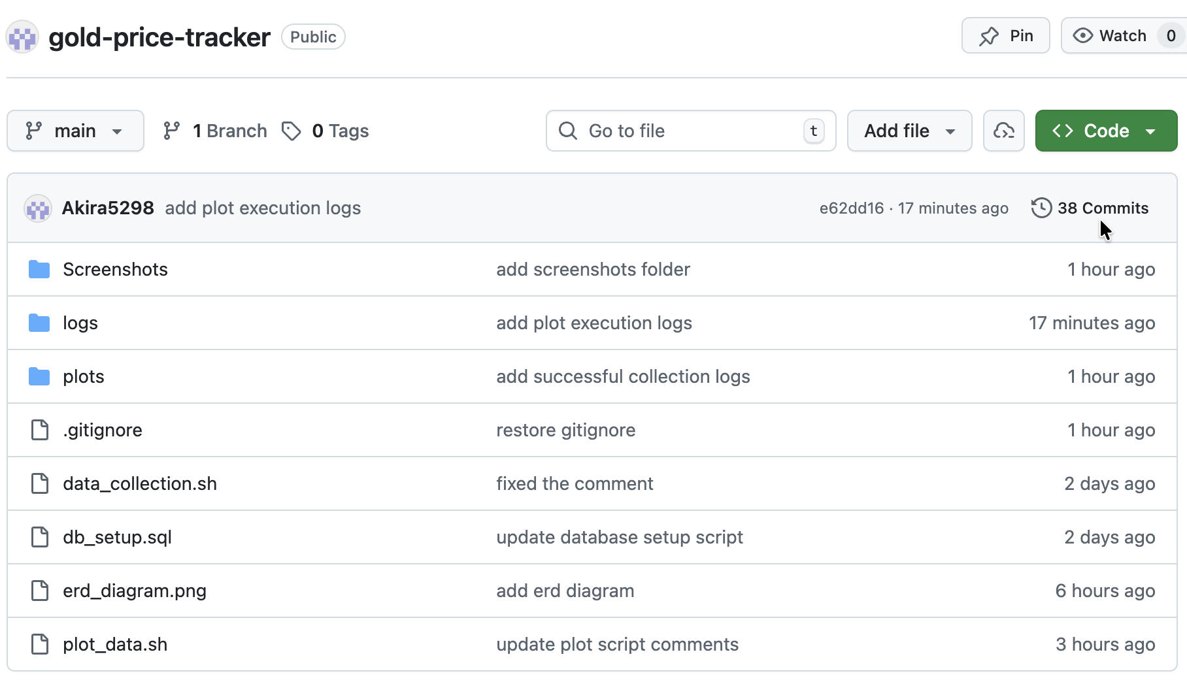
Figure 8: GitHub repository structure containing data collection, plotting, database scripts, etc.

4. MySQL for Data Storage

4.1 Database Design and Normalisation
Using MySQL rather than plain text files allows structured storage, the avoidance of duplicate records, effective searching, and long-term historical analysis.
The <goldtracker> database employs three specific tables to guarantee normalisation to prevent a flat-file structure:
- <goldprice> Table: Stores raw daily data. To avoid duplicate data for the same day, the <collecteddate> column is marked <UNIQUE>.
- <pricestatistics> Table: To enhance plotting efficiency, pre-calculated metrics (Weekly/Monthly Averages) are stored here.
- <collectionlogs> Table: Keeps track of each run's status (SUCCESS/FAILED) to look for any errors.
To illustrate table relationships, an Entity Relationship Diagram (ERD) was created.
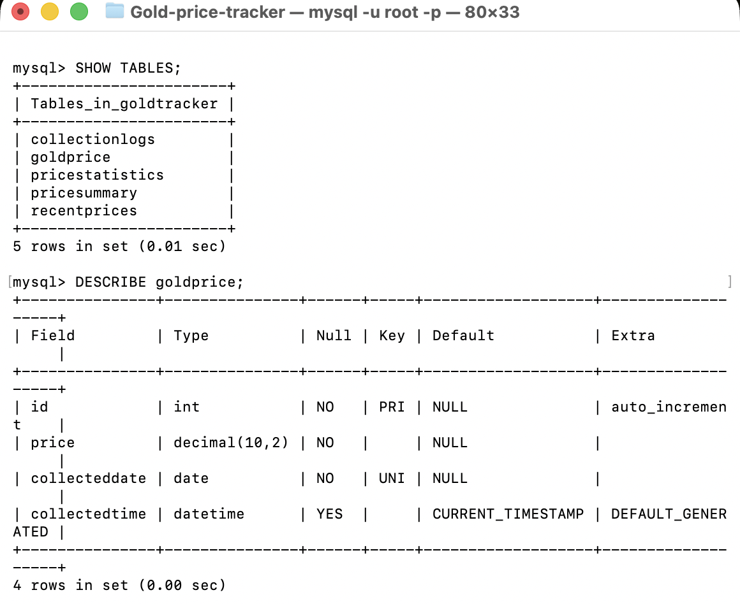
Figure 9: MySQL database structure and goldprice table schema
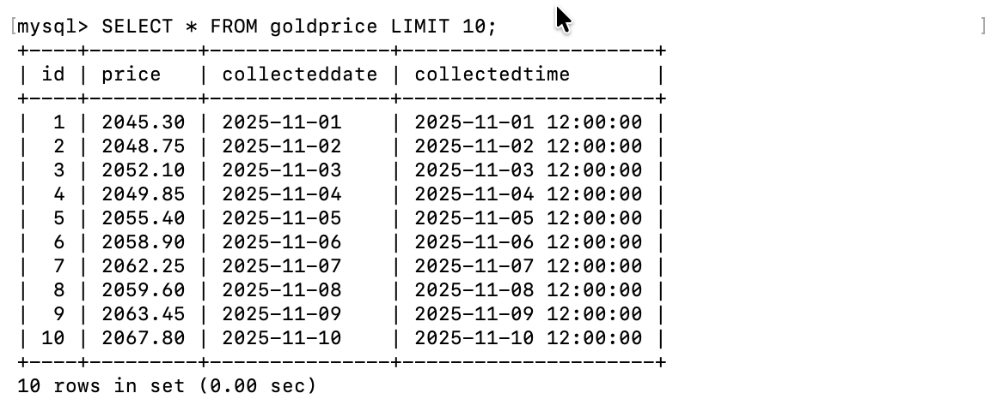
Figure 10: Sample gold price records stored in the goldprice table
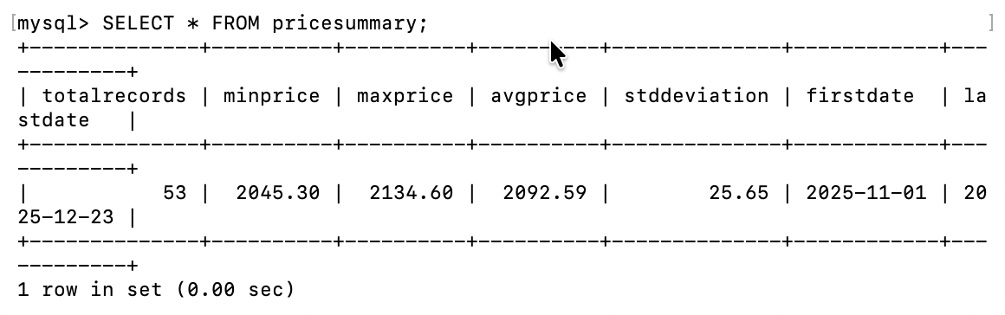
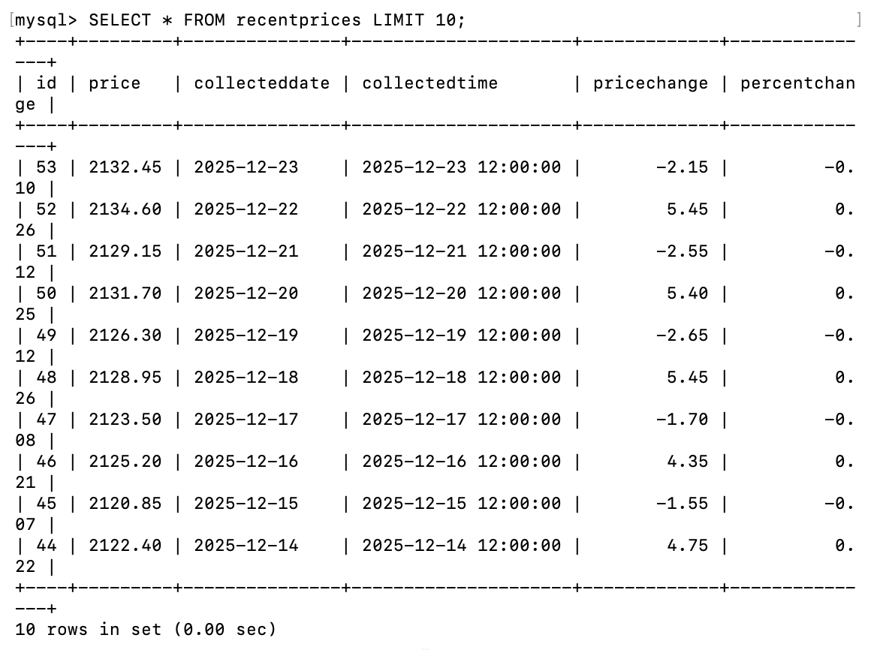
Figure 11: Database views displaying recent price changes and summary statistics
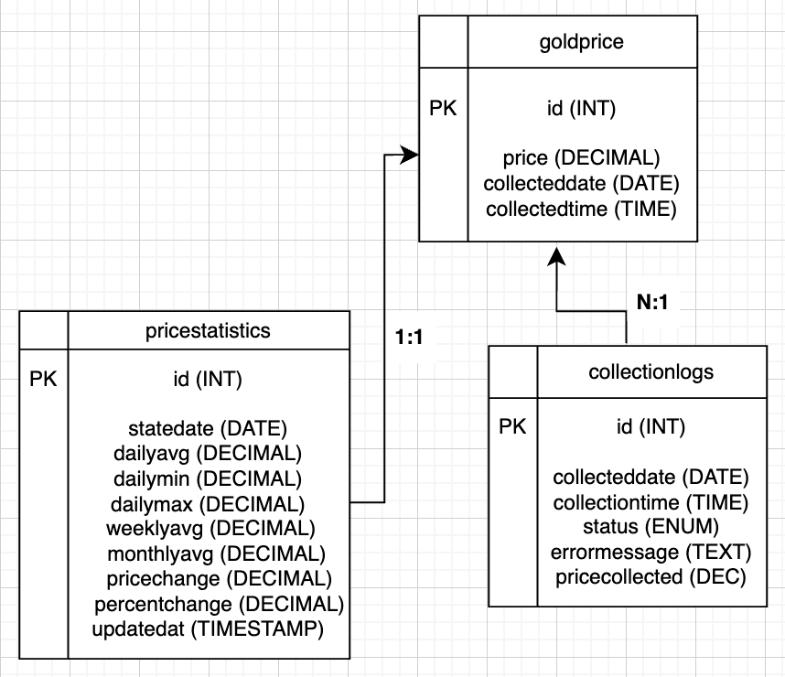
Figure 12: Entity Relationship Diagram (ERD) created using draw.io

4.2 Analytical Views

To make complicated queries easier to understand, I created two SQL views:
- <recentprices>: Enables automatic calculation by using the <LAG()> window function to determine the price difference between each day and the prior day.
- <pricesummary>: Offers a "snapshot" of the full dataset (Min, Max, Avg, and Std Dev).

5. Conclusion
This project effectively illustrates an end-to-end automated data management system that includes thorough analysis and visualisation (Gnuplot), organised data storage (MySQL), and dependable data collecting (Unix/CURL).
System reliability is maintained by error handling, logging, and data validation, and the normalised database design facilitates scalability and long-term historical tracking.

