Team 9: Akira Doi,
Professor Malik Luti
CECS 429 Sec02
09/27/2026
Assignment 2
Part 0: Generating N-Grams
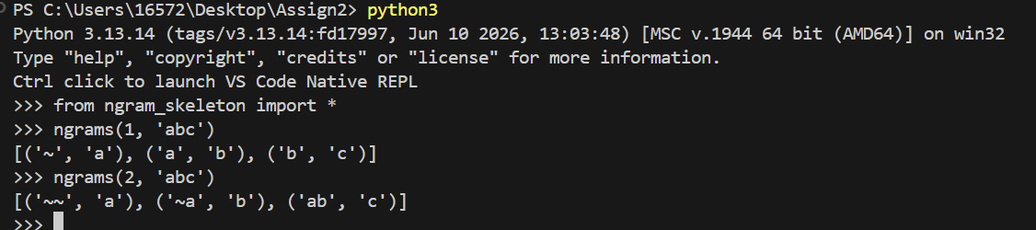
We updated the code to implement N-grams. The resulting screenshot is shown above. The input consists of numbers and text. The text is being checked by one character at a time, and the specified number of characters preceding that character is displayed together with that text. We confirmed that it behaves as expected based on the properties of the n-gram.

Part 1: Creating an N-Gram Model
1-2. update(self, text) and prob(self, context, char)
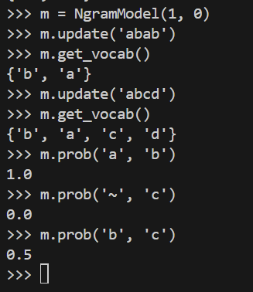
We updated the methods “update(self, text)” and “prob(self, context, char)” in the skeleton code and achieved results matching the example. For example, we have padded text “~abab” and “~abcd.” The letter ‘a’ appears a total of three times, and the sequence “ab” also appears three times. Therefore, the result is 1.0.

1-3. random_char(self, context)
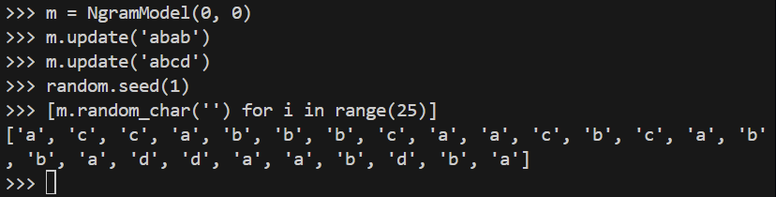
We tested command “random_char(self, context).” From the commands, we have “abab” and “abcd” as training texts. Since there are a total of eight characters and ‘a’ and ‘b’ are more frequent, we should see those characters appear more often in the random output generated by “random_char(self, context)”. The results matched the example, confirming that our assumption was correct.

1-4. random_text(self, length)
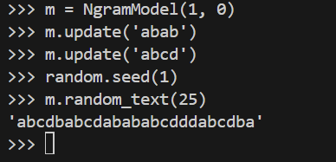
We obtained results matching the example because the random number seed was set to 1. The text generated by “random_text(self, length)” is composed of elements from the trained text. Therefore, it has been implemented correctly.

Writing Shakespeare:
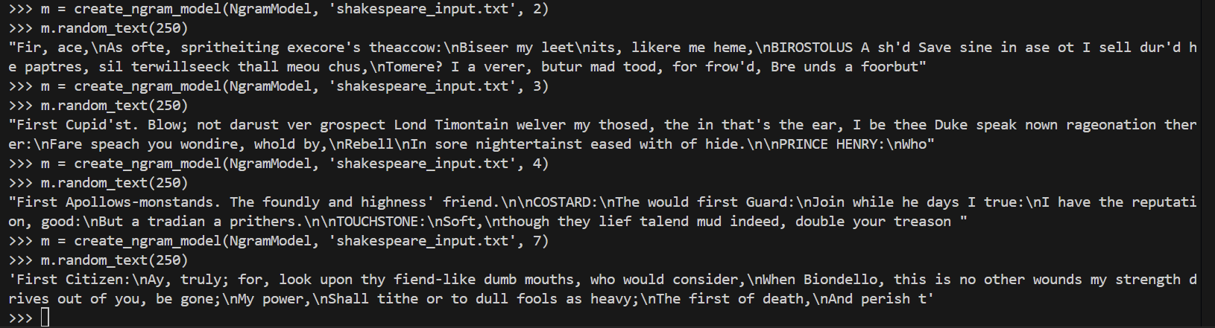
What do you think?
Based on the results, the most important aspect of this command “m = create_ngram_model()” is the numbers. In this command, “shakespeare_input.txt” is loaded as the training text, and random text is generated by setting the value of N for the N-gram. The larger the value of n provided resulted in the generation of more meaningful text. The word “first” was not fully visible when n = 2. The word “citizen,” which follows it, finally became visible when n = 7. Because the text is referenced by going back n-characters. Therefore, commands with larger values of n took longer to produce results but generated text that made more meaningful sense.

Part 2: Perplexity, Smoothing, and Interpolation
・Perplexity
First, we try the example provided.
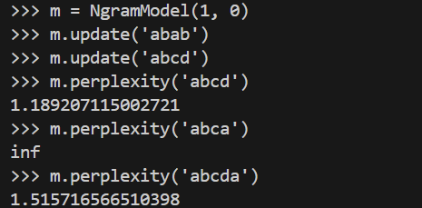
In this example, the N-grams with zero smoothing of the unigrams. As training data, “abab” and “abcd” are used. These are evaluated using m.perplexity(). Perplexity is used to determine whether a language model is good. In the case of the variable ‘abcd’, a smaller value is derived because its pattern is more similar to the training model than that of ‘abcda’. A lower perplexity value indicates that the text and the training model’s probabilities are higher. Also, the probability of ‘abca’ is 0, so it returns inf as specified in the instructions.
Now, discuss the perplexity for text that is similar and different from Shakespeare’s plays.
(We evaluated the “shakespeare_input.txt” file used in the previous part, along with the two provided text files, “nytimes_article.txt” and “shakespeare_sonnets.”)
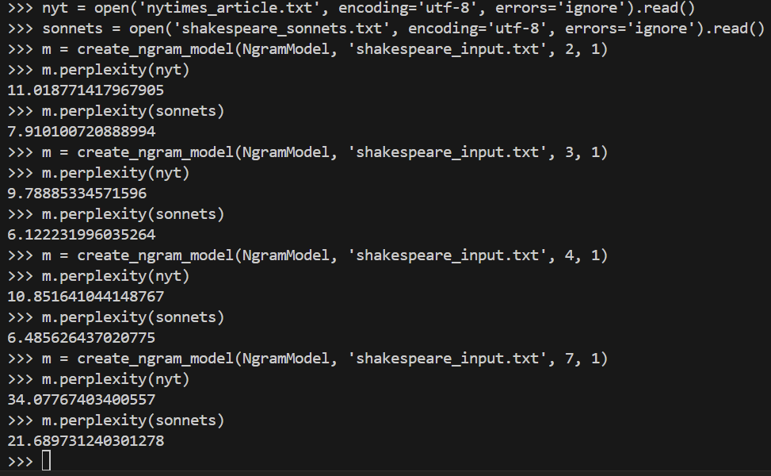
The training data is “shakespeare_input.txt,” and we are comparing results while varying the value of N.

