Username_LastName_ExamModelA

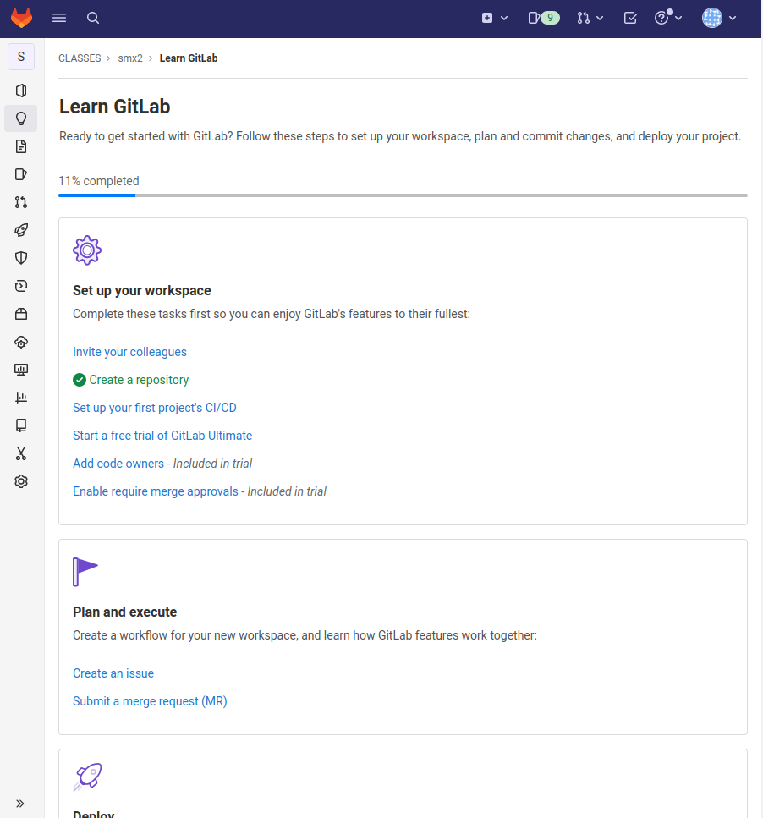

https://gitlab.com/classes5/smx2/

