Assignment No 1: configure httpd server using Jenkins.

Step 1 : Launch 1 EC@ instance with below configuration

1.java installation - e,g java 11

>>amazon-linux-extras install java-openjdk11 -y

2.git install

>>yum install git -y

3.Configure Tomcat server -9 (version 9 )

>>wget <https://dlcdn.apache.org/tomcat/tomcat-9/v9.0.82/bin/apache-tomcat-9.0.82.zip>

>>unzip apache-tomcat-9.0.82.zip

>> chmod -R 777 apache-tomcat-9.0.82

4.hosting Jenkins in tomcat

Got webapps folder and download latest jankins jar file:

/mnt/server/apache-tomcat-9.0.82/webapps

>> wget <https://get.jenkins.io/war-stable/2.414.3/jenkins.war>

5.start the tomcat server

Go to /mnt/server/apache-tomcat-9.0.82/bin

>>./startup.sh

And hit below URL

<http://3.109.152.151:8080/jenkins/>

\*after that configure Jenkins user

Job creation on Jenkins:

Step 1: Login on Jenkins dashboard as below.

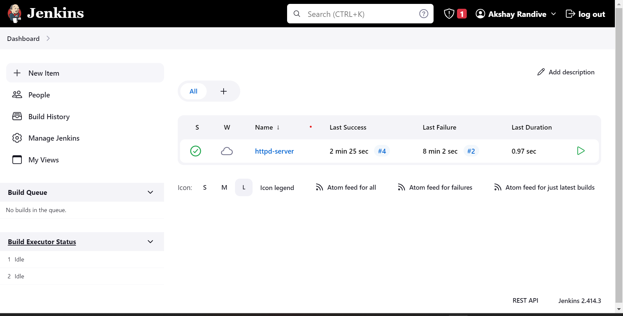

Step 2 : click on New item button and start with new job creation process.

1.enter iteam name

2.select freestyle project

Then click on “Ok ” button

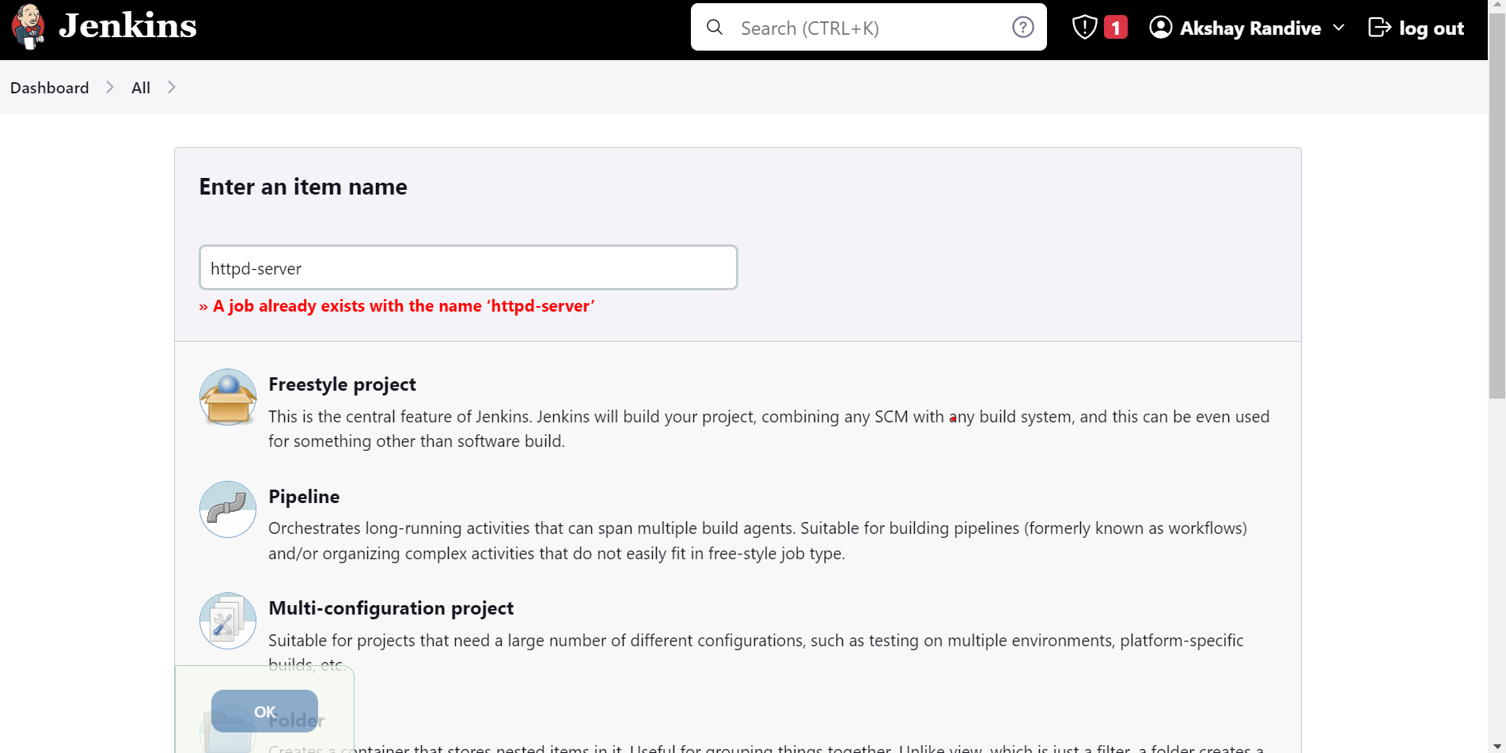

Step 3: write General description and select Build steps tab and inside that select “executed shell” option. and write shell as below

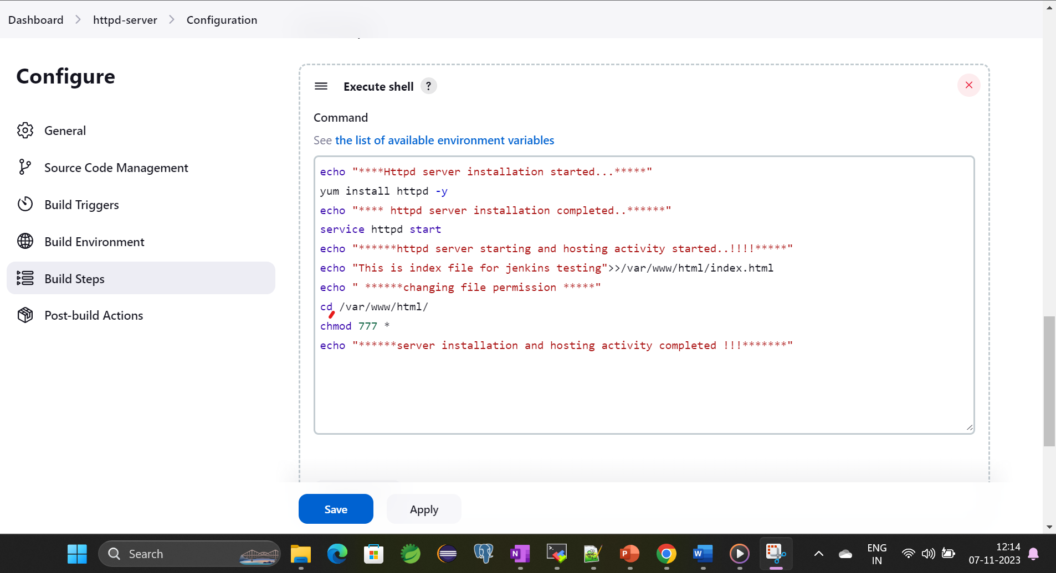

SHELL SCRIPT

echo "\*\*\*\*Httpd server installation started...\*\*\*\*\*"

yum install httpd -y

echo "\*\*\*\* httpd server installation completed..\*\*\*\*\*\*"

service httpd start

echo "\*\*\*\*\*\*httpd server starting and hosting activity started..!!!!\*\*\*\*\*"

cd /var/www/html

rm -rf \*

echo "This is index file for jenkins testing">>/var/www/html/index.html

echo " \*\*\*\*\*\*changing file permission \*\*\*\*\*"

chmod 777 \*

echo "\*\*\*\*\*\*server installation and hosting activity completed !!!\*\*\*\*\*\*\*"

Then Apply and save.

Step 4: go to dashboard select our job and click on build now

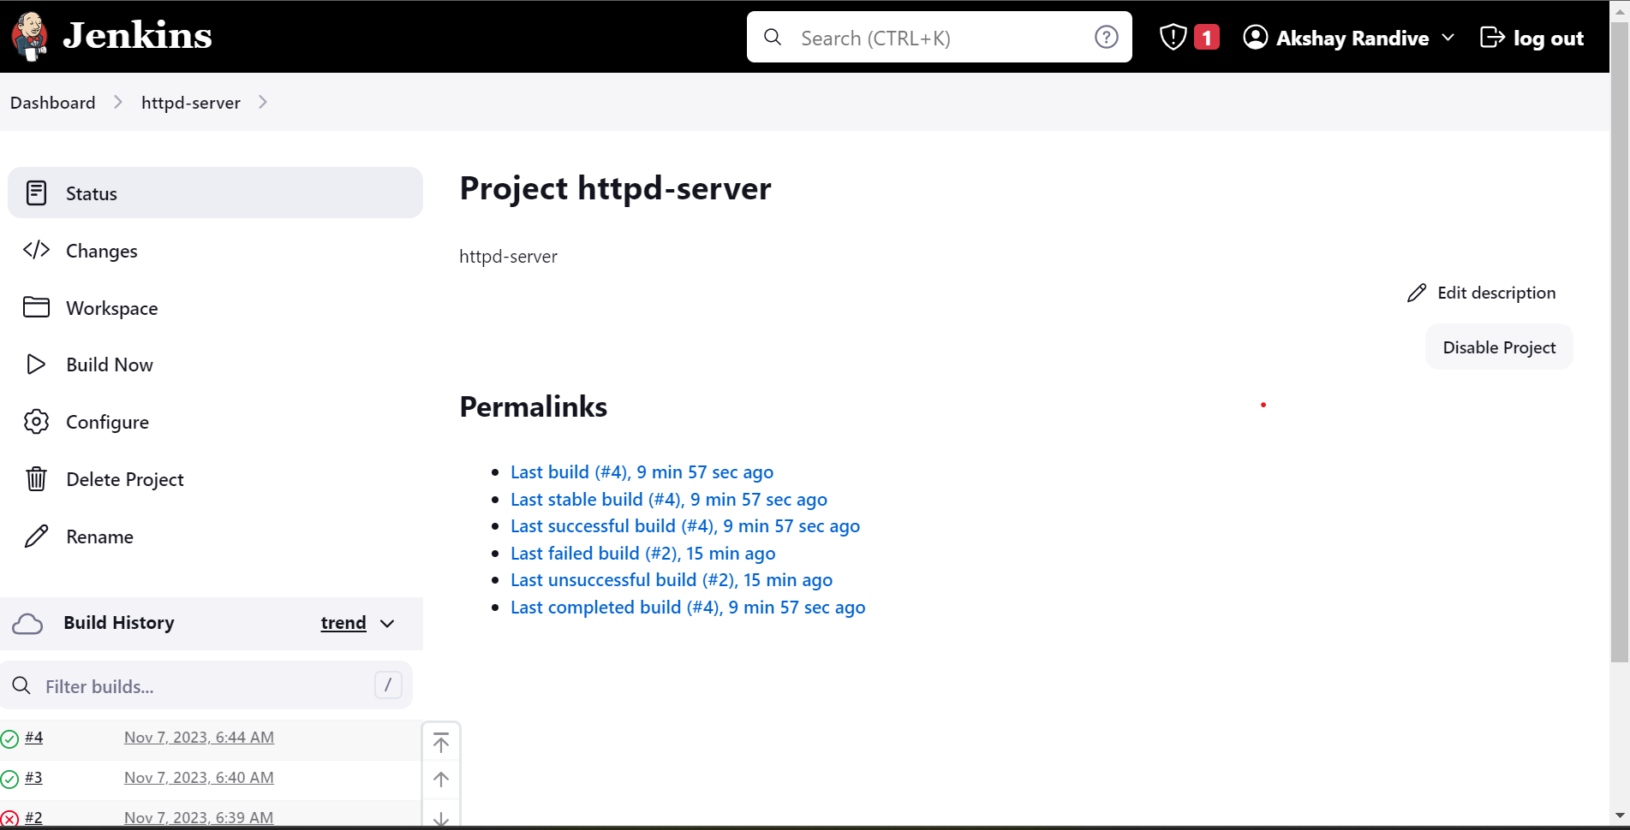

Check Console output for logs.

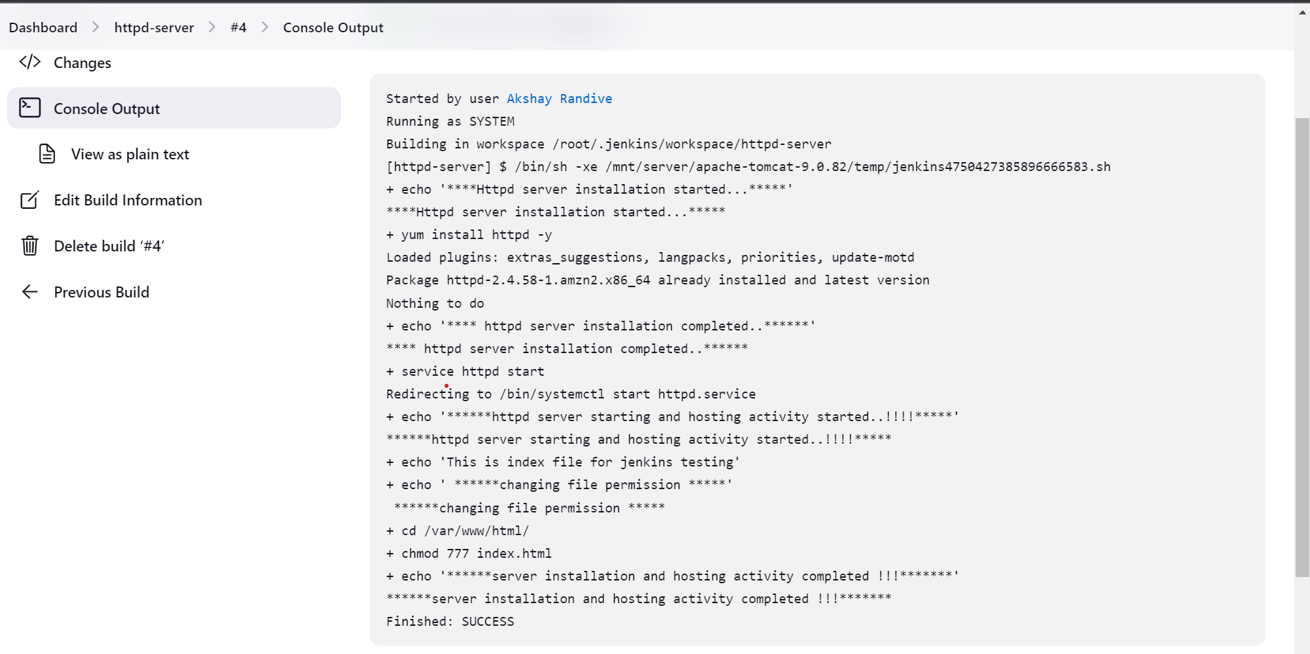

Got instance and check hosting completed or not .

