ISTANBUL KÜLTÜR UNIVERSITY • FACULTY OF ENGINEERING
SOFTWARE DEVELOPMENT WITH STANDARDS
BI-WEEKLY PROJECT PROGRESS REPORT

Report Number: | Report #1 (Weeks 1-2: 17.10 – 31.10.2026) | Submission Date: | 31.10.2026
Project Title: | MediTrace: IEC 62304-Compliant Medical Device Data Management System (SDS-02) | Project Group No.: | SDS-02 (one of the two groups assigned to Project 2)
Reference Standards: | IEC 62304:2006+A1:2015, ISO 14971:2019, IEC 60601-1-8, ISO 13485:2016, KVKK (Law No. 6698) | Overall Completion (%): | 15%
GitHub / Repo Link: | [Repository URL] | Active Sprint / Phase: | Sprint 1: Planning & Requirements Analysis
1. Executive Summary
In this first bi-weekly period the team defined MediTrace, a vital-sign data management system for a general hospital ward, and started the IEC 62304 planning (5.1) and requirements analysis (5.2) activities. The software was classified as IEC 62304 Class B, an initial SRS with 17 traceable requirements and an ISO 14971 risk analysis with 10 risks were produced, and a layered architecture on Python/FastAPI, PostgreSQL and React was drafted. A shared ID scheme (REQ/RISK/RCM/ARC/TC) and a first traceability matrix now link every requirement to a risk control, a component and a planned test. As this is the first report, there is no previous report to compare against; all key pre-coding decisions are in place, and the next period focuses on completing the SRS and building the first working skeleton. Detailed project documentation is provided in Annexes A–F.
2. Completed Work Packages and Standard Mapping
WP ID | Completed Work / Developed Module | Related Standard & Clause | Responsible Member(s) | Evidence / Deliverable (Commit ID / PR / Document Section)
WP-01 | Definition of intended use, use environment (general ward) and scope baseline (in/out of scope, assumptions) | ISO 14971:2019 - Clause 5.2 | Barış Bağbekleyen (Project & Standards Lead) | Annex A.1 – A.3
WP-02 | Study of IEC 62304 process clauses and tailoring them to the project | IEC 62304 - Clauses 5–9 | Barış Bağbekleyen (Project & Standards Lead) | Annex B.2 (process mapping table)
WP-03 | Software safety classification: Class B decision, rationale and external risk controls | IEC 62304 - Clause 4.3 | Barış Bağbekleyen (Project & Standards Lead) | Annex B.3
WP-04 | Initial SRS draft: 17 identified requirements (11 safety-related) | IEC 62304 - Clause 5.2 | Barış Bağbekleyen (Project & Standards Lead) | Annex C.1 (REQ-001 – REQ-017)
WP-05 | Risk management criteria: severity/probability scales and 5×5 risk acceptability matrix | ISO 14971:2019 - Clause 4.4 | Ege Arıcan (Risk Management Lead) | Annex C.2
WP-06 | Initial hazard identification and risk analysis: 10 risks with control measures, incl. a risk introduced by a control measure (RISK-009) | ISO 14971:2019 - Clauses 5.4, 5.5, 6, 7.1, 7.5 | Ege Arıcan (Risk Management Lead) | Annex C.3 – C.4 (RISK-001 – RISK-010)
WP-07 | Architecture draft: 9 components and requirement allocation | IEC 62304 - Clause 5.3 | Bahadır Duran (Backend & Security Developer) | Annex D.1 – D.2 (ARC-001 – ARC-009)
WP-08 | Technology selection, security approach (AES-256-GCM, JWT, Argon2) and first SOUP list | IEC 62304 - Clauses 5.3.3, 8.1.2; KVKK | Bahadır Duran (Backend & Security Developer) | Annex D.3 – D.4
WP-09 | Project repository, branching strategy and issue templates | IEC 62304 - Clauses 8 and 9 | Bahadır Duran (Backend & Security Developer) | [Repo URL / initial commit ID]
WP-10 | Dashboard screen list: login, patient list, patient detail, alarm screen, administration | IEC 62304 - Clause 5.2.2 | Mert Eser (Frontend & Test Lead) | Annex A.3, Annex D.1
WP-11 | Test strategy draft, TC-xxx convention and traceability matrix draft | IEC 62304 - Clauses 5.1.1, 7.3.3 | Mert Eser (Frontend & Test Lead) | Annex E (TC-001 – TC-017)

3. Individual Team Member Contributions and Effort Distribution
Student ID | Full Name | Role in Project | Concrete Tasks Completed in This Period | Effort Spent (Hours / % Share)
2300005352 | Barış Bağbekleyen | Project & Standards Lead | Defined intended use, use environment and scope baseline (WP-01); tailored IEC 62304 processes to the project (WP-02); performed the Class B safety classification (WP-03); drafted the SRS with 17 requirements (WP-04); compiled this progress report | 12 Hours / 25%
2300007951 | Bahadır Duran | Backend & Security Developer | Drafted the architecture with 9 components (WP-07); selected the technology stack, encryption/authentication approach and first SOUP list (WP-08); set up the repository, branching strategy and issue templates (WP-09); started the blind-index investigation (RSK-06) | 12 Hours / 25%
2300005997 | Ege Arıcan | Risk Management Lead | Defined severity/probability scales and the 5×5 acceptability matrix (WP-05); identified 10 hazards with risk control measures, including RISK-009 introduced by smart alarm validation (WP-06); proposed the critical / non-critical threshold split that resolved RSK-08 | 12 Hours / 25%
2300002912 | Mert Eser | Frontend & Test Lead | Defined the dashboard screen list (WP-10); drafted the test strategy, TC-xxx convention and the first traceability matrix linking 17 requirements to 17 planned tests (WP-11) | 12 Hours / 25%

Effort is an estimate: the total of about 48 hours for this period was shared equally among the four members. Responsibilities of each role are listed in Annex A.4.
4. Technical/Process Risks Encountered and Mitigation Actions (IEEE 1012)
Risk / Issue ID | Encountered Issue or Standard Deviation | Impact Level | Detection Method (V&V) | Mitigation / Resolution Action Taken
RSK-01 | Full texts of IEC 62304 and ISO 14971 are paid documents; no team member had access, making correct interpretation of clauses harder | Medium | Document review | Requested standards access from the university library; meanwhile used official preview pages, IEC/ISO summaries and academic sources. Status: Partially resolved
RSK-02 | Team disagreement on the software safety class (B or C); Class C would significantly increase documentation workload | High | Team review of the IEC 62304 classification flow | Applied the IEC 62304 A1:2015 classification flow step by step; fixed the use environment as a general ward, defined external risk controls (bedside monitor, nursing rounds), chose Class B and recorded the assumption in the risk file. Status: Resolved
RSK-03 | Probability of software failure could not be estimated numerically, so risk scores may be unreliable | Medium | Risk analysis review | Assumed the software can fail and estimated the probability that the hazardous situation leads to harm; values will be updated with hazard-log data. Status: Partially resolved
RSK-04 | Without a real medical device, realistic faulty data is hard to produce; tests may miss real failure modes | Medium | Test design review | Derived simulator scenarios from the risk table (disconnection, artefacts, unpaired device); researching open vital-sign datasets (e.g. PhysioNet). Status: Partially resolved
RSK-05 | Scope grew quickly during brainstorming (HL7/FHIR, mobile app, decision support, three extra features) | High | Requirements / scope review | Wrote explicit in-scope and out-of-scope lists; marked the trend alert as optional and noted other ideas as future extensions. Status: Resolved
RSK-06 | Fields encrypted with AES-GCM (e.g. patient names) cannot be searched or sorted; patient search conflicts with REQ-010 | Medium | Design review (requirements vs. architecture consistency) | Investigating an HMAC-based "blind index" for searchable fields; alternatively, search limited to the patient number. Status: Open
RSK-07 | Overlapping course schedules made it hard for four members to meet, delaying decisions | Low | Sprint retrospective | Set a fixed weekly online meeting; work is assigned and tracked through GitHub Issues. Status: Resolved
RSK-08 | Smart alarm validation (waiting for consecutive readings) conflicted with the 3-second alarm requirement REQ-004 and risked delaying real alarms (RISK-009) | High | Requirements consistency analysis / traceability review | Split thresholds into critical and non-critical; critical thresholds skip validation and alarm immediately, and the REQ-004 deadline is measured from the end of validation. Status: Resolved

RSK-xx entries are project/process issues. Product hazards are tracked separately as RISK-xxx in the ISO 14971 risk analysis (Annex C). Open and partially resolved issues will be reported again with their current status in Report #2.
5. Next Bi-Weekly Sprint Plan
Goal ID | Planned Work / Deliverable | Related Standard Criterion | Responsible Team Member & Target Date
PLN-01 | Complete the SRS with acceptance criteria for every requirement | IEC 62304 - Clause 5.2 | Barış Bağbekleyen - 15.11.2026
PLN-02 | Write the Software Development Plan (SDP) | IEC 62304 - Clause 5.1 | Barış Bağbekleyen - 15.11.2026
PLN-03 | Write the risk management plan; evaluate additional measures for RISK-002 and RISK-005; confirm critical / non-critical smart-alarm thresholds against the literature | ISO 14971:2019 - Clauses 4.4, 7.1 | Ege Arıcan - 15.11.2026
PLN-04 | FastAPI project skeleton, database schema and first version of the device simulator | IEC 62304 - Clauses 5.3, 5.5 | Bahadır Duran - 15.11.2026
PLN-05 | Conclude the blind-index investigation and close RSK-06 | IEC 62304 - Clause 5.3; KVKK | Bahadır Duran - 15.11.2026
PLN-06 | Screen wireframes for all dashboard screens | IEC 62304 - Clause 5.2.2 | Mert Eser - 15.11.2026
PLN-07 | Test plan document, first automated test on CI, and the code/test tagging format used by the compliance report | IEC 62304 - Clauses 5.5, 5.7, 7.3.3 | Mert Eser - 15.11.2026
PLN-08 | Finalize role assignments, pin SOUP versions and jointly review the architecture document | IEC 62304 - Clauses 5.3.6, 8.1.2 | All members - 15.11.2026

Annexes – Detailed Project Documentation
The annexes below contain the full project documentation produced in this period and referenced in Sections 2–5.
Annex A – Project Definition
A.1 Project Description and Objectives
MediTrace is a data management system that collects patients' heart rate, blood pressure and oxygen saturation (SpO₂), stores them securely, and alerts clinical staff when values become abnormal. It is developed through a process compliant with IEC 62304 (medical device software life cycle) and ISO 14971 (risk management).
Problem statement: On hospital wards, vital signs often remain on the device screen or are recorded by hand. This leads to data loss, late detection of critical values, and no record of who accessed which data. Because such failures directly affect patient safety, how medical software is developed matters as much as what it does.
Objectives:
- Collect and validate vital-sign data from simulated medical devices in near real time.
- Store the data in an encrypted database and restrict access to authorized roles (RBAC).
- Raise alarms on threshold violations and automatically log hazardous events (data loss, implausible readings, unauthorized access attempts).
- Run development according to the IEC 62304 activities: planning, requirements analysis, architectural design, implementation, verification and release.
- Perform risk analysis according to ISO 14971 and link every risk control measure to a requirement and a test.
- Produce a traceability matrix linking requirements → risks → design → tests.
Expected deliverables:
- A working web application (device simulator, backend service, monitoring dashboard)
- Risk analysis matrix and software hazard logging module
- Requirement–test traceability matrix
- RBAC and an encrypted database layer
- IEC 62304 documentation set: Software Development Plan, SRS, architecture document, test plan and reports, release notes
A.2 Distinguishing Features
- Smart alarm validation: Alarms are raised for threshold violations confirmed by consecutive readings, not by a single faulty reading. The goal is to reduce alarm fatigue; for critical thresholds the alarm is raised immediately without waiting for confirmation.
- Automated compliance report: The traceability matrix and an IEC 62304 compliance summary (PDF) are generated automatically from REQ/RISK/TC tags in the code and tests; requirements without a passing test are flagged.
- Trend alert (optional): An early warning that detects slow deterioration before a threshold is crossed (e.g. SpO₂ falling steadily over an hour). It will be added in the Report #4 period if time allows.
Note: This is an educational project. No real patient data will be used; all data is generated by the simulator.
A.3 Project Scope
The scope is sized so that four people can complete it within one semester while still demonstrating every main process of the standards.
In scope:
- A device simulator producing heart rate, systolic/diastolic blood pressure and SpO₂ (including normal, boundary and faulty-data scenarios)
- A backend service that receives, validates and stores readings in encrypted form
- Per-patient configurable thresholds, alarms with three priority levels and consecutive-reading smart validation; optionally, trend alerts
- A hazard logging module that records hazardous events together with their risk ID
- RBAC with Admin, Doctor, Nurse and Auditor roles
- An audit log recording every data access and change
- A web-based monitoring dashboard with a patient list, live charts and an alarm screen
- IEC 62304 and ISO 14971 documentation, with an automatically generated traceability matrix and compliance report
Out of scope:
- Hardware integration with real medical devices (HL7/FHIR integration noted only as a future extension)
- Decision-support functions that diagnose or recommend treatment
- A mobile application
- Formal CE/MDR certification and clinical validation
- A full usability engineering file under IEC 62366
Assumptions:
- The system is designed for a single general hospital ward, running on the local network.
- The simulator represents the data format and failure modes of a real device.
- The system's alarms do not replace clinical observation; they are supplementary alerts.
A.4 Roles and Responsibilities
Role | Member | Main Responsibilities
Project & Standards Lead | Barış Bağbekleyen | Software development plan, requirements (SRS), safety classification, traceability matrix, compiling progress reports
Risk Management Lead | Ege Arıcan | ISO 14971 risk analysis, risk matrix, alarm logic, hazard logging module
Backend & Security Developer | Bahadır Duran | API, database, encryption, role-based access control (RBAC), audit log, device simulator
Frontend & Test Lead | Mert Eser | Monitoring dashboard and alarm screen, test plan, unit/integration/system tests

Each member writes the unit tests for their own module. The Project & Standards Lead and the Frontend & Test Lead jointly maintain the requirement-to-test mapping.
A.5 Team Meetings and Identification Conventions
- Meeting 1 – [date]: Selection of the project topic, communication and working arrangements
- Meeting 2 – [date]: Decisions on scope, use environment, safety class, technology stack and distinguishing features; review of the first requirement and risk lists
A shared ID scheme keeps all documents traceable; the IDs are used as comments or tags in code and tests so that the traceability matrix and compliance report can be generated automatically:
- REQ-xxx: software requirement
- RISK-xxx: risk record
- RCM-xxx: risk control measure
- ARC-xxx: architectural component
- TC-xxx: test case
Annex B – Applicable Standards and Safety Classification
B.1 Applicable Standards and Their Impact
Standard | Subject | Impact on the Project
IEC 62304:2006 + A1:2015 | Medical device software life cycle processes | Defines the development process, documents and the activities required for the safety class
ISO 14971:2019 | Risk management for medical devices | Hazard identification, risk estimation (severity × probability), risk control measures, residual risk evaluation
IEC 60601-1-8 | Alarm systems in medical electrical equipment | Reference for alarm priority levels (high / medium / low) and alarm acknowledgement behaviour
ISO 13485:2016 | Quality management system for medical devices | The quality framework assumed by IEC 62304; reference for documentation and record-keeping discipline
KVKK (Turkish Law No. 6698) | Personal data protection | Health data is a special category of personal data: encryption, access control and access logging are treated as mandatory

B.2 IEC 62304 Processes Applied in the Project
Clause | Process | Implementation in the Project
4.3 | Software safety classification | Class B decision (Annex B.3)
5.1 | Software development planning | Software Development Plan (SDP), two-week iterations
5.2 | Software requirements analysis | SRS with REQ-xxx identifiers
5.3 | Software architectural design | Component diagram and interface definitions
5.4 – 5.5 | Detailed design, unit implementation and verification | Module designs, code review, unit tests
5.6 – 5.7 | Integration and system testing | Test plan, TC-xxx test cases and test reports
5.8 | Software release | Release notes, list of known anomalies
7 | Software risk management | Risk file together with ISO 14971, RISK-xxx records
8 | Configuration management | Git branching strategy, release tags, SOUP list
9 | Problem resolution | Defect tracking, analysis and closure via GitHub Issues

For Class B, IEC 62304 requires the software to be divided into units (5.4.1), while the detailed design of each unit (5.4.2) is mandatory only for Class C. To strengthen traceability, the team decided to also prepare detailed designs for safety-critical modules such as alarm handling and data validation.
B.3 Software Safety Classification (IEC 62304 Clause 4.3)
MediTrace is classified as Class B software. The decision considers the worst harm the software could contribute to, together with risk control measures external to the software.
Class | Definition (IEC 62304 A1:2015) | Assessment
A | The software cannot contribute to a hazardous situation, or cannot lead to unacceptable risk | Not applicable: a missed alarm could contribute to patient harm
B | Unacceptable risk is possible, but the resulting harm is non-serious injury | Selected
C | Death or serious injury is possible | Not applied because of the external risk controls below

Rationale:
- The intended use environment is a general hospital ward.
- MediTrace is positioned as a secondary (central) monitoring system that does not replace bedside monitors. The bedside device's own alarm is the primary risk control.
- The nurses' periodic rounds and manual measurements form a second external risk control.
- Thanks to these two external controls, a software failure in MediTrace alone is not expected to cause death or serious injury; the worst case is delayed intervention resulting in non-serious harm.
Obligations that Class B brings:
- Software development plan, requirements analysis and architectural design are mandatory
- Dividing the software into units, unit verification, integration testing and system testing are mandatory
- Third-party components (SOUP) must be listed with their required functions and performance
- Software items used as risk control measures must be verified separately
If the assumption changes (for example, if MediTrace becomes the primary alarm system or is used in intensive care), the software must be reclassified as Class C. This is recorded as an explicit assumption in the risk file.
Annex C – Requirements and Risk Analysis
C.1 Initial Requirements (SRS Draft)
The first version defines 17 requirements; 11 of them are marked as safety requirements because they directly implement a risk control measure. The list will be refined with acceptance criteria in Report #2.
ID | Requirement | Type | Priority | Related Risk
REQ-001 | The device simulator sends heart rate, systolic/diastolic blood pressure and SpO₂ for each patient once per second. | Functional | Mandatory | –
REQ-002 | The system validates every reading against a physiologically plausible range (HR 20–300 bpm, SpO₂ 50–100%, systolic 40–300 mmHg); out-of-range values are marked invalid, excluded from alarm evaluation and written to the hazard log. | Safety | Mandatory | RISK-002
REQ-003 | If no data arrives from a patient for 10 seconds, the system raises a "data loss" technical alarm. | Safety | Mandatory | RISK-001
REQ-004 | A threshold alarm appears on the dashboard within 3 seconds after validation is complete. | Performance / Safety | Mandatory | RISK-003
REQ-005 | Alarms are classified as high, medium or low priority; high-priority alarms give both visual and audible alerts. | Functional | Mandatory | RISK-003
REQ-006 | Per-patient alarm thresholds can be changed only by the Doctor role, and every change is written to the audit log. | Safety | Mandatory | RISK-004
REQ-007 | A high-priority alarm stays active until a user acknowledges it; the acknowledging user and time are recorded. | Safety | Mandatory | RISK-005
REQ-008 | Users log in with a username and password; passwords are hashed with Argon2, and the account is locked for 15 minutes after 5 failed attempts. | Safety | Mandatory | RISK-006
REQ-009 | The system supports Admin, Doctor, Nurse and Auditor roles; every API endpoint is checked against the role permission matrix. | Safety | Mandatory | RISK-006
REQ-010 | Patient identity data and readings are stored in the database encrypted with AES-256-GCM. | Safety | Mandatory | RISK-007
REQ-011 | Every data access and change is written to an append-only audit log. | Safety / Compliance | Mandatory | RISK-007
REQ-012 | The hazard logging module records hazardous events with time, patient, event type and related RISK ID. | Functional | Mandatory | All
REQ-013 | Each device is paired with exactly one patient; data from an unpaired device is rejected and written to the hazard log. | Safety | Mandatory | RISK-008
REQ-014 | The patient detail screen shows the last 24 hours of readings as a time-series chart. | Functional | Important | –
REQ-015 | For non-critical threshold violations, an alarm is raised only if the violation persists for 5 consecutive readings (5 seconds); for critical thresholds (SpO₂ < 85%, HR < 40 or > 150 bpm) the alarm is raised immediately without confirmation. | Safety | Mandatory | RISK-005, RISK-009
REQ-016 | The system automatically generates the traceability matrix and an IEC 62304 compliance summary as a PDF from REQ/RISK/TC tags in code and tests, flagging requirements with missing or failing tests. | Compliance | Mandatory | RISK-010
REQ-017 | The system raises a low-priority trend alert for values that deteriorate steadily over the last 60 minutes (e.g. an SpO₂ drop of more than 4 points) before any threshold is crossed. | Functional | Optional | –

Threshold and timing values (10 s, 3 s, 5 readings, 5 attempts) are initial estimates and will be reviewed against literature and alarm standard references in Report #2.
C.2 Risk Scales and Acceptability Criteria (ISO 14971)
Value | Severity (S) | Probability (P)
1 | Negligible: inconvenience, no harm | Very low: not expected during the system's life
2 | Minor: temporary harm, no intervention needed | Low: rarely
3 | Moderate: temporary harm requiring medical intervention | Medium: occasionally
4 | Serious: permanent harm or life-threatening | High: frequently
5 | Catastrophic: death | Very high: almost every use

Risk score = S × P. 1–4 acceptable, 5–9 ALARP (as low as reasonably practicable; must be reduced where reasonable and justified), 10–25 unacceptable. Severity values are given for the worst case, without credit for external risk controls.
C.3 Initial Risk Analysis
The initial hazard analysis identified 10 risks; 2 are unacceptable before risk control, and the proposed measures bring every risk into the acceptable or ALARP region.
Risk ID | Hazardous Situation | Possible Harm | S | P | S×P | Risk Control Measure | Req. | Residual S×P
RISK-001 | Device or network connection drops and missing data goes unnoticed | Deteriorating patient noticed late | 4 | 3 | 12 | RCM-001: technical alarm after 10 s without data | REQ-003 | 4×1=4
RISK-002 | Sensor artefact or faulty reading enters the system | False alarm, or a real alarm being masked | 3 | 4 | 12 | RCM-002: plausibility range check, marking invalid data | REQ-002 | 3×2=6
RISK-003 | Threshold alarm reaches the dashboard late | Delayed intervention | 4 | 2 | 8 | RCM-003: 3 s alarm deadline, audible high-priority alert, performance test | REQ-004, REQ-005 | 4×1=4
RISK-004 | Unauthorized user changes an alarm threshold | Alarm silenced, delayed intervention | 4 | 2 | 8 | RCM-004: threshold changes restricted to the Doctor role and logged | REQ-006 | 4×1=4
RISK-005 | Alarm closes unnoticed, or alarm fatigue develops | Critical condition missed | 3 | 3 | 9 | RCM-005: alarms stay until acknowledged, three priority levels, smart alarm validation | REQ-005, REQ-007, REQ-015 | 3×2=6
RISK-006 | Unauthorized access via password guessing or out-of-role API calls | Misuse of data or settings | 3 | 3 | 9 | RCM-006: Argon2, account lockout, per-endpoint RBAC | REQ-008, REQ-009 | 3×1=3
RISK-007 | Health data leaks after the database is compromised | Privacy breach, legal liability | 3 | 2 | 6 | RCM-007: AES-256-GCM encryption, tamper-proof audit log | REQ-010, REQ-011 | 3×1=3
RISK-008 | A reading is attached to the wrong patient | Intervention on the wrong patient | 4 | 2 | 8 | RCM-008: one-to-one device–patient pairing, rejection of unpaired data | REQ-013 | 4×1=4
RISK-009 | Smart alarm validation delays the alarm during a real deterioration | Delayed intervention | 4 | 2 | 8 | RCM-009: validation window limited to 5 s, immediate alarm for critical thresholds | REQ-015 | 4×1=4
RISK-010 | Compliance report shows an untested requirement as satisfied | An unverified safety measure reaches a release | 3 | 2 | 6 | RCM-010: report generated only from real CI test results, untested requirements flagged red | REQ-016 | 3×1=3

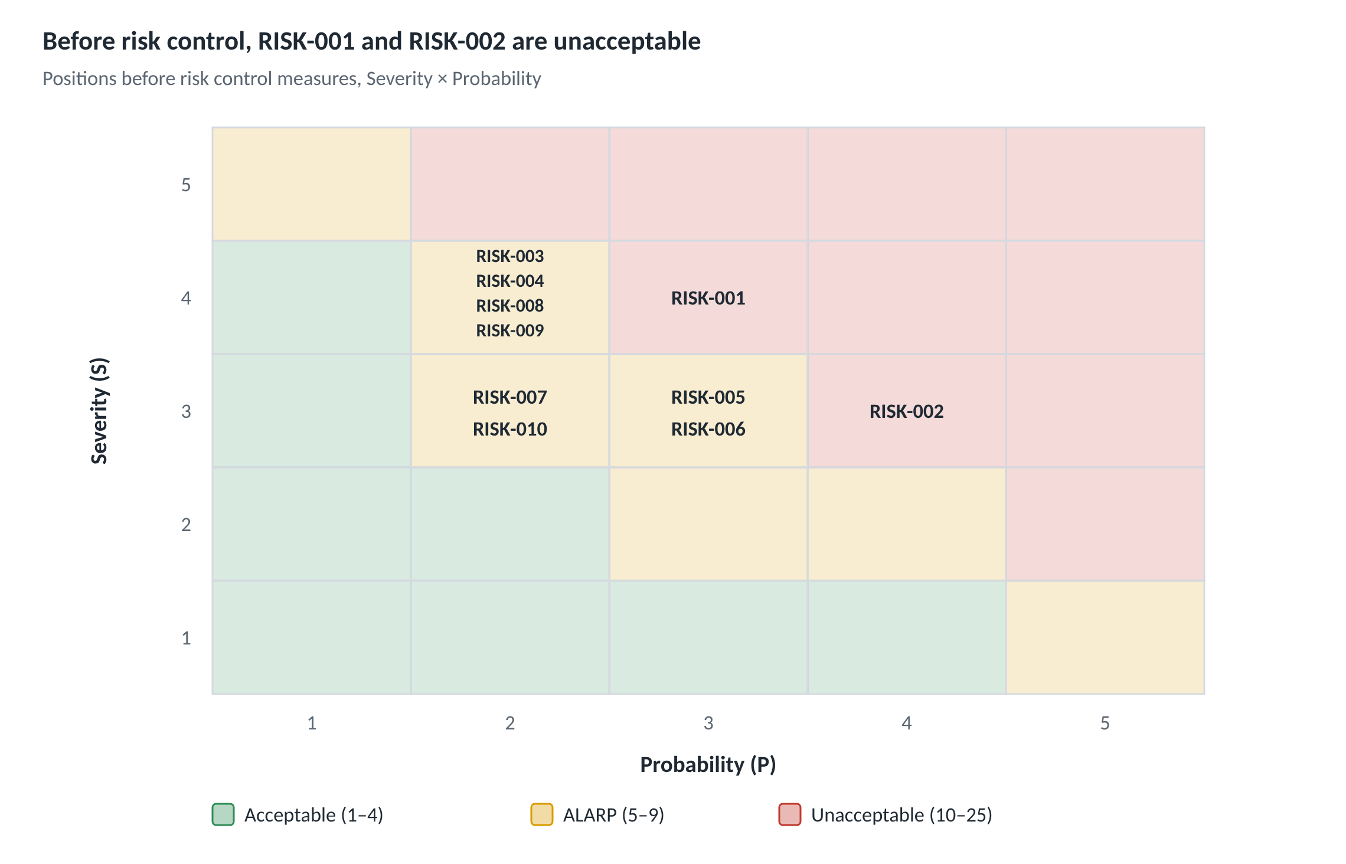
Figure 1 – Initial risk matrix: 10 risks positioned before risk control (2 unacceptable, 8 ALARP)
C.4 Notes on the Risk Analysis
- After risk control, RISK-002 and RISK-005 remain in the ALARP region. Additional measures for these two risks will be evaluated in Report #2. Probability values are initial estimates and will be updated after testing.
- A new risk introduced by a control measure: RISK-009 shows that a risk control measure such as smart alarm validation can itself create a new risk. ISO 14971 requires risks arising from control measures to be identified and evaluated as well, so RISK-009 was added as a separate record.
- Role of the hazard logging module: When one of the hazardous situations above occurs at runtime (data loss, invalid reading, rejected device data, failed login attempts), the module records the event with the related RISK ID. These records will be used to update the probability estimates with real data.
Annex D – Architecture and Technology
D.1 Architecture Draft
The system is built as a layered architecture: a device simulator, a Python/FastAPI backend service, a PostgreSQL database and a React monitoring dashboard.
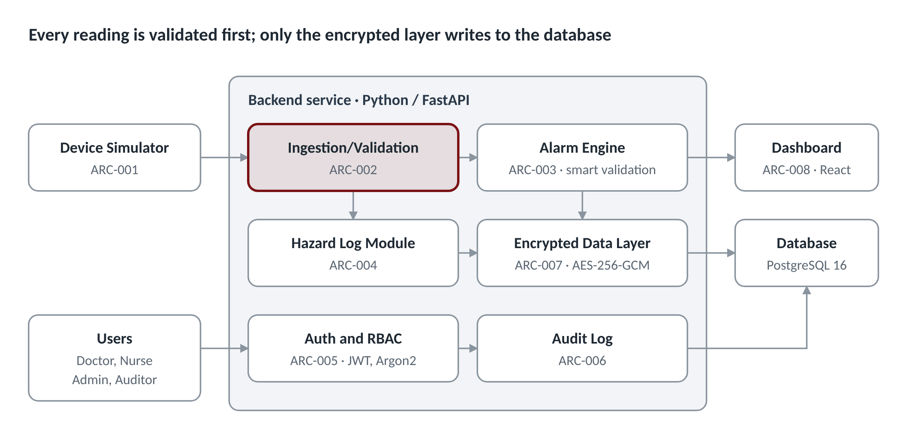
Figure 2 – MediTrace architecture draft (8 runtime components). Readings flow from the simulator to validation and the alarm engine; alarms reach the dashboard over WebSocket. User requests pass through authentication and RBAC, and every access is written to the audit log.
D.2 Architectural Components
ID | Component | Responsibility | Requirements Covered
ARC-001 | Device Simulator | Generates readings with normal, boundary and faulty-data scenarios | REQ-001
ARC-002 | Data Ingestion and Validation Service | Receives readings, checks device–patient pairing and plausibility range | REQ-002, REQ-013
ARC-003 | Alarm Engine | Threshold checks, smart alarm validation, priority assignment, data-loss detection, alarm acknowledgement, optional trend alerts | REQ-003 – REQ-005, REQ-007, REQ-015, REQ-017
ARC-004 | Hazard Log Module | Records hazardous events with their RISK ID | REQ-012
ARC-005 | Authentication and RBAC | Login, JWT, account lockout, per-endpoint authorization | REQ-006, REQ-008, REQ-009
ARC-006 | Audit Log | Records every access and change in append-only form | REQ-011
ARC-007 | Encrypted Data Access Layer | Encrypts sensitive fields on write, decrypts on read | REQ-010
ARC-008 | Monitoring Dashboard | Patient list, live charts, alarm screen, administration screens | REQ-004, REQ-005, REQ-014
ARC-009 | Compliance Reporter (CI tool) | Reads code/test tags and CI test results to generate the traceability matrix and compliance PDF; not part of the runtime system, so not shown in Figure 2 | REQ-016

D.3 Technology Stack
Layer | Technology | Rationale
Backend | Python 3.12, FastAPI | Best-known language in the team; built-in input validation (Pydantic) and automatic OpenAPI documentation
Database | PostgreSQL 16 | Strong data-integrity constraints; permissions and triggers support the append-only audit log
Encryption | cryptography library, AES-256-GCM | Widely accepted algorithm providing both confidentiality and integrity
Authentication | JWT, Argon2 (argon2-cffi) | Current recommendation for password hashing; stateless sessions
Live data | WebSocket | Persistent connection needed for the 3-second alarm requirement
Frontend | React, TypeScript, a charting library | Component-based UI; type safety catches errors early
Testing | pytest, React Testing Library | Unit and integration tests; tests can carry TC/REQ tags
Configuration management | Git, GitHub, GitHub Actions | Branching strategy, code review, automated tests on every change (IEC 62304 Clause 8)
Deployment | Docker Compose | Identical environment for every team member

D.4 SOUP and Configuration Management
SOUP (software of unknown provenance): For Class B, IEC 62304 requires third-party components to be listed with their versions and with the functional and performance requirements expected of them. FastAPI, PostgreSQL, cryptography, argon2-cffi and React form the first SOUP list; versions will be pinned in Report #2.
Branching strategy: main contains only reviewed code that passes all tests. Every task starts as an issue, is developed on a feature/REQ-xxx-short-name branch and is merged after approval by at least one other team member.
Annex E – Traceability Matrix Draft
In the first version every requirement is linked to an architectural component and at least one planned test case; since no tests have been written yet, all rows are in "Planned" status.
Req. ID | Risk | Control Measure | Component | Planned Test | Status
REQ-001 | – | – | ARC-001 | TC-001: does the simulator produce one reading per second | Planned
REQ-002 | RISK-002 | RCM-002 | ARC-002 | TC-002: is an out-of-range heart rate (350 bpm) marked invalid | Planned
REQ-003 | RISK-001 | RCM-001 | ARC-003 | TC-003: is a technical alarm raised after 10 s of data loss | Planned
REQ-004 | RISK-003 | RCM-003 | ARC-003, ARC-008 | TC-004: does the alarm appear on the dashboard within 3 s | Planned
REQ-005 | RISK-003, RISK-005 | RCM-003, RCM-005 | ARC-003, ARC-008 | TC-005: priority levels and audible alert | Planned
REQ-006 | RISK-004 | RCM-004 | ARC-005 | TC-006: does a Nurse get HTTP 403 when changing a threshold | Planned
REQ-007 | RISK-005 | RCM-005 | ARC-003 | TC-007: does an unacknowledged high-priority alarm stay active | Planned
REQ-008 | RISK-006 | RCM-006 | ARC-005 | TC-008: is the account locked after 5 failed logins | Planned
REQ-009 | RISK-006 | RCM-006 | ARC-005 | TC-009: role permission matrix test for every endpoint | Planned
REQ-010 | RISK-007 | RCM-007 | ARC-007 | TC-010: are raw database records unreadable | Planned
REQ-011 | RISK-007 | RCM-007 | ARC-006 | TC-011: is the audit log impossible to update or delete | Planned
REQ-012 | All | – | ARC-004 | TC-012: is a hazardous event logged with its RISK ID | Planned
REQ-013 | RISK-008 | RCM-008 | ARC-002 | TC-013: is data from an unpaired device rejected | Planned
REQ-014 | – | – | ARC-008 | TC-014: is the 24-hour chart drawn with the correct data | Planned
REQ-015 | RISK-005, RISK-009 | RCM-005, RCM-009 | ARC-003 | TC-015: a single outlier raises no alarm, 5 consecutive violations do; a critical threshold alarms immediately | Planned
REQ-016 | RISK-010 | RCM-010 | ARC-009 | TC-016: is a requirement without a test flagged red in the report | Planned
REQ-017 | – | – | ARC-003 | TC-017: is a trend alert raised for a slow SpO₂ drop over 60 minutes | Planned (optional)

The matrix is currently maintained by hand. From Report #3 onwards, the compliance reporter developed under REQ-016 will generate it automatically from the tags in code and tests, keeping it up to date as the code changes.
Annex F – Semester Roadmap and References
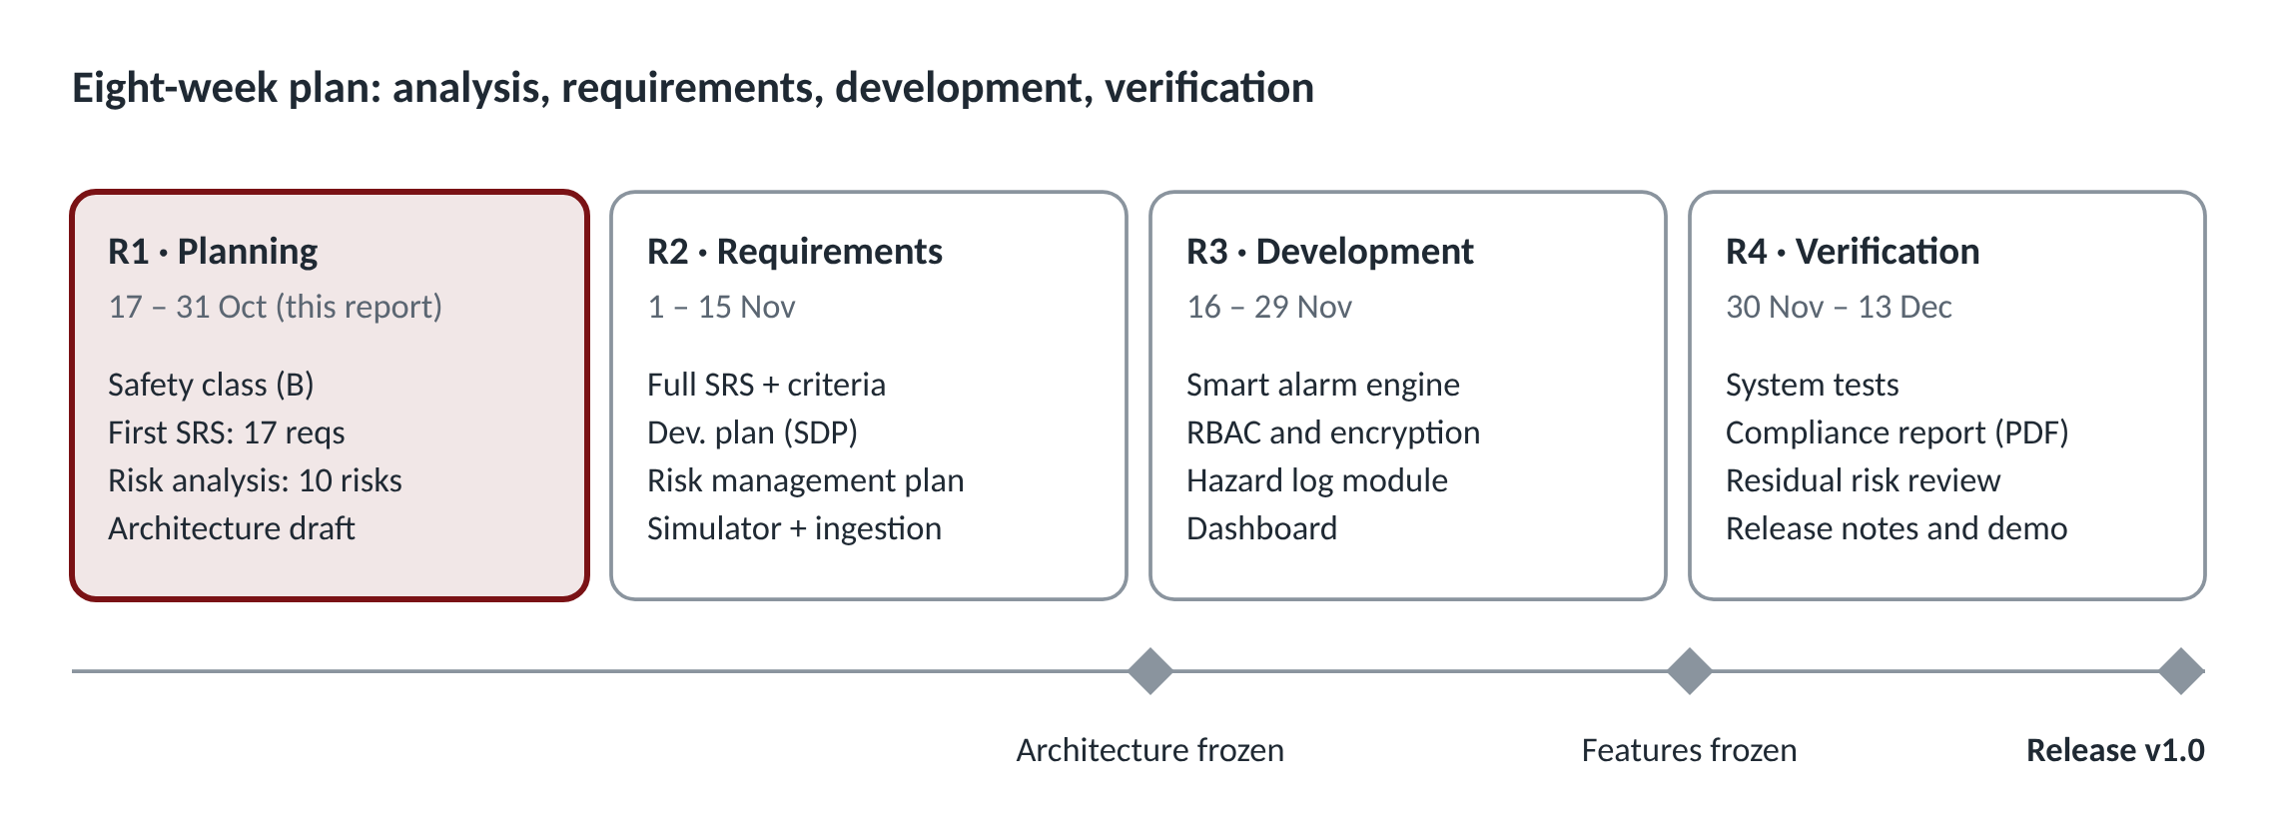
Figure 3 – Semester roadmap: 4 progress reports over 8 weeks
The minimum of 4 progress reports required in the course spans 8 weeks. The architecture is frozen at the end of Report #2 and the feature list at the end of Report #3; Report #4 is reserved for verification and release.
References:
- IEC 62304:2006 – Medical device software: Software life cycle processes. https://www.iso.org/standard/38421.html
- IEC 62304:2006/Amd 1:2015 – Amendment 1. https://www.iso.org/standard/64686.html
- ISO 14971:2019 – Medical devices: Application of risk management to medical devices. https://www.iso.org/standard/72704.html
- Turkish Personal Data Protection Law No. 6698 (KVKK), Ministry of Justice. https://mgm.adalet.gov.tr/Resimler/SayfaDokuman/51120191031036698%20KVKK.pdf
- Health data under Turkish data protection law and the 2024 amendments by Law No. 7499 (Medikal Akademi, in Turkish). https://www.medikalakademi.com.tr/?p=218216

