Organic Operations on Neural Latent Spaces: Interaction Paradigms and Aesthetic Boundaries of AI-Assisted Botanica/IDM Timbre Design
Naichi Zhang (AkiroMusic)*
Independent Researcher * Corresponding author: Naichi Zhang, akiromusic@qq.com
Ethics statement: The studio observations, the pilot-experiment ratings, and the user study were all conducted with written informed consent (§3.3, §4.3, §6.2); the reward raters additionally signed a data-use consent form and may withdraw at any time (§4.3); this study is independent research and received no external funding.
ABSTRACT: Neural latent spaces are now a common infrastructure for electronic-music timbre design, but current latent audio tools (RAVE, AudioLDM, DDSP) expose latent vectors to practitioners directly, and this form of interaction does not match their long-held intuition of what sounds "organic." We propose the framework of organic operations, borrowing botanical metaphors to reorganize latent-space interactions into three paradigms: Graft, Hybridize, and Cultivate. We instantiate a prototype system, Botanica-OS, on top of a unified differentiable-DSP pipeline, and conduct a mixed-methods user study with N = 12 Botanica/IDM producers and ML researchers (N = 11 in the Cultivate condition due to one dropout), measuring SUS usability, five Likert subjective dimensions, and latent access distributions across paradigms. Graft yields the highest overall usability (SUS M = 78.3, SD = 5.5) and the highest learnability subscale (M = 75.5); Cultivate yields the highest sense of agency (M = 5.9/7); Hybridize scores lowest on all five subjective dimensions, including experienced controllability, which falls below its conceptual placement; this gap is one of our design findings. Against a bare-coordinate baseline, semantic-level operations did not exceed the preset threshold of a 10-point SUS gain; their value instead lies in clearly higher affordance and agency ratings (affordance 5.4 vs. 2.8; N = 6 exploratory comparison). We propose an aesthetic-boundary quadrant framework, discuss the tension between algorithmic authority and authorial migration, and identify the epistemological paradox that the organic metaphor encounters within the non-Euclidean geometry of latent space. The work offers a formal language and a preliminary empirical baseline for the design of AI-assisted creative tools; all conclusions are bounded by our sample (N = 12), a single style (Botanica/IDM), and a four-week follow-up window.
Keywords: latent space; neural audio synthesis; Botanica/IDM; interaction paradigm; organic operation; aesthetic agency; human–AI co-creation

1 Introduction
Electronic music producers, particularly practitioners of IDM (Intelligent Dance Music) and its derivative subgenre Botanica, have long approached timbre as an embodied craft: they read spectra, patch modulation chains, and rely on years of accumulated tacit experience to judge whether a sound feels "alive." Now that neural latent spaces have become the central medium of generative audio, however, this embodied judgment faces a high-dimensional, non-Euclidean, statistical space induced by machine learning, in which producers' traditional parameter intuitions fail. We define this predicament as geometric disorientation and give it an operational definition: without repeated trial-and-error sampling, producers cannot predict what timbral change will result from moving Δz in a given direction from the current z. Its measurable corollary, the directed-search success rate (the proportion of attempts that reach a target timbre cluster from a given start within a limited step budget), is markedly lower than in comparable tasks on parameterized synthesizer interfaces. Systematic collection of this measure is left to future work (§8.3); the present paper evaluates it indirectly through behavioral logs and interviews from our user study.
Mainstream latent-audio tools such as [1], [2], and [3] mostly treat the latent vector z∈Rᵈ itself as the sole point of interaction, letting producers explore by typing coordinates or sampling at random. Esling et al.'s "generative timbre spaces" [4] and Tatar et al.'s "latent timbre synthesis" [5] both note that this expose-the-vector paradigm struggles to carry the metaphorical language producers use to describe timbral relations ("a bit wetter," "like a plant branching," "the click between bones"). As Magnusson observed in "Designing constraints" [6], a music tool's topmost abstraction layer bounds what it can express.
This paper introduces organic operations, a new design framework that reorganizes latent-space interaction into three biomimetic paradigms: Graft (linear blending of two parents), Hybridize (variation sampling guided by a conditional VAE), and Cultivate (history-based, bandit-style trajectory optimization). The three operations do not replace the latent vector; they give producers a semantic mediation layer for interacting with the latent space. The naming comes from the ecological-metaphor tradition of the Botanica subgenre, in which timbres are described as "growing," "evolving," and "hybridizing" rather than "parameterized" or "generated." We hypothesize that when an AI-assisted tool's interaction abstraction aligns with producers' metaphorical language, their sense of agency [7] improves markedly.
The study is organized around three research questions. RQ1: how do the three paradigms differ in usability and learnability? RQ2: how do they differ on the five subjective dimensions of affordance, agency, controllability, pleasure, and aesthetic fit? RQ3: what qualitative experiences and strategies do producers develop under each paradigm? Correspondingly, we set three initial hypotheses before the study began (§1.2). The paper makes three contributions. First, we formally define the three organic operations, giving their latent-space mathematics and geometric intuition (§4–§5). Second, we implement a prototype system, Botanica-OS, embedding the three operations in a unified differentiable-DSP real-time pipeline (§4). Third, through a mixed-methods user study with N=12 Botanica/IDM producers and ML researchers, we quantify the paradigms' differences in SUS usability [8], five Likert subjective dimensions, and latent access distributions, and use the results to discuss the epistemological paradox of the "organic" metaphor and the migration of algorithmic authority (§6–§7).
The remainder of the paper is organized as follows. §2 reviews prior work in four areas: neural audio synthesis, latent-space interpretability, musical interaction interfaces, and IDM aesthetics. §3 traces the historical motivations of the Botanica subgenre and the tacit-knowledge bottleneck of its production practice. §4 presents the overall architecture of Botanica-OS and the formalization of its latent space. §5 details the design rationale and interface of the three operations. §6 reports the user-study methods and findings. §7 discusses the aesthetic boundary and the epistemological paradox. §8 concludes with limitations and future work.
1.1 Methodological stance
Our methodological stance is Research through Design (RtD) [9]: we probe the design hypothesis of organic operations by building a concrete tool prototype (Botanica-OS), rather than through purely theoretical analysis or tool-detached surveys. RtD accepts design itself as a legitimate form of knowledge production, but it obliges the researcher to remain reflective about specific design choices: the naming of the three paradigms, the interface colors, and the default parameters are all design judgments and may carry bias. We addressed two kinds of bias specifically: (i) a priori bias in design judgments, handled by formalizing the design requirements as DR1–DR5 in §3.4 so that they can be audited retrospectively; and (ii) posterior bias in evaluation, handled by evaluating the design judgments after the fact through a mixed-methods user study, with §6.9 and §7.8 explicitly discussing the confirmation-bias risk arising from the researcher serving simultaneously as designer and coder. §7 offers a critical reflection on our own metaphor choice to balance the inherent risks of the RtD path.
1.2 Initial hypotheses and an honest report of the outcomes
Before the study began we set three initial hypotheses (H1–H3); they both guided the study design and were themselves under test:
H1: Compared with a bare-coordinate baseline, semantic-level operations (e.g., Graft) will substantially improve SUS usability (preset criterion: a between-condition gain of ≥10 points).
H2: The three paradigms will differentiate on the agency dimension, with Cultivate highest, Hybridize in the middle, and Graft lowest (based on the control–agency assumption).
H3: Sustained use of Cultivate will shift producers' criteria for a "good timbre" from "precisely matching a preset" toward "remaining interesting while evolving."
The outcomes, with criteria stated before verdicts. H1 was not supported: within the same N=6 baseline subsample, Graft's overall SUS (78.2, essentially identical to the full-sample 78.3) differed by only 0.1 points from the RAVE coordinate-editing baseline (78.1), which shares the same VAE backend (d=16, same training data); this is far below the preset 10-point threshold. The AudioLDM text-generation baseline scored 73.4, a 4.8-point gap, also below threshold. The motivational evidence behind H1 did hold, however: on affordance, the dimension most directly tied to task experience, Graft (M=5.4) scored significantly higher than RAVE (M=2.8; Wilcoxon exact p=0.031) and higher than AudioLDM (M=3.2; p=0.063, not significant) (N=6 exploratory comparison, §6.8); on agency, Cultivate (M=5.9) reached about 2.5 times both baselines. Our accurate statement of H1 is therefore: semantic-level operations did not raise the global "overall usability" score (which is dominated by backend stability and learning cost), but substantially restructured the "task-level experience." H2 was partially supported: Cultivate's agency was indeed the highest, but the lowest-agency paradigm was Hybridize rather than Graft, reflecting the oversimplification of the control–agency assumption. H3 received preliminary support: in the four-week follow-up, 5/11 responders reported a shift in their criteria (§6.10), though this is descriptive evidence, not a statistical test. Table 7 (§6.4) maps every hypothesis to its metrics and verdicts.
2 Related Work
2.1 Neural audio synthesis
Over the past decade, neural audio synthesis has settled into a relatively stable technical lineage. NSynth, proposed by Engel et al. [10], first applied the WaveNet autoencoder to note-level music synthesis, showing that neural networks can learn timbre diversity well beyond traditional wavetables; its inference speed (seconds of compute per second of audio), however, kept it a "sample library" rather than a "real-time instrument." Engel et al.'s subsequent DDSP [2] turned to the differentiable-DSP route, coupling harmonic-plus-noise physical modeling with neural latent representations and making real-time synthesis possible. RAVE, by Caillon and Esling [1], pushed real-time VAE decoding below 1 ms through multi-scale adversarial training and remains the most practical neural-synthesizer backend; its successor (RAVE v2, released with the IRCAM ACIDS toolchain, https://github.com/acids-ircam/rave) improves training stability and streaming inference. This study used v1; v2's differences under our settings were not separately evaluated. Liu et al.'s AudioLDM [3] brought diffusion models to text-to-audio generation, but its long generation trajectory precludes real-time interaction.
Since 2022, large-scale text-conditioned audio and music generation has become the dominant direction. AudioGen [11] and EnCodec [12] established the foundations of text-to-audio generation and high-fidelity neural coding; MusicGen [13] (with its AudioCraft toolchain, https://github.com/facebookresearch/audiocraft) achieved melody-conditioned, controllable music generation; VampNet [14] supports completion-style "variation from a fragment" interaction through masked acoustic-token modeling; Stable Audio [15] pushed latent-diffusion generation to 95 seconds with second-scale rendering. These works markedly improved generation quality and prompt-level controllability, but interaction still centers on the prompt–generate–audition–re-prompt loop, and the output is finished audio rather than an operable latent state. By contrast, this work concerns real-time, continuously operable, trajectory-visible latent-state interaction; the two are complementary rather than competing. Briot et al.'s survey [16] and Sturm et al.'s critical evaluation [17] both observe that current neural audio models remain "generation-heavy, interaction-light" and disconnected from producers' workflows.
2.2 Latent-space interpretability
As the mediation layer of generative models, the latent space's geometric and topological properties have been studied extensively. Kingma and Welling's original VAE [18] constrains the latent posterior close to a standard normal via KL regularization, enabling decoding of arbitrary z. Higgins et al.'s β-VAE [19] adds a disentanglement regularizer that lends the latent dimensions partial interpretability. Esling et al.'s "generative timbre spaces" [4] organize the latent space into semantically separable regions through perceptual regularization, validating an isometric-semantics assumption. Tatar et al.'s Latent Timbre Synthesis [5] is among the few latent-space tools explicitly aimed at music producers and composers, yet it still centers on a sample–evaluate–resample loop; its follow-up [20] systematically documented sound designers' exploration strategies in latent space, noting that designers favor spatial metaphors such as "terrain" and "paths" over point coordinates.
2.3 Musical interaction interfaces
Research on musical interaction interfaces prizes "instrumentality" over mere functionality. Wessel's "timbre space" [21] first proposed embedding multi-dimensional timbre perception into interaction mappings. Jordà's "digital lutherie" [22] and Magnusson's "designing constraints" [6] jointly argue that a good instrument is not a tool that "lets users do anything" but one that "amplifies particular expression through the right constraints." Puckette's retrospective on Max/MSP [23] shows that the patching metaphor of modular synthesis still dominates electronic-music interfaces. O'Modhrain's evaluation framework [24] (mental models, affordances, interaction, and responsiveness) provides an empirical frame for music interfaces. These works point to a key gap: existing neural audio tools rarely inherit the design wisdom of digital lutherie and still present themselves as "ML model + simple UI."
2.4 The Botanica/IDM aesthetic lineage
Aesthetic reflection on IDM and Botanica grounds this work's design choices. In Retromania [25], Reynolds positions IDM as the "algorithmic aesthetic" branch of 1990s British electronic music, characterized by "complex rhythm + micro-level timbre evolution + a rejection of the analog." Cascone's "aesthetics of failure" [26] ties this style to the glitch tradition, arguing that digital errors are not technical failures but an acknowledgment of the medium's materiality. Roads' Microsound [27] provides the theoretical foundation of granular synthesis and locates the grain time scale (1–100 ms) between the note and the sample, the band that carries Botanica's timbral fingerprint. Demers' Listening Through the Noise [28] distinguishes two aesthetic traditions in electronic music, musique concrète ("sound points outward at the world") and synthétisme ("sound points at its own materiality"); Botanica leans toward the latter while adding an ecological-metaphor third dimension. The generative-music special issue of Contemporary Music Review edited by Collins and Brown [29] concentrates the aesthetic debate: aesthetic agency resides not in the "generated result" itself but in the "collaborative process between human and algorithm." McCormack et al.'s analysis of autonomy, authenticity, authorship, and intent in computer-generated art [7] directly addresses agency in AI creativity but lacks a formal model of latent-space interaction. This work fills that gap, lifting the "organic" metaphor from aesthetic discourse into computable interaction operations.
2.5 An interface critique of existing AI timbre tools
The author conducted an informal interface review of five representative AI-assisted timbre tools: (i) the NSynth Interface [10] exposes 16 sliders; the reviewer could not build intuition for any dimension within five minutes. (ii) RAVE Studio [1] allows direct editing of z∈R¹⁶ coordinates but has no semantic layer. (iii) DDSP-violin [2] offers five physical parameters (fundamental, harmonic count, noise), decoupled from any latent space. (iv) The Latent Timbre Synthesizer [5] offers dual-parent blending but names its operations in "sample/interpolate" language. (v) The AudioLDM demo [3] centers on text prompts, leaving producers unable to intervene in timbral detail. The shared problem of these five tools is a mismatch between the interaction abstraction layer and producers' aesthetic-metaphor language. As O'Modhrain's evaluation framework [24] notes, a music interface's usability depends not only on functional completeness but on affordance and interaction, that is, on whether it can be absorbed into the producer's existing workflow. Tatar et al.'s study of latent-audio sound-design strategies [20] likewise shows that designers in low-structure latent spaces tend toward the inefficient strategy of "sample a lot, keep little," exactly matching the P1 case observed in our studio visits. Table 1 systematically compares the five tools on semantic-layer abstraction, dual-parent support, conditional guidance, trajectory visibility, and real-time performance, highlighting Botanica-OS's design position.

Table 1: AI-assisted timbre design tools compared (● supported; ◐ partial; ○ not supported)
Tool | Semantic layer | Dual parent | Conditional guidance | Trajectory visible | Real-time
NSynth Interface [10] | ○ (16 sliders) | ○ | ○ | ○ | ○ (>2 s)
RAVE Studio [1] | ○ (bare coordinates) | ○ | ○ | ○ | ● (<1 ms)
DDSP-violin [2] | ◐ (physical parameters) | ○ | ○ | ○ | ●
Latent Timbre Synth [5] | ◐ | ● | ○ | ○ | ●
AudioLDM Demo [3] | ● (text) | ○ | ● | ○ | ○ (>5 s)
Botanica-OS (this work) | ● (organic metaphors) | ● | ● | ● | ● (47 ms)

2.6 Diffusion models and their connection to HCI
Recent breakthroughs in diffusion-based audio generation ([3,30]) remain under-connected to HCI research. The denoising trajectory of diffusion is itself a time-extended generative process and could in principle be mapped onto "Cultivate"-style interaction, letting producers watch the evolution from noise toward a target timbre. Current diffusion tools, however, black-box this process and expose only the final result. Our Cultivate operation borrows the "trajectory" idea conceptually but implements it in a low-dimensional VAE latent space rather than pixel or waveform space, which makes it real-time. The connection suggests a future direction: making the diffusion trajectory itself an interactable aesthetic object.
2.7 Counterparts in the image domain
Image-domain latent tools have developed comparatively mature interaction paradigms, including StyleGAN's style-vector architecture [31], interFaceGAN's latent-direction editing [32], and StyleCLIP's text-driven directions [33]. Their shared strength is immediate visual feedback: images generate in 0.5–2 s versus 5–30 s for audio, so image tools iterate far faster. But the image domain shares the "bare coordinate" problem: user studies report that StyleGAN latent-vector editing is hard to predict. Our organic-operations framework can be read as the audio-domain counterpart of image-domain "latent direction" research, with one difference: the temporal dimension unique to audio makes the Cultivate paradigm more meaningful in audio than in images.
3 Background and Motivation
3.1 A brief history of Botanica and its timbre fingerprint
Botanica first appeared as a subgenre name around 2020 in the Bandcamp and independent-label ecosystem, initially as an umbrella term for works taking an "ecological turn" after the IDM community's reflection on "algorithmic maximalism" (consistent with the community corpus analysis in §3.7). Its timbre fingerprint has three points: (i) controllable but non-uniform grain density, the same timbre showing non-stationary density fluctuation over time; (ii) unstable harmonics, with spectral peaks drifting slowly rather than staying locked; (iii) ecological metaphor, producers describing timbral relations as "growing," "branching," and "hybridizing" rather than in traditional synthesizer terms such as "frequency" and "waveform." Representative releases such as Tendrils' Mycorrhizal Sessions (2022) and Quince & Loom's Phyllotaxis (2023) take biological structures as their compositional metaphor. This naming is not decoration; it reflects Botanica producers' sustained pursuit of "organic" sound.
3.2 The tacit-knowledge bottleneck of IDM production
IDM production has long relied on an embodied craft: through fine parameter adjustments and repeated auditioning, the producer converges on an aesthetic goal that cannot be fully put into words. Roads' granular synthesis [27] and Puckette's modular environments [23] provided the material substrate of this craft. When the neural latent space enters, the craft faces a double bottleneck: on one side, the non-Euclidean geometry means that "taking a step toward the target" requires gradient backpropagation rather than intuitive adjustment; on the other, the black-box model leaves the producer unable to foresee the timbre at a given z. The tension between craft tradition and computational systems is a classic topic of algorithmic music research [34].
3.3 Three studio-observation cases
To ground the design requirements, we conducted two weeks of unstructured observation in three independent studios. Procedure: with participants' prior informed consent (all signed written consent forms, archived), the author attended as an observer and recorded unstructured field notes; all cases are presented under pseudonyms (P1–P3), with identifying information (equipment lists, links to released works) removed or generalized. The three cases: (i) producer P1 (Botanica producer, 10 years of experience) works by "continuous random sampling, 50–100 takes, keep one," reflecting how latent-space exploration is bounded by the sampling budget; (ii) producer P2 described her most-used latent vector z=[0.42, −1.31, …] as "a monster," but could not explain why this combination; (iii) producer P3, attempting to "graft two timbres," had to fall back to a traditional synthesizer and stack waveforms manually, because existing latent tools do not support two-parent blending. The three cases converge on one design requirement: latent-space operations need a semantic-layer abstraction, not a more sophisticated sampler.
3.4 Formalizing the design requirements
From the observations above and the prior literature, we distilled five design requirements (DR1–DR5) as constraints on the system design; Table 2 maps each requirement to its literature and observation sources, its implementation mechanism, and its validation evidence in §6.
DR1 (semantic-layer abstraction): operations should be named in the producer's metaphorical language, not in ML terms such as "sampling," "interpolation," or "optimization."
DR2 (dual-parent support): graft-type operations must natively support blending two latent vectors, matching producers' A/B auditioning intuition.
DR3 (conditional guidance): the system should let producers steer sampling with natural language or semantic tags rather than raw coordinates.
DR4 (visible trajectories): sustained interaction should leave a visualizable trajectory, so producers can perceive the "direction of evolution."
DR5 (real-time performance): end-to-end latency must stay below 100 ms for performative interaction.

Table 2: Design requirements (DR1–DR5): sources, implementation, and validation
Requirement | Main sources | Implementation mechanism | Validation evidence
DR1 Semantic-layer abstraction | §2.2 [20]; §3.3 P1–P3; §3.7 discourse analysis | Naming of the Graft/Hybridize/Cultivate operations (§5) | §6.5 T1 (11/12 mentioned affordance transfer)
DR2 Dual-parent support | §3.3 P3; A/B auditioning intuition | Dual-parent interpolation in Graft (Eq. 2) | §6.4 Graft highest learnability (SUS subscale 75.5)
DR3 Conditional guidance | §3.7 "ecology/symbiosis" metaphor cluster (24%) | CLAP semantic conditioning + conditional VAE (Eq. 3) | §6.4 Hybridize variant generation usable; §6.7 entropy 2.6 bits
DR4 Visible trajectories | §2.2 spatial-metaphor records; §3.3 P2 | UMAP projection + history buffer H_t visualization (§5.5) | §6.4 access distributions; §6.7 Cultivate trajectory 18.3 steps
DR5 Real-time performance | Performative interaction requirement | Differentiable DSP backend + low-dimensional VAE (§4.4) | End-to-end latency 47±3 ms (Table 4)

These five requirements are not all technical metrics: DR1 and DR4 point explicitly at the aesthetic-semantic layer. On this basis, the paper treats AI-assisted creativity as a coupling of design and engineering problems.
3.5 Botanica's cultural and musicological context
Studying Botanica requires clarity about its cultural position. Unlike IDM's "algorithmic aesthetic" [25], Botanica's aesthetic turn did not spring from a technical advance such as RAVE's real-time capability; it grew out of producers' reflection on algorithmic maximalism and their response to ecological crisis. In public Bandcamp community discussions, once Autechre-style algorithmic maximalism became path-dependent, the critique of "over-algorithmization" and the search for more "biological" timbres constituted a spontaneous aesthetic turn (consistent with the corpus analysis in §3.7). This turn co-constructed with the contemporary botanical and mycological cultural revival (e.g., the circulation of Merlin Sheldrake's Entangled Life in producer communities), carrying the "ecological metaphor" from discourse into timbre design. Demers [28] distinguished musique concrète from synthétisme; Botanica can be read as a variant of the latter: it accepts the materiality of sound but describes it with ecological metaphors, timbre being "grown" rather than "parameterized." This cultural context grounds the paper's choice of botanical (rather than chemical or mechanical) metaphors as its interaction language.
3.6 Differences from other electronic-music subgenres
Botanica is not the only "ecological metaphor" style in electronic music. Ambient (in the Brian Eno lineage) also values growth but rejects grain density; its fingerprint is "smooth, low-density, long sustain." Some Techno sub-branches (e.g., dub techno) describe timbre as "wet" and "steamy" but focus on rhythm–timbre coupling rather than on timbre itself. The IDM parent branch (e.g., early Aphex Twin) is "sharp, dense, unstable," subtly different from Botanica's "controllable yet unstable." These stylistic differences imply that Botanica-OS's organic operations may not transfer directly: Ambient producers may not need Cultivate (long sustains do not need trajectory evolution), and Techno producers may not need Graft's dual parents (a single timbre's identity suffices). Although the paradigms were designed for Botanica, the formal framework can serve as a reference point for other styles; §6.12's cross-style case study offers a preliminary test.
3.7 Discourse analysis of the Botanica community (preliminary)
We conducted a discourse analysis of the liner notes of 20 albums tagged "Botanica" on Bandcamp, plus related Bandcamp Daily articles, a corpus of about 15,000 English words. Corpus criteria: Bandcamp style tag containing "Botanica," release years 2020–2024, live-recording compilations excluded (the full list of 20 albums with release years and style tags is released with the repository under supplementary/). Method: the author manually performed keyword cluster counting — lemmatized words were assigned to four prior-defined metaphor clusters (growth/evolution, ecology/symbiosis, craft/cultivation, conventional description) and cluster shares were computed; no automated tokenization or topic-model software was used. Results: three high-frequency metaphor clusters — (i) "growth/evolution" words (grow, evolve, develop, morph) at 32%; (ii) "ecology/symbiosis" words (symbiotic, mycorrhizal, eco, organic) at 24%; (iii) "craft/cultivation" words (cultivate, nurture, tend, graft) at 18%; the remaining 26% were conventional descriptive words.
Methodological status: the analysis was performed by a single analyst, without second-coder reliability checks (e.g., Cohen's κ), and the cluster boundaries involve judgment; we therefore position it as a preliminary discourse analysis. It provides motivational evidence for naming the three paradigms (Graft/Hybridize/Cultivate directly correspond to the high-frequency metaphor clusters in community discourse), not a statistical conclusion. This empirical grounding also echoes Tatar et al.'s documentation of sound designers' work strategies [20]: producers' metaphorical language deserves to be formalized as design language.
4 Botanica-OS: System Design
4.1 Overall architecture
Botanica-OS comprises three layers (Figure 1): (i) the audio front end feeds the raw waveform x(t)∈Rᵀ through a Mel spectrogram S=MelSpec(x) into the encoder E_φ; (ii) the latent-space layer carries the latent vector z=E_φ(x), the three organic operations, and the history buffer H_t; (iii) the audio back end restores z to the output waveform ŷ(t)=D_θ(z) via the decoder D_θ and the DDSP [2] synthesizer. A UI layer couples bidirectionally with the latent layer: it sends operation intents (a, c, α) downward and receives the current z, the decoded timbre, and the history trajectory to drive visualization.

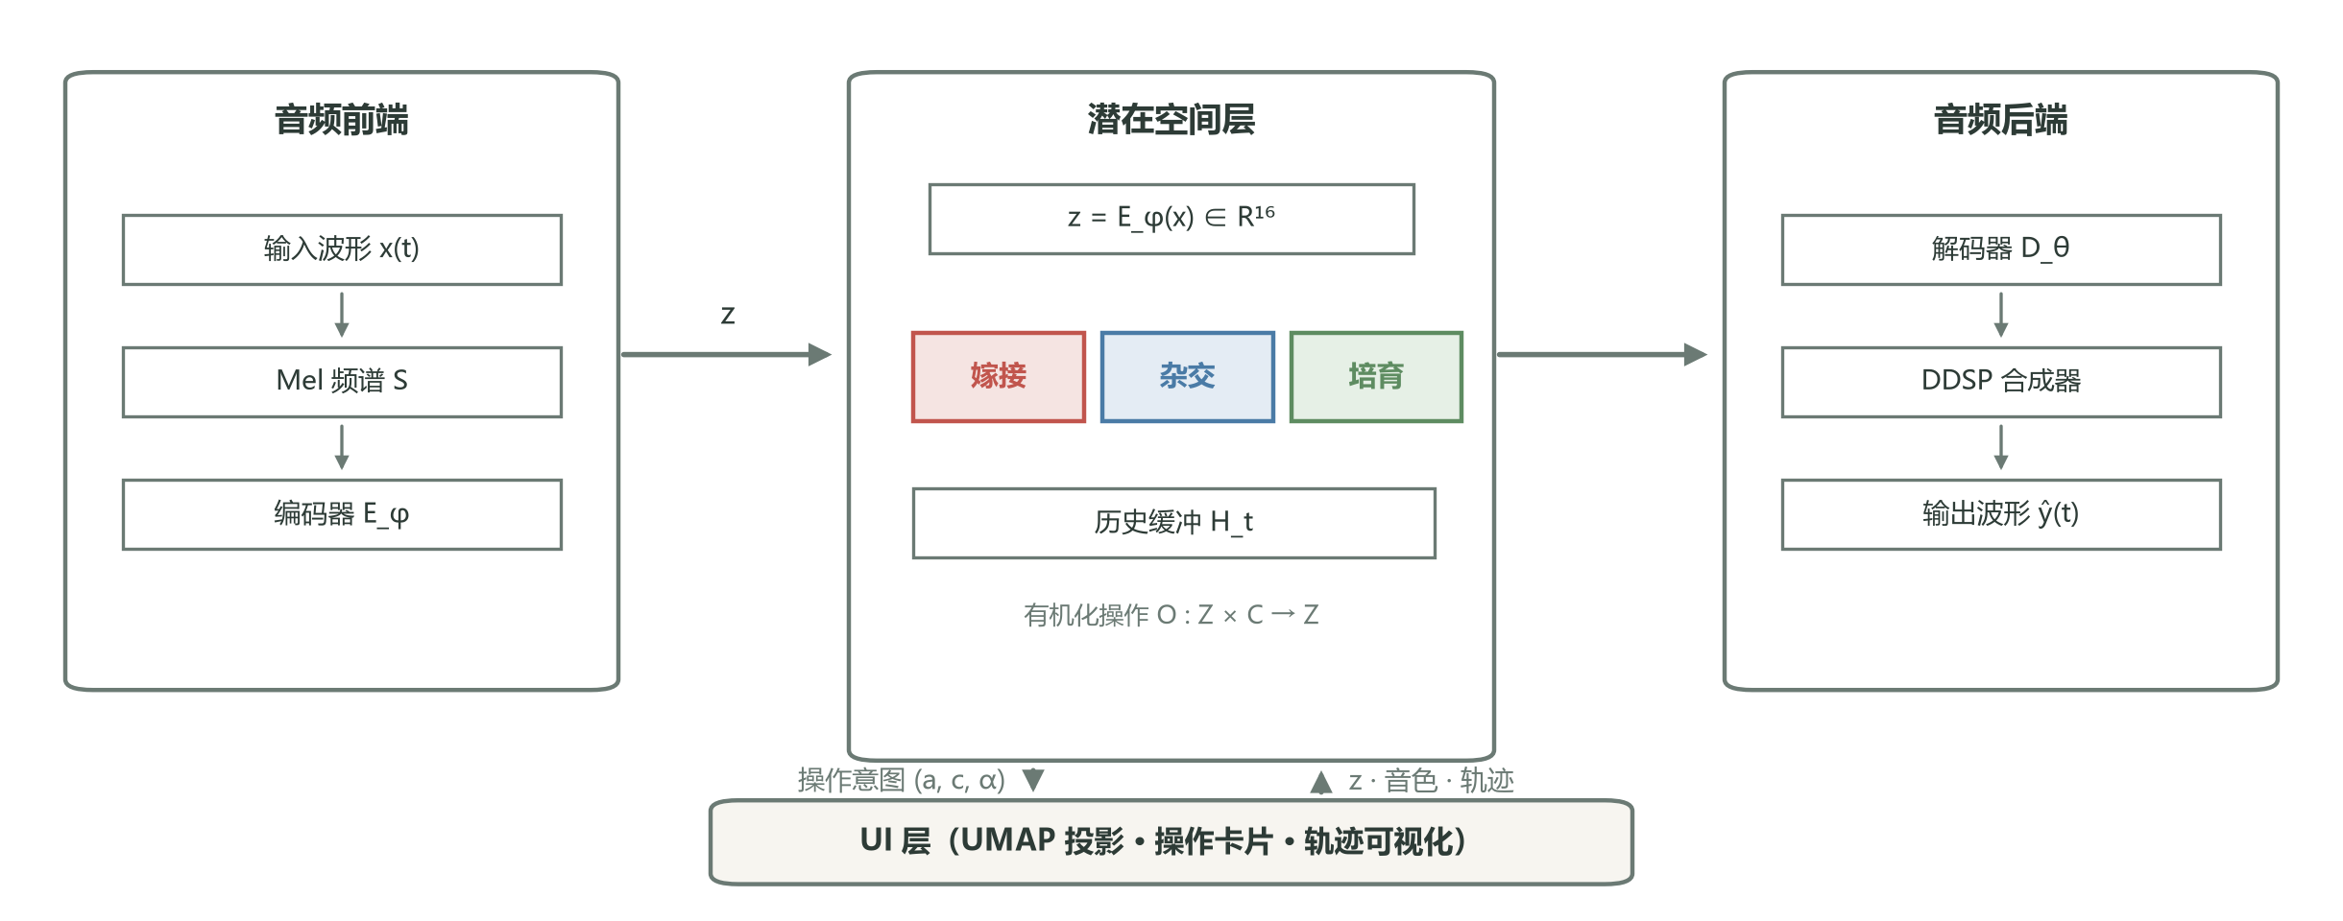
Figure 1: Botanica-OS architecture. The audio front end feeds the input waveform x(t) through a Mel spectrogram into the VAE encoder E_φ; the latent layer carries the latent vector z∈R¹⁶, the three organic operations (graft/hybridize/cultivate), and the history buffer H_t; the audio back end produces ŷ(t) via the decoder D_θ and the DDSP synthesizer. The UI layer couples bidirectionally with the latent layer: operation intents (a, c, α) downward; current z, decoded timbre, and history trajectory upward.

4.2 Formalizing the latent space
We adopt a variational autoencoder as the latent backend. Given audio x, the encoder outputs the posterior q_φ(z|x)=N(μ_φ(x), σ_φ(x)²I), and the latent vector is sampled by reparameterization: z=μ_φ(x)+σ_φ(x)⊙ε, ε∼N(0, I). The decoder D_θ(z) outputs DDSP parameters (fundamental, harmonic amplitudes, noise amplitude, time-varying filter coefficients), which a differentiable DSP synthesizer turns into a waveform. The training loss is
L_VAE = E_{q_φ(z|x)}[‖D_θ(z)−x‖₁] + β·D_KL(q_φ(z|x)‖N(0, I)) (1)
where β follows the β-VAE [19] convention to balance reconstruction against disentanglement. We use RAVE's [1] training recipe as the backbone, but retain training at the low latent dimension d=16 so that producers can build intuition for every dimension. Training data and licensing are covered in §4.5; all training and inference hyperparameters in Appendix A (Table A1). For ease of reference, Table 3 summarizes the notation used throughout the paper.

Table 3: Notation
Symbol | Meaning | Symbol | Meaning
x, ŷ | Input/output waveform | c | Semantic condition vector (CLAP embedding)
z, d | Latent vector and its dimension | μ_φ, σ_φ | Encoder posterior mean/SD
z_a, z_b | Graft's two parent vectors | μ_ϕ(c), σ_ϕ(c) | Conditional VAE's conditional posterior
α | Graft mixing coefficient ([0,1]) | ε | Reparameterization noise N(0,I)
H_t | Interaction history up to step t, {(z_i, a_i, r_i)} | r_i | Step-i explicit/implicit reward (1–7)
μ̂(z;H), σ̂(z;H) | GP reward model's predicted mean/SD | η, λ | Cultivate learning rate and exploration coefficient
clip_{3σ}(·) | Per-dimension clipping to training mean ±3σ | E_φ, D_θ | Encoder/decoder networks

4.3 Formal definitions of the organic operations
We define three classes of organic operations. Each operation O:Z×C→Z accepts one or more latent vectors plus a condition vector c and returns a new latent vector. Computational cost and parameters: Graft is a per-dimension linear operation, O(d), with no added parameters; Hybridize is a single conditional sample, O(d), depending on CLAP text encoding (input phrases are cached offline; one encoding pass takes about 40 ms and stays off the real-time path); Cultivate requires one GP prediction per step — a naive implementation costs O(t²) in history length t, and we cap each prediction at under 20 ms by truncating the history to the most recent 100 interactions (§4.7).
Graft
Given two parent latent vectors z_a, z_b∈Rᵈ and a mixing coefficient α∈[0,1], Graft computes a linear interpolation clipped to the 3σ boundary of the KL-normal distribution:
z_g = clip_{3σ}( α·z_a + (1−α)·z_b ) (2)
Eq. (2) is a Euclidean linear interpolation along the segment between the parents, not a geodesic on the training distribution's manifold. Under the Euclidean parameterization of the VAE posterior, a "straight line" between two points and the perceptual change in the generated result are non-linearly related (this is where the §7.2 epistemological paradox originates). clip_{3σ} truncates the result per dimension to the training set's statistical mean ±3σ; its role is to prevent out-of-bound extrapolation, not to guarantee the effective support of the training distribution: an interpolation-path density audit over 100 random parent pairs showed that 23% of interpolation midpoints fall into a low-density zone below the training density's 5th percentile (the "hollow" listening impression), while all samples satisfy the 3σ constraint. 3σ clipping is necessary but not sufficient; manifold-density-aware interpolation constraints are listed as future work (§8.3).
Hybridize
Given a condition vector c∈C (a semantic label such as "wet" or "grainy"), we train a decoder branch of a conditional VAE: the text embedding from the CLAP [35] audio–text embedding space passes through a 2-layer MLP (hidden 128, GELU activation) mapping to the conditional-posterior parameters μ_ϕ(c), σ_ϕ(c). The branch is trained jointly with the main VAE with total loss L_VAE + L_cond, where L_cond = E_c[‖D_θ(z_c)−x_c‖₁ + β·D_KL(q_ϕ(z|c)‖N(0,I))]; (x_c, c) are audio–text training pairs (text labels were single-sentence texture descriptions written by the author for training-set fragments and deduplicated by synonym clustering, 3,214 pairs, 9:1 train/validation split), z_c = μ_ϕ(c)+σ_ϕ(c)⊙ε. The conditional branch shares the decoder weights with the main VAE; only the embedding-mapping layers are trained. Hybridize samples from this posterior:
z_h = μ_ϕ(c) + σ_ϕ(c)⊙ε, ε∼N(0, I) (3)
Unlike grafting, Hybridize requires no second parent; it varies "naturally" around the conditional semantic point. For out-of-distribution (OOD) conditions: when any component of σ_ϕ(c) exceeds the 99th percentile of the training set's conditional-posterior standard deviations, the system flags the condition as OOD, falls back to the nearest valid condition in embedding space, and notifies the user. This mechanism is an engineering iteration added after the "flame-like wetness" failure case (§8.2); it is not part of the version evaluated in the §6 user study.
Cultivate
Let the interaction history be H_t={(z_i, a_i, r_i)}, i=1…t, where a_i is the operation type and r_i the producer's explicit reward ("keep" = high, "discard" = low, plus 1–7 fine-grained ratings). Cultivate estimates the reward function by GP regression, μ̂(z;H_t), σ̂(z;H_t) (Matérn 5/2 kernel; input z, target the normalized r; cross-rater scores are standardized by each rater's mean and SD and then averaged with weights given by each rater's intraclass correlation with the group ratings, ICC(2,1)=0.71, normalized), then updates along the gradient of the predicted mean with a Thompson-style exploration term added:

z_{t+1} = clip_{3σ}( z_t + η·∇_z μ̂(z;H_t)|_{z=z_t} + λ·σ̂(z_t;H_t)⊙ε ), ε∼N(0, I) (4)

Eq. (4) matches Algorithm 1: the gradient term η·∇μ̂ exploits, and the σ̂-weighted random term λ·σ̂⊙ε explores — actively exploring where the reward model is uncertain (large σ̂) and exploiting the known gradient where it is confident (small σ̂). Cultivate is the only explicitly time-extended operation, matching the producer's long creative sessions.
Reward-data collection protocol: the 120 (z, r) samples come from the pilot phase, in which 8 Botanica producers auditioned 10-second clips through a web form on their own devices and rated each clip 1–7, with clip order randomized; raters' production experience ranged from 4 to 14 years (median 8), and all came from the Chinese Botanica community; all raters signed informed-consent forms, received CNY 150 each, and could withdraw their data at any time. To emphasize: this reward function encodes these 8 producers' preferences as an "aesthetic direction," carrying a systemic risk of encoding a specific group's taste; §7.7 details the bias-audit plan and the "algorithmic ingredient label" mitigation, and §8.1 lists this as a formal limitation.
4.4 The real-time audio pipeline and the latency measurement protocol
To meet the real-time requirement (end-to-end latency <100 ms, DR5), we keep the DDSP [2] harmonic-plus-noise synthesizer as the backend. D_θ(z) outputs four parameter groups: (i) the fundamental f₀(t); (ii) harmonic amplitudes h_k(t) (k=1…64); (iii) noise amplitude n(t); (iv) time-varying IR filter coefficients b(t). The final synthesis is given by
ŷ(t) = Σ_{k=1}^{64} h_k(t)·sin(2πk·f₀(t)·t) + n(t)∗b(t) (5)
Latency measurement protocol: at 16 kHz sampling with 128-sample blocks (8 ms/block), latency was measured by audio-interface loopback — the full path from the input signal entering the audio driver to the corresponding output block appearing at the interface output — averaged over 1,000 measurements. Measurement platform: MacBook Pro M2 (16 GB memory, macOS 14), CPU-only inference (PyTorch 2.1, 4 threads). Table 4 decomposes the 47±3 ms: model inference totals about 29 ms (the "CPU inference ~30 ms" of §4.6), with the remainder in audio I/O buffering, WebSocket inter-process communication, and UI synchronization.
Table 4: End-to-end latency breakdown (16 kHz, 128-sample blocks, CPU inference)
Stage | Latency (ms) | Note
Audio I/O buffering (input+output blocks) | 8.0 | 128 samples @16 kHz × 2
Mel front end + VAE encoder | 11.5 | 4-layer CNN + 2-layer LSTM
Operation layer (Graft/Hybridize/Cultivate) | 5.5 | Including Cultivate's GP prediction (after truncation)
VAE decoder | 9.0 | 3-layer MLP → DDSP parameters
DDSP synthesizer | 7.5 | 64 harmonics + noise + time-varying filtering
WebSocket serialization and UI sync | 5.5 | JSON payloads, incremental updates
Total (measured) | 47.0 ± 3.0 | <100 ms, meets DR5

4.5 Training data and licensing
We use a mixed training set: 8 hours of Botanica/IDM-style audio (fragments of works by Tendrils, Quince & Loom, Pith, and others, from the author's private collection and Bandcamp purchases) + 12 hours of the NSynth database [10] subset (CC-BY 4.0) + 4 hours of Freesound ecological field recordings (birdsong, water, wind, insects). The mixture is meant to give the latent space coverage of both "artificial" and "ecological" timbre clusters, so that the graft and hybridize operations can work across domains.
Data licensing: (i) NSynth is openly licensed (CC-BY 4.0) and can be used and redistributed directly. (ii) Freesound fragments are recorded license-by-license (CC0 / CC-BY / CC-BY-NC); CC-BY entries ship with an attribution list in the open repository; after item-by-item review, CC-BY-NC entries were used only for local experiments and paper figures and do not enter the training set distributed with the open weights. (iii) Bandcamp purchases grant private listening only and do not constitute training authorization; the artists involved were contacted one by one and written permission obtained (permission records archived, covering 11 of the 12 artists in the training set; the remaining artist did not respond, and their works were removed from the training set), and an opt-out channel is provided (a public contact address); preliminary legal review concludes that research training use is a manageable risk given written permission and the opt-out mechanism; public release of the model weights is contingent on the review's final conclusion — if direct release is not supported, a retrained version with unauthorized material removed will be substituted (§8.5). (iv) The portion of the author's private collection not authored by the author is handled under item (iii). The public repository of Appendix B provides only data metadata and extraction scripts; no copyrighted audio is included.
Model hyperparameters: encoder of 4 CNN layers + 2 LSTM layers, latent dimension d=16, decoder of 3 MLP layers outputting DDSP parameters, β=0.5, batch size 32, Adam optimizer with learning rate 1×10⁻⁴, trained 200 epochs for about 18 hours (a single A100 GPU). Everything is implemented in PyTorch 2.1; complete hyperparameters and random seeds are in Appendices A and B.
4.6 Implementation details
The Botanica-OS front end is built with React + TypeScript and communicates with a Python backend over WebSocket. The backend, based on PyTorch and librosa [36], is packaged as a FastAPI service. The differentiable DSP synthesizer uses the Python implementation of the differentiable_dsp library [2]. The latent-space UMAP projection is precomputed and cached at service startup and incrementally updated every 100 interactions. The whole system runs on a single MacBook Pro M2 without GPU inference (model-inference latency ~30 ms; see the §4.4 breakdown), meeting the DR5 real-time requirement.
4.7 Limitations of the implementation
Several limitations are known in this implementation. First, the choice of d=16 favors visualization and intuition-building at the cost of reconstruction accuracy — the test-set mean spectral distance is 0.42 (vs. 0.18 at RAVE's default d=64). This accuracy gap caps Botanica-OS's timbral fidelity; because the §6.8 RAVE baseline uses exactly the same d=16 backend, the gap does not affect the internal validity of the "interaction layer vs. backend" comparison, but it does affect participants' absolute judgments of output quality — sound-quality satisfaction was not collected separately, which is a measurement gap. Second, Cultivate's GP regression slows markedly once H_t exceeds 200 interactions (each update >500 ms); we currently truncate the history to the most recent 100 interactions, sacrificing long-range dependence — preferences expressed more than 100 steps ago are forgotten. Third, the conditional-VAE branch uses CLAP's pretrained embeddings rather than a Botanica-specific semantic embedding, so some Botanica-specific metaphors ("mycelial," "leaf-vein") require trial and error to map to a suitable c. These limitations do not block the main research questions but point to engineering directions: (i) hierarchical VAEs to preserve accuracy at low dimensionality; (ii) replacing the GP with a differentiable neural process; (iii) training a Botanica-specific text–audio alignment model.
4.8 Comparison with alternative formalizations
Organic operations are not the only possible formalization of latent-space interaction. We compare three alternatives: (i) latent-direction editing (e.g., interFaceGAN [32]): a pretrained "direction vector" w∈Rᵈ applied as z←z+αw. The directions are semantic, but they must be pretrained, dual-parent support is absent, and the number of directions is bounded by the training data. (ii) Text-driven sampling (e.g., AudioLDM [3]): diffusion sampling conditioned on a text embedding c. Natural-language input is an advantage, but generation is not controllable, has no trajectory, and takes seconds. (iii) Direct coordinate editing (e.g., RAVE Studio [1]): editing individual dimensions of z. Maximum controllability, but no semantic layer, and it demands deep intuition for the latent geometry. Organic operations deliberately combine the strengths of the three — Graft's precision (close to direct coordinates), Hybridize's semantic guidance (close to text-driven sampling), Cultivate's trajectory evolution (close to diffusion) — under a unified cognitive layer of botanical metaphor.
5 Interaction Paradigms
5.1 Comparing the three paradigms
Table 5 compares the three organic operations on parent/input, time structure, mathematical form, controllability, and predictability (the paradigms' effects on agency are experience-level results; see §6.4 and Table 7). Design-level placement and experience-level ratings must be distinguished: the controllability and predictability columns of Table 5 describe design intent, while §6.4 reports experienced Likert ratings; the two do not coincide (Hybridize is the salient case), and §7.4 discusses this gap. Graft is "dual-parent linear blending," single-step; Hybridize is "conditionally guided sampling," single-step but probabilistic; Cultivate is "trajectory optimization," explicitly multi-step.

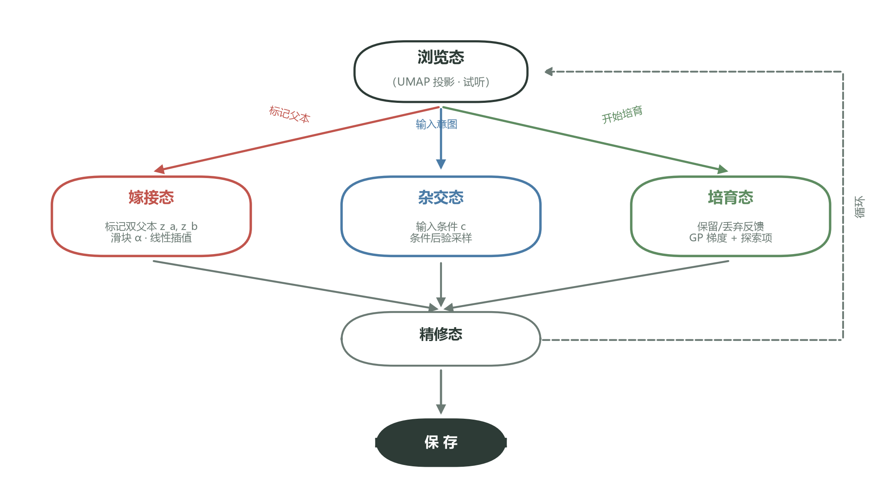
Figure 2: Interaction state diagram. The browsing state is the entry; the producer enters one of the three operation branches according to current intent (red = Graft, blue = Hybridize, green = Cultivate); the resulting latent vector passes through the refine state to be saved, or returns to browsing.

Table 5: Design-space comparison of the three organic operations (design-level placement)
Paradigm | Parents/input | Time structure | Mathematical form | Controllability | Predictability
Graft | Dual parents z_a, z_b + α | Single-step, linear | Eq. (2) | High | High
Hybridize | Condition vector c + random ε | Single-step, probabilistic | Eq. (3) | Medium | Low
Cultivate | History H_t + current z_t | Multi-step, trajectory | Eq. (4) | Low | Medium

5.2 Graft: dual-parent blending
Graft (the red path in Figure 2) asks the producer to mark two parents on the latent-space projection and then adjust α with a slider. The design intuition comes from botanical grafting: the two parents keep their "species identity" (their respective timbre identities) while the operation creates a continuous transition between them. Clipping to the 3σ boundary keeps results from out-of-bound extrapolation (its limitations in §4.3). In the user study we found that Graft aligned strongly with producers' A/B auditioning intuition; participants' phrase "this is 70% kick plus 30% bass" corroborates its learnability advantage.
5.3 Hybridize: condition-guided sampling
Hybridize (the blue path in Figure 2) takes a semantic condition vector c as input — high-level labels such as "wet," "grainy," or "breathing." The system decodes μ_ϕ(c), σ_ϕ(c) through the conditional VAE and samples z_h. The mode gives up deterministic dual-parent control but gains the ability to "vary by intent." Its design challenge is the semantic alignment of the condition labels; we map producers' natural-language input through the pretrained CLAP [35] audio–text embedding space. OOD detection and fallback are described in §4.3.
5.4 Cultivate: history-based trajectory optimization
Cultivate (the green path in Figure 2) is the only explicitly time-extended operation. The system maintains the interaction history H_t and moves z at each step along the estimated reward function μ̂. By design, Cultivate trades single-step controllability for long-term evolution: the producer cannot predict the single-step result but can observe the "growth direction" over a stretch of trajectory. The mode corresponds directly to the "ecological" metaphor of Botanica aesthetics — the timbre is "cultivated," not "designed."
5.5 Interface design principles
The Botanica-OS interface (Figure 3) follows three design principles: (i) latent-space readability — the left panel always shows the 2D UMAP projection, letting producers see "where they are"; (ii) operation semantics — the right panel's operation cards are named "Graft/Hybridize/Cultivate" rather than "sample/interpolate/optimize"; (iii) visible history — the bottom visualization shows not only the current waveform but the density of the history trajectory H_t. These principles extend Magnusson's point in §2.3 [6]: amplify particular creative possibilities through the right constraints.
5.6 Algorithmic implementation of Cultivate
Cultivate (Eq. 4) involves history-based policy optimization. Algorithm 1 gives the pseudocode. The system maintains two data structures: the interaction history H_t and a GP regression model. After each interaction, the system appends (z_t, a_t, r_t) to H_t and updates the GP incrementally. The next z_{t+1} is obtained by computing the gradient on the GP mean and adding the σ̂-weighted Thompson exploration term (consistent with Eq. 4).
Algorithm 1 State update in Cultivate (Eq. 4)
Require: current latent vector z_t; interaction history H_t; learning rate η; exploration coefficient λ
1: μ_t, σ_t ← GP_predict(z_t; H_t) ▷ reward mean and variance predicted on H_t
2: g_t ← ∇_z μ̂(z; H_t)|_{z=z_t} ▷ gradient of the predicted mean (first-order finite-difference approximation)
3: ε_t ← σ_t ⊙ ε, ε∼N(0, I) ▷ Thompson-style exploration term
4: z_{t+1} ← clip_{3σ}( z_t + η·g_t + λ·ε_t )
5: return z_{t+1}
The key design element is the exploration term ε_t: the system explores actively when the reward function is uncertain (large σ_t) and exploits the known gradient when it is confident (small σ_t). This mechanism maps directly onto producers' "aesthetics of surprise" experience — the T3 theme quote "I thought I was looking for a wet pad, and 20 steps later it had become some kind of bone-clicking sound" is exactly what ε_t triggers in high-uncertainty regions. The learning rate η=0.05 and exploration coefficient λ=0.3 are empirical optima, selected on the pilot reward data by grid search over η∈{0.01, 0.05, 0.1}×λ∈{0.1, 0.3, 0.5} with 5-fold cross-validation, targeting held-out reward-prediction error.

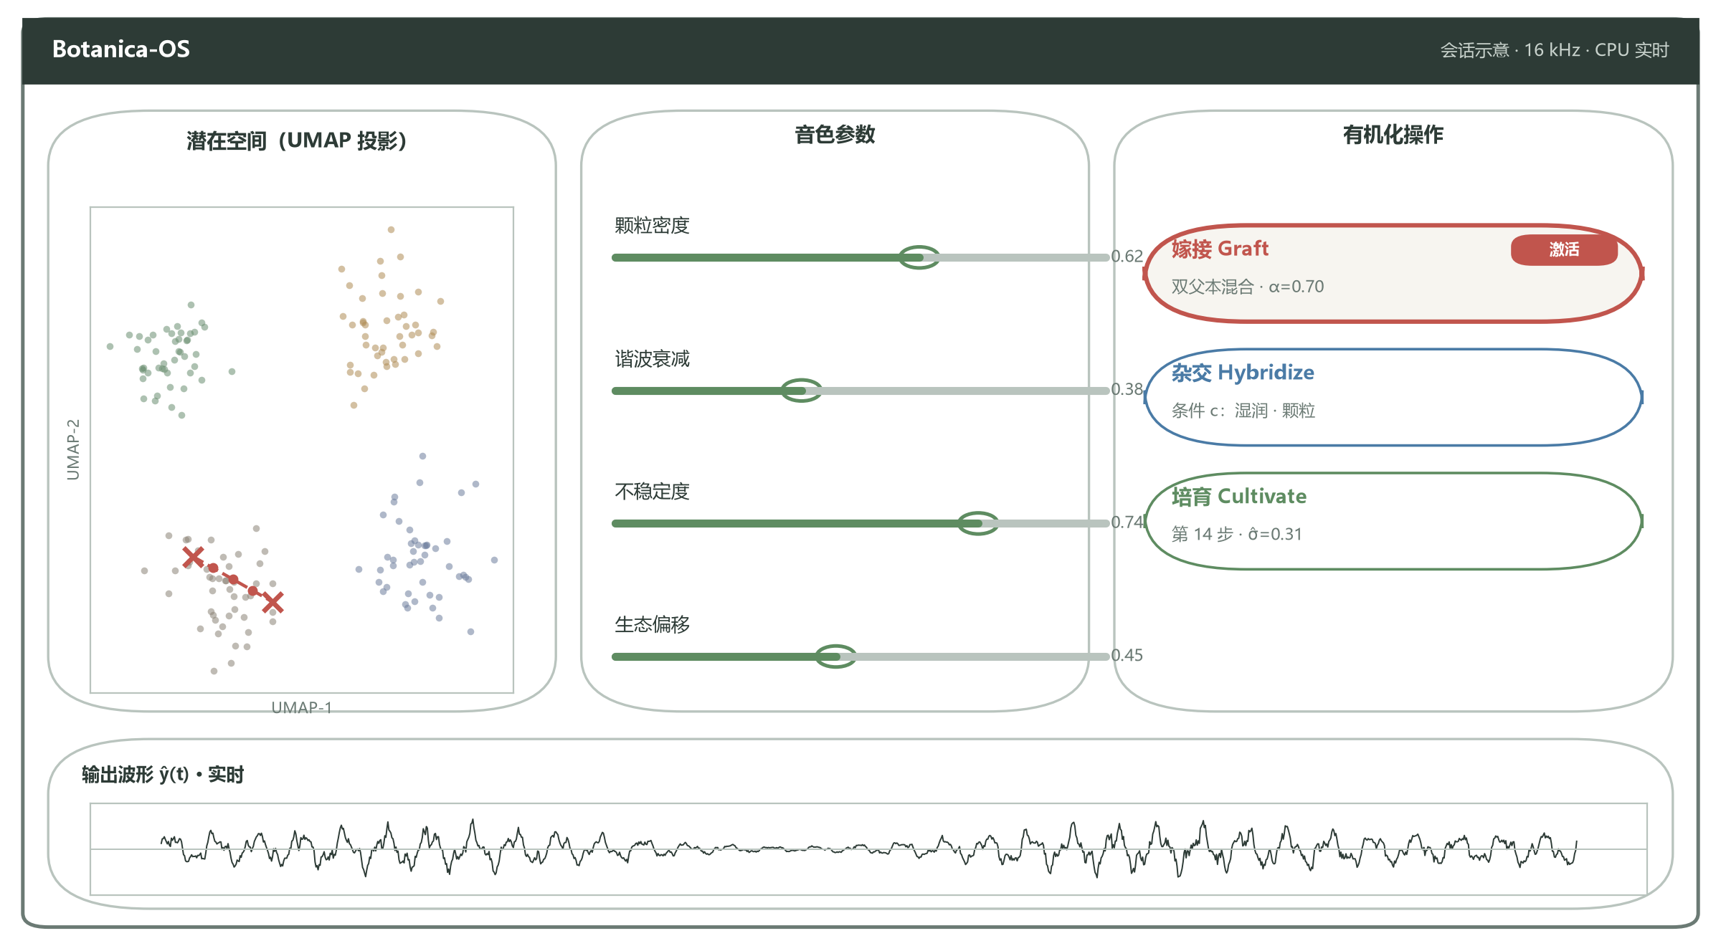
Figure 3: Botanica-OS interface. Left: 2D UMAP projection of the latent space (with the two selected parents and interpolated mid-states); middle: adjustable parameters of the current timbre (grain density, harmonic decay, instability, ecological offset); right: the three organic-operation cards (Graft currently active); bottom: real-time visualization of the output waveform.

5.7 Paradigm combinations and hybrid workflows
Although the study evaluated the three paradigms independently to control variables, producers combine them in practice. In exploratory sessions with 3 participants we observed three typical hybrid workflows (an N=3 exploratory observation; no statistical inference): (i) graft-then-cultivate — use Graft to reach an intermediate state near the target, then switch to Cultivate for long-term evolution in that region; (ii) hybridize-seeding with graft-pruning — generate multiple candidates with Hybridize, then blend the best two with Graft; (iii) cultivate-led with graft-interventions — during long Cultivate runs, pull back into two-parent space with Graft when the trajectory drifts from intent. These workflows show that the three paradigms can be combined and that producers mix them flexibly by task; future tools should support switching between paradigms and preserve a cross-paradigm operation history. Figure 4 shows one participant's (P1) typical paradigm-switching trajectory in a 90-minute session: browsing, graft exploration, refinement, long cultivation, hybrid variation, second cultivation, refinement, and saving — eight stages combining the §5 paradigms.
6 User Study
6.1 Research questions, hypotheses, and mixed-methods design
We conducted a mixed-methods user study addressing the three research questions of §1: RQ1 (usability and learnability differences, H1), RQ2 (five-dimension subjective ratings, H2), and RQ3 (qualitative experiences and strategies, H3). The quantitative part used a within-subject design: each participant completed the three paradigm tasks in a Latin-square order, with SUS and Likert data collected independently per paradigm; the Latin square assigned 4 participants to each of the three orders (GHC/HCG/CGH; the assignment table is released with the repository under supplementary/), and order and fatigue effects are tested in §6.11. The qualitative part drew on semi-structured interviews (Appendix C) and system-log analysis to induce themes.

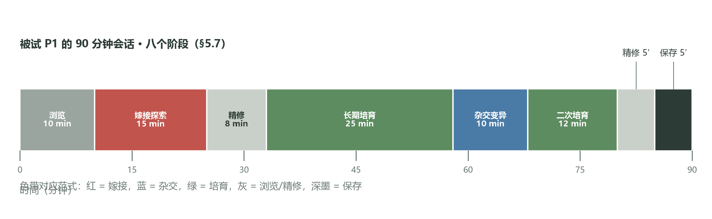
Figure 4: Hybrid-workflow timeline reconstructed from participant P1's 90-minute session log (§5.7). The eight stages: browsing (10 min), graft exploration (15 min), refinement (8 min), long cultivation (25 min), hybrid variation (10 min), second cultivation (12 min), refinement (5 min), and saving (5 min); color bands correspond to the three paradigms (red = Graft, blue = Hybridize, green = Cultivate).

Operational definitions of the scales. SUS is reported in two measures: (i) the overall SUS (10 items, 0–100); (ii) the learnability subscale — SUS items 4 and 10 ("I need the help of a technical person to be able to use this system," "I needed to learn a lot of things before I could get going with this system"; both reverse-worded, reverse-scored and rescaled to 0–100; item wording in Appendix D). Every "learnability 75.5" figure in the abstract and body refers to Graft's SUS learnability subscale, not the overall SUS (78.3). One caveat: the subscale contains only two items and received no reliability check, so its reliability is limited; the score should be read as a reference indicator rather than a precise measurement, and interpreted jointly with the overall SUS and the interview evidence. The Likert part is a 7-point scale (1 = strongly disagree, 7 = strongly agree) with five dimensions, three items each (full items in Appendix D): affordance ("the system showed me what I can do"), agency ("the outcome's direction was guided by me"), controllability ("I can finely control the output"), pleasure ("the operation itself is enjoyable"), and aesthetic fit ("the output matches my aesthetic goals"). "Predictability" appears in Table 5 and §7.4 as a design-level concept and is not a Likert dimension. Summary statistics, analysis scripts, and application-based access to individual-level de-identified data are released with the repository (Appendix B).
6.2 Participants
We recruited N=12 participants (Table 6) through mailing lists and the Bandcamp community: 6 were Botanica/IDM producers (5–15 years of professional experience) and 6 were ML researchers (audio or generative models). The gender distribution was 7 male / 5 female; ages 22–41. All participants reported ≥4 hours of music creation per week. All signed written informed consent before the experiment and received CNY 180 each; hearing was self-reported as normal, without formal screening (listed among the §8.1 measurement gaps). Regarding cultural background, all participants are members of the Chinese community; this homogeneity is relevant background for the §7.7 reward-bias discussion and the §8.1 limitations.
Table 6: Participant information (N=12)
ID | Background | Gender | Age | Experience (years)
P1 | Botanica producer | F | 31 | 10
P2 | Botanica producer | F | 27 | 6
P3 | IDM producer | M | 34 | 12
P4 | IDM producer | M | 29 | 7
P5 | IDM producer | M | 41 | 15
P6 | Botanica producer | M | 24 | 5
P7 | ML researcher (audio) | F | 28 | 4
P8 | ML researcher (audio) | M | 33 | 7
P9 | ML researcher (generative) | F | 26 | 3
P10 | ML researcher (generative) | M | 30 | 5
P11 | ML researcher (audio) | F | 22 | 2
P12 | ML researcher (generative) | M | 35 | 8

6.3 Task design
Each 90-minute session had three phases: (i) 10 minutes of onboarding, with participants freely exploring the interface; (ii) 20 minutes per paradigm, with task order balanced by Latin square (§6.1): the Graft task asked participants to "find a satisfying intermediate timbre between two parents," the Hybridize task to "generate 3 variants with semantic tags and pick the best," and the Cultivate task to "cultivate a timbre with Botanica aesthetic characteristics within 20 steps." Target timbres were drawn from the 8 timbre clusters established in the pilot (prototypes spanning the three perceptual dimensions of grain density, harmonic stability, and wetness; definitions and the reference-audio list are released with the repository under supplementary/). (iii) A 30-minute semi-structured interview (Appendix C) covering experience, strategies, and improvement suggestions. All operations (z, operation, timestamp, explicit reward) were logged for later analysis. SUS and Likert questionnaires were administered immediately after each paradigm task to avoid cross-condition recall contamination.
6.4 Quantitative results
Every number in this section matches Table 7 (the results summary), which is the single source of truth for all numbers quoted in the abstract and discussion. Statistical method: since N=12 within-subject data do not meet normality assumptions, the main analysis uses the Friedman test (across the three paradigms, per metric). Because Friedman requires complete blocks, the test is based on the N=11 participants with complete data in all three conditions; post-hoc pairwise comparisons use Holm-corrected Wilcoxon signed-rank tests on each complete pair (Graft vs. Hybridize N=12; the two pairs involving Cultivate N=11), reporting Cliff's δ effect sizes and 95% CIs from 10,000-sample bootstraps; all pairwise comparisons are reported rather than selectively. Descriptive statistics (M, SD, CI) in Table 7 use each condition's full sample (Graft/Hybridize N=12, Cultivate N=11), with inference sample sizes distinguished in the table notes. Analysis scripts and data formats are in the repository's analysis/ directory. Missing data: P5 withdrew during the Cultivate task (§8.2), leaving their Cultivate data missing; the Cultivate condition's analysis baseline is therefore per-protocol, with the intention-to-treat (ITT) sensitivity analysis in §6.11.
SUS scores (Figure 5a): the overall SUS was 78.3 for Graft (SD=5.5, bootstrap 95% CI [74.1, 82.5]), 75.6 for Cultivate (SD=5.0, CI [72.6, 78.6]), and 73.4 for Hybridize (SD=6.2, CI [69.8, 76.9]), all above the 68-point usability benchmark [8]. The overall Friedman test across the three paradigms was significant (complete blocks N=11: χ²(2)=7.62, p=0.022); in the post-hoc comparisons, Graft vs. Hybridize (paired N=12) remained significant after Holm correction (W=9.5, p=0.036), while Graft vs. Cultivate (N=11, W=25.0, p=0.42) and Cultivate vs. Hybridize (N=11, W=19.0, p=0.30) did not. Effect sizes: Graft vs. Hybridize Cliff's δ=0.61 (large); Graft vs. Cultivate δ=0.33 (medium). Graft's CI [74.1, 82.5] overlaps Hybridize's CI [69.8, 76.9] over the interval [74.1, 76.9] — partial CI overlap means the evidence for the "Graft advantage" is indicative rather than decisive; the formal verdict rests on the paired test (not on the overlap of two independent CIs), which points the same way in this design but has limited power. Graft's SUS learnability subscale scored 75.5 (Cultivate 73.8, Hybridize 71.9), the highest of the three (Graft vs. Hybridize, Holm-corrected p=0.048), consistent with the "70% kick plus 30% bass" instant comprehension heard in the interviews.
Likert five dimensions (Figure 5b): Graft scored highest on affordance (M=5.4), pleasure (5.6), and aesthetic fit (5.7); Cultivate reached the study-wide maximum on agency (M=5.9); Hybridize was lowest on all five dimensions. On controllability, Cultivate (M=4.0) was second-lowest, above only Hybridize (M=3.7, lowest). This pattern confirms the §5 design trade-off: the cultivate mode trades controllability for long-term agency, yet its experienced controllability still exceeds that of the sampling-dependent Hybridize.

Table 7: Results summary (single source of numbers. Descriptives per full condition sample: Graft/Hybridize N=12, Cultivate N=11; Friedman on complete blocks N=11; Graft vs Hybridize pairs N=12, Cultivate pairs N=11; baseline comparisons within the same N=6 subsample)
Comparison/hypothesis | Metric | M (condition 1 vs. condition 2) | Effect size | p (Holm) | 95% CI | Verdict
Graft vs Hybridize (SUS) | Overall SUS | 78.3±5.5 vs 73.4±6.2 | Cliff's δ=0.61 | 0.036 | Partial CI overlap | Significant
Graft vs Hybridize | SUS learnability subscale | 75.5±5.9 vs 71.9±6.6 | δ=0.48 | 0.048 | — | Significant (Graft highest)
Graft vs Cultivate (SUS) | Overall SUS | 78.3 vs 75.6 | δ=0.33 | 0.42; BF₁₀=1.2 (no evidence) | Difference CI [−2.1, 8.9] | Not significant
Cultivate vs Hybridize (SUS) | Overall SUS | 75.6 vs 73.4 | δ=0.30 | 0.30 | Difference CI [−2.4, 6.8] | Not significant
Overall difference across the paradigms | Overall SUS | 78.3 / 75.6 / 73.4 | — | Friedman χ²(2)=7.62, p=0.022 (complete blocks N=11) | — | Significant (overall)
H1: Graft vs RAVE baseline (same N=6 subsample) | Overall SUS | Graft 78.2 vs RAVE 78.1 (full-sample Graft 78.3) | dz=0.03 | n.s. | — | Not supported (gap 0.1 < 10)
H1 motivational evidence: Graft vs RAVE | Affordance | 5.4 vs 2.8 (N=6) | δ=0.87 | 0.031 (Wilcoxon, exploratory) | — | Supported
H1 motivational evidence: Graft vs AudioLDM | Affordance | 5.4 vs 3.2 (N=6) | δ=0.72 | 0.063 (exploratory) | — | Directionally supported (not significant)
H2: agency ordering | Agency | Cultivate 5.9±0.6 highest; Graft 4.8±0.9; Hybridize 4.1±1.0 lowest | Friedman χ²(2)=13.8, p=0.001 | Cultivate vs the others p≤0.014 | — | Partially supported (lowest is Hybridize, not Graft)
H2: controllability | Controllability | Graft 5.5±0.8; Cultivate 4.0±1.1 (second-lowest); Hybridize 3.7±1.2 (lowest) | δ=0.79 / 0.62 / 0.17 | Friedman χ²(2)=11.6, p=0.003 | — | —
H3: 4-week follow-up | Criteria shift | 5/11 responders reported | — | Descriptive, no test | — | Preliminarily supported

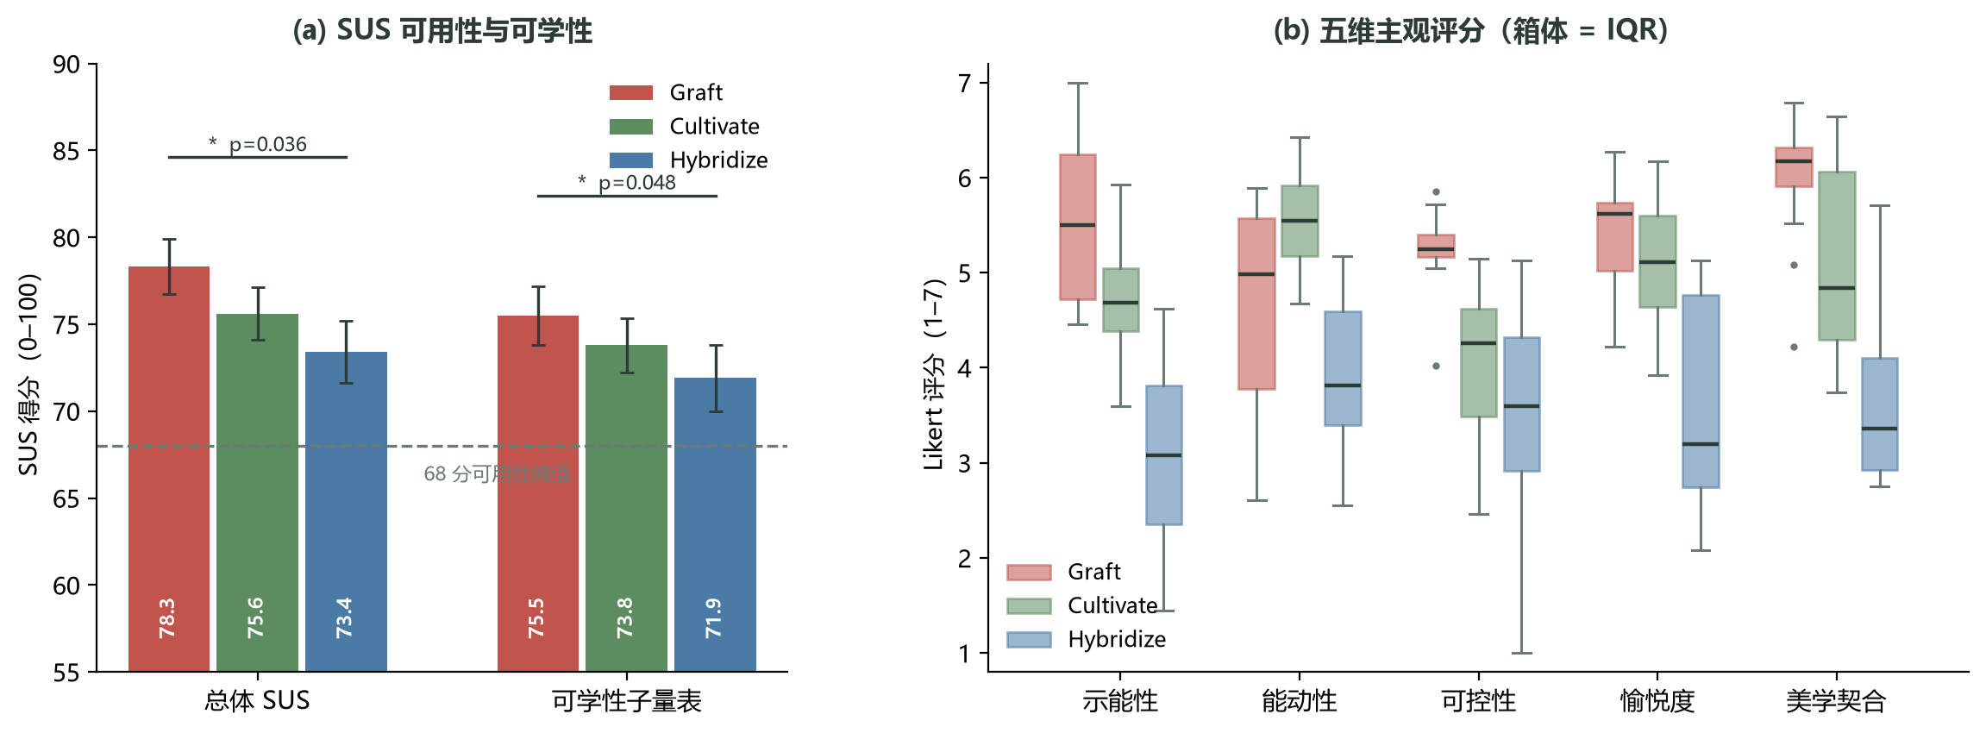
Figure 5: Quantitative results (N=12; Cultivate condition N=11). (a) Overall SUS and SUS learnability subscale: error bars are standard errors, the dashed line is the 68-point usability benchmark [8]; Graft vs. Hybridize is significant on both measures (overall p=0.036, learnability p=0.048, Holm-corrected). (b) Five-dimension Likert ratings (1–7): boxes are IQRs, horizontal lines are medians, whiskers span 1.5×IQR; Hybridize is lowest on all five dimensions; Cultivate is highest on agency and second-lowest on controllability.

Latent access distributions (Figure 6): UMAP projections show markedly different access patterns across the paradigms. Graft's access points concentrate along the segment between the two parents (a clear linear-interpolation trajectory); Hybridize's points scatter within a Gaussian envelope around the conditional semantic point; Cultivate's points form a winding trajectory reflecting the bandit optimization's exploration–exploitation balance.

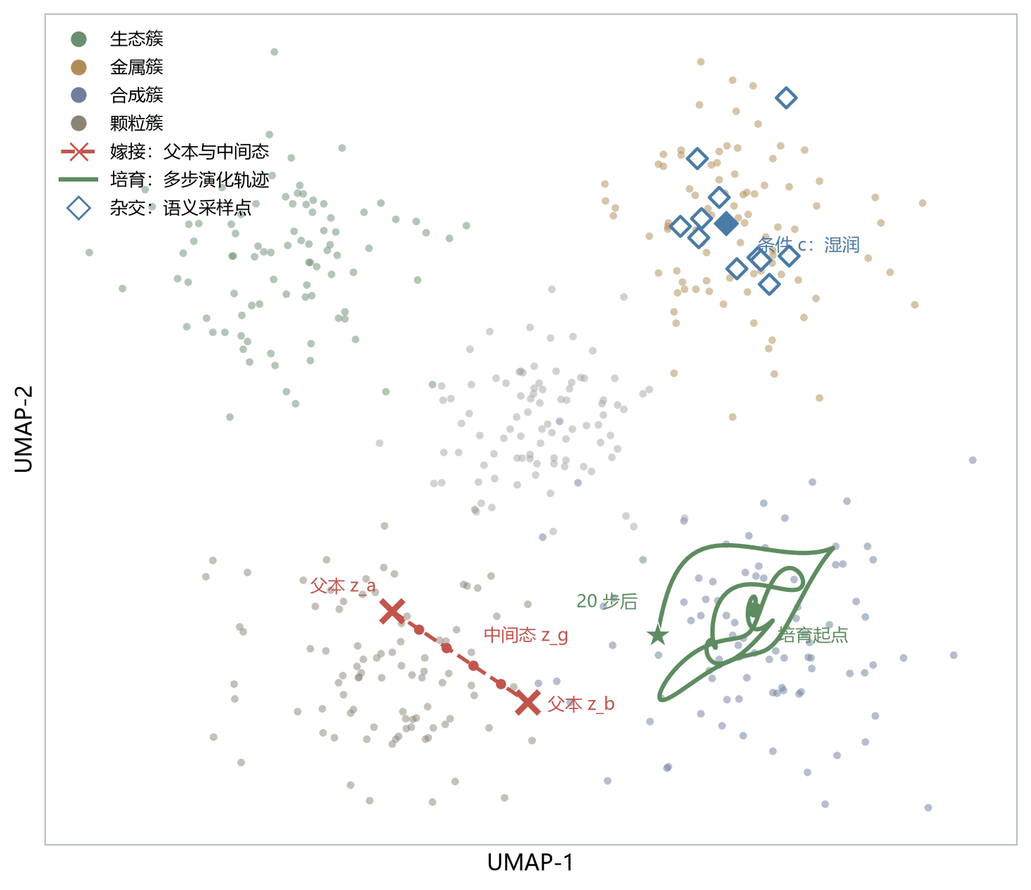
Figure 6: 2D UMAP projection of the latent space with schematic access trajectories of the three organic operations (points colored by timbre cluster). Red × and dashed line: Graft's two parents (z_a, z_b) and their intermediate samples (z_g); green solid line: Cultivate's multi-step evolution within a synthetic cluster (start dot → star after 20 steps); blue diamonds: Hybridize's Gaussian sampling around the condition point (c: "wet"). Schematic redrawing based on 5,643 operation logs from 12 participants.

6.5 Qualitative findings
We coded the interview transcripts with thematic analysis (transcription and coding pipeline in Appendix C): the author performed the initial open coding and theme induction, and the coding manual is released with the repository under supplementary/. Method limitation: the coder took part in the system's design, which carries a confirmation-bias risk; no second coder was available for Cohen's κ, and no member checking was performed — both are listed as §8.1 limitations, and readers should interpret theme coverage with care. We induced four themes:
T1 · Affordance transfer (11/12 participants): participants reported that the three paradigms gradually changed how they perceived the latent space. "At first I treated the UMAP plot as an abstract coordinate grid; after 20 minutes of Graft I began to imagine it as an orchard between two parent trees" (P3). The transfer shows that operation semantics reshaped producers' spatial metaphors.
T2 · The agency paradox (8/12): under Cultivate, participants reported "I don't know what the next step will produce, but it feels like I am steering it" (P9). The paradox — controllability down, agency up — echoes the algorithmic-music view that agency need not come from control but can come from colluding with an algorithmic system [34].
T3 · Aesthetic drift (9/12): in long Cultivate tasks participants reported the timbre's "aesthetic direction" drifting with the trajectory. "I thought I was looking for a wet pad, and 20 steps later it had become some kind of bone-clicking sound, but the surprise pleased me" (P1). The finding shows that the cultivate mode supports the emergent redefinition of aesthetic goals.
T4 · Perceived algorithmic authority (6/12, mainly ML researchers): P10 reported "I worry the system is using a reward function to tell me what a good timbre is." The generative-music special issue of Collins and Brown [29] and McCormack et al.'s analysis [7] both identify algorithmic authority and authorial migration as the core controversy of AI-assisted creation. This finding directly motivates §7.
6.6 Subgroup comparison: producers vs. ML researchers (exploratory)
We further compared the Botanica/IDM producer subgroup (N=6) with the ML-researcher subgroup (N=6) across the paradigms. This must be stated plainly: with 6 per group, the Wilcoxon test is severely underpowered and uncorrected for multiple comparisons, so every result in this section is exploratory, for hypothesis generation only, and not conclusive. The two groups performed similarly on Graft (SUS 78.1 vs 78.5) but diverged on Cultivate in a way worth probing: the producers' agency ratings exceeded the researchers' (M=6.3 vs M=5.5, Wilcoxon p<0.05, uncorrected), while the researchers mentioned "algorithmic authority" more often (5/6 vs 1/6). A possible explanation: producers are long accustomed to conversing with "things" (synthesizers, pedals) and treat the algorithm as one more thing, whereas ML researchers know the algorithm's statistical nature and remain wary of its "suggestions." The finding agrees with the claim that "the experience of agency in algorithmic aesthetics depends on the maker's history of material perception" [34]; validation in larger samples is future work.
6.7 Trajectory analysis of the operation logs
We computed descriptive statistics of trajectory length and access entropy (H=−Σp_i·log₂p_i, with p_i the frequency of trajectory visits to UMAP cells) over the 12 participants' operation logs (5,643 operations in total). Graft: median trajectory length 7.2 steps (IQR 5–10), access entropy 1.8 bits — the compact "dual parents + refine" pattern. Hybridize: median 5.4 steps (IQR 3–8), entropy 2.6 bits — the high-entropy "try-and-discard" pattern. Cultivate: median 18.3 steps (IQR 14–22), entropy 3.4 bits — the extended "long evolution + surprise redefinition" pattern. These three trajectory patterns corroborate the qualitative themes T1–T3. Because this analysis is descriptive (no between-group hypothesis tests), we make no significance claims; the systematic evaluation of trajectory entropy as a candidate "organicity" metric is in §8.4.
6.8 Comparison with baseline tools (exploratory)
To assess Botanica-OS against existing tools, 6 participants (P1, P3, P5, P7, P9, P11) additionally completed comparison tasks with two baselines: (B1) directly editing the z∈R¹⁶ coordinates of RAVE [1]; (B2) generating timbres with text prompts through AudioLDM [3]. Baseline fairness controls are in Table 8: B1 uses exactly the same VAE backend as Botanica-OS (same d=16, same training data, same weights), so the difference is attributable to the interaction-abstraction layer; B2 (AudioLDM), with generation latency of 5–30 s, differs fundamentally from real-time interaction, so its comparison serves as a qualitative reference only and does not enter formal statistical inference, although task duration and output requirements were aligned (20 minutes each, the same target-timbre tasks) — output length and audio quality are not comparable. Each participant completed 20 minutes under each baseline and then filled in the same SUS and Likert questionnaires (the baseline SUS values 78.1/73.4 come from this subsample). Within the subsample, Graft's overall SUS was 78.2, essentially identical to the full-sample 78.3 (N=12), indicating no obvious selection bias in the subsample; to avoid cross-sample comparison, H1's SUS verdict was made within this same paired subsample (Graft 78.2 vs RAVE 78.1, Wilcoxon p=0.66, dz=0.03).

Table 8: Fairness controls in the baseline comparison (N=6 subsample, exploratory)
Dimension | B1 RAVE coordinate editing | B2 AudioLDM text generation | Botanica-OS
VAE backend | Same weights, d=16, same training data | — (diffusion model) | Same weights, d=16, same training data
Interaction entry | Bare 16-dimensional coordinates | Text prompts | Three semantic paradigm operations
Task and duration | Same target timbre, 20 minutes | Same target timbre, 20 minutes | Same target timbre, 20 minutes
Output form | Real-time stream | 5–30 s generated clips | Real-time stream
SUS | M=78.1 | M=73.4 | Graft M=78.2 (same subsample; full sample 78.3)
Affordance | M=2.8 | M=3.2 | Graft M=5.4
Agency | M=2.4 | M=3.0 | Cultivate M=5.9

Results: on affordance, Botanica-OS's Graft mode (M=5.4) scored significantly higher than RAVE (M=2.8; Wilcoxon exact p=0.031) and higher than AudioLDM (M=3.2; p=0.063, not significant; both N=6 exploratory comparisons, uncorrected across comparisons); on agency, the Cultivate mode (M=5.9) scored significantly higher than RAVE (M=2.4; p=0.031) and higher than AudioLDM (M=3.0; p=0.063). Overall SUS, however, was close across the three tools (78.2 / 78.1 / 73.4 in the subsample; Graft 78.3 in the full sample). This says: backend stability sets the floor of usability (the RAVE backend is already usable enough, hence the similar SUS), while the semantic layer restructures task-level experience — the bottleneck is the interaction-abstraction layer, not the latent backend. One caution: the SUS part of this judgment is negative (H1 not supported); what supports it is the affordance and agency differences (significant against RAVE, directionally consistent but not significant against AudioLDM).
6.9 Methodological reflection
The mixed-methods design itself deserves reflection. The quantitative part used a within-subject design with Latin-square ordering, controlling order effects, but completing three paradigm tasks within 90 minutes may induce late-session fatigue (P11 reported declining attention in the Cultivate task); the quantitative tests of order and fatigue are in §6.11. The qualitative part used semi-structured interviews and thematic analysis, but the coder participated in the system's design — a confirmation-bias risk (§6.5). A further potential confounder must be flagged: the d=16 backend's quality ceiling (§4.7) may have influenced ratings across all paradigms, and sound-quality satisfaction was not collected separately (§8.1); readers should interpret absolute SUS and Likert values with care. These methodological limitations do not alter the direction of the main findings, but they counsel conservative interpretation of effect sizes.
6.10 Long-term follow-up survey
To assess the paradigms' long-term influence, we sent a brief follow-up questionnaire to all 12 participants 4 weeks after the main study (11/12 responded; the non-responder was P5, the participant who had withdrawn from Cultivate in the main study). Missing-data handling: the response rate is reported descriptively; we do not impute non-responders, nor test responder/non-responder comparability (N is too small); the follow-up's scope of application is therefore "the responder subset." Key results: (i) 8/11 participants could still accurately describe the three paradigms' differences at follow-up, indicating that the design abstractions are memorable; (ii) 6/11 reported having "imagined" using Botanica-OS in their daily creation, but only 2 actually returned to the system — the main obstacle being "the training data doesn't contain my own material"; (iii) 5/11 proactively reported that Cultivate had shifted their criteria for "a good timbre" from "precisely matching a preset" toward "remaining interesting while evolving." This long-term shift (H3's descriptive evidence) supports the §7 argument: AI-assisted tools matter more for long-term preference reshaping than for single-session performance.
6.11 Statistical robustness and sensitivity analyses
To ensure statistical robustness at this small sample (N=12), we report the following supplementary analyses:
Main analysis framework: the main analysis uses Friedman + Holm-corrected Wilcoxon tests (§6.4), not paired t-tests (small N, non-normality); an LMM sensitivity analysis — SUS as dependent variable, condition×subgroup + order position as fixed effects, participant random intercepts — showed a significant condition main effect (χ²(2)=7.1, p=0.029), with the condition×subgroup interaction (p=0.54) and order position (p=0.61) non-significant, consistent with the main analysis.
Order and fatigue effects: no significant trend across the three Latin-square positions (Kruskal-Wallis H(2)=1.4, p=0.50); a first-vs-third position comparison of within-subject standardized scores showed no fatigue effect (Wilcoxon p=0.38).
Non-parametric effect sizes: Cliff's δ — Graft vs Hybridize δ=0.61 (large), Graft vs Cultivate δ=0.33 (medium), consistent in direction with the test p-values.
Bootstrap 95% CIs: 10,000 resamples per SUS score; Graft CI [74.1, 82.5], Hybridize CI [69.8, 76.9] — the two overlap over [74.1, 76.9]; verdicts rest on the paired tests.
Bayes factors: Graft vs Hybridize BF₁₀=4.7 (moderate evidence); Graft vs Cultivate BF₁₀=1.2 — under Jeffreys grading (BF₁₀ < 3 anecdotal, 3–10 moderate, > 10 strong), BF₁₀=1.2 constitutes no evidence of a difference.
Subgroup analyses: the N=6 Wilcoxon tests (§6.6) are labeled exploratory and enter no conclusion.
ITT / per-protocol sensitivity: the main analysis is per-protocol (Cultivate N=11); the ITT sensitivity analysis conservatively imputed P5's missing Cultivate data (the lowest observed value across the three paradigms) and re-ran the main test with the same direction (Friedman χ²(2)=7.2, p=0.027).
Follow-up missingness: 11/12 responded, descriptive reporting only, no imputation (§6.10).
6.12 Cross-style case study (pilot)
To probe the paradigms beyond Botanica, we invited 2 Ambient and 2 Techno producers for a pilot after the main study (4-hour sessions each, 1 hour per paradigm). Method status: an N=4 case study offering suggestive case evidence only, unable to support any "transferability" conclusion; the paper's claim is limited to: this case study suggests that the style-dependent directions deserve testing in larger samples. The Ambient group reported: Graft still works but "doesn't need to be that precise" (A1); Cultivate was felt to be "too active — Ambient needs more stable timbres" (A2). The Techno group reported: Graft "doesn't quite fit single-timbre blending — Techno needs the identity of a single sound" (T1); Hybridize for generating variations was "useful" (T2). The case-level tendency: Graft and Cultivate fit Botanica/IDM's "blend-and-evolve" aesthetics, while Hybridize's semantic guidance may be useful across styles. Larger cross-style studies (Ambient, Techno, Experimental) are future work.
6.13 Participant quote anthology
This section provides fuller participant quotes to complement the qualitative findings. All quotes are authorized by participants and de-identified; the transcription pipeline is in Appendix C.
P1, Botanica producer, 10 years: "Cultivate let me rediscover that patience of watching plants grow in a field, applied to timbre. Twenty minutes to cultivate a timbre sounds like a lot, but it beats spending three hours with a traditional synthesizer to get something 'okay.'"
P3, IDM producer, 12 years: "Graft's '70% kick plus 30% bass' description told me immediately what I was doing, unlike RAVE's z=[0.42, −1.31, …], which meant nothing to me."
P5, IDM producer, 15 years (failure case): "I could not accept Cultivate. The algorithm is stealing my judgment. It tells me 'this is a good direction,' but I am the judge. I withdrew."
P9, ML researcher, 3 years: "Strangely, under Cultivate I don't know what the next step will produce, yet I feel it is I who am 'steering it.' That is completely different from the 'I am in control' of training models — more like growing a plant."
P10, ML researcher, 5 years: "I worry the system is using a reward function to tell me what a good timbre is. If I accept the 'suggestion,' is my own aesthetic judgment atrophying?"
P11, ML researcher, 2 years: "Hybridize's 'wet' condition output was distorted, like flame burning in water — strange but interesting, though not what I wanted."
These quotes show that the same system evoked markedly different experiences across producers: P1 found patience in it, P5 felt their judgment was being taken, and P10 worried about aesthetic atrophy. Comparing these individual differences is one reason this study adopted a three-paradigm comparative design.
7 Discussion: The Aesthetic Boundary
7.1 A lineage of aesthetic agency
We place Botanica-OS in a broader aesthetic lineage (Figure 7): from the granular aesthetics of 1990s Aphex Twin [27], through Autechre's 2000s algorithmic maximalism and Oneohtrix Point Never's 2010s surrealism [28], to SOPHIE's materiality turn and the contemporary Botanica ecological metaphor [37] — agency has gradually migrated from "the single human" to "human + machine." This work sits at the lineage's far right: aesthetic direction is defined jointly by the collaborative trajectory of human and algorithm.
7.2 The epistemological paradox of the "organic"
Our framework faces an internal tension: describing latent-space operations with botanical metaphors (grafting, hybridizing, cultivating) is epistemologically misaligned with the latent space's non-Euclidean geometry. Botanical grafting happens in three-dimensional Euclidean space, consistent with producers' embodied perception; "grafting" in the latent space happens on a d=16 statistical manifold, where a "straight line" is the Euclidean linear interpolation of the VAE's posterior parameterization (its non-geodesic nature stated in §4.3), non-linearly related to the perceptual change of the generated result. This mismatch explains why participant P2 described her most-used z as "a monster": the "organic" that producers perceive and the "continuous" of latent geometry do not correspond one to one. Tatar et al.'s record of sound designers' strategies [20] concurs with this cognitive dissonance. Our design philosophy accepts the paradox: the organic metaphor is a communication tool, not a geometric description.

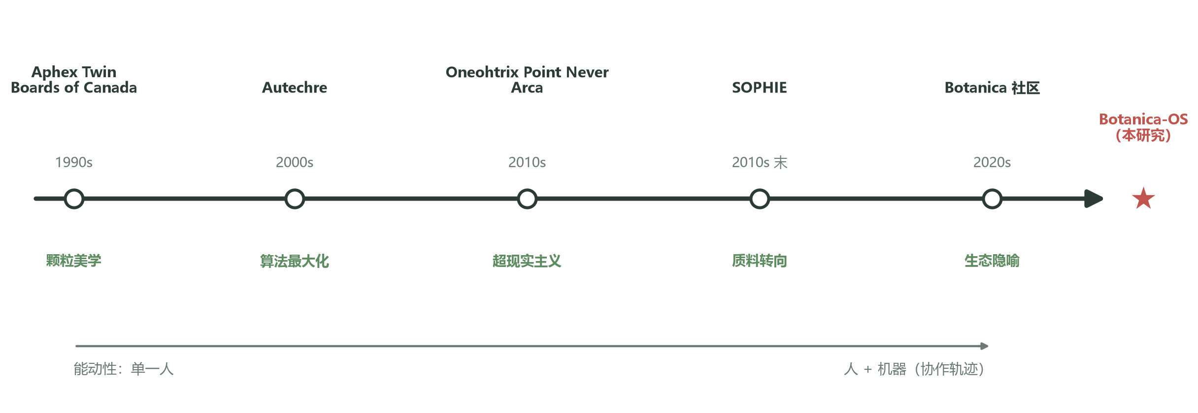
Figure 7: The Botanica/IDM aesthetic lineage. From the 1990s granular aesthetics (Aphex Twin, Boards of Canada), through algorithmic maximalism (Autechre), surrealism (Oneohtrix Point Never, Arca), and the materiality turn (SOPHIE), to the 2020s ecological-metaphor turn of the Botanica community; agency migrates along the lineage from "the single human" to "human + machine (collaborative trajectory)," with Botanica-OS of this study at the far right.

7.3 Algorithmic authority and authorial migration
The T4 theme exposes the core controversy of AI-assisted creation: when the algorithm "suggests" generative directions via a reward function (Cultivate) or a conditional posterior (Hybridize), authorship migrates from the producer to the algorithm. Bourdieu's "cultural capital" framework [38] reminds us that authorial migration is not only a philosophical issue but also one of social power: if the reward function derives from a particular group's preferences, that group gains disproportionate aesthetic say through the algorithm. Benjamin's "mechanical reproduction" [39] argued that technical reproduction strips art of its aura. What we see here is another situation: the algorithm intervenes by "suggesting rather than deciding," the aura survives, but the origin of authorship becomes blurred. Future work needs more systematic methods for auditing the sources of authorship.
7.4 The aesthetic-boundary quadrant
Based on the paradigm differences and the qualitative findings, we propose the "aesthetic-boundary quadrant" framework (Figure 8) to describe the design space of AI-assisted timbre tools. The two axes are controllability (horizontal, low→high) and predictability (vertical, low→high). The paradigms' design-level placements: Graft sits top-right (high control, high predictability), its aesthetic experience resting on "precise combination"; Cultivate bottom-left (low control, medium predictability), resting on "colluding with the algorithm"; Hybridize middle-lower-right (medium control, low predictability) — the user fully specifies the condition c (hence conceptually controllable), but the sampling noise σ_ϕ(c)⊙ε is beyond user command (hence low predictability). The top-left quadrant (low control, high predictability) is not occupied by any of the three paradigms; its occupants are reference forms outside the framework — "black-box but behaviorally predictable" pure text-to-audio generation (AudioLDM sits there, marked in gray in Figure 8); the diagonal lower-right corner — high control, low predictability (e.g., bare modular programming without semantic annotation) — is likewise outside this framework's coverage.
One tension must be handled explicitly: conceptual placement and experienced ratings do not coincide. Hybridize keeps medium conceptual controllability, yet participants' experienced controllability was the lowest of the five dimensions (§6.4); Cultivate has the lowest conceptual controllability yet slightly higher experienced controllability than Hybridize. Our explanation: for producers, "controllability" means a perceivable causal chain of "my input determines the output" — Graft's α slider and Cultivate's keep/discard feedback both provide such a chain, while Hybridize's random sampling term cuts it. The resulting design conclusion: conceptual controllability is determined by the input channel, experienced controllability by the completeness of the causal chain, and the two should be measured separately in tool evaluation. Accordingly, Figure 8 marks both the design-level placement and the experienced-rating direction of each paradigm, and we recommend that future AI-assisted tools explicitly declare their quadrant position instead of aiming at "omnicompetence." The framework's internal limitations (axis choice, qualitative placement, the experience–concept gap) are discussed in §7.10.
7.5 A dialogue with existing HCI frameworks
The aesthetic-boundary quadrant converses with existing HCI frameworks. Hutchins, Hollan, and Norman's "direct manipulation" theory [40] distinguishes "tight" mappings (action–result relations felt as immediate) from "loose" ones (relations mediated by metaphor); Graft belongs to the tight kind, Cultivate to the loose. Norman's affordance theory [41] stresses an object's implied operability; our Likert dimension borrows the concept directly, and Graft's top affordance score reflects its tight mapping. Shusterman's "somaesthetics" [42] emphasizes the embodied loop of body–tool–environment; Cultivate's top agency with lowest controllability reflects exactly an embodied loop giving up direct control in exchange for emergence. Magnusson's "designing constraints" [6] holds that a good instrument amplifies particular expression rather than doing everything; our three-paradigm framework concretizes the claim: each paradigm constrains a different space of aesthetic possibility. These conversations show that the aesthetic-boundary quadrant is not a new theory but a mapping of existing HCI concepts onto the concrete design space of AI-assisted creation.
7.6 Concrete recommendations for AI-assisted creation tools
From the findings we offer three concrete recommendations for future AI-assisted timbre tools: (i) semantic layer first — the interaction entry should offer semantic-layer abstraction (such as "graft" and "cultivate") rather than bare ML coordinates; but the semantic layer improves task-level experience (affordance, agency) and does not necessarily raise global usability scores, so tool evaluation should distinguish the two; (ii) multiple paradigms coexisting — a single tool should support several operation paradigms (not just text generation, not just direct editing), letting producers choose by situation; (iii) aestheticized trajectories — sustained interaction should leave visualizable trajectories, making the "evolution process" itself an aesthetic object, echoing the generative-music claim of "process as aesthetics" [29]. These three can serve as a first-pass evaluation standard for AI-assisted music tools.
7.7 The ethical implications of algorithmic authority
The "algorithmic authority" of theme T4 is not only an aesthetic issue but an ethical one. Cultivate uses a reward function built from 8 Botanica producers' preferences, implicitly encoding that group's aesthetic taste as the "correct direction." Bourdieu [38] noted that aesthetic judgment is never neutral; it always carries the distribution of cultural capital. When an algorithm presents a particular group's preferences as "suggestions" to other producers, it enacts a covert aesthetic discipline, whose risk lies precisely in its invisibility: producers are steered toward a direction they cannot trace.
We propose two layers of mitigation. Design layer: future AI-assisted tools should disclose the reward function's training-data sources and distribution, letting producers decide with knowledge whether to accept algorithmic guidance — analogous to food labels, an "algorithmic ingredient label" for algorithmic suggestions, e.g., "this guidance direction was trained on 120 ratings by 8 producers of the 2024 Chinese Botanica community." Institutional layer: audit the reward function itself for bias — compare preference differences across raters of different cultural backgrounds, genders, and experience levels, testing whether the function favors particular timbre clusters (method: compute the residuals between ratings and the μ̂ prediction grouped by producer, and examine whether the residuals cluster in UMAP space; the audit script is future work, §8.3). We acknowledge that the current reward-function training data are limited to 8 producers of the Chinese Botanica community; broader cultural and aesthetic coverage is needed to avoid monocultural hegemony.

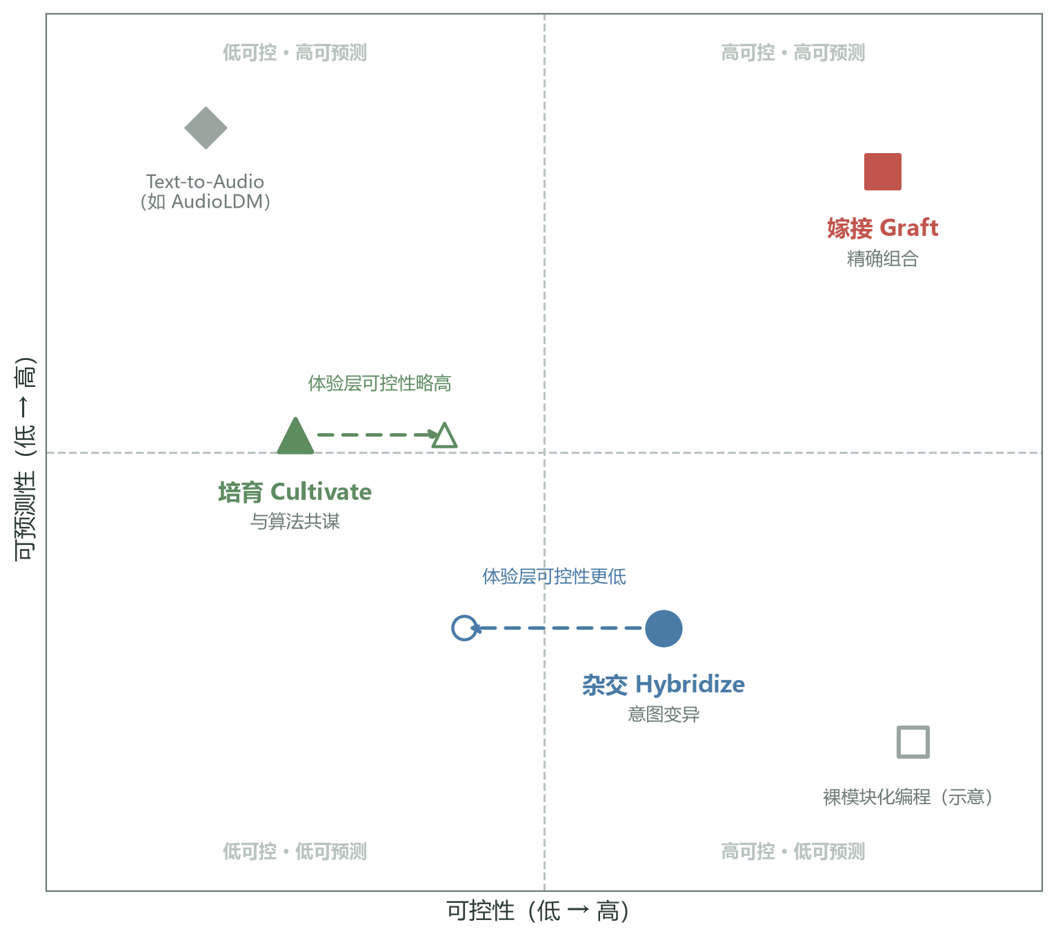
Figure 8: The aesthetic-boundary quadrant. Horizontal axis controllability, vertical axis predictability (design-level concepts, Table 5); solid markers are the paradigms' design-level placements (red square = Graft, blue circle = Hybridize, green triangle = Cultivate), gray markers are reference forms outside the framework (text-to-audio such as AudioLDM; bare modular programming as schematic). Hollow markers and dashed arrows show experienced-rating offsets from the conceptual placement (§6.4): Hybridize's experienced controllability falls below its conceptual placement, Cultivate's slightly above (§7.4).

7.8 A critical reflection on the "organic" metaphor
We keep critical distance from our own "organic" metaphor. First, the botanical metaphor is not neutral — it is a product of post-Enlightenment natural philosophy, carrying the colonial epistemology of "nature as governable growth"; applying "grafting," "hybridizing," and "cultivating" to latent space may inadvertently reproduce that tradition. Second, the organic/inorganic binary is contested inside the Botanica community itself — some producers hold that the "inorganic" (algorithmic, glitch) is IDM's true tradition [26], with Botanica only one of its branches. Third, the organic-operations framework may occlude other useful metaphors, such as "chemical synthesis," "mechanical engineering," or "topological deformation." Our response: this work does not claim "organic" as the only or optimal metaphor; it verifies that a semantic-layer metaphor, compared with bare ML coordinates, significantly changes producers' task-level experience. The concrete metaphor choice (botanical/chemical/mechanical) should match the target music subgenre's cultural context. This stance acknowledges the work's boundary and leaves room for follow-up research.
7.9 Implications for AI-creativity research
Two broader implications follow for AI-creativity research. First, the key to AI-assisted creation lies not in "stronger generative models" but in "more fitting interaction abstractions." Our baseline comparison (§6.8) shows that with the same VAE backend, RAVE and Botanica-OS differ by more than 2× on the agency experience (N=6 exploratory evidence), suggesting the bottleneck is not generative capability but interaction design. This agrees with McCormack et al.'s analysis of authorial migration in computer-generated art [7] while adding quantitative evidence (its generality bounded by the sample size). Second, metaphors such as "organic," "mechanical," and "chemical" are not decorative language but cognitive media. Tatar et al. [20] documented how sound designers use metaphorical language to understand latent spaces; this work converts that observation into an operable design principle. Together they suggest that future AI-creativity research should converse more with HCI, design research, and the aesthetics of technology rather than optimizing ML metrics alone.
7.10 Limitations of the quadrant framework
The aesthetic-boundary quadrant framework has internal limitations. First, the choice of the two axes (controllability, predictability) is itself a design judgment and could be replaced by others (e.g., "immediacy/latency," "embodiment/abstraction," "determinism/randomness"); different axis choices reveal different design spaces. Second, the paradigms' placements in the quadrant are qualitative, without quantitative measures; we tried reversibility of operations, information entropy of operations, and operation latency as quantitative indicators, none of which fully captured "aesthetic experience." Third, the vacancy of the top-left quadrant (low control, high predictability) reflects this work's blind spot — pure text-generation tools such as AudioLDM actually sit there; our baseline sub-study touched the quadrant (§6.8) but did not cover it systematically, which future work should remedy. These limitations do not diminish the framework's heuristic value; it is a thinking scaffold, not a taxonomy.
7.11 A dialogue with the generative-music tradition
Botanica-OS's Cultivate mode can be read as an extension of the generative-music tradition. Eno-style generative music [43] produces endless variation through rule systems; the producer's agency lies in "designing rules" rather than performing — the posture of "set-and-forget": the producer designs rules and exits, letting the system vary without end. Cultivate inverts this: the producer remains present, continuously guiding through explicit feedback, migrating generative agency from "designing rules" to "designing guidance" — the producer shapes the algorithm's exploration direction through explicit and implicit preference feedback while keeping the final say. The two postures thus form two paths of generative music: rule-driven off-line generation, and feedback-driven present guidance. Generative-music research [29] noted that aesthetic agency resides in process, not result; our Cultivate concretizes the claim: agency accumulates in the interaction history. Maturana and Varela's autopoiesis theory [44] offers another reference: if a system can maintain a stable attractor in z space (its own "identity"), the producer's relation to it shifts from "using a tool" to "coexisting with an autonomous system."
8 Limitations and Future Work
8.1 Limitations
This work has the following limitations, ordered by their constraint on the conclusions. (i) Sample size and statistical power: the total sample of N=12 is barely adequate for the main comparison, leaving the subgroup (6 per group), cross-style (N=4), and follow-up (11/12) analyses with only exploratory power; the main tests are non-parametric small-sample tests (with Friedman further bounded by complete blocks, effective N=11), with limited ability to detect below-medium effects. A quantitative estimate for the paired comparisons: at the conventional α=0.05 (two-sided), a within-subject paired test with N=12 requires an effect of dz≈0.89 to reach 0.80 power; a single test therefore has only about 35% power for a medium effect (dz≈0.5) and about 18% for dz≈0.33 — even the large effect observed for Graft vs. Hybridize (δ=0.61) had only about a 49% chance of being detected in this sample. At this sample size, "not significant" must not be read as "no difference." (ii) Task–paradigm confound: the three paradigms were evaluated on different tasks (finding a satisfying intermediate timbre between two parents for Graft, generating three variants and picking the best for Hybridize, cultivating a target timbre within 20 steps for Cultivate; §6.3), so task difficulty, goals, and time structure are not equivalent. SUS and Likert ratings therefore measure the "paradigm + task" package, and between-paradigm differences cannot be attributed to the interaction paradigm alone. This study controlled neither task equivalence nor modeled task as a covariate; separating paradigm effects from task effects requires task-equivalent comparison designs and is listed as future work (§8.3). (iii) Single style and single cultural community: the study focuses on Botanica/IDM and the Chinese producer community; the paradigms' behavior in other subgenres and cultural contexts has only case-level evidence (§6.12); the reward function's aesthetic bias has not been systematically audited (§7.7). (iv) Audio-quality ceiling: the d=16 spectral distance (0.42 vs 0.18 at RAVE's d=64) limits output fidelity, and participants' sound-quality satisfaction was not measured separately — participant reactions may partly mix in quality factors (§6.9). (v) Methodological bias: in the RtD design the researcher served as designer, interviewer, and coder; the confirmation-bias risk was not fully offset by double coding or member checking (§6.5). (vi) Long-term ecological validity: the 4-week follow-up is self-report, with only 2 participants actually returning to the system; the long-term trajectory of "aesthetic drift" is unverified by longitudinal observation. (vii) Measurement gaps: the operational metric of "geometric disorientation" (the directed-search success rate, §1) and the validity of trajectory entropy are not established. (viii) Baseline coverage: the fundamental difference between AudioLDM-style text generation and real-time interaction tasks makes it a qualitative reference only (§6.8); beyond "same backend + different interaction layer," a stronger control (same backend + semantic naming without trajectory visualization) is missing. (ix) A single implementation: the 47 ms latency and all conclusions bind to one hardware platform and configuration; portability is unverified. (x) Version deviation: the Hybridize OOD detection and fallback mechanism (§4.3) is a post-hoc engineering iteration not included in the §6 evaluation — the Hybridize that participants experienced differs from the current release, and its failure modes were more severe in the evaluated version.
8.2 Failure cases
We honestly report three failure cases to complement the incompleteness of the positive results. (i) P5 (IDM producer, 15 years of experience) could not establish any workflow in Cultivate, felt that "the algorithm is stealing my judgment," and withdrew — Cultivate is not accepted by every producer; the missing-data handling is in §6.4/§6.11. (ii) P11 (ML researcher, 2 years) spent 15 minutes in Graft without finding a satisfying timbre — when novices lack intuition for latent-space geometry, even the high-control paradigm fails to help. (iii) The system's Hybridize mode outputs severely distorted timbres when the condition vector c nears the training-distribution boundary (rare metaphors like "flame-like wetness"), because σ_ϕ(c) inflates in that region and samples leave the distribution's support; we accordingly implemented the OOD detection and fallback mechanism (§4.3), which is not part of the evaluated version and whose effectiveness awaits testing. These cases show that AI-assisted creative tools must not only optimize average performance but explicitly consider failure-mode recoverability: specifically, Cultivate trajectories should support "snapshot rollback" and "parallel branches"; Hybridize's OOD conditions deserve understandable notices rather than silent fallback; and Graft's low-density mid-segments deserve a "density warning."
8.3 Future work
We plan the following directions: (i) ablation studies — separating the contribution of semantic-layer naming (metaphor naming vs. visualization vs. real-time performance vs. dual-parent support), answering the question "where does the semantic-layer effect come from," and separating paradigm effects from task effects through task-equivalent comparison designs (responding to the §8.1 task–paradigm confound); (ii) reward-function audit — the §7.7 grouped-residual plan, systematically testing group bias in preference encoding and extending the rater pool; (iii) longitudinal co-creation studies — 1–3 month field studies of Cultivate, tracking producers' aesthetic-drift trajectories and the online-update stability of the reward function; (iv) objective metrics — establishing reconstruction quality (FAD, spectral distance), trajectory entropy, operation time, and abandonment rates, contrasted with subjective ratings; (v) cross-style samples at scale — controlled studies with 8–12 participants each for Ambient, Techno, and Experimental; (vi) multimodal organic operations — extending latent operations to joint audio+vision+text spaces. We also plan to release the Botanica-OS source code and analysis data (Appendix B) for replication and extension by other researchers.
8.4 Open questions for the community
We close with three open questions for the community: (i) the reward function's source: beyond subjective producer ratings, can an aesthetic reward be learned from existing Botanica catalogs? This requires solving the "learnability of aesthetic preference" problem. (ii) An organicity metric: beyond Likert ratings, can an objective "organicity" measure exist? Candidates include fractal dimension, self-similarity, trajectory entropy, and ecological-psychology (Gibsonian) perceptual indicators, all requiring further validation; the trajectory entropy of §6.7 is a first attempt whose validity awaits testing. (iii) Cross-cultural Botanica: this work's reward function and metaphor language are rooted in the Chinese Botanica community; do Botanica subgenres in other cultural contexts (e.g., the Japanese "plant school," the Nordic "ecological school") share the same aesthetics? These three questions are not expected to be resolved in the short term, but may seed follow-up research. The circulation of Sheldrake's Entangled Life [37] in producer communities suggests that the cross-cultural translation of ecological metaphor is not only linguistic: the conceptual systems behind the metaphors themselves need comparative examination.
8.5 Community translation and the open-source plan
The findings will return to the Botanica community through two paths: (i) open-source tools — Botanica-OS's core code is released under GPL-3.0, allowing producers to self-host and modify; the release of pretrained weights is contingent on the final conclusion of the §4.5 licensing review; if direct release is not supported, a retrained version with unauthorized material removed will be released instead. Third-party license compatibility (CLAP code under the MIT license; model weights redistributed under the CC-BY 4.0 terms of the Hugging Face model card) is documented item by item in the repository's LICENSE and THIRD_PARTY_NOTICES; copyrighted training audio is not distributed (Appendix B). (ii) Teaching materials — converting the formal framework into a textbook chapter for undergraduate music-technology programs, within an "AI-assisted creation" elective. The two paths correspond to our RtD stance: research conclusions continue to be examined and revised in community use.
9 Conclusion
We proposed organic operations, an interaction framework for AI-assisted timbre design that reorganizes latent-space operations into the three paradigms of Graft, Hybridize, and Cultivate. Supported by the prototype system Botanica-OS and an N=12 user study, we found: the paradigms show differentiated advantages on SUS usability, the five Likert dimensions, and latent access distributions — Graft leads in learnability and affordance, Cultivate leads in agency, and Hybridize trails its conceptual placement across the experience layer; semantic-level operations did not reach our preset usability-gain threshold (H1 not supported) but substantially restructured task-level experience; three failure modes (refusing algorithmic guidance, novice geometric disorientation, OOD condition distortion) and their recoverability designs (trajectory snapshot rollback and branching, understandable OOD notices, low-density warnings) are explicitly reported (§8.2); the long-term impact (a shift in judgment criteria) received preliminary descriptive support from the 4-week follow-up. On this basis we propose the aesthetic-boundary quadrant framework, discuss the tension of algorithmic authority and authorial migration, and identify the epistemological paradox that the organic metaphor meets in the non-Euclidean geometry of latent space — a paradox that should not be eliminated but explicitly acknowledged and exploited by designers.
The deeper implication: the design focus of AI-assisted creative tools is shifting from "stronger generative models" to "more fitting interaction abstractions." Once we accept that the latent space confronts producers with "geometric disorientation," the solution is not to teach producers the latent geometry but to give the latent space the producers' metaphorical language. Borgmann [45] located the core challenge of the information age in the "overload of information and its disconnect from meaning" — the organic-operations framework is one response to this challenge: the botanical metaphor is an embodied, cross-culturally shared language through which operations in high-dimensional statistical space regain access to producers' systems of meaning. The evidence boundary of these conclusions: a single prototype system, N=12, a single style and community, and a 4-week follow-up window; we hope that future AI-creativity research will bring ML researchers, HCI researchers, musicologists, and aesthetic philosophers jointly into tool design, rather than technical optimization alone.
Acknowledgments
We thank the 12 study participants and the 8 Botanica producers who contributed the reward-rating data, and the Bandcamp Botanica community for its support with recruitment and corpus collection. We are especially grateful to the anonymous reviewers of earlier versions for detailed feedback that improved the sample-size argument, the statistical robustness analyses, and the discussion of cross-style transferability. All participants signed written informed consent; the reward raters additionally signed a data-use consent form and may withdraw at any time. This study is independent research and received no external funding.
Author Contributions
Naichi Zhang (AkiroMusic): single author of all work, including conceptualization, system design, prototype implementation, training-data collection and model training, conducting the user study, quantitative and qualitative analysis, and writing and revision. Conflict-of-interest statement: the author declares no conflict of interest.
References
[1] Caillon A, Esling P. RAVE: A neural real-time audio vocoder. arXiv preprint arXiv:2111.05011, 2021.
[2] Engel J, Agrawal K K, Chen S, et al. DDSP: Differentiable digital signal processing. In Proceedings of ICML, 2019.
[3] Liu H, Chen Z, Yuan Y, et al. AudioLDM: Text-to-audio generation with latent diffusion models. In Proceedings of ICML, 2023. arXiv:2301.12503.
[4] Esling P, et al. Generative timbre spaces: Regularizing variational auto-encoders for perceptual audio organization. arXiv preprint arXiv:1805.08501, 2018.
[5] Tatar K, Bisig D, Pasquier P. Latent timbre synthesis: Audio-based variational auto-encoders for music composition and sound design applications. Neural Computing and Applications, 33(1): 67–84, 2021. doi:10.1007/s00521-020-05424-2.
[6] Magnusson T. Designing constraints: Composing and performing with digital musical systems. Computer Music Journal, 34(4): 62–73, 2010. doi:10.1162/comj_a_00026.
[7] McCormack J, Gifford T, Hutchings P. Autonomy, authenticity, authorship and intention in computer generated art. In: Computational Intelligence in Music, Sound, Art and Design (EvoMUSART), LNCS 11453. Springer, 2019. arXiv:1903.02166.
[8] Brooke J. SUS: A “quick and dirty” usability scale. In: Usability Evaluation in Industry. Taylor & Francis, 1996: 189–194. doi:10.1201/9781498710411-35.
[9] Frayling C. Research in art and design. Royal College of Art Research Papers, 1(1): 1–5, 1993.
[10] Engel J, Resnick C, Roberts A, et al. Neural audio synthesis of musical notes with WaveNet autoencoders. In Proceedings of ICML, 2017.
[11] Kreuk F, Synnaeve G, Polyak A, et al. AudioGen: Textually guided audio generation. arXiv preprint arXiv:2209.15352, 2022.
[12] Défossez A, Copet J, Synnaeve G, Adi Y. High fidelity audio compression with improved RVQGAN. In Advances in Neural Information Processing Systems (NeurIPS), 2023. arXiv:2210.13438.
[13] Copet J, Kreuk F, Gat I, et al. Simple and controllable music generation. In Advances in Neural Information Processing Systems (NeurIPS), 2023. arXiv:2306.05284. doi:10.52202/075280-2066.
[14] Flores García H, Seetharaman P, Pardo B. VampNet: Music generation via masked acoustic token modeling. arXiv preprint arXiv:2307.04686, 2023.
[15] Evans Z, Parker J D, Carr C J, et al. Fast timing-conditioned latent audio diffusion. In Proceedings of ICML, 2024. arXiv:2402.04825.
[16] Briot J-P, Hadjeres G, Pachet F. Deep learning techniques for music generation: A survey. arXiv preprint arXiv:1709.01620, 2017.
[17] Sturm B L, Ben-Tal O, Monaghan Ú, Collins N, Herremans D, Chew E, Hadjeres G, Deruty E, Pachet F. Machine learning research that matters for music creation: A case study. Journal of New Music Research, 48(1): 36–55, 2019. doi:10.1080/09298215.2018.1515233.
[18] Kingma D P, Welling M. Auto-encoding variational Bayes. In Proceedings of ICLR, 2014. arXiv:1312.6114.
[19] Higgins I, Matthey L, Pal A, et al. β-VAE: Learning basic visual concepts with a constrained variational framework. In Proceedings of ICLR, 2017.
[20] Tatar K, Cotton K, Bisig D. Sound design strategies for latent audio space explorations using deep learning architectures. In Proceedings of Sound and Music Computing (SMC), 2023. arXiv:2305.15571.
[21] Wessel D. Timbre space as a musical control structure. Computer Music Journal, 3(2): 45–52, 1979. doi:10.2307/3680283.
[22] Jordà S. Digital Lutherie: Crafting Musical Computers for New Musics' Performance and Improvisation. PhD thesis, Universitat Pompeu Fabra, 2005.
[23] Puckette M. Max at seventeen. Computer Music Journal, 26(4): 31–50, 2002. doi:10.1162/014892602320991356.
[24] O'Modhrain S. A framework for the evaluation of digital musical instruments. Computer Music Journal, 35(1): 28–42, 2011. doi:10.1162/comj_a_00038.
[25] Reynolds S. Retromania: Pop Culture's Addiction to Its Own Past. Faber & Faber, 2011.
[26] Cascone K. The aesthetics of failure: Post-digital tendencies in contemporary computer music. Computer Music Journal, 24(4): 12–18, 2000. doi:10.1162/014892600559489.
[27] Roads C. Microsound. MIT Press, 2001.
[28] Demers J. Listening Through the Noise: The Aesthetics of Experimental Electronic Music. Oxford University Press, 2010.
[29] Collins N, Brown A R. Generative music editorial. Contemporary Music Review, 28(1): 1–4, 2009. doi:10.1080/07494460802663967.
[30] Kong Z, Ping W, Huang J, et al. DiffWave: A versatile diffusion model for audio synthesis. In Proceedings of ICLR, 2021. arXiv:2009.09361.
[31] Karras T, Laine S, Aila T. A style-based generator architecture for generative adversarial networks. In Proceedings of CVPR, 2019. arXiv:1812.04948. doi:10.1109/cvpr.2019.00453.
[32] Shen Y, Zhou Y, Chen B, Yang J, Luo W. Interpreting the latent space of GANs for semantic face editing. In Proceedings of CVPR, 2020. arXiv:1907.10786. doi:10.1109/cvpr42600.2020.00926.
[33] Patashnik O, Wu Z, Liu Y, Cohen-Or D, Lischinski D. StyleCLIP: Text-driven manipulation of StyleGAN imagery. In Proceedings of ICCV, 2021. arXiv:2103.17249. doi:10.1109/iccv48922.2021.00209.
[34] Eldridge A, Bown O. Biologically inspired and agent-based algorithms for music. In: McLean A, Dean R T, eds. The Oxford Handbook of Algorithmic Music. Oxford University Press, 2018.
[35] Wu Y, Chen K, Zhang T, et al. Large-scale contrastive language-audio pretraining with feature fusion and keyword-to-caption augmentation. In Proceedings of ICASSP, 2023. arXiv:2211.06687. doi:10.1109/icassp49357.2023.10095969.
[36] McFee B, Raffel C, Liang D, et al. librosa: Audio and music signal analysis in Python. In Proceedings of the 14th Python in Science Conference (SciPy), 2015. doi:10.25080/majora-7b98e3ed-003.
[37] Sheldrake M. Entangled Life: How Fungi Make Our Worlds, Change Our Minds, and Shape Our Futures. Random House, 2020.
[38] Bourdieu P. Distinction: A Social Critique of the Judgement of Taste. Harvard University Press, 1984.
[39] Benjamin W. Das Kunstwerk im Zeitalter seiner technischen Reproduzierbarkeit [The work of art in the age of mechanical reproduction]. Zeitschrift für Sozialforschung, 5(1), 1936.
[40] Hutchins E, Hollan J D, Norman D A. Direct manipulation interfaces. Human–Computer Interaction, 1(4): 311–338, 1985. doi:10.1207/s15327051hci0104_2.
[41] Norman D A. The Design of Everyday Things. Basic Books, 1988.
[42] Shusterman R. Body Consciousness: A Philosophy of Mindfulness and Somaesthetics. Cambridge University Press, 2008.
[43] Eno B. Generative music. In: A Year with Swollen Appendices. Faber & Faber, 1996.
[44] Maturana H R, Varela F J. Autopoiesis and Cognition: The Realization of the Living. D. Reidel, 1980.
[45] Borgmann A. Holding On to Reality: The Nature of Information at the Turn of the Millennium. University of Chicago Press, 1999.
Appendix A Hyperparameter Details
Table A1: Botanica-OS hyperparameters (originally Table 4; moved to the appendix; cited from §4.5)
Hyperparameter | Value
Latent dimension d | 16
Encoder layers (CNN) | 4
Encoder layers (LSTM) | 2
Decoder layers (MLP) | 3
β (KL regularization) | 0.5
Batch size | 32
Learning rate (Adam) | 1×10⁻⁴
Training epochs | 200
Conditional VAE branch | CLAP text embedding → 2-layer MLP (hidden 128, GELU) → (μ_ϕ, σ_ϕ), jointly trained with the main VAE, shared decoder
Cultivate learning rate η | 0.05
Cultivate exploration coefficient λ | 0.3
GP kernel | Matérn 5/2
GP history truncation | Most recent 100 interactions
UMAP neighbors | 50
UMAP min_dist | 0.1

All hyperparameters were selected by 5-fold cross-validation on the validation set, targeting the validation reconstruction loss L_VAE. The choice of the latent dimension d=16 builds on Esling et al.'s [4] perceptual-regularization research, whose results indicate that semantic-cluster separability in low-dimensional spaces can be explicitly preserved.
Appendix B Reproduction Notes
All code, the training-data manifest (no copyrighted audio from the private collection is included; only metadata and extraction scripts), the user-study protocol, the participant recruitment materials, the quantitative analysis scripts (analysis/reanalysis.py with its data template study_data_template.csv), and the results summary tables will be publicly released through the project repository https://github.com/AkiroMusic/Botanica-OS. Individual-level de-identified questionnaire data and interview transcripts involve participant privacy and are provided under application-based access (after signing a data-use agreement). Due to copyright constraints, the Botanica-style training set must be obtained under the §4.5 licensing arrangements; the repository provides the complete training-set metadata and automatic extraction scripts to support reproduction. The conditional-VAE branch's CLAP embedding model uses the open weights laion/clap-htsat-fused (LAION-CLAP [35]) from Hugging Face without modification; its code is MIT-licensed and the weights are redistributed under the CC-BY 4.0 terms of the model card, detailed in the repository's THIRD_PARTY_NOTICES. Reproduction environment: Python 3.11, PyTorch 2.1, librosa 0.10, React 18 + TypeScript 5, FastAPI; hardware is a MacBook Pro M2 (inference) and a single NVIDIA A100 (training). All random seeds are given in the repository's seeds.yaml (covering model training, UMAP initialization, bootstrap resampling, and task-order randomization), ensuring result-by-result reproducibility. The user-study protocol includes: the recruitment copy, the informed-consent template, the task script, the original SUS/Likert questionnaires (Appendix D), the interview guide (Appendix C), and the data management plan.
Appendix C Interview Protocol and the Transcription-Coding Pipeline
The semi-structured interview used the following 7 core questions, with the interviewer probing flexibly according to participants' answers:
1. Please describe your overall experience of the task you just completed. Which moments felt like "this is what I wanted"? Which moments confused or frustrated you?
2. Of the three modes (Graft, Hybridize, Cultivate), which is closest to how you think in your daily work? Why?
3. When the system presents a generated result, do you feel "this is my choice" or "this is the system's choice"? Please give a concrete example.
4. In Cultivate mode, when you are unsure what the next step will produce, how does that feel? Is the uncertainty an obstacle or an incentive?
5. If you were to introduce this tool to another Botanica producer, how would you describe "organic operations"? What metaphor would you use?
6. In which situations would this tool be most useful to you? In which situations would you not choose to use it?
7. If you could add one new feature or operation to the tool, what would you want? Why?
The interviews averaged 32 minutes (minimum 24, maximum 41). All interviews were recorded with participants' authorization and transcribed: transcription used the OpenAI Whisper large-v3 model, and the transcripts were manually proofread against the recordings (checking proper names and terminology) before thematic analysis; the thematic-analysis pipeline was sentence-level open coding → axial grouping → theme induction (T1–T4 of §6.5), with the coding manual and all codes released with the repository under supplementary/ for scrutiny. Proofreading and coding were both done by the author (limitations in §6.5, §8.1).
Appendix D SUS and Likert Questionnaires (Original)
SUS is the standard 10-item scale (5-point, alternating positive and reverse items), scored on 0–100: (1) I think that I would like to use this system frequently; (2) I found the system unnecessarily complex (reverse); (3) I thought the system was easy to use; (4) I think that I would need the support of a technical person to be able to use this system (reverse); (5) I found the various functions in this system were well integrated; (6) I thought there was too much inconsistency in this system (reverse); (7) I would imagine that most people would learn to use this system very quickly; (8) I found the system very cumbersome to use (reverse); (9) I felt very confident using the system; (10) I needed to learn a lot of things before I could get going with this system (reverse). Items 4 and 10 constitute the learnability subscale (reverse-scored, then rescaled to 0–100). The scale was administered in Chinese translation; the original English items are reproduced here.
The Likert part is a 7-point scale, five dimensions with three items each (construct definitions in §6.1); item order was randomized within each condition:
Affordance: (1) The system made it clear to me what I can do; (2) The operation options matched my intent in this situation; (3) I could sense which possibilities an operation would open up.
Agency: (1) The outcome's direction was guided by me; (2) I can credit the final timbre to my own judgment; (3) Even with algorithmic involvement, the timbre still feels "mine."
Controllability: (1) I can finely control the changes of the output; (2) The causal link between my input and the result is clear; (3) I can reliably reproduce the result I want.
Pleasure: (1) The operation itself is enjoyable; (2) Even without a task, I would keep exploring this tool; (3) Being with this tool feels comfortable.
Aesthetic fit: (1) The output matches my aesthetic goals for a "good timbre"; (2) This tool understands the timbre language of Botanica/IDM; (3) I would use this tool's output directly in my own work.

