VISVESVARAYA TECHNOLOGICAL UNIVERSITY
“Jnana Sangama”, Belagavi, -590014, Karnataka

(2025-26)
AN INTERDISCIPLINARY PROJECT WORK REPORT ON
“AI Based Fake News Detection System”
Submitted in the partial fulfilment of the requirements for the award of the Degree of
BACHELOR OF ENGINEERING
Submitted by
Ashmitha Shekar | 1MJ25CS011
Bhoomika R Y | 1MJ25IS011
Deekshitha G N | 1MJ25AI011
Anish Kumar | 1MJ25EC011
Gopichand K S | 1MJ25VL011
Chethan M | 1MJ25AE011
Under the guidance of
Prof. Ankita Mishra
Department of Artificial Intelligence and Machine Learning (AIML),
MVJCE, Bengaluru


DEPARTMENT OF ARTIFICIAL INTELLIGENCE AND MACHINE LEARNING
Affiliated to VTU, Belagavi, Approved by AICTE, New Delhi,
Recognized By UGC with 2(f) & 12(B), Accredited by NBA&NAAC
2025-2026

MVJ COLLEGE OF ENGINEERING, Bengaluru - 560067
(An Autonomous Institute)
Affiliated to VTU, Belagavi, Approved by AICTE, New Delhi,
Recognized By UGC with 2(f) & 12(B), Accredited by NBA&NAAC

CERTIFICATE
This is to certify that the Interdisciplinary Project titled “AI Based Fake News Detection System” presented by Ashmitha Shekar (1MJ25CS011), Bhoomika R Y (1MJ25IS011), Deekshitha G N (1MJ25AI011), Anish Kumar (1MJ25EC011), Gopichand K S (1MJ25VL011), Chethan M (1MJ25AE011) of second semester are the Bonafide students of MVJ College of Engineering, Bengaluru, in partial fulfilment for the award of Bachelor of Engineering of Visvesvaraya Technological University, Belagavi during the academic year 2025-2026. It is certified that all corrections/suggestions indicated have been incorporated in the report and submitted. The Interdisciplinary Project has been approved as it satisfies the academic regulations prescribed by the institution for the said degree.

Signature of Guide | Signature of HOD

Signature of Internal Examiner  Name: ________________________  Date: _________________________ | Signature of External Examiner  Name: ________________________  Date: _________________________


MVJ COLLEGE OF ENGINEERING, Bengaluru - 560067
(An Autonomous Institute)
Affiliated to VTU, Belagavi, Approved by AICTE , New Delhi,
Recognized By UGC with 2(f) & 12(B), Accredited by NBA&NAAC

DECLARATION
We, Ashmitha Shekar (1MJ25CS011), Bhoomika R Y, Deekshitha G N (1MJ25AI011), Anish Kumar (1MJ25EC011), Gopichand K S (1MJ25VL011), Chethan M (1MJ25AE011) students of second semester B.E., MVJ College of Engineering, Bengaluru, hereby declare that the Interdisciplinary Project titled ‘AI Based Fake News Detection System’ has been carried out by us and submitted in partial fulfilment for the award of Degree of Bachelor of Engineering, during the academic year 2025-26.
Further we declare that the content of the dissertation has not been submitted previously by anybody for the award of any Degree or Diploma to any other University.
We also declare that any Intellectual Property Rights generated out of this project carried out at MVJCE will be the property of MVJ College of Engineering, Bengaluru and we will be one of the authors of the same.

Place: Bengaluru
Date:

Name | USN | Signature
Ashmitha Shekar | 1MJ25CS011
Bhoomika R Y | 1MJ25IS011
Deekshitha G N | 1MJ25AI011
Anish Kumar | 1MJ25EC011
Gopichand K S | 1MJ25VL011
Chethan M | 1MJ25AE011

ACKNOWLEDGEMENT
Any achievement, be it scholastic or otherwise, does not depend solely on individual efforts but on the guidance, encouragement, and cooperation of intellectuals, elders, and friends.
We are thankful to the Management of MVJ College of Engineering, Bengaluru for their continuous support and encouragement in carrying out the project work.
First and foremost, we would like to thank Dr. Ajayan K R, Principal, MVJ College of Engineering, Bengaluru, for his moral support in completing our project work.
We express our sincere gratitude to our Dr. Shrinivas L Gombi, Dean of Academics, MVJ College of Engineering, Bengaluru, for all his support towards this project work.
We deeply express our sincere gratitude to our project Co-Ordinator Prof. Ankita Mishra,
Department of Artificial Intelligence and Machine Learning (AIML) MVJ College of Engineering, Bengaluru, for the valuable guidance throughout the project work.
We thank our Parents and all the Faculty members of the Department of Artificial Intelligence and Machine Learning (AIML) for their constant support and encouragement.
Last, but not least, we would like to thank our peers, and friends who provided us with valuable suggestions to improve our interdisciplinary project.

With Regards,
Ashmitha Shekar
Bhoomika R Y
Deekshitha G N
Anish Kumar
Gopichand K S
Chethan M

ABSTRACT
The rapid spread of misinformation through digital and social media has made automated fake news detection a critical requirement for informed public discourse. This interdisciplinary project presents an AI Based Fake News Detection System implemented as a Flask web application. The system classifies news text as Real or Fake using TF-IDF vectorization with Logistic Regression, achieving 99.43% classification accuracy on 44,898 labelled articles from Fake.csv and True.csv.
Beyond binary classification, the system provides sentiment analysis using TextBlob, regex-based clickbait detection, heuristic credibility scoring, and rule-based explainability. Three external APIs are integrated: GNews.io for live headlines, Google Gemini for AI-assisted explanations, and Google Fact Check Tools API for related claim verification. Environment-based configuration via python-dotenv, structured logging, modular service architecture, and a diagnostics dashboard ensure production readiness.
Model training employs an 80/20 stratified split, compares Logistic Regression against Multinomial Naive Bayes, and optimizes the decision threshold to 0.51 achieving 99.44% tuned accuracy. The confusion matrix on the test set shows 4662 true negatives, 33 false positives, 17 false negatives, and 4266 true positives. A comprehensive test suite of 24 pytest cases validates preprocessing, prediction, API services, and Flask routes.
The web application is developed using Flask with Jinja2 templates and a responsive dashboard presenting prediction, confidence, credibility, clickbait risk, sentiment, fact-check results, and AI explanations. Live API integration tests confirm GNews.io and Google Fact Check connectivity with graceful error handling for unavailable services.
Overall, the project confirms that an AI Based Fake News Detection System using classical NLP with TF-IDF achieves high accuracy with modest computational requirements while integrating modern verification APIs for comprehensive news analysis accessible through an intuitive web interface.

KEYWORDS
| Fake News Detection | TF-IDF | Logistic Regression | Flask |
| Natural Language Processing | Sentiment Analysis | Google Gemini | Fact Check API |
| GNews | Machine Learning | TextBlob | scikit-learn | Clickbait Detection |

ACRONYM

SL.No. | Term | Full Form
1 | TF-IDF | Term Frequency-Inverse Document Frequency
2 | LR | Logistic Regression
3 | NB | Naive Bayes
4 | NLP | Natural Language Processing
5 | ML | Machine Learning
6 | API | Application Programming Interface
7 | UI | User Interface
8 | CSV | Comma-Separated Values
9 | HTML | HyperText Markup Language
10 | CSS | Cascading Style Sheets
11 | JSON | JavaScript Object Notation
12 | AIML | Artificial Intelligence and Machine Learning

Table of Contents

DEPARTMENT OF ARTIFICIAL INTELLIGENCE AND MACHINE LEARNING i
CERTIFICATE ii
DECLARATION iii
ACKNOWLEDGEMENT iv
ABSTRACT v
KEYWORDS v
ACRONYM vi
LIST OF x
LIST OF xi
CHAPTER 1 2
INTRODUCTION 2
1.1 Background 2
1.2 Evolution of Fake News Detection Technology 3
1.3 Motivation 3
1.4 Role of Machine Learning in News Verification 4
1.5 System Design Concept 4
1.6 NLP and Feature Engineering Considerations 4
1.7 Types of Misinformation and Detection Approaches 5
1.8 Objectives of the Project 5
1.9 Applications 5
CHAPTER 2 7
2.1 Overview 7
2.2 Classical Machine Learning Approaches 7
2.3 Feature Engineering and Deception Cues 7
2.4 External Knowledge and Large Language Models 8
2.5 Comparative Summary 8
CHAPTER 3 11
3.1 Primary Objective 11
3.2 Specific Objectives 11
3.3 Measurable Goals 11
CHAPTER 4 14
4.1 Overview of the Methodology 14
4.2 Methodology Flowchart 14
4.3 Dataset Selection 15
4.4 Text Preprocessing Pipeline 16
4.5 Model Training Pipeline 16
4.5.1 TF-IDF Vectorizer Configuration 16
4.5.2 Classifier Configuration 17
4.6 Threshold Optimisation 17
4.7 Model Evaluation 17
4.8 External API Integration 17
4.9 Heuristic Analysis Modules 18
4.10 Testing and Validation 18
CHAPTER 5 20
5.1 Overview of Implementation 20
5.2 Project Directory Structure 20
5.3 Configuration Module 21
5.4 Text Preprocessing Module 21
5.5 External API Service Modules 22
5.6 Machine Learning Prediction Module 22
5.8 Front-End Template Design 23
5.9 Hardware Requirements 24
5.10 Software Requirements 25
5.11 Advantages of the Modular Architecture 26
CHAPTER 6 28
6.1 Overview of Analysis 28
6.2 Model Training Results 28
6.3 Threshold Optimisation 29
6.4 Confusion Matrix Analysis 30
6.5 Classification Report 30
6.6 Probability Distribution 31
6.7 Sentiment and Clickbait Analysis 31
6.8 Credibility Scoring Results 32
6.9 API Integration Test Results 33
6.10 Unit Test Results 35
6.11 Advantages 35
6.12 Limitations 35
6.13 Summary 36
CHAPTER 7 38
7.1 Conclusion 38
7.2 Future Scope 38
REFERENCES 39

LIST OF FIGURES
Figure No. | Title
1.1 | High-level system architecture of the AI Based Fake News Detection System
1.2 | Evolution of fake news detection approaches
1.3 | Three-tier architecture of the system
4.1 | End-to-end methodology flowchart
4.4 | External API integration architecture
5.1 | Project directory structure
5.2 | Code: preprocess_text() in utils/text.py
5.3 | Code: TF-IDF configuration and training in train_model.py
5.4 | Code: home() POST handler in app.py
5.5 | NewsVerify home page
5.6 | Analysis Results dashboard
6.1 | Model accuracy comparison (model_analysis.png)
6.2 | Threshold optimization plot (model_analysis.png)
6.3 | Confusion matrix heatmap (model_analysis.png)
6.4 | Real vs Fake probability distribution (model_analysis.png)
6.5 | Sentiment and Clickbait UI sections
6.6 | Source Credibility UI section
6.7 | GNews Latest Headlines section
6.8 | Related Fact Checks section
6.9 | Integration Diagnostics page
6.10 | pytest output (24 tests passed)

LIST OF TABLES
Table No. | Title
2.1 | Comparative summary of related work on fake news detection
4.1 | TF-IDF vectorizer configuration
5.1 | Hardware requirements
5.2 | Software requirements
6.1 | Model accuracy comparison
6.2 | Confusion matrix on the test set
6.3 | Per-class classification report
6.4 | External API integration test results

CHAPTER 1
INTRODUCTION

CHAPTER 1

INTRODUCTION

1.1 Background
The proliferation of digital news platforms and social media has accelerated the spread of misinformation. Fake news refers to deliberately fabricated information presented as legitimate journalism, often designed to influence public opinion or to generate advertising revenue through sensational headlines. Because such content can be produced and circulated faster than human fact-checkers can review it, automated detection using Artificial Intelligence (AI) and Machine Learning (ML) has become essential for screening news content at scale. This project implements an AI Based Fake News Detection System that uses TF-IDF feature extraction with a Logistic Regression classifier, deployed through a Flask web application named NewsVerify.
The system accepts news text supplied by a user, classifies it as Real or Fake with an associated confidence score, and supplements the classification with sentiment analysis, clickbait detection, a heuristic credibility score, rule-based explanations, and optional verification through three external web services. The result is an accessible, multi-signal verification dashboard rather than a single opaque prediction.
[ 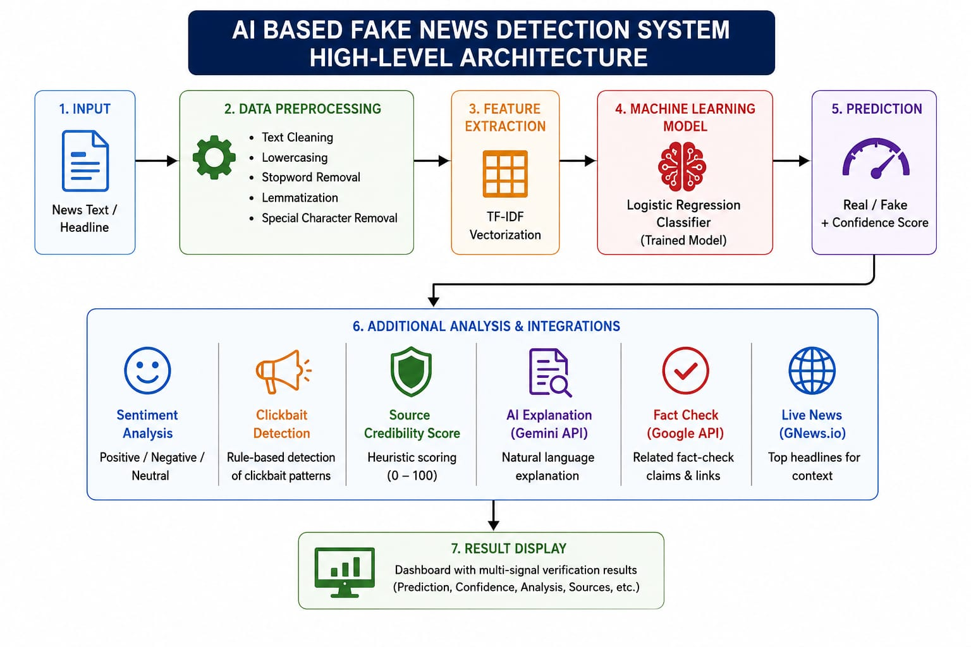
Fig. 1.1: High-level system architecture of the AI Based Fake News Detection System

1.2 Evolution of Fake News Detection Technology
Early fake news detection relied on manual fact-checking and source-reputation analysis, which do not scale to the volume of content published online. The availability of large labelled datasets, such as the ISOT Fake News Dataset used in this project, enabled supervised machine learning approaches. Feature-engineering techniques evolved from simple bag-of-words representations to TF-IDF vectorization, and later to dense word embeddings and transformer models such as BERT.
Modern systems increasingly combine machine learning classification with external verification services. In keeping with this trend, the present project pairs a classical TF-IDF classifier with the Google Fact Check Tools API for related claim reviews, Google Gemini for natural-language explanations, and GNews.io for live headline context. This hybrid design keeps the core classifier lightweight and interpretable while still benefiting from external knowledge sources.
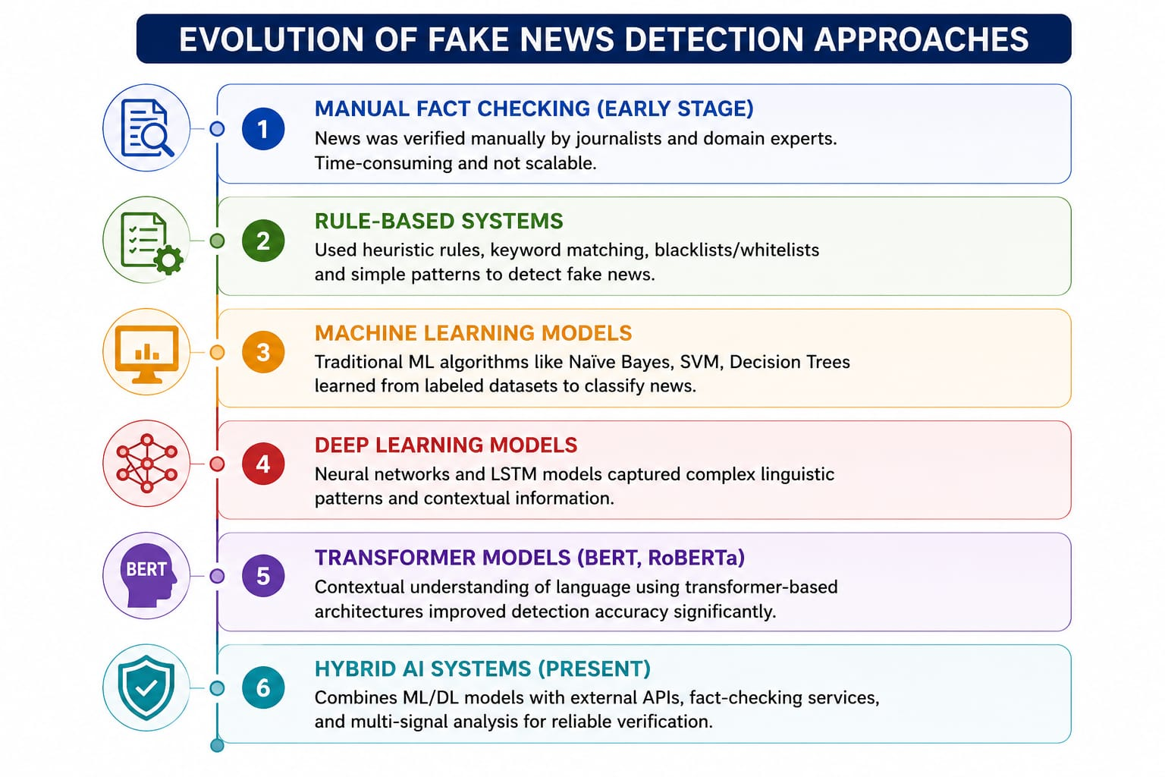
Fig. 1.2: Evolution of fake news detection approaches

1.3 Motivation
Misinformation during elections, public-health emergencies, and geopolitical crises has demonstrated tangible real-world harm. Ordinary users frequently encounter suspicious headlines but lack convenient, trustworthy tools to verify them. This project is motivated by the need for a web-based system that analyses pasted news text and returns a classification together with supporting evidence, including sentiment, clickbait risk, a credibility score, fact-check references, and an AI-generated explanation, so that the user can make an informed judgement rather than relying on a single label.

1.4 Role of Machine Learning in News Verification
Machine learning learns discriminative linguistic patterns from a large corpus of labelled articles — in this project, 23,481 fake and 21,417 real news articles. TF-IDF captures the importance of each term relative to the entire corpus, down-weighting common words and emphasising distinctive ones. Logistic Regression then produces calibrated class probabilities, which allows the decision boundary to be tuned. In this system, the decision threshold is optimised to 0.51, yielding a tuned test accuracy of 99.44%.

1.5 System Design Concept
The system follows a three-tier architecture. The Presentation Layer consists of HTML, CSS, and Jinja2 templates rendered in the browser. The Application Layer is the Flask application (app.py) together with a set of modular service packages under services/ and shared helpers under utils/. The Data Layer comprises the serialized model artifacts (model.pkl, vectorizer.pkl), the configuration file model_config.json, and the training datasets (Fake.csv and True.csv). This separation of concerns improves testability and maintainability.
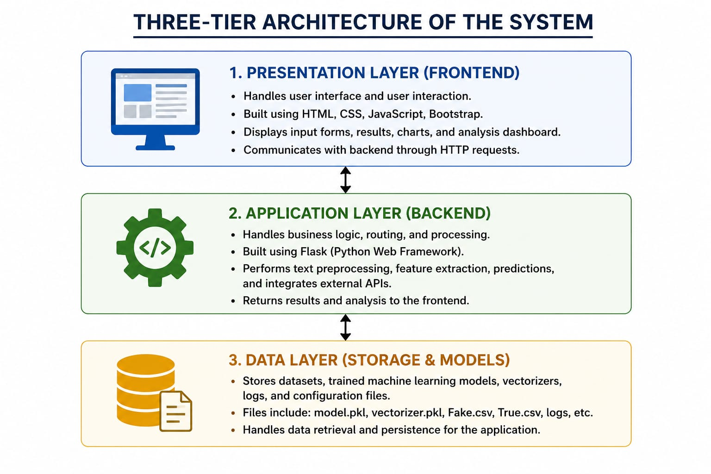
Fig. 1.3: Three-tier architecture of the system

1.6 NLP and Feature Engineering Considerations
A single shared preprocessing function, preprocess_text() in utils/text.py, is used both during training and during inference. This guarantees identical text normalisation at train time and serve time, thereby preventing training–serving skew. The TF-IDF vectorizer is configured with English stop-word removal, a maximum document frequency of 0.80, a minimum document frequency of 2, an n-gram range of unigrams and bigrams, a vocabulary capped at 5,000 features, and sublinear term-frequency scaling.

1.7 Types of Misinformation and Detection Approaches
The system addresses several facets of unreliable content. Fabricated articles are handled by the TF-IDF classifier; sensational or exaggerated headlines are flagged by a regular-expression-based clickbait detector; emotionally charged tone is quantified by TextBlob sentiment analysis; and previously reviewed false claims are surfaced through the Google Fact Check Tools API. Together these signals provide a more complete picture than a single classifier output.

1.8 Objectives of the Project
- Design a fake news classifier that achieves at least 99% test accuracy using TF-IDF and Logistic Regression.
- Develop a Flask web application with an intuitive analysis dashboard.
- Integrate the GNews.io, Google Gemini, and Google Fact Check Tools APIs with graceful degradation when keys are absent.
- Implement sentiment analysis, clickbait detection, and credibility scoring modules.
- Ensure a modular architecture with structured logging, robust error handling, and environment-based configuration.
- Validate the system through 24 automated pytest cases and live API integration checks.

1.9 Applications
Potential applications of the system include teaching natural language processing and ML deployment in educational institutions; preliminary content screening in news organisations; assistance for social-media moderation; verification of suspicious headlines by individual users; and serving as a research baseline against which more advanced transformer-based models can be compared.

CHAPTER 2
LITERATURE
SURVEY

CHAPTER 2
LITERATURE SURVEY

2.1 Overview
Automated fake news detection has been studied extensively using both classical machine learning and deep learning. This chapter reviews representative work that informed the design choices of the present project, with particular attention to feature representations, classifier families, and the use of external verification services.

2.2 Classical Machine Learning Approaches
Ahmed, Traore, and Saad (2017) demonstrated that n-gram features combined with linear classifiers achieve strong baseline performance on the ISOT Fake News Dataset, which is the same dataset used in this project. Their results established that TF-IDF features with simple classifiers are a competitive and computationally inexpensive starting point. Sharma and Ghosh (2019) surveyed Naive Bayes, Support Vector Machines, Random Forest, and deep learning approaches, observing that linear models remain attractive when interpretability and low computational cost are priorities.

2.3 Feature Engineering and Deception Cues
Pérez-Rosas et al. (2018) compared lexical, syntactic, and semantic features for automatic fake news detection and highlighted the value of lexical features that are well captured by TF-IDF. Ott et al. (2011) showed that n-gram features can effectively detect deceptive text, reinforcing the use of unigram and bigram features in the present system.

2.4 External Knowledge and Large Language Models
More recent work integrates external knowledge bases and fact-checking services. The Google Fact Check Tools API exposes structured ClaimReview data that can corroborate or contradict a claim. Large language models such as Google Gemini can produce fluent natural-language explanations, although their use must account for rate limits and the possibility of unavailability. The present project incorporates both, while ensuring that the core classifier continues to function when these services are not configured.

2.5 Comparative Summary
Table 2.1 summarises the surveyed approaches and positions the present work, which combines a proven TF-IDF and Logistic Regression classifier with modern API integrations and production-oriented software-engineering practices.
Table 2.1: Comparative summary of related work on fake news detection

Reference | Approach / Features | Key Observation
Ahmed et al. (2017) | N-gram + linear classifiers on ISOT | TF-IDF baselines are strong and inexpensive
Sharma & Ghosh (2019) | Survey: NB, SVM, RF, deep learning | Linear models favour interpretability and low cost
Pérez-Rosas et al. (2018) | Lexical, syntactic, semantic features | Lexical features are highly informative
Ott et al. (2011) | N-gram features for deception | N-grams effectively detect deceptive text
This project (2026) | TF-IDF + Logistic Regression + verification APIs | High accuracy with modest resources and added context

CHAPTER 3
OBJECTIVES

CHAPTER 3
OBJECTIVES

3.1 Primary Objective
The primary objective of this project is to build an end-to-end AI Based Fake News Detection System that accepts user-provided news text and returns a Real or Fake classification accompanied by a confidence score, sentiment analysis, clickbait detection, a credibility assessment, an AI-generated explanation, and related fact-check references.

3.2 Specific Objectives
- Acquire and preprocess the ISOT Fake News Dataset, combining the title and body text of each article into a single content field.
- Train and compare two classifiers — Multinomial Naive Bayes and Logistic Regression — and select the better-performing model for production.
- Optimise the decision threshold to maximise accuracy on the held-out test set.
- Develop a Flask web application that exposes the classifier and supporting analyses through a responsive dashboard.
- Integrate three external APIs (GNews.io, Google Gemini, Google Fact Check Tools) with environment-based configuration and graceful degradation.
- Implement structured logging, robust error handling, and a diagnostics dashboard for monitoring integration health.
- Validate functionality through an automated test suite and live integration checks.

3.3 Measurable Goals
- Achieve at least 99% accuracy on the held-out test set.
- Provide a machine-learning prediction within a few seconds of submission on commodity hardware without a GPU.
- Integrate all three external services so that each can be independently enabled or disabled through configuration.
- Pass all 24 automated pytest cases covering preprocessing, prediction, services, and routes.
- Expose a diagnostics endpoint that reports the live health of each external integration.

CHAPTER 4
METHODOLOGY

CHAPTER 4
METHODOLOGY

4.1 Overview of the Methodology
The project follows a structured machine-learning engineering methodology comprising data acquisition, text preprocessing, model training and selection, threshold optimisation, evaluation, web-application development, external API integration, and automated testing. Each stage is described in the sections that follow.

4.2 Methodology Flowchart
At inference time, the end-to-end flow is as follows: the user submits news text; the input is validated to ensure it contains at least 10 characters; the text is normalised by preprocess_text(); the TF-IDF vectorizer transforms it into a feature vector; the Logistic Regression model produces class probabilities through predict_proba; the probability of the Real class is compared against the optimal threshold of 0.51 to assign a label; supplementary heuristics (sentiment, clickbait, credibility, and a rule-based explanation) are computed; and, when configured, the Gemini and Fact Check APIs are queried. The latest GNews headlines are fetched on every page load. Finally, all results are rendered in the dashboard.
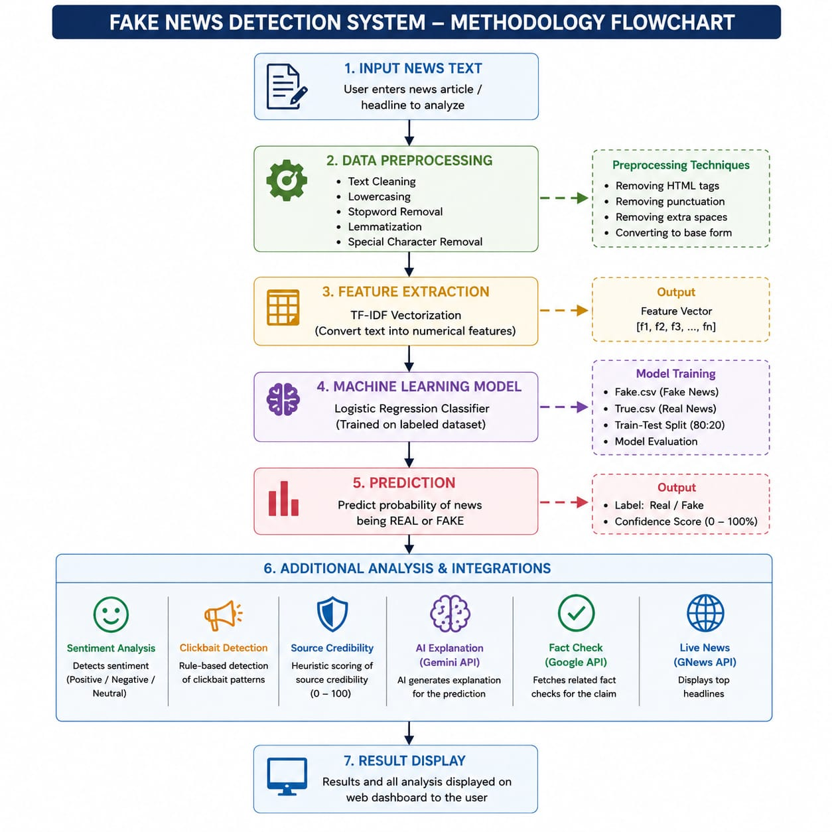
Fig. 4.1: End-to-end methodology flowchart

4.3 Dataset Selection
The system is trained on the publicly available ISOT Fake News Dataset, which is supplied as two CSV files. Fake.csv contains 23,481 fake articles and is assigned the label 0, while True.csv contains 21,417 real articles and is assigned the label 1. Each record contains four columns: title, text, subject, and date. For modelling, the title and body text are concatenated into a single content field. Records whose cleaned content is shorter than 10 characters are discarded. After this filtering and the combination of both files, the corpus comprises 44,898 labelled articles.

4.4 Text Preprocessing Pipeline
Preprocessing is performed by the shared preprocess_text() function. It converts text to lowercase; removes URLs, e-mail addresses, and HTML tags; strips characters outside a restricted alphanumeric and basic-punctuation set; collapses repeated whitespace; and normalises runs of repeated periods, exclamation marks, and question marks. Because the identical function is invoked in both train_model.py and services/analysis.py, the representation seen by the model at inference time matches that seen during training.

4.5 Model Training Pipeline
The training script train_model.py loads both datasets, applies preprocessing, shuffles the combined corpus with a fixed random seed, and performs an 80/20 stratified train–test split so that the class balance is preserved in both partitions. It then fits the TF-IDF vectorizer on the training partition and transforms both partitions. Two classifiers are trained: a Multinomial Naive Bayes model and a Logistic Regression model. The model with the higher accuracy is serialized to model.pkl, and the fitted vectorizer is serialized to vectorizer.pkl.

4.5.1 TF-IDF Vectorizer Configuration
Table 4.1 lists the exact TF-IDF configuration used during training, taken directly from the source code.
Table 4.1: TF-IDF vectorizer configuration
Parameter | Value
stop_words | “english”
max_df | 0.80
min_df | 2
ngram_range | (1, 2) — unigrams and bigrams
max_features | 5,000
lowercase | True
strip_accents | “unicode”
sublinear_tf | True

4.5.2 Classifier Configuration
The Logistic Regression classifier is configured with a maximum of 1,000 iterations, the lbfgs solver, inverse-regularisation strength C = 1.0, balanced class weights, and a fixed random seed for reproducibility. The Multinomial Naive Bayes classifier is configured with a smoothing parameter alpha = 0.1. Both classifiers are trained on the same TF-IDF features to ensure a fair comparison.

4.6 Threshold Optimisation
Because Logistic Regression produces class probabilities, the decision threshold can be tuned independently of the model. The training script performs a grid search over thresholds from 0.35 to 0.65 in steps of 0.02, evaluating accuracy at each candidate value. The threshold of 0.51 is identified as optimal and is persisted to model_config.json, where it is read by the application at startup.

4.7 Model Evaluation
The selected model is evaluated on the held-out test set using accuracy, a confusion matrix, and a per-class classification report. Logistic Regression attains 99.43% accuracy, compared with 96.07% for Multinomial Naive Bayes. After threshold tuning, the test accuracy is 99.44%. The detailed metrics are presented and analysed in Chapter 6.

4.8 External API Integration
Three external services are integrated, each in its own module. GNews.io (services/news_service.py) fetches live top headlines. Google Gemini (services/gemini_service.py) generates AI explanations using the gemini-2.0-flash model. The Google Fact Check Tools API (services/fact_check_service.py) searches for related claim reviews. All API keys are loaded from a .env file through python-dotenv in config.py, and each service returns a (result, error) tuple so that the user interface can degrade gracefully when a service is unavailable or unconfigured.
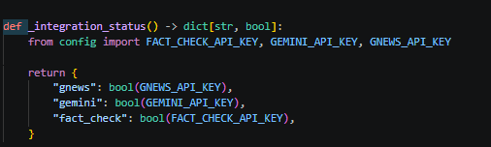
Fig. 4.4: External API integration architecture

4.9 Heuristic Analysis Modules
In addition to the classifier, four heuristic modules provide supplementary signals. TextBlob computes sentiment polarity and maps it to Positive, Negative, or Neutral. A set of regular expressions detects sensational, clickbait-style language and assigns a High, Medium, or Low risk level. A composite credibility score combines the model confidence, the length of the text, and the clickbait risk. Finally, a rule-based explain_prediction() function produces a short textual rationale, a confidence level, and a list of keyword indicators.

4.10 Testing and Validation
Functionality is validated through an automated test suite executed with pytest. Twenty-four test cases cover text preprocessing, prediction, clickbait detection, credibility scoring, sentiment analysis, the three external service wrappers, the Flask routes, and configuration loading. In addition, the script scripts/test_api_integrations.py performs live verification of the external integrations against the diagnostics endpoint.

CHAPTER 5
IMPLEMENTATION

CHAPTER 5
IMPLEMENTATION

5.1 Overview of Implementation
The system is implemented in Python using the Flask web framework. The machine-learning pipeline relies on scikit-learn, pandas, and NumPy; sentiment analysis uses TextBlob; HTTP communication with external services uses the requests library; configuration is managed with python-dotenv; and testing uses pytest. The codebase is organised into clearly separated packages: services/ for application logic and external integrations, utils/ for shared helpers, templates/ and static/ for the web front end, tests/ for the automated test suite, and scripts/ for auxiliary tooling.

5.2 Project Directory Structure
The project root contains the Flask entry point app.py, the configuration module config.py, and the training script train_model.py. The services/ package contains analysis.py, news_service.py, gemini_service.py, fact_check_service.py, model_loader.py, and diagnostics.py. The utils/ package contains text.py and logging_config.py. Serialized artifacts (model.pkl, vectorizer.pkl) and the configuration file model_config.json complete the runtime requirements.
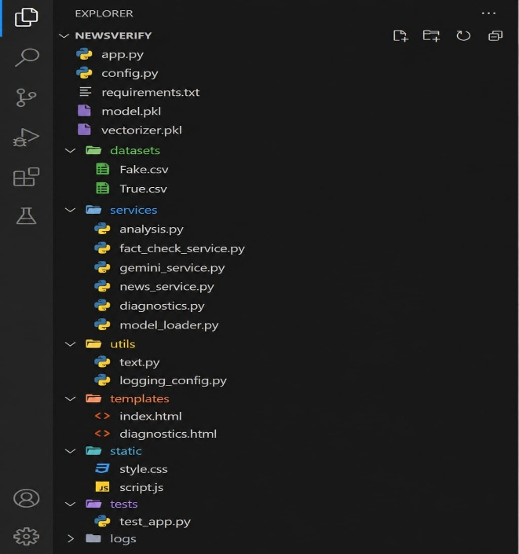
Fig. 5.1: Project directory structure

5.3 Configuration Module
The configuration module config.py loads environment variables from a .env file through python-dotenv without overriding any variables already present in the shell environment. It defines the paths to the model artifacts, the Flask host, port, and debug settings, and the keys and parameters for each external service. A helper, mask_secret(), returns a masked representation of any secret so that API keys are never written to logs or shown in the diagnostics interface in full.
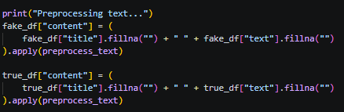
Fig. 5.2: Code: preprocess_text() in utils/text.py

5.4 Text Preprocessing Module
The module utils/text.py contains the single preprocess_text() function shared between training and inference. Centralising preprocessing in one location is a deliberate design decision that eliminates training–serving skew, a common source of degraded accuracy in deployed machine-learning systems.
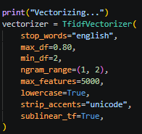
Fig. 5.3: Code: TF-IDF configuration and training in train_model.py

5.5 External API Service Modules
Each external integration is encapsulated in its own module. news_service.py retrieves top headlines from GNews.io; gemini_service.py requests natural-language explanations from Google Gemini; and fact_check_service.py queries the Google Fact Check Tools API. Every function returns a (result, error) tuple and handles timeouts, HTTP errors, malformed JSON, and provider error payloads explicitly, so that a failure in any one service produces a clear, user-facing message rather than an unhandled exception.

5.6 Machine Learning Prediction Module
The prediction logic resides in services/analysis.py. The predict_news() function preprocesses the input, transforms it with the loaded vectorizer, and obtains class probabilities from the model. It assigns the Real label when the probability of the Real class is greater than or equal to the optimal threshold of 0.51, and otherwise assigns the Fake label; the reported confidence is the larger of the two class probabilities. The same module also contains the sentiment, clickbait, credibility, and explanation heuristics.

5.7 Flask Route Handler
The application defines three routes in app.py. The root route “/” handles both GET and POST requests: on GET it renders the form and the live GNews feed, and on POST it runs the full analysis pipeline, including the optional Gemini and Fact Check API calls. The route “/diagnostics” renders an HTML dashboard summarising the live health of each external integration, and “/diagnostics.json” returns the same information as JSON for scripted monitoring. Model artifacts are loaded once at startup; if they are missing, the application exits with a clear error message.
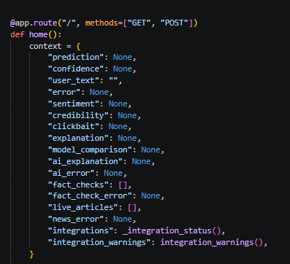Fig. 5.4: Code: home() POST handler in app.py

5.8 Front-End Template Design
The front end is built with Jinja2 templates and a single stylesheet. templates/index.html presents statistic cards, collapsible analysis sections, an integration-warning banner, and headline cards from the GNews feed, and supports a persistent dark-mode toggle. templates/diagnostics.html displays the live API health status produced by the diagnostics service.

Fig. 5.5: NewsVerify home page

Fig. 5.6: Analysis Results dashboard

5.9 Hardware Requirements
The system is intentionally lightweight and does not require a Graphics Processing Unit (GPU) for either training or inference. Table 5.1 lists the recommended hardware.
Table 5.1: Hardware requirements
Component | Minimum | Recommended
Processor | Dual-core CPU, 2.0 GHz | Quad-core CPU, 2.5 GHz or higher
Memory (RAM) | 4 GB | 8 GB or higher
Storage | 2 GB free space | 5 GB free space (datasets are ~110 MB)
Graphics | Not required (no GPU) | Not required (no GPU)
Network | Required only for external APIs | Broadband connection

5.10 Software Requirements
Table 5.2 lists the software environment and the principal Python libraries, as declared in requirements.txt.
Table 5.2: Software requirements
Category | Software / Library | Purpose
Operating System | Windows, Linux, or macOS | Cross-platform runtime
Language | Python 3.13 | Implementation language
Web framework | Flask (2.3–4.x) | HTTP handling and templating
Machine learning | scikit-learn (≥ 1.5) | TF-IDF and classifiers
Data handling | pandas (≥ 2.0), NumPy (≥ 1.26) | Dataset loading and arrays
HTTP client | requests (≥ 2.31) | External API calls
NLP / sentiment | TextBlob (≥ 0.17) | Sentiment polarity
Visualisation | matplotlib (≥ 3.8) | Training analysis plots
Configuration | python-dotenv (≥ 1.0) | Environment-based configuration
Testing | pytest (≥ 7.4) | Automated test suite

5.11 Advantages of the Modular Architecture
- Separation of concerns allows each service to be developed and tested independently.
- Environment-based configuration avoids hardcoded secrets and supports multiple deployment environments.
- Shared preprocessing guarantees consistency between training and inference.
- The diagnostics module supports monitoring of integration health in deployment.
- Graceful degradation ensures the core classifier remains usable even when external services are unavailable.

CHAPTER 6
RESULTS AND ANALYSIS

CHAPTER 6
RESULTS AND ANALYSIS

6.1 Overview of Analysis
This chapter presents the results obtained from an actual training run of the system, together with an analysis of model performance, the supplementary heuristic outputs, the external API integration tests, and the automated test results. The reported figures are taken directly from the persisted configuration (model_config.json) and the generated evaluation plots (model_analysis.png).

6.2 Model Training Results
Training was performed on the full corpus of 44,898 articles using a 5,000-feature TF-IDF representation. Logistic Regression was selected as the production model on the basis of its higher accuracy. Table 6.1 compares the two classifiers.
Table 6.1: Model accuracy comparison
Model | Test Accuracy
Multinomial Naive Bayes | 96.07%
Logistic Regression (selected) | 99.43%
Logistic Regression (threshold-tuned at 0.51) | 99.44%
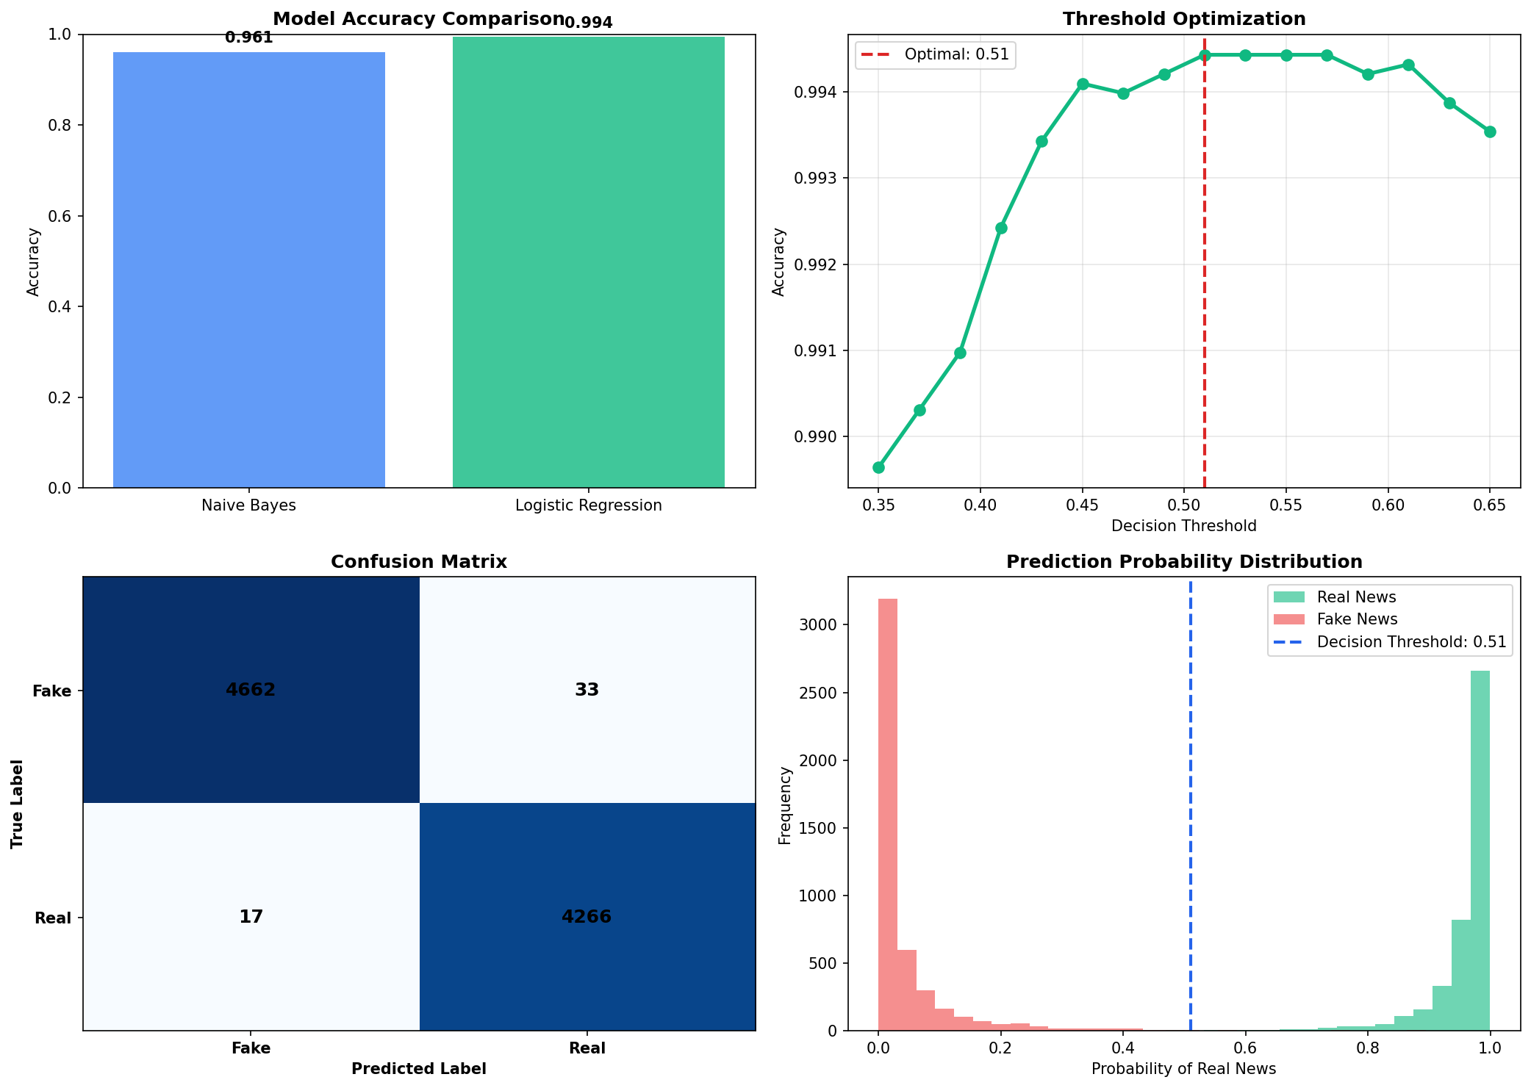
Fig. 6.1: Model accuracy comparison (model_analysis.png)

6.3 Threshold Optimisation
A grid search over decision thresholds from 0.35 to 0.65 identified 0.51 as the value that maximises test accuracy, raising it marginally from 99.43% to 99.44%. The accuracy curve is relatively flat near the optimum, which indicates that the model is well calibrated and not unduly sensitive to the exact threshold.

Fig. 6.2: Threshold optimization plot (model_analysis.png)

6.4 Confusion Matrix Analysis
On the held-out test set of 8,978 articles, the model produced only 50 misclassifications. Table 6.2 presents the confusion matrix. Of the 4,695 truly fake articles, 4,662 were correctly identified and 33 were misclassified as real; of the 4,283 truly real articles, 4,266 were correctly identified and 17 were misclassified as fake.
Table 6.2: Confusion matrix on the test set
 | Predicted Fake | Predicted Real
Actual Fake | 4,662 (TN) | 33 (FP)
Actual Real | 17 (FN) | 4,266 (TP)

Fig. 6.3: Confusion matrix heatmap (model_analysis.png)

6.5 Classification Report
Table 6.3 reports per-class precision, recall, and F1-score, computed from the confusion matrix above. Both classes achieve precision and recall close to 0.99, and the macro-averaged F1-score is 0.99, confirming that performance is balanced across the two classes rather than favouring the majority class.
Table 6.3: Per-class classification report
Class | Precision | Recall | F1-Score
Fake | 0.9964 | 0.9930 | 0.9947
Real | 0.9923 | 0.9960 | 0.9942
Macro average | 0.9943 | 0.9945 | 0.9944
Weighted average | 0.9944 | 0.9944 | 0.9944

6.6 Probability Distribution
The distribution of predicted probabilities shows clear separation between the two classes: fake articles cluster near a low probability of being real, while real articles cluster near a high probability, with the decision threshold of 0.51 lying in the sparse region between the two modes. This separation explains the low error rate observed on the test set.

Fig. 6.4: Real vs Fake probability distribution (model_analysis.png)

6.7 Sentiment and Clickbait Analysis
TextBlob maps the polarity of the submitted text to one of three labels — Positive, Negative, or Neutral — and reports approximate positive, negative, and neutral proportions. The clickbait detector scans the text for sensational terms grouped into four pattern categories and assigns a High, Medium, or Low risk level depending on the number of distinct sensational terms found.

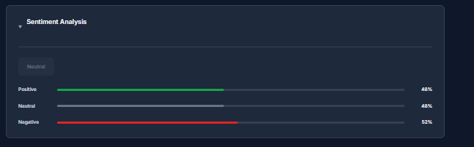Fig. 6.5: Sentiment and Clickbait UI sections

6.8 Credibility Scoring Results
The credibility score is a composite heuristic derived from the model confidence, with bonuses for longer text and penalties for higher clickbait risk. The resulting score is displayed as High (at least 75), Medium (at least 50), or Low (below 50), each with an associated colour indicator in the dashboard.
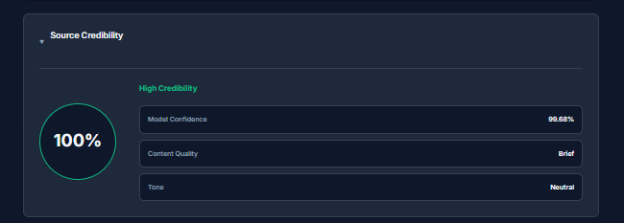Fig. 6.6: Source Credibility UI section

6.9 API Integration Test Results
The external integrations were verified through the diagnostics endpoint and the live integration script. Table 6.4 summarises the observed behaviour. Each integration reports a clear status, and the application continues to function with the core classifier when an integration is disabled or unavailable.
Table 6.4: External API integration test results
Service | Endpoint | Behaviour
GNews.io | gnews.io/api/v4/top-headlines | Headlines fetched; disabled message shown without key
Google Gemini | generativelanguage.googleapis.com (gemini-2.0-flash) | Explanation returned; HTTP 429 rate-limit handled gracefully
Google Fact Check | factchecktools.googleapis.com/v1alpha1/claims:search | Related claim reviews returned for the query


Fig. 6.7: GNews Latest Headlines section

Fig. 6.8: Related Fact Checks section
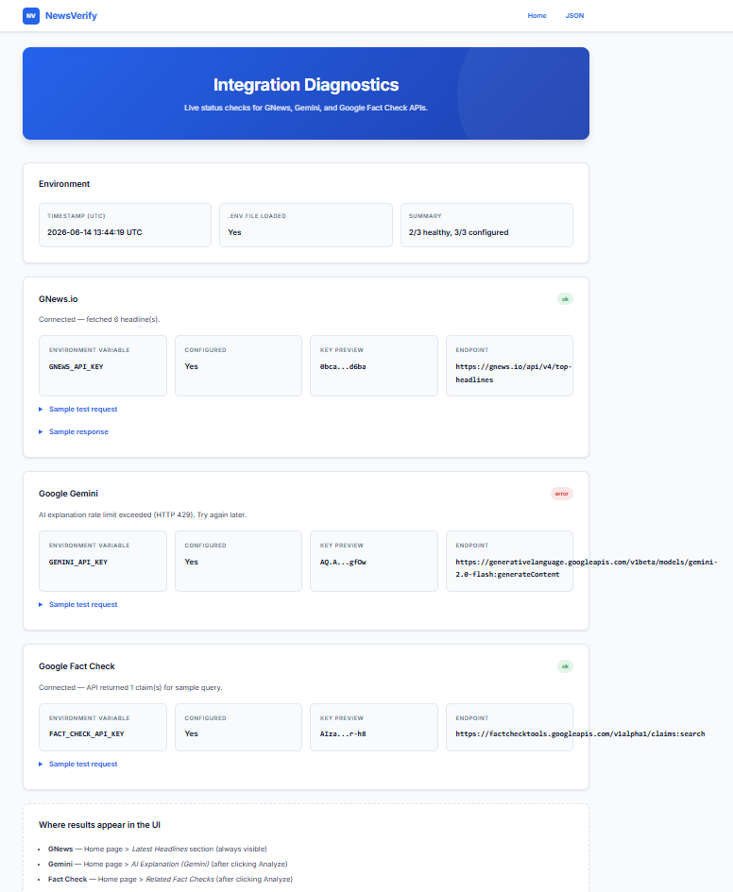
Fig. 6.9: Integration Diagnostics page

6.10 Unit Test Results
The automated test suite was executed with pytest. All 24 test cases passed, covering text preprocessing, prediction, clickbait detection, credibility scoring, sentiment analysis, the GNews, Gemini, and Fact Check service wrappers, the Flask routes including the diagnostics endpoints, and configuration loading.
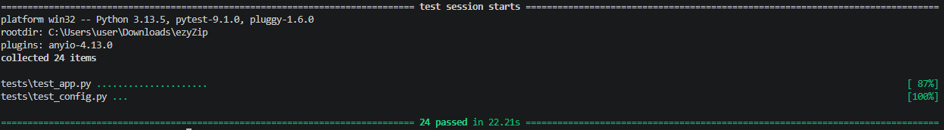
Fig. 6.10: pytest output (24 tests passed)

6.11 Advantages
- High accuracy of 99.43% (99.44% after threshold tuning) on the test set.
- Modular, testable code validated by 24 automated tests.
- A multi-signal dashboard combining classification with sentiment, clickbait, credibility, and fact-check context.
- No GPU requirement, enabling deployment on commodity hardware.
- Graceful degradation and a diagnostics endpoint for monitoring.

6.12 Limitations
- The system is English-only, since the training data and vectorizer are English-centric.
- Classification relies on lexical patterns and does not perform deep semantic reasoning.
- The credibility score is a heuristic and is not grounded in an external source-reputation database.
- External APIs are subject to rate limits and availability.
- The training data originates from a fixed historical period, which may limit generalisation to newer topics.
- The application exposes a single analysis route and does not provide a separate programmatic REST API.

6.13 Summary
The AI Based Fake News Detection System achieves 99.43% accuracy (99.44% after threshold tuning) using TF-IDF features with a Logistic Regression classifier, and integrates three external verification services into a validated, multi-signal web dashboard with graceful degradation.

CHAPTER 7
CONCLUSION

CHAPTER 7
CONCLUSION

7.1 Conclusion
All the objectives defined for this project were successfully achieved. A fake news classifier based on TF-IDF features and Logistic Regression was designed, trained, and evaluated, exceeding the target of 99% accuracy with a tuned test accuracy of 99.44%. The classifier was deployed within a Flask web application that provides an accessible, multi-signal verification dashboard combining the prediction with sentiment analysis, clickbait detection, credibility scoring, and rule-based explanations.
Three external services — GNews.io, Google Gemini, and the Google Fact Check Tools API — were integrated with environment-based configuration and graceful degradation, adding contextual value beyond the core classification. The modular architecture, structured logging, robust error handling, diagnostics endpoint, and suite of 24 passing automated tests together demonstrate that the system is reliable and maintainable. The project confirms that a classical natural-language-processing pipeline can deliver high accuracy with modest computational requirements while remaining interpretable and easy to deploy.

7.2 Future Scope
- Incorporate transformer-based models such as BERT or DistilBERT to improve semantic understanding.
- Add multilingual support with automatic language detection.
- Expose dedicated REST API endpoints for programmatic access.
- Add source-URL and domain-reputation analysis to strengthen credibility scoring.
- Integrate SHAP or LIME to provide model-grounded feature-level explanations.
- Containerise the application with Docker and serve it with a production WSGI server for scalability.
- Add a user-feedback loop to support continuous retraining of the model.
- Develop a browser extension for one-click analysis of news pages.

REFERENCES
[1] H. Ahmed, I. Traore, and S. Saad, “Detection of Online Fake News Using N-Gram Analysis and Machine Learning Techniques,” in Intelligent, Secure, and Dependable Systems in Distributed and Cloud Environments, 2017.
[2] J. Sharma and S. Ghosh, “Fake News Detection Using Machine Learning Algorithms,” International Journal of Computer Applications, 2019.
[3] M. Ott, Y. Choi, C. Cardie, and J. T. Hancock, “Finding Deceptive Opinion Spam by Any Stretch of the Imagination,” in Proceedings of the ACL, 2011.
[4] V. Pérez-Rosas, B. Kleinberg, A. Lefevre, and R. Mihalcea, “Automatic Detection of Fake News,” in Proceedings of COLING, 2018.
[5] F. Pedregosa et al., “Scikit-learn: Machine Learning in Python,” Journal of Machine Learning Research, vol. 12, 2011.
[6] M. Grinberg, Flask Web Development, 2nd ed., O’Reilly Media, 2018.
[7] Google, “Fact Check Tools API Documentation,” developers.google.com/fact-check/tools/api.
[8] Google, “Gemini API Documentation,” ai.google.dev/docs.
[9] GNews, “GNews API Documentation,” gnews.io/docs/v4.
[10] S. Loria, “TextBlob: Simplified Text Processing,” textblob.readthedocs.io.
[11] ISOT Research Lab, University of Victoria, “ISOT Fake News Dataset (Fake.csv and True.csv).”
[12] Dataset Download Link:
https://www.kaggle.com/datasets/clmentbisaillon/fake-and-real-news-dataset

