**Name:**M.Floric Esther

**College** **code:** 9530

**College name:** St.Mother Theresa Engineering College

**Team id:** proj_201054_Team_1

**Naan Mudhalvan id**:au953021104014

**Project Name:** Image Recognition with IBM cloud

**Problem Solution:**

**Image recognition project documentation**

**Step 1: Create an IBM Cloud Account**

**Use the link given to signup or login to IBM cloud.** [**https://cloud.ibm.com/registration**](https://cloud.ibm.com/registration)

**If you already have an IBM Cloud account you can just log in using the link above the Email field.**

**Note: To get enhanced benefits, please sign up with you business or corporate email address rather than a free email ID like Gmail, Hotmail, etc.**

**Step 2: Confirm Your Email Address**

**An email is sent to your email address to confirm your account. Go to your email account, and click on the “Confirm Account” link in the email that was sent to you.**

**Step 3: Login to Your Account**

**Step 4: Create a New Resource**

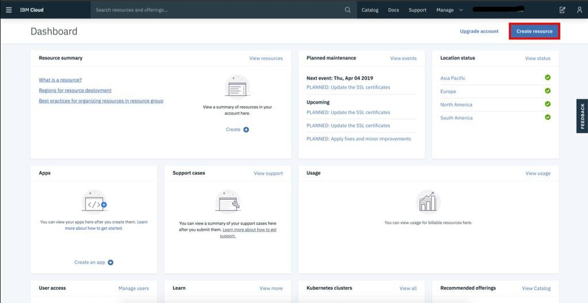**On your dashboard page, click on the Create a resource on the top right to create a new source.**

**Step 5: Create a Visual Recognition and Watson Studio Resource**

**On the Catalog page, select the AI category from the left pane, and then select the Visual Recognition resource.**

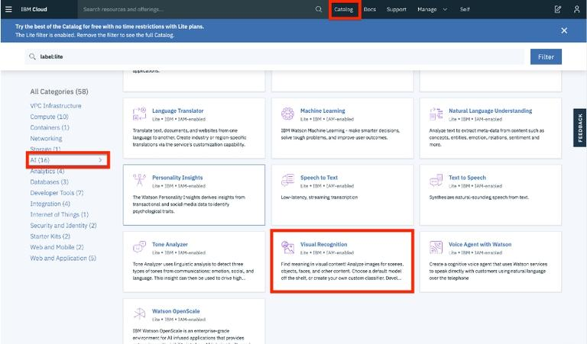

**On the next page, you will get to name your service instance and choose your region. Click on the arrow to reveal the drop-down menu of regions. Make sure to select the region that is closest to you. Then scroll down and make sure that the lite plan is selected, and click the Create button.**

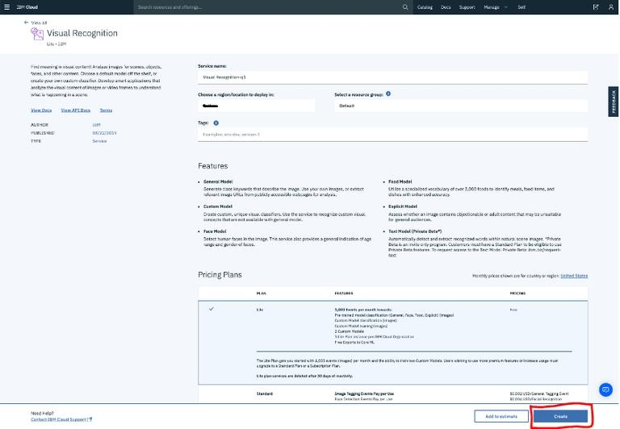**On the Catalog page, select the AI category from the left pane, and then select the Watson Studio resource.**

**On the next page, you will get to name your service instance and choose your region. Click on the arrow to reveal the drop-down menu of regions. Make sure to select the region that is closest to you. Then scroll down and make sure that the lite plan is selected, and click the Create button.**

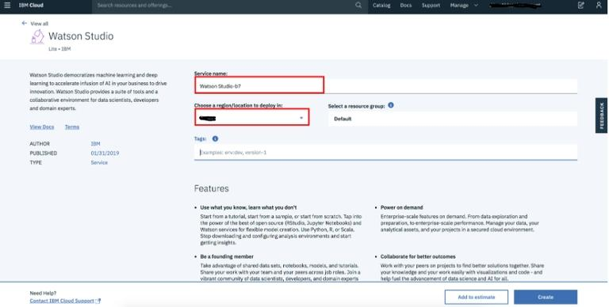**On the next page, click the Get Started button to start using Watson Studio.**

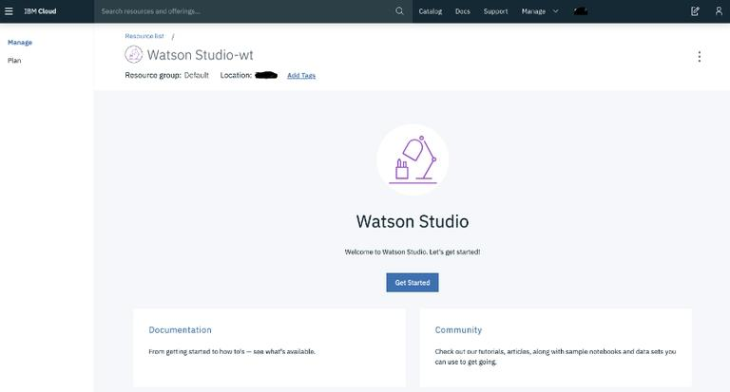

**Once the provisioning process is complete, click the Get Started button to start using Watson Studio.**

**Step 6: Create a Project**

**Once you land on the IBM Watson Studio main page, start by creating a project.**

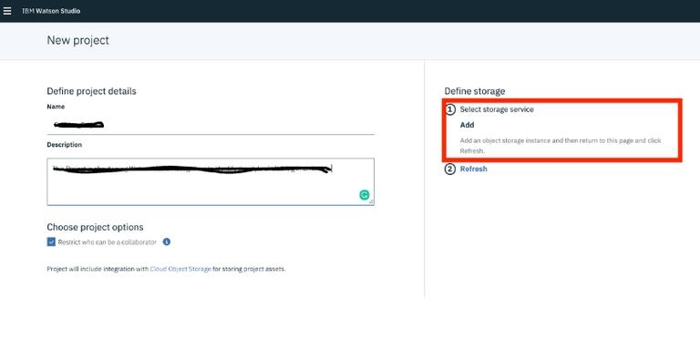

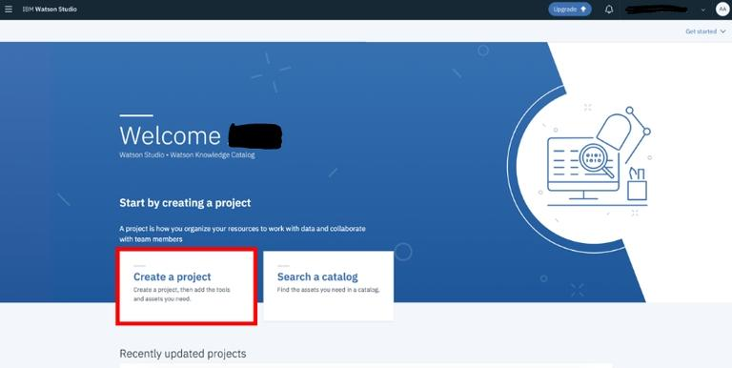**Step 7: Set up Your Proje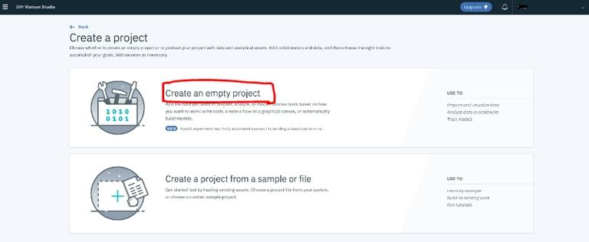Fill in some project details and click Create. The IBM Cloud Object Storage, which provides you storage for your images, should be automatically created for you but if not created you can click on add button below the heading on top right part of screen. If it is already created it will show you name and will not let you create a new one. .**

**Create the storage service with the lite plan and click on create button. Go to Add to project and choose Image classification.**

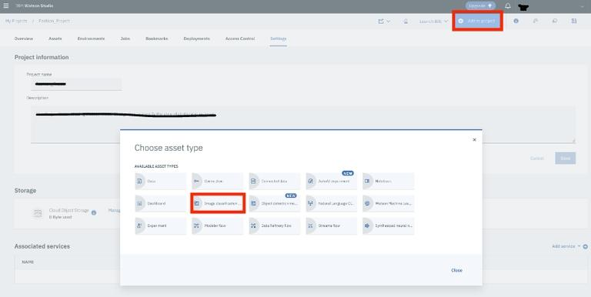

**Then provision a visual recognition service.**

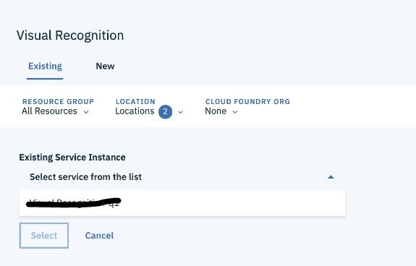**Step 8: Selecting Built-in Models for Watson Visual Recognition**

**After creating your project, by default, you will land on the page where you can perform some advanced tasks but we will skip this for now and use the built-in models. To access the built-in models, click on the name of the service, as seen in the red box below:**

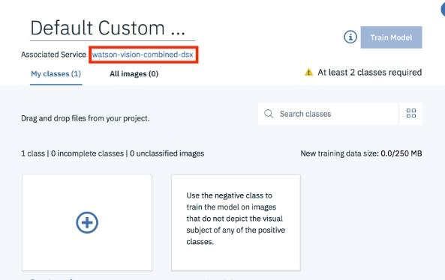

**Step 9: Choose the General model.**

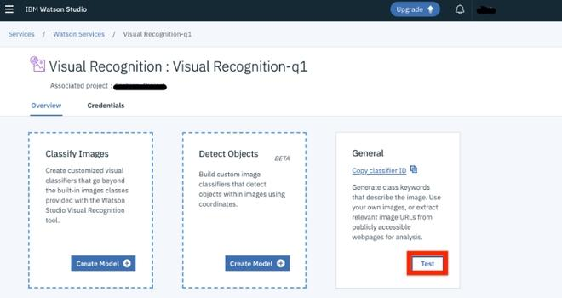**Now you can see all the built-in image classification models that IBM Watson provides! Let’s try the General model.**

**Step 10: Try out the General model**

**To test the General model, click on Test tab on top of screen.**

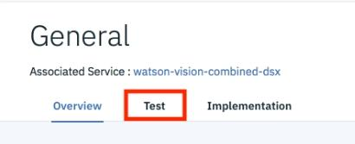

**Step 11: Upload Your Images!**

**Now you can upload any images you’d like by clicking on Browse. Remember that you will have to upload all the images that you want to test in a single go as once you upload images then you cannot add more images one by one. You will have to go back and upload all images including the new ones.**

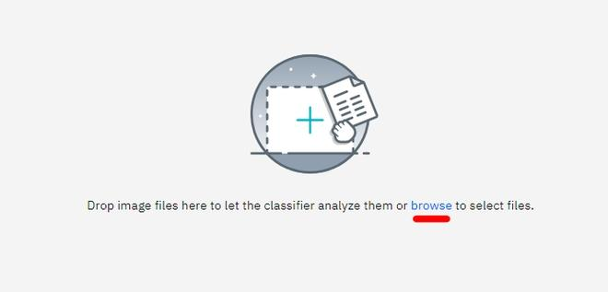

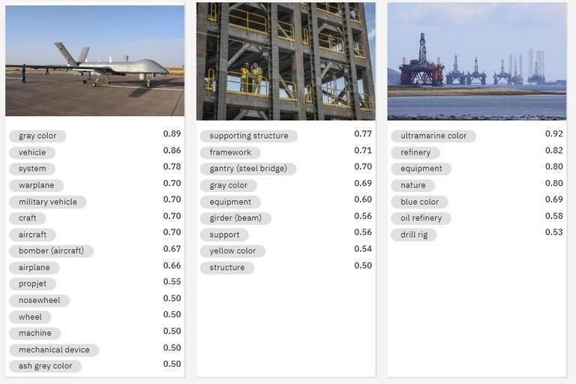**Step 12: Check Out the Results!**

**Once you have uploaded your images, it will tell you what it found in your images! Beside each class of object (or color, age, etc.), it will also give you a confidence score (between 0 and 1) on how confident it thinks it found that particular object in your image (0 for lowest confidence and 1 for highest confidence).**

**Git hub :**