# Wordpress2Doc – Help

# **1. Open the export menu**

Open the backend of your Wordpress blog, click on the „Tools“ menu item and then on the subitem „Export“.

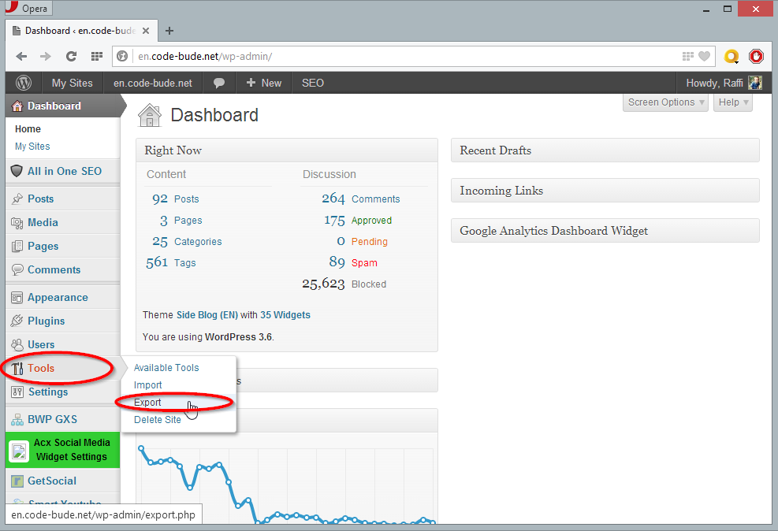

# **2. Export your articles**

Select the „Posts“ option, choose your preferred criteria and click on „Download Export File”.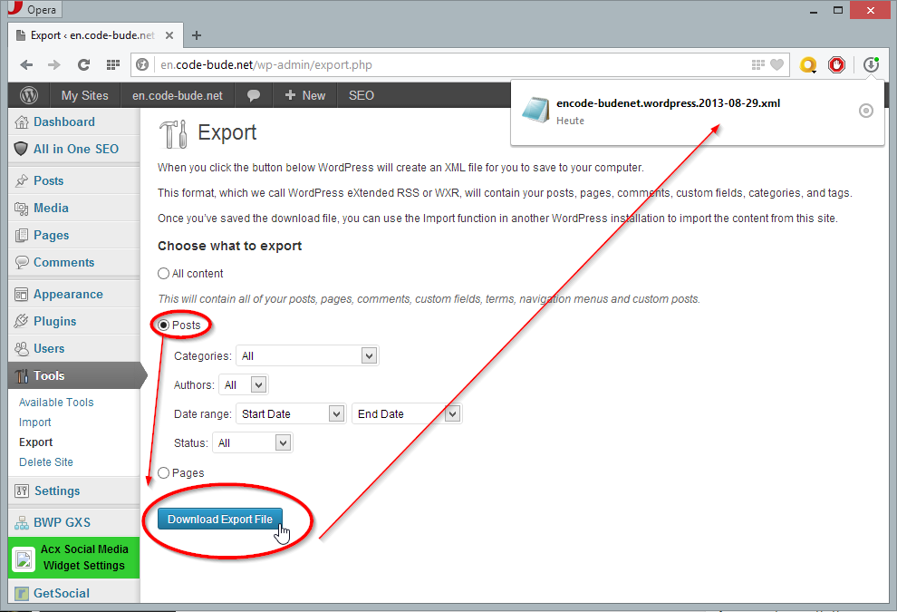

# **3. Load the export file**

Open Wordpress2Doc, click on the “Load Wordpress export.xml” tile and select the previously downloaded Wordpress export file.

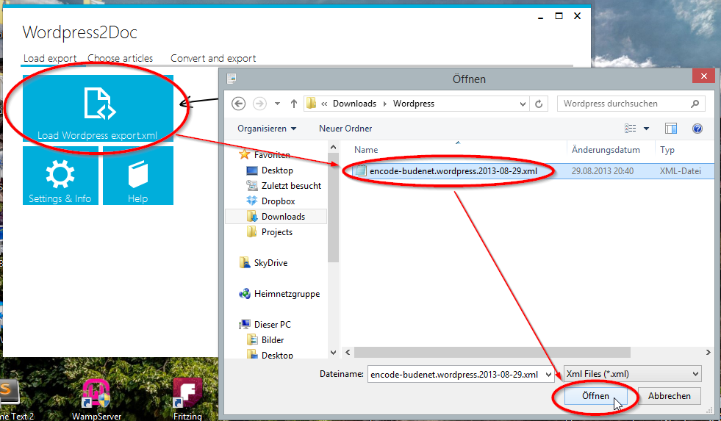

# **4. Choose articles**

Now choose the articles, which should be converted. You either use the “de-/select all” buttons or check every article one for one by hand.

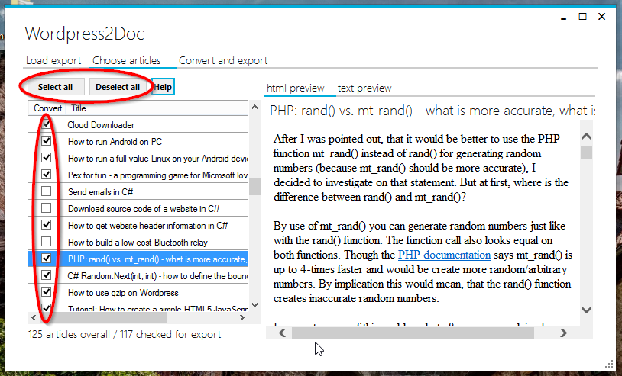

If you want to preview an article, you can double-click its title in the left-hand list. By double-clicking a headline, a html and a (sourcecode-)text preview will be loaded on the right-hand.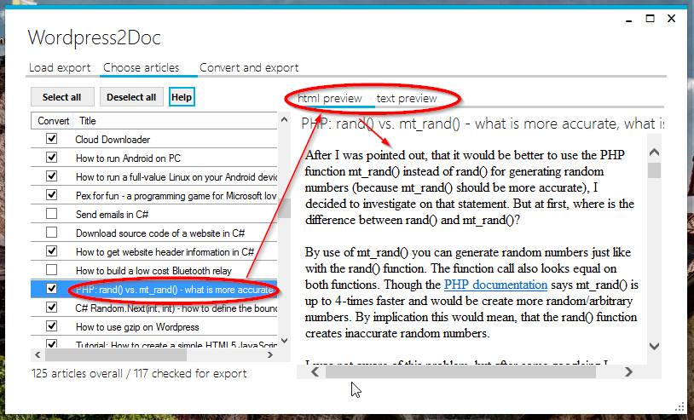

# **5. Convert your articles**

In the last step, choose one or both of the available export formats (.docx and .pdf). Then click on the “Convert choosen articles” tile, to begin the conversion process.

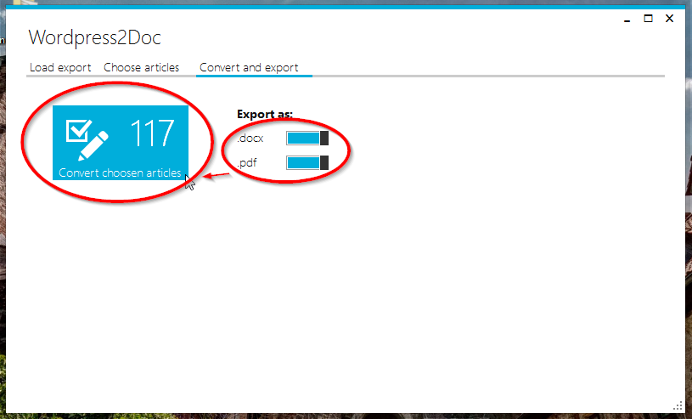

During the conversion process, Wordpress2Doc will show you the current status, so that you know how long you have to wait, until the process is finished.

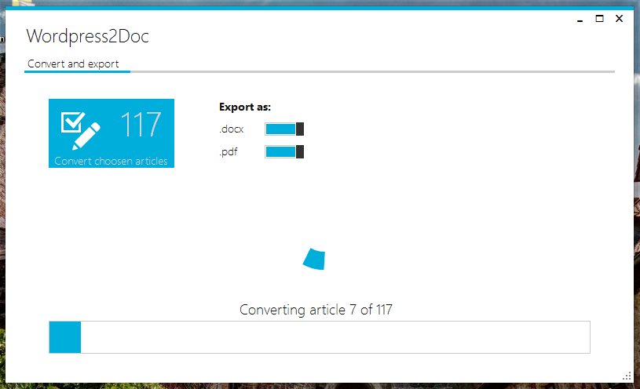

If you need more help, have a question or a feature wish, visit <http://en.code-bude.net> or send me an email to: [webmaster@code-bude.net](mailto:webmaster@code-bude.net)

WordPress2Doc is an open-source project. If you have paid for this application, try to get your money back! If you want to help, improve or fork this application, feel free to do so. The source code is available on GitHub: <https://github.com/codebude/Wordpress2Doc>