**ANOVA**

ANOVA is the **Analysis of Variance**. It is a statistical method used to compare the means of two or more groups to determine if at least one of them is significantly different from the others.

There are two types of ANOVA

**One-Way ANOVA**: 1 categorical affecting a numeric value

**Two-Way ANOVA**: 2 categorical variables and how they individually and together affect a numeric outcome

**Problem Statements with ANOVA**

**Q.** Can we check whether the genders have effect on SSLC, HSC and Degree Marks?

Two-Way ANOVA test whether gender has an effect on SSLC, HSC, and Degree marks, both individually and in combination with exam type.

**Q.** Can we check the average salary of employees in **IT, HR, and Marketing** departments?

One-Way ANOVA test whether the Department have effect on average salary

**Q.** Can we check the average fuel efficiency of 3 car models?

One-Way ANOVA test whether the car model have effect on average fuel consumption

**Q.** Can we compare treatment type and gender on recovery rate?

Two-Way ANOVA test whether gender has an effect on recovery rate both individually and in combination with treatment type

**Q.** Can we compare how season and region affect hotel occupancy?

Two-Way ANOVA test whether hotel occupancy has an effect on season and region both individually and in combination with treatment type

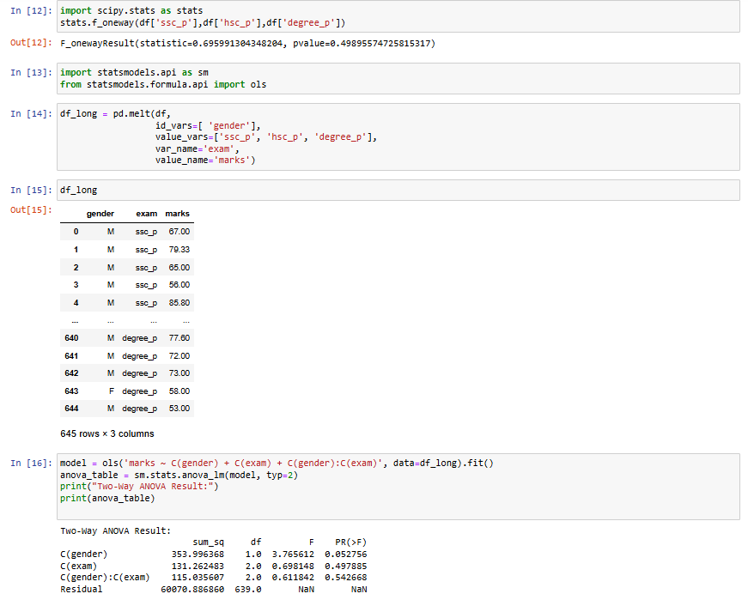

This is the python code for Two way ANOVA analysis

Two-Way ANOVA Result:

sum_sq df F PR(>F)

C(gender) 353.996368 1.0 3.765612 0.052756

C(exam) 131.262483 2.0 0.698148 0.497885

C(gender):C(exam) 115.035607 2.0 0.611842 0.542668

Residual 60070.886860 639.0 NaN NaN

Since in the results:

**1.Effect of Gender** (Main Effect)

H₀ (Null Hypothesis): There is no difference in average marks between males and females.

H₁ (Alternative Hypothesis): There is a difference in average marks between males and females.

**p-value = 0.0528**

**Interpretation**: The result is very close to 0.05. So,

**Conclusion**: Weak evidence that gender affects marks.

**2.Effect of Exam Type** (Main Effect)

H₀: The average marks are the same across ssc_p, hsc_p, and degree_p.

H₁: At least one exam type has a different average mark.

**p-value = 0.4979**

**Interpretation**: Much greater than 0.05.

**Conclusion**: Fail to reject H₀ — marks are similar across SSC, HSC, and Degree.

**3.Interaction Between Gender and Exam Type**

H₀: There is no interaction between gender and exam type — the effect of gender is consistent across exam types.

H₁: There is an interaction — the effect of gender depends on the exam type.

**p-value** = 0.5427

**Interpretation**: Greater than 0.05.

**Conclusion**: Fail to reject H₀ — the effect of gender is consistent across exam types (no interaction effect).