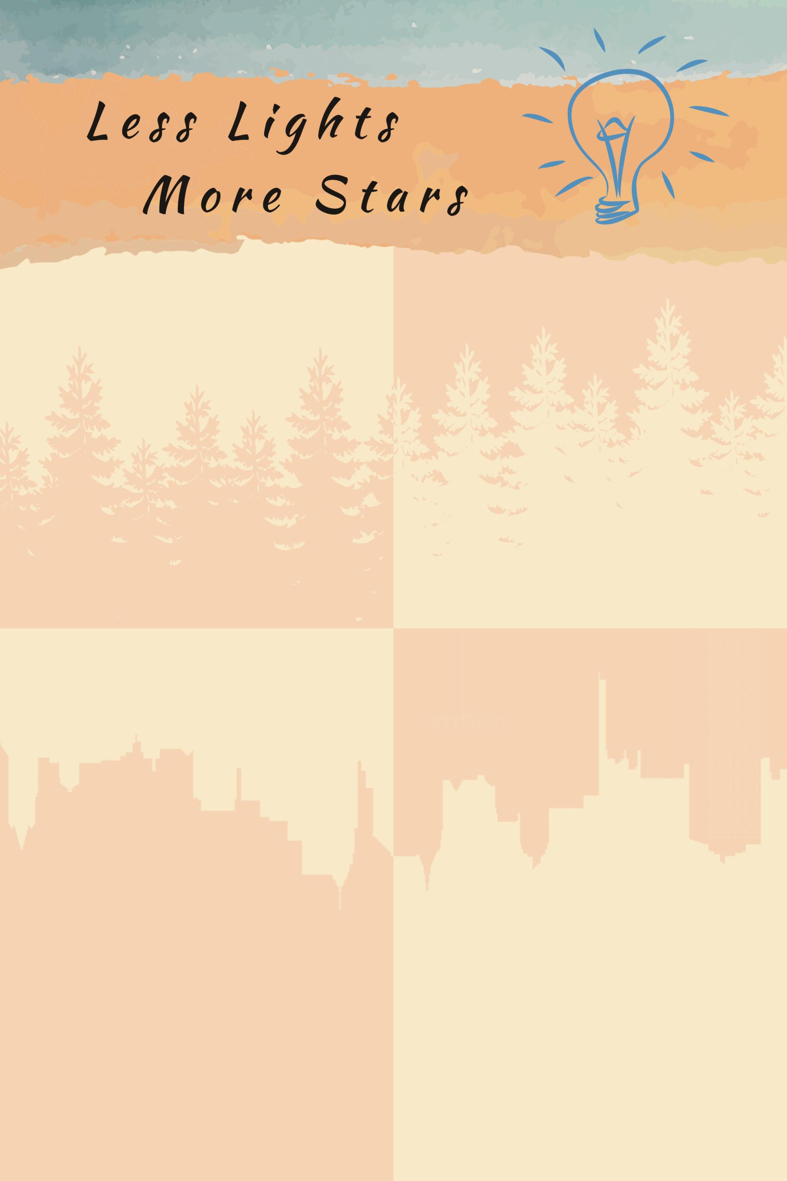--

In addition, we hope to see the introduction of relevant policies and education activities on light pollution.

**What is light pollution?**

It is caused by excessive or poor use of artificial lights and is very common in our daily life. Its ph- enomena include light trespass, over-illumination, light clutter and so on.

***Everyone can contribute to make our community a better place to live.***

***Let's do our part to return a bright starry sky to Xinjiekou  from now on!***

**What are the serious hazards of light pollution?**

Nowadays, when you look up at the sky at night in **Xinjiekou**, you will find that stargazing has become a luxury. But light poll- ution not only makes the stars disappear, but also increases ene- rgy consumption, causes traffic accidents, disrupts our circadian rhythm and damage ecosystem...

**What can we do?**

After research, **improving the artificial light source** is found to be the **most efficient strategy** for **Xinjiekou** to mitigate light pollution hazards:

* *Use lights with reduced rated power on the building*
* *Improve the efficiency of lamps through technology*
* *Encourage residents to use energy-saving lamps at home*

*When night falls,* ***Xinjiekou****, the busiest urban community in Nanjing, is harassed by "white night". Beautiful night lighting makes our nightlife colorful, but do you know that excessive use of artificial light leads to light pollution?*