APIC
- API Connect is one of the integration tools of Datapower.
- To develop API’s, we use IBM API Connect.
- The runtime of APIC is Datapower.
- APIC is based on specific user feedback, the features will be available only to that user.
- When you provide services with extra features rather than what is required, then it is of no use.
- APIC is customer level, means we can change our service according to the need of cost. (Eg: Hotstar, Aha, Netflix, prime etc.)
- Socialization means the API is visible to public.
- Monetization is making money with the use of API. (Eg: Recharge using different plans).

APIC Components:
- Cloud Manager:
- It contains LDAP, SSL (or) TLS, Gateway, servers, provider org., members.
- Cloud Manager is only accessible for Admins / Architects.
- API Manager:
- It consists of API’s and products, Members, Catalogs and spaces, Drafts, Dashboard, Analytics, Catalog settings, Admin config and roles.
- The configurations that are done in provider will be only visible in APIM.
- Drafts consists of Products and API’s, and Products consists of API’s and plans.
- Developer Portal:
- It is a market place for apic.
- It is based on Drupal.
- API’s are available in developer portal when API providers publish it in API manager.
- Each catalog has its own developer portal.
- It also provides forums, blogs, Support, and can review API’s too.
- In API Products, we can subscribe to API based on plan.
- Developer portal is always mapped to catalog.
- Gateway Service:
- Whenever we want to call any API service, we need to call the endpoint.
If API is deployed, the end point is used.
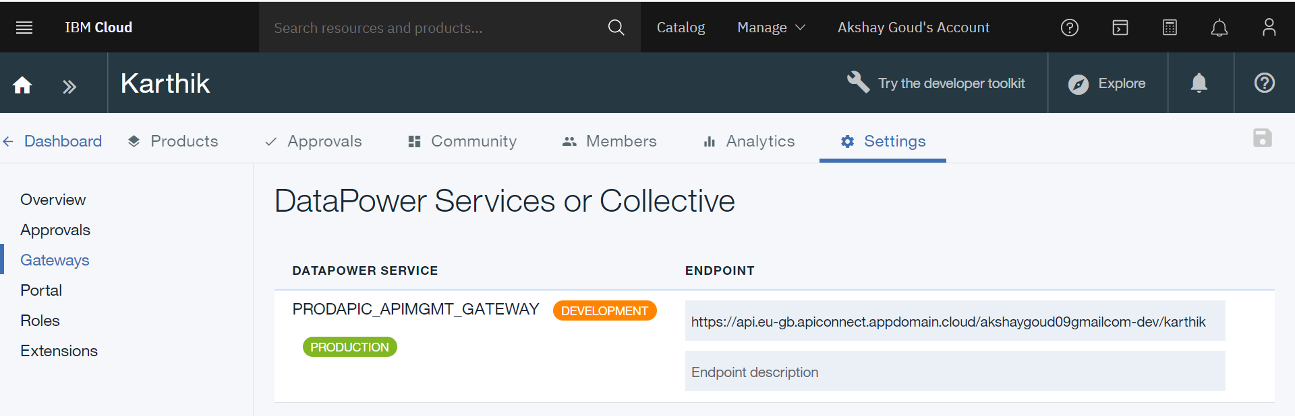
- Developer Toolkit:
- It provides a command line tool for creating and testing API.
- It is similar to command prompt.

SWAGGER:
Swagger is Open API. It is a universal format to define API structure with .yml and .Raml extension.
- Info: It generally contains basic information like title of api, name, version, description.
- Schemes: It defines which transfer protocol you want api to use. (http, https, ws, wss).
- Host: What ever the gateway is in catalog will get reflected here. Default is $(catalog.host)
- Basepath: It is the url prefix for all API paths. It should start with (/) following with path name.
- Consumes: The type of data that api takes as input.
- Produces: The type of data that api gives as output.
- Lifecycle: It contains 3 phases:
- Identified: API is in initial phase and is not designed fully nor implemented.
- Realized: It is a default state.
- Specified: API is fully designed but not yet implemented.
- Security Definition: It shows which type of security we want to use. It is of 3 types
- API Key
- Basic
- OAuth
- Security: It just shows the selection of how many types of security implementation.
- Properties: It is used to define values.
- Paths: It is used to add parameters by assigning name, location and data type. Also used to add different types of operations (GET, PUT, PATCH, POST, DELETE).
Phases of API:
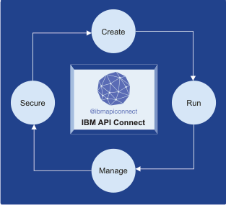

Product Life Cycle:
It consists of 5 stages:
- Stage: It is the initial stage when you publish the product. It is in development mode (or) in AUTO Subscription.
- Publish:
- Retire: When you retire a product, the product version cannot be viewed and plans are not subscribed.
- Deprecate: When you deprecate a product, the users who are subscribed already can use it, but no new users can subscribe to product.
- Supersede:

SECURITY IMPLEMENTATIONS:
3 types of implementations on API
- Client/API keys: We will be having a client ID and a client secret.
- Basic credentials: We will be having a username and a password.
- OAUTH (2.0): It uses tokens to prove identity between client and server. It allows third party websites or applications to access the data without requiring the user to share personal info.

Policies:
- In Datapower we call Actions, In APIC we call Policies.
- We can drag & drop the actions in the assemble tab.
Policies are categorized into 4 ways:
- Logic
- Transforms
- Policies
- Security

- LOGIC: It is divided into 4 policies,
- If
- Operation Switch: We can choose operation that is already defined in design path. We cannot edit it manually and there will be no otherwise case.
- Switch: Used to define conditions or operations. We can edit condition and we have otherwise case in switch.
- Throw: It is similar to try and catch.

- TRANSFORMS: It is divided into 5 policies,
- JSON-XML
- Map
- Redaction: If we want to remove the policy completely or remove a field we use redaction. It is nothing but hiding (or) masking password using *.
- XML-JSON
- XSLT

- POLICIES: It is divided into 6 policies,
- Activity log
- Gateway script
- Invoke:
- Proxy: It is used to expose the dummy service which acts as the original.
- Set variable:
- Validate: It checks whether the schema is properly or not.

- SECURITY: divided into 4 policies,
- Generate JWT
- Generate LTPA token
- Validate JWT
- Validate Username token

