Phase 2: Org Setup & Configuration Summary

H

**1. Core Company Configuration**

The foundational settings for the Salesforce org were established to mirror the environment of the university’s departments like placements, clubs, administration into one place -Educonnect PRO.

* **Company Information**: Default time zone (Asia/Kolkata), and locale to ensure all time-stamped data is accurate.
* **Business Hours & Fiscal Year**: Standard business hours (Mon-SAT, 12 AM - 12 AM) were set to enable future tracking of case/query response times. A standard fiscal year was confirmed for reporting consistency.
* **Developer Org**: A new Salesforce Developer Edition org was created to serve as the dedicated environment for this project.

**2. Security Model Implementation**

A multi-layered security model was configured to ensure data is accessible only to the appropriate users.

**Profiles:** Five custom profiles were created by cloning the "Standard User" profile:

1. **Academic Staff Profile**: For academic staff managing student records and courses.
2. **Faculty Profile**: For faculty members teaching courses.
3. **Placement Officer Profile**: For placement team managing job opportunities.
4. **Student Community Profile**: For students accessing their academic information
5. **Club Coordinator Profile**: For managing student clubs and activities

**Company Profile Setup:**

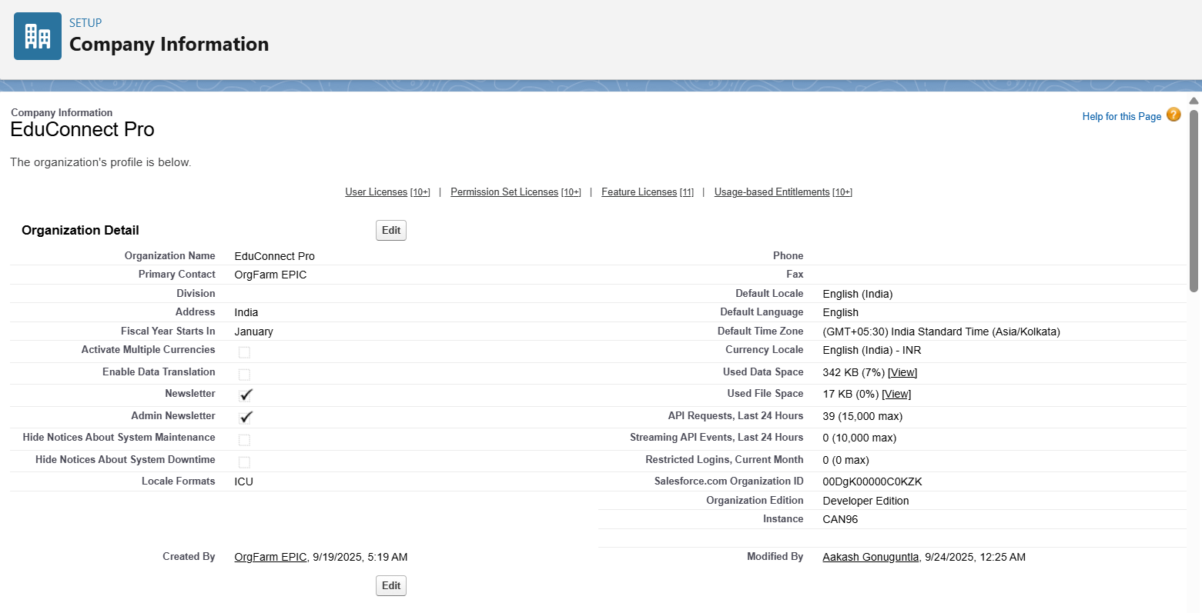

**Business Hours Configuration:**



**Holidays Setup:**

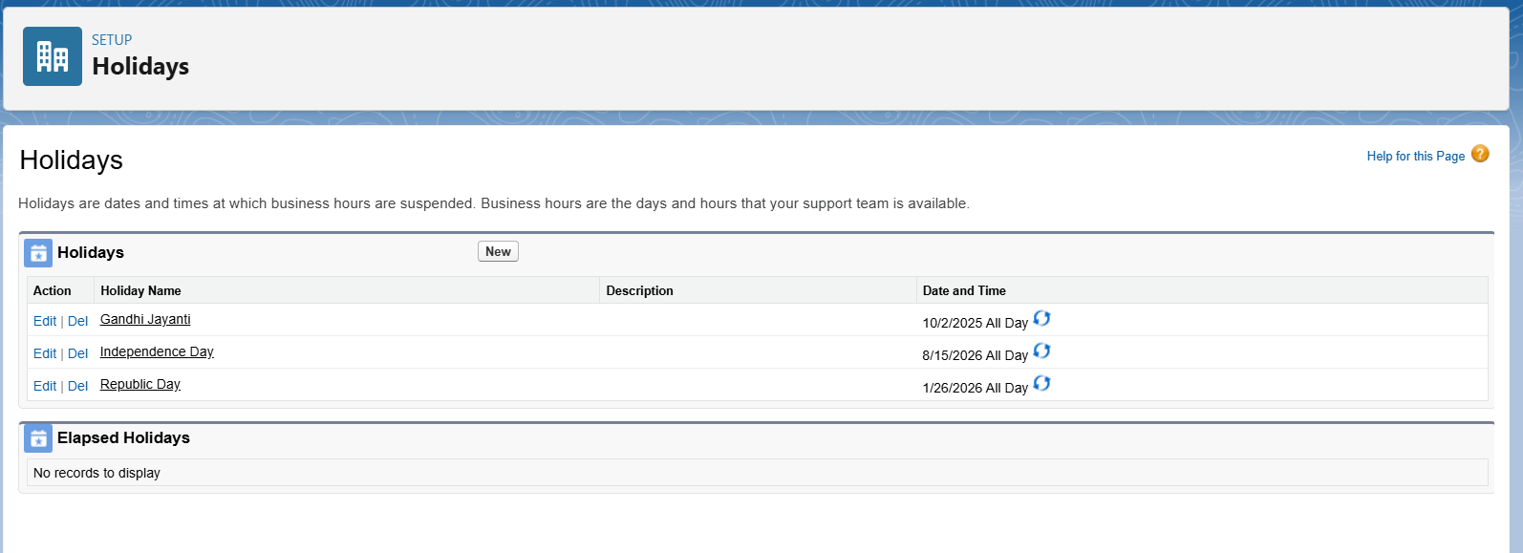

**Role Hierarchy:**

Five roles were created and this is the role hierarchy.

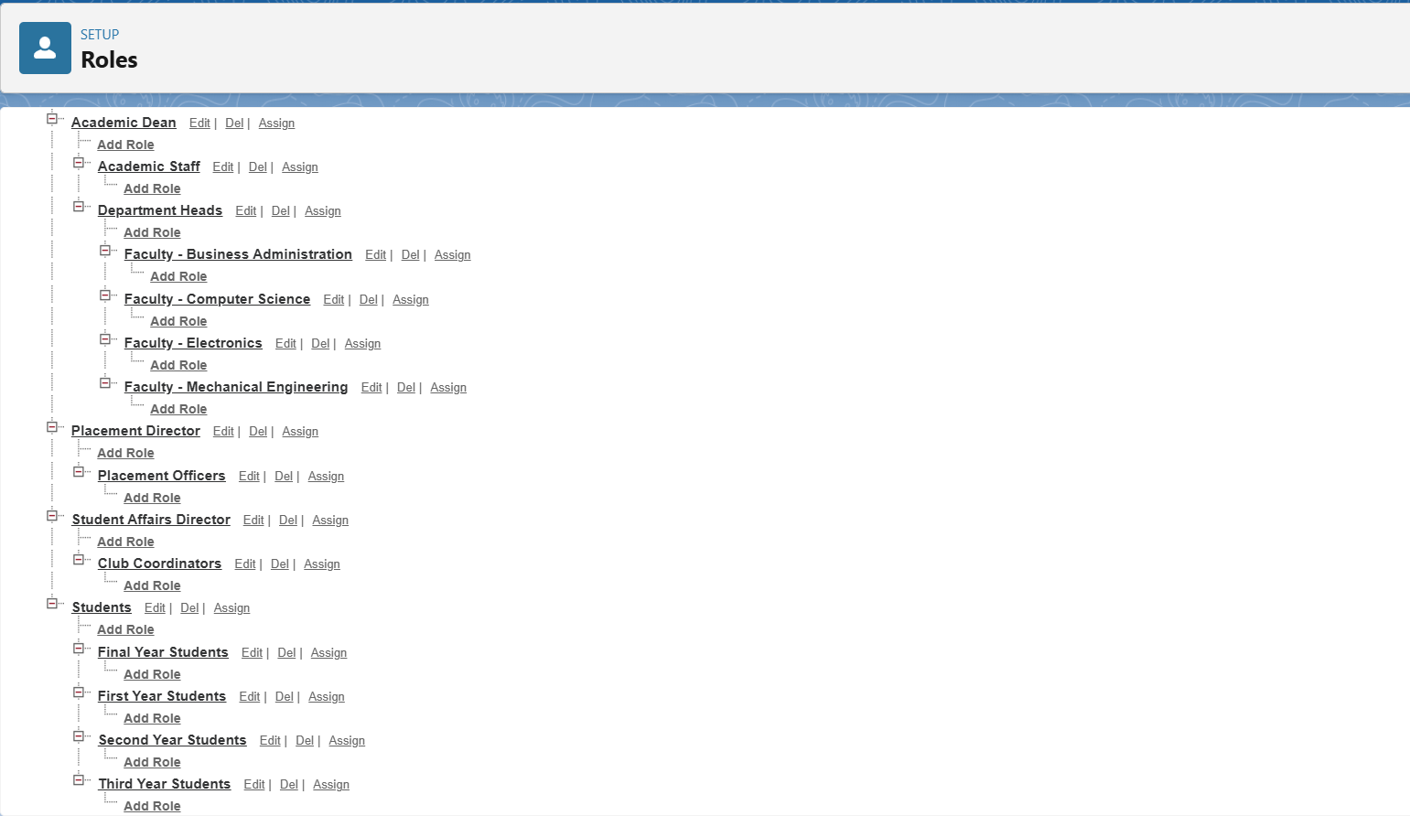

CREATE USERS:



**ORGANIZATION-WIDE DEFAULTS (OWD) CONFIGURATION:**

A Private data model was established as the baseline. This is a security best practice, ensuring users can only see their own records by default unless explicitly granted access.

**Security Model Implemented**:

| **Object** | **Internal Access** | **External Access** | **Controlled by Parent** | **Reasoning** |
| --- | --- | --- | --- | --- |
| Account | Public Read Only | Private | No | College/company info should be visible |
| Contact | Private | Private | Yes | Personal information protection |
| Case | Private | Private | No | Student support confidentiality |
| Lead | Private | Private | No | Prospect information security |
| Opportunity | Private | Private | Yes | Academic opportunity privacy |

**PERMISSION SETS:**

Usage Strategy:

* Assigned to senior faculty for advanced grade management
* Analytics permissions for department heads
* Flexible permission enhancement without profile changes

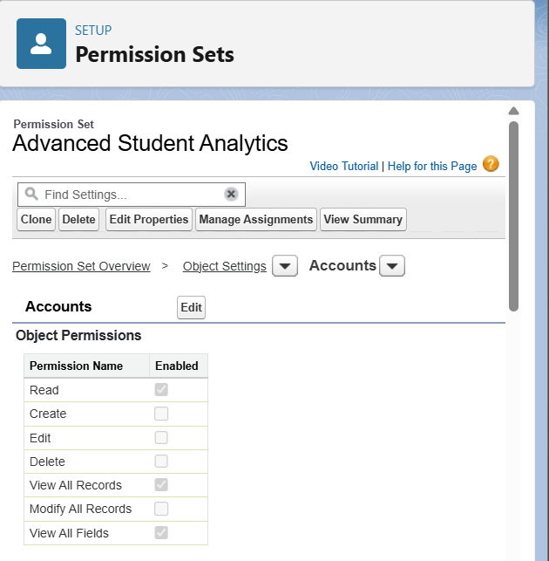

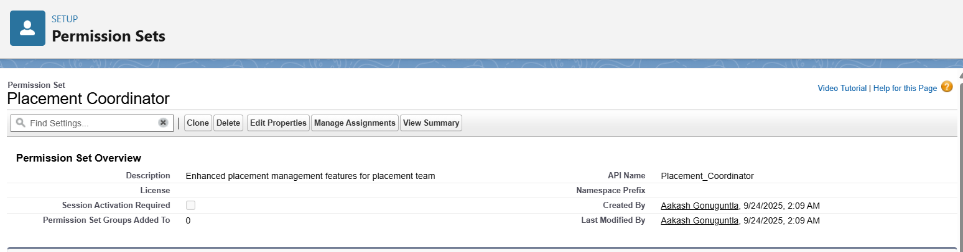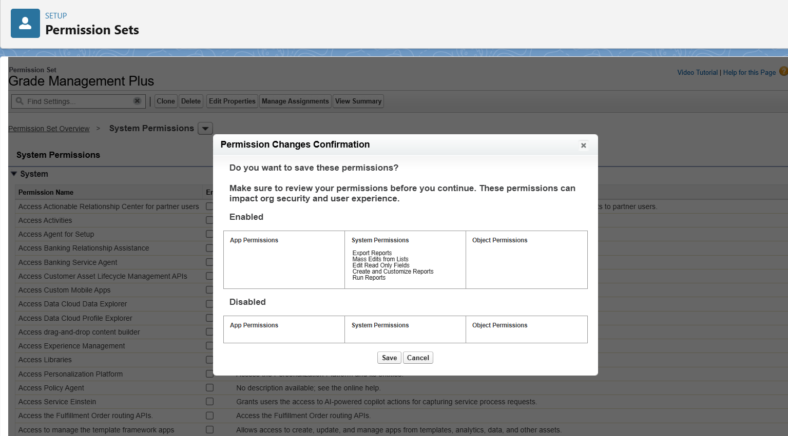

**LOGIN ACCESS POLICIES:**

**Policy Configuration**:

Login Hours: 06:00 AM - 10:00 PM IST

Time Zone: (GMT+05:30) India Standard Time

IP Restrictions: None (flexible access)

Invalid Login Attempts: 5 attempts

Lockout Period: 15 minutes

Administrator Login: Enabled for troubleshooting

**Educational Rationale**:

* **Extended Hours**: Covers early morning and evening study sessions
* **Geographic Flexibility**: Students access from home, hostels, library
* **Security Balance**: Protection without accessibility barriers