**Phase 3: Data Modeling & Implementation Report**

1. **Overview**

This document outlines the actions taken during the Data Modeling phase of the project. The objective was to create a robust, scalable, and secure data structure to support all functionalities of a college academics and placements. This involved configuring standard Salesforce objects, creating new custom objects and fields, establishing relationships, and enhancing the user interface.

Edu Connect Pro is designed as a comprehensive educational management platform, streamlining academic operations, student engagement, and institutional workflows. This report documents the completion of Phase 3, focusing on advanced CRM customizations, object creation, workflows, automation, and deployment readiness.

**Custom Objects Overview:**

**DETAILED OBJECT FIELD SPECIFICATIONS:**

**1. STUDENT OBJECT (Student__c)**

| **Field Label** | **API Name** | **Data Type** | **Required** | **Unique** | **Description** |
| --- | --- | --- | --- | --- | --- |
| Student Name | Name | Text | Yes | No | Auto-created Name field |
| Student ID | Student_ID__c | Text(20) | Yes | Yes | Unique college identifier |
| Department | Department__c | Picklist | No | No | 7 department options |
| Year of Study | Year_of_Study__c | Picklist | No | No | 5 year options |
| Academic Status | Academic_Status__c | Picklist | No | No | 5 status options, Default: Active |
| Current GPA | Current_GPA__c | Number(3,2) | No | No | Scale 0.00-10.00 |
| Date of Birth | Date_of_Birth__c | Date | Yes | No | Student's DOB |
| Phone Number | Phone_Number__c | Phone | No | No | Contact number |
| Personal Email | Personal_Email__c | Email | Yes | Yes | Student email |
| Parent Contact Number | Parent_Contact_Number__c | Phone | No | No | Guardian contact |
| Address | Address__c | Text Area(Long) | No | No | Permanent address |
| Admission Date | Admission_Date__c | Date | Yes | No | College admission date |
| Academic Advisor | Academic_Advisor__c | Lookup(User) | No | No | Faculty advisor |

**Relationships**:

* Lookup to User (Academic Advisor)
* Master in Student-Enrollment relationship
* Master in Student-Club_Membership relationship

**2. COURSE OBJECT (Course__c)**

| **Field Label** | **API Name** | **Data Type** | **Required** | **Unique** | **Description** |
| --- | --- | --- | --- | --- | --- |
| Course Name | Name | Text | Yes | No | Auto-created Name field |
| Course Code | Course_Code__c | Text(15) | Yes | Yes | Unique course identifier |
| Course Description | Course_Description__c | Text Area(Long) | No | No | Detailed description |
| Credits | Credits__c | Number(2,0) | No | No | Default: 3 |
| Department | Department__c | Picklist | No | No | 7 department options |
| Semester | Semester__c | Picklist | No | No | 8 semester options |
| Academic Year | Academic_Year__c | Picklist | No | No | 4 year options |
| Maximum Enrollment | Max_Enrollment__c | Number(3,0) | No | No | Default: 60 |
| Current Enrollment | Current_Enrollment__c | Number(3,0) | No | No | Default: 0 |
| Course Type | Course_Type__c | Picklist | No | No | 5 type options |
| Faculty Assigned | Faculty_Assigned__c | Lookup(User) | No | No | Teaching faculty |
| Prerequisites | Prerequisites__c | Lookup(Course) | No | No | Prerequisite course |

**Relationships**:

* Lookup to User (Faculty Assigned)
* Self-Lookup (Prerequisites)
* Master in Course-Enrollment relationship

**3. ENROLLMENT OBJECT (Enrollment__c) - Junction Object**

| **Field Label** | **API Name** | **Data Type** | **Required** | **Unique** | **Description** |
| --- | --- | --- | --- | --- | --- |
| Enrollment Name | Name | Auto Number | Yes | Yes | ENR-{0000} format |
| Student | Student__c | Master-Detail(Student) | Yes | No | Related student |
| Course | Course__c | Master-Detail(Course) | Yes | No | Related course |
| Enrollment Date | Enrollment_Date__c | Date | Yes | No | Default: TODAY() |
| Enrollment Status | Enrollment_Status__c | Picklist | No | No | 5 status options, Default: Enrolled |
| Final Grade | Final_Grade__c | Picklist | No | No | 9 grade options |
| Grade Points | Grade_Points__c | Number(4,2) | No | No | Scale 0.00-10.00 |
| Attendance Percentage | Attendance_Percentage__c | Percent(5,2) | No | No | Attendance tracking |

**Relationships**:

* Master-Detail to Student (Many-to-Many junction)
* Master-Detail to Course (Many-to-Many junction)

**4. GRADE OBJECT (Grade__c)**

| **Field Label** | **API Name** | **Data Type** | **Required** | **Unique** | **Description** |
| --- | --- | --- | --- | --- | --- |
| Grade Record | Name | Auto Number | Yes | Yes | GRD-{00000} format |
| Student | Student__c | Lookup(Student) | Yes | No | Related student |
| Course | Course__c | Lookup(Course) | Yes | No | Related course |
| Assessment Type | Assessment_Type__c | Picklist | No | No | 8 assessment options |
| Assessment Name | Assessment_Name__c | Text(100) | Yes | No | Specific assessment name |
| Maximum Marks | Maximum_Marks__c | Number(3,0) | Yes | No | Total marks possible |
| Marks Obtained | Marks_Obtained__c | Number(3,2) | No | No | Marks scored |
| Percentage | Percentage__c | Percent(5,2) | No | No | Calculated percentage |
| Grade Date | Grade_Date__c | Date | No | No | Default: TODAY() |
| Faculty Comments | Faculty_Comments__c | Text Area(Long) | No | No | Teacher feedback |

**Relationships**:

* Lookup to Student
* Lookup to Course

**5. JOB POSTING OBJECT (Job_Posting__c)**

| **Field Label** | **API Name** | **Data Type** | **Required** | **Unique** | **Description** |
| --- | --- | --- | --- | --- | --- |
| Job Title | Name | Text | Yes | No | Auto-created Name field |
| Company | Company__c | Lookup(Account) | Yes | No | Hiring company |
| Job Description | Job_Description__c | Text Area(Long) | No | No | Detailed job description |
| Package (LPA) | Package_LPA__c | Currency(16,2) | No | No | Annual package |
| Job Location | Job_Location__c | Text(100) | Yes | No | Work location |
| Eligible Departments | Eligible_Departments__c | Multi-Select Picklist | No | No | 7 department options |
| Minimum CGPA Required | Min_CGPA_Required__c | Number(3,2) | No | No | CGPA requirement |
| Application Deadline | Application_Deadline__c | Date/Time | Yes | No | Application cutoff |
| Job Type | Job_Type__c | Picklist | No | No | 4 type options |
| Experience Required | Experience_Required__c | Picklist | No | No | 5 experience levels |
| Skills Required | Skills_Required__c | Text Area(Long) | No | No | Required skills |
| Job Status | Job_Status__c | Picklist | No | No | 4 status options, Default: Active |

**Relationships**:

* Lookup to Account (Company)

**6. JOB APPLICATION OBJECT (Job_Application__c)**

| **Field Label** | **API Name** | **Data Type** | **Required** | **Unique** | **Description** |
| --- | --- | --- | --- | --- | --- |
| Application Number | Name | Auto Number | Yes | Yes | APP-{00000} format |
| Student | Student__c | Lookup(Student) | Yes | No | Applying student |
| Job Posting | Job_Posting__c | Lookup(Job_Posting) | Yes | No | Applied job |
| Application Date | Application_Date__c | Date | Yes | No | Default: TODAY() |
| Application Status | Application_Status__c | Picklist | No | No | 9 status options, Default: Applied |
| Resume Link | Resume_Link__c | URL | No | No | Resume document link |
| Cover Letter | Cover_Letter__c | Text Area(Long) | No | No | Application letter |
| Interview Date | Interview_Date__c | Date/Time | No | No | Scheduled interview |
| Interview Mode | Interview_Mode__c | Picklist | No | No | 5 mode options |
| Interview Feedback | Interview_Feedback__c | Text Area(Long) | No | No | Interview comments |
| Final Result | Final_Result__c | Picklist | No | No | 4 result options |

**Relationships**:

* Lookup to Student
* Lookup to Job_Posting

**7. CLUB OBJECT (Club__c)**

| **Field Label** | **API Name** | **Data Type** | **Required** | **Unique** | **Description** |
| --- | --- | --- | --- | --- | --- |
| Club Name | Name | Text | Yes | No | Auto-created Name field |
| Club Category | Club_Category__c | Picklist | No | No | 10 category options |
| Club Description | Club_Description__c | Text Area(Long) | No | No | Club details |
| Faculty Advisor | Faculty_Advisor__c | Lookup(User) | No | No | Advising faculty |
| Established Date | Established_Date__c | Date | No | No | Club founding date |
| Total Members | Total_Members__c | Number(3,0) | No | No | Default: 0 |
| Club Status | Club_Status__c | Picklist | No | No | 3 status options, Default: Active |
| Meeting Schedule | Meeting_Schedule__c | Text(255) | No | No | Regular meeting time |

**Relationships**:

* Lookup to User (Faculty Advisor)
* Master in Club-Club_Membership relationship

**8. CLUB MEMBERSHIP OBJECT (Club_Membership__c) - Junction Object**

| **Field Label** | **API Name** | **Data Type** | **Required** | **Unique** | **Description** |
| --- | --- | --- | --- | --- | --- |
| Membership Number | Name | Auto Number | Yes | Yes | MEM-{0000} format |
| Student | Student__c | Master-Detail(Student) | Yes | No | Member student |
| Club | Club__c | Master-Detail(Club) | Yes | No | Joined club |
| Join Date | Join_Date__c | Date | Yes | No | Default: TODAY() |
| Member Role | Member_Role__c | Picklist | No | No | 6 role options, Default: Member |
| Membership Status | Membership_Status__c | Picklist | No | No | 3 status options, Default: Active |
| Contributions | Contributions__c | Text Area(Long) | No | No | Member contributions |

**Relationships**:

* Master-Detail to Student (Many-to-Many junction)
* Master-Detail to Club (Many-to-Many junction)

**9. EVENT OBJECT (Event__c)**

| **Field Label** | **API Name** | **Data Type** | **Required** | **Unique** | **Description** |
| --- | --- | --- | --- | --- | --- |
|  | Name | Text | Yes | No | Auto-created Name field |
| Event Type | Event_Type__c | Picklist | No | No | 10 type options |
| Event Description | Event_Description__c | Text Area(Long) | No | No | Event details |
| Organizing Club | Organizing_Club__c | Lookup(Club) | No | No | Host club |
| Event Date | Event_Date__c | Date/Time | Yes | No | Event start |
| End Date | End_Date__c | Date/Time | No | No | Event end |
| Venue | Venue__c | Text(255) | Yes | No | Event location |
| Maximum Capacity | Max_Capacity__c | Number(4,0) | No | No | Venue capacity |
| Current Registrations | Current_Registrations__c | Number(4,0) | No | No | Default: 0 |
| Registration Required | Registration_Required__c | Checkbox | No | No | Default: Checked |
| Registration Fee | Registration_Fee__c | Currency(16,2) | No | No | Default: 0 |
| Event Status | Event_Status__c | Picklist | No | No | 6 status options, Default: Planned |

**Relationships**:

* Lookup to Club (Organizing Club)

**Schema Builder Visualization**

The Schema Builder was used to view the complete data model. This provides a clear, visual blueprint of all objects and their intricate relationships, confirming the logical integrity of the application's architecture.

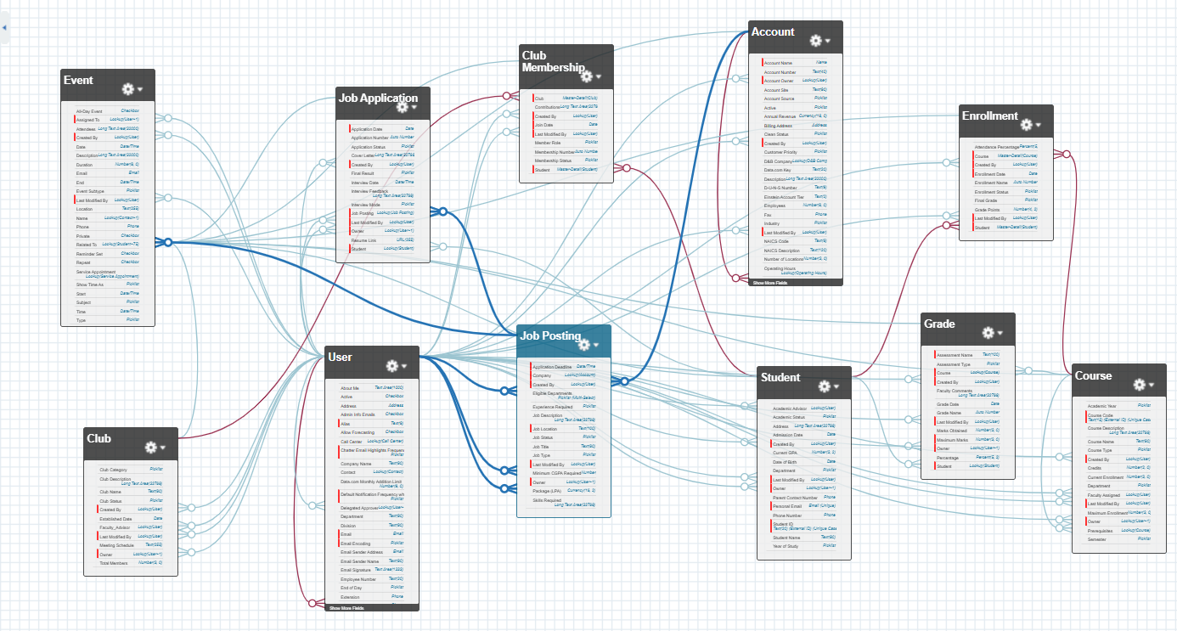

**Conclusion** :

Phase 3 of Edu Connect Pro has been successfully completed with all 9 custom objects implemented, tested, and automated workflows deployed.