clc; clear all; close all;

%Mic_count = input('enter the number of mics >>> '); Mic_count = 2;

- [filename,path] = uigetfile('.wav','select an speech file');

- Sig = strcat(path,filename);

[sig,Fs] = audioread('speech1.wav');

- [sig,Fs] = audioread(Sig);

- [filename1,path1] = uigetfile('.wav','select an noise file');

- noise = strcat(path1,filename1);

[Noise,Fsn] = audioread('engine5.wav'); % [Noise,Fsn] = audioread(noise);

sig_mic1 = [sig(:,1).' sig(:,1).' sig(:,1).' sig(:,1).' sig(:,1).' sig(:,1).'];

sig_mic2 = [sig(:,2).' sig(:,2).' sig(:,2).' sig(:,2).' sig(:,2).' sig(:,2).'];

noise_mic1 = [Noise(:,1).' Noise(:,1).' Noise(:,1).' Noise(:,1).' Noise(:,1).' Noise(:,1).'];

noise_mic2 = [Noise(:,2).' Noise(:,2).' Noise(:,2).' Noise(:,2).' Noise(:,2).' Noise(:,2).'];

Mic1 = ((0.7*sig_mic1) + noise_mic1);

Mic2 = (sig_mic2 + (0.7*noise_mic2));

SIG(:,1) = Mic1.';

SIG(:,2) = Mic2.';

audiowrite('speech_noise2.wav',SIG,Fs);

- W = fir1(1,0.001,'high');

- figure;

- freqz(W);

%

- Mic1_filtered = filter(W,1,Mic1);

- Mic2_filtered = filter(W,1,Mic2);

- Mic = (Mic1_filtered + Mic2_filtered);

Mic = Mic1 + Mic2;

N = length(Mic);

Filter_length = 0.004;

% Filter_length = input('Enter the length of the filter in terms of sampling frequency >>> ');

1

Filter_length = Filter_length*Fs;

L = round(N/Filter_length);

Mic_seg= zeros(L,Filter_length);

for i = 0 : L-1

for j = 0 : Filter_length-1

Mic_seg(i+1,j+1) = Mic(1,j+1+(i*Filter_length));

end

U1(1,i+1) = mean(Mic_seg(i+1,:));

end

e = 10^(-16);

x = zeros(L,1); E1 = zeros(L,1);

for i = 1 : L

for j = 1 : Filter_length

y(i,j) = ((Mic_seg(i,j) - U1(1,i)).^2); x(i,1) = x(i,1) + y(i,j);
end

E1(i,1) = (x(i,1)./(Filter_length-1))+e; E1(i,1) = 10*log10(E1(i,1));

end

Mic_eng = 0; for i = 1 : 20
Mic_eng = (Mic_seg(i,:)*Mic_seg(i,:).')/32 + Mic_eng;

end

Mic_eng = Mic_eng/20;

E_max = max(E1);

E_min = ceil(min(E1));

Thresh_initial = 18; %ranges from 20-30

for i = 1 : L

if ((E1(i,1) > (E_max - Thresh_initial)) && (E1(i,1) > E_min)) Mic_vad_out(i) = 1;

else

Mic_vad_out(i) = 0;

end

end

x = zeros(1,N);

for i = 0 : L-1

x(1,(i*Filter_length)+1:(i+1)*Filter_length) = Mic_vad_out(i+1);

end

2

figure;

plot(Mic1); hold on; plot(x);

title('Noisy speech signal with VAD') xlabel('Samples')

ylabel('Amplitude in V') legend('Noisy Speech','VAD output') hold off;

- Mic1_filt = filter(1,1,Mic1_filtered);

- Mic2_filt = filter([0 1],1,Mic2_filtered);

Mic1_filt = filter(1,1,Mic1);

Mic2_filt = filter([0 1],1,Mic2);

X_blocked = Mic1_filt + Mic2_filt;

X_blocked_seg = zeros(L,Filter_length);

for i = 0 : L-1

for j = 0 : Filter_length-1

X_blocked_seg(i+1,j+1) = X_blocked(1,j+1+(i*Filter_length));

end

end

Beta = 0.005;

Weights = zeros(1,Filter_length);

E = zeros(L,Filter_length);

Y = zeros(L,Filter_length);

for i = 1 : L

X = X_blocked_seg(i,:); d = Mic_seg(i,:);

X_conv = convm(X,Filter_length);

for k = 1 : Filter_length

A = X_conv(k,:)*X_conv(k,:)'+0.0001; U = Beta/A;

Y(i,k) = Weights *(X_conv(k,:).'); E(i,k) = d(1,k) - Y(i,k);
if Mic_vad_out(i) == 0

Weights = Weights + (U * E(i,k) * conj(X_conv(k,:)));

end

end

end

for i = 1 : L isolated_noise(1,(((i-1)*Filter_length)+1):(i*Filter_length)) =

Y(i,:); enhanced_speech(1,(((i-1)*Filter_length)+1):(i*Filter_length)) =

E(i,:); end

3

figure;

plot(Mic1);

title('Input Speech Signal with Noise') xlabel('Samples');

ylabel('Amplitude in V');

figure; plot(sig_mic1);

title('Input Speech Signal without Noise') xlabel('Samples');

ylabel('Amplitude in V');

figure; plot(enhanced_speech); title('Enhanced Speech') xlabel('Samples'); ylabel('Amplitude in V');

SNR_in = 10*log10(sum(sig_mic1.^2)./sum(noise_mic1.^2));

SNR_out = real(10*log10(sum(sig_mic1.^2)./sum((enhanced_speech).^2)));

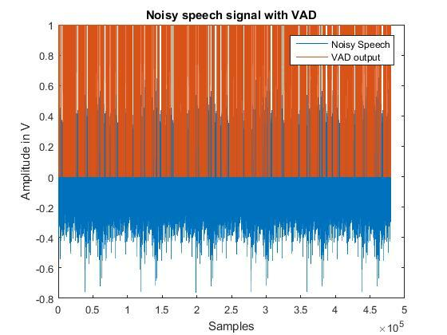

4

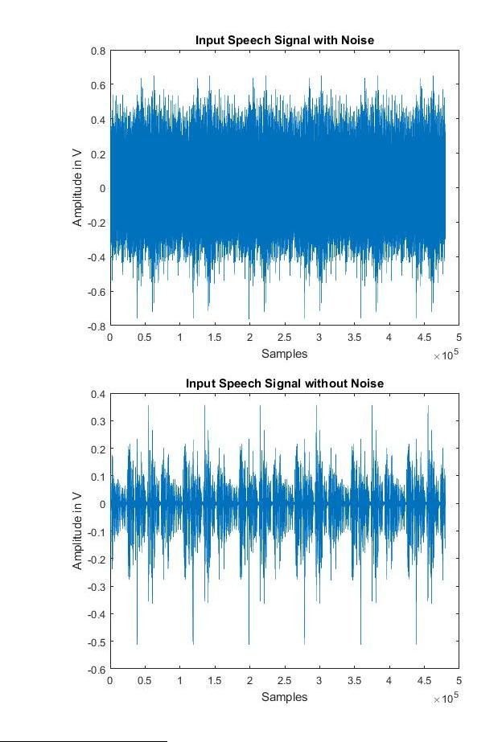

5
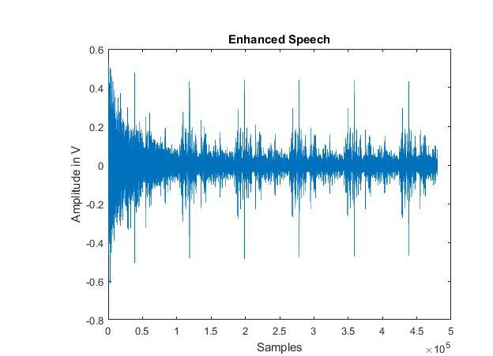

Published with MATLAB® R2015b

6

