Waveforms

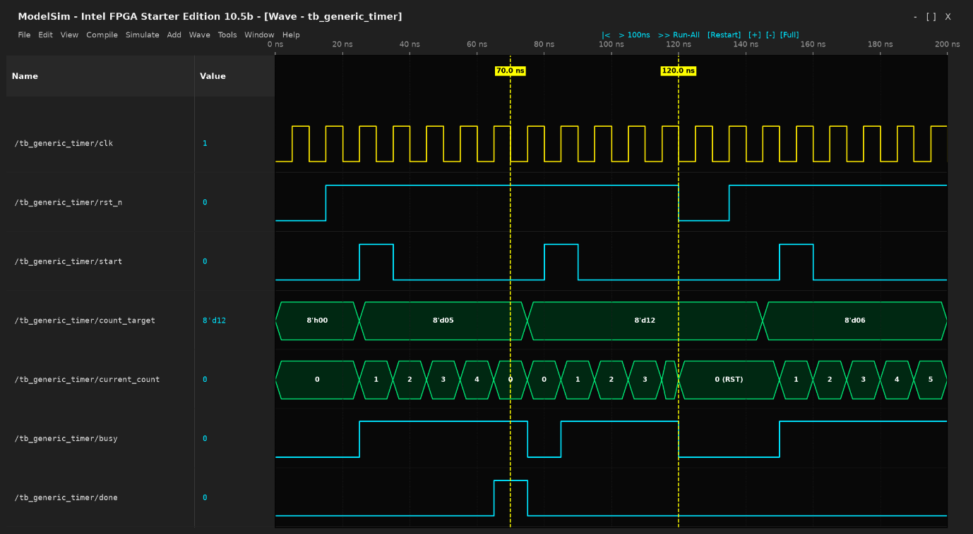
Fig. Waveform_generation_timer

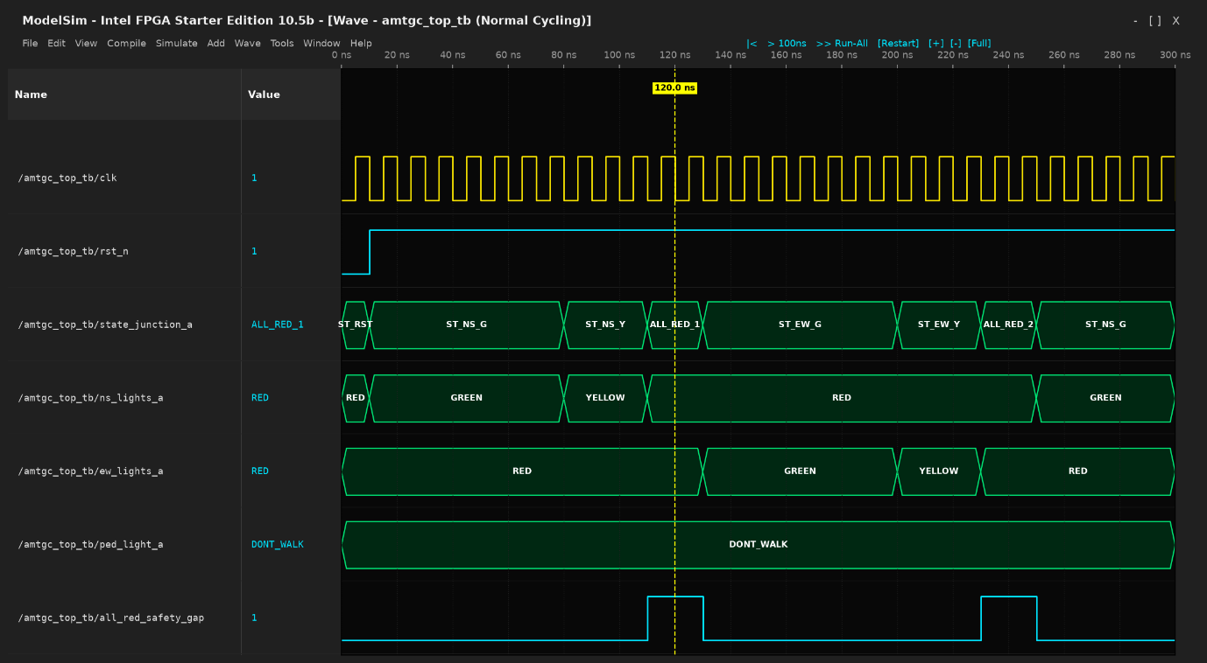
Fig.Waveform_normal_traffic_coordination

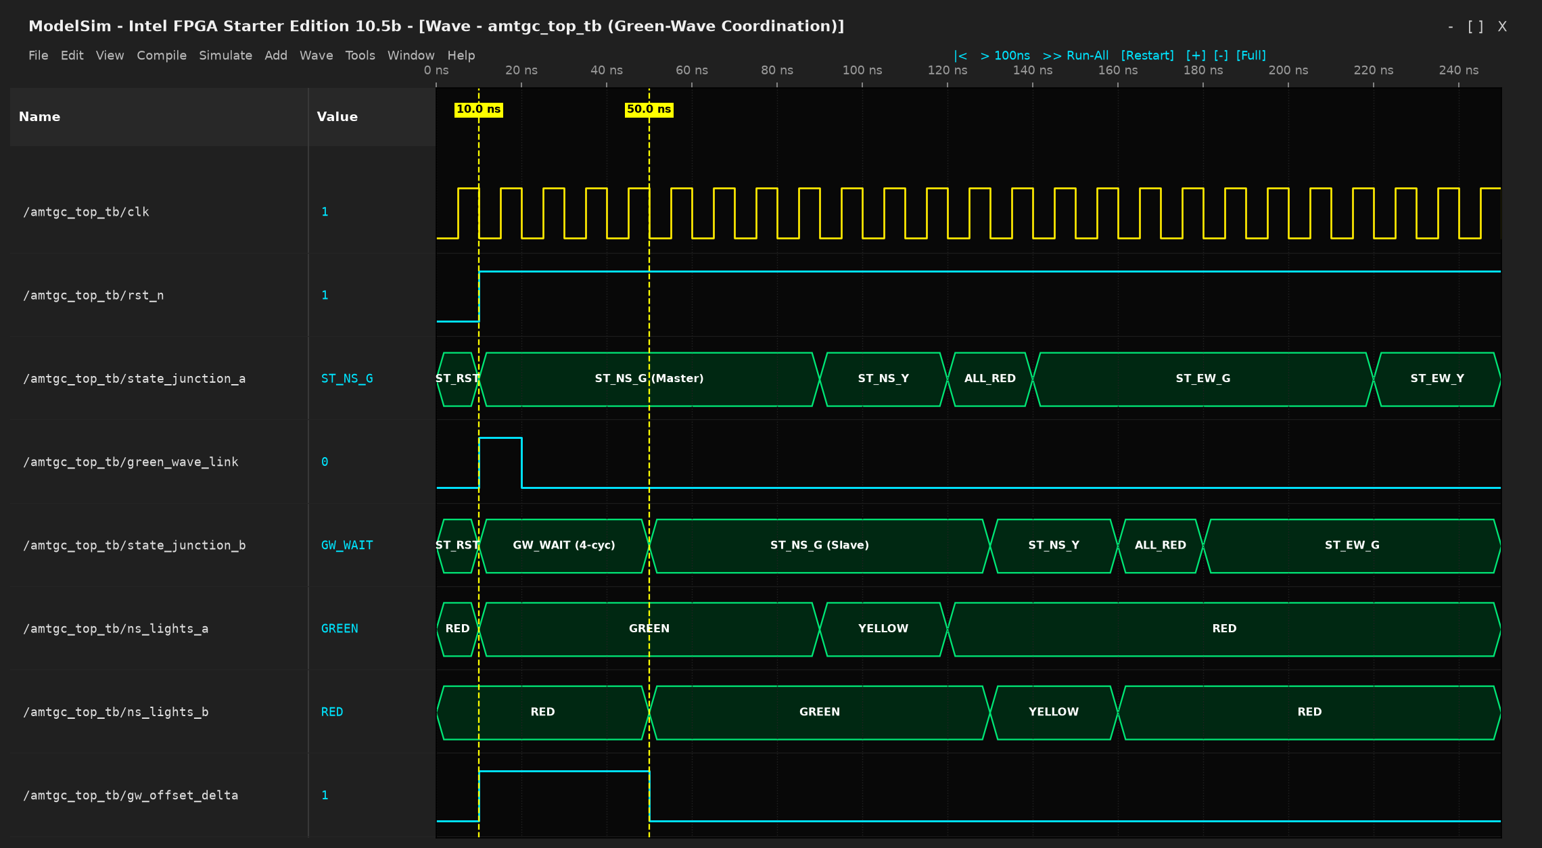
Fig. Waveform_green_wave_sync

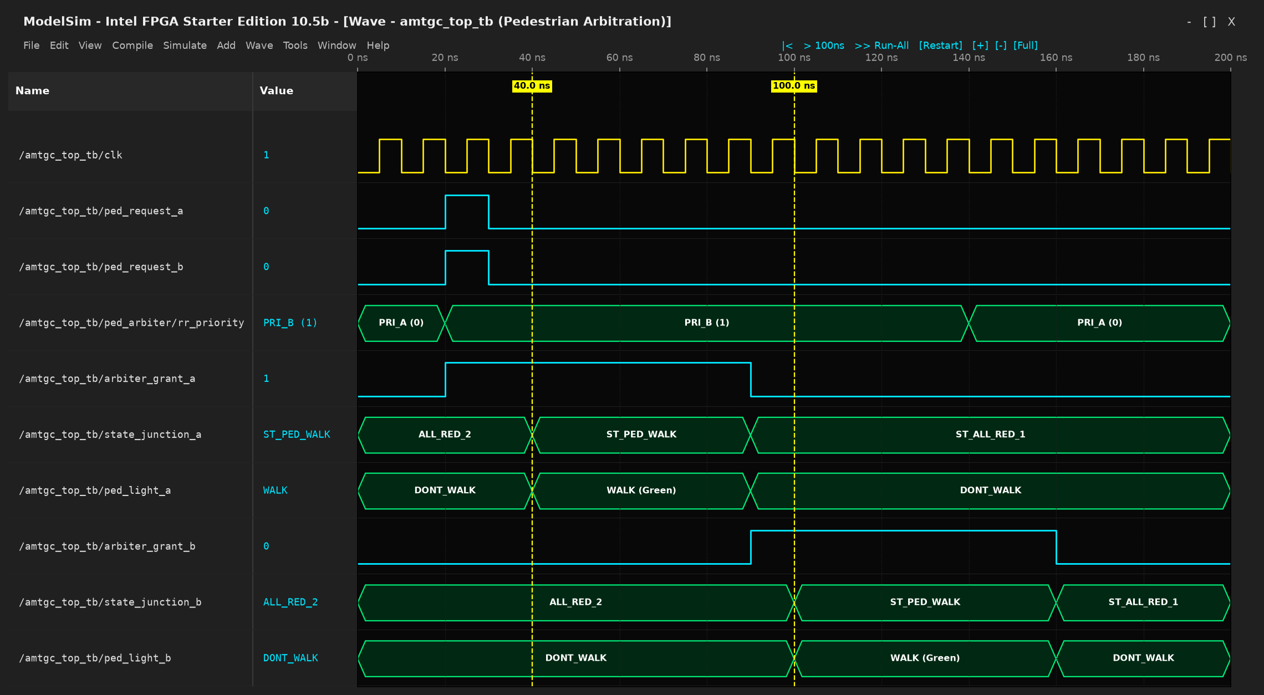
Fig. Waveform_pedestrian_arbitration_fairness

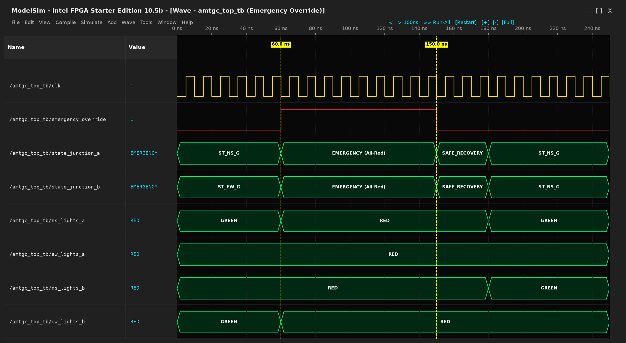
Fig. Waveform_emergency_override

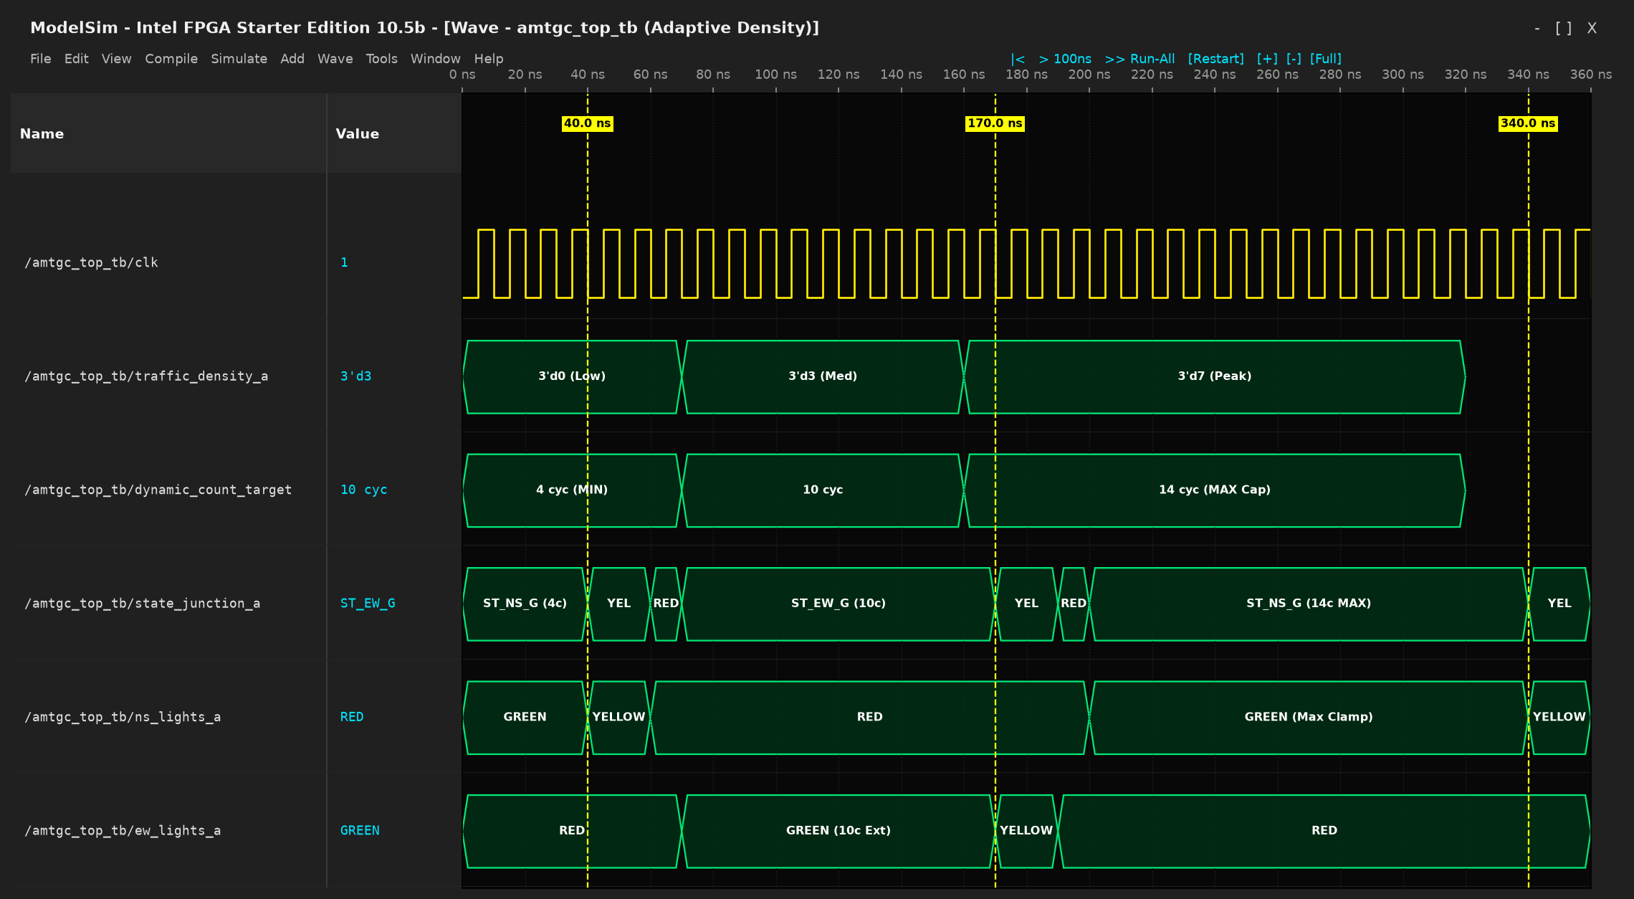
Fig. Waveform_adaptive_traffic_density

