**All Commands:**

* Add
* ls
* update
* rm
* *Get files from workspace*
* *You can check the added, updated, listed file in Path: FileStorage/file_store/*

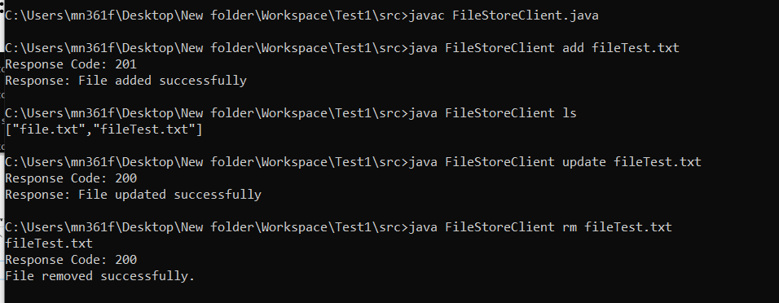

**Adding Files:**

CMD:  
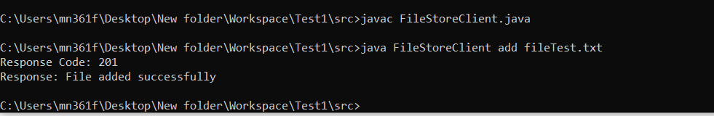

Folder:  
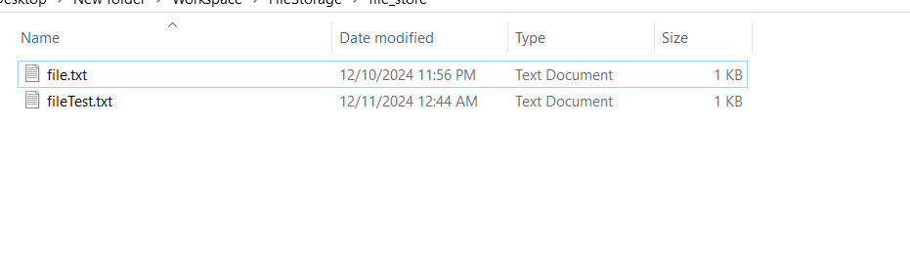  
  
File:  
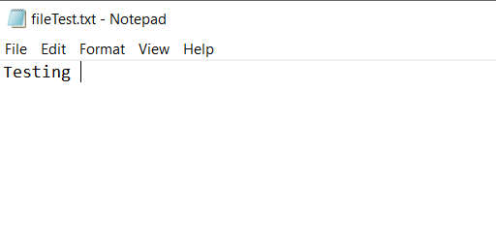  
**File with Data is added.**

**Listing Files:**

CMD:  
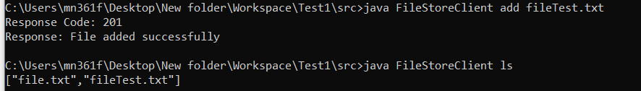

**Updating Files:**

CMD:

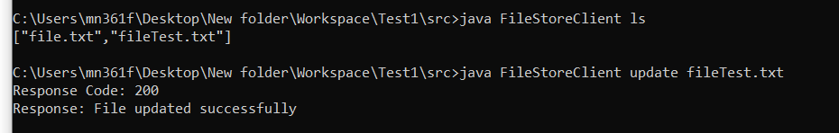

Folder:

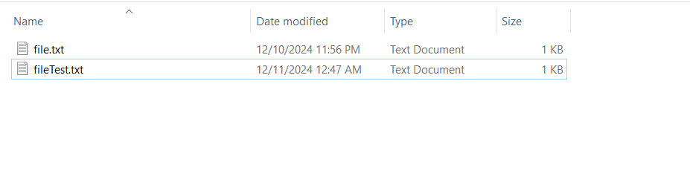

File:

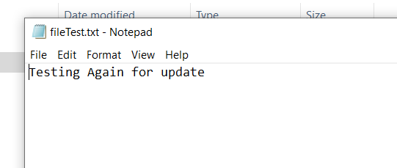

**Data is updated**

**Removing File:**

CMD:

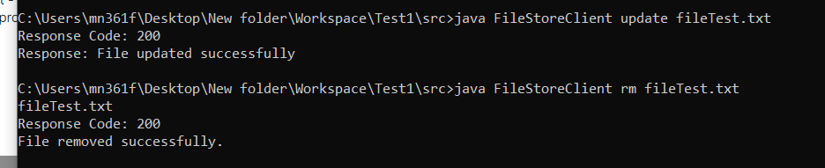

Folder:

