

|  |
| --- |
| DelREMO Customer Login Layout  Specification Ver 1.0 |
| 11/02/19 18:53 |
| **Author:** Veronica Agrawal  **File name:** DeltaV2_specificationsVer1  **Version** 1.0 |

|  |
| --- |
| Site Map |
|  |

1. Site Map / DelremoV1

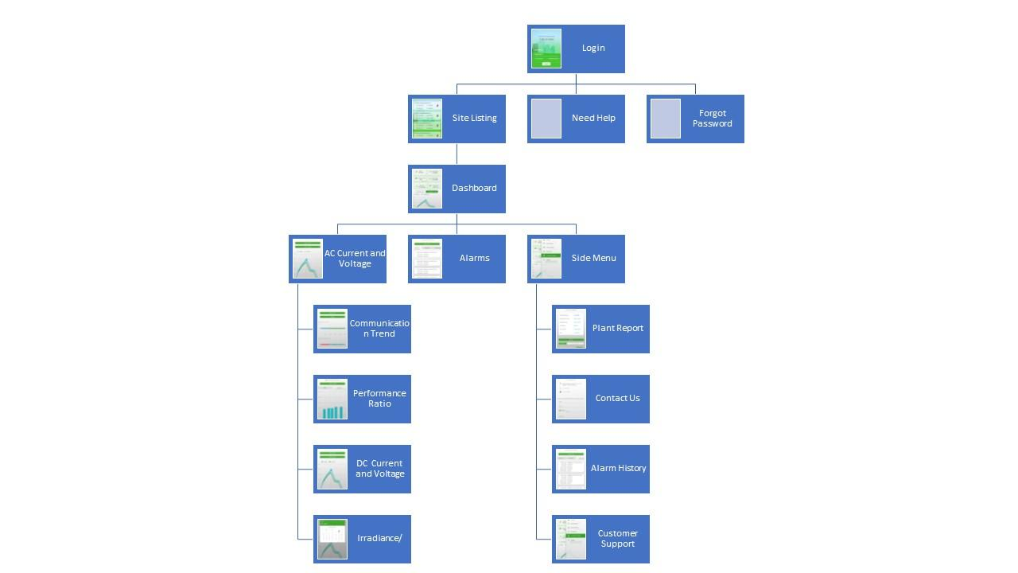

|  |
| --- |
| Screens |
|  |

**Introduction**

This Document contains the Screen Design and Layout of the DelREMO mobile app-Customer Login. Each Screen is shown along with the interactions taking place in it. The API’s used to populate the screen are depicted before the Screen Layout, for example we have the Sitelisting API followed by the Sitelisting Screen.

02. Screens / DelremoV1

Login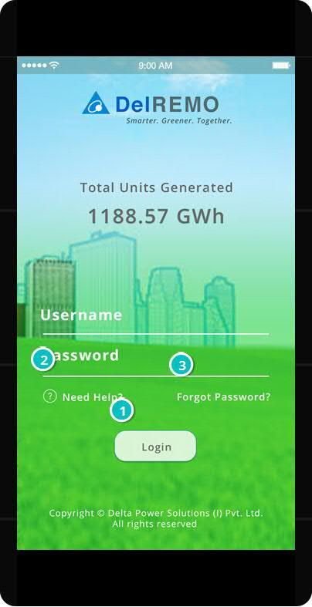



**API INFORMATION -LOGIN**

|  |  |  |  |  |  |  |  |  |
| --- | --- | --- | --- | --- | --- | --- | --- | --- |
| **Webservice 14**  **= Link :** [**[URL]**](https://www.fitterclients.com/v1s/login)**: https://delremo.emonitoring.co.in/dlrapiV2/api/Homeinfo**  **= Method Type : POST** | | | | | | | **API Objective - To return Total Energy, Total Capacity and Total Number of Plants that Delta has** | |
| **INPUT** | | | | **OUTPUT** | | | | |
| Key/Entry | Type | Description | Key/Entry | | Type | Description | |
| Token_DELTA | String | Pass parameter ‘123’. | DRDatainfo | | Array | Ex: {  "DRDatainfo": [  {  "energy": 1210098560,  "capacity": 334569.344,  "plantnumber": "2853"  }  ]  } | |

**API INFORMATION -SITELISTING**

|  |  |  |  |  |  |  |
| --- | --- | --- | --- | --- | --- | --- |
| Webservice 1  **= Link: [URL]: https://delremo.emonitoring.co.in/dlrapiV2/api/Login**  **= Method : login**  **= Method Type : POST** | | | | | | **API Objective - To return TokenID** |
| INPUT | | | OUTPUT | | | |
| Key/Entry | Type | Description | Key/Entry | Type | Description | |
| LoginID | String | This is the registered email address with DelREMO. | Token ID | String | This token will be generated by the server after successfully authenticating the credentials in the DB. This will work as the session key for all the further webservice calls and will authenticate the validity of the user. | |
| Password | String | This is the password associated with the account of the user. | User | Dictionary | After successfully logging in, server provides the user details.  "ActiveToken": [  {  "TokenID": "63682720233211023972",  "ExpDate": "2019-01-24T12:27:49.9617859+05:30",  "LoginID": "admin"  }  ] | |
| MAC | String | This is the device mac address to identify the customers it can be null |
| **Webservice 4**  = **Link :** [**[URL]**](https://www.fitterclients.com/v1s/login)**:** [**https://delremo.emonitoring.co.in/dlrapiV2/api/UserSiteList**](https://delremo.emonitoring.co.in/dlrapiV2/api/UserSiteList)  **= Method Type : POST** | | | | | | **API Objective - To return Sitename, SiteId, Total Number of Current Alarms, Communication Status and Power Capacity** |
| INPUT | | | OUTPUT | | | |
| Key/Entry | Type | Description | Key/Entry | Type | Description | |
| Token ID | String | This is the registered email address with fitterclients.com. | SiteList | Array | The array of the site details will be generated by the server after successfully  authenticating the credentials in the DB.  Ex: [{"SiteId":3564,"SiteName":"23rd & 25th Battalion Bhopal","Critical":0,"Minor":0,"Major":0,  "ComStatus":"synced",  "AlarmCatgory":"ok","powerCapacity":"11",  "Latitude":"23.223653",  "Longitude":"77.380683"}] | |
| SiteID | Integer | Ex:3163 |  |  |  | |
| EvTime | Date | Ex:12-jun-2018 |
| **Webservice 7**  **= Link: [URL]: https://delremo.emonitoring.co.in/dlrapiV2/api/Login**  **= Method : login**  **= Method Type : POST** | | | | | | **API Objective - To return Installed power, date of integration, Number of Inverters** |
| INPUT | | | OUTPUT | | | |
| Key/Entry | Type | Description | Key/Entry | Type | Description | |
| TokenID | String | TokenID we will get once we login to application | siteInfo | Array | The array of the site values will be generated by the server after  successfully authenticating the credentials in the DB.  Ex: [{"SiteID":"3163","SiteName":"AAI-NSCBI Airport","NoOfInv":"34",  "InstalledPowerDC":"2000",  "InstalledPowerAC":"1680","DateOfCommissioning":"05-10-2015 00:00:00","DateOfIntegration":"13-10-2015 00:00:00",  "PlantDescription":"2000 kWp Solar PV Power Plant","PanelType":"MultiCrystalline","PanelWattage":"260",  "NoOfPvPanel":"7695","PanelTilt":"20","ModuleEffi":"15.53",  "KWhRates":"7.8","PacketDuration":"7","Longitude":"88.44",  "Latitude":"22.65","PlantArea":"12312","Address":"AAI NSCBI Airport Kolkata ","Country":"India","IsPCurveSelect":false,"PCurveValue":"0",  "IsUPSAvail":false,"IsFollowIEC61724Std":true,"IsEnergyMeterAvil":false,  "IsMultiGwAtchd":true,"CommunicationVia":"GSM","SiteStatus":"Ready"}],  "siteImages":  [{"Image1Url":"delremo.emonitoring.co.in/DLRAPI/api/SiteINfo/GetImage?  SiteID=3163&PlntImg=PImg1","Image2Url":"delremo.emonitoring.co.in/DLRAPI/api/SiteINfo/GetImage?SiteID=3163&PlntImg=PImg2","Image3Url":"delremo.emonitoring.co.in/DLRAPI/api/SiteINfo/GetImage?SiteID=3163&PlntImg=PImg3"}]} | |
| SiteID | Integer | Ex:3163 |

02. Screens / DelremoV1

**SiteListing**

|  |
| --- |
|  |

**API INFORMATION-Dashboard**

|  |  |  |  |  |  |  |
| --- | --- | --- | --- | --- | --- | --- |
| **Webservice 5**  **= Link :** [**[URL]**](https://www.fitterclients.com/v1s/login)**: https://delremo.emonitoring.co.in/dlrapiV2/api/Homeinfo**  **= Method Type : POST** | | | | | | **API Objective - To return Yield Till Date, Today Energy, Current Alarms, Power** |
| **INPUT** | | | **OUTPUT** | | | |
| Key/Entry | Type | Description | Key/Entry | Type | Description | |
| TokenID | String | TokenID we will get once we login to application | siteHomeInfo | Array | The array of the site values will be generated  by the server after successfully authenticating  the credentials in the DB.  Ex:[{"TotalKWH":"2173989.80","TodayKWH":"4643.71",  "Alarms":"0","Power":"231.87"}] | |
| SiteID | Integer | Ex:3163 |
| EvTime | Date | Ex:12-jun-2018 |
| **Webservice 3**  **= Link:** [**[URL]**](https://www.fitterclients.com/v1s/login)**: https://delremo.emonitoring.co.in/dlrapiV2/api/SiteKWh**  **= Method Type : POST** | | | | | | **API Objective - To return Monthly Yield for current month and previous month** |
| **INPUT** | | | **OUTPUT** | | | |
| Key/Entry | Type | Description | Key/Entry | Type | Description | |
| TokenID | String | TokenID will get once we login to application | SiteEnergy | Array | The array of the energy values will be generated by the server after successfully authenticating the credentials in the DB.  Ex Daily: [{"DateTime":"12-Jun-2016 05:00:00","KWH":"0.00"}].  Ex Month: [{"DateTime":"01-Jun-2016","KWH":"6583.445"}].  Ex Year: [{"DateTime":"Jan-2016","KWH":"151651.00"}] | |
| SiteID | Integer | Ex:3163 |
| EvTime | Date | Ex:12-JAN-2019 |
| **Webservice 2**  **= Link :** [**[URL]**](https://www.fitterclients.com/v1s/login)**: https://delremo.emonitoring.co.in/dlrapiV2/api/PwrNdIrr**  **= Method Type : POST** | | | | | | **API Objective - To return Power Irradiance Graph for today** |
| **INPUT** | | | **OUTPUT** | | | |
| Key/Entry | Type | Description | Key/Entry | Type | Description | |
| TokenID | String | TokenID will get once we login to application | PowerAndIrr | Array | The array of the power and irradiance values will be generated by the server after successfully authenticating the credentials in the DB.  Ex: [{"dateTime":"12-Jun-2016 05:00:00","Irradiance":"38.00","Power":"0.00"}] | |
| SiteID | Integer | Ex:3163 |
| EvTime | Date | Ex:12-JAN-2019 |

02. Screens / DelremoV1

**Dashboard**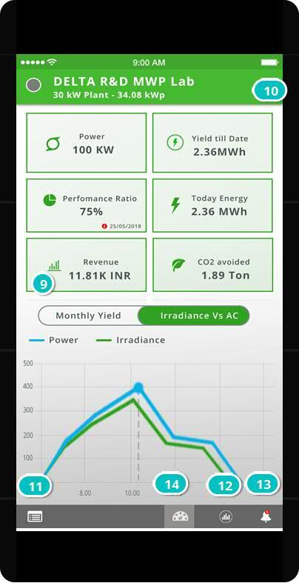

|  |
| --- |
|  |

02. Screens / DelremoV1

DashboardCur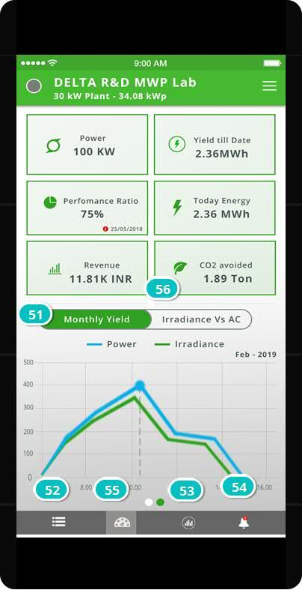



02. Screens / DelremoV1

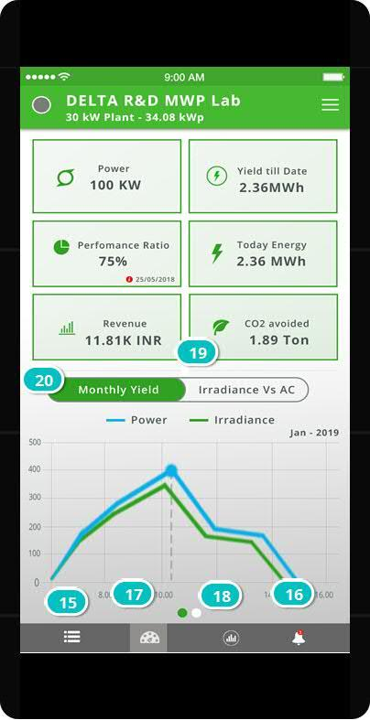

DashboardPrev

|  |
| --- |
|  |
|  |  |
|  |  |
|  |  |
|  |  |
|  |  |
|  |  |



02. Screens / DelremoV1

SideMenu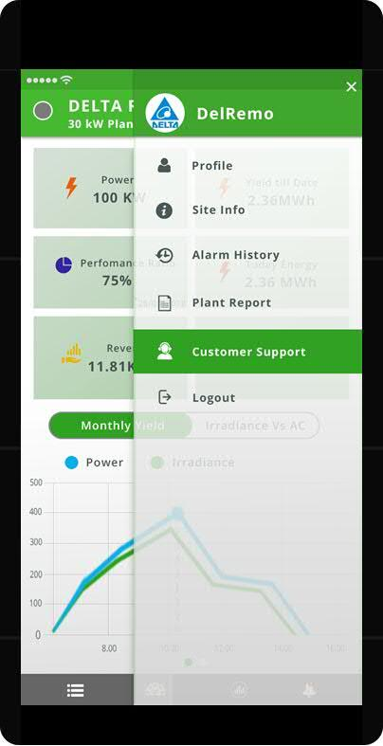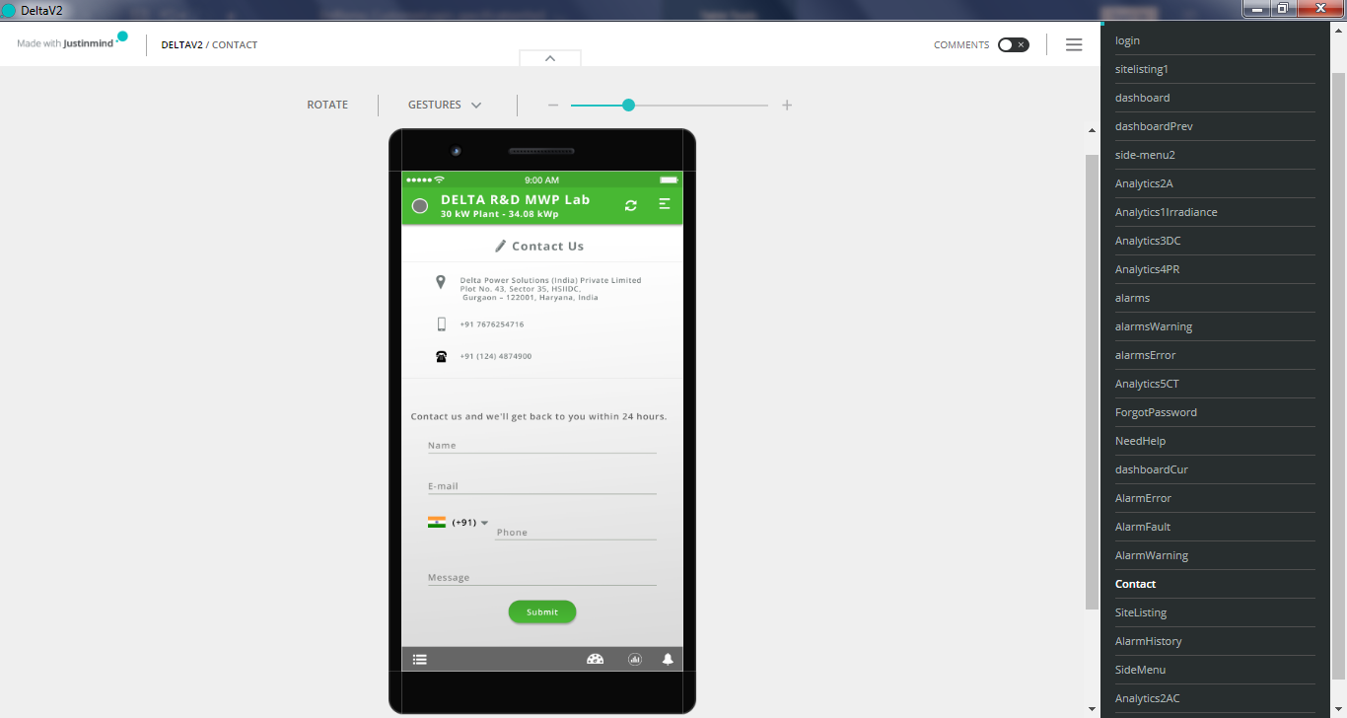

|  |
| --- |
|  |



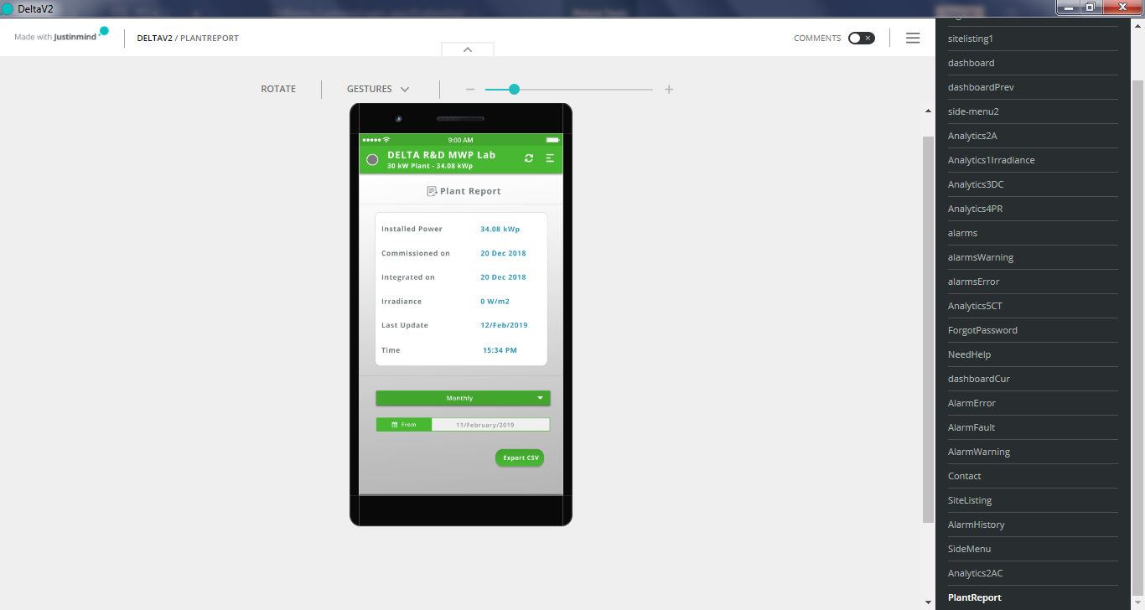

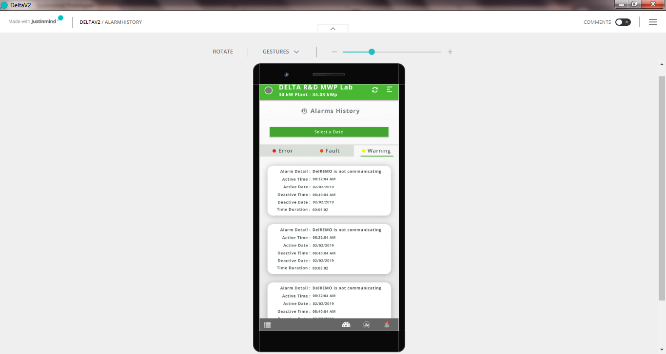



**API Information-Power and Irradiance**

**On Click**ing Analytics icon on Navigation bar.

|  |  |  |  |  |  |  |
| --- | --- | --- | --- | --- | --- | --- |
| **Webservice 2**  **= Link :** [**[URL]**](https://www.fitterclients.com/v1s/login)**: https://delremo.emonitoring.co.in/dlrapiV2/api/PwrNdIrr**  **= Method Type : POST** | | | | | | **API Objective - To return Power Irradiance Graph for today** |
| **INPUT** | | | **OUTPUT** | | | |
| Key/Entry | Type | Description | Key/Entry | Type | Description | |
| TokenID | String | TokenID will get once we login to application | PowerAndIrr | Array | The array of the power and irradiance values will be generated by the server after successfully authenticating the credentials in the DB.  Ex: [{"dateTime":"12-Jun-2016 05:00:00","Irradiance":"38.00","Power":"0.00"}] | |
| SiteID | Integer | Ex:3163 |
| EvTime | Date | Ex:12-JAN-2019 |

02. Screens / DelremoV1

Analytics1Irradiance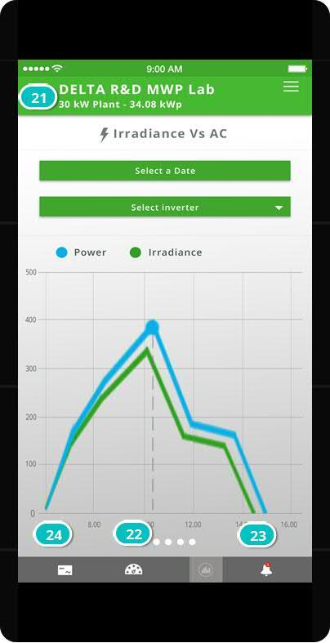



**PI Called**

**API Information-** **AC Voltage and Current graph**

On swiping left on the Analytics1 Screen the Analytics2AC Screen is loaded

|  |  |  |  |  |  |  |
| --- | --- | --- | --- | --- | --- | --- |
| **Webservice 8**  **= Link :** [**[URL]**](https://www.fitterclients.com/v1s/login)**: https://delremo.emonitoring.co.in/dlrapiV2/api/Analytics/InvVCInfo**  **= Method Type : POST** | | | | | | **API Objective - To return AC Voltage and Current graph** |
| **INPUT** | | | **OUTPUT** | | | |
| Key/Entry | Type | Description | Key/Entry | Type | Description | |
| TokenID | String | TokenID will get once we login to application | SiteInvACVC | Array | The array of the site values will be generated by the server after successfully authenticating the credentials in the DB and this will be a 5 minutes’ interval data will be used for to plot the chart.  Ex: [{"DateTime":"13-Jun-2016 05:01:14","VoltagePhase1":"0","VoltagePhase2":"0","VoltagePhase3":"0","CurrentPhase1":"0","CurrentPhase2":"0","CurrentPhase3":"0"} ] | |
| SiteID | Integer | Ex:3163 |
| EvTime | Date | Ex:12-JAN-2019 |
| InvID | Integer | Ex : 1 |  |  |  | |

Analytics2AC

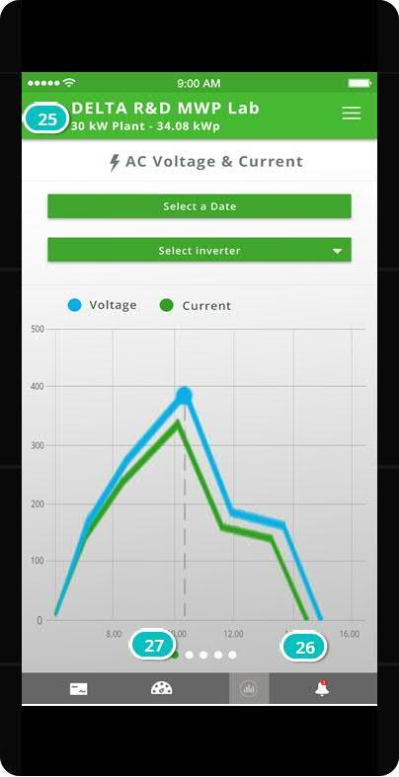

|  |
| --- |
|  |

**API Information-** **DC Voltage and Current graph**

On swiping left on the Analytics2 Screen the Analytics3DC Screen is loaded

|  |  |  |  |  |  |  |
| --- | --- | --- | --- | --- | --- | --- |
| **Webservice 8**  **= Link :** [**[URL]**](https://www.fitterclients.com/v1s/login)**: https://delremo.emonitoring.co.in/dlrapiV2/api/Analytics/InvVCInfo**  **= Method Type : POST** | | | | | | **API Objective - To return DC Voltage and Current graph** |
| **INPUT** | | | **OUTPUT** | | | |
| Key/Entry | Type | Description | Key/Entry | Type | Description | |
| TokenID | String | TokenID will get once we login to application | SiteInvACVC | Array | The array of the site values will be generated by the server after successfully authenticating the credentials in the DB and this will be a 5 minutes’ interval data will be used for to plot the chart.  Ex: [{"DateTime":"13-Jun-2016 05:01:14","VoltagePhase1":"0","VoltagePhase2":"0","VoltagePhase3":"0","CurrentPhase1":"0","CurrentPhase2":"0","CurrentPhase3":"0"} ] | |
| SiteID | Integer | Ex:3163 |
| EvTime | Date | Ex:12-JAN-2019 |
| InvID | Integer | Ex : 1 |  |  |  | |

02. Screens / DelremoV1

Analytics3DC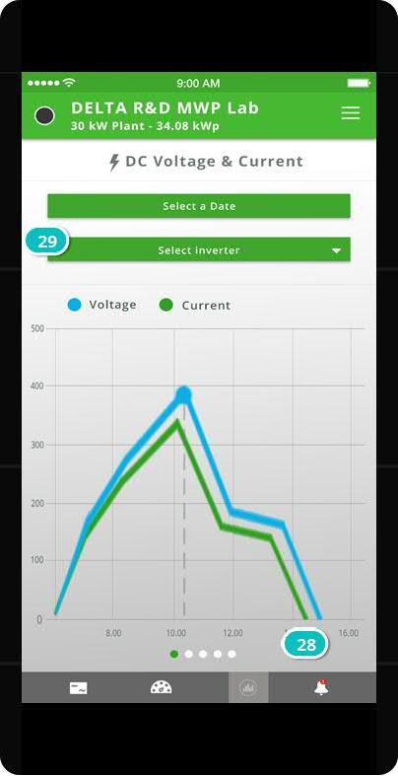

|  |
| --- |
|  |

**API Information-** **Performance Ratio**

On swiping left on the Analytics3 Screen the Analytics4PR Screen is loaded

|  |  |  |  |  |  |  |
| --- | --- | --- | --- | --- | --- | --- |
| **Webservice 11**  **= Link :** [**[URL]**](https://www.fitterclients.com/v1s/login)**: https://delremo.emonitoring.co.in/dlrapiV2/api/Analytics/PR**  **= Method Type : POST** | | | | | | **API Objective - To return** Performance Ratio graph |
| **INPUT** | | | **OUTPUT** | | | |
| Key/Entry | Type | Description | Key/Entry | Type | Description | |
| TokenID | String | TokenID will get once we login to application | SitePRCalculated | Array | The array of the site values will be generated by the server after successfully authenticating the credentials in the DB.  Ex: {  "SitePRCalculated": [  {  "SiteID": "6940",  "Date": "01-Jan-2019",  "PR": "0.00"  },  {  "SiteID": "6940",  "Date": "02-Jan-2019",  "PR": "0.00"  }, | |
| SiteID | Integer | Ex:3163 |
| EvTime | Date | Ex:12-JAN-2019 |
| PRSearchType | String | Ex : day/month |

02. Screens / DelremoV1

Analytics4PR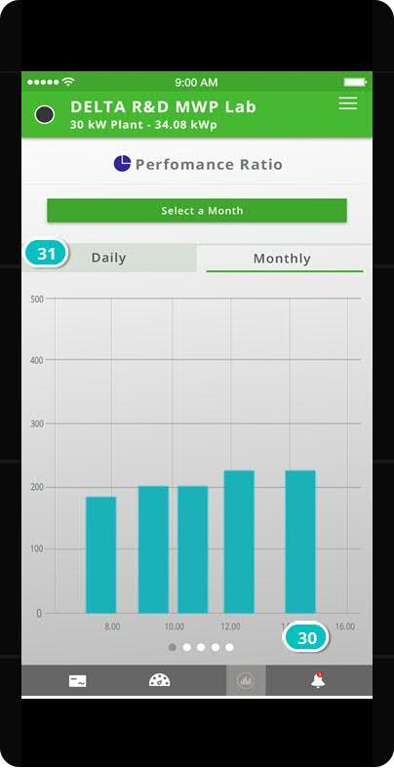

|  |
| --- |
|  |

**API Information-** **Communication Trend graph data**

On swiping left on the Analytics4 Screen the Analytics5CT Screen is loaded

|  |  |  |  |  |  |  |
| --- | --- | --- | --- | --- | --- | --- |
| **Webservice 12**  **= Link :** [**[URL]**](https://www.fitterclients.com/v1s/login)**: https://delremo.emonitoring.co.in/dlrapiV2/api/Analytics/** **CommunicationTrend**  **= Method Type : POST** | | | | | | **API Objective - To return** Communication Trend graph data |
| **INPUT** | | | **OUTPUT** | | | |
| Key/Entry | Type | Description | Key/Entry | Type | Description | |
| TokenID | String | TokenID will get once we login to application | CommunicationTrend | Array | The array of the site values will be generated by the server after successfully authenticating the credentials in the DB.  Ex: {  "CommunicationTrend": [  {  "DelRemoTime": "28-Jan-2019 04:05:18",  "PortalTime": "28-Jan-2019 03:42:43",  "InvComStatus": "0",  "GatewayId": "54:10:EC:17:9B:84"  },  {  "DelRemoTime": "28-Jan-2019 04:05:41",  "PortalTime": "28-Jan-2019 04:04:06",  "InvComStatus": "0",  "GatewayId": "D8:80:39:BA:BB:AC"  }]} | |
| SiteID | Integer | Ex:3163 |
| From | String | Ex:12-JAN-2019 |
| To | String | Ex:12-JAN-2019 |

02. Screens / DelremoV1

Analytics5CT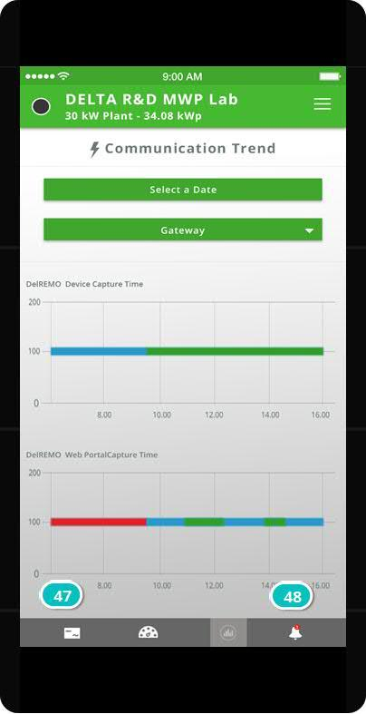

|  |
| --- |
|  |

**API Information-Current Alarms**

**On Click**ing the Alarm Icon on Navigation bar

|  |  |  |  |  |  |  |
| --- | --- | --- | --- | --- | --- | --- |
| **Webservice 10**  **= Link https://delremo.emonitoring.co.in/dlrapiV2/api/sitealarms**  **= Method Type : POST** | | | | | | **API Objective - To return** Active Time, Alarm Description, Inverter Id, Alarm Category, Status |
| **INPUT** | | | **OUTPUT** | | | |
| Key/Entry | Type | Description | Key/Entry | Type | Description | |
| TokenID | String | TokenID will get once we login to application | SiteAlarmsList | Array | The array of the site values will be generated by the server after successfully authenticating the credentials in the DB.  Ex: [{"SiteID":"3311","ActiveTime":"20-May-2016 07:24:42","AlarmDesc":"No Grid","AlarmOn":"Inverter 1","AlarmCategory":"Error","DeactiveTime":"21-May-2016 07:06:30","Status":"Active"}] | |
| SiteID | Integer | Ex:3163 |
| AlarmSelectionCategory | String | Ex: current |

02. Screens / DelremoV1

AlarmsError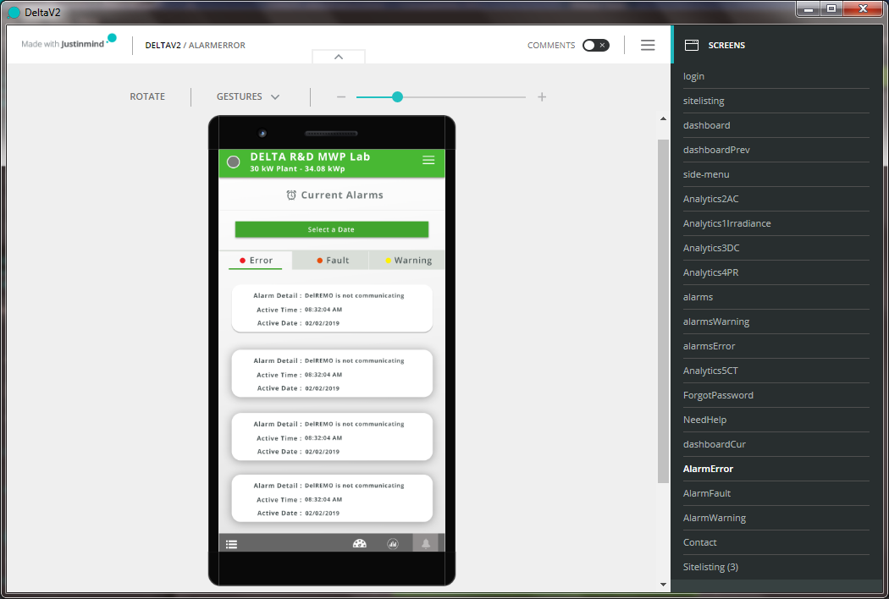

|  |
| --- |
|  |

AlarmsFault and AlarmsWarning