**Report**

1. **Task Description**

Implement drag-and-drop functionality for the image only.

1. **Task Output Screenshot**

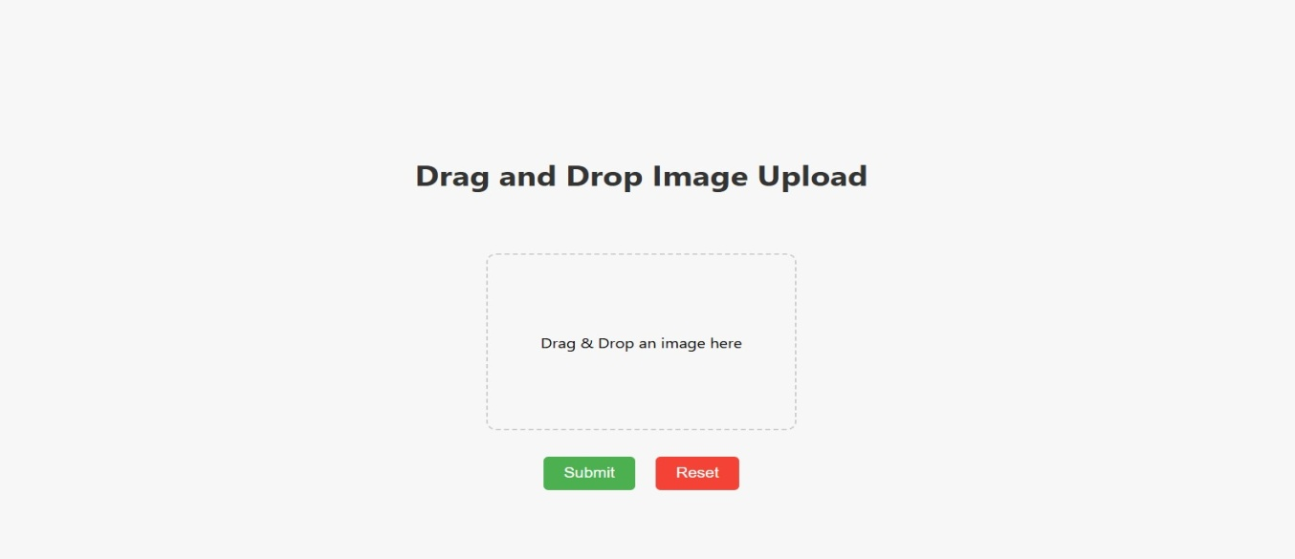**Fig.1**

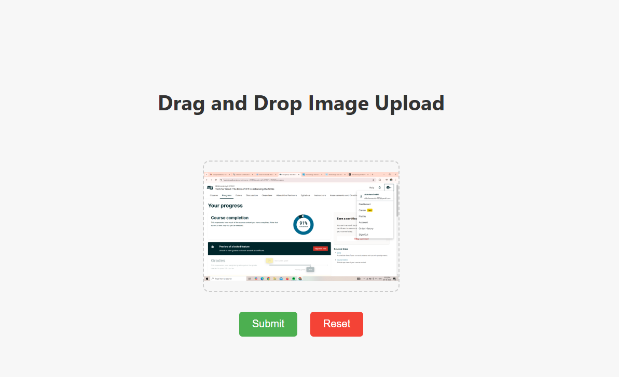

**Fig.2**

1. **Widget/Algorithm Used In Task**

**Widget:-**

• **File Drop Zone:** Drag-and-drop area for file upload.Styled with a dashed border.

* **Image Preview**:Displays the uploaded image.

• **Error Message**:Shows an error if a non-image file is uploaded.

• **Remove File Button**:Allows users to remove the uploaded image.

• **File Information**:Displays the name of the uploaded file.

**Algorithms:-**

* Used useState to manage the state for the selected file (selectedFile) and the image preview (preview).
* Utilized onDragOver and onDrop event handlers to manage the drag-and-drop functionality. The handleDragOver prevents default behavior, and handleDrop handles file selection and preview generation.
* Applied inline styles for the drag-and-drop area to visually indicate the drop zone, including dashed borders and centered content.
* Implemented a submit button (which can be extended to send the file to a backend) to trigger the upload action.

.