**Report**

1. **Task Description**
2. Create custom common component for the input using formik with all kind of validation.
3. **Task Output Screenshot**

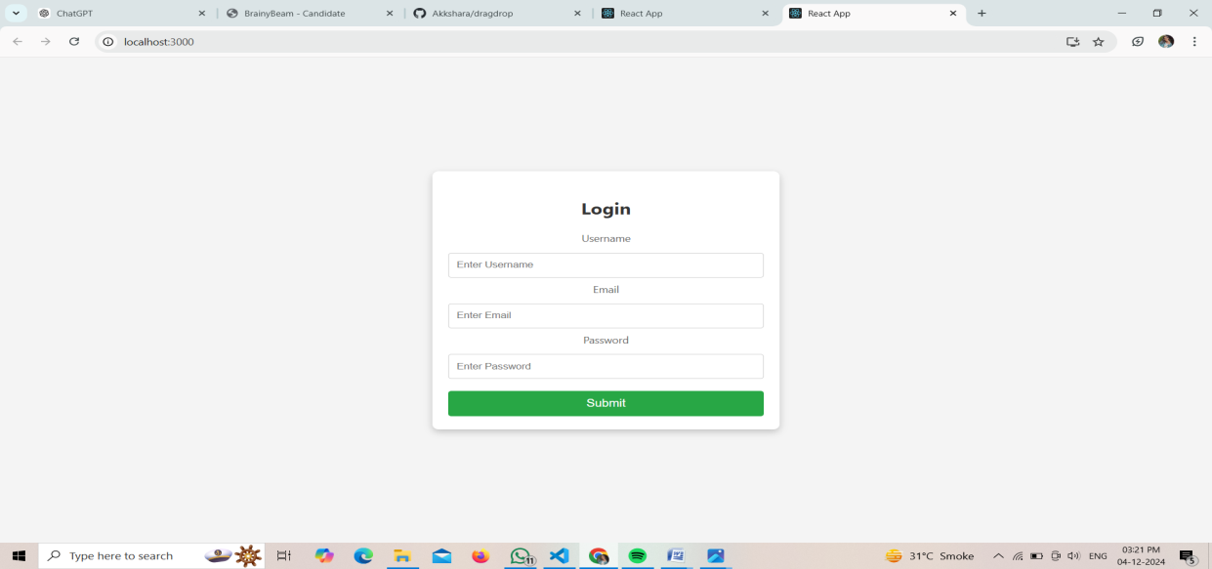

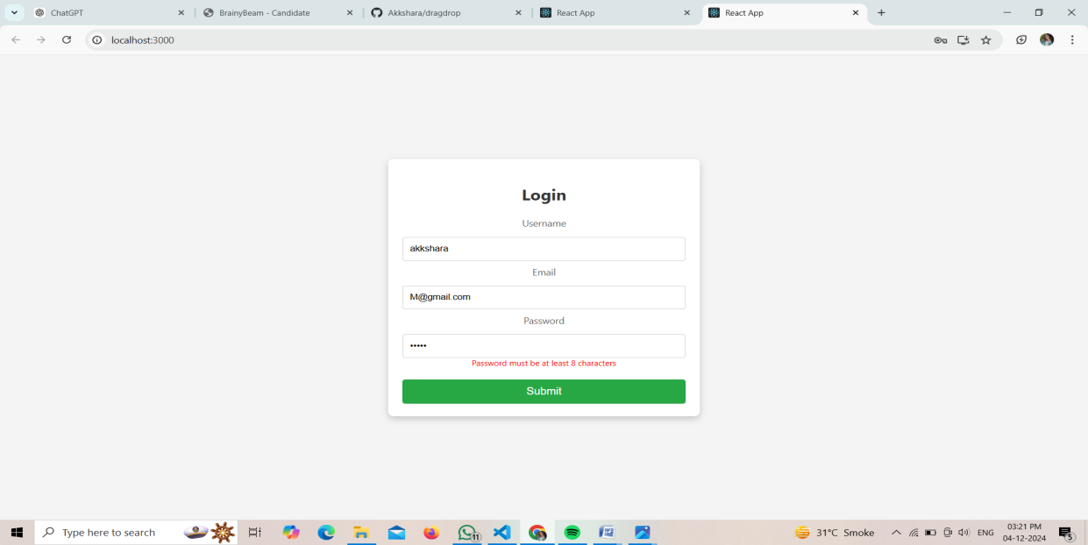

1. **Widget/Algorithm Used In Task**

**Widget:**

1. **Form**: Contains input fields (Username, Email, Password) wrapped in a Formik form.
2. **Custom Input**: Custom input components for each field, using Formik’s Field and ErrorMessage.
3. **Submit Button**: Button to submit the form data to the backend.

**Algorithm:**

1. **Initial Values**: Define the initial state for the form (e.g., empty fields for username, email, and password).
2. **Validation**: Apply Formik’s validation using a schema (e.g., Yup) to validate the inputs (e.g., email format, password strength).
3. **Handle Submit**: On form submission, send the data to the backend using fetch or axios for processing.
4. **Reset After Submit**: Reset the form values and validation status after a successful submission.