**Report**

1. **Task Description**

Create pagination for the table of dummy data it's has previous and next button with three dots with three middle button

1. **Task Output Screenshot**

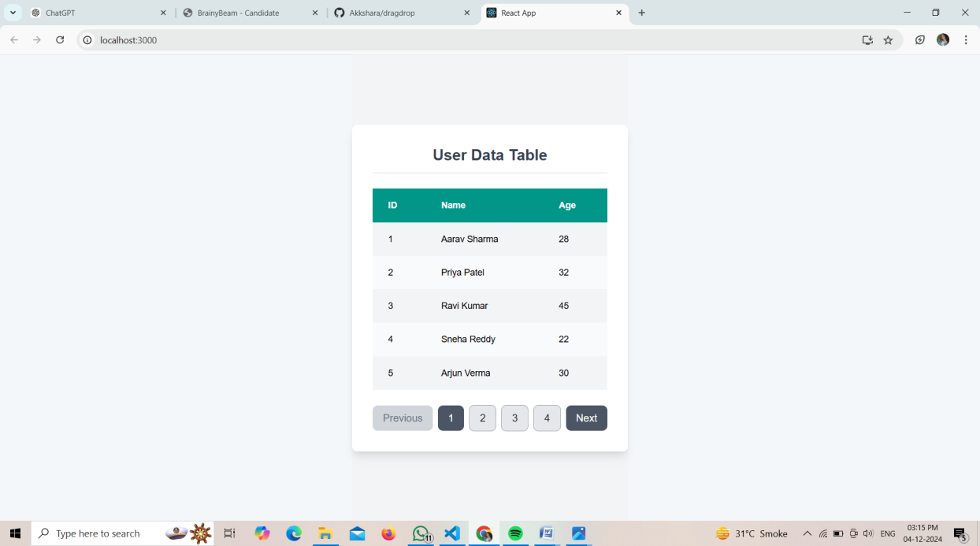

1. **Widget/Algorithm Used In Task**

**Widget:**

1. **Table**: Displays data in rows and columns (ID, Name, Age).
2. **Pagination Controls**: "Previous" and "Next" buttons, page numbers with ellipses.

**Algorithm:**

1. **Calculate Total Pages**: Based on total items and items per page.
2. **Handle Page Navigation**: Update the current page when navigating between pages.
3. **Display Current Data**: Show data corresponding to the current page.
4. **Render Pagination**: Dynamically render page numbers and ellipses for non-adjacent pages