**Report**

1. **Task Description**

Implement a global app theme switcher using context and local storage.

1. **Task Output Screenshot**

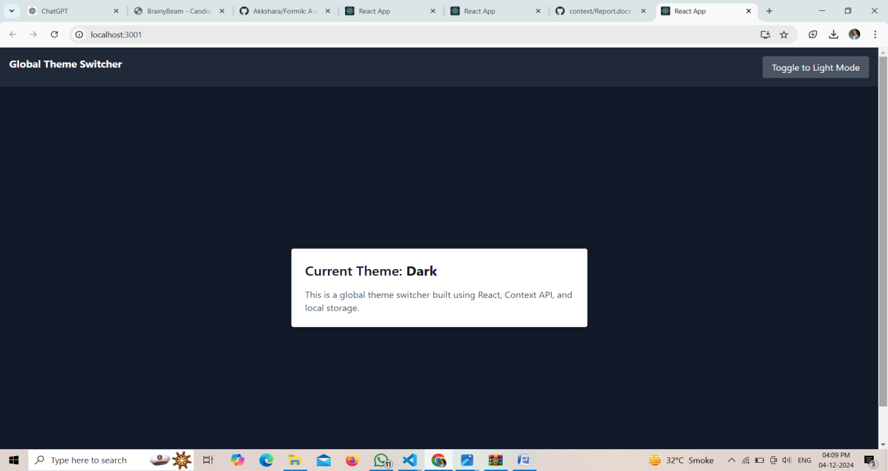**Fig.1**

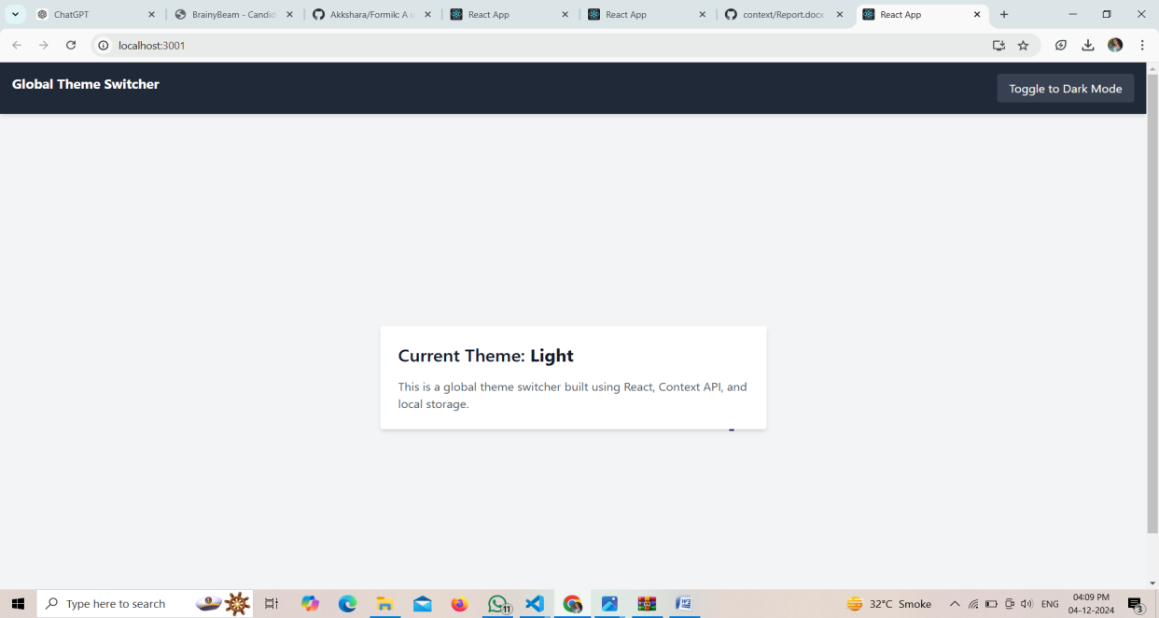

**Fig.2**

1. **Widget/Algorithm Used In Task**

**Widget:**

1. **Toggle Button**: Allows users to switch between light and dark themes.
2. **Global Theme Context**: Manages the selected theme across the application.
3. **Themed Components**: UI components that dynamically adapt based on the selected theme.
4. **Local Storage**: Saves the user’s theme preference for persistence.

**Algorithm:**

1. **Initialize Theme Context**: Create a React context to manage the current theme and a function to update it.
2. **Check Local Storage**: On app load, check for a saved theme preference in local storage.
3. **Apply Theme**: Set the theme in the context and apply corresponding CSS classes to the app.
4. **Toggle Theme**: When the user toggles, update the theme in context and local storage.